Name: Elaine Joyce

Relationship to Resident: Friend
Full Address: 121 Parmenter rd, Newton, MA 02465

Dear Commissioner Goldstein and Members of the Public Health Council:
I am submitting this comment as a friend of a resident at Seven Hills Pediatric Center. My friend has severe, lifelong medical and developmental disabilities and depends on skilled nursing care every hour of every day to remain safe and stable.
Seven Hills Pediatric Center is not a traditional nursing home. It provides highly specialized care for children and young adults who are medically fragile, non-verbal, and dependent on complex medical supports such as feeding tubes, seizure management, and respiratory care. Many residents, including adults over age 22, remain at Seven Hills because it is the only place equipped to meet their needs.
The proposed changes to 105 CMR 150.003(E) and 150.011(M) could be misinterpreted and used to require residents to leave pediatric skilled nursing facilities based on age alone, even when no safe alternative exists. This is not realistic. Outside of Seven Hills Pediatric Center and New England Pediatric Care, there are no adult facilities in Massachusetts that can safely care for people with this level of medical complexity.
Forcing these transitions would break continuity of care and separate residents from staff who know them best. For individuals with lifelong disabilities, turning 22 does not reduce their needs—it often increases them.
I respectfully urge the Department to withdraw the proposed amendments and preserve individualized decision-making based on need to ensure residents can remain safe and stable where they are.
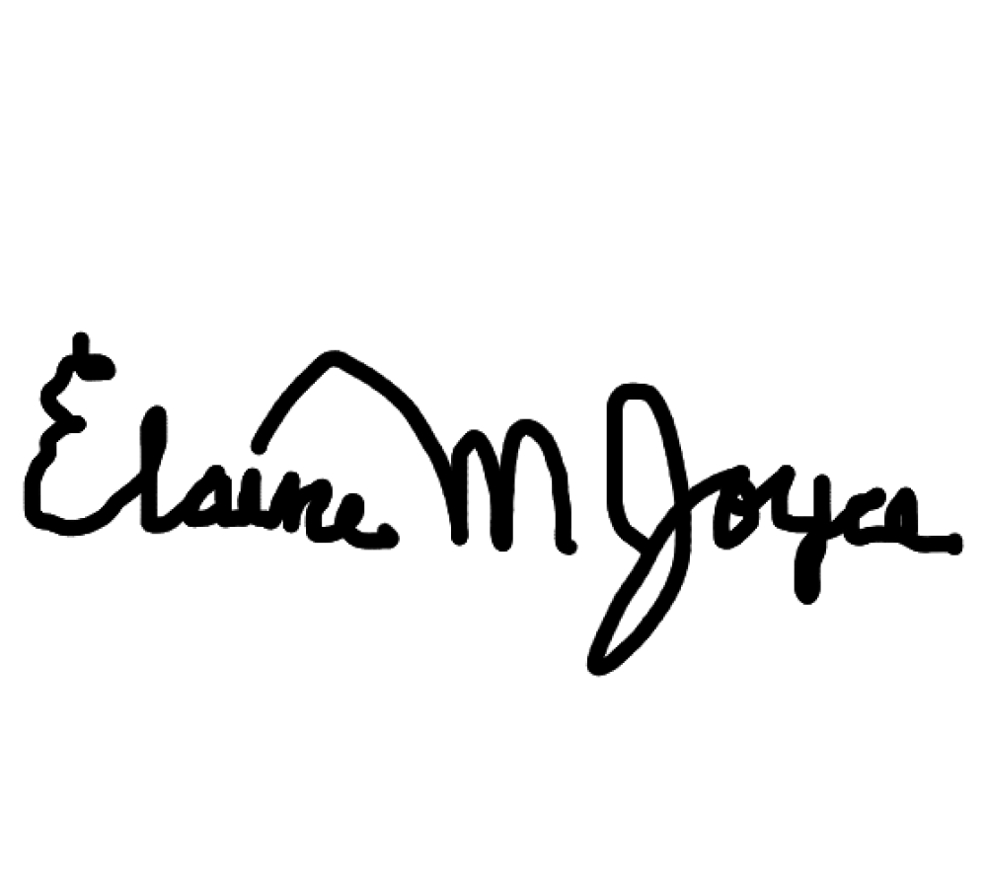
Thank you for considering my comment.
Sincerely,

