

How to Apply for the SEI Endorsement in ELAR: A Step by Step Guide
July 2015

Access ELAR System
- Go to www.mass.gov/ese/licensure | 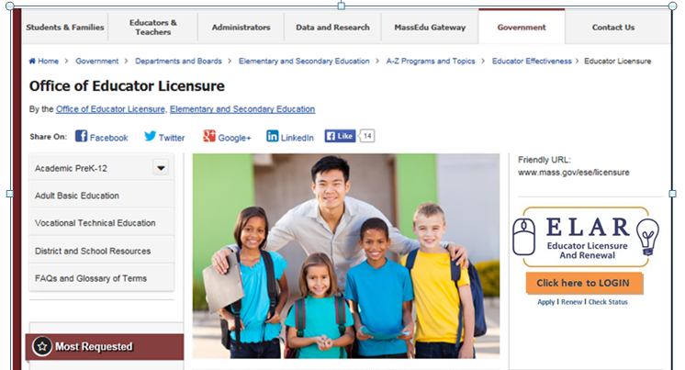
- Click on ELAR Login Image | 

Log-in to ELAR Portal
- Input your User Name and Password  Note:  - If you do not have an ELAR account yet, click on the Create ELAR Profile link and create a new profile/account.  - If you do not know if you have an account, or have forgotten your ELAR User Name or Password, click on the Forgot User Name/Password link and follow prompts. | 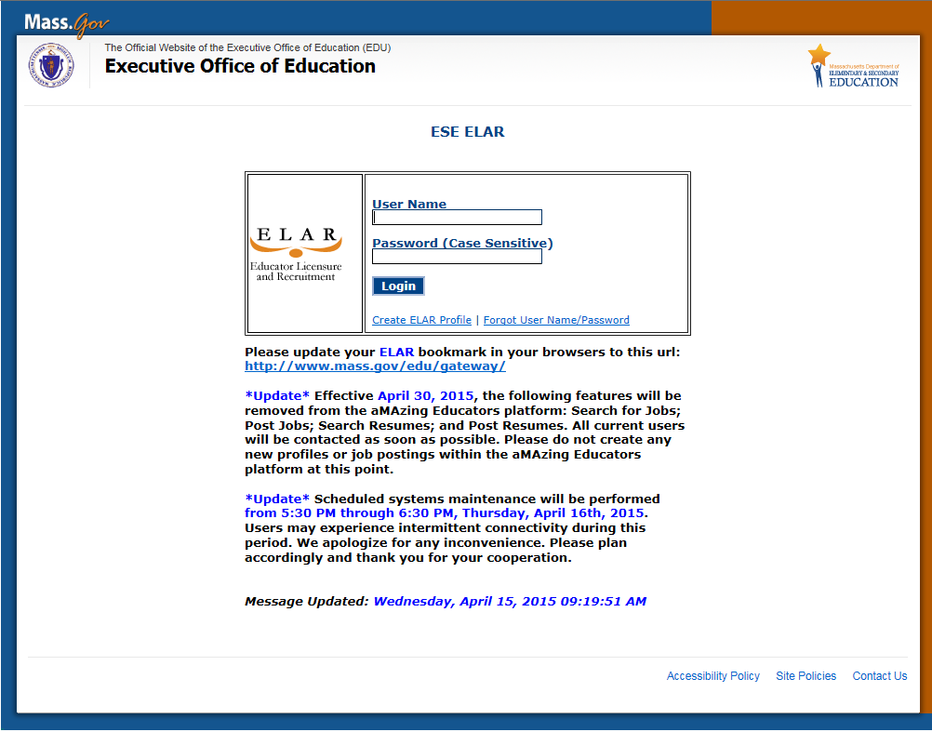

ELAR Welcome Page
- Click on Apply for a new license, apply for an Endorsement, or advance to the next level license | 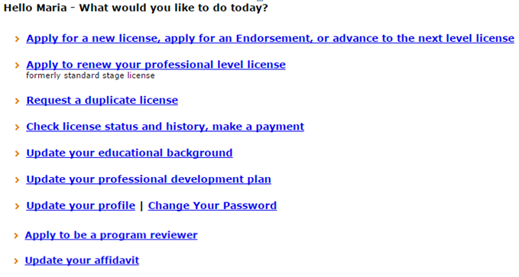
Apply for Licensure - Introduction Page
- Review instructions for how to navigate within the ELAR system.  - Click Next button | 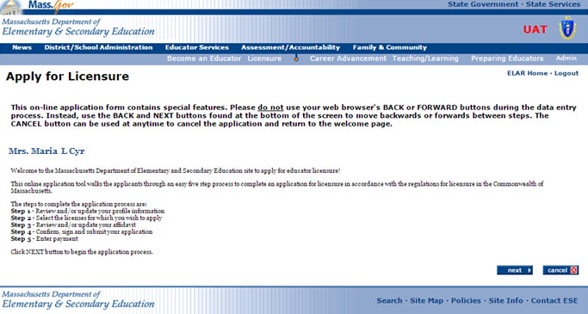

Step 1: Verify Profile
- Verify profile information.  - Click Next button  Note:  - The Department of Elementary and Secondary Education will communicate with you regarding your application via email so please ensure that you have provided a current and valid email address.  - You cannot update your name, birth date, or social security number.  To update your name, please follow the instructions on and submit the: Request for Name Change/Hard Copy form.  To update your social security number, please send a copy of your social security card to the Office of Educator Licensure. | 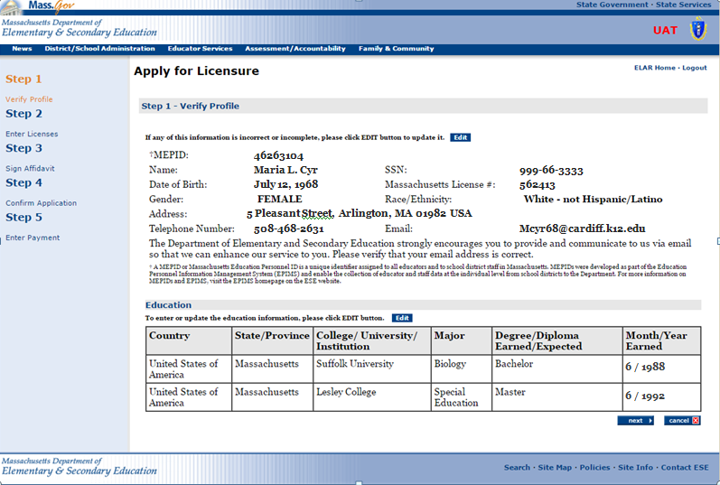
Step 2: Enter Licenses for Approval
- Select ‘Endorsements’ in the first Field drop-down list  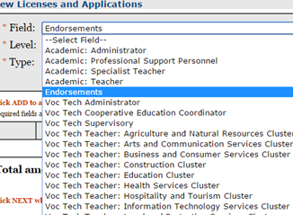 | 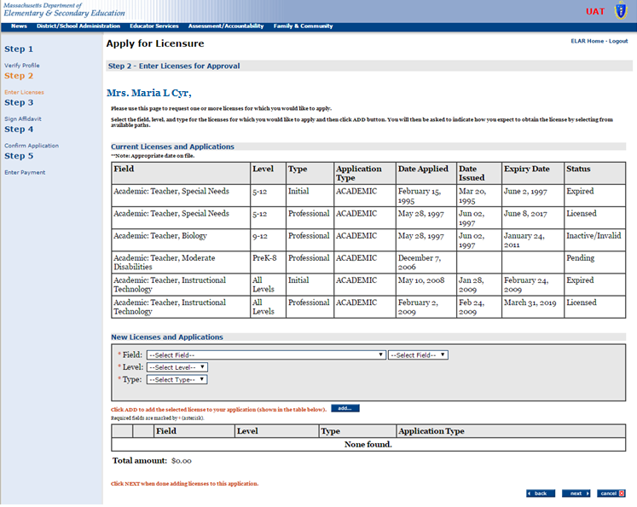
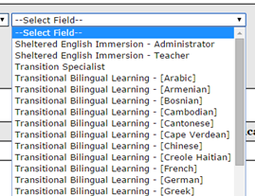
- Select the type of Endorsement in the second Field drop-down list
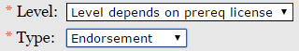
- Select the Level and Type in the drop-down lists
- Click on the Add button
Note: When you click on the add… button another window will open up outlining the license requirements

Step 2a: Enter License Requirements
Most licenses/endorsements have multiple paths and requirement sets that lead to the license/endorsement. The path that is most appropriate for you will depend upon your educational background, experience, and license(s) already held.  Shown on this page are examples of some common paths to the license/endorsement you seek. You can click on any of the requirements that make up a path to learn more about how to satisfy that particular requirement.  - Select the path that bests fits how you have or how you plan to earn the SEI endorsement, and click “next”. For Administrators there is one path and for teachers there is either path 1 (for those who have done/will do one of the following: taken the ESE course, have an ESL/ELL license, passed the SEI MTEL) or path 2 (a transcript review based on a related degree or graduate level training).  Please note that should you choose a path that is not the most appropriate path for you, you will be placed upon the proper path during the evaluation of your license application.  - Click on the Next button | 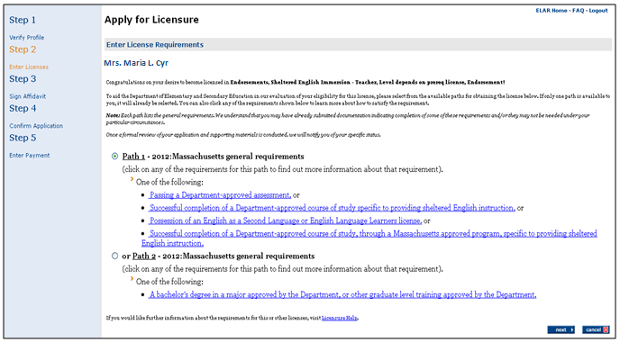
Step 2: Enter Licenses for Approval (cont.)
- At this point in the application you can edit the endorsement you are applying for or remove the endorsement that you selected to apply for.  - Click the Next button when you are ready to move forward with your application. | 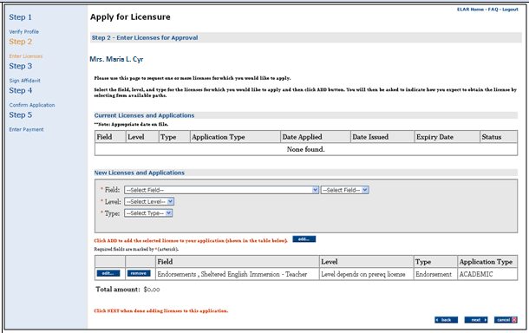
Step 3: Sign Affidavit
- Affirm the following statements are true (a check mark indicates the statement is true).  - Click on the box next to any statement to check/uncheck it.  - Please explain any unchecked boxes in the area provided at the bottom of the screen.  - If you wish to exit without saving, click CLOSE.  - When finished, click SIGN to save your changes.  By SIGNING you are confirming that all the information in your affidavit is true and contains no misrepresentations or falsehoods. | 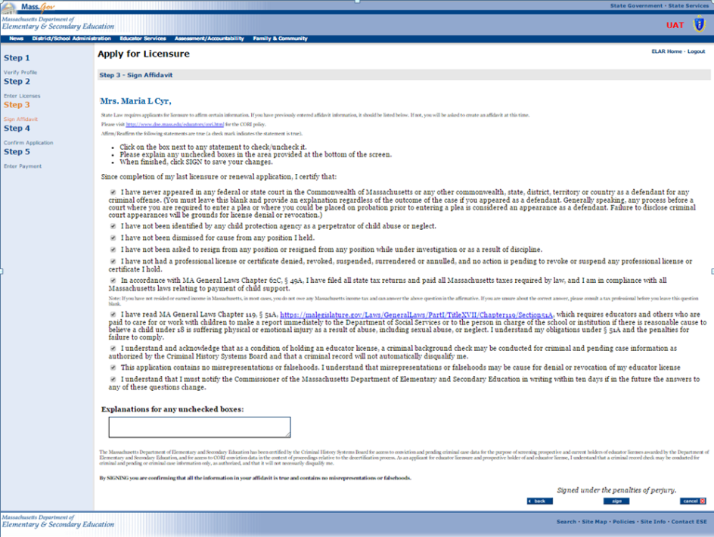
Step 3a: Sign Affidavit
- You will see a pop-up window confirming that you have successfully signed your affidavit.  - Click on the OK button | 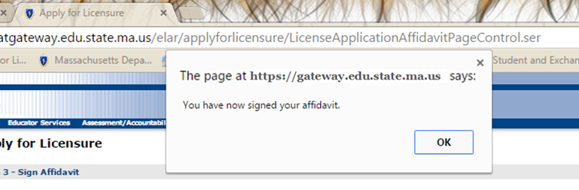
Step 4: Confirm Application
- You will now be prompted to sign your application.  - Click on the Sign button  - A window will pop-up verifying that you have signed your application.  - Click on the OK button | 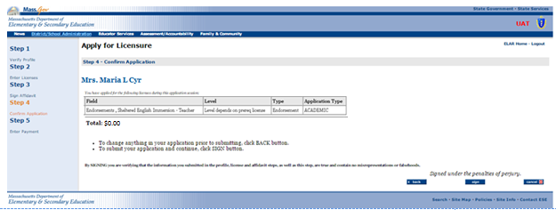

Applying for Graduate Credit
Applying for graduate credit is up to the individual course participant. To facilitate the acquisition of graduate credit, the Department of Elementary and Secondary Education has gotten pre-approval for credit with a number of colleges and universities. Information on these schools can be found at http://www.doe.mass.edu/retell/credit.html.
Anyone seeking graduate credit must complete the registration requirements and payment for the college or university.
If additional assistance is required, please contact the Licensure Call Center (Monday-Friday, 9:00am-12:00pm and 2:00pm-5:00 pm) at (781) 338-6600).

