Introduction: The Executive Office of Aging & Independence (AGE) provides this website for reporting suspected Elder Abuse which includes physical abuse, emotional abuse, caretaker neglect, financial exploitation, and self-neglect. Elder Protective Services only has jurisdiction to investigate cases of abuse where the individual is over the age of 60 and resides in the community.

-Call 911 or your local law enforcement agency if you have an emergency or life-threatening situation that must be dealt with immediately
-To report abuse of an adult Under the Age of 60, contact the Disabled Persons Protection Commission at 1-800-426-9009.
-To report abuse of a patient by Nursing Home or Hospital staff, contact the Massachusetts Department of Public Health at 1-800-462-5542.
The online reporting webpage can be found at: https://www.mass.gov/report-elder-abuse

Stop! Do not file an Online Elder Abuse Report in the following situations:
- Emergency or urgent situations that require immediate attention from Protective Services as it may take more than 24 hours to process online reports; and/or
- You want to report anonymously, as filing online requires you submit your name; and/or
- You do not have the name and address of the victim. The online reporting system will not allow you to file such reports.
If any of these situations apply you must make a verbal report to the Massachusetts Elder Abuse Hotline at 1-800-922-2275.

Using the Web Intake: The web intake system consists of the following sections in the order listed below.
- Reporter Information (Required)
- Incident Information (Required)
- Alleged Victim Information (Required)
- Alleged Perpetrator Information (Required if not a Self-Neglect Report)
- Other Participant Information
- Attachments
Each section has fields that are essential to the intake process and are marked required. These fields will be identified with the word required in red text next to the question.
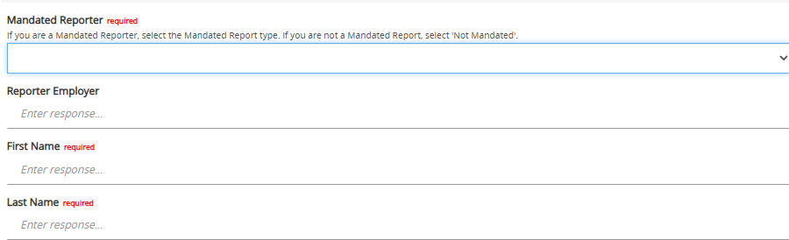
The city/state and zip code field appears in multiple sections throughout the web intake. These fields have been built in functionality to help users choose the correct information. All city/towns and zip codes are linked so that only the appropriate information will appear based on the selected city/town. Enter data into these fields slowly and allow the dropdown menus to populate before making your selection.

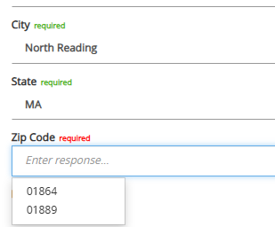
Incident Information Section: This section contains all of the information pertaining to the incident that caused you to report. It is necessary to fill out the city/town, state and zip of the alleged victim’s residence as this will assign it to the correct Protective Service Agency. To complete the assignment you must manually select the Protective Service agency and who will screen the report. Once you enter the Alleged Victims residency information the correct PS Agency and Screener will be the only option available in the drop down menu.

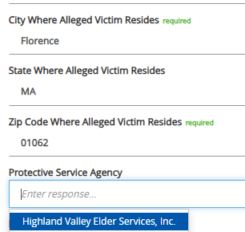

The answer to the self-neglect question determines whether or not the system will require you to enter an Alleged Perpetrator before submitting. Elders who are self-neglecting should not be labeled as an Alleged Perpetrator.
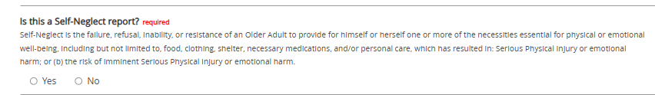

Participant Information Sections: Select the “New” button located below of the section description. When selected a new screen will appear which consists of all of the demographic information needed.
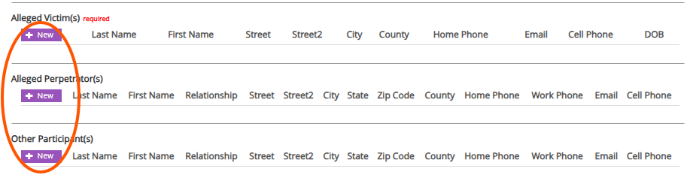
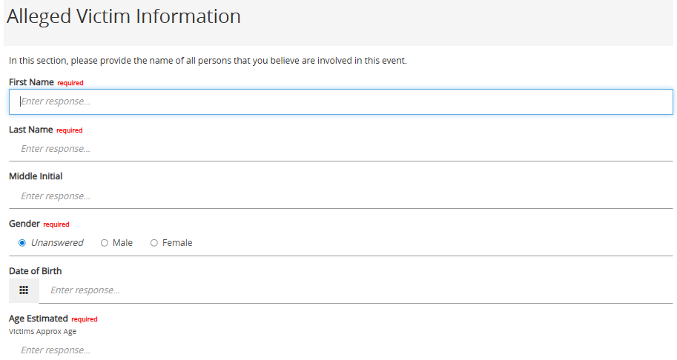
You can edit the information or delete the participant by using the “Open” and “Delete” button. These buttons will appear once a participant is added.
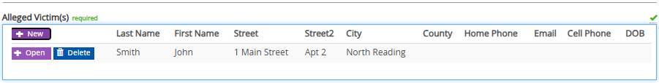

Attachments: To add an attachment, click on the white box in the Browse field which will open up a dialog box where you can navigate to the file on your computer you would like to attach to the Web Intake Form.
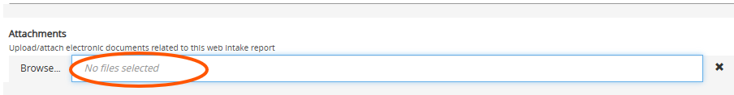
Submission: When you have completed your web intake you will submit it using the “submit” button located on the bottom of the form. A pop-up box will appear notifying you that your web intake has been submitted. Select “OK”
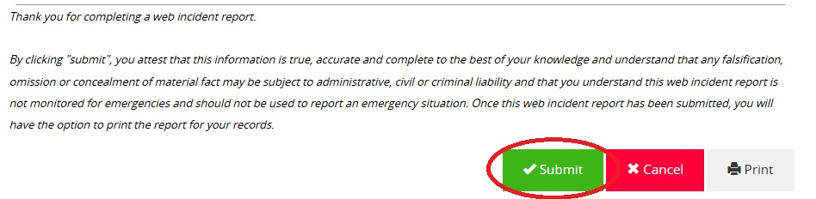
Frequently Asked Questions:
1. Should I put my personal address information.
a. We recommend you put your work address information into the system if you are filing in your
professional capacity.
2. Can Web Intakes be used for emergency situations.
a. No. Web Intake should only be used for situations that do not need immediate attention. If you
have an emergency situation we require you to file a verbal report with the Elder Abuse Hotline
3. If I do not know where the elder resides can I use the web intake
a. No. Where the elder resides determines which Protective Service Agency will review the web
intake. If you do not know where the elder resides you must make a verbal report with the Elder
Abuse Hotline.
4. How long will it take for my web intake to be reviewed.
a. In most cases intakes are reviewed the same day, but regulations do allow up to 48 hours.
5. Can I do one web intake for multiple Elder’s
a. No: You must file a web intake for each individual Elder.

