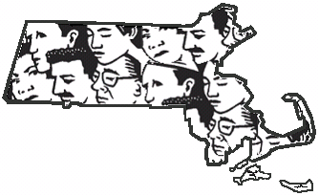

Massachusetts FACE • Occupational Fatality Report

Massachusetts Department of Public Health
Occupational Health Surveillance Program
Fatality Assessment and Control Evaluation Project

Municipal Electrician Dies after Falling from the Raised Bucket of a Vehicle-mounted Aerial Lift That Was Struck by a Tractor-trailer – Massachusetts

Investigation: # 11-MA-043-01
Release Date: October 31, 2012
______________________________________________________________________________
SUMMARY

On October 18, 2011 a 58-year-old male municipal maintenance technician/electrician (victim) was fatally injured when he fell from a vehicle-mounted aerial lift’s raised bucket. The victim and two co-workers were repairing a faulty cantilevered traffic signal at a four-way intersection. The victim was inside the raised bucket accessing the traffic light when a tractor-trailer driving through the intersection struck the raised bucket. The victim was ejected out of the bucket and fell approximately seventeen feet to the roadway below. A call was placed for Emergency Medical Services (EMS) by the co-workers. Within minutes EMS and the local police arrived at the incident location and the victim was transported to a local hospital where he was pronounced dead. The Massachusetts FACE Program concluded that to prevent similar occurrences in the future, municipalities should:
- Ensure that fall protection is used when working from an aerial lift truck’s raised bucket/platform;
- Ensure that when performing work in roadways that work zones are set up, at a minimum, in accordance with the Manual on Uniform Traffic Control Devices (MUTCD), Part 6, developed by the U.S. Department of Transportation Federal Highway Administration;
- Ensure that employees’ exposure to moving traffic is minimized when working in and around roadways by developing temporary traffic control plans, including never allowing traffic to pass underneath raised aerial lift buckets/platforms;
- Provide and ensure that employees wear the appropriate personal protective equipment, including American National Standard Institute (ANSI) compliant high visibility safety apparel, when working along roadways;
- Provide work zone safety training for all employees who will be required to complete tasks while in proximity to roadways;
- Ensure that each department develops, implements, and enforces a comprehensive health and safety program that includes hazard recognition and avoidance of unsafe conditions; and
- Provide work environments that, at a minimum, meet all relevant Occupational Safety and Health Administration (OSHA) regulations and industry accepted standards of practice.

In addition manufacturers of aerial lifts and municipalities should:
- Consider using contrasting colors and installing strobe lights along the booms of aerial lifts.

INTRODUCTION

On October 18, 2011, the Massachusetts FACE Program was notified through the local media that earlier that same day a 58-year-old male city employee had died from injuries sustained when he fell out of an aerial lift truck’s elevated bucket when the bucket was struck by a tractor-trailer. An investigation was initiated. On October 28, 2011, the Massachusetts FACE Program and a representative from the Massachusetts Department of Labor Standards (DLS) traveled to the city and met with representatives from the Department of Traffic and Parking, the Department of Public Works and the Laborers’ International Union of North America to discuss the incident. On November 9, 2011, the Massachusetts FACE Program and a representative from DLS traveled back to the city and met with a representative of the municipal police department and then viewed the incident location. Photographs were taken of the aerial lift truck and incident location.

The city where the incident occurred has been incorporated for more than 218 years and has a population of over 92,000 residents. The victim was a 30-plus year employee of the city with most of his public employment in the city’s Traffic and Parking Department. The Department of Traffic and Parking is responsible for design, installation, and operation of all public parking facilities as well as traffic signs, traffic signals, and pavement markings. The victim held the job title of Traffic and Signal Maintenance Technician/Electrician. The normal work shift for Traffic and Parking Department employees was 7:00 a.m. to 3:30 p.m.

The department did not have a health and safety program and did not provide annual safety training. The labor management safety committee was defunct and had not met in the four years prior to the incident. Fall protection, including a body harness and lanyard, was made available for the aerial lift operator. The victim had both the state-issued hoisting license and electrician license, and had multiple certifications from the International Municipal Signal Association, one of which was the Work Zone Traffic Control Safety Certification. The department routinely used police traffic details when employees were working in roadways except for short-duration tasks, such as in this incident, in part due to a four-hour minimum detail fee. The victim was part of a collective bargaining unit.

INVESTIGATION

About a year before the incident, the Department of Traffic and Parking had removed their aerial lift truck from service and began renting an aerial lift truck while a new replacement truck was being built. The aerial lift truck that was involved in the incident was the truck being rented and the victim was the only employee assigned to operate it. The rental aerial lift truck’s chassis and aerial lift body were both manufactured in 2008 and were white in color (Figure 1). The truck’s gross vehicle weight rating was 8,845 pounds, and it was equipped with dual rear wheels and a diesel engine. The telescoping and articulating boom platform had height and weight ratings of 38 feet and 300 pounds respectively. There were two sets of controls for the movement of the truck’s boom/bucket. One control was mounted to the bucket and the other control was mounted to the truck’s body at the ground level. The vehicle was equipped with yellow light-emitting-diode (LED) strobe lights located in the truck’s bumper. There was also a fall protection anchor point located at the truck’s bucket along with a danger decal warning of the fall hazard and the need to use fall protection (Figure 2). A body harness and lanyard with signs of past use was observed during the site visit in the side cabinet of aerial lift truck.

On the morning of the day of the incident, the victim had received a call indicating that an automated traffic signal for a four-way intersection was not activating properly. This four-way intersection is made up of a four lane main roadway and two smaller side streets, one on each side of the intersection (Figure 3). The faulty traffic signal was not changing to a green light for vehicles that approached the four-way intersection from one of the side streets.

The intersection has multiple cantilevered traffic signal structures. One of these cantilevered structures was the traffic signal that was being accessed at the time of the incident. The base of the cantilevered structure is located on the sidewalk and the vertical section is approximately 18 feet high. The cantilevered section is fastened to the top of the vertical section and extends perpendicularly out over the two southbound main roadway lanes (Figure 3).

The main roadway generally runs north and south and has two travel lanes of traffic for each direction. The area around the intersection has no significant grade, is relatively straight and is designated as a 30 mile-per-hour speed zone. There are multiple painted roadway markings in the area. The four lane roadway’s same direction travel lanes are separated by dashed white painted lines and the opposite travel lanes are separated by solid double yellow painted lines. There are painted white traffic light stop lines and crosswalks for three of the four sides of the intersection. There are no painted fog lines at the main roadway edges and the two smaller side streets do not have any roadway markings.

The weather at the time of the incident was overcast and gray with a temperature of approximately 54 degrees. There was a light wind of approximately 9 miles-per-hour and no precipitation. Prior to going to the intersection to start trouble shooting the faulty traffic signal, the victim asked two co-workers to assist him with the task. These co-workers arrived at the intersection in a separate city owned pickup truck. Once at the intersection, the victim turned on the aerial lift truck’s yellow LED strobe lights, located in the truck’s bumper, and parked the truck in the right hand southbound travel lane at the southwest corner of the intersection. Two orange traffic cones were placed behind the aerial lift truck. The exact position of these cones at the time of the incident is unknown.

It was reported that the victim was wearing high visibility safety apparel (vest or jacket), but the exact type and class was not known. The victim, without donning personal fall protection equipment, climbed into the truck’s bucket and raised and extended the boom and bucket out over the active roadway’s left hand southbound travel lane. The truck’s boom has two main sections. At the time of the incident, the first section of the boom was positioned vertically and the second section was perpendicular to the first section extending horizontally out to the traffic signal. The bottom of the bucket was raised approximately 12 feet 7 inches from the roadway (Figure 3). At this same time, one of the co-workers was accessing the traffic signal control box that was located on the sidewalk next to the aerial lift truck. The other co-worker was in the cab of the pickup truck located on the side street.

While the victim was in the raised bucket, an 18-wheeled tractor-trailer was traveling on the main roadway heading southbound in the left hand travel lane. The enclosed trailer section of the tractor-trailer is 53 feet long and 13 feet 6 inches high. As the tractor-trailer approached the intersection, the cab with its wind deflector passed underneath and cleared the raised bucket. When the trailer section reached the raised bucket, the trailer impacted the bucket causing the bucket to bounce up and land on top of the trailer’s roof (Figure 4). The victim was ejected out of the bucket and fell approximately 17 feet to the asphalt roadway below. The tractor-trailer operator stopped the truck immediately after the incident occurred. A call was placed for Emergency Medical Services (EMS). Within minutes EMS and the local police arrived at the incident location, and the victim was transported to a local hospital where he was pronounced dead.

According to the police report, the tractor-trailer is 2012 model year and was estimated to be traveling between 20-30 miles-per-hour. Both the aerial lift truck and the tractor-trailer were inspected as part of the police investigation and no mechanical malfunctions were revealed. It was also reported that the operator of the tractor-trailer noticed the truck in the right lane and then noticed the truck’s bumper strobe lights.

The police report suggested that several factors might have contributed to the victim’s position being less noticeable to passing motorists. These factors include: the boom of the aerial lift following the same 90 degree angle as the cantilevered traffic signal structure, the lack of contrast between the white truck and boom against the light gray sky, and the strobe lights drawing attention away from the raised bucket and towards the aerial lift truck’s bumper.

CAUSE OF DEATH

The medical examiner listed the cause of death as blunt force trauma of head and torso with fractures and visceral injuries.

RECOMMENDATIONS/DISCUSSION

Recommendation #1: Municipalities should ensure that fall protection is used when working from an aerial lift truck’s raised bucket/platform.

Discussion: In this incident, the victim was working from a raised aerial lift truck without fall protection, although fall protection was available. Fall protection is required to be used whenever working from an aerial lift truck’s raised platform.¹ There are two main types of fall protection systems that can be used with aerial lift trucks.

1) Restraint Systems. Restraint systems are the preferred method of protection since it allows the worker to move around the bucket and will prevent the worker from falling out of the bucket. The components of a restraint system include either a body belt or a harness (harness is recommended) connected to a lanyard. The lanyard must not be longer than two feet and the other end of the lanyard must be attached to an anchor point. Aerial lift truck anchor points are usually located on either the truck’s bucket or boom. In this case the anchor point was located on the truck’s boom.

2) Fall Arrest Systems. Fall arrest systems are intended to stop a falling worker before they strike a lower level and must not allow the worker to fall more than six feet. Fall arrest systems require the use of a body harness (body belts should never be used with a fall arrest system). The body harness connects to a lanyard and the other end of the lanyard connects to an anchor point. Not all aerial lift trucks are designed for the use of fall arrest systems. Therefore always check with the aerial lift truck manufacturer to see which fall protection system should be used.

Recommendation #2: Municipalities should ensure that when performing work in roadways that work zones are set up, at a minimum, in accordance with the Manual on Uniform Traffic Control Devices (MUTCD), Part 6, developed by the U.S. Department of Transportation Federal Highway Administration.

Discussion: Employees who are required to complete tasks in and around roadways face multiple hazards, one of which is being struck by oncoming motor vehicles. In this case, two orange traffic cones were placed behind the aerial lift truck to warn approaching vehicles of the work being performed within the roadway. This was not an adequate traffic control measure for this task.

The U.S. Department of Transportation’s (DOT) Manual on Uniform Traffic Control Devices (MUTCD) sets forth the basic principles that govern the design and usage of traffic control signs and devices.² Part 6 of the MUTCD provides specific work zone designs to be used during roadway construction, maintenance, and utility operations. To help ensure employee safety while performing these and other roadway operations, employers should follow the MUTCD minimum standards and guidelines in Part 6. These standards and guidelines will help determine the appropriate number and locations of traffic control devices, such as warning signs, cones, and lights.

When performing work in a roadway that will occupy a location for a few minutes up to one hour, employers should follow the short-duration roadway work application outlined in the MUTCD, Part 6G, Types of Temporary Traffic Control Zone Activities. Because most short-duration roadway work is usually maintenance and utility based operations, the MUTCD recommends traffic control devices that have greater mobility. The MUTCD specifically states that worker safety during short-duration roadway work should not be compromised by using fewer traffic control devices.²

The MUTCD acknowledges that during short-duration work it can sometimes take longer to set up the work zone properly. Therefore, the MUTCD suggests that appropriately colored or marked vehicles with high-intensity rotating, flashing, oscillating, or strobe lighting may be used in place of signs. In addition, the MUTCD suggests that these vehicles may be augmented with signs or arrow panels.²

Recommendation #3: Municipalities should ensure that employees’ exposure to moving traffic is minimized when working in and around roadways by developing temporary traffic control plans, including never allowing traffic to pass underneath raised aerial lift buckets/platforms.

Discussion: To ensure the safety of workers whose jobs bring them in and around roadways, employers should develop temporary traffic control plans (TCP) that outline the temporary traffic control devices to be used, how they should be set up during roadway work, and proper placement of any work equipment and vehicles. A TCP will not only help ensure worker safety, it will also help ensure motorist and pedestrian safety as well. TCPs should be based on the MUTCD as discussed in Recommendation #2. An individual TCP should be developed for each major highway and street project.

For short duration relatively common tasks, such as accessing cantilevered traffic signals, a general TCP should be developed and modified when appropriate. A general TCP for accessing cantilevered traffic signals could include, but not be limited to:
- Assessing the work site upon arrival to determine the best location for work vehicles and mobile equipment and the appropriate number and locations of traffic control devices, such as warning signs and lights based on the MUTCD;
- Ensuring that placement and use of vehicle-mounted aerial lifts does not allow roadway traffic to pass underneath the raised aerial lift bucket/platform at any time;
- Determining if assistance in the form of traffic details or flaggers would be beneficial;
- Wearing the appropriate high-visibility safety apparel at all times;
- Facing and watching out for approaching traffic; and
- Spending as little time as possible in and around the roadway.

In this case, due to the high volume of traffic on a relatively narrow four lane roadway, assistance in the form of a traffic detail or a flagger should be considered as a part of the TCP.

Recommendation #4: Municipalities should provide and ensure that employees wear the appropriate personal protective equipment, including American National Standard Institute (ANSI) compliant high-visibility safety apparel, when working along roadways.

Discussion: Traffic and parking department employees can face many hazards while working. These employees are routinely working in and along roadways, bringing them in close proximity to motor vehicle traffic usually with no barriers between them and the moving vehicles. In this case, the clothing being worn by the victim reportedly contained reflective material. The garment class of the clothing was not known.

The Manual on Uniform Traffic Control Devices (MUTCD) states that all workers exposed to the risks of moving roadway traffic or construction equipment should wear high-visibility safety apparel.² The MUTCD refers to the American National Standard Institute’s (ANSI) standard for High–Visibility Safety Apparel (ANSI/ISEA 107-2004).⁴ This standard, published by the International Safety Equipment Association (ISEA), recommends specific types of reflective equipment while working in or near moving vehicles. This standard specifies three classes of garments based on the workers’ activities. These classes are:

- Class 3 garments provide the highest level of visibility for workers who face serious hazards with high task loads that require attention away from their work where traffic exceeds 50 miles per hour (mph).
- Class 2 garments are intended for use where greater visibility is necessary during inclement weather conditions and when activities occur near roadways where traffic speeds exceed 25 mph.
- Class 1 garments (not for use along highways and streets) are intended for use in activities that permit the wearer's full and undivided attention to approaching traffic. There should be ample separation of the worker from traffic, which should be traveling no faster than 25 miles per hour.

The ANSI standard also states that a competent person designated by the employer should be responsible for selecting the appropriate class of garment for the workers. A competent person, as defined by the Occupational Safety and Health Administration (OSHA), is a person who, through training or knowledge, is capable of identifying existing and predictable hazards in the surroundings or working conditions that are unsanitary, hazardous, or dangerous to employees, and who has authorization to take prompt corrective measures to eliminate them. In addition, employers should ensure that workers are wearing the high-visibility safety apparel provided.

Recommendation #5: Municipalities should provide work zone safety training for all employees who will be required to complete tasks while in proximity to roadways.

Discussion: Work zone safety training for municipal workers should include, but not be limited to, properly selecting and setting up the most effective work zone configuration, how to work near motor vehicle traffic in a way that will minimize exposure to moving vehicles, as well as the proper techniques for warning device usage, placement, and retrieval. Training municipal workers in roadway work zone safety should also include short and long duration work zone set up and design and appropriate personal protective equipment. This training would not only provide municipal workers with the knowledge to better protect themselves so tasks can be completed safely, but will also help keep pedestrians and motorists in the community safe as well. All trainings should be updated annually and documented. The documentation should include who provided the training and their qualifications, the content of the training, workers who were trained, and the assessments of workers’ comprehension of the training. Employers should ensure that the trainer who provides training is qualified through education and/or experience to conduct training.

Recommendation #6: Municipalities should ensure that each department develops, implements, and enforces a comprehensive health and safety program that includes hazard recognition and avoidance of unsafe conditions.

Discussion: In this case, the traffic and parking department did not have a comprehensive health and safety program, employee training was not routinely provided, and the joint labor management safety committee was defunct and had not met in the four years prior to the incident. The labor management safety committee should be reestablished and then take the lead in the development of the health and safety program. Management support will help keep the safety committee current and effective.

The comprehensive written health and safety program should address common hazards municipal employees face, such as electrical, confined space and work zone hazards. Hazard recognition and the avoidance of unsafe conditions is another area that the health and safety program should address. When developing the health and safety plan, the employer with employee participation should conduct a job safety analysis (JSA).⁵

A JSA is a technique to systematically evaluate job tasks to ensure the tasks are performed safely. It involves identifying all potential hazards and hazardous situations that could occur when performing tasks by focusing on the relationship between the worker, the task, the tools and the work environment. JSAs should be routinely performed to identify uncontrolled hazards by breaking down the tasks to be performed into steps, including the operation of any equipment and use of tools to complete the task. Each step should be evaluated to identify the hazards or potential hazards. Once hazards are identified, appropriate preventive measures should be implemented to eliminate or control these hazards.

OSHA has developed a webpage that addresses how to implement health and safety programs (www.osha.gov/dsg/topics/safetyhealth/evaluation.html). This webpage includes a link to the OSHA draft proposed safety and health program rule and to other useful links. In addition, there is a Roadway Safety Awareness Program available in English, Spanish and Portuguese at www.workzonesafety.org/training/courses_programs/rsa_program. This program Roadway Safety + provides an overview of common hazards in highway and road construction and prevention measures that can be incorporated in to a health and safety program.

Recommendation #7: Municipalities should provide work environments that, at a minimum, meet all relevant Occupational Safety and Health Administration (OSHA) regulations and industry accepted standards of practice.

Discussion: The federal Occupational Safety and Health Act requires private sector employers to provide workplaces that are free from recognized hazards likely to cause death or serious physical harm to employees. While private sector employees are covered by federal OSHA, public sector employees in Massachusetts are not. The Massachusetts Department of Labor Standards (DLS), in accordance with Chapter 149 Section 6, is charged with inspecting public sector workplaces in Massachusetts and determining what procedures and practices are required to protect workers.⁶ As a matter of policy, DLS references OSHA Standards as well as other consensus standards, such as ANSI, in determining whether proper procedures are being followed to protect workers. In this case, adhering to the following OSHA standards may have prevented this incident: 29 CFR 1926.453 Aerial lifts and 29 CFR 1926.202, Barricades, which refers to the MUTCD for design and usage of traffic control signs and devices and work zone designs. ^{1,7}

Recommendation #8: Manufacturers of aerial lifts and municipalities should consider using contrasting colors and installing strobe lights along the booms of aerial lifts.

Discussion: The operator of the tractor-trailer indicated that he did observe the aerial lift truck in the roadway and the truck’s bumper strobe lights, but that he did not notice the extended boom and the worker in the bucket.

Aerial lift trucks are often used in and around roadways, which can place the truck in close proximity to moving vehicles. To help make aerial lift trucks, including their booms and buckets, as visible as possible, consideration should be given to adding contrasting colors, which could also be florescent and/or reflective, to both the boom, bucket and to some areas of the truck. In addition, adding some light-emitting-diode (LED) strobe lights to sections of the boom, bucket and truck might increase both the visibility of the truck and the actual location of workers when they are working from the truck’s raised bucket.

REFERENCES

- Code of Federal Regulations [1996]. 29 CFR 1926.453. Aerial lifts. Washington DC: U.S. Government Printing Office, Office of the Federal Register.

- U.S. DOT 2009. Manual on Uniform Traffic Control Devices (MUTCD), 2009 Edition, U.S. Department of Transportation Federal Highway Administration. http://mutcd.fhwa.dot.gov/. Date accessed: 2/1/2010.

- NIOSH 2001. Building Safer Highway Work Zones: Measures to Prevent Worker Injuries from Vehicles and Equipment, Department of Health and Human Services, Centers for Disease Control and Prevention, National Institute for Occupational Safety and Health, DHHS (NIOSH) Publication No. 2001-128.

- ANSI/ISEA [2004]. American National Standard for high-visibility safety apparel. New York, NY: American National Standards Institute, ANSI/ISEA 107 -2004.

- U.S. DOL 2002. Job Hazard Analysis. Occupational Safety and Health Administration, OSHA Publication No. OSHA-3071, 2002 (revised).

- General Laws of Massachusetts, Title XXI, Labor and Industries, Chapter 149: Section 6. Safety devices and means to prevent accidents and diseases generally; fees for structural painting.

- Code of Federal Regulations [2002]. 29 CFR 1926.202. Barricades. Washington DC: U.S. Government Printing Office, Office of the Federal Register.

Figure 1 – Vehicle-mounted aerial lift involved in the incident

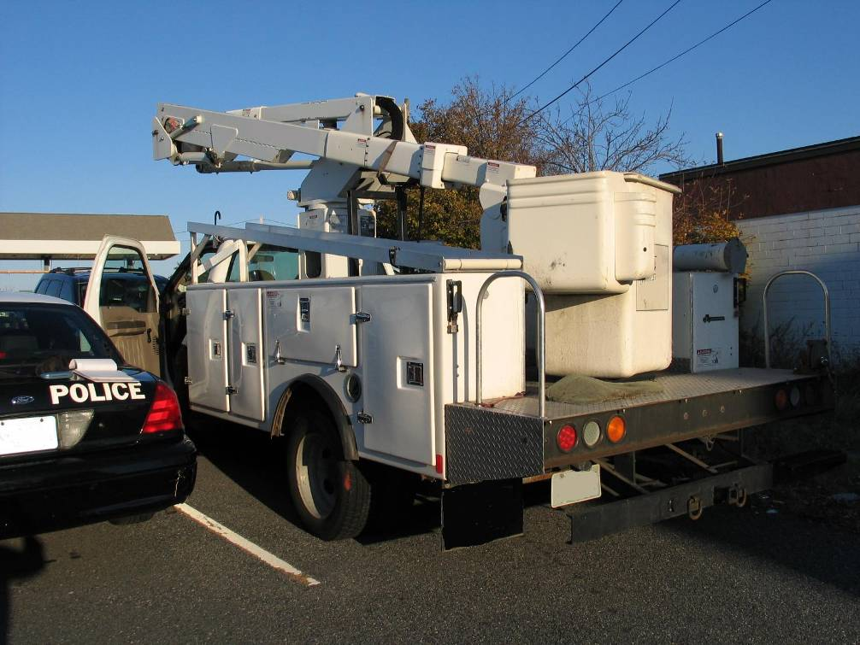

Figure 2 – Vehicle-mounted aerial lift fall hazard danger decal

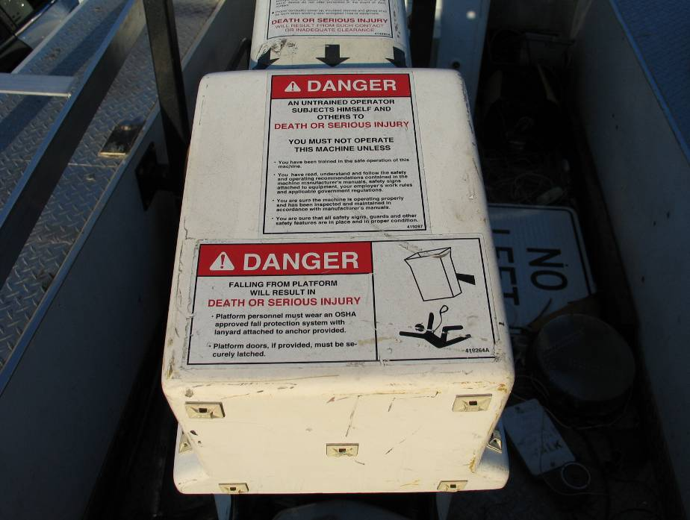
Figure 3 – Incident location with vehicle-mounted aerial lift

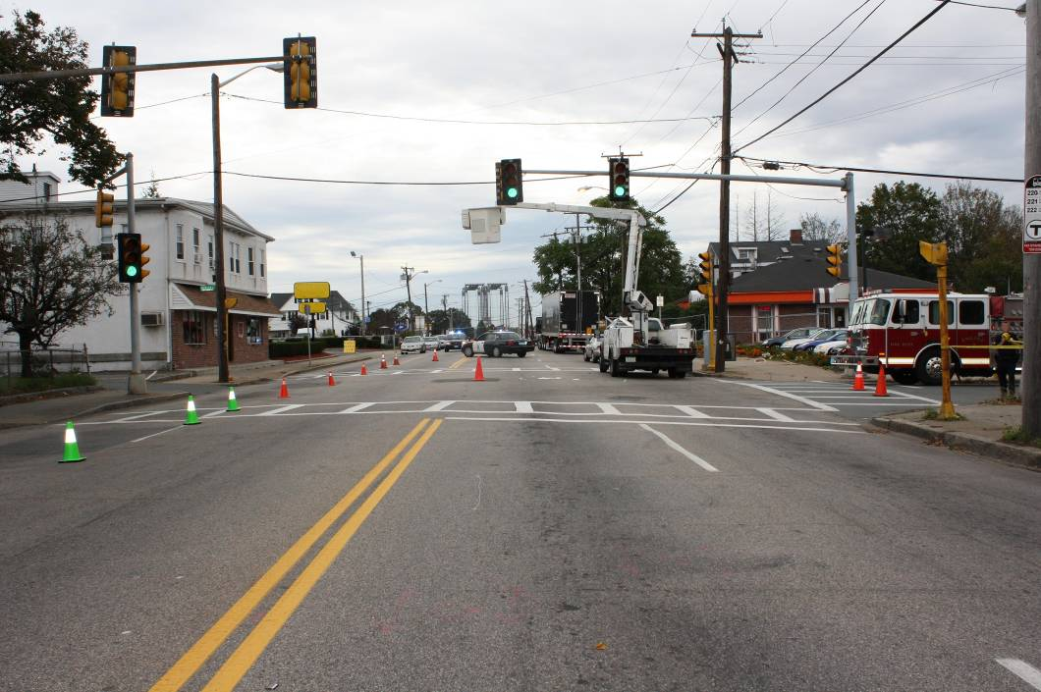

Figure 4 – Tractor-trailer with raised bucket

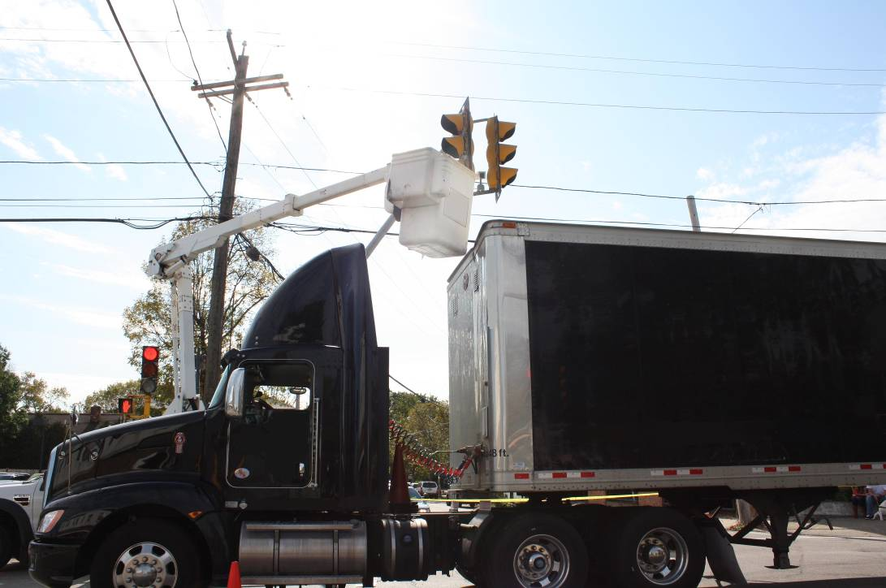

Michael A. Fiore, MS, Director | Letitia Davis, Sc.D., Ed.M., Director
Massachusetts FACE Program | Occupational Health Surveillance Program
Occupational Health Surveillance Program | Massachusetts Department of Public Health
Massachusetts Department of Public Health

******************************************************************************

FATALITY ASSESSMENT AND CONTROL EVALUATION PROGRAM

The Massachusetts Department of Public Health, in cooperation with the National Institute for Occupational Safety and Health (NIOSH), conducts investigations on the causes of work-related fatalities. The goal of this program, known as Massachusetts Fatality Assessment and Control Evaluation (Massachusetts FACE) is to prevent future fatal workplace injuries. Massachusetts FACE aims to achieve this goal by identifying and studying the risk factors that contribute to workplace fatalities, by recommending intervention strategies, and by disseminating prevention information to employers and employees.

Massachusetts FACE also collaborates with engineering and work environment faculty at the University of Massachusetts at Lowell to identify technological solutions to the hazards associated with workplace fatalities.

NIOSH funded state-based FACE Programs currently include: California, Iowa, Kentucky, Massachusetts, Michigan, New Jersey, New York, Oregon, and Washington.

**********************************************************************************

Additional information regarding this report is available from:

Occupational Health Surveillance Program
Massachusetts Department of Public Health
250 Washington Street, 6th floor
Boston, Massachusetts 02108-4619
(617) 624-5627

Evaluate this report

We would appreciate your feedback on these reports so we may continue to improve the MA FACE project and our investigation reports. A feedback form can be found at: www.mass.gov/eohhs/docs/dph/occupational-health/report-evaluation.doc
The completed form may be returned by fax to (617) 624-5676, by mail to FACE, 250 Washington Street, 6th Floor, Boston, MA 02108, or by email to ma.face@state.ma.us.

