

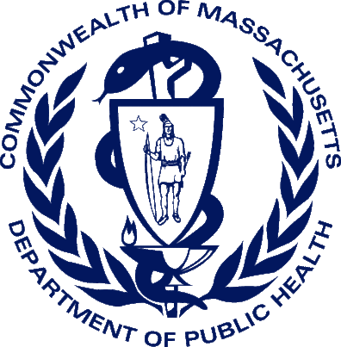
Phone: 617-740-2600
Fax: 617-740-2711
E-mail: vipprojectteam@massmail.state.ma.us
150 Mount Vernon Street
Dorchester, MA 02125

Vitals Information Partnership (V.I.P.)

What is an EDRS?
Massachusetts Department of Public Health
Registry of Vital Records and Statistics
Vitals Information Partnership (V.I.P.)

Vitals Information Partnership (VIP)
An electronic death registration system (EDRS) enables death registration partners to create and file death records online. An EDRS, such as the Massachusetts V.I.P. system, allows multiple death registration participants, such as physicians, funeral directors, boards of health, and city/town clerks to work on the same case through an electronic workflow. With an EDRS, you will be able to report cause-of-death and other medical certification items with increased accuracy and timeliness which not only benefits the families of the decedent, but also improves mortality data for disease surveillance and medical research.
What Physicians and
Other Medical Professionals Should Know About

ELECTRONIC
DEATH
REGISTRATION

Vitals Information Partnership (V.I.P.) System

Massachusetts Registry of Vital Records and Statistics
For more information please visit:
www.mass.gov/dph/rvrs


Reduces time and effort for users through online completion of death certificate
Minimizes errors with online edits and instructions
Electronic workflow between funeral homes, hospitals, nursing homes, physicians, medical examiners and local and state registrars increases efficiency
Improves the timeliness of death reporting
Promotes uniformity in cause-of-death statistics
Improves mortality data used by disease surveillance and medical research
Reduces fraud through secure authentication, verification of social security numbers, birth/death matching and prevention of records loss and forgery
Electronic burial permits
Online corrections and amendments
V.I.P. EDRS SYSTEM FEATURES

User-friendly death certificate data entry
Highly secure and Internet-accessible
Available 24 hours a day, 7 days a week
Accommodates hospitals, nursing homes, private physician practices and medical examiners offices

VITALS INFORMATION PARTNERSHIP (V.I.P.)
ELECTRONIC DEATH REGISTRATION SYSTEM
When will this happen?
Roll-out activities will begin in late 2013. More detailed information and training materials will become available as the roll-out proceeds. Also check the Registry’s web site www.mass.gov/dph/rvrs for updates.

How will I participate?
Physicians, their authorized staff members, or in some cases a funeral director, may prepare the electronic death record for certification.
A physician will then certify the medical information directly online or through an alternate fax attestation method.

Will there be training?
Online and regional training sessions will be available for physicians and other registration partners.

Can I help?
Yes! The Registry depends on physicians and other partners to work with us to refine the system, help with outreach and education.
AMERICAN MEDICAL ASSOCIATION (AMA) RESOLUTION

In 2002, the AMA House of Delegates adopted a resolution sponsored by the American College of Preventive Medicine (ACPM) related to improving the reporting of cause-of-death. This resolution calls for the following four measures:
Emphasize to the medical community that precise cause-of-death reporting is critical
Work with the Centers of Disease Control (CDC) National Center for Health Statistics (NCHS), as well as state medical associations, to ensure use of uniform cause-of-death terminology
Educate state legislators on the importance of uniformity in mortality statistics so research dollars may be appropriately disbursed
Train physicians in medical schools, residency programs and continuing education courses on how to fill out a death certificate. This may require AMA to partner with the Association of American Colleges to create a death certificate curriculum
BENEFITS
FAQ
How do I get more information?
The V.I.P. Project Team can be reached by email at vipprojectteam@massmail.state.ma.us

