CHAPTER VI:
ELECTRONIC REPORTING
AND SURVEILLANCE SYSTEM

(MAVEN - Massachusetts Virtual Epidemiologic Network)

IMPORTANT RESOURCES
(ISIS - Office of Integrated Surveillance and Informatics Services)
ISIS Help Desk: 617-983-6801
ISIS Fax Number: 617-983-6813
isishelp@state.ma.us (No confidential or identifying info)
Epidemiologist on Call 617-983-6800
MAVEN 101
MAVEN LBOH FBI Module Training
Foodborne Illness Complaint PDF

June 2017
A. Background

MAVEN is a secure web-based disease surveillance and case management system for use by the Massachusetts Department of Public Health Bureau of Infectious Disease and Laboratory Sciences (MDPH-BIDLS) and local boards of health (LBOHs). It captures all data required for surveillance and case management while streamlining business processes for case investigation and surveillance. It also interfaces with the Health Information Exchange (HIE) for timely and electronic notification of laboratory reports. Transparency and timeliness are the two key features that the system has brought to disease surveillance in Massachusetts.

MAVEN is an Internet-Based system that uses the encryption technology of the banking industry. It can be accessed from anywhere, so it's only as secure as the user.
- One should never log on from a public place and only use from home when absolutely necessary.
- Have a strong password that is never shared.
- Never log in as anyone else.

Access is limited by a user's roles and groups. For example, the Epidemiology Program users will not see STD/HIV events; TB Program users will see only TB events and LBOH users can see only their residents, unless an event is shared. Workflows and reports have the same restrictions on users.

Infectious disease surveillance is the routine collection, analysis, interpretation and distribution of data in order to reduce morbidity and mortality through the control and/or prevention of disease. Surveillance data is used to:
- Monitor disease trends over time
- Rapidly detect increases in disease occurrence
- Implement control measures
- Identify high-risk groups
- Allocate resources and guide public health policy and action
There are approximately 90 notifiable infectious diseases that have a required response. (See Attachment 4-3, at the end of Chapter IV.)

MDPH responds to disease reports 24/7 and coordinates with the 351 LBOHs. There are over 1,000 active users from MDPH-BIDLS and LBOHs.

B. MAVEN Features

MAVEN allows for complete data capture in a single integrated system across the BIDLS with real time information sharing. Role based access gives users at LBOHs the ability to see, but not edit, questions that are completed only by MDPH. Pager notification of immediate diseases is possible and automated.

1. A Person Based System: Events are organized by a single person. Appropriate demographic information on the case is shared across multiple events.

2. Quicker Notification, Investigation and Processing: Investigation time frames have been drastically reduced since the introduction of MAVEN. Under the old paper system, even with phone calls and faxes, the time frame for an investigation of a Hepatitis A case could take one to six months. With the enhanced MAVEN system, that time frame has been reduced to one to three weeks.

3. Dashboard: The main screen or Dashboard is the point from which most actions take place. From this screen users are able to:
- Create a new disease event
- Search for existing disease events
- View user workflows

Figure 6-1. MAVEN Navigation Bar
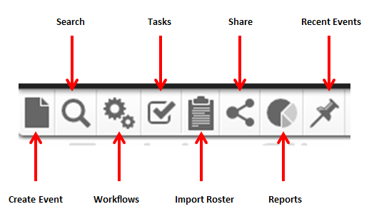

Figure 6-2. MAVEN Dashboard

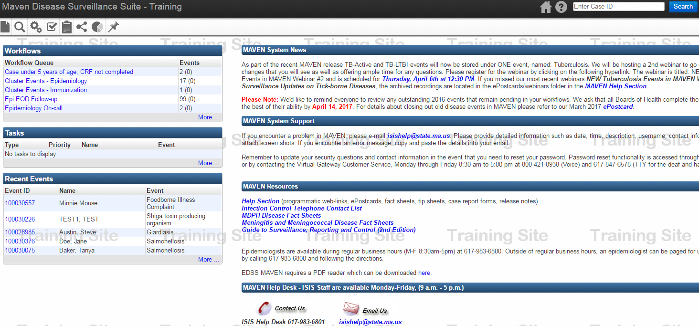

4. Workflows: MAVEN features electronic triage of reportable diseases between MDPH and LBOHs. The workflows display the outstanding work requiring completion. Which ones you see varies depending on your role in the system. When a positive lab is received, via fax or electronically, it will enter a notification workflow alerting users to the new event. MAVEN will generate an automated notification to local users and the Epidemiologist on call for that day (EOD) for immediate disease events. It will move through workflows based on the status of the investigation.

Figure 6-3: MAVEN Workflows

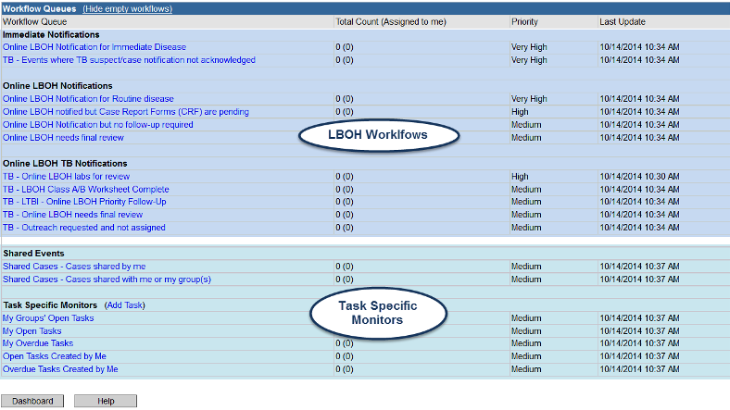

5. Question Packages: Case Report Forms are all in MAVEN. The old paper forms have been reconfigured into Question Packages under the Event Data tab. All of the questions are now answered online. If there is a hyper-linked "Add New" next to a question, it allows you to create an additional entry for that question, such as a second hospitalization for the same disease event.

Figure 6-4: MAVEN Event Summary

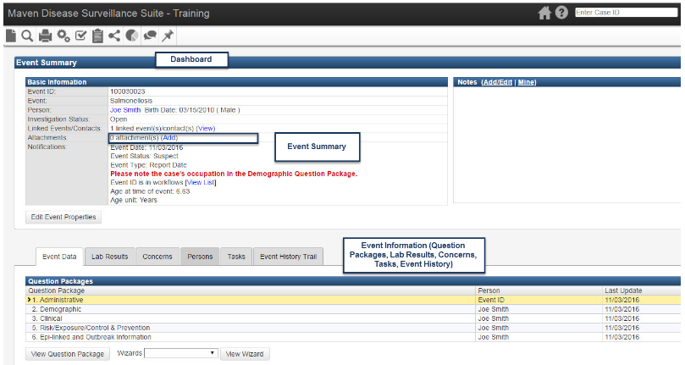

6. Creating Events: All users can create new events. A search to see if the person is already in MAVEN must always be done before you create an event. The "Create Event" icon on the toolbar will bring up a screen where users select a specific disease from a dropdown list. This list of available diseases is dependent on the user's role in the system. The diagnosed infectious disease will trigger the appropriate question packages the user will have to answer in order to successfully complete the case report form.

7. Logging Out:
It is important to logout when you are finished with your work. The two step process of logging out is shown below. 1) Logout from MAVEN application, then 2) Logout from Virtual Gateway.

Figure 6-5: MAVEN Surveillance and Case Management System

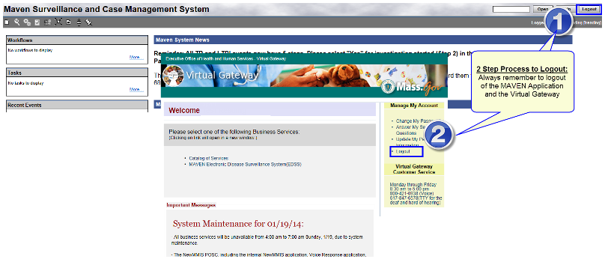

C. Lab Results

The Bureau of Infectious Disease and Laboratory Sciences (BIDLS) monitors and responds to over 90 reportable infectious diseases in the Commonwealth. These reports of infectious diseases are collected via various case report forms and lab results indicating both suspected and confirmed cases. Massachusetts receives approximately 96% of disease reports via electronic lab reporting (ELR), which is the electronic transmission of laboratory reports of reportable conditions from laboratories to public health. The benefits of automating the disease reporting process for clinical and commercial laboratories to MDPH have been:
  - Improved timeliness of notifiable reports
  - Increased accuracy (due to reduction of manual data entry errors)
  - Reports that are more complete
  - Reports that are more consistent across various data sources

ELR replaces fax, e-mail and ad hoc electronic data. ELR does not eliminate reporting, by phone, cases that may require a public health intervention immediately and upon suspicion. These exceptions include meningococcal disease, measles, rubella, tularemia, anthrax, or potential agents of bioterrorism. For laboratories that do not have ELR capabilities, paper lab results are faxed, entered into MAVEN, and triaged to the appropriate epidemiologist for response and outreach.

The goals of ELR are:
- Collect laboratory reports of notifiable conditions electronically and automatically
- Present a single point of contact for all infectious disease reporting
- Automate disease reporting process
- Improve timeliness of reporting of notifiable conditions
- Improve data quality
- Provide hospitals with tools to transmit reports to MDPH
- Provide a system with the flexibility to meet future needs

Results:
- Number of Clinical Laboratories Transmitting ELR 72
- Commercial Laboratories Transmitting ELR 5
- Labs and Hospitals Using Paper Reports 3
- ESPnet sites transmitting Data 4 + MLCHC
- Electronic Laboratory & Case Reporting Throughput Approx. 7,000,000

There has been a 4.4-fold increase in the total number of reports received via ELR as opposed to paper reports, and there has been a 7.9-day decrease in mean time from diagnosis to report.

D. Foodborne Illness Complaint Resources

The MAVEN Foodborne Illness Complaint Module replaces the previous database maintained by MDPH that had been in existence since 1995. This module is available to all LBOH users. Foodborne illness complaint worksheets can now be submitted via MAVEN when you identify a suspect food item during a case interview.

1. Dashboard Icons:
As described above, when you log onto MAVEN, you will first see the Splash Screen. The
Dashboard Icons include "Create Event" which is used to create a new FBI Complaint. The "Search" icon can be used to search for a specific FBI Complaint based on various search criteria.

2. Foodborne Illness Complaint Worksheet:
LBOH personnel can now report complaints by entering the information directly into MAVEN by creating an FBI Illness Complaint event. The worksheet has been reformatted as a fillable PDF. When you enter a Suspect Food or Drink into MAVEN events, users are prompted to create a new Foodborne Illness Complaint directly into MAVEN or complete a Foodborne Illness Complaint Worksheet and send it to the Food Protection Program.

The worksheet can be accessed from the MAVEN Help section under “Foodborne Illness Complaint Resources” or accessed directly online here: http://www.maventrainingsite.com/maven-help/WGFICTraining_2014/TEST%20FBI%20Complaint_1.pdf

3. Creating a New Foodborne Illness Complaint Event: New FBI Complaints will be created by the Food Protection Program (FPP) when they receive a completed Foodborne Illness Complaint Worksheet. The FPP, as well as the Epidemiology Program, may also create new FBI complaint events directly after learning of a new complaint over the phone. LBOHs can now also enter complaints directly into MAVEN by clicking on the "New Event" icon on the dashboard, and then selecting "Foodborne Illness Complaint" from the drop-down list of diseases. Once a new FBI Complaint event is created, an email notification will go out to the FPP Notification Group alerting them to the newly created event. The event will also enter the FPP notification of newly created FBI events workflow that the FPP monitors and acts upon for newly created events by LBOHs.

E. FBI Question Packages with LBOH Access

1. Administrative: This is for the FPP Program. LBOHs will see the questions but have restricted access to this question package. The Administrative question package captures FPP notification information. When a new complaint is created, the FPP will open this question package and answer the FPP Notified question as "Yes" and note the date. These variables are grayed out which means they are restricted variables for LBOH users. This package also shows the date and time an email notification was sent to the FPP to let them know of a newly created FBI event.

2. Complaint Information: The Complaint Information question package contains information collected on the first page of the Foodborne Illness Complaint Worksheet. It is broken up into the same sections as the paper Worksheet. Information for the Name of the Complainant will be grayed out since you already entered it when you created the FBI event. Once you click the "Save" button, the Official Complainant City will populate. If out of state it will show as N/A. The illness information section captures aggregate information on the person(s) who are ill. The time must be entered as "XX:XX" with a zero in front of single numbers.

3. Food History: The food history question package contains information collected on the second page of the FBI Complaint Worksheet. It also includes a way to track whether Inspectional Services was notified, and, if "yes," when and who was notified. Click on "Add New" hyperlink in order to address each food item from the FBI worksheet. Note that, if you notified appropriate inspectional services for your jurisdiction, if warranted, the FPP will not have to follow up with them directly.

4. Adding Notes: The notes section on the Dashboard of an event is useful for documenting additional information regarding an event that is not already captured in the question packages. Since members of the Epidemiology Program as well as the FPP have access to FBI Complaints in MAVEN, the notes section can be useful to document ongoing notes regarding an investigation. Anyone accessing the event will be able to view or add a note.

5. Unloading or Closing an Event: Once you have finished entering information into an event, you should unload or close it. An event can only be accessed and edited by one person at a time so it is important to close the event as soon as you are finished so that someone else may open it and perform additional data entry as necessary. To close an event, go to the main screen and click on the "X" in the upper right hand corner. This action does not save the event. It places the file back into the database so the next person can edit the event if needed. If you forget to do this action, the system will unload or close the event automatically in about 15 minutes.

F. Reports Available to LBOHs

Currently LBOHs are able to run reports in MAVEN by disease, establishment, foodborne illness complaints and implicated food. These reports can be run using the MAVEN generating report guidelines. Communities are encouraged to contact ISIS for assistance if needed.

The following reports are required by the FDA Voluntary Food Standards, #5, Data Review and Analysis:

- Foodborne disease outbreaks, suspect and confirmed, in a single establishment
- Foodborne disease outbreaks, suspect and confirmed, in the same establishment type
- Foodborne disease outbreaks, suspect and confirmed, implicating the same food
- Foodborne disease outbreaks, suspect and confirmed, associated with similar food prep processes
- Number of confirmed foodborne disease outbreaks
- Number of foodborne disease outbreaks and suspect foodborne disease outbreaks
- Contributing factors most often identified
- Number of complaints involving real and alleged threats of intentional food contamination
- Number of complaints involving the same agent and any complaints involving unusual agents, when agents are identified

In general, MAVEN does not currently track some of the information required for these reports. The preparation of this updated manual has led to discussions regarding the utility of making changes to MAVEN that could allow more detailed reporting of foodborne illness outbreaks. In the meantime, both the Food Protection Program and Epidemiology Program can assist with providing some information regarding the required reports listed above.

Overall, communities do not have that many foodborne illness outbreaks in a single year and a matrix, both paper and electronic, listing the required information can be made available in the near future. The purpose of this reporting is to ensure that an annual analysis of foodborne illness outbreaks occurs so that appropriate education and controls can be initiated.

Completion of the National Environmental Assessment Reporting System (NEARS) Checklist after a foodborne illness outbreak investigation (described in Chapter VII) will contribute greatly to the ability of MDPH to assist with producing the required report data.

