Commonwealth of Massachusetts
Executive Office of Health and Human Services

Office of Medicaid
www.mass.gov/masshealth

MassHealth
Eligibility Letter 230
June 29, 2018

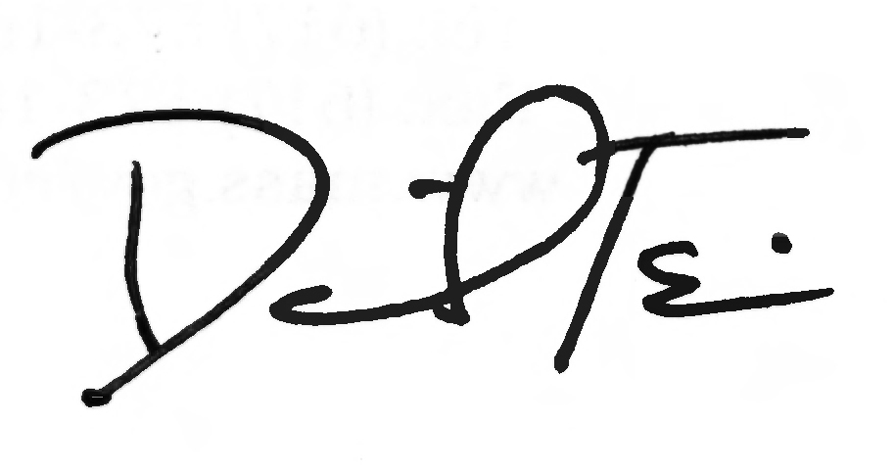
TO: MassHealth Staff

FROM: Daniel Tsai, Assistant Secretary for MassHealth

RE: Revisions to the Regulations at 130 CMR 506.000

MassHealth is revising the regulations at 130 CMR 506.005(A)(2) to clarify when household income is considered verified using reasonable compatibility rules.

These emergency regulations are effective July 1, 2018.

MANUAL UPKEEP

Insert Remove Trans. By

506.005 506.005 E.L. 228

130 CMR: DIVISION OF MEDICAL ASSISTANCE

Trans. by E.L. 230
Rev. 07/01/18
MASSHEALTH: FINANCIAL REQUIREMENTS
Chapter 506
Page 506.005

(J) income received by independent foster-care adolescents described at 130 CMR 505.002(H): Eligibility Requirements for Former Foster-Care Individuals;

(K) income from children and tax dependents who are not expected to be required to file a tax return under section 6012(a)(1) of the Internal Revenue code for the taxable year in which eligibility for MassHealth is being determined, whether or not the children or the tax dependents files a tax return; and

(L) any other income that is excluded by federal laws other than the Social Security Act.

506.005: Verification of Income

Verification of income is mandatory. Income may be verified either through electronic data matches or paper verification.

(A) Electronic Data Matches.
(1) Data Matches. MassHealth electronically matches with federal and state data sources described at 130 CMR 502.004: Matching Information to verify attested income.
(2) Reasonable Compatibility. The income data received through an electronic data match is compared to the attested income amount to determine if the attested amount and the data source amount are reasonably compatible. If these amounts are reasonably compatible, the attested income is considered verified for purposes of an eligibility determination. To be considered reasonably compatible
(a) both the attested income and the income from the data sources must be above the applicable income standard for the individual; or
(b) both the attested income and the income from the data sources must be at or below the applicable income standard for the individual; or
(c) the attested income is at or below the applicable standard and the income from the data sources is above the applicable standard but their difference is 10% or less; or
(d) the attested income is above the applicable standard and the income from the data sources is at or below the applicable standard.
(3) Self-attested Income. When self-attested income is reasonably compatible with the electronic data, the income amount used to determine eligibility is the self-attested amount.

(B) Paper Verification. If the attested income and the income from the electronic data source are not reasonably compatible, or if the electronic data match is unavailable, paper verification of income is required.
(1) Paper verification of monthly earned income includes, but is not limited to
(a) recent paystubs;
(b) a signed statement from the employer; or
(c) the most recent U.S. Individual Tax Return.
(2) Verification of monthly unearned income is mandatory and includes, but is not limited to
(a) a copy of a recent check or paystub showing gross income from the source;
(b) a statement from the income source, where matching is not available; or
(c) the most recent U.S. Individual Tax Return.

