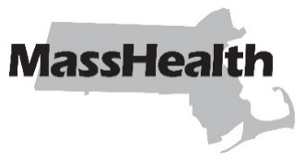
Eligibility Letter 257
Commonwealth of Massachusetts
Executive Office of Health and Human Services
Office of Medicaid
www.mass.gov/masshealth
DATE: February 2026
TO: MassHealth Staff
FROM: Elizabeth LaMontagne, Chief Operating Officer [signature of Elizabeth LaMontagne]
RE: Revised Regulation 130 CMR 517.000: MassHealth: Universal Eligibility Requirements

Background
MassHealth has updated its regulations at 130 CMR 517.000: MassHealth: Universal Eligibility Requirements. This regulation amendment includes the following change.
Utilization of potential other benefits: Pursuant to federal law, MassHealth is eliminating the requirement that individuals apply for other cash benefits to which they may be entitled as a condition of Medicaid eligibility (e.g., Social Security, retirement benefits).
These regulations are effective February 13, 2026.

MassHealth Website
This Eligibility Letter is available on the MassHealth website at MassHealth Eligibility Letters.

New Material
The pages listed here contain new or revised language.

Regulation 130 CMR 517.000: MassHealth: Universal Eligibility Requirements
Pages 1 through 9

Obsolete Material
The pages listed here are no longer in effect.

Regulation 130 CMR 517.000: MassHealth: Universal Eligibility Requirements
Pages 517.000 through 517.012—transmitted by Eligibility Letter 227
Please note: Eligibility Letters no longer include the updated regulation pages. Updated regulations are on our member eligibility regulations page.
MassHealth on Facebook MassHealth on LinkedIn MassHealth on X MassHealth on YouTube

