INDOOR AIR QUALITY ASSESSMENT

Elm Street School
160 Elm Street
Gardner, Massachusetts

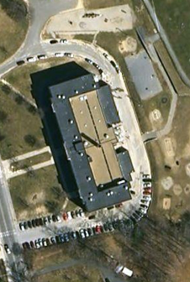

Prepared by:
Massachusetts Department of Public Health
Bureau of Environmental Health
Indoor Air Quality Program
June 2010

Background/Introduction
At the request of Mr. Bob O’Brien, Facilities Director for the Gardner Public Schools (GPS), the Massachusetts Department of Public Health (MDPH), Bureau of Environmental Health (BEH) provided assistance and consultation in an on-going effort to monitor and improve indoor air quality conditions in each of Gardner’s public schools. On February 8, 2010, Lisa Hébert, Environmental Analyst/Regional Inspector for BEH’s Indoor Air Quality (IAQ) Program conducted an assessment at the Elm Street School (ESS), 160 Elm Street, Gardner, Massachusetts.
The ESS is a three-story brick building that was constructed as a high school in 1926. The building also utilizes an occupied lower level. A small addition was added on the east side of the building in the late 1960s. In 1976, the building was converted to an elementary school. In addition to classrooms, the ESS houses a library, auditorium, gymnasium, kitchen, cafeteria, and administrative offices. Windows are openable throughout the building.

Methods
Air tests for carbon monoxide, carbon dioxide, temperature and relative humidity were conducted with the TSI, Q-Trak, IAQ Monitor, Model 7565. Air tests for airborne particle matter with a diameter less than 2.5 micrometers were taken with the TSI, DUSTTRAK™ Aerosol Monitor Model 8520. BEH staff also performed visual inspection of building materials for water damage and/or microbial growth.

Results
The school houses 477 children in grades three through five and has a staff of approximately 60. Tests were taken during normal operations at the school and results appear in Table 1.

Discussion

Ventilation
It can be seen from Table 1 that carbon dioxide levels were above 800 parts per million (ppm) in 48 of 54 areas surveyed indicating poor air exchange throughout the building. It is also important to note that some of the rooms were empty or sparsely populated at the time carbon dioxide measurements were taken, which can greatly reduce carbon dioxide levels. Carbon dioxide levels would be expected to increase with full occupancy.
The heating/ventilation of classrooms in the original portion of the building were designed to use unit ventilators (univents) made by the Peerless Unit Ventilation Co., Inc. (Pictures 1 and 2). A univent draws air from the outdoors through a fresh air intake located on the exterior wall of the building and returns air through an air intake located at the base of the unit. Fresh and return air are mixed, filtered, heated and provided to classrooms through an air diffuser located in the top of the unit (Figure 1). At the present time, these 1920s vintage univents are not functioning as designed and many are disconnected. Therefore, the only means of introducing fresh air into the original building is via openable windows. Univents also provide mechanical ventilation to the majority of classrooms in the 1960s addition (Picture 3). These univents, though operational, are at least forty years old.
Efficient function of such aged equipment is difficult to maintain, since compatible replacement parts are often unavailable. According to the American Society of Heating, Refrigeration and Air-Conditioning Engineering (ASHRAE), the service life for a unit heater, hot water or steam is 20 years, assuming routine maintenance of the equipment (ASHRAE, 1991). Despite attempts to maintain these univents, the operational lifespan of this equipment has been exceeded. Maintaining the balance of fresh air to exhaust air will be difficult with equipment of this vintage.
Stale air was originally designed to be exhausted from the building via mechanical means through wall mounted exhaust vents (Picture 4). It was reported to BEH that this exhaust system was disconnected in the 1960s. Once again, the only means at present to exhaust stale air is by means of openable windows.
To maximize air exchange, the MDPH recommends that both supply and exhaust ventilation operate continuously during periods of occupancy. In order to have proper ventilation with a mechanical supply and exhaust system, the systems must be balanced to provide an adequate amount of fresh air to the interior of a room while removing stale air from the room. It is recommended that HVAC systems be re-balanced every five years to ensure adequate air systems function (SMACNA, 1994). The mechanical venation components cannot be balanced in their current condition.
The Massachusetts Building Code requires that each room have a minimum ventilation rate of 15 cubic feet per minute (cfm) per occupant of fresh outside air or openable windows (SBBRS, 1997; BOCA, 1993). The ventilation must be on at all times that the room is occupied. Providing adequate fresh air ventilation with open windows and maintaining the temperature in the comfort range during the cold weather season is impractical. Mechanical ventilation is usually required to provide adequate fresh air ventilation.
Carbon dioxide is not a problem in and of itself. It is used as an indicator of the adequacy of the fresh air ventilation. As carbon dioxide levels rise, it indicates that the ventilating system is malfunctioning or the design occupancy of the room is being exceeded. When this happens, a buildup of common indoor air pollutants can occur, leading to discomfort or health complaints. The Occupational Safety and Health Administration (OSHA) standard for carbon dioxide is 5,000 parts per million parts of air (ppm). Workers may be exposed to this level for 40 hours/week, based on a time-weighted average (OSHA, 1997).
The MDPH uses a guideline of 800 ppm for publicly occupied buildings. A guideline of 600 ppm or less is preferred in schools due to the fact that the majority of occupants are young and considered to be a more sensitive population in the evaluation of environmental health status. Inadequate ventilation and/or elevated temperatures are major causes of complaints such as respiratory, eye, nose and throat irritation, lethargy and headaches. For more information concerning carbon dioxide, consult Appendix A.
Indoor temperature measurements ranged from 65º F to 74º F, which were within or near the lower end of the MDPH recommended comfort range in the majority of areas the day of the assessment (Table 1). The MDPH recommends that indoor air temperatures be maintained in a range of 70º F to 78º F in order to provide for the comfort of building occupants. In many cases concerning indoor air quality, fluctuations of temperature in occupied spaces are typically experienced, even in a building with an adequate fresh air supply. In addition, it is difficult to control temperature and maintain comfort without operating the ventilation equipment as designed (e.g., univents/exhaust vents deactivated/nonfunctional).
The relative humidity measured in the building ranged from 15 to 35 percent, which was below the MDPH recommended comfort range in all areas surveyed during the assessment (Table 1). The MDPH recommends a comfort range of 40 to 60 percent for indoor air relative humidity. Relative humidity levels in the building would be expected to drop during the winter months due to heating. The sensation of dryness and irritation is common in a low relative humidity environment. Low relative humidity is a very common problem during the heating season in the northeast part of the United States.

Microbial/Moisture Concerns
Water-damaged ceiling tiles and panels were observed in a number of areas, which indicate current/historic plumbing and/or roof leaks (Pictures 5 and 6). Water-damaged ceiling tiles can provide a source of mold and should be replaced after a water leak is discovered and repaired.
The US Environmental Protection Agency (US EPA) and the American Conference of Governmental Industrial Hygienists (ACGIH) recommend that porous materials be dried with fans and heating within 24 to 48 hours of becoming wet (US EPA, 2001; ACGIH, 1989). If not dried within this time frame, mold growth may occur. Once mold has colonized porous materials, they are difficult to clean and should be removed and discarded.
A section of the gymnasium floor was rotted due to a chronic roof leak around a drain line (Pictures 7 and 8). A section of the plumbing was missing below a hand sink in the janitor’s closet, which likely caused water to leak onto the floor (Picture 9). Window sills in at least one classroom (Room 101) exhibited water damage (Picture 10).
Carpets were observed in some basement rooms. Consideration should be given to removal of porous flooring materials from below grade areas, since carpeting is generally not recommended for use in sub-grade areas that are prone to chronic dampness such as basements (US EPA, 2001; MDPH, 2006). In order to ensure fungal growth does not occur, it may be prudent to avoid placing wall-to-wall carpeting or other porous materials (such as upholstered furniture) in below grade areas.
Plants were noted in several classrooms (Picture 11). Plants can be a source of pollen and mold which can be respiratory irritants to some individuals. Plants should be properly maintained and equipped with drip pans and should be located away from univents to prevent the aerosolization of dirt, pollen and mold.
BEH staff examined the exterior of the building to identify breaches in the building envelope and other conditions that could provide a source of water penetration. Several potential sources were identified:
- Moss growth was observed on the roof (Picture 12). The presence of moss on the roof shown in Picture 12 is indicative of repeated water exposure. Moss is a sign of chronic dampness and can hold moisture against building components, which can subsequently accelerate its decomposition. “The two main requirements of a moss are sufficient moisture and accessible nutrients. For example, the moist environment of a rooftop shaded by trees seems just fine for mosses, [which] prefer to colonize shingles above the eaves, on detritus that builds up in the eaves’ troughs or other depressions. Mosses will be at their best in the winter when there is plenty of water, little light, and low temperatures” (OSU, 2000).
- Mortar was loose or missing in some locations (Picture 13).
- Shrubs were located in close proximity to the building in some areas (Picture 14). The growth of roots against exterior walls can bring moisture in contact with the foundation. Plant roots can eventually penetrate, leading to cracks and/or fissures in the sublevel foundation.
The aforementioned conditions represent potential water penetration sources. Over time, these conditions can undermine the integrity of the building envelope and provide a means of water entry into the building via capillary action through foundation concrete and masonry (Lstiburek & Brennan, 2001). In addition, these breaches may provide a means for pests/rodents to enter the building.
One classroom (Room 101) exhibited a slight musty odor upon entering. In addition to the water-damaged window sills previously mentioned, this room contained a number of older books, which had a musty odor. Books can absorb moisture and emit odors. In this room, (and perhaps in others as well) cardboard is being placed on top of old chalkboards and is being used as a bulletin board (Picture 19). Cardboard, like paper, can absorb moisture and odors. Although no visible mold colonization was observed on the exposed cardboard, it may be prudent to remove it from the classroom.

Other IAQ Evaluations
Indoor air quality can be negatively influenced by the presence of respiratory irritants, such as products of combustion. The process of combustion produces a number of pollutants. Common combustion emissions include carbon monoxide, carbon dioxide, water vapor, and smoke (fine airborne particle material). Of these materials, exposure to carbon monoxide and particulate matter with a diameter of 2.5 micrometers (μm) or less (PM2.5) can produce immediate, acute health effects upon exposure. To determine whether combustion products were present in the indoor environment, BEH staff obtained measurements for carbon monoxide and PM2.5.

Carbon Monoxide
Carbon monoxide is a by-product of incomplete combustion of organic matter (e.g., gasoline, wood and tobacco). Exposure to carbon monoxide can produce immediate and acute health effects. Several air quality standards have been established to address carbon monoxide and prevent symptoms from exposure to these substances. The MDPH established a corrective action level concerning carbon monoxide in ice skating rinks that use fossil-fueled ice resurfacing equipment. If an operator of an indoor ice rink measures a carbon monoxide level over 30 ppm, taken 20 minutes after resurfacing within a rink, that operator must take actions to reduce carbon monoxide levels (MDPH, 1997).
The American Society of Heating Refrigeration and Air-Conditioning Engineers (ASHRAE) has adopted the National Ambient Air Quality Standards (NAAQS) as one set of criteria for assessing indoor air quality and monitoring of fresh air introduced by HVAC systems (ASHRAE, 1989). The NAAQS are standards established by the US EPA to protect the public health from six criteria pollutants, including carbon monoxide and particulate matter (US EPA, 2006). As recommended by ASHRAE, pollutant levels of fresh air introduced to a building should not exceed the NAAQS levels (ASHRAE, 1989). The NAAQS were adopted by reference in the Building Officials & Code Administrators (BOCA) National Mechanical Code of 1993 (BOCA, 1993), which is now an HVAC standard included in the Massachusetts State Building Code (SBBRS, 1997). According to the NAAQS, carbon monoxide levels in outdoor air should not exceed 9 ppm in an eight-hour average (US EPA, 2006).
Carbon monoxide should not be present in a typical, indoor environment. If it is present, indoor carbon monoxide levels should be less than or equal to outdoor levels. Outdoor carbon monoxide concentrations were non-detect (ND) the day of the assessment (Table 1). No measureable levels of carbon monoxide were detected in the building during the assessment (Table 1).

Particulate Matter
The US EPA has established NAAQS limits for exposure to particulate matter. Particulate matter is airborne solids that can be irritating to the eyes, nose and throat. The NAAQS originally established exposure limits to particulate matter with a diameter of 10 μm or less (PM10). According to the NAAQS, PM10 levels should not exceed 150 microgram per cubic meter (μg/m³) in a 24-hour average (US EPA, 2006). These standards were adopted by both ASHRAE and BOCA. Since the issuance of the ASHRAE standard and BOCA Code, US EPA established a more protective standard for fine airborne particles. This more stringent PM2.5 standard requires outdoor air particle levels be maintained below 35 μg/m³ over a 24-hour average (US EPA, 2006). Although both the ASHRAE standard and BOCA Code adopted the PM10 standard for evaluating air quality, MDPH uses the more protective PM2.5 standard for evaluating airborne particulate matter concentrations in the indoor environment.
Outdoor PM2.5 concentration was measured at 12 μg/m³ (Table 1). PM2.5 levels measured indoors ranged from 3 to 13 μg/m³ (Table 1), which were below the NAAQS PM2.5 level of 35 μg/m³. Frequently, indoor air levels of particulates (including PM2.5) can be at higher levels than those measured outdoors. A number of mechanical devices and/or activities that occur indoors can generate particulate during normal operations. Sources of indoor airborne particulates may include but are not limited to particles generated during the operation of fan belts in the HVAC system, cooking in the cafeteria stoves and microwave ovens; use of photocopiers, fax machines and computer printing devices; operation of an ordinary vacuum cleaner and heavy foot traffic indoors.

Volatile Organic Compounds
Indoor air concentrations can be greatly impacted by the use of products containing volatile organic compounds (VOCs). VOCs are carbon-containing substances that have the ability to evaporate at room temperature. Frequently, exposure to low levels of total VOCs (TVOCs) may produce eye, nose, throat and/or respiratory irritation in some sensitive individuals. For example, chemicals evaporating from a paint can stored at room temperature would most likely contain VOCs. In an effort to identify materials that can potentially increase indoor VOC concentrations, BEH staff examined classrooms for products containing these respiratory irritants.
Several classrooms contained dry erase boards and markers. Materials such as permanent markers, dry erase markers and dry erase board cleaners may contain VOCs, such as methyl isobutyl ketone, n-butyl acetate and butyl-cellusolve (Sanford, 1999), which can be irritating to the eyes, nose and throat.
Cleaning products were also observed in one classroom. Like dry erase materials, cleaning products contain VOCs and other chemicals. These chemicals can be irritating to the eyes, nose and throat and should be kept out of reach of students. Furthermore, a Material Safety Data Sheet (MSDS) should be available at a central location for each product in the event of an emergency. Consideration should be given to providing teaching staff with school issued cleaning products and supplies to ensure that MSDS information is available for all products used at the school.
A lamination machine was observed in one room. Lamination machines can give off waste heat and odors. It is recommended that local separate exhaust system be provided (US DOE, Unknown).

Other Conditions
Other conditions that can affect indoor air quality were observed during the assessment. As previously reported, a hand sink in the janitor’s closet lacked the trap portion of the drain line (Picture 15). Without a wet trap, the room was open to the drainage system. If a mechanical device (e.g., a fan) depressurizes the room, air, gas and odors can be drawn from the drainage system into the room. The effect of this phenomenon can be increased if heavy rains cause an air backup in the drainage system.
At least two local exhaust fans were deactivated in bathrooms, indicating either the motors were either deactivated or disconnected from their power source. Without functioning exhaust ventilation, moisture and restroom odors will tend to linger within the building.
Carpets were observed at ESS, many of which were approximately 20 years old. The Institute of Inspection, Cleaning and Restoration Certification has determined the usable life span of a carpet to be eleven years (IICRC, 2002). Therefore, these carpets have exceeded their life span and can serve as a source of airborne fiber as the flooring deteriorates.
Stuffed toys and pillows were observed in the classroom (Picture 16). Stuffed pillows/toys can be a point source for dust collection. Stuffed toys used by an individual child should be washed on a weekly basis to prevent disease (Hale and Polder, 1996). Close contact with such items can leave oils, perspiration, hair and skin cells. Dust mites feed upon human skin cells and excrete waste products that contain allergens. Dust can be irritating to the eyes, nose and respiratory system. Dust accumulation was also noted on canvas window shades (Picture 17). These window shades reportedly were installed when the building was constructed in 1926. Disintegrating textiles can be a source of airborne particulates, which can be irritating to the eyes, nose and throat. In addition, dust accumulation was noted on the blades of the ceiling fan in the gym.
Open utility holes and large penetrations were noted in some areas (Picture 18). Open utility holes can provide a means of egress for odors, fumes, dusts and vapors between rooms and floors.
In several classrooms, items were observed on the floor, windowsills, tabletops, counters, bookcases and desks. The large number of items stored in classrooms provides a source for dusts to accumulate. These items (e.g., books, papers, folders, boxes) make it difficult for custodial staff to clean. Items should be relocated and/or be cleaned periodically to avoid excessive dust build up. In addition, these materials can accumulate on flat surfaces (e.g., desktops, shelving and carpets) in occupied areas and subsequently be re-aerosolized causing further irritation.
Room 101 contained a portable air purifier. This equipment has air filters that should be cleaned or changed as per the manufacturer’s instructions to avoid the reaerosolization of dusts and particulates.

Conclusions/Recommendations
The conditions noted at the ESS raise a number of indoor air quality issues. The general building conditions, maintenance, work hygiene practices and the age/condition of HVAC equipment, if considered individually, present conditions that could degrade indoor air quality. When combined, these conditions can serve to further degrade indoor air quality. For these reasons, a two-phase approach is recommended. The first consists of short-term measures to improve air quality and the second consists of long-term measures that will require planning and resources to adequately address the overall indoor air quality concerns.
In view of the findings at the time of the visit, the following short term recommendations are provided:
- Use openable windows to facilitate air exchange. Care should be taken to ensure windows are properly closed at night and weekends to avoid the freezing of pipes and potential flooding.
- Improve air exchange in classrooms. An increase in the percentage of fresh air supply and increased exhaust capabilities is recommended. Contact an HVAC engineering firm to evaluate the existing equipment in order to determine the best method of providing fresh air to the classroom and for removing stale classroom air.
- Once ventilation system has been repaired/replaced, consider adopting a balancing schedule of every 5 years for all mechanical ventilation systems, as recommended by ventilation industrial standards (SMACNA, 1994).
- For buildings in New England, periods of low relative humidity during the winter are often unavoidable. Therefore, scrupulous cleaning practices should be adopted to minimize common indoor air contaminants whose irritant effects can be enhanced when the relative humidity is low. To control dusts, a high efficiency particulate arrestance (HEPA) filter equipped vacuum cleaner in conjunction with wet wiping of all surfaces is recommended. Avoid the use of feather dusters. Drinking water during the day can help ease some symptoms associated with a dry environment (throat and sinus irritations).
- Repair any existing water leaks and replace any remaining water-damaged ceiling tiles. Examine the area above these tiles for mold growth. Disinfect areas of water leaks with an appropriate antimicrobial, as needed. Repair plaster as necessary.
- Repair gymnasium floor.
- Contact a plumber to repair drain line below hand sink in janitor’s closet.
- Investigate and remediate source of water-damaged windowsills.
- Ensure plants are equipped with drip pans. Examine drip pans periodically for mold growth and disinfect with an appropriate antimicrobial, as needed.
- Routinely check roof drains to ensure water does not accumulate on the roof.
- Repair loose and missing mortar.
- Ensure plants on the exterior of the building do not come within 5 feet of the building.
- Routinely clean dry erase board trays of accumulated particulate.
- Store cleaning products properly and out of reach of students. All cleaning products used at the facility should be approved by the school department with MSDS’ available at a central location.
- If hand sink and/or mop sink in janitor’s closet are not often utilized, routinely pour water
down drain to maintain seal in drain traps.
- Evaluate bathroom exhaust fans and repair/replace as necessary.
- Wash stuffed toys used by children weekly.
- Clean accumulated dust and debris periodically from the surface of blades of personal and ceiling fans.
- Seal spaces around utility holes and breaches in walls/floors and ceilings with an appropriate fire rated sealant. Repair larger penetrations into the framing.
- Relocate or consider reducing the amount of materials stored in classrooms to allow for more thorough cleaning of classrooms. Any musty, water-damaged porous materials should be removed from the classroom. Clean items regularly with a wet cloth or sponge to prevent excessive dust build-up.
- Consider removing cardboard from blackboards.
- Clean filters in portable air purifier in accordance with the manufacturer’s instructions to avoid the reaerosolization of dusts and particulates.
- Relocate laminator to an area with local exhaust ventilation.
- Consider adopting the US EPA (2000) document, “Tools for Schools”, as an instrument for maintaining a good indoor air quality environment in the building. This document is available at: http://www.epa.gov/iaq/schools/index.html.
- Refer to resource manual and other related indoor air quality documents located on the MDPH’s website for further building-wide evaluations and advice on maintaining public buildings. These documents are available at: http://mass.gov/dph/iaq.

In view of the findings at the time of the visit, the following long term recommendations are provided:
      - Contact an HVAC engineering firm for an assessment of the building’s mechanical ventilation systems (e.g., controls, air intake louvers, thermostats). Based on the age, physical deterioration and availability of parts for ventilation components, such an evaluation is necessary to determine the operability and feasibility of repairing/replacing the equipment.
      - Replace sections of roofing as necessary.
      - Consider developing a plan to systematically replace older carpets. Replace sub-level carpets with nonporous floor covering (e.g., tile).
      - Consider replacing old canvas window shades.
      - Consider providing dedicated exhaust for laminating machine.
References
ACGIH. 1989. Guidelines for the Assessment of Bioaerosols in the Indoor Environment. American Conference of Governmental Industrial Hygienists, Cincinnati, OH.
ASHRAE. 1989. Ventilation for Acceptable Indoor Air Quality. American Society of Heating, Refrigeration and Air Conditioning Engineers. ANSI/ASHRAE 62-1989
ASHRAE. 1991. ASHRAE Applications Handbook, Chapter 33 “Owning and Operating Costs”. American Society of Heating, Refrigeration and Air Conditioning Engineers, Atlanta, GA.
BOCA. 1993. The BOCA National Mechanical Code/1993. 8th ed. Building Officials and Code Administrators International, Inc., Country Club Hill, IL.
Hale, C.M., Polder, J.A. 1996. The ABC’s of Safe and Healthy Child Care a Handbook for Child Care Providers, Department of Health and Human Services. United States Public Health Service, Centers for Disease Control.
IICRC. 2002. A Life-Cycle Cost Analysis For Floor Coverings in School Facilities. Institute of Inspection Cleaning and Restoration, Vancouver, WA.
Lstiburek, J. & Brennan, T. 2001. Read This Before You Design, Build or Renovate. Building Science Corporation, Westford, MA. U.S. Department of Housing and Urban Development, Region I, Boston, MA.
MDPH. 1997. Requirements to Maintain Air Quality in Indoor Skating Rinks (State Sanitary Code, Chapter XI). 105 CMR 675.000. Massachusetts Department of Public Health, Boston, MA.
MDPH. 2006. Guidance Concerning Remediation and Prevention of Mold Growth and Water Damage in Public Schools/Buildings to Maintain Air Quality. Massachusetts Department of Public Health, Bureau of Environmental Health, Indoor Air Quality Program, Boston, MA.

OSHA. 1997. Limits for Air Contaminants. Occupational Safety and Health Administration. Code of Federal Regulations. 29 C.F.R 1910.1000 Table Z-1-A.

OSU. 2000. Basic Moss Biology. Retrieved August 19, 2008, from Oregon State University, Living with Mosses website: http://bryophytes.science.oregonstate.edu/mosses.htm.
Sanford. 1999. Material Safety Data Sheet (MSDS No: 198-17). Expo® Dry Erase Markers Bullet, Chisel, and Ultra Fine Tip. Sanford Corporation. Bellwood, IL.
SBBRS. 1997. Mechanical Ventilation. State Board of Building Regulations and Standards. Code of Massachusetts Regulations. 780 CMR 1209.0
SMACNA. 1994. HVAC Systems Commissioning Manual. First Edition. Sheet Metal and Air Conditioning Contractors’ National Association, Inc., Chantilly, VA.
US DOE. Unknown. School Design Guidelines for Hot, Dry Climates. US. Department of Energy, High Performance School Initiative, Washington, DC.
US EPA. 2000. Tools for Schools. Office of Air and Radiation, Office of Radiation and Indoor Air, Indoor Environments Division (6609J). EPA 402-K-95-001, Second Edition. http://www.epa.gov/iaq/schools/tools4s2.html
US EPA. 2001. Mold Remediation in Schools and Commercial Buildings. Office of Air and Radiation, Indoor Environments Division, Washington, DC. EPA 402-K-01-001. March 2001. Available at: http://www.epa.gov/iaq/molds/mold_remediation.html
US EPA. 2006. National Ambient Air Quality Standards (NAAQS). US Environmental Protection Agency, Office of Air Quality Planning and Standards, Washington, DC. http://www.epa.gov/air/criteria.html
Picture 1

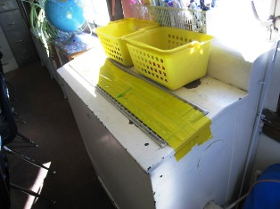

1920’s Vintage Unit Ventilator in Disuse

Picture 2

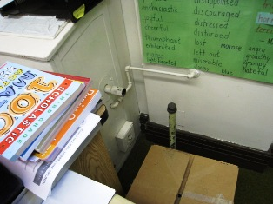

Disconnected 1920’s Vintage Univent

Picture 3

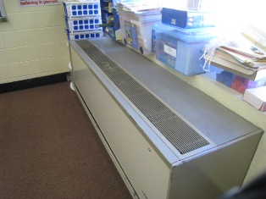

Unit Ventilator in Newer Addition

Picture 4

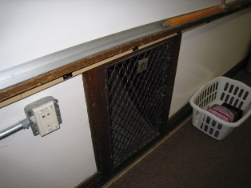

Wall Mounted Exhaust Vent

Picture 5

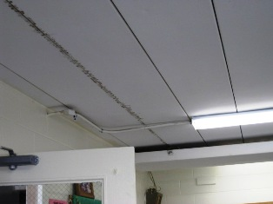

Stained Ceiling Panels

Picture 6

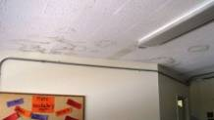

Water-Damaged Ceiling Tiles

Picture 7

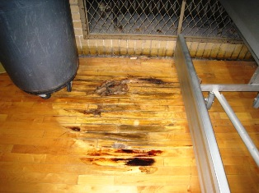

Water-Damaged Floor of Gymnasium

Picture 8

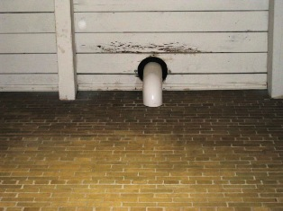

Drain Line Above Gymnasium Floor

Picture 9

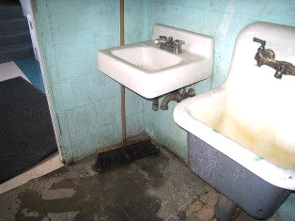

Hand Sink in Janitorial Closet Lacking Portion of Drain Line
Note Water on Floor
Picture 10

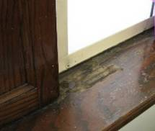

Water-Damaged Window Sill

Picture 11

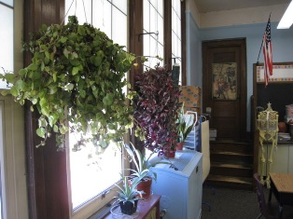

Numerous Plants in Classroom

Picture 12

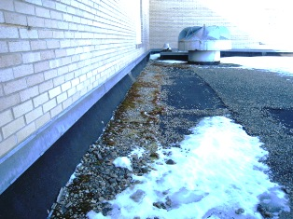

Moss Growth on Roof

Picture 13

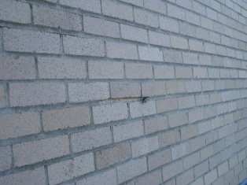

Missing Mortar

Picture 14

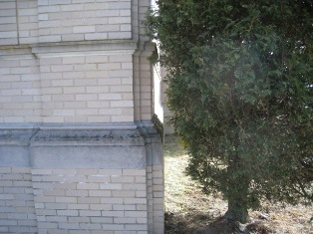

Portion of Shrub Resting Against Exterior Wall

Picture 15

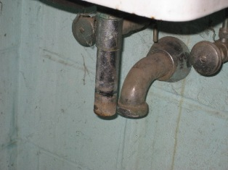

Missing Portion of Drain Line Allows Sewer Gas
to Enter Janitorial Room
Picture 16

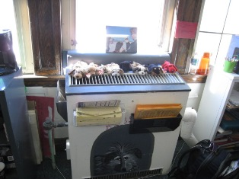

Stuffed Toys in Classroom

Picture 17

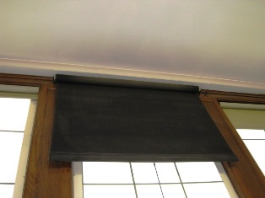

Dust Accumulation Visible on Canvas Window Shade
Picture 18

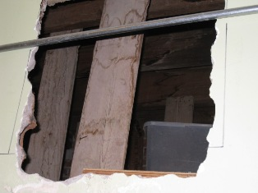

Open Penetration into the Framing of the Building

Picture 19

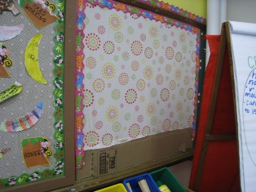

Cardboard Placed on Chalkboard
Location/ Room | Occupants  in Room | Temp  (°F) | Relative  Humidity  (%) | Carbon  Dioxide  (ppm) | Carbon Monoxide  (ppm) | PM2.5  (µg/m3) | Windows  Openable | Ventilation |  | Remarks
 |  |  |  |  |  |  |  | Supply | Exhaust | Remarks
background | - | 29 | 31 | 354 | ND | 12 | - | - | - | Sunny, clear; visibility 10 miles; wind speed 13mph (NW); 0.00 in. precipitation
Room 301 | 13 | 65 | 29 | 1190 | ND | 3 | Y | Y  off | Y | DO, AC, efflorescence on ceiling
Room 302 | 22 | 68 | 27 | 1430 | ND | 8 | Y | Y  off | Y | DO, DEM, WD ceiling
Room 303 | 21 | 70 | 27 | 1700 | ND | 5 | Y | Y  off | Y  blocked | DO, DEM
Room 304 | 0 | 69 | 27 | 1995 | ND | 5 | Y | Y  off | Y  blocked | DO, DEM, FC, refrig, micro
Room 305 | 43 | 71 | 29 | 2432 | ND | 11 | Y | Y  off | Y | DO
Room 306 | 0 | 72 | 34 | 1502 | ND | 9 | Y | Y  off | Y | DO, copier
Room 307 | 0 | 68 | 25 | 1314 | ND | 9 | Y | Y | Y  blocked | DO, DEM
Room 308 | 17 | 70 | 23 | 1164 | ND | 13 | Y | Y | Y | DEM, PF
Room 309 | 2 | 70 | 26 | 1192 | ND | 10 | Y | Y  off | Y | DO, DEM, PF
Room 310 | 22 | 71 | 26 | 1561 | ND | 6 | Y | Y | Y | DO, DEM
Room 311 | 0 | 71 | 22 | 1106 | ND | 7 | Y | Y | Y | DC, DEM, laminator
Room 210 | 19 | 71 | 35 | 1401 | ND | 5 | Y | Y  off | Y  blocked | DO, DEM
Room 209 | 20 | 71 | 26 | 1505 | ND | 10 | Y | Y  off | Y  blocked | DO, DEM, WD ceiling
Room 208 | 16 | 73 | 25 | 1566 | ND | 5 | Y | Y | Y  blocked | DC, DEM bathroom exhaust not working and has WD CT
Room 207 | 14 | 70 | 21 | 1329 | ND | 5 | Y | Y | Y  blocked | DEM
Room 206 | 22 | 70 | 21 | 1221 | ND | 6 | Y | Y | Y  blocked | DO, DEM
Library | 1 | 71 | 18 | 914 | ND | 9 | Y | Y  off | Y  blocked | Copier
Auditorium | 0 | 72 | 19 | 1141 | ND | 10 | N | Y | Y | Both supply and exhaust reported to be nonfunctioning
Room 205 | 21 | 72 | 21 | 1546 | ND | 10 | Y | Y | Y  Blocked | DEM
Room 204 | 20 | 72 | 20 | 1530 | ND | 6 | Y | Y | Y | DO, DEM
Room 203 | 2 | 71 | 23 | 1570 | ND | 6 | Y | Y | Y  blocked | DO, DEM, (students left room immediately preceeding testing.)
Room 202 | 0 | 72 | 21 | 1482 | ND | 5 | Y | Y | Y | DO, DEM, (students left room approx. 5 minutes prior)
Room 201 | 0 | 71 | 22 | 1462 | ND | 4 | Y | Y  off | Y | DO, DEM
Room 109 | 1 | 70 | 21 | 1002 | ND | 6 | Y | Y  Off | Y  blocked | DO, DEM
Gym | 22 | 69 | 19 | 737 | ND | 11 | N | Y | Y | Rotted floor due to leak
Room 108 (Poscoe)) | 1 | 73 | 19 | 926 | ND | 8 | Y | N | N | DO, DEM, FC, utility holes not sealed
Room 108 (Thibeault) | 0 | 71 | 20 | 880 | ND | 8 | Y | Y | N | DO, PF
Room 107 | 2 | 74 | 16 | 877 | ND | 4 | Y | Y  blocked | Y  blocked | DO, DEM
Boys’ Room |  |  |  |  |  |  |  |  | Y  off | WD CT
Room 106 | 1 | 71 | 17 | 868 | ND | 6 | Y | Y | Y | DO, DEM, CT broken
Nurse’s office | 2 | 72 | 19 | 1089 | ND | 9 | Y | N | N | DO, Exhaust in bathroom
Conference Room/  Guidance | 0 | 72 | 15 | 798 | ND | 4 | Y | N | N | Plants
Office (front desk area) | 2 | 72 | 19 | 1047 | ND | 8 | Y | N | N | DO, plants
Principal’s Office | 0 | 72 | 18 | 1130 | ND | 10 | Y | N | N | DO
Assistant Principal’s Office | 0 | 72 | 19 | 1006 | ND | 9 | Y | N | N | DO, sink
Room 105 | 16 | 71 | 18 | 1114 | ND | 5 | Y | Y  blocked | Y  blocked | DO
Room 104 | 17 | 71 | 21 | 1404 | ND | 8 | Y | Y | N | DO, DEM, unable to locate exhaust
Room 103 | 4 | 71 | 20 | 1158 | ND | 13 | Y | Y  off | Y  blocked | DO, DEM, peeling paint on ceiling
Room 102 | 17 | 72 | 23 | 1632 | ND | 4 | Y | Y | N | DO, DEM, exhaust likely blocked by bookcases
Room 101 | 18 | 72 | 24 | 1921 | ND | 7 | Y | Y  off | Y  blocked | PF, musty odor upon entering room
Room 115 | 0 | 70 | 25 | 1781 | ND | 12 | Y | N | N | DO, WD ceiling
Room 114 | 6 | 72 | 16 | 911 | ND | 7 | Y | Y  univent | N | Open utility holes
Room 113 | 3 | 65 | 20 | 777 | ND | 3 | Y | Y  univent | N | DEM, curtains
Room 110 | 3 | 68 | 20 | 1132 | ND | 3 | Y | Y  univent | Y  univent | WD CT, both supply and exhaust were blocked; hallway outside exhibited WD CTs
Room 111A | 0 | 73 | 16 | 999 | ND | 3 | Y | Y  univent | N | DO, DEM, WD CTs
Room 111B | 2 | 73 | 19 | 1275 | ND | 4 | Y | N | Y
Room 112 | 4 | 73 | 16 | 989 | ND | 4 | Y | Y  univent | Y  univent | DO, WD CTs, old canvas shades
Room 3-401 | 6 | 71 | 28 | 1463 | ND | 6 | Y | N | N | DO, DEM, carpet
Room 3-402 | 6 | 74 | 22 | 1209 | ND | 4 | Y | Y | Y | DEM, carpet
Cafeteria | 1 | 71 | 24 | 997 | ND | 11 | Y | N | Y | DO
B-4 Art | 22 | 70 | 25 | 1442 | ND | 7 | Y | N | Y | DC
Kitchen | 0 | 70 | 20 | 851 | ND | 8 | Y | N | Y | DO
B-Music | 2 | 68 | 15 | 572 | ND | 5 | Y  1/8 open | N | N | DC
Teachers (A) | 0 | 68 | 19 | 781 | ND | 6 | N | Y | N | DO
Teachers B | 0 | 68 | 17 | 650 | ND | 5 | N | Y | N | DO

The service life is the median time during which a particular system or component of …[an HVAC]… system remains in its original service application and then is replaced. Replacement may occur for any reason, including, but not limited to, failure, general obsolescence, reduced reliability, excessive maintenance cost, and changed system requirements due to such influences as building characteristics or energy prices (ASHRAE, 1991).

