Emergency Dispensing Sites (EDS)

A GUIDE FOR LOCAL HEALTH ON PLANNING FOR MEDICAL COUNTERMEASURE (MCM) DISPENSING OPERATIONS

July 2019

Emergency Dispensing Sites (EDS)
  - A Guide for Local Health on Planning for Medical Countermeasure (MCM) Dispensing Operations

Table of Contents

Record of Change 6
1. INTRODUCTION 7
1.1 PURPOSE & SCOPE 7
1.2 MEDICAL COUNTERMEASURE DISTRIBUTION 8
1.2.1 Strategic National Stockpile (SNS) 8
1.2.2 Receive, Stage & Store (RSS) 9
1.3 MEDICAL COUNTERMEASURE DISPENSING MODELS 9
1.3.1 Pre-Positioned Medical Countermeasures 9
1.3.2 Medical vs. Non-Medical Dispensing 10
1.3.3 Sustained Dispensing 11
1.3.4 Pull-Method Dispensing 11
1.3.5 Push-Method Dispensing 13
1.4 MEDICAL COUNTERMEASURE DISPENSING SERVICES & PROCESS 14
1.4.1 Intake 14
1.4.2 Screening 16
1.4.3 Dispense/Vaccinate 16
1.4.4 Form Collection/Exit 17
1.4.5 Medication Dispensing 17
1.4.6 Vaccine Dispensing 20
2 ACTIVATION 21
2.1 SURVEILLANCE 21
2.1.1 Massachusetts Virtual Epidemiologic Network (MAVEN) 21
2.1.2 Electronic Laboratory Reporting (ELR) 22
2.1.3 BioSense – Syndromic Surveillance 22
2.1.4 Biohazard Detection System (BDS) 22
2.1.5 Influenza Surveillance 22
2.2 INCIDENT NOTIFICATION & ACTIVATION DETERMINATION 22
2.2.1 Local Emergency Management Notification 23
2.2.2 EDS Activation Requests & Triggers 23
2.2.3 EDS Activation Determination 23
2.3 EDS ACTIVATION & INCIDENT ACTION PLANNING 24
2.3.1 EDS Activation Request & Assessment 24
2.3.2 EDS Management Team Activation 24
2.3.3 Situational Awareness 26
2.3.4 Incident Action Planning 27
2.3.5 Medical Standing Orders 27
2.3.6 Tactical Communications & Information Technology 28
3 OPERATIONS 29
3.1 PUBLIC INFORMATION MOBILIZATION & OPERATIONS 29
3.1.1 Public Information Systems & Staff 29
3.1.2 Press Notifications & Inquiries 30
3.1.3 Message Development 31
3.1.4 Message Approval 32
3.1.5 Message Accessibility 32
3.1.6 Message Dissemination 34
3.2 EDS STAFF MOBILIZATION & OPERATIONS 34
3.2.1 Staffing Requirements 34
3.2.2 Staff Shift Schedules 35
3.2.3 Staff Notifications & Acknowledgement 35
3.2.4 Staff Registration, Rosters, Credentialing, Assignments & Confirmation 36
3.2.5 Additional Staff Requests 36
3.2.6 Staff Assembly & Identification 37
3.2.7 Spontaneous Volunteers 37
3.2.8 Operations Briefing & Training 37
3.3 EDS RESOURCE MOBILIZATION & OPERATIONS 38
3.3.1 Inventory Management Systems & Staff 38
3.3.2 Resource Requirements, Identification & Transportation 39
3.3.3 Resource Requests & Purchasing 39
3.3.4 Resource Distribution 40
3.4 EDS SET-UP & OPENING 40
3.4.1 Site Layout & Set-Up 40
3.4.2 Internal Site Communications 41
3.4.3 Site Walk Through 41
3.4.4 Target Prophylaxis Groups 41
3.4.5 Coordinated Opening 41
3.5 EDS OPERATIONS MONITORING 42
3.5.1 Public Information Monitoring 42
3.5.2 Clinic Flow & Throughput Monitoring 42
3.5.3 Health, Safety & Security Monitoring 43
3.5.4 Staff Monitoring 43
3.5.5 Resource Monitoring 43
3.5.6 Massachusetts Immunization Information System (MIIS) 44
3.5.7 Vaccine Adverse Event Reporting System (VAERS) 44
4 DEMOBILIZATION & RECOVERY 45
4.1 EDS DEMOBILIZATION PLANNING 45
4.1.1 Demobilization Criteria 45
4.1.2 Demobilization Plan (site-specific) 46
4.1.3 Stand-down Notification 46
4.2 EDS RESOURCE DEMOBILIZATION 46
4.2.1 Inventory, Repackaging & Loss and Damage 46
4.2.2 Collection, Storage & Transportation 47
4.2.3 Site-Owned Resources 47
4.3 EDS STAFF DEMOBILIZATION 47
4.3.1 Staff Release, Debrief & Hot Wash 47
4.3.2 Post-Deployment Staff Services 48
4.3.3 Staff Acknowledgement 48
4.4 EDS SITE DEACTIVATION 48
4.4.1 Waste Disposal 49
4.4.2 Cleaning & Disinfecting 49
4.4.3 Site Damage Assessment 49
4.5 AFTER-ACTION REVIEW & EVALUATION 49
4.6 RECOVERY 49
5 PLAN DEVELOPMENT & MAINTENANCE 51
5.1 PLAN DEVELOPMENT 51
5.1.1 Planning Team 51
5.1.2 Planning Objectives 52
5.1.3 Plan Format & Structure 52
5.1.4 Risk Assessments 52
5.1.5 Jurisdictional Characteristics 52
5.1.6 Demographics 53
5.1.7 Site Selection 54
5.1.8 Security Planning 54
5.1.9 Transportation Assets Planning 55
5.1.10 Volunteer Recruitment 55
5.1.11 Role Assignments & Agreement 55
5.2 PLAN MAINTENANCE & DISTRIBUTION 55
5.2.1 Plan Review Process & Timeline 56
5.2.2 Plan Distribution 56
5.2.3 ICS Training 56
5.2.4 EDS Training 57
5.2.5 Public Information & Communications Training 57
5.2.6 Drills & Exercises 58
5.2.7 Evaluations 58
5.3 AUTHORITIES & REFERENCES 58
5.3.1 Liability & Workers Compensation 58
5.3.2 Staff Compensation 58
5.3.3 Civil Defense Act 59
5.3.4 Special Town Employees (Tort Claims Act) 59
5.3.5 Public Health Preparedness Capabilities 59
6 ACRONYMS 60
7 RESOURCES 62
7.1 Planning Considerations for Local Public Health Relative to Priority Prophylaxis for Responders and Critical Infrastructure Staff 62
7.2 Planning for and Establishing a Closed Emergency Dispensing Site (EDS) 63
7.3 Generic Antibiotic Emergency Dispensing Site Flowchart Template 67
7.4 Generic Vaccine Emergency Dispensing Site Flowchart Template 68
7.5 Name Address Personal History (NAPH) Forms and Instructions 69
7.6 Emergency Dispensing Site Inventory Tracking Form and Instructions 74
7.7 Process for Volunteer Requests During a Cross-Jurisdictional Event 80
7.8 Emergency Dispensing Site Facility Survey 87

Record of Change
The Record of Change reflects any changes made to the Guidance since its last revision, with the most recent change documented at the top of the record. The revision date (cover page and footer) is updated following any change to this document.

Change Number | Date of Revisions | Subject Area and Summary of Change | Name
1 | 06.14.19 | Insert Record of Change page | C. Hunter
2 | 06.14.19 | 1.2.1 Change distribution time for Managed Inventory to 12 hours | C. Hunter
3 | 06.14.19 | 1.3.1 Insert Resource | C. Hunter
4 | 06.14.19 | 1.4.1.4 Resources: added paragraph pertaining to Emergency Preparedness Portal | C. Hunter
5 | 06.14.19 | 1.4.2.1 Remove “signature for consent” | C. Hunter
6 | 06.14.19 | 3.3.1 Include reference to Inventory Tracking documents | C. Hunter
7 | 06.14.19 | 3.3.3 Include reference to Inventory Tracking documents | C. Hunter
8 | 06.14.19 | 4.2.2 Change wording re: securing and transporting unused resources
9 | 06.14.19 | 5.3.3 Remove link to Civil Defense Act | C. Hunter
10 | 06.14.19 | Resources: Closed EDS - remove reference to SNS Extranet (defunct) | C. Hunter
11 | 06.14.19 | Resources: Add Planning Considerations for Responder Priority Prophylaxis | C. Hunter
12 | 06.14.19 | Resources: Updated NAPH Form and Directions page | C. Hunter
13 | 06.14.19 | Resources: Updated NAPH Algorithm and Directions | C. Hunter
14 | 06.14.19 | Resources: New Inventory Tracking Form and Directions | C. Hunter
15 | 06.14.19 | Resources: Update Process for Volunteer Requests and new Volunteer Deployment Roster | C. Hunter
16 | 06.14.19 | Resources: Remove “Volunteers & Liability Overview” | C. Hunter
17 | 06.14.19 | Resources: Remove Civil Defense Act | C. Hunter

INTRODUCTION
Distribution and dispensing of medical countermeasures (MCM) is a critical response capability for public health and emergency management officials. MCM, such as antibiotics and vaccines, are used to prevent against, protect from, and as treatment for public health threats. Pre-event planning, training, and exercises improve the ability of federal, state, and local officials to rapidly distribute MCM to healthcare providers, pharmacies, and local Emergency Dispensing Sites.
An Emergency Dispensing Site (EDS) is a planned space where MCM are dispensed to individuals who may have been exposed to a health threat. An EDS may be used to respond to a range of health threats, including:
- Exposure to infectious diseases (Hepatitis A in a food handler)
- Infectious disease outbreaks (pandemic Influenza)
- Acts of terrorism (biological, chemical, radiological, nuclear)
- Disease outbreaks resulting from natural disasters
In Massachusetts, Local Boards of Health/Health Departments (LBOH) and their community partners have made significant progress in planning for EDS management and operations. Since the 2001 anthrax attacks, local communities have identified 603 primary and back-up EDS, formed 45 Medical Reserve Corps (MRC) units, and recruited thousands of clinical and non-clinical volunteers statewide. LBOH routinely demonstrate the ability to dispense vaccines through annual Influenza (flu) clinics, which are often used to exercise EDS plans and evaluate staff and volunteer training. The 2009-2010 H1N1 flu pandemic further tested these plans and demonstrated their scalability to larger, more complex dispensing campaigns.

The Massachusetts Department of Public Health (MDPH) has also made significant progress in planning for MCM distribution to hospitals and local EDS during a public health emergency. The MDPH has developed plans and agreements for two Receive, Stage, and Store (RSS) facilities with the capability to receive, store, reapportion, and distribute large quantities of MCM. Exercises have been conducted at both RSS facilities to evaluate these plans.

PURPOSE & SCOPE
Each city and town should be covered by a written plan to dispense emergency MCM to its residents, workers, and visitors. This EDS Planning Guide provides local communities with technical assistance to develop and maintain an EDS plan in conjunction with partner agencies. The EDS plan is intended to be an annex to the local Comprehensive Emergency Management Plan (CEMP).
The EDS Planning Guide organizes planning recommendations and requirements by the corresponding response phase. Activation describes the actions necessary to activate the plan, notify key response personnel, develop situational awareness and an initial Incident Action Plan (IAP), and activate the EDS. Operations describes the actions necessary to mobilize staff, volunteers, resources, and public information, set up the EDS and open it, and monitor and adjust operations over time. Demobilization describes the actions necessary to determine when to close the EDS, demobilize resources, staff, and volunteers, deactivate the EDS, evaluate the response, and support recovery efforts.
There are several new features to this version of the EDS Planning Guide:
- Improved integration of the Public Health Emergency Preparedness Capabilities and the Health Care Preparedness and Response Capabilities
- Emphasis on all-hazards MCM planning that engages diverse community stakeholders
- Improved descriptions of MCM inventory management requirements that consider worst case scenarios
- Highlighted pre-event planning recommendations, resources, and model practices
- Transition to the federal Medical Countermeasure Operational Readiness Review (MCM-ORR) for evaluation of state and local readiness
- Introduction of the Health and Medical Coordinating Coalitions (HMCC) and their future anticipated planning and response roles

MEDICAL COUNTERMEASURE DISTRIBUTION
Medical countermeasures are life-saving medicines and medical supplies regulated by the U.S. Food and Drug Administration (FDA) that can be used to diagnose, prevent, protect from, or treat conditions associated with chemical biological, radiological, or nuclear (CBRN) threats, emerging infectious diseases, or a natural disaster. Distribution of emergency MCM to local EDS is largely performed by federal and state officials. While the primary function of an EDS is MCM dispensing, the EDS staff must also perform on-site inventory management function that include several distribution functions, including the ability to receive, securely store, and possibly redistribute MCM to another EDS. The focus of this section of the Planning Guide is on federal and state MCM distribution roles.

Strategic National Stockpile (SNS)
The Strategic National Stockpile (SNS) was maintained by the Centers for Disease Control and Prevention (CDC) for many years, but was moved under the Assistant Secretary for Preparedness and Response (ASPR) in 2018. The SNS is the nation’s largest supply of potentially life-saving MCM for use in a public health emergency severe enough to deplete local supplies. ASPR can rapidly deploy the SNS assets to the site of an emergency when state and local resources are deemed insufficient. The Governor of the Commonwealth (or a designee) may request the SNS if advised of the need for assets by the MDPH and the Massachusetts Emergency Management Agency (MEMA). The Governor may declare a general state of emergency to facilitate the SNS request and coordinate its arrival and further distribution.
MCM contained in the SNS are organized and distributed in either the 12-hour Push Package (Push Package) or Managed Inventory (MI). The following table provides resource descriptions and characteristics for each.
Table 1: Descriptions & Characteristics of the MCM contained in the SNS
Push Package  Health threat is ill-defined (unknown disease or agent, geographic area, exposed population, etc.)  Examples: widespread illness from unknown agent; detection of possible aerosolized anthrax | - Pre-packaged, transport ready containers  - Distributed within 12 hours of federal decision to deploy  - Contains 50 tons of medical resources (including antibiotics, vaccines, antitoxins & supplies used to dispense them)
Managed Inventory  Health threat is specific (known disease or agent, geographic area, exposed population, etc.)  Examples: pandemic Influenza | - Palletized individual resources  - Distributed within 12 hours of federal decision to deploy  - Contains life-support medications, IV administration, respiratory care supplies, medical and surgical supplies  - Used to supplement the Push Package with additional specific items (e.g. medication)

Receive, Stage & Store (RSS)
Massachusetts supports two (2) RSS facilities that serve as warehouse and distribution facilities. When the SNS is deployed to the state, the MDPH opens the RSS to receive, temporarily store, reapportion, and distribute MCM to activated EDSs and hospitals. The RSS apportions MCM based on demographics provided by the local community and posted to the EDS board on the MDPH WebEOC. Working through the State Emergency Operations Center (SEOC), if activated, or the Department Operations Center (DOC), MDPH will work with the RSS to coordinate transportation assets to distribute the MCM from the RSS to the EDS or local health department with a security escort coordinated by the Massachusetts State Police. The MDPH MCM Coordinator and Assistant MCM Coordinator develop and maintain plans for the state RSS facilities.

MEDICAL COUNTERMEASURE DISPENSING MODELS
There are three methods that can be used for dispensing emergency medical countermeasures: 1) pre-positioned method, 2) pull-method, and 3) push-method. Each of these methods can be achieved using one or more dispensing models depending on the type of incident, required MCM, and available staff and resources.

Pre-Positioned Medical Countermeasures
While most communities do not rely on pre-positioned MCM, the earliest available MCM should be dispensed to first responders, Critical Infrastructure Staff (CIS), and their household members as indicated based on guidance from the ASPR. First responders include police, fire, and emergency medical services (EMS). CIS describes the personnel required to perform the MCM mission, as well as those needed to maintain critical services and systems. Examples of CIS may include, but are not limited to: health department staff, public works staff, staff of local utilities, hospital personnel, volunteers (MRC, CERT, etc.), and bus drivers.

Pre-Event Planning
Local plans should outline procedures and assigned roles for MCM dispensing to first responders and CIS. When distributing MCM, the MDPH will allocate an additional 10% over the total local population. This additional allocation can be dispensed to first responders, CIS, and their household members if indicated as a target treatment group. This can be done prior to opening the EDS to affected members of the general population or by utilizing a mobile dispensing team. To estimate the number of household members, local health can multiply the number of first responders and CIS by a factor of three.

Resources
Planning Considerations for Local Public Health Relative to Priority Prophylaxis for Responders and Critical Infrastructure Staff

Medical vs. Non-Medical Dispensing
EDS staff should follow a medical dispensing model where a licensed medical professional dispenses the recommended MCM based on an individual medical assessment (e.g. screening for medical history, allergies, and pre-existing conditions). EDS staff can transition from a medical to a non-medical dispensing model if it is determined that the change will significantly improve dispensing operations. Possible triggers for transition from a medical to non-medical dispensing model include:
- Estimated number of people who are exposed or at-risk
- Availability of qualified medical professionals
- Required amount of time to complete the dispensing operation
- Severity of the health threat
- Throughput needs
- Changing conditions at the EDS (e.g. long lines, weather, etc.)
- Outside guidance from state or federal authorities
In a non-medical dispensing model, the medical evaluation or screening may rely on triage by non-clinical staff or a self-assessment. Additionally, non-medical staff can be trained to dispense medication under the supervision of a licensed medical professional. While the transition between medical and non-medical models is not used when dispensing vaccines, in an emergency the Commissioner of Public Health has the authority to relax requirements to allow additional categories of licensed healthcare professionals to administer vaccines (MGL, Chapter 111, Section 5A).
Pre-Event Planning
When planning for medical and non-medical dispensing operations, local health should develop policies and procedures with assigned roles to address:
- When to use either model
- When to transition from the medical to non-medical model
- Triggers for transitioning between models
- Authorization for making the transition
Resources
Dispense Assist is an online self-screening tool that allows users to generate vouchers for medication or vaccine prior to going to an EDS. This allows the public to complete and pre-print a type of Name, Address, Personal History (NAPH) Form prior to going to the EDS. Additionally, Dispense Assist has online training resources for dispensing staff.

Sustained Dispensing
Certain situations, such as vaccines that require multiple-dose administration and medication dispensing for aerosolized anthrax, may require that the EDS transition from initial operations to sustained operations to provide MCM over an extended period of time, such as the additional 50-day regimen of antibiotics recommended for exposure to anthrax. Additionally, initial operations (e.g. clients receiving their first dose of vaccine) may still be occurring when the EDS transitions to sustained (extended) operations (e.g. clients receiving their second dose of vaccine).
Pre-Event Planning
When planning for sustained EDS operations, local health should develop plans, policies, and procedures with assigned roles to address:
- Evaluation of staff availability, efficiency, and utilization at the EDS
- Criteria for additional staff requests, staff reassignment, and releasing staff
- Evaluation of resource availability, utilization, and security
- Criteria for the resupply requests and resource transfers between EDS
- Evaluation of service delivery and process at the EDS
- Criteria for expanding high demand stations within the EDS (e.g. dispensing)
- Criteria for contracting or eliminating low-demand stations within the EDS
- Criteria for contracting or eliminating stations that are not needed for sustained (extended) operations
- Criteria for closing underutilized EDS and transitioning staff and resources to higher use facilities
- Evaluation of public information accuracy and adequacy to ensure continued dissemination

Pull-Method Dispensing
Most people will receive emergency medical countermeasures by going to (or being “pulled” to) an EDS. Pull-method dispensing is also referred to as “open” EDS that serves the general public. Once at the EDS, there are several models that can be used to dispense to clients.

Head of Household Model
Head of Household (HOH) dispensing can significantly reduce the number of EDS clients by allowing an individual from each household to pick up medication for all household members. HOH dispensing is not used in incidents that require all household members to be seen at the EDS (e.g. vaccine dispensing). When using the HOH model, EDS staff should account for and allow exceptions, including:
- Unaccompanied minors
- Single parents who may need to bring their children
- In-home caregivers to older adults and persons with access and functional needs
Unless it is deemed necessary through incident action planning (e.g. limited resource availability), the MDPH does not limit the number of bottles of medication that an individual can receive. The EDS Dispensing Staff should evaluate each individual request for multiple unit-of-use bottles and make a clinical determination on the number to dispense.

Pre-Event Planning
Local health should review community demographics to estimate average family and household size. In situations where resources are limited, these averages can be used to determine the number of bottles of medication dispensed to each household. Household and family estimates are available through the American Community Survey (U.S. Census Bureau). More information about demographic information in the American Community Survey is provided in Section 5: Plan Development and Maintenance.

Drive-Thru Model
Drive-thru dispensing pulls clients to an announced location where they receive the medication or vaccine while remaining in their vehicle. When used in combination with a walk-thru EDS, drive-thru dispensing could be used to expedite dispensing for clients who completed their registration forms online or used to improve service for individuals with access and functional needs by allowing them to remain in their vehicle. If used as a stand-alone model, drive-thru dispensing requires additional planning for individuals who lack transportation (i.e. no vehicle households).
Pre-Event Planning
When planning for a drive-thru EDS, local health should develop plans, policies, and procedures with assigned roles to address:
- Drive-thru location and its queued vehicle capacity
- Dispensing layout, traffic flow, and waiting areas
- Driver and staff safety (e.g. vehicle and pedestrian accidents, carbon monoxide monitoring)
- Stalled vehicles (e.g. towing, refueling, etc.)
- Inclement weather (e.g. limit use to certain weather types, use of covered structures or tents, etc.)
- Resource requirements (e.g. traffic cones, barriers, sign boards, etc.)
- Transportation resources for individuals who lack vehicle access (e.g. public transportation, school buses, etc.)
Resources
No-vehicle household estimates can be found in table B08201 through the American Community Survey (U.S. Census Bureau).

Regional Model
Neighboring communities may choose to collaborate and develop a regional EDS plan and designate a regional EDS. There are several benefits to this approach, especially for smaller communities or agencies with limited resources. When adopting this model, partnering communities and agencies should develop a written agreement regarding command and control of operations and a plan with clearly defined roles and responsibilities. A regional EDS may also require additional planning for client transportation to the EDS location.

Concurrent Dispensing Model
Concurrent dispensing describes a situation where both medication and vaccine are dispensed from the EDS at the same time. This model is further explored in the EDS Planning Scenario for anthrax. In that scenario health officials may advise that the initial immediate MCM intervention is for medication dispensing and further advise vaccination in addition to dispensing the second round of medication as the EDS transitions to sustained operations. The concurrent dispensing model has a narrow application and represents a worst-case scenario.

Push-Method Dispensing
Push-method dispensing is used to distribute or “push” the MCM to individuals in congregate settings (Closed EDS) or directly to homes (door-to-door).

Closed EDS Model
A Closed EDS utilizes large businesses and residential settings and their staff to dispense MCM to a defined population. Ideally, a Closed EDS has on-site staff who are authorized to dispense. Absent that, dispensing at the Closed EDS may be performed by staff and volunteers who accompany the MCM (e.g. mobile dispensing team). Pre-dispensing functions, especially registration, can be performed by non-clinical staff at the Closed EDS prior to the arrival of the MCM and dispensing staff. Developing Closed EDS agreements for large businesses and residential settings can:
- Decrease the demand for services at the public EDS
- Decrease logistics and transportation challenges for congregate populations
- Provide emergency services in a familiar, comfortable, or required setting
- Increase available staff to assist with pre-dispensing and dispensing functions
- Support individuals with access and functional needs
Examples of large residential settings include nursing homes, schools and colleges, and prisons and jails. The MDPH is responsible for MCM distribution to most military bases and Massachusetts Department of Correction facilities which will function as state-supported Closed EDS operations.

Resources
Planning for and Establishing a Closed Emergency Dispensing Site (EDS)

Door-to-Door Model
Door-to-door or mobile dispensing can be performed for those who are unable to reach a public EDS using either the medical or non-medical approach to dispensing. The EDS staff could include mobile dispensing teams that bring MCM to places such as hotels, large housing developments, or homebound populations and dispense them. Alternatively, the local community could collaborate with partner agencies that routinely provide in-home and other clients services to dispense MCM to their clients. Examples include Visiting Nurse Associations (VNA), Meals on Wheels, and agencies that serve individuals who are homebound or homeless.

MEDICAL COUNTERMEASURE DISPENSING SERVICES & PROCESS
In addition to the primary service of MCM dispensing, the EDS may provide secondary client services, including behavioral health, emergency treatment for allergic reactions, and Functional Needs Support Services (FNSS). While most clients are not likely to need or request these secondary services, the accessibility, efficiency, and safety of MCM dispensing operations are greatly improved by their availability at the EDS.
Once at the EDS, most clients will follow a simple basic process to receive the recommended MCM. The basic EDS process is described in four steps: 1) Intake; 2) Screening; 3) Dispense/Vaccinate; and 4) Forms Collection/Exit. Some clients and certain scenarios may require additional steps to receive the MCM. The following are descriptions of each step in the dispensing process and stations that can be used and scaled to meet the operational needs. Generally, it is recommended that all stations be used during an MCM response to meet the broadest possible client needs and to improve client flow through the EDS.

Resources
Dispensing Flow Diagrams

Intake
During this step in the process, clients are oriented to the EDS, the MCM that they will receive, and other available services. Staff provides clients with the appropriate forms, explains how to complete them, and where to take them once completed.

Greeting
Greeting Staff (Greeters) welcome clients to the EDS and direct them to where they will receive their forms, orientation, and education. Greeters identify clients with immediate medical needs and refer them to Triage. Unaccompanied minors and clients exhibiting signs of stress should be referred to Behavioral Health. Additionally, Greeters identify individuals with access and functional needs and connect them with appropriate FNSS (e.g. wheelchair, walker, interpreter, etc.) as early in the dispensing process as possible. To maintain client flow, Greeting Staff should be positioned in the parking area or exterior of the site and throughout the facility leading to where they will receive forms.

Triage
Depending on the health threat, licensed medical professionals may triage EDS clients for exposure or symptoms and direct them to an alternate location for treatment or care. Triage Staff interview clients to determine possible exposure for referral to local health regarding possible quarantine measures and evaluate clients exhibiting signs or symptoms of illness for possible transport to a treatment center. Once a client is medically cleared by Triage Staff, they may return to the queue and proceed with the dispensing process. Triage Staff work closely with the Greeting Staff and are typically located within the same area of the EDS.

Behavioral Health
Behavioral Health Staff should be positioned throughout the EDS to identify clients and staff who need reassurance and emotional support. Behavioral Health Staff should have access to a quiet area that is somewhat removed from the dispensing process where they can provide support services or de-escalate situations (when needed). The decision to remove a client from the EDS should involve both Behavioral Health Staff and Security Staff.

Functional Needs Support Services (FNSS)
Early identification of functional needs connects the individual with appropriate support services so that they can maintain their independence while at the EDS and access the dispensing services. All EDS staff share responsibility for identifying and supporting individuals with access and functional needs.

Examples of FNSS that should be included in an EDS plan include:
- Clear and understandable instructions and information (e.g. use of pictograms and verbal announcements, large print, multiple language translation)
- Availability of interpreters (i.e. predominant languages, sign language)
- Availability of Durable Medical Equipment (DME) (e.g. wheelchairs, walkers, canes, etc.)
- Maintaining clear pathways that accommodate mobility equipment
- Accommodating clients accompanied by service animals and Personal Care Attendants (PCA)
- Availability of accessible transportation services to and from the EDS
- Modifying the EDS process, policies, and procedures (if needed)
Resources
The MDPH Bureau of Environmental Health (BEH) has developed and maintains the Environmental Public Health Tracking Portal (EPHTP), which provides expansive information on each of the 351 communities in Massachusetts. Currently, the portal provides demographic data on income, race, age, and poverty as well as health data on asthma and heart attack rates. Additionally, there is information on environmental health including lead exposure, air quality, water quality, and heat exposure. Users can select their communities and explore the data on the website or export and print a PDF. BEH is working with the Office of Preparedness and Emergency Management (OPEM) to expand the portal by adding data on vulnerable populations including language and disabilities. Website: https://matracking.ehs.state.ma.us/

Additionally, OPEM collaborated with BEH to create the Emergency Preparedness Portal. This tool, modeled off of the BEH Environmental Profiles, provides data gleaned from the American Community Survey for each community and census tract in Massachusetts and aggregate data for each Health and Medical Coordinating Coalition in the Commonwealth. The profiles in the portal feature summarized information on disability, transportation, age, poverty, and limited English proficiency along with mapping of critical infrastructure and locations of hospitals, long term care facilities, police, and fire stations.
Website: https://www.mass.gov/orgs/office-of-preparedness-and-emergency-management

Orientation & Education
Orientation and Education Staff distribute client forms and information on the health threat and the recommended MCM and describe the EDS process. Orientation and Education Staff also instruct clients on how to complete their forms and assist them to do so when needed. If time and space permit, this can be done as a briefing to groups of clients. Client briefing areas also serve as a holding location to better manage client flow and reduce bottlenecks. Once clients complete their forms and orientation, they are referred to registration for form review and screening (if needed). This step can be modified or omitted in situations where increasing client throughput is necessary or staffing is limited.

Resources
Name Address Personal History (NAPH) Registration Form
Show Me Communication Tool for Emergency Shelters

Screening
During this step in the process, clients present their completed forms to staff for review. Staff will determine completeness of forms and if additional medical screening is necessary prior to receiving the MCM.

Registration
Registration Staff ensure that all required client information is accurate and complete. Registration Staff also review the forms for responses that suggest contraindications (e.g. allergies, complex medical conditions, breastfeeding, pregnancy) to the MCM. Generally, contraindications can be identified by a “Yes” response to questions on a registration or screening form (see NAPH form). Clients with contraindications or complex medical questions are referred to licensed medical professionals for screening and medical consultation prior to receiving the MCM. Clients with complete forms and no contraindications are directed to the dispensing area. In addition to reviewing client forms, Registration Staff may also collect and record client information for data management and follow-up (if needed). This step can be modified or omitted in situations where increasing client throughput is necessary.

Screening
Licensed medical professionals screen clients who indicated contraindications to the recommended MCM or asked complex medical questions. Screening staff then determine if the client should receive the MCM or direct them to take alternate precautions or actions. When it is determined that a client can receive the MCM, the Screening staff can either direct the client to the dispensing area or dispense the MCM from the screening area. Depending on the MCM, examples of contraindications may include allergies to Doxycycline and Ciprofloxacin, severe allergies to eggs, pregnancy, breastfeeding, and complex medical conditions.

Dispense/Vaccinate
During this step of the process, a licensed medical professional reviews the client’s forms, confirms their responses, and dispenses the MCM per the medical standing orders. Clients are then discharged from the EDS or directed to a waiting area where they will be monitored for adverse reactions to the MCM.

Dispensing
The dispensing area can be organized in several ways to improve client flow and better utilize Dispensing Staff. Generally, families with children will require additional time to receive the MCM and can be directed to stations with Dispensing Staff with pediatric training and skills. This allows adult-only households to be seen at other stations and can improve client flow and throughput. Additionally, stations can be organized to dispense a specific countermeasure (e.g. intranasal only, injection only). While the EDS is typically a public setting (e.g. school), Dispensing Staff should take all reasonable steps to ensure client privacy, including use of privacy screens and securely maintaining client forms.

Medical Evaluation
Depending on the MCM or the client’s medical history (e.g. first-time vaccine recipient), clients may be asked to briefly remain at the EDS to be monitored for adverse reactions. Emergency Medical Services (EMS) personnel are often utilized to monitor for adverse reactions, as well as provide first aid and medical transport to the hospital (if needed).
Pre-Event Planning
Generally, EMS personnel should be available at the EDS during dispensing operations with access to an ambulance for emergency transport. This also ensures availability of supplies to treat anaphylactic reactions (e.g. epinephrine, diphenhydramine) and other medical emergencies. Local health should develop agreements with local Fire/EMS for medical evaluation, first aid, and medical transport services.

Resources
Example of Model Standing Orders: Emergency Treatment for Vaccine Reactions

Form Collection/Exit
During this step of the process, client forms are collected (if not retained by the dispensing provider) and clients are provided with any additional instructions prior to being discharged from the EDS. Forms for data collection are available on the MDPH website and through the HHAN.

EDS PLANNING SCENARIOS
Local health departments have developed valuable experience with MCM dispensing operations through exercises, annual flu clinics, and responses to real events. Experience with high-probability, low-impact events provides local health with the framework to scale up operations for low-probability, high-impact incidents. While the following planning scenarios for MCM dispensing are low-probability, they require significant coordination of staff, volunteers, and resources and pose a high-impact on the community and the emergency management, public health, and healthcare systems. When planning for EDS, local health should develop plans, policies, and procedures from an all-hazards perspective and then evaluate the needed capabilities to respond to these less likely, but worst case, scenarios.

Medication Dispensing
An incident involving aerosolized anthrax (bioterrorism) poses a significant planning challenge for MCM distribution and dispensing. In this scenario, individuals who have been exposed will require a 60-day supply of post-exposure prophylactic antibiotics (e.g. Doxycycline, Ciprofloxacin) beginning within 48 hours of exposure (for optimal protection). Additionally, federal health officials may recommend that the multi-dose Anthrax Vaccine Absorbed (AVA) be administered to the exposed population. Currently, however, there is not clear federal guidance on this concurrent dispensing operation.
The CDC Cities Readiness Initiative (CRI) is designed to enhance preparedness in the nation’s largest population centers to effectively respond to a large scale MCM incident. The CRI establishes a planning target for local jurisdictions to dispense oral medication to 100 percent of the population within 48 hours of the federal decision to deploy the SNS. The following table provides a sample timeline for the CRI target from the time of the decision to deploy the SNS.

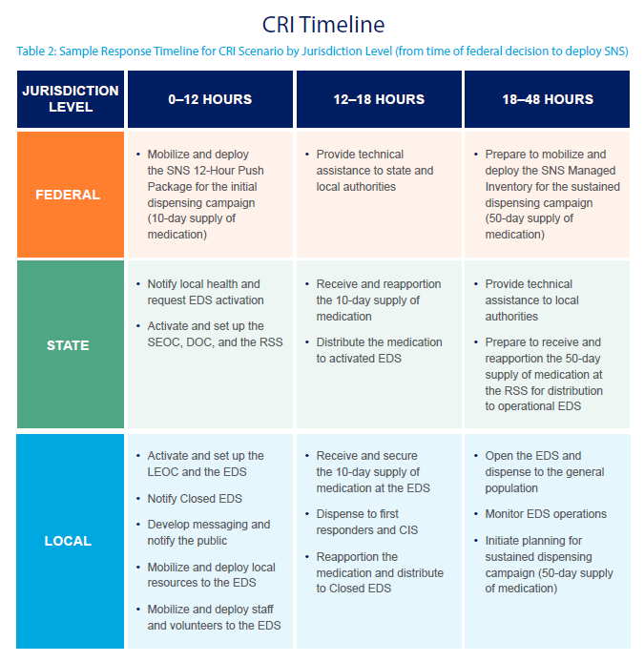

Initial Dispensing Campaign
The SNS material will be deployed to the RSS where pre-filled bottles with a 10-day supply of antibiotics will be sent to activated EDS. EDS staff can anticipate delivery of the initial medication to the RSS within 12 hours from the federal decision to deploy and to their EDS within another 6 hours. Assuming these timeframes, EDS staff would need to complete (or significantly complete) the initial dispensing campaign within 30 hours of receipt of the medication at the EDS.

Sustained Dispensing Campaign
The remaining 50-day supply of follow-on antibiotics would be deployed from the SNS Managed Inventory to the RSS where it is reapportioned for direct distribution to operational EDS or local health for the sustained dispensing campaign, including distribution from local health to locally-supported Closed EDS as provided in local plans. EDS staff could anticipate delivery of the follow-on medication beginning within 5-7 days of completing the initial dispensing campaign and would need to complete (or significantly complete) the sustained dispensing campaign prior to the end of an individual’s 10-day supply. Additionally, if indicated by ASPR, the EDS staff could anticipate delivery of the AVA vaccine and vaccine administration supplies during this period (see vaccine dispensing scenario).

Medication Storage & Handling
The current configuration of the SNS is 50% Doxycycline and 50% Ciprofloxacin, but the amounts of each deployed to the RSS may not be known until they are received. A pallet of the 10-day supply of both medications contains 9,600 bottles. A pallet of the 50-day supply of Doxycycline contains 9,600 bottles, while a pallet of the 50-day supply of Ciprofloxacin only contains 5,184 bottles. A standard pallet is 48”x40” (4’x3.33’) with an approximate height of 5 feet. When creating rows of pallets, a 10’ aisle is recommended to allow for clearance of a pallet jack. Medications should be stored in a secured location at 58-86 degrees Fahrenheit.
Pre-Event Planning
Local health should identify a secured storage area within the EDS that will accommodate the estimated number of pallets of medication for the initial and sustained dispensing campaigns. The following tables provide information on the medication packaging and estimates on the number of cases and pallets that a community would receive based on a range population sizes (including the additional 10% allocation to dispense to first responders and CIS).
Table 3: SNS Medication Details & Packaging
Medication | Strength | Dose | Initial Campaign | Sustained Campaign
 |  |  | Quantity Per Bottle | Quantity Per Bottle
Doxycycline | 100mg/tablet | 1 tablet twice per day | 20 tablets | 100 tablets
Ciprofloxacin | 500mg/table | 1 tablet twice per day | 20 tablets | 100 tablets

Table 4: Estimated Total Cases & Pallets of Medication by Population Size (based on current (50/50) SNS configuration)
Population | 10%  Additional  Allocation | 10-day Supply |  |  |  | 50-day Supply
 |  | 50% Doxy |  | 50% Cipro |  | 50% Doxy |  | 50% Cipro
 |  | Cases | Pallets | Cases | Pallets | Cases | Pallets | Cases | Pallets
5,000 | 5,500 | 28 | 1 | 28 | 1 | 28 | 1 | 20 | 1
10,000 | 11,000 | 55 | 1 | 55 | 1 | 55 | 1 | 39 | 1
25,000 | 27,500 | 138 | 2 | 138 | 2 | 138 | 2 | 96 | 3
50,000 | 55,000 | 275 | 3 | 275 | 3 | 275 | 3 | 191 | 6
100,000 | 110,000 | 550 | 6 | 550 | 6 | 550 | 6 | 382 | 11

Resources
FDA Guidelines for Doxycycline Preparation for Children

Vaccine Dispensing
A severe Influenza pandemic poses a significant planning challenge for vaccine distribution, management, and dispensing at local EDS. In this scenario, individuals may require two doses of vaccine separated by at least three weeks. The CDC has established a vaccination target of administering both doses to 80 percent of the population over a 16-week dispensing campaign. This campaign would likely involve vaccination services through EDS, healthcare practices, and pharmacies.
In this scenario, local communities may receive vaccines from the MDPH or directly from a CDC or ASPR-identified vendor through an apportionment formula determined by the MDPH. Vaccine providers would be registered in the Massachusetts Immunization Information System (MIIS) and vaccine distribution would be tracked through that system.
In an anthrax scenario, if recommended by ASPR, the Anthrax Vaccine Adsorbed (AVA) can be used as post-exposure prophylaxis for people who were potentially exposed to Bacillus anthracis and, in some cases, B. anthracis. Pre-exposure vaccine use is limited to military personnel and laboratorians working directly with the disease agent, though may be soon become available to emergency responders. Only pre-exposure vaccination is FDA approved. The SNS currently holds a limited supply of the AVA. Jurisdictions should be aware that during an anthrax response, the AVA can be administered to all adults (those over 18) under an Emergency Use Authorization (EUA) 5 for post-exposure prophylaxis, but for pediatric patients, AVA will require an Investigational New Drug (IND) protocol. The AVA vaccine contained in the SNS would be distributed to the RSS for redistribution to local EDS and will require cold chain storage.
Pre-Event Planning
Given the limited vaccine storage capacity at local health departments, local health should collaborate with their surrounding communities and work with their HMCC to evaluate current vaccine storage capacity of partner agencies and, if needed, identify options to expand capacity through just-in-time purchases or rentals. The following table estimates the necessary refrigerator capacity to store up to 2000 doses in a single refrigerated unit.
Table 5: Estimated Refrigerated Vaccine Storage Capacity by Number of Doses of Vaccine
Doses of Vaccine | Minimum Cubic Feet
1,000-2,000 | 40
900-1,000 | 36
801-900 | 21-23
701-800 | 17-19.5
400-700 | 16.7
100-399 | 4.9-6.7
Source: American Academy of Pediatrics

ACTIVATION
This chapter describes pre-event planning activities and a recommended operational framework for activation of an EDS, including:
- Review of incident details and maintaining situational awareness
- Activation of one or more EDS for MCM dispensing
- Develop an initial Incident Action Plan (IAP)

SURVEILLANCE
Disease surveillance involves the collection, monitoring, analysis, and interpretation of health-related data. Surveillance is used to define baseline levels of disease, detect unusual occurrences or increased frequency of disease, and recommend control and prevention measures. The MDPH Bureau of Infectious Disease and Laboratory Sciences (BIDLS) collaborates with LBOH, healthcare providers, and laboratories to conduct surveillance for approximately 80 reportable infectious diseases. Generally, the BIDLS Epidemiology Program takes the lead for investigation and control of vaccine-preventable diseases. While LBOH are the lead for investigation of other infectious diseases, under state law the MDPH has “co-ordinate powers” with LBOH and the authority to initiate an infectious disease investigation on its own. When a LBOH is unavailable, the MDPH may receive reports directly from healthcare providers.
When clusters of illness, potential bioterrorist agents, emerging infections, or other serious threats are identified, the MDPH provides technical assistance to LBOH including:
- Consultation or direct management of the investigation
- Implementation of control and prevention measures and follow-up activities
- Request for federal technical assistance from ASPR (requests must come from the MDPH)
The following systems are used to conduct surveillance for diseases that may require activation of an EDS for MCM dispensing.

Resources
MDPH Guide to Surveillance, Reporting & Control

Massachusetts Virtual Epidemiologic Network (MAVEN)
Massachusetts Virtual Epidemiological Network (MAVEN) is a web-based disease surveillance and case management system that enables MDPH and local health to capture and transfer appropriate public health, laboratory, and clinical data efficiently and securely over the Internet in real-time. The system interfaces with Electronic Laboratory Reporting (ELR) efforts, has automatic (24/7/365) notification of state and local officials of any event requiring their attention, and geographic information system (GIS) activities. MAVEN will replace the current paper-based methods of data exchange between MDPH, local public health, and clinicians. MDPH regulations require that LBOH utilize MAVEN for reporting and case management of notifiable diseases.

Pre-Event Planning
Local health should designate staff to be trained to use MAVEN for infectious disease reporting and case management. MAVEN staff can provide in person training and an online training is available.

Electronic Laboratory Reporting (ELR)
ELR is a secure, automated mechanism for the reporting of laboratory and patient information for reportable conditions by hospitals and commercial laboratories. ELR facilitates accurate and timely automated entry of this information into MAVEN so that sudden changes in disease trends may be more quickly identified than could otherwise with manual data entry of paper laboratory reports received by mail. ELR is mandated by regulation.

BioSense – Syndromic Surveillance
Massachusetts participates in the CDC’s National Syndromic Surveillance Program (NSSP). The NSSP, through its BioSense Platform, provides MDPH and other public health officials with a common cloud-based health information system with standardized tools and procedures to rapidly collect, evaluate, share, and store information. Syndromic data can be analyzed and exchanged – improving health officials’ common awareness of health threats over time and across regional boundaries.

Biohazard Detection System (BDS)
The Biohazard Detection System (BDS) refers to technology designed exclusively for the United States Postal Service (USPS). The BDS uses sophisticated DNA matching to detect the presence of anthrax in the mail at USPS Processing and Distribution Centers located in Boston, Brockton, and Shrewsbury. Response to a BDS alarm at any of these facilities may involve laboratory testing, decontamination, and MCM dispensing to the exposed postal employees and first responders.

Influenza Surveillance
During influenza season, the MDPH publishes weekly flu surveillance reports that document regional influenza-like illness (ILI) activity and the number of laboratory confirmed cases.

INCIDENT NOTIFICATION & ACTIVATION DETERMINATION
Once an MCM incident has been identified, the appropriate LBOH and other healthcare partners will receive an initial incident notification from the MDPH through the Health and Homeland Alert Network (HHAN). The LBOH should then notify key staff and other partner agencies of the incident. The MDPH will issue another HHAN notification with further instructions and a timeline for a conference call with public health and emergency management subject matter experts. During the conference call the MDPH will share what is known about the incident, establish times for future conference calls, and indicate which EDS should activate.

Local Emergency Management Notification
The LBOH should notify the Local Emergency Management Director (EMD) of the MCM incident to determine if the Local Emergency Operations Center (LEOC) should be activated. The LEOC may be needed to support planning, coordinate logistics, and document expenses for EDS operations, as well as to address broader community needs resulting from the incident. Alternately, these command and control function can be performed on-site at the EDS.

EDS Activation Requests & Triggers
The EDS plan should document who is authorized to request activation of the EDS and potential triggers for activation. An EDS may be activated when:
- MDPH requests activation to respond to a statewide, multi-community, or local incident that requires MCM dispensing services; or
- Local public health and emergency management determine that MCM dispensing services are needed to respond to a local incident; or
- A partner agency requests assistance to provide MCM dispensing services for a residential or specific population
Pre-Event Planning
The EDS plan should outline situations that could trigger an EDS activation, including:
- Federal Public Health Emergency Declaration
- State Declared Emergency (Civil Defense Act)
- State Declared Public Health Emergency (MGL Chapter 17, Section 2A)
- Public health emergency that occurs in neighboring town(s) that may impact the local community
- Emerging health threat outside of the country or state that is likely to impact the local community in the future (e.g. World Health Organization (WHO) Phases of Pandemic Alert)

EDS Activation Determination
The EDS plan should outline procedures and assigned roles for selecting one or more EDS for activation and for determining when to activate the EDS. Additionally, the EDS plan should include decision criteria for making the determination, including if:
- Activation of the EDS can occur within the needed timeframe
- EDS operations can be initiated, maintained, and terminated without disruption
- Necessary staff, systems, and equipment can be accommodated at the EDS
- Sustained operations can be accommodated (when needed)
Generally, the decision to activate the EDS should be made within 60 minutes of notification (or based on the response requirements).
Pre-Event Planning
To ensure that facilities selected are appropriate for EDS operations, local health should:
- Review current population estimates (e.g. total population, total households, daytime and seasonal population increases, etc.)
- Calculate throughput for worst-case scenarios (i.e. 100% of households in 30 hours)
- Identify facilities that can accommodate the throughput requirements (e.g. appropriately sized, layout supports client flow, meets accessibility standards, etc.)
- Complete an Emergency Dispensing Site Facility Survey for each EDS
Once a facility is selected as an EDS, local health should develop a site-specific written plan that includes a clinic flow layout, staffing estimates, security plan, and other operational details. Additionally, local health should collaborate with facility representatives to develop a facility use agreement or Memorandum of Understanding (MOU) and review it annually.

Resources
Emergency Dispensing Site Facility Survey

EDS ACTIVATION & INCIDENT ACTION PLANNING
The EDS plan should document policies, procedures, and assigned roles for activating the EDS and the EDS Management Team, maintaining situational awareness, and developing an Incident Action Plan (IAP).

EDS Activation Request & Assessment
The LBOH should notify the EDS facility representative of the incident and confirm the availability and suitability of the facility including that:
- Services to the facility are operational (power, water, sewer, HVAC, etc.)
- Access to the facility is not obstructed (streets, sidewalks, etc.)
- The facility is available for the anticipated response period
Based on the activation assessment, the LBOH then notifies the MDPH of the status of the facility for EDS operations (e.g. available, available with conditions, not available, etc.). When a designated EDS is deemed inappropriate or unavailable, a non-designated facility can be used if it meets access and functional needs requirements. Once the facility is confirmed as available, the LBOH should update the MDPH WebEOC EDS Board with the location, population, operational hours, and anticipated throughput.
Pre-Event Planning
Local health should document at least primary and secondary contacts for the designated EDS facilities and conduct annual (at minimum) facility notification exercises. The MDPH recommends identifying tertiary contacts for redundancy, if possible.

EDS Management Team Activation
Once the EDS location is confirmed, the LBOH should activate the EDS Management Team to support development of an initial IAP and to mobilize public information, staff and volunteers, and resources for EDS operations. The EDS Management Team command and general staff should be organized according to Incident Command System (ICS) principles. ICS is flexible and scalable, and the size of the response needed will determine the number of roles that will need to be filled. One person may be assigned to fill more than one role. The EDS Manager is responsible for the functions that fall under roles that are not filled.

Within the EDS Management Team, the command roles include the EDS Manager, and staff that report to the Manager, including the safety officer, public information officer, and liaison officer.
The EDS Manager is the primary decision maker for the EDS and implements and updates the IAP. The Safety Officer develops and implements the safety plan for the EDS. Note that coordination with law enforcement for EDS or transport security will occur through the security unit within Operations section. The Public Information Officer (PIO), under the direction of the EDS Manager, develops and disseminates public information about the health threat and the emergency public health services, as well as serves as the spokesperson for the EDS to the media and the public. The Liaison Officer serves as the point of contact for representatives from partner agencies that are supporting the MCM dispensing operations.

General staff are incident management personnel organized according to function and reporting to the EDS Manager. The General Staff normally consists of the Operations Section Chief, Planning Section Chief, Logistics Section Chief and Administration and Finance Section Chief.

Operations
The Operations Section is responsible for all tactical operations at the EDS. Examples of Operations units include Greeting, Registration, Triage, Forms Distribution/Forms Collection, Screening, Medication or Vaccine Dispensing, Behavioral Health, and Transport.

Planning
The Planning section is responsible for the collection, evaluation and dissemination of information related to the EDS, and for the preparation and documentation of IAPs. Planning also maintains information on the current and anticipated situation, and on the status of resources assigned to the EDS. Examples of Planning units include Situation, Resources, Documentation and Demobilization.

2.3.2.3 Logistics
The Logistics section is responsible for providing facilities, services and materials for the EDS. Examples of Logistics units include Facilities, Inventory Management, Food Services, First Aid (for staff and volunteers) and Childcare

Administration and Finance
The Administration and Finance section is responsible for all incident costs and financial considerations. Examples of Administration and Finance units include the Time unit, Procurement unit, Compensation/Claims unit and Cost unit.

Figure 1: ICS Flowchart
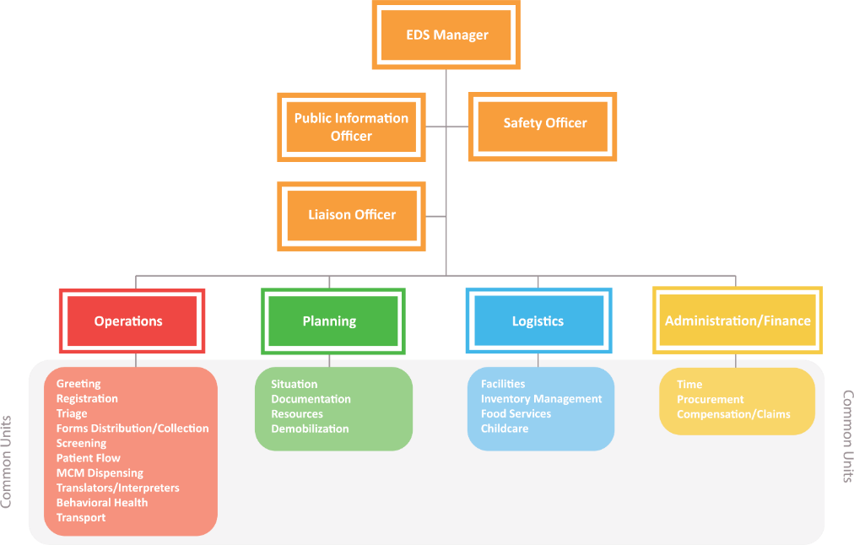

Pre-Event Planning
Local health should identify at least primary and secondary staff for each position on the EDS Management Team and conduct quarterly notification exercises. The MDPH recommends identifying tertiary staff for each position for redundancy, if possible.

Resources
As of the date of this publication, the MDPH is updating template Job Action Sheets for EDS based on the recommended command structure and staff positions. A notice will be distributed when they are available.
ICS Training Resources

Situational Awareness
Once briefed on the initial incident information, the EDS Management Team should develop broader situational awareness to support development of an initial IAP and to share information with the appropriate partner agencies. The HMCC acts as an important source of public health and healthcare situational awareness and will distribute state and federal guidance. In addition to the HMCC, the following are potential sources of information for MCM and EDS situational awareness.

MDPH WebEOC
The MDPH WebEOC is an online incident management system used to develop and maintain situational awareness of local and statewide health and medical hazard impacts and response activities across state, regional, and local entities. In addition to status boards for healthcare facilities, the MDPH WebEOC includes an EDS board that contains important information about each designated EDS facility and provides a means of tracking and documenting resource requests.

Health & Homeland Alert Network (HHAN)
The MDPH Health and Homeland Alert Network is used to distribute important information to public health and healthcare partners, including information on diseases and agents, clinical guidance, medical standing orders, and EDS forms.
Pre-Event Planning
Local health should identify key personnel who require access to and training on the MDPH WebEOC and the HHAN.

Incident Action Planning
An Incident Action Plan documents goals, objectives, and strategies for responding to the health threat. The EDS Management Team should collaborate to develop an initial IAP and revise it each operational period (at minimum) or when it is necessary to modify the response goals, objectives, and strategies. The IAP is a supporting document to the EDS plan and typically includes the following Incident Command System (ICS) forms:
- ICS Form 202, Incident Objectives
- ICS Form 203, Organization Assignment List
- ICS Form 204, Assignment List
- ICS Form 205, Radio Communications Plan
- ICS Form 205A, Communications List
- ICS Form 206, Medical Plan
- ICS Form 208, Safety Plan
The IAP should describe or document the following:
- Health threat and the population at risk, including those with higher vulnerabilities to the health threat and individuals with access and functional needs
- Recommended control measures, countermeasures, and protective actions
- Immediate (current operational period) and long-term response objectives
- Incident and EDS-specific health, safety, and security plans
- Number and type of staff and volunteers needed to support EDS operations
- Workforce protection plan (e.g. dispensing to critical staff, protective equipment, etc.)
- Quantity and type of resources, including MCM, needed to support EDS operations

Medical Standing Orders
A standing order is written to address one or more of the following: screening, vaccine administration, medication dispensing, and/or treatment of adverse reactions at the EDS. The order is signed by a healthcare professional licensed to prescribe, such as a physician, for the purpose of providing instructions to other licensed healthcare professionals including nurses and pharmacists.
Standing Orders are typically issued by a local, prescribing medical professional for a local event. In certain situations, such as larger or more emergent events, MDPH may issue a standing order. If there is a declared Public Health Emergency, however, the Commissioner of Public Health can take action as she deems necessary to ensure the maintenance of public health and to prevent disease, with the approval of the Governor and the Public Health Council. The Commissioner may suspend certain statutes and regulations, if necessary, to protect the public health. The Commissioner may also permit certain licensed healthcare professionals and/or non-medical personnel (who otherwise would be unable to do so) to dispense and administer MCM if they receive proper training.
Pre-Event Planning
Local health should identify who will issue or sign the medical standing orders and approve medical information that will be distributed at the EDS. The EDS plan should document procedures and assigned roles for obtaining the standing orders and approving all clinical forms and information that will be used in the EDS.

Tactical Communications & Information Technology
Under the recommended EDS command structure, the Communications Unit is responsible for managing tactical communications for the EDS. Tactical communications refer to the type of equipment needed to communicate between:
- The EDS and the LEOC (if activated)
- The EDS and external agencies or another EDS
- The EDS Manager and key EDS staff
Pre-Event Planning:
Local health should identify available tactical communications equipment and document policies, procedures, and assigned roles for their use, including:
- Standard modes of communication (e.g. telephone, cell phone, Internet, email, and fax)
- Redundant or advanced modes of communication (e.g. radio, satellite phones, WebEOC, Government Emergency Telecommunications Service (GETS))
- Establishing communications between activated or potential command and/or coordination locations (SEOC, LEOC, and EDS) and other key partner agencies (police, fire/EMS, hospital, etc.)
- Availability of Information Technology (IT) staff and resources at the EDS
- Quarterly test of all standard and redundant modes of tactical communications

OPERATIONS
This chapter describes pre-event planning activities and a recommended operational framework for:
- Public information and media relations
- Mobilization, deployment, and training of staff and volunteers
- Mobilization, deployment, and maintenance of resources
- EDS set-up and opening
- EDS operations monitoring and reporting

PUBLIC INFORMATION MOBILIZATION & OPERATIONS
During public information mobilization and operations, the EDS Public Information Officer (PIO), as directed by the EDS Manager:
- Coordinates with partner agencies to activate public information notification systems
- Develops and seeks approval of risk and safety messages
- Disseminates risk and safety messages to partner agencies, the media, and the public
- Coordinates with partner agencies to ensure information consistency
- Provides regular updates to partner agencies, the media, and the public

Public Information Systems & Staff
The EDS PIO should coordinate with partner agencies to use public information systems to disseminate information to and obtain feedback from the public. Examples of public information systems include reverse 911 systems, call centers, and social media.
Many communities and School Districts maintain reverse 911 systems that can contact individuals by phone with a recorded message. In some cases, these systems can target a specific area within a town. Typically, systems used by School Districts will only reach staff and families associated with the district or a specific school. The EDS PIO should prepare messages and disseminate them to Town and School District officials who then record them for further dissemination.
A call center may be used to respond to questions from the public, direct them to appropriate resources, schedule appointments, and track trends in public information needs. Mass 211 has the capability to establish an information line during large scale emergencies. Local communities may have call center capabilities through the Local Emergency Operations Center (when activated) or the Town or City Hall. The EDS PIO should prepare messages and disseminate them to call centers, as well as monitor trends in public inquiries to update and improve messaging.
Many local agencies have developed social media capability and routinely communicate with the public about community events and services. Additionally, the local and statewide media actively use social media in reporting, especially during an emergency. The EDS PIO should develop messages about the health threat, recommended actions, and EDS operations that are appropriate for use on social media (e.g. character limits, infographics, etc.). Social media messaging can also be disseminated to partner agencies for use on their social media platforms.

Pre-Event Planning
Local health should document public information systems available through partner agencies in the community, including non-electronic systems for contingency situations (i.e. power or phone outages) and to reach individuals who may lack access to communication technologies (i.e. phone, Internet, etc.) Additionally, local health should develop a list of public information staff from partner agencies, including individuals assigned to the roles of agency PIO, spokesperson, and Subject Matter Experts (SME). A spokesperson is authorized to speak for an agency and an SME has the knowledge or credentials to speak on a specific topic. Once identified, the community should conduct quarterly (at minimum) notification exercises and update the public information staff list as needed. Local health should document that staff assigned to the EDS PIO are trained on the EDS plan, their roles and responsibilities, and risk communications.

Press Notifications & Inquiries
As directed by the EDS Manager, the EDS PIO should issue an initial press notification that:
- Acknowledges the incident
- Describes the initial actions taken
- Directs the press to the appropriate official source(s) of information
- Provides an anticipated EDS timeline
- Establishes a timeline for providing the press with additional or updated information
Prior to responding directly to press inquiries and questions, the EDS PIO should gather additional information from the reporter, including the nature of the inquiry and their deadline. This allows the EDS PIO to gather the appropriate information (if needed) prior to responding to or redirecting the reporter to an appropriate SME. Below are recommended media relations methods and guidelines for issuing press advisories and press releases and for conducting a press conference.

Pre-Event Planning
Local health should develop a list of media contacts, including language-based and cultural media, and update it quarterly. As with other contact lists, the media list can be used to conduct an annual notification exercise. Involving media in exercises reinforces the framework used for emergency public information, builds trust between public information staff and the media, and exercises roles. Additionally, local health should develop a template press advisory and press release that can be easily updated at the time of the incident.

Press Advisories
A press advisory is used to invite the press to attend a press conference or event (e.g. a tour of the EDS). When possible, the press advisory should be issued at least 90 minutes prior to the press conference to allow the press to assemble. The following format is recommended for press advisories:
- No more than one page in length
- “Press Advisory” as the title
- Contact information and date of issue
- Headline describing the event (e.g. press conference, EDS tour)
- Short paragraph with event details (i.e. date, time, location)
- Featured speakers (if any)
- Photo opportunities (if any)
- Process for press credentialing and press conference registration (if needed)

Press Releases
A press release is used to make an announcement or provide details about the incident that are easily summarized. A press release is issued to the press by email or fax, as well as posted to the websites of partner agencies. The following format is recommended for press releases:
- Headline is ten words or fewer
- First sentence contains most important statement
- First paragraph summarizes situation
- Last paragraph restates the main point
- No more than two pages
- List EDS PIO contact (i.e. name, phone number, and email)

Press Conferences
A press conference is used to provide details about the incident that are not adequately described in a press release. It is a preferred format for television and radio media. During a press conference one or more speakers will make a statement, followed by questions from the press. When conducting a joint press conference (e.g. with MDPH, MEMA, etc.), the responding partner agencies should agree on communication roles and responsibilities prior to the conference. After a press conference, a list of media questions and the provided responses is compiled for further dissemination. Unanswered questions should be researched for follow-up with the press as soon as possible. Prior to a press conference, a media packet is prepared with the following recommended resources:
- Previously issued press advisories and releases (if any)
- Fact sheets and other pertinent information
- Speaker bios (if available)
- Schedule for media updates (if determined)
Additionally, a sign language interpreter should be at all press conferences and the use of closed captioning and digital presentations (where available) should be requested. If a press conference will include a tour of the EDS, the press should be advised to observe client privacy (if present). Ideally, a press tour of the EDS would occur once it is determined that the site and staff are operationally ready and prior to opening to the public. At minimum, the press should obtain verbal authorization from a client to photograph, video, or interview them for publication. The EDS staff and volunteers should only speak to the press if authorized by the EDS PIO.

Message Development
To develop messages for the public information campaign, the EDS PIO should gather relevant information from trusted sources and verify its accuracy by consulting additional reputable sources, particularly as it relates to the clinical aspects of the incident. When developing the messages, the EDS PIO:
- Determines limits on release of information (e.g. information potentially associated with a criminal investigation)
- Establishes a communications goal
- Identifies target audience(s)
- Identifies key messages and supporting facts
At the time of the incident, federal and state health officials will update or develop clinical messages that can be included in the local public information campaign, including information about:
- Diseases and agents
- Signs, symptoms, and communicability
- At-risk populations and higher vulnerability populations
- Target populations (and the justification for targeted dispensing)
- Personal risk reduction
- Treatment and countermeasures
- Other containment and control measures
The EDS PIO should develop the messages related to local response actions and EDS operations, including information about:
- Locations, directions, and dates and hours of operation
- Transportation and parking options
- Available services and countermeasures and the process for receiving them
- Public information access points (e.g. websites, hotlines, etc.)
- What to bring and wear to the EDS (e.g. list of medications, weights of children, etc.)
- What to anticipate while at the EDS (e.g. lines, wait times, etc.)
- What to do if you can’t get to the EDS (e.g. individuals who are homebound or require specialized transportation)

Message Approval
Approved clinical messages will be disseminated by federal and state health officials or by the SEOC PIO. The EDS PIO should coordinate with local health or the EDS clinical subject matter expert to review the clinical messages prior to including them in the local public information campaign. Any changes to federal or state clinical messages should be reviewed by the MDPH to avoid inconsistent messaging. Once the messages about local actions and EDS operations have been developed, the EDS PIO should verify all information with the appropriate partner agencies and seek approval from the EDS Manager prior to releasing it. When possible, the clinical and EDS operations messages should be released jointly.

Message Accessibility
Messages should be developed in multiple formats to ensure accessibility for individuals with access and functional needs, including formats that address:
- Language and literacy barriers, including limited language proficiency
- Physical and cognitive disabilities
- Age (older adults and young children)
- Lack of access to technology
- Cultural considerations and geographic isolation
When developing messages about individuals with access and functional needs People First Language should be used (e.g. "person with a disability” as opposed to “disabled person”).
Written materials should be translated to the predominant languages spoken locally. Federal and state officials will translate clinical messages to the most common predominant languages spoken. Interpretation services, including sign language, should be available at the EDS or through phone or video interpretation. Ideally, translation and interpretation services would be performed by individuals trained in medical terminology. Since EDS staff and volunteers may also serve as interpreters, the shift registration process should collect information about languages spoken by staff and volunteers. While not preferred, family members may provide interpretive services to EDS clients.
The EDS PIO should coordinate with Logistics to arrange for translation and interpretation resources. When requesting translation of written information, the EDS PIO should:
- Identify the languages needed
- Collect approved documents (preferably electronic)
- Determine translation deadline and priority
- Submit all documents to the translation service
When requesting interpreters, the EDS PIO should:
- Identify the languages needed
- Determine location, date, and time for interpreters
- Collect background information for the interpreters
- Evaluate the need for onsite interpreters versus phone or video interpretation
Pre-Event Planning
Local health should identify the predominant languages spoken in the community and collaborate with partner agencies to identify sources for translation and interpretation services, including:
- Hospital and healthcare phone and video interpretation services
- College and school language programs
- Cultural and faith-based organizations
- Language-based media
Additionally, local health should collaborate with partner agencies that serve individuals with access and functional needs to identify communication resources that may be needed at the EDS (e.g. magnifiers, readers, etc.).

Resources
The Massachusetts Commission for the Deaf and Hard of Hearing provides free professional and educational in-services and presentations to organizations, agencies, and businesses that seek to improve efficacy of interactions with people who are deaf and hard of hearing.
The Show Me Communication Tool for Emergency Shelters is a pictogram-based tool that can be used to identify the language spoken by a client, provide direction through the EDS, and to communicate about key service concepts.

Message Dissemination
The EDS PIO disseminates approved messages using the documented public information systems and through press notifications. The EDS PIO should document all information disseminated to the public and the press, including:
- Message type and format
- Dissemination methods and recipients
- Follow-up actions

EDS STAFF MOBILIZATION & OPERATIONS
During staff mobilization and operations, the EDS Manager should coordinate with the General Staff to:
- Determine the staffing requirements (e.g. command structure, number and type of staff, etc.)
- Establish a shift schedule
- Notify and register staff and volunteers and develop a staff roster
- Verify staff and volunteer credentials
- Provide deployment instructions to available staff and volunteers
- Request additional staffing resources (when needed)
- Assemble, brief, and train staff and volunteers
Pre-Event Planning
Local health should designate a Staffing/Volunteer Coordinator to promote existing recruitment and pre-credentialing efforts for clinical volunteers and non-clinical volunteers (e.g. MA Responds, MRC, CERT, ARC, etc.) and to develop staffing agreements with local agencies and organizations for EDS operations. If EDS staffing arrangements include utilization of LBOH personnel, local health should consider existing labor agreements, added costs to conduct exercises, etc.
Resources
MA Responds
Massachusetts Medical Reserve Corps
Community Emergency Response Team (Citizen Corps)

Staffing Requirements
Based on the nature of the incident, the EDS Manager should determine which positions and units are needed and establish a command structure. Based on the size and scope of the incident, the EDS Manager should also determine the number of staff and volunteers needed, the credentials and skills required, and the number and length of staff shifts. This information is used by the Logistics section to issue notifications to the appropriate partner agencies.
Pre-Event Planning
Local health should review recent population estimates and develop an EDS staffing estimate for each unit. Based on federal planning requirements, it is recommended that the staffing estimates be based on the worst-case scenarios. These low-probability staffing estimates can then be scaled down to the higher-probability incidents. Additionally, local planner should consider the impact on staffing when an extended dispensing campaign is required. Once a staffing estimate is reached, it can be tested using tools like RealOpt and used to inform staff and volunteer recruitment.

Staff Shift Schedules
When determining the staff shift schedule, the EDS Manager and Operations, Planning and Logistics Section Chiefs should consider the following:
- Staff supporting EDS set up can be scheduled for a separate shift or to overlap with the first shift to allow for additional staffing during the first operational period.
- Staff may need to arrive at the EDS up to two hours prior to their shift to allow for check-in, assignments, and training (depending on the complexity of the dispensing operation). Returning staff could then arrive one hour (or less) prior to their shift (assuming no significant operational changes).
- Incoming staff should overlap with current staff to allow for smooth transition of assigned roles and information sharing about the prior operational period.
- Outgoing staff should be given time within their shift to sign-out and debrief.
- Staff supporting EDS closure can be scheduled for a separate shift or to overlap with the last shift to relieve fatigued staff.
A shift should not be less than 3 hours and not exceed 12 hours. A shorter shift (3 to 6 hours) may be better for vaccination dispensing and more appropriate for volunteers. Other potential benefits of a shorter shift may include:
- More staff and volunteers can commit to a shorter shift
- More staff and volunteers can commit to multiple shifts over time (e.g. sustained dispensing campaign)
- Fewer staff breaks are required
- Less stressful on staff and volunteers
A longer shift (7 to 12 hours) may be better for medication dispensing and more appropriate for first responders and healthcare professionals. Potential benefits of a longer shift may include:
- Less staff intake and out-processing
- Fewer Just-in-Time Trainings
- Staff and volunteers are in assigned roles for longer periods

Staff Notifications & Acknowledgement
Logistics should develop a notification message to request that partner agencies mobilize their staff and volunteers for EDS operations. At minimum, the notification message includes information about the:
- Nature, size, and scope of the incident
- Medical countermeasure to be dispensed
- Number and type of staff and volunteers needed
- Work conditions, appropriate apparel, anticipated weather
- Health, safety, and security issues
- Immunization requirements (if any) and prophylaxis (if recommended)
- Shift registration process, reporting location and time, and personal identification requirements
- Request to acknowledge receipt of the notification and ability to respond
Each partner agency then uses its notification systems to point available staff and volunteers to the EDS staff registration system. Partner agencies that have not acknowledged the notification within 60 minutes should be contacted using a redundant communication method.
Pre-Event Planning
Local health should identify primary and back-up methods for notifying partner agencies of the EDS activation and registering staff and volunteers for shifts. Depending on the local staff and volunteer resources, the system may notify staff and volunteers directly (e.g. MA Responds) or the system notifies an agency contact who then notifies their staff and volunteers. When planning for a redundant system, local health should consider contingency methods for when power, phone, and Internet are not available. Staff and volunteer notification systems should be tested and contact information updated quarterly.

Staff Registration, Rosters, Credentialing, Assignments & Confirmation
Planning and Logistics should establish a process for registering staff and volunteers for shifts and determine the minimum information to be collected, including:
- Licensure, credentials, and skills (e.g. are they authorized to dispense?)
- Agency or organization affiliation
- Preferred site (if multiple EDS are activated)
- Shift availability (including multiple shifts)
- Email, address, and cell phone
- Potential role or interest
- Languages spoken
- Allergies (food, latex, etc.)
- Emergency contact
- Access and functional needs
Planning then uses staff and volunteer registrations to develop a staff roster for each shift. The Resources Unit, within Planning should verify staff and volunteer credentials by requesting a copy of their license or certification prior to assigning them to specific EDS roles. Once assignments are finalized, confirmation should be sent to the registered staff and volunteers with any further reporting instructions and their assignment.
Pre-Event Planning
Local health should promote volunteer registration with existing MRC units and CERT through MA Responds to ensure advanced verification of credentials.

Additional Staff Requests
If local staffing is insufficient, the EDS Manager should request additional staff and volunteers through the ESF-8 desk at the SEOC (if activated) or the MDPH Duty Officer. Requests for additional staff and volunteers, including requests for additional volunteers through MA Responds and federal response teams, should be entered and tracked in the MDPH WebEOC. When requesting additional staff, the EDS Manager should provide information on the number of staff needed, licensure or skills required, and the shifts needed.

Resources
Process for Volunteer Requests during a Cross-Jurisdictional Event

Staff Assembly & Identification
Staff and volunteers will either assemble at an offsite staging area or at an intake area within the EDS. A staff staging area can be used in situations where parking at the site is limited or to enhance security. If a staff staging area is needed, the Logistics section should announce the location when sending confirmation to registered staff and volunteers and arrange for transportation and security escort (if needed) to the EDS. Otherwise, a staff intake area is used to receive and process registered staff and volunteers who are deployed to the EDS. To assemble staff and volunteers, the following should occur:
- Establish a check-in process and procedures
- Assign staff to manage intake (Staff Resources Unit)
- Prepare all required check-in forms and documentation
- Set up staff staging or intake area
- Post signage directing staff to the staging or intake area
- Sign-in staff and volunteers and confirm emergency contact
- Review required photo identification and copy of licensure or certification
- Review staff assignments and confirm qualifications and comfort with role
- Distribute site and role-specific identification (vests, badges, etc.)
- Report “no shows” to address potential staff shortages
Staff and volunteers working in the EDS should wear vests that indicate their assigned role and position. Typically, the vests are color coded to indicate roles (e.g. command, operations, etc.). Position titles are worn on the vest along with a badge that includes the individual’s name, agency name, credentials, site name, and site access restrictions (when applicable). Alternatively, staff and volunteers may display the badges issued by their agency or organization. Further, staff and volunteers who speak languages in addition to English should be identified by an interpreter badge (e.g. I Speak Spanish, Sign Language Interpreter, etc.).

Spontaneous Volunteers
Individuals who report to a staff staging or intake area and are not registered staff and volunteers should be directed to the Staff Resources Unit as a spontaneous volunteer. The Staff Resources Unit can either refer the spontaneous volunteer to a volunteer organization or determine their skillset and register them to work at the EDS with a restricted access and role that does not require professional license verification. These restrictions should be noted on their site-specific badge. The MDPH does not recommend utilizing spontaneous volunteers.

Operations Briefing & Training
The Operations section should coordinate with pertinent subject matter experts to develop Just-in-Time Training (JITT) resources or revise an existing JITT. The purpose of the JITT is to provide staff and volunteers with the required knowledge and skills to implement their assigned EDS roles. The EDS Manager and members of the command and general staff should brief staff and volunteers and conduct the JITT for each incoming shift. Returning staff and volunteers should only require retraining if operational changes have been implemented between shifts. The staff briefing should include all pertinent information that will support the MCM dispensing operations and provide for the health and safety of staff, volunteers, and clients. The staff briefing should include the following:
- Current emergency conditions, response objectives, and response actions
- Available medical countermeasures and the process for receiving services
- Incident Command and reporting structure
- Staff and volunteer roles, including who is authorized to dispense
- Expected code of conduct while working in the EDS
- Security instructions
- Health and safety instructions (e.g. how to report safety issues, location of first-aid)
- Available staff services (e.g. food services, resting area, behavioral health support)
- Personal Protective Equipment (PPE)
- Liability issues and protections
- Media policy (e.g. refer all media to the EDS PIO)
- Site walk-through
Following the operational briefing, each Unit Leader should review the Unit JAS with their assigned staff and volunteers and conduct a training on unit-specific responsibilities, procedures, and protocols (e.g. screening, dispensing, etc.). Ideally, staff and volunteers should be cross trained to at least one additional role to provide the flexibility to move staff and cover breaks.

EDS RESOURCE MOBILIZATION & OPERATIONS
During resource mobilization and operations, the EDS Manager should coordinate with Planning and Logistics to review the incident-specific resource requirements and to:
- Identify available local resources
- Determine additional resource needs
- Request additional resources from partner agencies (when needed)
- Request the SNS resources (when needed)
- Coordinate resource deployment to the EDS
- Safely and securely store resources for use or further distribution (i.e. to Closed EDS)

Inventory Management Systems & Staff
Inventory may be tracked on paper or managed electronically by employing a simple spreadsheet program that deducts items from inventory as they are dispensed or removed from the secured storage area within the EDS. The MDPH will request inventory counts at regular intervals throughout the event. A schedule will be shared with local communities once established. The MDPH MCM Program has posted an Excel spreadsheet on the HHAN that may be used by each EDS.
Pre-Event Planning
Local health should document a primary and back-up Inventory Management System (IMS) to track and report on MCM inventories during EDS operations. At minimum, the IMS should have the capability to track inventory levels (e.g. bottles, cases, vials), medication or vaccine name, manufacturer, dose, National Drug Code (NDC), lot numbers, and expiration dates. Additionally, local health should document that staff assigned to the EDS Inventory Management Unit are trained on the primary and back-up IMS.

Resources
Emergency Dispensing Site Inventory Tracking Form

Resource Requirements, Identification & Transportation
The EDS Manager and the Logistics staff should review federal and state guidance to determine the following incident-specific resource requirements for the EDS:
- Type and quantity of resources needed
- Storage capacity needed
- Cold chain storage (if needed)
- Secured storage (if needed)
Based on the resource requirements, the inventory management staff within the Logistics section will develop a detailed list of the MCM resources needed at the EDS. If resources include refrigerated vaccines, the Inventory Management Unit Leader should calculate the storage capacity needed, determine the currently available storage space, and coordinate with the EDS Manager to request additional sources of cold chain storage if needed (e.g. hospital, mobile refrigerated units, etc.).
The Logistics staff should then review the list of MCM resources needed, determine availability through local, state, and private sources, and document immediate and potential resource gaps. Logistics will coordinate deployment of locally available resources to the EDS, and, when needed, arrange for transportation assets to move resources to the EDS.
Pre-Event Planning
Local health should document locally available supplies and equipment, including those available at the EDS.

Resource Requests & Purchasing
If additional resources are needed for the EDS, the EDS manager may work with the Administration and Finance Section to purchase the resources, or make a request for state assistance. For medical resources, local health may request the resources through the ESF-8 desk at SEOC (if activated) or the MDPH Duty Officer, using the MDPH Resource Request process. For non-medical resources (e.g., a generator, electronic sign board) local health should work through local emergency management to request the resource through MEMA, using MEMA’s resource request process. If the requested medical resources are not available through state sources, MDPH will coordinate with MEMA to determine whether a request for federal assets might be appropriate.

Local health should document all of its costs associated with purchasing resources so that it can work with state and federal authorities to seek reimbursement if it is available following the event.

Resource Receiving, Security & Storage
The EDS Manager should sign the Transfer of Custody Form for all MCM received at the EDS. The Inventory Management Unit should verify all incoming resources (receipts) and store them in a designated secured storage area. A manifest will accompany the SNS resources and can be used to verify items by type, lot number, and expiration date. When SNS resources are removed from the secured storage area, they should be deducted from the site inventory and carefully monitored to determine the timing of a resupply request (if needed).
Handling and storage guidelines for medication and vaccines will accompany each shipment and be available on the MDPH website. Additionally, the package insert should be consulted for optimal storage criteria. The Inventory Management Unit should follow relevant state and federal guidance to ensure proper storage and cold chain management of vaccines.
Pre-Event Planning
Local health should document secured storage areas for medication and cold chain management capabilities for vaccines at the EDS.

Resources:
CDC Vaccine Storage & Handling Toolkit

Resource Distribution
The MCM received at the EDS will be distributed internally to Dispensing staff to dispense to individuals at the EDS. The MCM may also be reapportioned for pick-up by Closed EDS staff (per local Closed EDS agreements).

EDS SET-UP & OPENING
During EDS set-up, Logistics staff should:
- Set up the stations based on the site plan, clinic flow layout, and services to be provided
- Post signs directing clients to and through the facility
- Distribute appropriate resources to each station
The EDS Manager then coordinates with command and general staff to:
- Implement the IAP (including safety and security plans)
- Conduct a site walk-through to ensure operational readiness
- Treat target groups if recommended (e.g. first responders, higher risk groups, etc.)
- Coordinate with neighboring communities prior to opening the facility (if applicable)
- Open the facility and dispense MCM to the at-risk population
Pre-Event Planning
A set-up team within Logistics should coordinate EDS set-up to allow command and general staff to focus on IAP implementation. Set-up of on-site resources (e.g. tables, chairs, etc.) can be performed by custodial staff at the facility, if available, in advance of station set-up and establishing clinic flow (e.g. signs, stanchions, etc.). Possible staffing for a set-up team includes volunteers from MRC, CERT, Boy Scouts, Girl Scouts, or other civic groups.

Site Layout & Set-Up
The EDS plan or Facility Survey should include a diagram that shows service locations (e.g. entrance, registration, screening, dispensing, exit), client flow through the site, and traffic flow and parking. The EDS set-up team or Facility unit should coordinate set-up of on-site resources, such as tables and chairs, and to close off (and possibly lock down) areas of the site that will not be used. The diagram should be used to set-up the site and scale the number of stations and the client flow to meet the throughput requirement. Changes to the layout or client flow (from the diagram) must be approved by the EDS Manager. Once the client flow is finalized, the Logistics staff should post signs at unobstructed sightlines to direct clients to and through the site (e.g. pictogram-based EDS signs). The Inventory Management Unit will distribute resources to the appropriate units and stations. Each Unit Leader should coordinate with unit staff to set-up the stations based on the services to be provided (e.g. vaccine administration, medication dispensing, etc.).
Resources
Sample EDS Flow Diagram (Medication Dispensing)
Sample EDS Flow Diagram (Vaccine Dispensing)

Internal Site Communications
The Communications Unit should distribute communications equipment (e.g. walkie-talkies, radios, etc.) to the EDS Manager, command and general staff, and other key positions). As a contingency for internal communications, the Communications Unit can develop a phone list using the personal cell phones of individuals assigned to these roles or a system of runners who deliver messages. Additionally, the Communications Unit is tasked with ensuring external communications to partner agencies (e.g. phone, Internet, radio).

Site Walk Through
Once the site set-up is complete, the EDS Manager should conduct a walk-through to confirm operational readiness, including appropriate staffing and inventory levels. The Safety Officer should confirm that all elements of the EDS safety plan have been implemented, that there are no hazards that prevent opening, and that the site is accessible to individuals with access and functional needs.

Target Prophylaxis Groups
Certain incidents may require that certain groups receive the MCM prior to opening the site to the at-risk or general populations. This may include first responders, critical infrastructure staff, and their families, as well as individuals in higher risk or target groups. When applicable, federal and state health authorities will provide guidance on target prophylaxis groups. Dispensing to the target groups can be used to validate staff training, evaluate dispensing procedures, and improve client flow prior to opening. If target prophylaxis groups are not indicated, and the site is ready to open, the EDS Manager should coordinate with other sites to open.

Coordinated Opening
When multiple sites are used within a single community or within a region, the MDPH recommends coordinating openings to maintain order. If the coordinated opening is for multiple sites within a community, the EDS Manager notifies the other local EDS Managers when the site is ready to open. If the coordinated opening is across multiple communities, the EDS Manager should notify the ESF-8 desk at the SEOC (if activated) or the MDPH Duty Officer. Once it has been confirmed that other sites are ready to open, the EDS Manager should notify staff to open the site and provide dispensing services.

EDS OPERATIONS MONITORING
During EDS operations, the EDS Manager should review the IAP and evaluate progress toward meeting the response objectives. The EDS Manager should work with the Planning section to update the IAP each operational period (or as needed). When evaluating EDS operations, the following should be considered:
- Public information accuracy and adequacy
- Dispensing service delivery, appropriateness, and adequacy
- Site operational readiness (including for sustained operations)
- Staff availability and staffing levels (including for sustained operations)
- Resource availability and inventory levels (including for sustained operations)

Public Information Monitoring
The EDS PIO should monitor local and statewide media for accuracy, content, possible responses, and to address rumors, including on social media. When information is found to be inaccurate, the EDS PIO should request that the media organization correct it. To address rumors or inaccurate information found on social media, the EDS PIO should provide the accurate information to local and statewide media and respond directly using an official social media account. If a call center is being used, the EDS PIO should monitor trends in public information inquiries and adjust messaging and communication strategies (when needed).

Clinic Flow & Throughput Monitoring
The Clinic Flow staff within the Operations section should monitor the flow of individuals through the EDS, identify and address bottlenecks, and estimate and report on client throughput. At minimum, client throughput should be estimated in the registration, screening, and dispensing areas. Throughput estimates can be reached using any (or a combination) of the following methods:
- Numbered registration forms
- A numbered ticket system
- Hand tally counters
- Number of clients seen per station
During initial operations (e.g. the first 1-2 hours), throughput estimates should be frequently reported (e.g. every 15 minutes) to the EDS Manager. The EDS Manager should compare the estimates to the hourly throughput target and authorize changes to non-medical processes to improve clinic flow and increase client throughput. Examples of non-medical changes include:
- Advanced distribution of client forms (e.g. posted on websites)
- Additional public information about the process, services, and potential wait times
- Open additional stations and reassign staff to areas with client backlog
- Use of stanchions to snake queues and create lines
- Separate entrance and exit to eliminate client cross flow
- Improved signage
- Expedited (and escorted) service for individuals with access and functional needs

Health, Safety & Security Monitoring
During EDS operations, the Safety Officer and security staff should monitor the site for any health, safety, and security concerns. The Safety Officer should routinely monitor for safety hazards within the site, as well as any client and staff injuries, documenting any actions taken in response. The security staff should routinely monitor internal and external security operations (and recommend changes as needed), as well as crowd management practices (and make recommendations to the EDS Manager relax practices or further restrict access as needed).

Within the Logistics section, the Facility Officer or other designated staff should routinely monitor and report on the operational readiness of the facility (including power, HVAC, restrooms), accessibility of the facility (and address barriers or obstructions), and medical and non-medical waste disposal

Staff Monitoring
During EDS operations, the Staff Resources Unit, within Planning should monitor staffing levels, gather and implement staffing improvement recommendations, coordinate shift changes, and monitor staff services (e.g. feeding, housing, etc.). Each Unit Leader within Operations should periodically report on the unit staffing level as either
- Sufficient (staff are optimally utilized)
- Insufficient (additional staff needed)
- Underutilized (staff available for reassignment)
Prior to requesting additional staff, the Staff Resources Unit should utilize reassignments to address insufficient staffing.
To coordinate shift changes, the Staff Resources Unit should ensure that all incoming staff receive the JITT prior to receiving a briefing from the individual they will replace. Outgoing staff should be given time within their shift to sign-out, debrief with Behavioral Health, and complete medical screening (if needed). At the end of each shift, Unit Leaders should instruct staff and volunteers to:
- Complete their assigned duties (per their Job Action Sheet)
- Clean up their work area or station
- Account for equipment and supplies used
- Return all unused equipment and supplies (unless needed by their replacement)
- Complete required documentation
- Debrief with their shift replacement

Resource Monitoring
During EDS operations, the Inventory Management Unit should monitor resource levels and request resupply (when needed), maintain resources, and coordinate transfer of resources to closed EDS or other sites as appropriate. Each Unit Leader should periodically report on the unit inventory levels as either:
- Sufficient (inventory above 50% of the anticipated need)
- Insufficient (inventory below 50% of the anticipated need; resupply needed)
- Underutilized (low demand for resources; potentially available for repackaging or transfer)
Reporting on consumable resources, especially critical and high demand resources should occur multiple times during each shift to avoid resource shortage. Resupply of the MCM resources may come from another EDS or the RSS. A request for re-supply of MCM should be directed to the ESF-8 desk at the SEOC (if activated) or the MDPH Duty Officer and entered in the MDPH WebEOC for tracking. The Inventory Management Unit should maintain situational awareness of changing needs or priorities that could impact inventory levels (e.g. weather, transportation issues, client surge, etc.).

Massachusetts Immunization Information System (MIIS)
The Massachusetts Immunization Information System (MIIS) provides a mechanism to establish a complete, accurate, secure, real-time immunization record for residents of Massachusetts of all ages. Providers have access to more complete immunization records of their patients and receive clinical decision support. Public health systems will use the information to help monitor and control vaccine preventable diseases. In the event of a pandemic, the MIIS will be used to document vaccine administration.

Vaccine Adverse Event Reporting System (VAERS)
The Vaccine Adverse Event Reporting System (VAERS) is a national vaccine safety surveillance program that is administered by the CDC and the FDA. During EDS operations that involve vaccine dispensing, clients should be given written information about VAERS and reporting an adverse event.

DEMOBILIZATION & RECOVERY
Demobilization is the process of scaling back or ending the EDS operations. This chapter describes pre-event planning activities and a recommended operational framework for:
- Developing an incident and site-specific demobilization plan
- Repackaging, collecting, and returning resources
- Debriefing and releasing staff and volunteers and providing post-deployment services
- Site deactivation and damage assessments
- After action review, evaluation, and improvement planning
- Participation in public health, healthcare, and behavioral health systems recovery

EDS DEMOBILIZATION PLANNING
When responding to an incident, planning for demobilization of staff and resources and deactivation of the EDS should begin during the activation phase of the response. The decision to close the EDS will be situation-dependent and should be based on established criteria and done in coordination with the MDPH.

Demobilization Criteria
The EDS Manager should determine when to demobilize staff, volunteers, and resources and when to close and deactivate the EDS. The timing for closing the EDS should weigh several possible criteria, including:
Status of the response objectives: The EDS Manager should review the current IAP, situation reports, and dispensing data to determine if the response objectives have been sufficiently met. While it is not required that all objectives be met to close the EDS, specific attention should be given to the objectives that relate to dispensing targets.
Status of the dispensing services and resources: Dispensing data should be reviewed from each operational period and used to estimate the number of at-risk individuals who still require dispensing services. If applicable and available, this information should be compared to data from other local or neighboring EDS. Additionally, the EDS Manager, working with Logistics, should evaluate if projected available staff and resource levels are sufficient to sustain the operations.
Incident status and current threat intelligence: The EDS Manager should assess current situational awareness, surveillance, and threat intelligence and consult with the MDPH, and local emergency management and law enforcement agencies (when applicable) to validate the decision to close the EDS.
Change in status of the site: If it is determined that an EDS is no longer suitable for the dispensing services (e.g. power failure, security breach, etc.), the EDS Manager should immediately notify local health and emergency management. A decision should be made to re-establish the EDS at an identified back-up location, redeploy to other local or neighboring EDS, or fully deactivate the site. The need to regain social order in the community (e.g. return students to school, etc.) is another factor that may influence the decision to close the EDS.

Demobilization Plan (site-specific)
Once it is determined that the EDS will close, the EDS Manager should work with the Planning section to develop an incident and site-specific demobilization plan that includes:
- Timeline for full EDS deactivation
- Actions for phased or full resource demobilization including storage of remaining MCM
- Actions for phased or full staff and volunteer demobilization
- Actions for public information and media notifications on EDS closure and alternate services
- Schedule for debriefs and hot wash
Prior to implementing the demobilization plan and issuing a stand-down request to partner agencies, the EDS Manager should contact the ESF-8 desk at the SEOC (if activated) or the MDPH Duty Officer to confirm their demobilization status. The EDS Manager and the command and general staff are responsible for implementing the demobilization plan and for closing and deactivating the site.

Stand-down Notification
Once the demobilization plan has been completed, the EDS Liaison Officer should notify partner agencies of the stand-down request including:
- Instructions to phase down or discontinue staff and resource deployment
- Timing and process for release of staff and volunteers from the EDS
- Timing and process for return of resources (e.g. dollies, stanchions, etc.) to points of origin
Additionally, the EDS PIO should notify the media and the public of the timing of the EDS closure and provide information about alternate dispensing services. The public information notifications should be reviewed and approved by the EDS Manager prior to their release.

EDS RESOURCE DEMOBILIZATION
Resource demobilization should occur prior to staff demobilization to provide adequate staffing to inventory unused resources and prepare them for return. The inventory totals for the unused MCM should be reported to the MDPH and the unused MCM should be directed to local health to determine storage. During resource demobilization, the Inventory Management Unit should review the demobilization plan and coordinate with each Unit Leader to:
- Implement a phased or full demobilization of resources
- Inventory and repackage all resources and document loss and damage
- Collect, temporarily store, and return non-MCM resources to points of origin
- Direct MCM resources to local health to determine storage
- Return all site resources to storage location

Inventory, Repackaging & Loss and Damage
When demobilizing resources, each Unit in the EDS should conduct an inventory of its remaining resources, repackage them for collection by the Inventory Management Unit, and provide an updated inventory of the resources that were assigned to the Unit. If resource demobilization will be phased to allow for continued dispensing services, the Unit should retain sufficient resources until demobilization is fully implemented. Each Unit should also document any loss or damage to resources that were assigned to the Unit for submission to the Inventory Management Unit.

Collection, Storage & Transportation
The Inventory Management Unit should collect the repackaged resources from each Unit in the EDS, reconcile the updated inventory, and temporarily store them in a secured area until further directions provided by OPEM. For items that require cold chain storage, the Inventory Management Unit should ensure proper cold chain management until they are transported from the EDS to a location arranged by the LBOH. Local health should coordinate with any Closed EDSs to either arrange for return of the unused MCM or agree to store the unused MCM at the Closed EDS facility.
The Logistics section should arrange for appropriate transportation assets to return the non-MCM resources to the points of origin, a temporary storage location (if needed), or another EDS (if being redeployed).

Site-Owned Resources
The Facility Officer or other Logistics staff should coordinate with the on-site custodial staff to collect, inventory, and return all site-owned resources to storage (e.g. tables, chairs, etc.). Any loss or damage to site-owned resources should be documented and reported to the EDS Manager for review and verification.

EDS STAFF DEMOBILIZATION
During staff demobilization, the Staff Resources Unit should review the demobilization plan and coordinate with each Unit Leader to:
- Implement a phased or full demobilization of staff and volunteers
- Debrief staff and volunteers and compile improvement recommendations
- Provide post-deployment staff and volunteer services (as needed)

Staff Release, Debrief & Hot Wash
Based on the demobilization plan, Unit Leaders should coordinate release of staff in phases or through consolidation of units, at the end of the shift or operational period, or immediately. Staff and volunteers should be instructed to:
- Complete their assigned duties (per the Job Action Sheet)
- Clean up their work area or station
- Account for equipment and supplies used
- Return all unused or durable equipment and supplies
- Complete required documentation
The EDS Manager should coordinate with the Staff Resources Unit to debrief with staff and volunteers, collect feedback on EDS operations, compile improvement recommendations, and provide information on post-deployment staff services. At minimum, the staff debrief should collect:
- Operational strengths and weaknesses
- Resource gaps (e.g. type, suitability, etc.)
- Staffing gaps (e.g. qualifications, staffing levels, etc.)
- Communications gaps
Once staff and volunteers have been debriefed, the Staff Resources Unit should collect badges, vests, and other staff resources, confirm contact information, and ensure that each person signs out. Once general staff have been released, the EDS Manager should conduct a hot wash with command staff, Group Supervisors, and Unit Leaders. Local health and emergency management may participate in the EDS hot wash and/or conduct a separate hot wash on the broader response to the incident. The local community should compile the information collected during staff debriefing and the hot wash and develop an AAR/IP.

Post-Deployment Staff Services
Certain situations or incidents may require that staff and volunteers be provided access to post-deployment medical and behavioral health services. If staff will be referred to an off-site provider for post-deployment services, the EDS Manager should ensure that appropriate medical, occupational health, and behavioral health resources are available through partner agencies, agreements, or contracted services. The Staff Resources Unit should provide information about these off-site resources to all demobilized staff and volunteers before they leave the facility.
If the post-deployment services will be provided to staff prior to leaving the facility (e.g. as determined by exit screening), the Staff Resources Unit should coordinate with appropriate EDS units to:
- Screen staff and volunteers prior to leaving the site
- Document staff and volunteer injury and illness
- Evaluate the injury or illness and treat (if appropriate)
- Provide further healthcare instructions
- Dispense medical countermeasures (if indicated)
- Refer for additional medical care or occupational health (if indicated)
- Provide self-help information
- Refer to emotional, spiritual, or behavioral health services (if indicated)

Staff Acknowledgement
The local community should always acknowledge and thank partner agencies, staff, and volunteers who supported the EDS operations. Staff acknowledgements could be in the form of a proclamation, thank you letter or email, certificate, letter to the editor, or an awards presentation at a meeting.

EDS SITE DEACTIVATION
Once the timeline for site deactivation is determined, the EDS Manager should notify the owner of the site and coordinate with staff to:
- Return the site to its pre-incident condition and use
- Remove medical and non-medical waste
- Clean the site and conduct a damage assessment
- Notify the ESF-8 desk at the SEOC (if activated) or the MDPH Duty Officer of the site deactivation status

Waste Disposal
The Logistics section should ensure that all medical waste that resulted from the EDS operations is removed from the site (per local disposal requirements, agreements, and service contracts). All materials soiled with body fluids (e.g. blood, urine, etc.) should be placed in red biohazard bags and removed along with all biomedical waste and sharps containers for proper disposal. The Facility Officer should coordinate with site custodial staff to dispose of non-medical waste (per existing disposal methods used by the facility during normal operations).
Pre-Event Planning
Local health should document medical waste disposal agreement for the EDS through partner agencies (e.g. VNA, hospital, etc.) or through existing service contracts (e.g. health department, EMS, school department, etc.).

Cleaning & Disinfecting
Surfaces within the EDS can be cleaned using the cleaning agents and standard practices used by the facility owner. If needed, the EDS Manager should obtain guidance on cleaning and disinfecting site surfaces from the MDPH. The Facility Officer should provide the owner of the site with written documentation of the actions taken and a list of the cleaning and disinfecting agents used.

Site Damage Assessment
The EDS Manager and the Facility Officer should conduct a final walk-thru of the site to document any damage that resulted from the EDS operations. A copy of the damage report should be submitted to local health and emergency management and the facility owner to determine repair or replacement costs, submit an insurance claim, or seek reimbursement from state and federal authorities (if made available).

Resources
The American Red Cross Facility/Shelter Opening & Closing Inspection Form could be used (or adapted) to determine the readiness of a facility for EDS operations and to then assess any damage caused to the facility during operations.

AFTER-ACTION REVIEW & EVALUATION
The local community should conduct an after-action meeting within 30 days after the EDS operations and develop an After-Action Report (AAR) and Improvement Plan (IP) based on lessons learned and feedback received from staff, volunteers, and clients. The IP should designate who is responsible for implementing the improvements and track the progress toward meeting the improvement recommendations. The local community should then coordinate with its partner agencies to re-train staff and volunteers on any revised policies and procedures and to conduct exercises to evaluate the changes and staff training.

RECOVERY
Following an event that requires activation of EDS, coordinated, long-term recovery activities may be required to restore the public health, healthcare, and behavioral health systems to their pre-incident status. Following the EDS operations, local public health, in coordination with local emergency management, should coordinate with state and federal emergency management and state and federal public health to assess potential recovery needs, document expenditures and in-kind costs associated with the response, and submit for state and federal reimbursement (when available). Throughout the recovery phase, local health should monitor media reports to ensure that information about recovery efforts is accurate and that public information is disseminated to the intended audience.

PLAN DEVELOPMENT & MAINTENANCE

PLAN DEVELOPMENT
The EDS plan is intended as a support annex to the local Comprehensive Emergency Management Plan (CEMP). It provides the organizational and operational framework to prepare for, respond to, and recover from public health incidents that require MCM dispensing. The plan development phase requires that local health work with diverse stakeholders to assess risks and current capabilities, review population data, develop policies and procedures, and assign roles and responsibilities.

Planning Team
Local health should recruit key stakeholders for an EDS Planning Committee to support development and maintenance of the EDS plan. The CDC has identified 11 community sectors as essential for public health preparedness and response activities. The EDS Planning Committee membership should include agencies and organization with potential MCM dispensing roles. Additionally, agencies and organizations that represent individuals with access and functional needs should be included in the EDS planning process. The EDS Planning Committee should meet annually (at minimum) and as needed following exercises or real events. Local health should document meeting attendance, minutes, and preparedness and evaluation activities related to MCM dispensing. The following local agencies and organizations may have a potential planning role for EDS operations and MCM dispensing:
- Health Department and/or Board of Health
- Emergency Management Agency/Director
- Fire Department
- Emergency Medical Services
- Hospitals, Community Health Centers, Visiting Nurse Associations
- Law Enforcement/Public Safety
- Public Works
- Town or City Management
- School Department
- Information Technology
- Behavioral Health Organizations
- Volunteer Organizations (e.g. CERT, MRC, ARC)
- Community Organizations (e.g. cultural and faith based, functional needs, etc.)

Planning Objectives
Once formed, the EDS Planning Committee should establish objectives to develop, maintain, and improve the EDS plan over time, including to:
- Conduct and review state and local risk and capability assessment.
- Engage partner agencies with MCM preparedness and response roles.
- Develop and maintain plans to coordinate staff, volunteers, resources, and information.
- Train staff and volunteers on ICS and the EDS response roles.
- Exercise, evaluate, and improve the EDS plan.

Plan Format & Structure
To improve understanding about MCM dispensing roles and responsibilities, the MDPH recommends that the EDS plan be structured as an Annex to the local CEMP. Local health should collaborate with local emergency management to review and update the local CEMP to reflect public health roles, including for non-MCM incidents, and to integrate the EDS plan into the CEMP as an Annex. This guide outlines a basic structure for the Annex by organizing MCM roles by the phases of an EDS response (activation, operations, and demobilization). Additional guidance on plan structure and format is available through the FEMA Comprehensive Preparedness Guide (CPG) 101: Developing and Maintaining Emergency Operations Plans v.2.0.

Risk Assessments
From 2012 to 2014, the MDPH conducted a Hazard Vulnerability Assessment (HVA) within each of the HMCC regions. The purpose of the HVA was to assess the potential impacts of hazards on the healthcare, behavioral health, and public health systems and to identify mitigation strategies. Results from these HVA are available through the regional Public Health Coordinators. Additionally, local health should review local risk assessments, including those conducted by local emergency management and hospitals, for any analysis that relates to MCM dispensing.

Jurisdictional Characteristics
The EDS plan should include a map of the community that shows the location of the designated EDS. The EDS plan should document jurisdictional characteristics that could inform EDS planning or influence MCM dispensing operations, including:
- Location and neighboring jurisdictions
- Critical facilities and infrastructure (e.g. hospitals, long term care, etc.)
- Transportation (e.g. main roadways, public transit, etc.)
- Points of interest and seasonal influxes (e.g. tourism, retail, etc.)
- Special events and estimated number of attendees (e.g. fairs, races, etc.)
- Large employers and employee estimates
- Schools and staff and student estimates
- Large residential communities (e.g. colleges, residential facilities, prisons, etc.)
Local health should use this information to plan for resource requirements (e.g. staffing, amount of MCM needed, etc.) and to identify alternate dispensing strategies (e.g. Closed EDS).

Demographics
Local health should document recent demographics that can be used to:
- Determine the number of sites needed
- Evaluate and select dispensing models and methods
- Inform incident action planning at the time of the incident
The BEH Environmental Public Health Tracking Portal provides community demographic data on income, race, age, and poverty as well as health data on asthma and heart attack rates. Additionally, there is information on environmental health including lead exposure, air quality, water quality, and heat exposure. BEH is working with OPEM to expand the portal by adding data on vulnerable populations including language and disabilities.
Additionally, community demographic information is available through the U.S. Census Bureau and the American Community Survey (ACS). The following table lists types of recommended demographic information to include in the EDS plan, potential data sources, and their planning purpose.
Table 6: Recommended Demographic for Use in EDS Planning
Demographics | Source & Data Elements | Planning Purpose
General Population | U.S. Census, ACS (B01001)  - Total population  - Population by age | - Calculate throughput requirements for vaccine dispensing  - Inform planning for situations that require tiered dispensing by age groups
Households | U.S. Census, ACS (S1101)  - Total households  - Average household size  - Average family size  U.S. Census, ACS (B11001)  - Total family households  - Total non-family households  - Total householders living alone  - Total single parent households  U.S. Census, ACS (B11016)  - Family households by household size  - Non-family households by household size | - Calculate Head of Household (HOH) throughput requirements for medication dispensing  - Determine number of regimen (medication) dispensing requirements  - Identify strategies to expedite dispensing to non-family households
Predominant Languages | U.S. Census, ACS (B16001)  - Language spoken at home  - Speak only English  - Speak languages other than English  - Speak English less than “very well” | - Identify predominant languages  - Determine translation and interpretation needs  - Identify sources for translators and interpreters
Access & Functional Needs | U.S. Census, ACS (S1810)  - Population with a disability  - Disability by age  - Hearing difficulty  - Vision difficulty  - Cognitive difficulty  - Ambulatory difficulty  - Self-care difficulty  - Independent Living difficulty  U.S. Census, ACS (C18108)  - Age by number of disabilities | - Estimate disability types  - Determine Functional Needs Support Services (FNSS) needed  - Identify sources of FNSS  - Sign language interpreters  - Braille & large print materials  - Accommodating service animals  - Wheelchairs/walkers  - Accessible transportation  - Assistive technology & equipment
No-Vehicle Households | U.S. Census, ACS (B08201)  - Total no-vehicle households  - No-vehicle households by household size (1 to 4+ persons)  U.S. Census, ACS (B25045)  - No-vehicle households by householder age  - No-vehicle households by tenure | - Estimate total number of no-vehicle households  - Determine characteristics of no-vehicle households (household size and householder age)  - Determine need for transportation resources to EDS  - Identify sources of transportation, including accessible transportation assets

Site Selection
Local health should identify primary and back-up facilities for EDS, complete a
Facility Survey, and develop a site-specific written operations plan for each. The site-specific plan should include a facility layout that shows client flow and areas designated for MCM resources and services (e.g. staff intake area, secured storage area, etc.). When selecting a facility as an EDS, local health should consider the following:
- Location in relation to the population, transportation resources, and emergency services
- Public familiarity with the facility
- Traffic configuration to the facility and parking and public transit availability
- Backup power (i.e. on-site generator or access to portable generator)
- Accessibility of the facility (i.e. meets Americans with Disabilities Act (ADA) standards)
- Size, layout, and amenities (e.g. loading dock, kitchen, climate control, Internet, etc.)
- On-site resources (e.g. tables, chairs, communications equipment, copiers, etc.)
The EDS Planning Committee should conduct a site visit to complete the Facility Survey and evaluate its appropriateness for MCM dispensing. Once a site has been selected, it should be added it to the EDS Board on the MDPH WebEOC and the information should be reviewed and updated at least annually.

Resources:
Emergency Dispensing Site Facility Survey

Security Planning
Local health should collaborate with local law enforcement to develop and approve a site-specific security plan for each selected facility and determine security staffing requirements. While security staffing is primarily a law enforcement role, some security functions at the EDS could be performed by trained volunteers or through signed agreements with private security firms (e.g. directing traffic, monitoring a security post, etc.). At minimum, the security plan should describe procedures for:
- Exterior and interior physical security, including security sweeps, access control points, and security posts
- Security of staff and resources, including security escorts when needed
- Crowd control and management
- Traffic and parking
- Facility evacuation and breach of security
- Specialized security units (e.g. canine, tactical, etc.)
Once the security plan is completed, local health should document that local law enforcement are trained on the SNS security requirements and the EDS security procedures.

Transportation Assets Planning
Local health should identify sources of transportation assets that can be used to move resources, staff and volunteers, and clients (if necessary), including assets that are appropriate for individuals with access and functional needs. Once identified, local health should develop agreements for use of the transportation assets and drivers.

Volunteer Recruitment
The number of staff and volunteers needed to meet hourly throughput estimates will be based on current population estimates and the nature of the dispensing operation. Local health should work with existing local or regional Medical Reserve Corps (MRC), Citizen Emergency Response Team (CERT), or other community-based organizations to recruit, credential, and train volunteers for EDS operations. Many MRC units participate in MA Responds, an online registration and credentialing system that can be used to notify credentialed volunteers of an incident and register them for shifts at an EDS. MRC units that do not participate in MA Responds must credential their volunteers to the same level as MA Responds and have policies and procedures in place to train and activate volunteers to support local EDS operations as needed.

Role Assignments & Agreement
Once the plan is drafted, local health should collaborate with partner agencies to assign roles and responsibilities for the EDS plan and to enter into formal, written agreements (when necessary). Specifically, signed agreements should be considered for use of facilities and assistance provided by outside agencies during EDS operations (e.g. printing, food services, childcare, etc.). Additionally, agreements should be developed with entities that will serve as Closed EDS and between communities that elect to establish a Regional or multi-community EDS. Local health should review and update agreements and related plans annually.

PLAN MAINTENANCE & DISTRIBUTION
Each community should designate staff to maintain the EDS plan. Local health should review the EDS plan annually to identify needed updates and to recommend changes based on model practices, lessons learned through exercises or real events, and evaluations. Updates and changes to the EDS plan must be National Incident Management System (NIMS) compliant and should be approved by the EDS Planning Committee. In addition to the annual review, the EDS plan should be reviewed and updated when there are:
- Updates to contact information
- Changes within partner agencies (key staff, capabilities, capacity for assigned roles, etc.)
- Changes to warning and communications systems
- Changes to the designated sites
- New agreements developed or changes to existing agreements
- New risk assessments available
- Changes to federal and state guidance and requirements

Plan Review Process & Timeline
Staff assigned to maintain the EDS plan should establish a process and timeline for the annual review that addresses:
- Timing for the annual review
- Method for proposing changes (e.g. annual review meeting)
- Authorization to approve the proposed changes
- Method for documenting changes to the plan (e.g. Record of Changes log)
- Method for documenting distribution of the updated plan (e.g. Record of Distribution log)

Plan Distribution
The EDS plan should be distributed to partner agencies with designated roles and responsibilities for MCM distribution and dispensing.

TRAINING, EXERCISES & EVALUATION
Local health should develop a schedule for staff and volunteer trainings on EDS and the Incident Command System (ICS), conduct quarterly notification drills, and conduct periodic tabletop and full-scale exercises to evaluate the EDS plan. The Homeland Security Exercise and Evaluation Program (HSEEP) provides the recommended framework for exercise design, management, evaluation, and improvement planning. The focus of the exercises should be consistent with the most current Public Health Emergency Preparedness (PHEP) and Hospital Preparedness Program (HPP) Cooperative Agreement guidance.

ICS Training
The National Incident Management System is a single, consistent framework that enables all levels of government, the private sector, and nongovernmental organizations to work together during an incident. Local health and staff assigned to EDS management roles (e.g. EDS Manager, PIO, etc.) should complete and document Incident Command System (ICS) training. Additionally, local health should establish a minimum ICS training requirement for volunteers who will work in the EDS. The following table lists the recommended minimum ICS training for staff in the EDS management roles.
Table 7: ICS Training Matrix for LEOC & EDS Management Roles
Staff Assignment | IS-100.b | IS-200.b | IS-700.a | IS-800.b
EDS Management Team | X | X | X | X
The training matrix is comprised of the following free ICS trainings that are available online or through the MEMA Training and Exercise Unit:
- IS-100.b, Introduction to Incident Command System
- IS-200.b, ICS for Single Resources and Initial Action Incidents
- IS-700.a, National Incident Management System, An Introduction
- IS-800.b, National Response Framework, An Introduction

EDS Training
Local health and all staff and volunteers who will work in the EDS should complete and document training on EDS operations. Ideally, the EDS training should orient staff and volunteers to the:
- Purpose, layout, and flow of the EDS
- Potential uses for the EDS and services provided
- Command structure at the EDS
- Staff roles and qualifications (e.g. review of Job Action Sheets)
- Provided resources and what staff should bring with them to the EDS
Additionally, local health should develop an EDS just-in-time training that can be used to rapidly retrain staff and volunteers. At the time of an incident, the JITT is also updated to include details about the specific health threat, the MCM, and the dispensing protocols.
Resources
The Local Public Health Institute offers free online training in Emergency Dispensing Site Management.

Public Information & Communications Training
Local health and staff assigned to the role of PIO should complete and document training on risk communications. The following trainings are recommended for staff with communications and media relations roles:
- IS-702.a, NIMS Public Information Systems
- Crisis Emergency Risk Communications (CERC)
- CERC for Pandemic Influenza
Resources
The Local Public Health Institute offers a free online basic training in Emergency Risk Communication for Public Health Professionals and advanced classroom training in Emergency Risk Communication in Practice.
Advanced level PIO training is available through the FEMA PIO training resources.

Drills & Exercises
Local health should conduct and document an annual notification drill to EDS facilities to request activation, notification, and assembly drills with staff assigned to EDS management roles (recommended quarterly), and an annual (at minimum) notification drill to volunteers. The staff and volunteer notification drills should document each individual’s acknowledgement and their ability to respond. Additionally, local health should conduct and document quarterly tests of redundant methods of communication (e.g. cell phones, walkie-talkies, 800-mgHz radios, etc.) between command and control locations (e.g. between the LEOC and the EDS). Response to an incident or use of an event, such as seasonal flu clinics, can be used toward drill and exercise requirement. Following an exercise or real event, local health should document lessons learned and recommended improvements in an After Action Report/Improvement Plan (AAR/IP).

Evaluations
The MDPH collaborates with local health to periodically review and evaluate local EDS plans using the Medical Countermeasure Operational Readiness Review (MCM-ORR). The MCM-ORR was developed by the CDC to evaluate jurisdictional readiness for medical countermeasure dispensing and other associated public health preparedness capabilities. The MCM-ORR replaced the prior evaluation tool known as the Local Technical Assistance Review. Results from the MCM-ORR should be used to improve the EDS plan, identify training needs, and plan for future drills and exercises.
Beginning in 2017, the OPEM MCM staff will review local EDS plans for selected key components annually, and provide feedback and develop guidance or resources as needed to address common gaps or challenges.

AUTHORITIES & REFERENCES

Liability & Workers Compensation
Liability protections will depend on the role of an individual and their particular licensure status while working at an EDS, as well as whether they are paid staff or volunteers. Similarly, the availability of Workers Compensation coverage will depend upon whether the individual is functioning in a position that has this coverage.

Staff Compensation
Staff compensation will depend on the role of an individual and their particular employment status with the municipality or private entity and should be outlined in the EDS plan.

Civil Defense Act
The Civil Defense Act allows the Governor to declare a State of Emergency, giving the Massachusetts Emergency Management Agency (MEMA) broad authority to operate in an emergency.

Special Town Employees (Tort Claims Act)
Towns can provide liability protection under the state Tort Claims Act to volunteers if they make the volunteers Special Town Employees. This generally takes a vote of the select board or city or town council.

Public Health Preparedness Capabilities
The CDC Public Health Preparedness Capabilities were developed as a national standard for state and local public health preparedness. Local health should use these capabilities to guide EDS planning and develop an operational framework.

ACRONYMS
AAR | After Action Report
ACS | American Community Survey
ADA | Americans with Disabilities Act
ARC | American Red Cross
ASPR | Assistant Secretary for Preparedness and Response
AVA | Anthrax Vaccine Absorbed
BDS | Biohazard Detection System
BEH | Bureau of Environmental Health (MDPH)
BIDLS | Bureau of Infectious Disease & Laboratory Sciences (MDPH)
CBRN | Chemical, Biological, Radiological, Nuclear
CDC | Centers for Disease Control & Prevention
CEMP | Comprehensive Emergency Management Plan
CERC | Crisis Emergency Risk Communications
CERT | Community Emergency Response Team
CIS | Critical Infrastructure Staff
CPG | Comprehensive Preparedness Guide
CRI | Cities Readiness Initiative
DME | Durable Medical Equipment
DOC | Department Operations Center (MDPH)
EDS | Emergency Dispensing Site
ELR | Electronic Laboratory Reporting
EMD | Emergency Management Director
EMS | Emergency Medical Services
EUA | Emergency Use Authorization
FDA | Food & Drug Administration
FNSS | Functional Needs Support Services
GETS | Government Emergency Telecommunications Service
GIS | Geographic Information System
HHAN | Health & Homeland Alert Network
HMCC | Health & Medical Coordinating Coalitions
HOH | Head of Household Dispensing
HPP | Hospital Preparedness Program
HSEEP | Homeland Security Exercise & Evaluation Program
HVA | Hazard Vulnerability Assessment
IAP | Incident Action Plan
ICS | Incident Command System
ILI | Influenza-Like Illness
IMS | Inventory Management System
IND | Investigational New Drug
IT | Information Technology
IP | Improvement Plan
JAS | Job Action Sheet
JITT | Just-in-Time Training
LBOH | Local Board of Health/Health Department
LEOC | Local Emergency Operations Center
LEPC | Local Emergency Planning Committee
MAVEN | Massachusetts Virtual Epidemiologic Network
MCM | Medical Countermeasures
MCM-ORR | Medical Countermeasure Operational Readiness Review
MDPH | Massachusetts Department of Public Health
MEMA | Massachusetts Emergency Management Agency
MI | Managed Inventory
MIIS | Massachusetts Immunization Information System
MOU | Memorandum of Understanding
MRC | Medical Reserve Corps
MYTEP | Multi-Year Training & Exercise Plan
NAPH | Name, Address, Personal History Form
NDC | National Drug Code
NIMS | National Incident Management System
NSSP | National Syndromic Surveillance Program
OPEM | Office of Preparedness & Emergency Management (MDPH)
PCA | Personal Care Attendant
PHEP | Public Health Emergency Preparedness
PIO | Public Information Officer
PPE | Personal Protective Equipment
RSS | Receive, Stage & Store
SEOC | State Emergency Operations Center
SME | Subject Matter Expert
SNS | Strategic National Stockpile
USPS | United States Postal Service
VAERS | Vaccine Adverse Event Reporting System
VNA | Visiting Nurse Association
WHO | World Health Organization

RESOURCES

Planning Considerations for Local Public Health Relative to Priority Prophylaxis for Responders and Critical Infrastructure Staff
Purpose:
The purpose of this document is to provide “priority prophylaxis” guidance, and what information is advisable to consider within local EDS plans. This information is intended to complement, not supersede, other items within the guidance document. The key element of priority prophylaxis is providing the right medicine to those who need to perform a role in support of the EDS mission. Priority prophylaxis allows for dispensing or vaccinating a key group of individuals prior to beginning EDS operations in a public health event. This is done to protect the workforce who will be supporting EDS operations. When considering priority prophylaxis for responders and critical infrastructure staff your EDS plan should include:
- A list of pre-identified responders. "Responders”, may not be what is traditionally thought of as first responders, but are the essential personnel who will support a variety of EDS functions during a public health event. This may include but are not limited to:
  - Volunteers/MRC Units
  - Board of Health staff
  - Local Government Officials
  - Law Enforcement
  - Emergency Medical Services
  - Fire/Emergency Management
  - Department of Public Works
  - Others unique to your plan or community
- A list of facilities and systems that would be needed to ensure the continuity of operations for the city or town (e.g. communications, transportation, etc.). These are considered “critical infrastructure staff” (CIS) and may include:
  - Utilities
  - Communications
  - Transportation companies (public transportation or if providing shuttle service to EDS)
  - Others unique to your plan or community
- A procedure to also provide priority prophylaxis to Household/family members of responders and CIS.
- The estimated number of personnel (and household/family members) who will receive priority prophylaxis.
- A location to dispense/administer to responders/CIS at either the EDS location or another pre-identified location.
- A plan for priority prophylaxis for a vaccine or Head of Household dispensing model campaign, including necessary staffing.
- Identify the communication platforms (reverse 911, HHAN group, etc.) used to notify responders/CIS where and when they should receive their MCM.
- A process to mitigate potential risks including stress, mental health, and physical injury for responders.

Planning for and Establishing a Closed Emergency Dispensing Site (EDS)

Local health can enter into agreements with entities such as businesses, colleges and universities, private boarding schools, and healthcare facilities that are willing and able to dispense medical countermeasures (MCM) to their populations in a secure setting during an emergency. These emergency dispensing sites – known as Closed EDS - are not open to the public. A Closed EDS can provide benefits for the local health department and the entity as described below.
Defining a Closed EDS
A Closed EDS is a dispensing site designed to serve individuals affiliated with an entity located within a city or town who represent a sizable portion of the community’s population or who might have difficulty accessing dispensing sites open to the public (e.g., students and faculty at a college, employees of a large business; residents at a skilled nursing facility; the local police or fire department). Typically, a Closed EDS is operated by an entity with a physical site located in a town or city and is not open to the public. A dispensing site set up to provide MCM only to the community’s police, fire or other first responders before public EDS are open would also be considered a Closed EDS.
The state will make Closed EDS agreements with some large organizations and entities to deliver MCM directly to their facilities. These include but may not be limited to acute care hospitals, some military installations, large ambulatory care organizations and governmental agencies. Local health should consult with OPEM to determine if a state Closed EDS agreement is in place prior to contacting these entities to discuss a locally-supported Closed EDS.

Benefits of a Closed EDS
Establishing a Closed EDS can benefit both local health and the Closed EDS entity. Local health strengthens its relationship with a planning and response partner in the community and can focus attention on individuals in the community who cannot be served through a Closed EDS. The partner entity agrees to operate a Closed EDS to provide MCM to its identified population members and their families, reducing the burden on local health by decreasing the number of individuals who would otherwise seek MCM at an EDS open to the public. Typically, the partner entity utilizes its own facilities and staffing to operate its Closed EDS, reducing the need for local health to identify additional dispensing locations and staffing. The partner entity helps assure its continuity of operations by providing MCM through the Closed EDS to its identified recipients in a timely and efficient manner. And, finally, the partner entity takes on an active role in supporting the community’s overall resiliency.
Characteristics of a Closed EDS entity
There is no hard and fast rule in terms of type or size of an entity that can effectively partner with local health to operate a Closed EDS, but there are several things to consider when assessing an entity’s potential. Typically, it will have a significant presence in the city or town, and qualified medical personnel or other staff available to handle dispensing of MCM so that it decreases the number of individuals seeking MCM through an Open EDS. Alternatively, the entity serves a population that has limited mobility or faces other barriers to accessing an EDS open to the public.
Possible examples of Closed EDS partner entities include but are not limited to:
  - A college or boarding school that has 1,000 students and faculty in the community who could be served by a Closed EDS on campus.
  - A large business whose employees and their families represent 5% or more of the local population that would need MCM and could be served by a Closed EDS at its facility.
  - A long term care facility, whose residents would require assistance to travel to an Open EDS. Even if the number of residents is relatively small, it could be advantageous for the facility to operate a Closed EDS for its residents and staff to ensure continuity of services and avoid the need to transport residents to and from an Open EDS.
  - A utility company whose employees may be involved in maintaining critical infrastructure.
  - A large community health center in the community.
Identifying and engaging potential Closed EDS partners
The process of identifying and working with an entity that may become a Closed EDS partner will require collaboration and planning. In some instances, an entity may determine that it wants to serve as a Closed EDS for its population, and will reach out to local health to develop an agreement and a plan. More often, the town or city Health Director and Emergency Manager should confer to identify local entities with the potential to become a Closed EDS partner. Local Emergency Planning Committees, Regional Emergency Planning Committees, and other response partners in your community/region may also provide ideas of about potential partner entities. In considering an entity’s potential, the following steps will be helpful.
- Determine if the entity’s operation of a Closed EDS would significantly reduce the number of individuals to be served through Open EDS, or facilitate timely provision of MCM to individuals who would experience barriers to accessing an EDS open to the public.
- Schedule an in-person meeting with the entity to discuss the rationale and requirements for operating a Closed EDS. Provide an overview of the Strategic National Stockpile (SNS) and MCM emergency dispensing during the meeting or at another convenient time.
- Invite the entity to the city or town’s next SNS-MCM planning meeting, and to observe any upcoming EDS exercises, such as a tabletop or a flu clinic being run as an EDS operation, to provide a better idea of what a Closed EDS would do.
- Contact the MCM staff in the Office of Preparedness and Emergency Management (OPEM) for current training material available from ASPR to share with the Closed EDS partner.
- Offer training on setting up a mass dispensing operation to the entity. A local Medical Reserve Corps unit may be able to provide this training. If not, reach out to the local planner and Preparedness Coordinator for Public Health for assistance. If there is other Closed EDS partner in the community, they may be willing share their experience and lessons learned with the new entity.
Establishing a Closed EDS
Once it has been determined that the entity is willing and able to operate a Closed EDS for its population, and has identified an appropriate location, local health and the entity should work together to enter into a written agreement, or Memorandum of Understanding (MOU). The MOU between the local health agency and Closed EDS entity should identify realistic and achievable expectations for each of the parties. Local health and the entity must fully understand and be able to accomplish all of the activities required to support and operate a Closed EDS.
The MOU formalizes the agreement of the two parties to work together in support of the Closed EDS. The agreement should describe the agreed upon roles and responsibilities of the local health department and the entity in terms of activating the Closed EDS if necessary. The draft MOU should be reviewed by MDPH OPEM to ensure that it is consistent with state and federal MCM guidance. Before executing the agreement, both parties should consult with appropriate legal counsel to ensure that the agreement is consistent with any applicable policies and procedures of the local jurisdiction and the organization.
With the MOU in place, local health and the entity should work together to create a site-specific plan for the Closed EDS. The plan should address the operational and logistical components necessary to support the Closed EDS. An Emergency Dispensing Site Facility Survey should be completed to ensure that the location is appropriate and determine proper station layout, client flow, and to address any potential security issues. It will be critical to engage local law enforcement and facility security personnel in conducting the Facility Survey. They will need to be a part of the planning process, as they will be relied on to provide site security.
The written Closed EDS plans should include the basic components of an Open EDS plan including:
  - Description of population to be served, including the number and demographics of anticipated recipients.
  - A map of the location(s) of the Closed EDS.
  - Diagrams of the expected Closed EDS layout.
  - Notification procedures and contact information.
  - Communications plan.
  - Activation and operations procedures.
  - Incident command structure and staffing (e.g., command and general staff, administrative staff, medical personnel, behavioral health support, maintenance or custodial staff) and job action sheets.
  - Procedure for obtaining MCM for the Closed EDS. Local health and the entity must work together to determine whether the MCM will be picked up from the local health department by entity’s staff, or delivered to the Closed EDS location by the local health department), including necessary transfer of custody procedures and forms to formalize the exchange of material from community to partner. OPEM recommends that that the entity assigns at least two staff members pick up MCM from local health, or to manage delivery if local health will be delivering MCM to the organization. Security, which would include the role of the organization’s security personnel as well as clarification of support that may be provided by local law enforcement to help manage traffic flow, ensure access for transport vehicles, ensure safe custody of the medicines, and address other public safety concerns.
  - Inventory management procedures.
  - Dispensing operations, including registration, screening, and monitoring for adverse reactions.
  - Demobilization procedures.
  - Procedures and a schedule for plan maintenance and drills and exercises to test and improve plan provisions. Additional guidance on plan maintenance can be found in Section 5 of the MDPH guidance document Emergency Dispensing Sites (EDS): A Guide for Local Health on Planning for Medical Countermeasure (MCM) Dispensing Operations.
The local health department should ensure that its overall EDS plan includes necessary details and procedures to support each Closed EDS that could be stood up in the community to distribute MCM. The MOU and the written Closed EDS plan should be updated as necessary to reflect staffing or other changes, and should be reviewed and exercised at least annually.
Once the agreement is formalized and the Closed EDS plan completed, ongoing contact with the entity will keep it engaged and current with the community’s plans for responding to an event that requires MCM distribution. Inviting them to participate in planning activities and observe exercises will help to cement the partnership. Encourage and support them in exercising their notification and activation procedures at least annually to test the soundness of the plan and identify opportunities for improvement.
Additional resources
- If you need assistance, contact your local public health planner, Preparedness Coordinator for Public Health, or the MCM staff in OPEM. They may be able to answer your questions immediately, or identify other resources that can help.
  - The National Association of City and County Health Officials (NACCHO) includes Medical Countermeasure resources on its website at:
    - http://www.naccho.org/programs/public-health-preparedness/medical-countermeasures

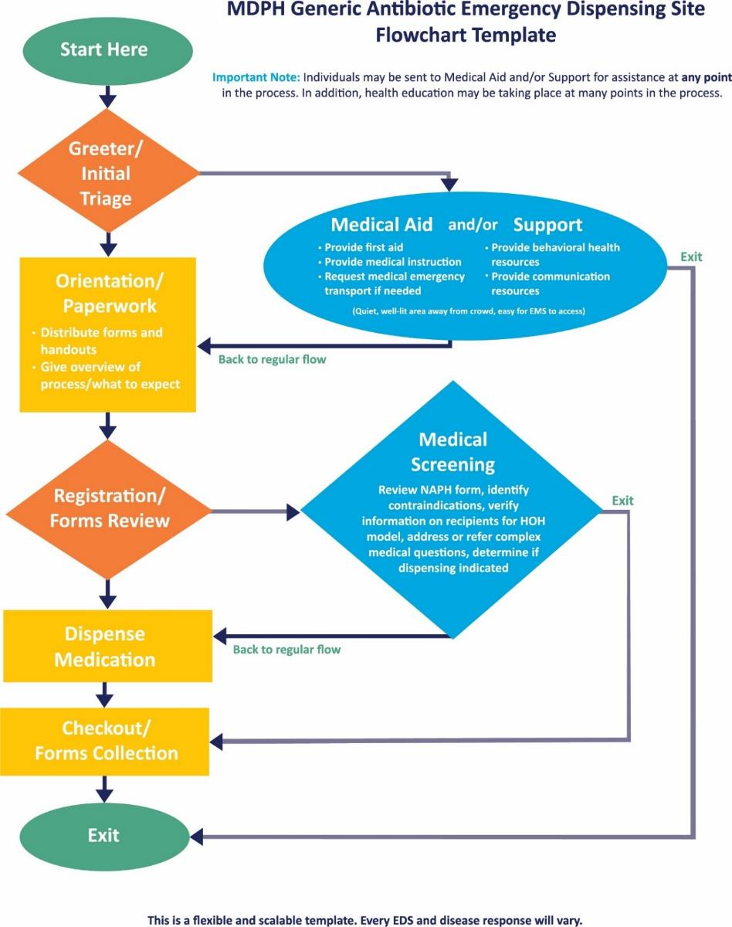
Generic Antibiotic Emergency Dispensing Site Flowchart Template

Generic Vaccine Emergency Dispensing Site Flowchart Template
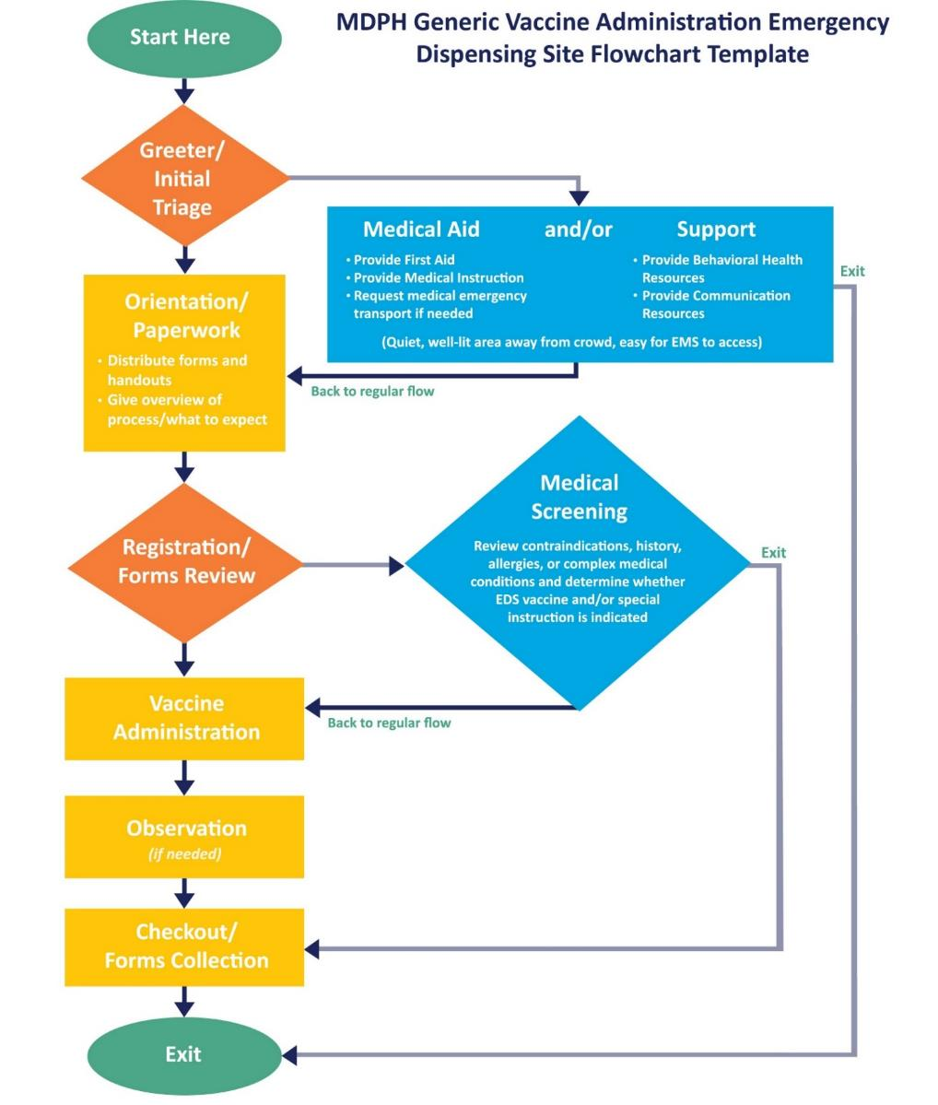

Name Address Personal History (NAPH) Forms and Instructions
Directions for Emergency Dispensing Site (EDS)
Name, Address, Personal History (NAPH) Registration Form

When using a Head of Household model to dispense medical countermeasures (MCM) at a public Emergency Dispensing Site (EDS), Closed EDS, or hospital, the person picking up MCM for the family (Person #1) is the only one who needs to complete the form. More than one form will be needed if there are more than 5 people in the household/family.
Line on the Form | Description
Name (person #1) | The person completing the form and/or picking up MCM for household. Complete Last name, First name, Middle initial (M.I.)
Address | The address of the person filling out the form
Phone | Phone number in case they need to be reached regarding the medicine
Official Use Only box (top right) | Where the dispensing site screener reviewing the form places their initials, the date and time of the form review
Person #2 – Person #5 | Additional household members for whom Person #1 is picking up medications, if appropriate. Each person gets their own column.
Last Name/First Name | Names of persons #2 - #5
Age | Age of persons #1 - #5
Weight if under 76 pounds  (this only pertains to dosing) | Enter the weight of any person under 76 pounds. Provide “In an Emergency: How to Prepare Doxycycline Hyclate for Children and Adults Who Cannot Swallow Pills” handout for children or upon request.
A: Pregnant/Breastfeeding | Check Yes or No for each person #1 - #5
B: Allergic to Tetracyclines? | Check Yes or No for each person #1 - #5.  See the boxes in the middle of the NAPH Form for names of drugs (Tetracyclines, Quinolones, and Penicillins)
C: Allergic to Quinolones? | Check Yes or No for each person #1 - #5
D: Allergic to Penicillins? | Check Yes or No for each person #1 - #5
OFFICIAL USE ONLY SECTION | The rows of information below the heavy, black line are for EDS staff usage. The Screener completes the “Screener” row, and the person (#1) picking up the medication takes the form to the Dispenser to get the appropriate medication.
SCREENER: Circle medication to be given or check consult  If child, circle Pedi(atric) | To determine which medication to give each person, consult the NAPH Medication Algorithm page. Then circle D (Doxy), C (Cipro) , or A (Amox) as appropriate. If Amoxicillin is not available and any person (#1 - #5) needs that medication, direct Person #1 to a physician for a consultation. Circle “Pedi” if the person is a child to ensure pill crushing instructions are provided.
DISPENSER (Initials ___): Check off the medication given  If Pedi provide crushing instructions | The Dispenser should check off the medication given for each person (#1 - #5). Check “None/med consult” if no medication was given and/or if the client was referred to a medical consult. Provide crushing instructions if Pedi or if adult has difficulty swallowing pills.
DISPENSER: Affix Med Label OR fill in info | The bottles of medicine to be dispensed should have 2 peel-off labels on the side of the bottle. Affix one label for the medication provided for each person in that person’s column or fill in by hand if labels are not available.

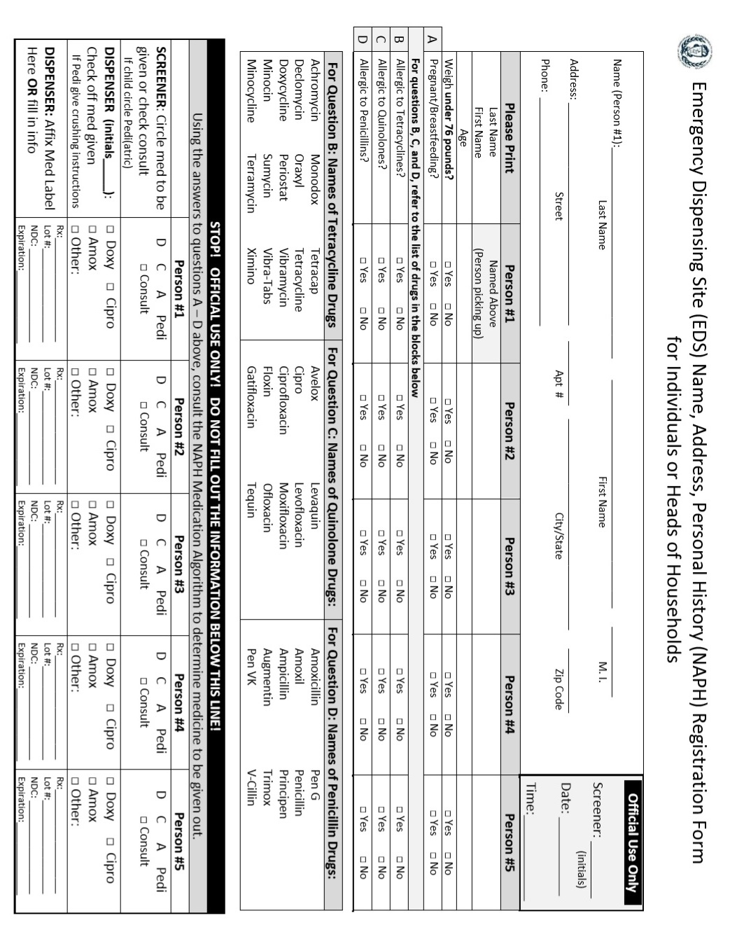
NAPH Form Medication Algorithm Directions

Answer each question (row) in order as listed on the NAPH Form (A, B, C, D).
Based on the response to Question A, circle or highlight all the YESs or NOs in the top row.

For example, if the person is NOT pregnant or breastfeeding, circle/highlight NO in the first 5 blocks of the Question A row.

For each following question, you need only circle the YESs or NOs that appear under the circled/highlighted blocks in the previous question.

A column where all the YESs or NOs are circled or highlighted will indicate in the bottom row which drug should be provided.

In the example below, the person is NOT pregnant/breastfeeding (row A), is NOT allergic to Doxycycline or Tetracycline drugs (row B), IS allergic to Ciprofloxacin or Quinolone drugs (row C), and is NOT allergic to Amoxicillin or Penicillin drugs (note: a YES or NO response in row D would not change the drug provided in some cases). The column with all blocks highlighted in rows A through D tells us which drug to provide (bottom row). In this example, the drug dispensed should be Doxycyline.
A  Is the person PREGNANT or BREASTFEEDING? | No | No | No | No | No | Yes | Yes | Yes | Yes | Yes
B  Is the person allergic to Doxycycline or Tetracycline drugs? | No | No | Yes | Yes | Yes | Yes | Yes | Yes | No | No
C  Is the person allergic to Ciprofloxacin or Quinolone drugs? | No | Yes | No | Yes | Yes | Yes | Yes | No | Yes | No
D  Is the person allergic to Amoxicillin or Penicillin drugs? | Yes or No | Yes or No | Yes or No | No | Yes | No | Yes | Yes or No | No | Yes or No
Provide | Doxy (D) or Cipro (C) | Doxy (D) | Cipro (C) | Consult / Amox (A)? | Consult | Consult / Amox (A)? | Consult | Cipro (C) | Consult / Amox (A)? | Cipro (C)

NOTE: Consider keeping a laminated blank Algorithm sheet at each screening station at the EDS. This laminated sheet could then be used repeatedly with a write-on/wipe-off marker to determine which drug should be dispensed to each individual.

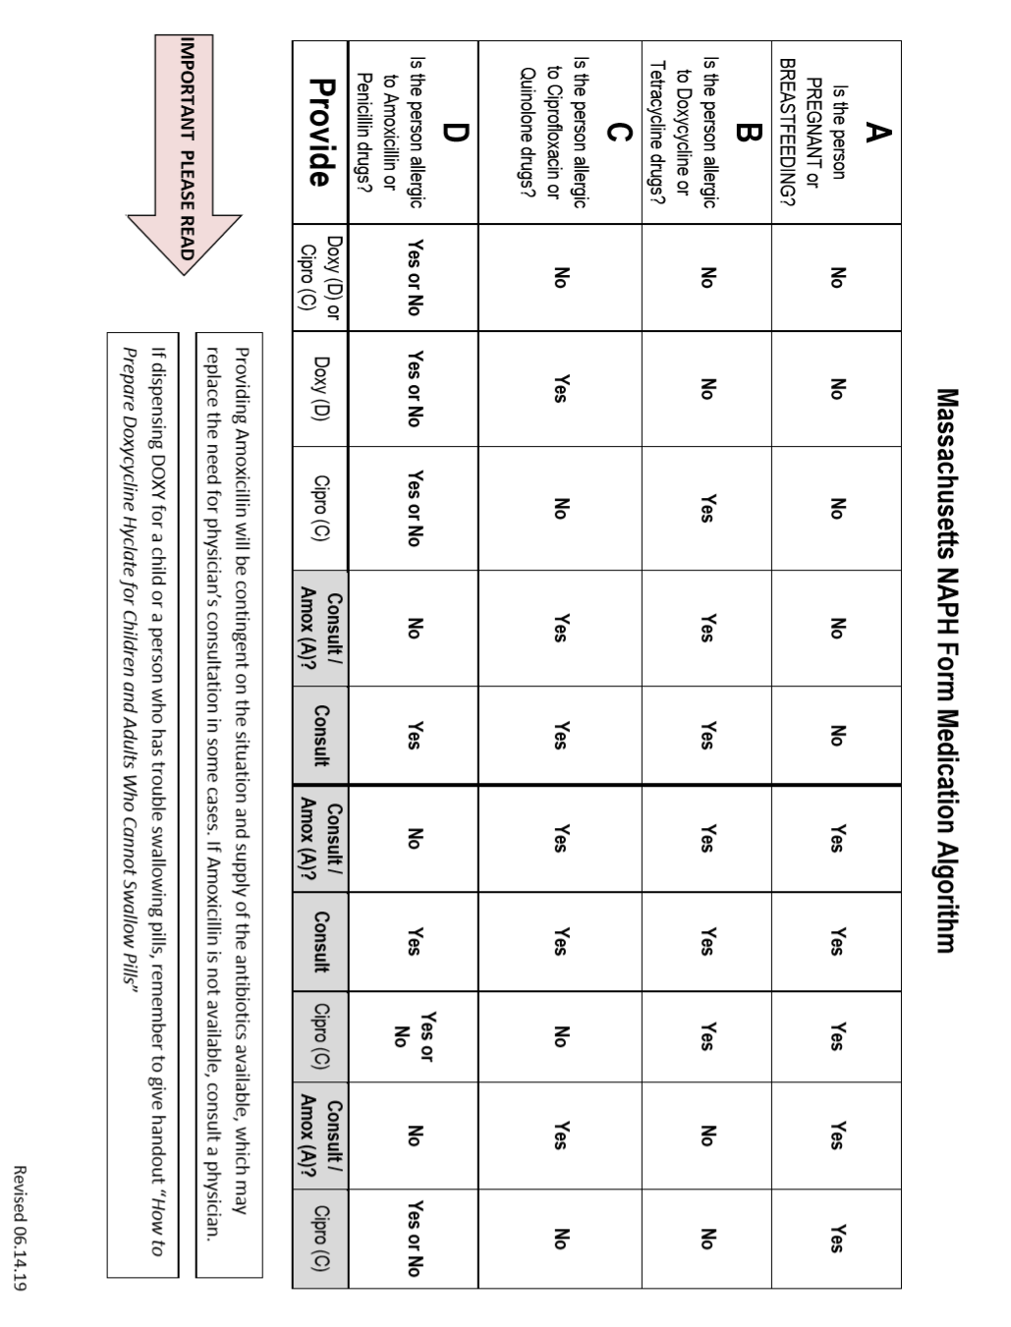
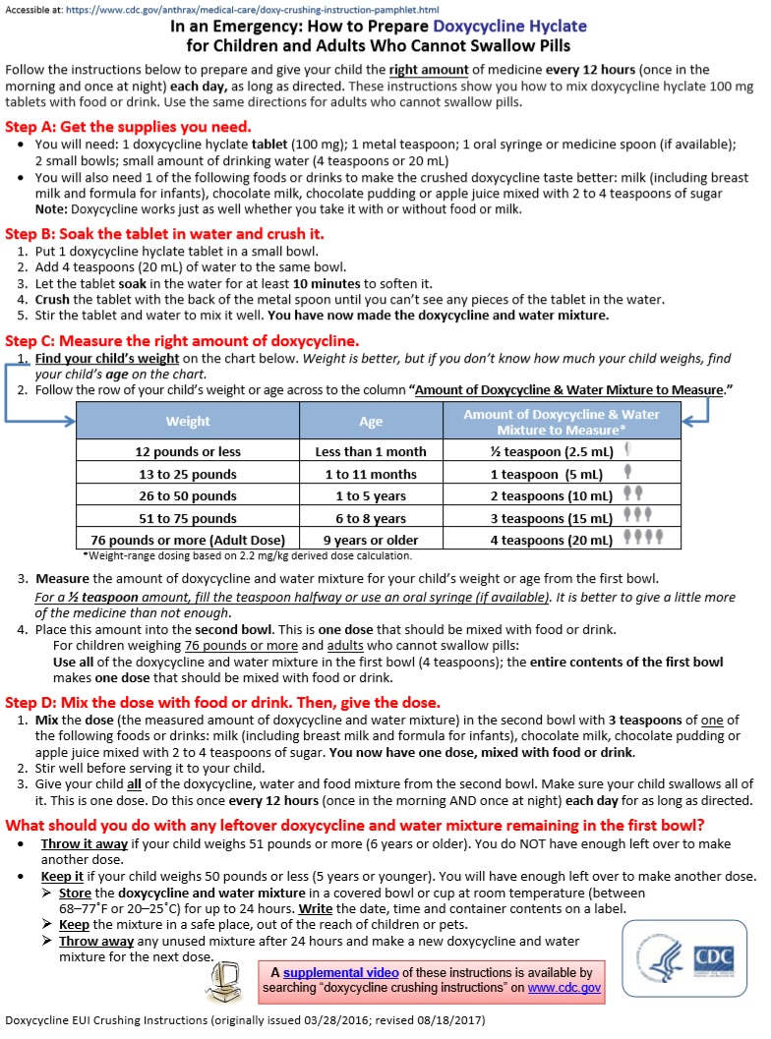

Emergency Dispensing Site Inventory Tracking Form and Instructions

The accompanying Inventory Tracking Form should be used to track the inventory (Medical Countermeasures [MCM] or medical supplies [Personal Protective Equipment, etc.]) that is received at the EDS whether by shipment from the state's warehouse partner (Receipt, Stage, & Store facility [RSS]) or transferred from another EDS. The Inventory Manager or back-up should know the status of every case/item received for the purposes of reordering and/or reporting to the state or ASPR as requested.

Reporting and the frequency of reporting may be conducted by email, phone, WebEOC or other manner depending on the incident. ASPR, through MDPH, may request inventory updates daily, weekly, or at another interval. MDPH may request more frequent updates and will reach out for this information via HHAN alert or scheduled conference call.

Upon arrival at the EDS the truck driver delivering MCM will provide a Bill of Lading containing a detailed inventory of the shipment. When possible, the MCM inventory list will be sent electronically to the local email address provided in the WebEOC EDS Board prior to the shipment’s arrival.

Once a shipment is received at the EDS the product must be checked to ensure it matches the Packing List which is the starting point for the inventory. The EDS Manager, or designee as indicated in the local plan, must sign for the assets, noting any missing or damaged product on the Packing List. This proof of receipt - the Medical Material Transfer of Custody and Packing List (both received from the delivery driver) - should be signed and a copy made to be kept on site (originals return with driver). These forms must then be faxed or scanned to MDPH. Directions and contact information are on the Transfer of Custody form.

Terminology on the Inventory Tracking Form
Item: The products received. In most instances an EDS will receive medication but could also receive medical supplies (Personal Protective Equipment, syringes if receiving vaccine, etc.). Record the name of the item on the form. If it is medication, record its name, strength, National Drug Code (NDC) number, number of bottles per case, Lot Number (#) and expiration date. This information is found on each case and each bottle.

Date/Time Transaction: Enter on the “Start” line when the shipment arrived and was signed for at the EDS; enter the Date/Time when each subsequent transaction is made (other cases received, dispensed, transferred or returned).

Cases Received: The number of cases of each medication (Doxycycline, Ciprofloxacin, etc.) received and placed in the secured medication storage/staging area. Each will need its own Inventory Tracking Form. Indicate in the first line of the form ("Start") the number of cases received.

Cases Transferred: The number of cases sent to another EDS (public/open or private/closed), Long Term Care Facility, Community Health Center, or other dispensing partner. MDPH recommends rounding population numbers up and transferring whole cases.

Cases Dispensed: The number of cases sent to the dispensing lines from the secure storage/staging area. The product may have been dispensed or may be in the dispensing area to be handed out.

A Transfer of Custody Form must accompany all medication transfers; a copy should be attached to the EDS’ Inventory Tracking Form and a copy should accompany the medication being transferred to the receiving site.

Cases Returned: The number of cases returned to the storage/staging area from other locations. Any unused medications should be returned to the EDS storage/staging area.

Cases Remaining: The number of cases remaining in the storage/staging area after each transaction (dispensing, transferring, or returning). Should correspond to the actual inventory of cases in the storage/staging area.

Initials of Inventory Mgr.: The Inventory Manager or back-up who is monitoring the inventory must initial each line when MCM is dispensed from or received at the storage area.

Throughout the dispensing process it is important to keep track of the inventory. There is space at the bottom of the tracking form to record order status and make notes.

Inventory Tracking Form Directions and Example

The table below is an Excel spreadsheet showing how to track medical countermeasures inventory at the EDS. Those responsible for tracking the inventory at the EDS may complete the form electronically or print out a paper copy and enter information manually. All movement of the medical countermeasures (MCM) should be tracked on these pages. Similar to a checkbook register, record the inventory that goes in and out of the inventory storage area. A running total is automatically calculated in the grey “Cases Remaining” column. A blank page should be used for each unique item and lot number, i.e. if you receive 500 cases of Doxycycline but 300 cases have one lot number and 200 cases have a different lot number, they should be tracked on separate sheets. At pre-announced intervals, MDPH will request and gather inventory data from all activated dispensing sites to report the data to our federal partners.

In the example below 300 cases of Doxycycline are received at the EDS at 0530. This information is entered in the “Start” line and the specific drug information (shown in red below) is entered at the top of the spreadsheet. The example shows that 40 cases are moved to the EDS’ dispensing area to be dispensed and 30 cases are transferred to a neighboring EDS (Wing School) to be dispensed. These 30 cases are considered transferred because they are off-site where someone else will dispense the medication. Whenever the MCM is moved out of the EDS, a Transfer of Custody Form must be signed to show who is taking responsibility for the medication. The example below continues to show 50 more cases are moved within the EDS to be dispensed, 4 cases are picked up by (transferred to) a Long Term Care Facility (LTCF) Closed EDS, and 20 cases are transferred to the drive-through EDS elsewhere in town.

At 1300 hours an additional shipment is received of 100 cases of Doxycycline 100mg tablets, 20 tablets/bottle, with the same lot number. If the nd shipment had a different lot number, a new Inventory Tracking Form would be completed. For clarity of record-keeping, do not dispense the second shipment (100 cases) until the first shipment (300 cases) is dispensed entirely. At the end of the shift, 3 full and 1 partial case were returned from the school and 3 cases were returned from the drive-through area (1 box was damaged). Note these on the spreadsheet and in the Final Disposition box.

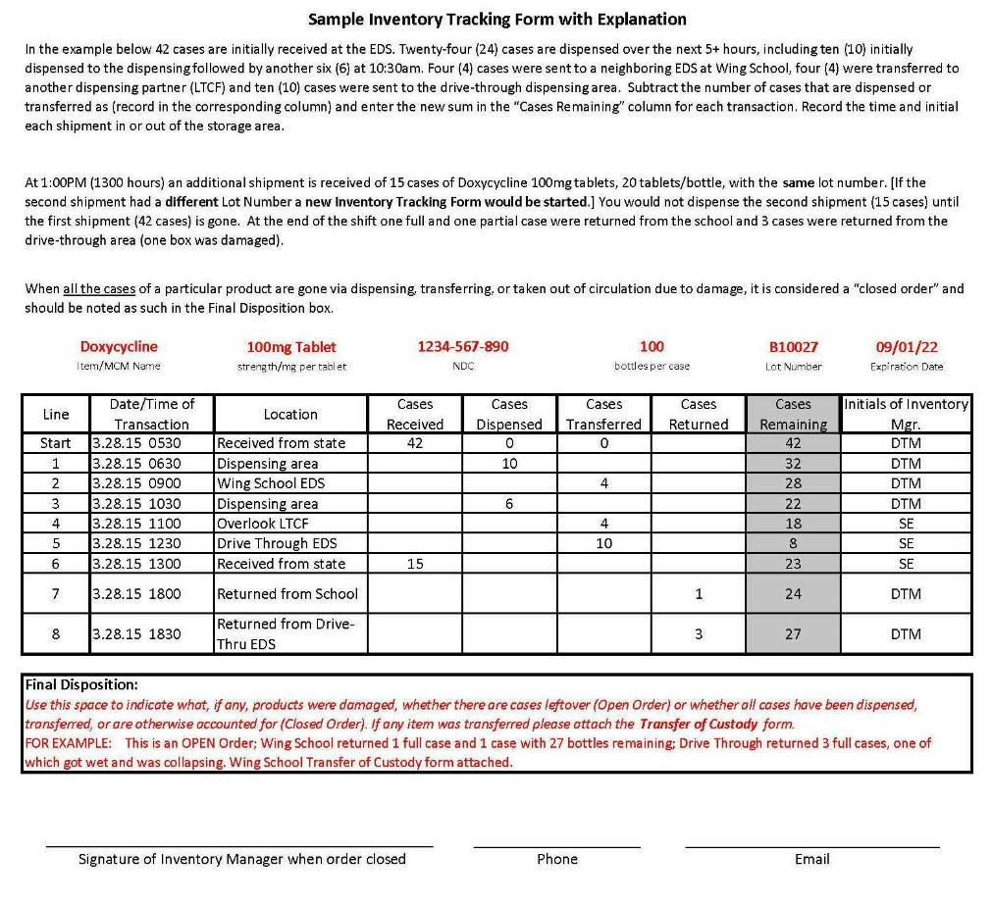
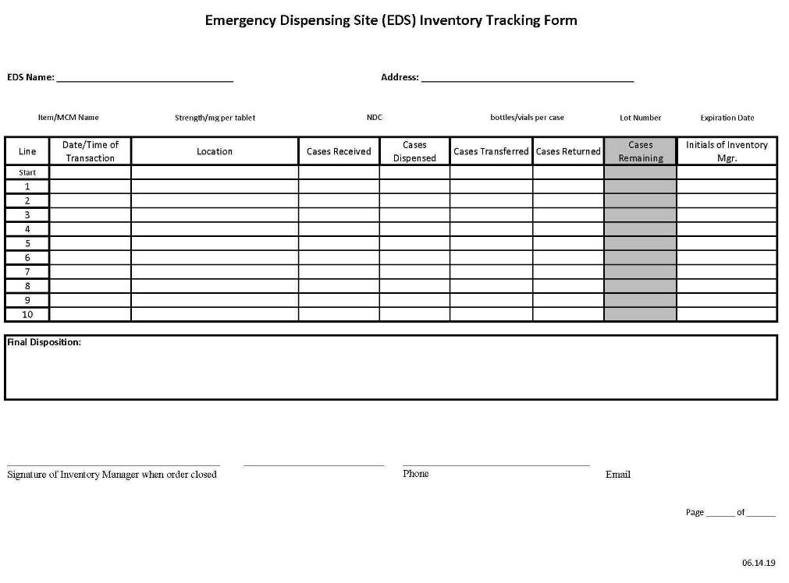

Process for Volunteer Requests During a Cross-Jurisdictional Event

Emergency Dispensing Site Facility Survey

An Emergency Dispensing Site Facility Survey should be completed for each location that may be used as an Open or Closed EDS. The Survey will help planners assess facility suitability when choosing a site or reviewing existing EDS locations and plans. An EDS may be used for emergency prophylaxis in a variety of circumstances (e.g., an influenza pandemic, measles outbreak, or a Hepatitis A in a food handler), but a key federal priority is identification of one or more facilities that could handle through-put in a “worst case” anthrax scenario when antibiotics must be dispensed to the entire target population within 48 hours of exposure.
It is crucial to include representatives of the facility in the Facility Survey, and to involve local law enforcement and security agencies in planning for site security and vehicular traffic flow for an emergency dispensing site.

Emergency Dispensing Site Facility Survey
Massachusetts Department of Public Health
Medical Countermeasures Program

Name(s) of person(s) conducting survey: |  |  |  |  |  | Date of survey completion:
A. Physical Space
Name of Facility: |  |  |  |  |  | City/Town
Street Address: |  |  |  |  |  | Zip Code
Type of facility (School, senior center, clinic, etc.)
List all cities/towns/entities covered by this EDS:

To do:
Obtain an architectural rendering of the building floorplan and indicate the traffic flow within the site.
Obtain an aerial drawing/photo of the site and surrounding area; note traffic flow and parking for staff and visitors. Note where EMS will be stationed.
Note receiving area for MCM material.
Number of Ground Level Entrances and Exits

List locations of entrance/exit points:

Available bathroom facilities:
Total number: | Men______ |  | Women______ |  | Unisex______
Number that are ADA Compliant: | Men |  | Women |  | Unisex
 |  |  |  |  |  |  | Check One:
Will the EDS be able to take place on only one level of the building? |  |  |  |  |  |  |  | Yes | No
Is the facility compliant with the Americans with Disabilities Act? (At a minimum is the area that the public will access ADA compliant?) |  |  |  |  |  |  |  | Yes | No
Is there a kitchen area and/or area other than bathrooms with working sinks? |  |  |  |  |  |  |  | Yes | No

Is there a functional loading dock or adequate area to unload trucks away from the public? Please indicate maximum truck length that can be accommodated. (The standard sizes that the SNS Program plans to use are 26’ or 53’) |  |  |  | Maximum Truck Length: |  | Yes |  | No
Is the building able to accommodate lines of people and multiple stations? (Stations may include: screening/triage, forms distribution, forms review, medical counseling area and/or first aid, special needs line, behavioral health area, command area, staff break area away from the public, dispensing area or appropriate vaccination space, etc.) |  |  |  |  |  | Yes |  | No
Is there an area available for individuals who become ill or severely anxious and/or need to be removed from the operations area and/or crowd? |  |  |  |  |  | Yes |  | No
Is adequate refrigeration available to store vaccines and food separately? (vaccines cannot be stored in refrigerators containing food) |  |  |  |  |  | Yes |  | No
Is dispensing area temperature controlled between 68° and 77° F. (room temperature) |  |  |  |  |  | Yes |  | No
Is a back-up generator available that would, at a minimum, supply light and heat to the building? |  |  |  |  |  | Yes |  | No
Is onsite parking available for staff and volunteers? |  |  |  |  |  | Yes |  | No
Is parking for staff and volunteers adequate to accommodate shift changes? |  |  |  |  |  | Yes |  | No
Is there a room available for a staff break space away from the dispensing operation and/or crowd? |  |  |  |  |  | Yes |  | No
B. Site and Supply Security |  |  |  |  |  | Check One:
Has law enforcement agency participated in a vulnerability assessment of the site? |  |  |  |  |  | Yes |  | No
Is property or facility able to be locked down? |  |  |  |  |  | Yes |  | No
Does the site have an appropriate area for a law enforcement command center? |  |  |  |  |  | Yes |  | No
Does site allow for officers, guards or security volunteers to coordinate the following?
- Ingress and egress of vehicular traffic  - Parking  - Crowd Control outside the facility  - Protection of staff and volunteers  - Access control to facility  Notes: |  |  |  |  |  | Yes  Yes  Yes  Yes  Yes |  | No  No  No  No  No
Secure indoor storage area for medications or supplies? |  |  |  |  |  | Yes |  | No
Is queuing (line) area adequate for anticipated use/throughput? |  |  |  |  |  | Yes |  | No
If the queue/line is expected to extend outdoors, is there adequate accommodation for inclement weather? |  |  |  |  |  | Yes |  | No
Is the loading dock or unloading area able to be secured? |  |  |  |  |  | Yes |  | No
 | C. Vehicular Traffic Flow |  |  |  | Check One
 | Will normal traffic patterns be altered? |  |  |  |  | Yes |  |  | No
 | Are there separate exit and entrance roads or driveways? |  |  |  |  | Yes |  |  | No
 | Dedicated emergency vehicle access, staging location, and/or entrance? |  |  |  |  | Yes |  |  | No
 | Is parking capacity at this site or a public staging/overflow area adequate for the expected throughput? |  |  |  |  | Yes |  |  | No
 | Is routine public transportation available? |  |  |  |  | Yes |  |  | No
 | Is this building isolated by water, bridges, etc.? |  |  |  |  | Yes |  |  | No
 | List any potential traffic bottlenecks or traffic hazards in the area surrounding the site given a large influx of traffic:
 | D. Location |  |  |  | Notes
 | Are there other planned uses for the facility during emergencies (e.g., shelter, EOC, Emergency Planning Zone Reception Center, etc.) Do any of these incidents or scenarios conflict with use as an EDS?
 | Proximity to nearest hospital?
 | Proximity to major access roads or highways (if applicable)?
 | Proximity to a staging area or off-site parking?
 |  |  |  |  | Check One:
 | Is the site outside of flood plain? |  |  |  | Yes |  | No
 | E. Facility Communication |  |  |  | Notes:
 | How many phone lines could be made available during an emergency?
 | How many fax lines could be made available during an emergency?
 |  |  |  |  | Check One:
 | Does the facility have an internal PA system? |  |  |  |  | Yes |  |  | No
 | Do cell phones work within the facility? |  |  |  |  | Yes |  |  | No
 | Do 2-way radios work within the facility? |  |  |  |  | Yes |  |  | No
 | Is there high speed internet within the facility? |  |  |  |  | Yes |  |  | No
 | Does the facility have wireless internet capability? |  |  |  |  | Yes |  |  | No

External link- https://www.fda.gov/emergency-preparedness-and-response/about-mcmi/what-are-medical-countermeasures
External link- https://www.cdc.gov/phpr/readiness/capabilities.htm
External link- https://www.phe.gov/Preparedness/planning/hpp/reports/Documents/2017-2022-healthcare-pr-capablities.pdf
External link- http://www.mass.gov/eohhs/gov/departments/dph/programs/emergency-prep/health-medical-coord-coalitions.html
External link- https://www.phe.gov/about/sns/Pages/default.aspx
External Link- https://malegislature.gov/Laws/GeneralLaws/PartI/TitleXVI/Chapter111/Section5A
External link- http://www.dispenseassist.net/default.html
External link- https://factfinder.census.gov/faces/nav/jsf/pages/index.xhtml
External link- https://factfinder.census.gov/faces/nav/jsf/pages/index.xhtml
External link- http://www.mass.gov/eohhs/docs/dph/emergency-prep/risk-communication/show-me-tool.pdf
External link- http://www.mass.gov/eohhs/docs/dph/cdc/immunization/mso-emergency-treatment.pdf
External link- https://www.fda.gov/downloads/Drugs/EmergencyPreparedness/BioterrorismandDrugPreparedness/UCM131001.pdf
External link- http://www.mass.gov/eohhs/gov/departments/dph/programs/id/epidemiology/rdiq/reporting-diseases-and-surveillance-information.html
External link- http://www.mass.gov/eohhs/gov/departments/dph/programs/id/epidemiology/rdiq/public-health-cdc-surveillance-and-reporting.html
External link- http://www.maventrainingsite.com/maven-help/EvalTraining_2014/EvalTrainingTool_2014/index.html
External link- https://www.cdc.gov/nssp/biosense/
External link- https://www.phe.gov/Preparedness/legal/Pages/phedeclaration.aspx
External link- http://www.who.int/csr/disease/swineflu/phase/en/
External link- http://www.mass.gov/eohhs/gov/departments/dph/programs/emergency-prep/health-and-homeland-alert-network.html
External Link- https://www.phe.gov/Preparedness/planning/mscc/handbook/Pages/appendixc.aspx
External link to FEMA ICS Forms- https://training.fema.gov/emiweb/is/icsresource/icsforms.htm
External link- https://www.dhs.gov/government-emergency-telecommunications-service-gets
External link- http://en.wikipedia.org/wiki/People-first_language
External link- http://www.mass.gov/eohhs/gov/departments/mcdhh/
External link- http://www.mass.gov/eohhs/docs/dph/emergency-prep/risk-communication/show-me-tool.pdf
External link- https://maresponds.org/
External link- http://www.mamedicalreservecorps.org
External link- https://www.ready.gov/citizen-corps
External link- http://www2.isye.gatech.edu/medicalor/realopt/research.php
External link- https://www.cdc.gov/vaccines/hcp/admin/storage/toolkit/index.html
External link- https://vaers.hhs.gov/index.html
External link- http://nationalmasscarestrategy.org/wp-content/uploads/2016/08/FacilityShelterOpenCloseInspectionForm.pdf
The CDC Community Preparedness capability identifies the following 11 community sectors as essential to public health preparedness: business, community leadership, cultural and faith-based organizations, emergency management, healthcare, social services, housing and sheltering, media, behavioral health, elder services, and education and childcare.
External link- https://www.fema.gov/pdf/about/divisions/npd/CPG_101_V2.pdf
External link- https://matracking.ehs.state.ma.us/
External link- https://www.maresponds.org/
External link- https://preptoolkit.fema.gov/web/hseep-resources
External link- https://mematraining.chs.state.ma.us/TRS/home.do
External link- https://training.fema.gov/is/courseoverview.aspx?code=IS-100.b
External link- https://training.fema.gov/is/courseoverview.aspx?code=IS-200.b
External link- https://training.fema.gov/is/courseoverview.aspx?code=IS-700.a
External link- https://training.fema.gov/is/courseoverview.aspx?code=IS-800.b
External link- http://sites.bu.edu/masslocalinstitute/2014/11/06/emergency-dispensing-site-management/
External link- https://training.fema.gov/is/courseoverview.aspx?code=IS-702.a
External link- https://emergency.cdc.gov/cerc/training/basic/index.asp
External link- https://emergency.cdc.gov/cerc/training/panflu/index.asp
External link- http://sites.bu.edu/masslocalinstitute/2012/09/21/emergency-risk-communication-for-public-health-professionals/
External link- http://sites.bu.edu/masslocalinstitute/training/classroom-trainings/emergency-risk-communication-in-practice/
External link- https://training.fema.gov/programs/pio/
External link- https://www.cdc.gov/phpr/readiness/capabilities.htm

