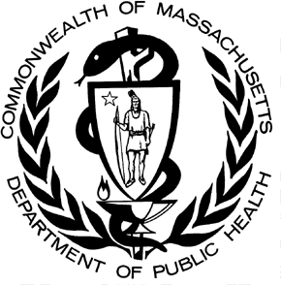

POSTED: NOVEMBER 2016

Massachusetts Department of Public Health

**Opioid-related EMS Transports Massachusetts Residents: 2013-2016**

# Enhancement of Opioid Overdose Surveillance

MATRIS, the Massachusetts Ambulance Trip Reporting Information System, is a statewide database for collecting emergency medical service data from licensed ambulance services. It was not specifically designed to track opioid overdose incidents. DPH is currently working with all Emergency Medical Services (EMS) providers to improve the quality and completeness of these data especially with respect to opioid overdose incidents. Data for Boston came directly though Boston EMS’ estimates of Narcotic Related Incidents (NRI) and not from DPH’s MATRIS algorithm. To more accurately identify ambulance trips that are opioid-related, several pieces of information from MATRIS are combined such notation that a trip was listed as a poisoning, that there was an administration of naloxone, or that the patient admitted to drug use. In combination, this information allows DPH to more accurately count opioid overdose incidents. Not all services have reported their 2016 Q1/Q2 data yet so the numbers cited here are underestimates. Counts will be updated on a quarterly basis.

# Results

As in previous years, the data from the first two quarters of 2016 indicates that there was the greatest number of suspected opioid overdose incidents among males aged 25-34 (31% of opioid-related incidents).

Since 2013, there has been an increasing trend in the percentage of all incidents that are considered opioid- related. The rate of 2.9% in the second quarter of 2016 is almost three times what it was in the first quarter of 2013 (1.0%).

On average, EMS administered Naloxone 1.4 times per opioid-related incident in the first two quarters of 2016.

In the first two quarters of 2016, of the EMS services reporting their data to DPH, responses to opioid-related incidents were in 256 of the 351 MA cities and towns (73%). Overall, there was an 18% increase in the number of opioid-related EMS transport incidents in the first two quarters of 2016 compared with the first two quarters of 2015. Of note, the death rate increased at a slower rate than opioid-related EMS transports between 2013 and 2015 indicating that the proportion of overdoses that are fatal may be decreasing.

|  |  |  |  |  |  |  |  |  |
| --- | --- | --- | --- | --- | --- | --- | --- | --- |
| **All Suspected Opioid Related Incidents: 2016 (Quarter 1)** | | | | | | | | |
|  | **11-14** | **15-24** | **25-34** | **35-44** | **45-54** | **55-64** | **65+** | **Total** |
| Male | <7 | 290 | 999 | 552 | 365 | 223 | 103 | 2533 |
| Female | <7 | 199 | 546 | 336 | 251 | 153 | 84 | 1570 |
| **Total** | **<7** | **489** | **1545** | **888** | **616** | **376** | **187** | **4103** |

|  |  |  |  |  |  |  |  |  |
| --- | --- | --- | --- | --- | --- | --- | --- | --- |
| **All Suspected Opioid Related Incidents: 2016 (Quarter 2)** | | | | | | | | |
|  | **11-14** | **15-24** | **25-34** | **35-44** | **45-54** | **55-64** | **65+** | **Total** |
| Male | <7 | 336 | 1231 | 649 | 530 | 278 | 129 | 3154 |
| Female | <7 | 209 | 655 | 473 | 323 | 183 | 101 | 1947 |
| **Total** | **<7** | **545** | **1886** | **1122** | **853** | **461** | **230** | **5101** |

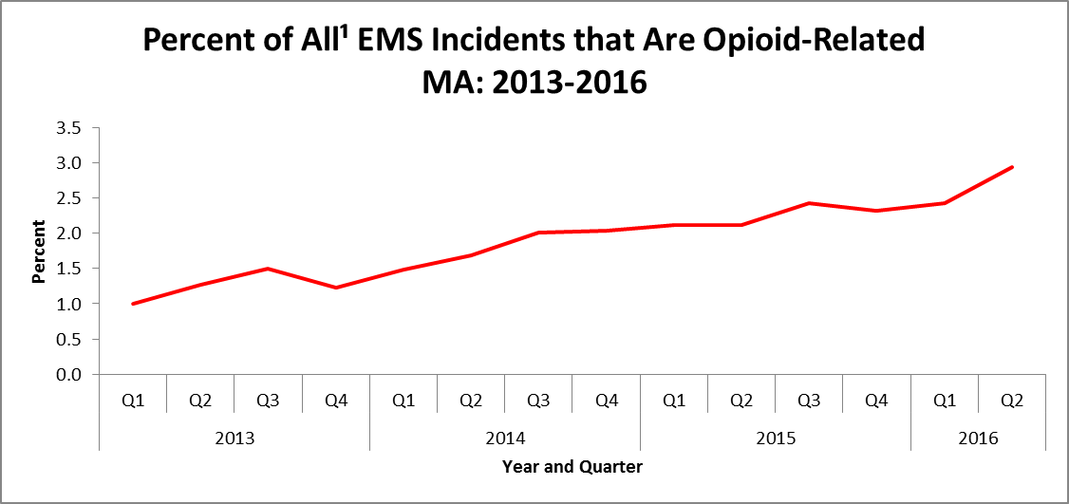

1. Includes all incidents where the patient was 11 years old or older.

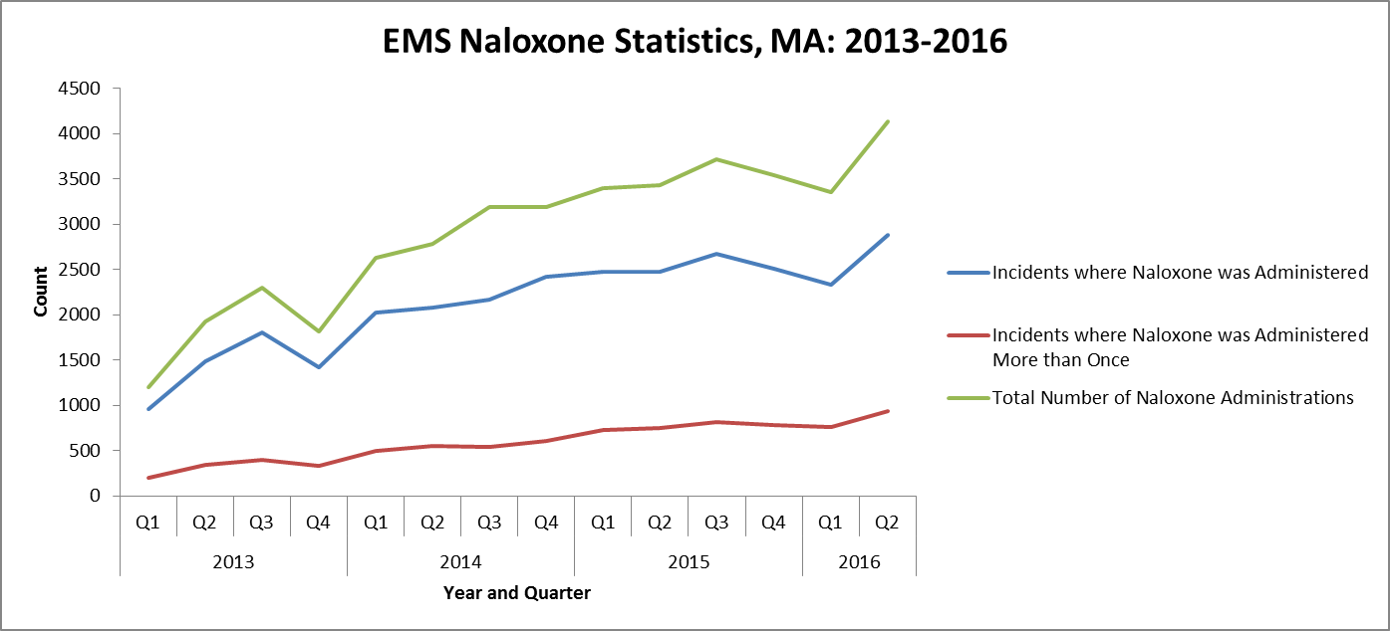

# Technical Notes

Suspected opioid related incidents for all cities/towns except for Boston are identified using an algorithm that DPH developed with CDC using multiple fields in the MATRIS system. Data for Boston came directly though Boston EMS’ estimates of Narcotic Related Incidents (NRI) and not from DPH’s MATRIS algorithm. Due to

differences in reporting by EMS services, these numbers are likely an undercount of true opioid-related incidents.

This data brief was supported by funds made available from the Centers for Disease Control and Prevention, Office for State, Tribal, Local and Territorial Support, under B01OT009024. The findings of this data brief are those of the authors and do not necessarily represent the official position of or endorsement by the Centers for Disease Control and Prevention.