INDOOR AIR QUALITY ASSESSMENT

Belchertown Emergency Medical Services
9 East Walnut Street
Belchertown, Massachusetts

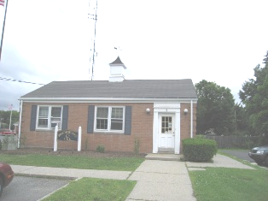

Prepared by:
Massachusetts Department of Public Health
Bureau of Environmental Health
Indoor Air Quality Program
December 2009

Background/Introduction
At the request of Judy Metcalf, Director of Public Health for the Quabbin Health District, the Massachusetts Department of Public Health (MDPH), Bureau of Environmental Health (BEH) provided assistance and consultation regarding indoor air quality concerns at Belchertown Emergency Medical Services (BEMS) office, 9 East Walnut Street, Belchertown, Massachusetts. The request was prompted by concerns regarding water damage and mold in the building. On June 22, 2009, a visit to conduct an assessment was made to the BEMS by Lisa Hébert, Environmental Analyst/Inspector in BEH’s Indoor Air Quality (IAQ) Program. During the assessment, BEH staff was accompanied by Steven J. Williams, Director of the Belchertown Department of Public Works and Ms. Metcalf.
The BEMS is a brick one-story building built in the 1950s as a post office. In the 1980’s, the building was renovated to become a police station with the loading dock converted into jail. Currently, the building contains office space, bunk rooms, a living area and a small kitchen with the former jail cells used for storage. The roof consists of two sections: a pitched asphalt shingle roof and a flat welded membrane roof. The age of the roof sections was unknown at the time of inspection and BEH staff were not able to access the roof. The building does not have a basement.

Methods
Air tests for carbon monoxide, carbon dioxide, temperature and relative humidity were conducted with the TSI, Q-Trak, IAQ Monitor, Model 7565. BEH staff also performed visual inspection of building materials for water damage and/or microbial growth. Moisture content of carpeting in selected areas was measured with a Delmhorst, BD-2000 Model, Moisture Detector equipped with a Delmhorst Standard Probe.

Results
The BEMS has an employee population of approximately 18 and is not generally visited by the public. Tests were taken under normal operating conditions and results appear in Table 1.

Discussion

Ventilation
It can be seen from Table 1 that carbon dioxide levels were below 800 parts per million (ppm) in all areas surveyed, indicating adequate air exchange in the building at the time of the assessment. It is important to note, however, that several areas had open windows and/or were empty/sparsely populated at the time of the assessment, which can greatly reduce carbon dioxide levels. Carbon dioxide levels would be expected to increase with full occupancy and windows closed.
The ventilation system at BEMS does not appear to be designed to provide either mechanical fresh air supply or exhaust ventilation. Fresh air is currently supplied by openable windows. With a lack of fresh air supply and/or exhaust ventilation, normally occurring indoor environmental pollutants can accumulate and lead to air quality/comfort complaints. The former cell block had a exhaust ventilation system, which was not in use. Restrooms have an exhaust vent system.
The Massachusetts Building Code requires a minimum ventilation rate of 20 cubic feet per minute (cfm) per occupant of fresh outside air or have openable windows in each room (SBBRS, 1997; BOCA, 1993). Providing adequate fresh air ventilation with open windows and maintaining the temperature in the comfort range during the cold weather season is impractical. Mechanical ventilation is usually required to provide adequate fresh air ventilation.
Carbon dioxide is not a problem in and of itself. It is used as an indicator of the adequacy of the fresh air ventilation. As carbon dioxide levels rise, it indicates that the ventilating system is malfunctioning or the design occupancy of the room is being exceeded. When this happens, a buildup of common indoor air pollutants can occur, leading to discomfort or health complaints. The Occupational Safety and Health Administration (OSHA) standard for carbon dioxide is 5,000 parts per million parts of air (ppm). Workers may be exposed to this level for 40 hours/week, based on a time-weighted average (OSHA, 1997).
The MDPH uses a guideline of 800 ppm for publicly occupied buildings. A guideline of 600 ppm or less is preferred in schools due to the fact that the majority of occupants are young and considered to be a more sensitive population in the evaluation of environmental health status. Inadequate ventilation and/or elevated temperatures are major causes of complaints such as respiratory, eye, nose and throat irritation, lethargy and headaches. For more information concerning carbon dioxide, consult Appendix A.
Temperature measurements in the BEMS ranged from 72° F to 76° F, which were within the MDPH recommended range (Table 1). The MDPH recommends that indoor air temperatures be maintained in a range of 70º F to 78º F in order to provide for the comfort of building occupants. In many cases concerning indoor air quality, fluctuations of temperature in occupied spaces are typically experienced, even in a building with an adequate fresh air supply.
The relative humidity measured in the building ranged from 53 to 64 percent, which was within or at the higher end of the MDPH recommended comfort range in the majority of areas surveyed (Table 1). The MDPH recommends a comfort range of 40 to 60 percent for indoor air relative humidity. Relative humidity levels in the building would be expected to drop during the winter months due to heating. The sensation of dryness and irritation is common in a low relative humidity environment. Low relative humidity is a very common problem during the heating season in the northeast part of the United States.

Microbial/Moisture Concerns
Several potential sources of moisture, water damage and/or mold growth were observed during the assessment. Broken/missing window glazing was observed throughout the building (Pictures 1 and 2). Gaps were also evident around window-mounted air conditioners. Nonfunctioning ventilation equipment used for the former jail cells was still in place and was open to the outdoor environment (Picture 3). All of these conditions may allow hot, moist air into the BEMS, which can potentially lead to the generation of condensation in the building, in addition to reducing air conditioning efficiency.
The bathroom vent appeared to terminate in the attic space. This was confirmed by Ms. Metcalf. The kitchen lacked an exhaust fan above the stove (Picture 4). Both of these conditions will allow moisture and odors to remain within the interior of the BEMS.
It was reported to BEH staff that ice dams have caused roof leaks in the past. Water damaged ceiling tiles were observed in two rooms. The source of these leaks should be identified and remedied prior to replacing the ceiling tiles. In addition to ice dams, damage to roof surfaces may also cause roof leaks. Due to the unknown age of the roof(s), an examination of both roofs would be prudent to determine their conditions and to develop a potential timeline for repair or replacement, if necessary.
A water cooler was located over a carpeted area (Picture 5). Overflow of the water basin or spills that occur often can moisten carpeting, which can lead to mold growth. It is important that the catch basin of a water cooler be cleaned regularly as stagnant water can be a source of odors, and materials (i.e., dust) collected in the water can provide a medium for mold growth.
In order for building materials to support mold growth, a source of water exposure is necessary. Identification and elimination of the source of water moistening building materials is necessary to control mold growth. Materials with increased moisture content over normal concentrations may indicate the possible presence of mold growth. To determine if carpeting was wet BEH staff conducted moisture testing of selected carpeting. All areas tested during the assessment were found to have low (i.e., normal) moisture content (Table 1). It is important to note that testing moisture content of materials is a real-time measurement of the conditions present at the time of the assessment.
The US Environmental Protection Agency (US EPA) and the American Conference of Governmental Industrial Hygienists (ACGIH) recommend that porous materials be dried with fans and heating within 24 to 48 hours of becoming wet (US EPA, 2001; ACGIH, 1989). If not dried within this time frame, mold growth may occur. Once mold has colonized porous materials, they are difficult to clean and should be removed/discarded.
In addition to the conditions observed that contribute to moisture accumulation within the interior of the building, BEH staff examined the exterior of the building to identify potential issues in the building envelope that could provide sources of water penetration. Several potential sources were identified:
- Flashing at the edge of the roof was in disrepair (Picture 6).
- Gaps were observed between window casings and exterior window sills (Picture 7).
- Sealant at the top of windows was deteriorated/missing (Picture 8).
- Window glazing was deteriorated and missing in some areas.
- Holes were observed in masonry (Picture 9). Some exterior walls exhibited cracked and/or bulging brick and mortar (Pictures 10 and 11). The bulging surfaces of brick and mortar were observed on both the east and west sides of the building, which may be an indication of a structural issue. The local building commissioner should be consulted to evaluate the building’s structural integrity.
- Some weep holes at the base of the masonry were blocked with dirt and debris. Weep holes allow for accumulated water to drain from a wall system (Dalzell, 1955).
- Cracks were evident on the exterior foundation (Picture 12).
- A section of the sweep below the front door was missing.
- Wood mulch was observed at the front of the building (Picture 13). One characteristic of mulch is that it is able to hold moisture in soil, which if in contact with the foundation may result in water vapor penetration through cracks and fissures in the building envelop.
- Plants and shrubbery were noted near the building’s entrance. Plants were also observed at the juncture of the BEMS foundation and pavement. Shrubbery can serve as a possible source of water impingement on the exterior curtain wall. Plants retain water and in some cases can work their way into mortar and brickwork causing cracks and fissures, which may subsequently lead to water penetration and possible mold growth.
The aforementioned conditions represent potential water penetration sources. Over time, these conditions can undermine the integrity of the building envelope and provide a means of water entry into the building via capillary action through foundation concrete and masonry (Lstiburek & Brennan, 2001). In addition, these breaches may provide a means for pests/rodents to enter the building.
Numerous plants were observed in the BEMS. Plant soil and drip pans can serve as a source of mold growth. Plants should be properly maintained and be equipped with drip pans.

Other IAQ Evaluations
Indoor air quality can be negatively influenced by the presence of respiratory irritants, such as products of combustion. The process of combustion produces a number of pollutants. Common combustion emissions include carbon monoxide, carbon dioxide, water vapor and smoke (fine airborne particle material). Of these materials, exposure to carbon monoxide can produce immediate, acute health effects upon exposure. To determine whether combustion products were present in the indoor environment, BEH staff obtained measurements for carbon monoxide.

Carbon Monoxide
Carbon monoxide is a by-product of incomplete combustion of organic matter (e.g., gasoline, wood and tobacco). Exposure to carbon monoxide can produce immediate and acute health effects. Several air quality standards have been established to address carbon monoxide and prevent symptoms from exposure to these substances. The MDPH established a corrective action level concerning carbon monoxide in ice skating rinks that use fossil-fueled ice resurfacing equipment. If an operator of an indoor ice rink measures a carbon monoxide level over 30 ppm, taken 20 minutes after resurfacing within a rink, that operator must take actions to reduce carbon monoxide levels (MDPH, 1997).
The American Society of Heating Refrigeration and Air-Conditioning Engineers (ASHRAE) has adopted the National Ambient Air Quality Standards (NAAQS) as one set of criteria for assessing indoor air quality and monitoring of fresh air introduced by HVAC systems (ASHRAE, 1989). The NAAQS are standards established by the US EPA to protect the public health from six criteria pollutants, including carbon monoxide and particulate matter (US EPA, 2006). As recommended by ASHRAE, pollutant levels of fresh air introduced to a building should not exceed the NAAQS levels (ASHRAE, 1989). The NAAQS were adopted by reference in the Building Officials & Code Administrators (BOCA) National Mechanical Code of 1993 (BOCA, 1993), which is now an HVAC standard included in the Massachusetts State Building Code (SBBRS, 1997). According to the NAAQS, carbon monoxide levels in outdoor air should not exceed 9 ppm in an eight-hour average (US EPA, 2006).
Carbon monoxide should not be present in a typical, indoor environment. If it is present, indoor carbon monoxide levels should be less than or equal to outdoor levels. On the day of assessment, outdoor carbon monoxide concentrations were 2.2 ppm (Table 1). Carbon monoxide levels measured in the BEMS ranged from 1.0 to 1.6 ppm, which were reflective of outside ambient conditions. A likely source of measurable levels of carbon monoxide in the area was vehicle exhaust. The BEMS is surrounded by parking lots and is in close proximity to the road.

Volatile Organic Compounds
Indoor air concentrations can be greatly impacted by the use of products containing volatile organic compounds (VOCs). VOCs are carbon-containing substances that have the ability to evaporate at room temperature. Frequently, exposure to low levels of total VOCs (TVOCs) may produce eye, nose, throat and/or respiratory irritation in some sensitive individuals. For example, chemicals evaporating from a paint can stored at room temperature would most likely contain VOCs. In an effort to identify materials that can potentially increase indoor VOC concentrations, BEH staff examined the BEMS for products containing these respiratory irritants.
Cleaning products and air deodorizers were in use at the BEMS. Both cleaning products and air deodorizers contain VOCs and other chemicals that can be irritating to the eyes, nose and throat of sensitive individuals. Many air fresheners contain 1,4-dichlorobenzene, a VOC which may cause reductions in lung function (NIH, 2006). Furthermore, deodorizing agents do not remove materials causing odors, but rather mask odors that may be present in the area.
A dry erase board was observed in the day room. Materials such as dry erase markers and dry erase board cleaners may contain volatile organic compounds (VOCs) (e.g., methyl isobutyl ketone, n-butyl acetate and butyl-cellusolve), which can be irritating to the eyes, nose and throat (Sanford, 1999).

Other Conditions
Other conditions that can affect indoor air quality were observed during the assessment. Of note is the use of a humidifier in the building. Humidifiers contain a reservoir of standing water to provide moisture. Humidifiers should be cleaned frequently in a manner consistent with manufacturer’s instructions. Failure to do so can make a humidifier a source and distribution medium for microbial growth (US EPA, 1991).
Rodent droppings were observed in the kitchen (Picture 14). To penetrate the exterior of a building, rodents require a minimal breach of ¼ inch (MDFA, 1996). The gap observed beneath the front door would be sufficient to allow rodents to enter the building. Rodent infestation results from easy access to food and water in a building. Rodent infestation can result in indoor air quality related symptoms due to materials in their wastes. Mouse urine contains a protein that is a known sensitizer (US EPA, 1992). A three-step approach is necessary to eliminate rodent infestation:
- removal of the rodents;
- cleaning of waste products from the interior of the building; and
- reduction/elimination of pathways/food sources that are attracting rodents.
To eliminate exposure to allergens, rodents must be removed from the building. Please note that removal, even after cleaning, may not provide immediate relief since allergens can exist in the interior for several months after rodents are eliminated (Burge, 1995). A combination of cleaning and an increase in ventilation should serve to reduce rodent associated allergens once the infestation is eliminated. Under current Massachusetts law that went into effect November 1, 2001, the principles of integrated pest management (IPM) must be used to remove pests in state buildings (Mass Act, 2000).
Some ceiling tiles were ill-fitting and buckled (Picture 15). Open utility holes were observed in several areas (Picture 16). These conditions can allow dust, vapors, odors and particulates to enter occupied rooms. Open utility holes also provide rodents with pathways to travel throughout the building.
The day room contained upholstered furniture. Upholstered furniture is covered with fabric that comes in contact with human skin. This type of contact can leave oils, perspiration, hair and skin cells on the furniture. Dust mites feed upon human skin cells and excrete waste products that contain allergens. In addition, if relative humidity levels increase above 60 percent, dust mites tend to proliferate (US EPA, 1992). In order to remove dust mites and other pollutants, frequent vacuuming of upholstered furniture is recommended (Berry, M.A., 1994). It is also recommended that upholstered furniture be professionally cleaned on an annual basis. If an excessively dusty environment exists due outdoor conditions or indoor activities (e.g., renovations), cleaning frequency should be increased (every six months) (IICRC, 2000). Elevated outdoor levels of airborne particulates can result in increased levels of indoor particulates by entering into the building through open windows and doors.
The floor drain in front of jail cells appeared to have a dry trap. The purpose of a drain trap is to prevent sewer system gases and odors from entering the occupied space. When water is poured into a trap, an air tight seal is created by the water in the U-bend section of the pipe. These drains must have water poured into the traps at least twice a week to maintain the integrity of the seal. Without water, the drain opens the room to the sewer system. If a mechanical device depressurizes the room, air, gas and odors can be drawn from the sewer system into the room. The effect of this phenomenon can be increased if heavy rains cause an air backup in the sewer system.
The aquarium in the day room was observed to contain algae growth (Picture 17). Aquariums should be properly maintained to prevent microbial/algae growth, which can emit unpleasant odors.
Damaged floor tiles were observed in some areas. These floor tiles may contain asbestos. Insulation consistent with asbestos was also observed on pipes in the boiler room as well. Intact asbestos-containing materials do not pose a health hazard. If damaged, asbestos-containing materials can be rendered friable and become aerosolized. Friable asbestos is a chronic (long-term) health hazard, but will not produce acute (short-term) health effects (e.g., headaches) typically associated with buildings believed to have indoor air quality problems. Where damaged asbestos-containing materials are found, these materials should be removed or remediated in a manner consistent with Massachusetts asbestos remediation laws (MDLI, 1993).

Conclusions/Recommendations
The conditions noted at the BEMS raise a number of indoor air quality issues. The general building conditions and lack of mechanical ventilation present conditions that could negatively impact indoor air quality. When combined, these conditions can serve to further degrade indoor air quality. Some of these conditions can be remedied by actions of building occupants. Other remediation efforts will require alteration to the building structure and equipment. For these reasons, a two-phase approach is required for remediation. The first consists of short-term measures to improve air quality and the second consists of long-term measures that will require planning and resources to adequately address the overall indoor air quality concerns.
In view of the findings at the time of the assessment, the following short-term recommendations are made for consideration:
- Repair broken panes of glass and deteriorated glazing in windows. Be advised that tightening up the building envelope by repairing/replacing windows without a subsequent increase in ventilation may result in an increase in carbon dioxide levels within the BEMS. (Please refer to long term recommendation # 1).
- Seal gaps surrounding window-mounted air conditioners.
- Remove old ventilation equipment in former jail cells and properly seal opening.
- Change filters for air conditioners as per the manufacturer’s instructions or more frequently if needed.
- Ensure leaks are repaired and replace water damaged ceiling tiles. Examine the area above and around these areas for mold growth. Disinfect areas of water leaks with an appropriate antimicrobial.
- Relocate water cooler onto a surface that is impervious to water or provide a mat beneath it that is impervious to water. Clean catch basin on a regular basis.
- Humidifiers should be cleaned frequently in a manner consistent with manufacturer’s instructions.
- Consider providing plants with drip pans and avoid over-watering. Examine drip pans periodically for mold growth. Disinfect with an appropriate antimicrobial where necessary.
- Repair flashing at edge of roof. Examine roof for damaged areas and repair.
- Develop routine maintenance schedule for roof drains/gutters to eliminate possibility of ice dams in the future.
- Seal gaps between window casings and exterior sills.
- Repair sealant at top of window casings.
- Repair holes in masonry. Re-point masonry where necessary.
- Contact local building inspector to request an evaluation of the structural integrity of the building envelope.
- Remove debris from blocked weep holes.
- Repair cracks in concrete foundation.
- Repair gap at base of front door.
- Consider removing mulch from front of building.
- All plants in contact with the foundation or walls of the BEMS should be removed. Cut shrubbery in a manner to maintain a space of 5 feet from the building.
- Clean dry erase trays to prevent accumulation of materials.
- Consider eliminating bathroom deodorizer.
- It highly recommended that the principles of integrated pest management (IPM) be used to rid the building of rodents. A copy of the IPM recommendations can be obtained from the Massachusetts Department of Food and Agriculture (MDFA) website at the following website: http://www.state.ma.us/dfa/pesticides/publications/IPM_kit_for_bldg_mgrs.pdf. Activities that can be used to eliminate rodents may include the following:
  - Holes as small as ¼” are enough space for rodents to enter an area. Examine each room and the exterior walls of the BEMS office for means of rodent egress and seal. If doors do not seal at the bottom, install a weather strip as a barrier to rodents.
  - Reduce harborages (e.g. discarded equipment and cardboard boxes) where rodents may reside (MDFA, 1996).
  - Regularly clean crumbs and other food residues from oven, toaster, coffee pot and other small appliances used in the kitchen.
  - To the extent possible, avoid eating at workstations. In areas were food is consumed, periodic vacuuming to remove crumbs is recommended.
  - Store food in tightly closed containers.
- Replace ill-fitting ceiling tiles.
- Seal all open utility holes throughout the building.
- In order to remove dust mites and other pollutants, frequent vacuuming of upholstered furniture is recommended (Berry, M.A., 1994). Cleaning frequency should be increased if an excessive dusty environment exists due to outdoor conditions or indoor activities (e.g., renovations) (IICR, 2000).
- Pour water into floor drain twice a week (or as needed) to maintain an airtight seal.
- Clean and maintain aquarium to prevent algae growth and associated odors.
- For buildings in New England, periods of low relative humidity during the winter are often unavoidable. Therefore, scrupulous cleaning practices should be adopted to minimize common indoor air contaminants whose irritant effects can be enhanced when the relative humidity is low. To control for dusts, a high efficiency particulate arrestance (HEPA) filter equipped vacuum cleaner in conjunction with wet wiping of all surfaces is recommended. Avoid the use of feather dusters. Drinking water during the day can help ease some symptoms associated with a dry environment (throat and sinus irritations).
- Refer to resource manual and other related indoor air quality documents located on the MDPH’s website for further building-wide evaluations and advice on maintaining public buildings. These documents are available at: http://mass.gov/dph/indoor_air.
- Determine the composition of floor tiles and pipe insulation in the BEMS. If it is determined that the pipe insulation contains asbestos, monitor the condition of the insulation on a routine basis. Remediate any damaged asbestos containing materials in conformance with Massachusetts asbestos remediation and hazardous waste disposal laws.
In view of the findings at the time of the assessment, the following long-term recommendations are made for consideration:
- Consider contacting an HVAC engineering firm to design and install an appropriately sized ventilation system.
- Consider installing replacement windows.
- Consider installing kitchen and bathroom vents that terminate on the outside of the building.

References
ACGIH. 1989. Guidelines for the Assessment of Bioaerosols in the Indoor Environment. American Conference of Governmental Industrial Hygienists, Cincinnati, OH.
ASHRAE. 1989. Ventilation for Acceptable Indoor Air Quality. American Society of Heating, Refrigeration and Air Conditioning Engineers. ANSI/ASHRAE 62-1989.
Berry, M.A. 1994. Protecting the Built Environment: Cleaning for Health, Michael A. Berry, Chapel Hill, NC.
BOCA. 1993. The BOCA National Mechanical Code/1993. 8th ed. Building Officials and Code Administrators International, Inc., Country Club Hill, IL.
Dalzell, J.R. 1955. Simplified Masonry Planning and Building. McGraw-Hill Book Company, Inc. New York, NY.
IICRC. 2000. IICR S001 Reference Guideline for Professional On-Location Cleaning of Textile Floor Covering Materials Institute of Inspection, Cleaning and Restoration Certification. Institute of Inspection Cleaning and Restoration, Vancouver, WA.
Lstiburek, J. & Brennan, T. 2001. Read This Before You Design, Build or Renovate. Building Science Corporation, Westford, MA. U.S. Department of Housing and Urban Development, Region I, Boston, MA.
Mass. Act. 2000. An Act Protecting Children and families from Harmful Pesticides. 2000 Mass Acts c. 85 sec. 6E.
MDFA. 1996. Integrated Pest Management Kit for Building Managers. Massachusetts Department of Food and Agriculture, Pesticide Bureau, Boston, MA.
MDLI. 1993. Regulation of the Removal, Containment or Encapsulation of Asbestos, Appendix 2. 453 CMR 6,92(I)(i).
MDPH. 1997. Requirements to Maintain Air Quality in Indoor Skating Rinks (State Sanitary Code, Chapter XI). 105 CMR 675.000. Massachusetts Department of Public Health, Boston, MA.
OSHA. 1997. Limits for Air Contaminants. Occupational Safety and Health Administration. Code of Federal Regulations. 29 C.F.R 1910.1000 Table Z-1-A.
Sanford. 1999. Material Safety Data Sheet (MSDS No: 198-17). Expo® Dry Erase Markers Bullet, Chisel, and Ultra Fine Tip. Sanford Corporation. Bellwood, IL.
SBBRS. 1997. Mechanical Ventilation. State Board of Building Regulations and Standards. Code of Massachusetts Regulations. 780 CMR 1209.0
US EPA. 1992. Indoor Biological Pollutants. US Environmental Protection Agency, Environmental Criteria and Assessment Office, Office of Health and Environmental Assessment, Research Triangle Park, NC. ECAO-R-0315. January 1992.
US EPA. 2001. “Mold Remediation in Schools and Commercial Buildings”. Office of Air and Radiation, Indoor Environments Division, Washington DC. EPA 402-K-01-001. March 2001. Available at: http://www.epa.gov/iaq/molds/mold_remediation.html
US EPA. 2006. National Ambient Air Quality Standards (NAAQS). US Environmental Protection Agency, Office of Air Quality Planning and Standards, Washington, DC. http://www.epa.gov/air/criteria.html.
Picture 1

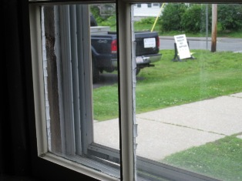

Deteriorated Glazing

Picture 2

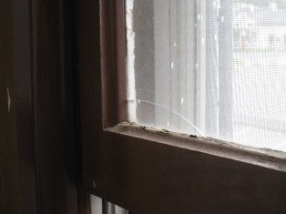

Broken Pane of Glass
Picture 3

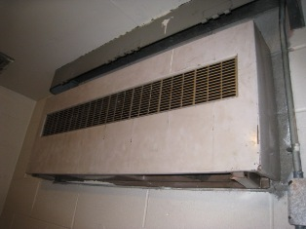

Nonfunctioning Ventilation Unit in Former Jail Cell

Picture 4

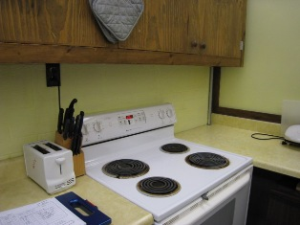

Exhaust Fan Lacking Above Stove
Picture 5

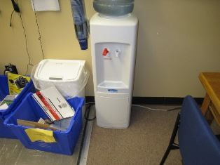

Water Cooler Located on Carpet

Picture 6

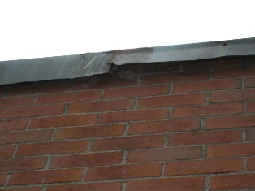

Flashing At Edge of Roof in Disrepair
Picture 7

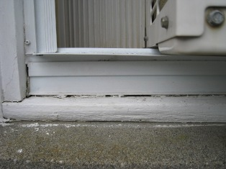

Gaps between Window Casing and Exterior Sill

Picture 8

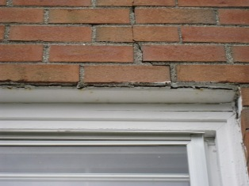

Sealant at Top of Window is Deteriorated
Note Cracked, Broken Masonry
Picture 9

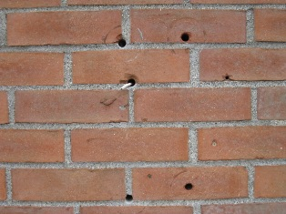

Holes in Brick

Picture 10

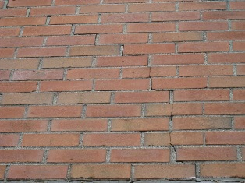

Cracks in Brick and Mortar
Picture 11

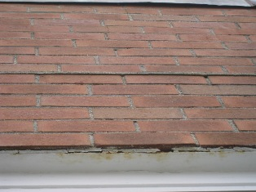

Cracked, Broken and Bulging Mortar

Picture 12

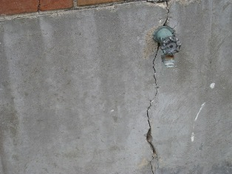

Crack in Foundation
Picture 13

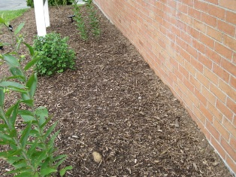

Wood Mulch at Front of Building

Picture 14



Rodent Droppings

Picture 15

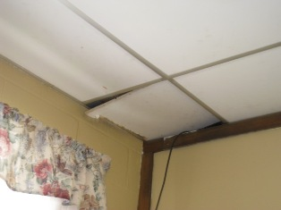

Ajar Ceiling Tile

Picture 16

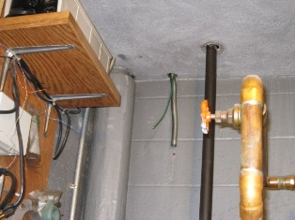

Open Utility Holes
Picture 17

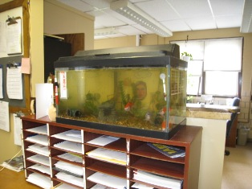

Algae Growth in Aquarium

Location | Occupants  in Room | Carbon  Dioxide  (ppm) | Temp  (°F) | Relative  Humidity  (%) | Carbon Monoxide  (ppm) | Windows  Openable | Ventilation |  | Remarks
 |  |  |  |  |  |  | Supply | Exhaust | Remarks
Outside  (Background) |  | 403 | 70 | 63 | 2.2
Front desk | 0 | 509 | 72 | 64 | 1.6 | Y  ½ open | N | N | DC, Carpet
EMS Director’s Office | 0 | 475 | 74 | 61 | 1.3 | Y  1/3 open | N | N | DO, window mounted AC
Large Bunk Room | 0 | 560 | 74 | 60 | 1.3 | Y  closed | N | N | DO, WDCTs, 1 comp.
Small Bunk Room | 0 | 726 | 75 | 60 | 1.1 | Y  closed | N | N | DC, PF, AC, WDCTs,  Carpet measured at base of wall 6.5 (Dry)
Day Room | 1 | 586 | 75 | 60 | 1.1 | Y  Closed | N | N | WC on carpet, UF, Humidifier, DEM  Carpet measured at base of wall 8.5 (Dry)
Kitchen | 3 | 641 | 75 | 58 | 1.0 | Y  1/1 open | N | N | No vent for stove, Holes in CTs, rodent feces
Bathroom | 0 | 601 | 75 | 58 | 1.1 | Y  1/1 open | N | Y | DO
Locker | 0 | 589 | 75 | 58 | 1.0 | N | N | N | DO, Floor tiles in disrepair
Boiler Room | 0 | 568 | 76 | 57 | 1.0 | Y  1/1 | N | N | DO
Radio office | 2 | 617 | 76 | 53 | 1.1 | Y  ½ open | N | N | DO, floor tiles

