K9.0 Police K9 Protocols

EMT/ADVANCED EMT/PARAMEDIC STANDING ORDERS
Under Chapter 23 of the Acts of 2022 (known commonly as “Nero’s Law,”) EMS is required to assess, treat and transport police K9s who are injured in the line of duty. However, EMS shall not transport an injured police K9 if providing such transport would inhibit their ability to provide emergency medical attention or transport to a person requiring such services.
- This statute defines "police dog" as a dog owned by a police department or police agency of the Commonwealth, or any political subdivision thereof, and used by the department or agency for official duties. EMS is not authorized to treat and transport any other type of dog.
- EMS will require the assistance of the police dog’s police handler or backup
handler, to approach the dog and ensure it is safe for EMS personnel to attend to the police dog. If neither police K9 handler or backup K9 handler are available, EMS may contact local Animal Control for assistance restraining and safely treating and transporting the police d o g . The Department is aware
E
that Animal Control capabilities vary greatly across the state, and in some areas, this may not be appropriate. However, if transport by ambulance would impair EMS’ ability to respond to persons who need EMS care and transport, Animal Control may be considered an appropriate transport choice as long as Animal Control is available and appropriately equipped to transport the police dog. At no time shall EMS care of a police dog take priority over a person needing EMS care.
Police K9 Protocols
/
A
/
- This statute requires EMS personnel to provide police dogs only BLS-level first aid, cardiopulmonary resuscitation and life-saving interventions, including, but
P
not limited to, administering naloxone. The statute does NOT authorize EMS to
provide ALS-level care to a police dog.
- The statute protects EMS personnel from liability when they provide care to police dogs in accordance with the statute and these protocols. It also exempts EMS care provided in accordance with the statute and these protocols from being considered the practice of veterinary medicine.
- Ambulance services shall alert the receiving facility at the phone number listed
in the Statewide Point-Of-Entry Plan for Police Dogs, using their Public Safety Access Point (PSAP) and/or cell phone.
- EMS shall document all responses to police dogs on a patient care report
(PCR). In electronic PCRs, and for submission to MATRIS, EMTs shall document Police Dog transports by entering “K9” in the Patient Last Name Field (ePatient.02).
- Injured or ill humans always take priority over police dogs.
- These guidelines are reserved for use only on police dogs who are injured in the line of duty.
- In accordance with the statute, the Department consulted with
veterinarians and with police dog handlers in the creation of these protocols, and thanks all these experts for their time and input.

Massachusetts Department of Public Health Office of Emergency Medical Services Statewide Treatment Protocols Effective by February 10, 2023

K9.1 Police K9 Restraint

EMT/ADVANCED EMT/PARAMEDIC STANDING ORDERS
The goal is to safely provide the police dog initial medical evaluation, treatment and transport to definitive care. An injured police dog may pose an unintentional threat to EMS; therefore it is imperative that the police dog be secured prior to medical evaluation. This is best done by the dog’s police handler. It is also preferable that the dog’s police handler stay with the police dog throughout all phases of care, evacuation, and transport unless they, themselves are injured or required for urgent police duties. If the primary handler is not available, contact backup police K9 handler, or, if animal control is available and equipped to do so, contact Animal Control to secure and stay with the injured police dog. If transport by ambulance would impair EMS’ ability to respond to persons who need EMS care and transport, Animal Control may be considered an appropriate transport choice as long as Animal Control is available and appropriately equipped to transport the police dog.

All injured police K9s should be muzzled before handling. The following are relative contraindications to muzzling:
- Unconsciousness
E
- Upper airway obstruction
- Vomiting
/
- Severe facial trauma
Police K9 Protocols
- Heat-related injury (need to allow for evaporative cooling via panting). If these police K9s need to be muzzled, a Cage- or Basket-type muzzle is preferred.
A
- The type of muzzle used depends on the size of the police K9, available material, type of injury and whether there is a need to access the police K9's head.
/

P
Muzzle Type | Required Materials | Suggested Use
Cage or Basket | Manufactured cage/basket muzzle (preferably made out of rubber) | - All Purpose  - Preferred muzzle: allows for open-mouth breathing  - Suggested if oxygen delivery is indicated
Fabric | Manufactured, pre-sized muzzle | All-purpose
Quick muzzle | Any available, broad-width (greater than 1-2 inches) tape, leash, webbing, gauze, etc. | - Use only if fabric or cage/basket muzzle is unavailable  - Narrow gauze etc. can cause injury, prevents panting (heat reduction) and may impede air flow To apply, create a loop with the gauze or leash, slip  over muzzle, tighten, wrap gauze so it is on the underside of the jaw and tie back behind the ears.

- The police K9 should be restrained in a position of comfort, which may include sitting or standing. Do not restrain the police K9 in such a manner that its ability to breathe or pant is impeded.
- Slide the appropriately-sized muzzle over the police K9's snout from the rostral (anterior) to caudal (posterior) aspect. Be sure that the lower jaw is captured in the muzzle and not free.
- Be sure to frequently check the security of the muzzle and make sure that it is not impeding the police K9's ability to breathe.

**It is important that the clinician be adequately trained to restrain the police K9 in order to safely apply a muzzle. A stressed police dog may not only bite the EMT or Paramedic or others, but may bite its handler as well.**

Massachusetts Department of Public Health Office of Emergency Medical Services Statewide Treatment Protocols Effective by February 10, 2023

K9.2
Police K9
Airway Obstruction and Management

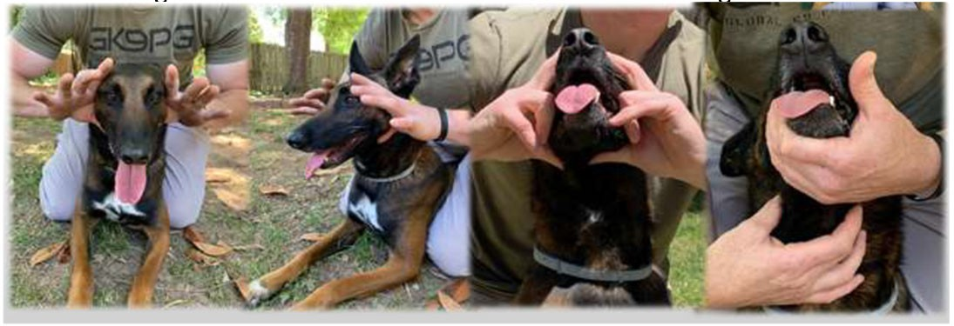
EMT/ADVANCED EMT/PARAMEDIC STANDING ORDERS

AIRWAY OBSTRUCTION
Clinical signs of airway obstruction include the following:
- Gagging
- Pawing at the mouth
- Excessive drooling
- Frequent swallowing motions
- Extension of the head and neck
- Tripod position
- Reluctance to lie down
- Cyanosis (late sign)
Similar to a person who can speak clearly without any respiratory distress, consider a police K9 that is barking, growling, or wining without any clinical signs
E
of respiratory distress to have a patent airway.
  - Allow for position of comfort (this may be sitting, standing, or lying with head elevated)
/
  - Secure police K9 with leash/rope (placing leash around neck and then pulling one front leg through the loop provides some control but does not constrict the neck)
Police K9 Protocols
A
  - Do not put hands in the police K9's mouth (serious injury to clinician can occur)
  - Attempt abdominal thrusts (avoid if sharp object involved)
/
    - “bear hug” or lay police K9 on side and place fist just below sternum or behind ribs.
P
    - Five (5) quick and upward abdominal thrusts following by airway check
This can be performed by using the two loops of gauze as shown below, or by placing a rolled towel towards the back of the dog’s mouth (let them bite down on that but be sure it is heavy enough to prevent the jaws from closing all the way).
    - If not successful, repeat 1-2 times
  - Palpate throat/trachea through the front of the neck – you may be able to dislodge a supraglottic foreign body out of the airway.
    - Palpate for the object at the front of the neck (midline, slightly below the jaw).
    - From bottom of palpated object, squeeze/push upwards towards the front of the mouth.
      - Two-handed with both thumbs, or
      - Single-handed with thumb and index or middle finger.

Protocol Continues

Massachusetts Department of Public Health Office of Emergency Medical Services Statewide Treatment Protocols Effective by February 10, 2023

Police K9
Airway Obstruction and Management

K9.2

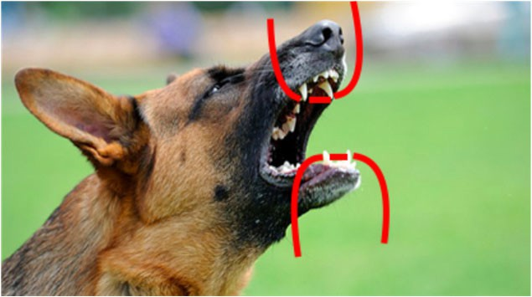

  - In an unconscious police K9, open the airway by extending the head and neck, and pull the tongue forward. A second rescuer should use gauze/leash looped behind upper canine teeth to keep the mouth open. Use a second length of gauze/leash for the lower jaw, as well.

  - In an unconscious police K9, if the obstruction is:
E
- VISIBLE: attempt to manually remove; do not push foreign body further back in airway.
/
- NOT VISIBLE: do not attempt a blind finger sweep due to risk of pushing the foreign body further down the airway. A blind finger sweep should never be attempted whether unconscious or conscious.
Police K9 Protocols
A
  - If object is not removed and police K9 collapses, provide chest compressions and mouth-to-snout or BVM (with a canine mask), see Protocol K9.4
/

P AIRWAY MANAGEMENT
- Place the Police K9 in the sternal (prone) position
- Open airway
  - Tilt head and slightly extend the neck
  - If foreign body suspected, refer to Airway Obstruction protocol, K9.2.
- Provide oxygen via BVM (with canine mask) with goal respiratory rate of 10-12 breaths/minute. Pediatric or Adult BVMs can be used targeting goal tidal volume on seeing chest rise.
  - If positive pressure ventilations are not required, supplemental oxygen may be administered by holding an NRB near the nose, taping oxygen tubing to the muzzle or holding a canine mask near the nose (without tight seal).

Massachusetts Department of Public Health Office of Emergency Medical Services Statewide Treatment Protocols Effective by February 10, 2023

K9.3
Police K9
Cardiac Arrest and Post ROSC Care

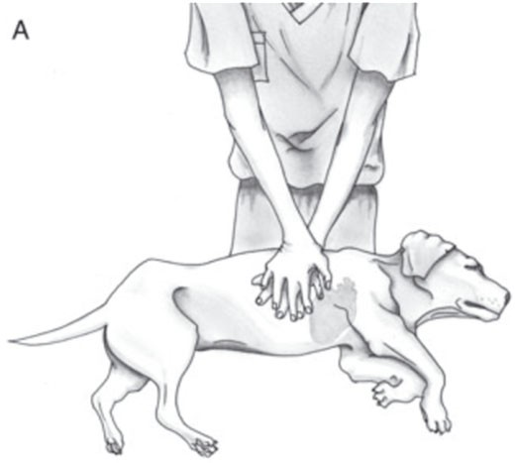
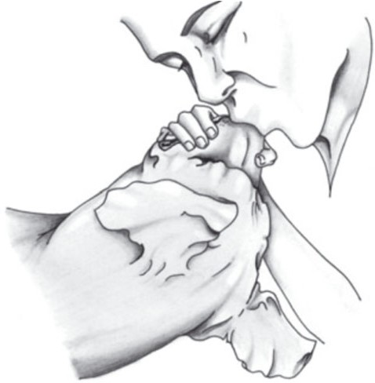
EMT/ADVANCED EMT/PARAMEDIC STANDING ORDERS

CARDIAC ARREST
- Place dog in lateral recumbency
- Initiate chest compressions
  - See photo below
- High-flow O2 with BVM ventilation 1 breath every 10 compressions during recoil and without interrupting compressions or at a ratio of 30:2
  - Compression rate of 100-120 compressions/minute
  - Depth of ½-1/3 of chest width
- Continue 2-minute cycles of chest compressions with pulse checks
- If ROSC occurs, manage airway and maintain ventilation rate between 10-12 breaths per minute.

E
/ A
Police K9 Protocols
/

P

Adapted from Journal of Veterinary Emergency and Critical Care 22(S1) 2012, pp S102–S131 doi: 10.1111/j.1476-4431.2012.00757.x

Massachusetts Department of Public Health Office of Emergency Medical Services Statewide Treatment Protocols Effective by February 10, 2023

K9.4

Police K9 Hemorrhage Control and Hemorrhagic Shock

EMT/ADVANCED EMT/PARAMEDIC STANDING ORDERS

HEMORRHAGE CONTROL
- Ascertain all sites of bleeding and control with direct pressure
  - Extremity: apply an elastic wrap/pressure bandage, or SWAT-T.

** Commercially made windlass tourniquets are not effective on Police K9s due to the tapered shape of their extremities.**
- For deep wounds in junctional areas or areas containing large muscle bellies (neck, thigh, shoulder/triceps area) control bleeding by applying a dressing with hemostatic agent and applying/maintaining pressure over the dressing for a minimum of 5 minutes.
  - Check for ongoing bleeding. If bleeding has stopped, apply appropriate pressure bandage over top of dressing; if bleeding continues, reapply pressure for a minimum of 5 minutes.
  - If bleeding continues, remove the initial hemostatic dressing and repeat
E
with a new hemostatic dressing.
- Manage airway as appropriate, per Protocol K9.2
/

Please note: the SWAT-T should be stored and used for LEK9 care only. This is not approved for use on humans.
Police K9 Protocols
A

/ HEMORRHAGIC SHOCK
P
If history of illness or mechanism of injury consistent with signs/symptoms of shock (elevated pulse, elevated respiratory rate, pale mucous membranes, altered mentation or LOC) then transport as soon and as efficiently as possible.

- Control bleeding, refer to Hemorrhage Control, above
- Manage airway as appropriate, see protocol K9.2

Stage of Shock | HR  beats/ min | Capillary  refill secs | Mucous Membranes | Mentation | Pulse Quality
Normal (at rest) | <120 | <2 | Pink | Bright, alert | Strong
Acute Compensatory | >120 | <1 | Red | Alert | Fair
Early Decompensatory | >140 | >2 | Pale | Depressed | Weak
Terminal/Irreversible | <80 | Absent | Pale | Stupor/ Comatose | Absent

Massachusetts Department of Public Health Office of Emergency Medical Services Statewide Treatment Protocols Effective by February 10, 2023

K9.5

Police K9 Chest Trauma

EMT/ADVANCED EMT/PARAMEDIC STANDING ORDERS
- Administer oxygen, as appropriate, assist ventilations (BVM) if needed
- Impaled Objects
  - Secure in place with bulky dressings
- Open Chest Wound
  - Cover with vented or non-vented occlusive dressing
  - If shock present, consider tension pneumothorax has developed and burp/ vent the chest seal.
- Flail segment with paradoxical movement and respiratory distress
  - Consider BVM ventilation

E
/ A
Police K9 Protocols
/

P

Massachusetts Department of Public Health Office of Emergency Medical Services Statewide Treatment Protocols Effective by February 10, 2023

K9.6

Police K9 Burns

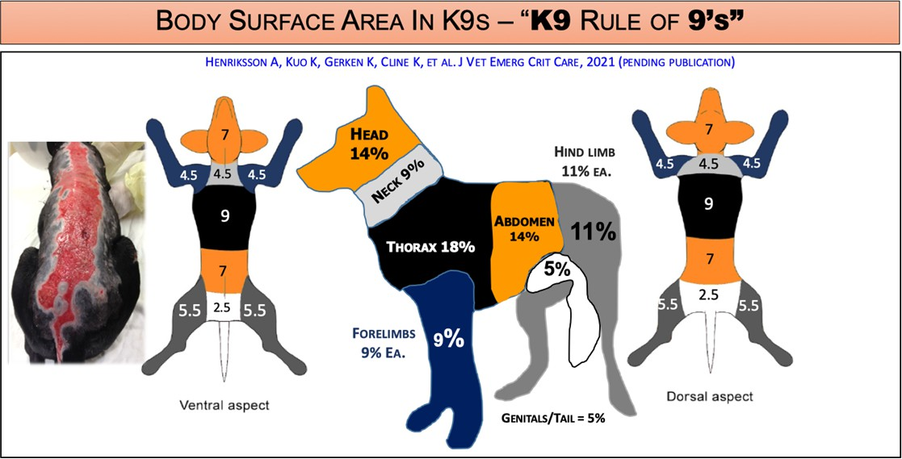
EMT/ADVANCED EMT/PARAMEDIC STANDING ORDERS
- Avoid pulling away any gear that is melted in the skin/coat. Only remove harness/collar if other methods are in place to control Police K9, otherwise, leave in place.
- Oxygen, as appropriate
- Give highest priority to airway problems and major trauma
- If burn is >15% TBSA (superficial or partial thickness), consider cooling burn with cool water (sterile water/saline if available).
- Cover burn with dry dressing, sterile sheet, or commercially prepared dry dressing
- Prevent heat loss/hypothermia

E
/ A
Police K9 Protocols
/

P

Massachusetts Department of Public Health Office of Emergency Medical Services Statewide Treatment Protocols Effective by February 10, 2023

K9.7

Police K9 Opioid Overdose/CO/CN/Smoke Exposure

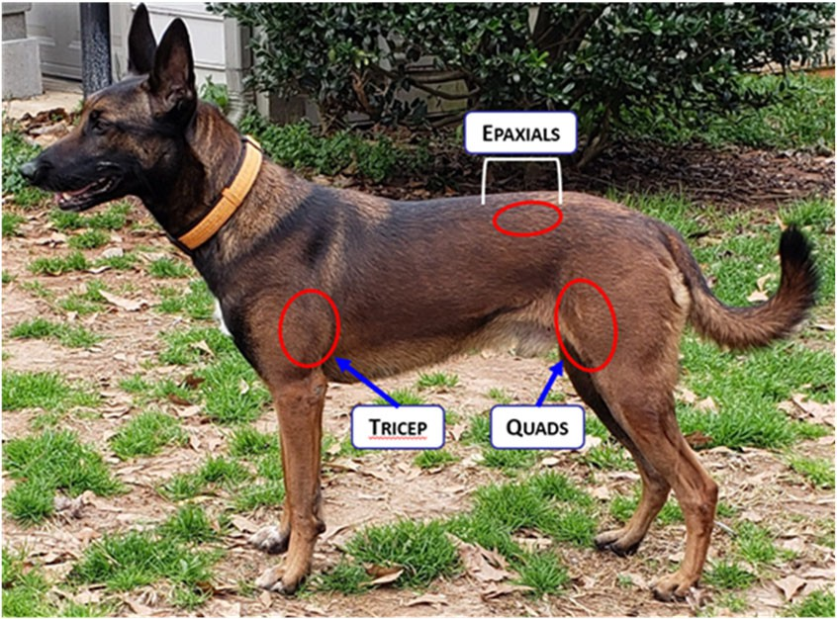
EMT/ADVANCED EMT/PARAMEDIC STANDING ORDERS OPIOID OVERDOSE:
Opioid overdose in Police K9 is manifested primarily by excessive sedation, bradycardia, and hypothermia. Police K9 are less susceptible than humans to the respiratory depressant effects of opioids.
  - Administer oxygen, as appropriate
  - Manage airway, providing rescue breaths if RR <8, see Protocol K9.3
  - Consider securing Police K9 with muzzle in anticipation of reversal of opioid
  - If it is suspected that the Police K9 came into contact with an opioid, is unresponsive and showing severe symptoms of opioid overdose, administer:
    - Naloxone 2-4mg IN, repeat every 2-5 minutes as needed (dose depends upon pre-packaged medication); OR
    - Naloxone 2-5mg IM via auto-injector (dose depends upon device), repeat
E
every 2-5 minutes as needed

CARBON MONOXIDE/CYANIDE/SMOKE EXPOSURE
/
** Remove Police K9 from source of smoke/inhalation**
Police K9 Protocols
- Secure Police K9, per Protocol K9.1
A
- Manage airway as per Protocol K9.2
/

If you suspect CO/CN exposure:
- Administer high flow O2

P *pulse oximetry may be inaccurate in exposure to CO/CN

Adapted from NAVEMS Training, used with permission

Clinical signs of cyanide toxicity are frothing at the mouth, rapid/deep breathing, excitability (tremors, seizure), and can progress to severe respiratory depression, loss of consciousness, coma, and death.

Massachusetts Department of Public Health Office of Emergency Medical Services Statewide Treatment Protocols Effective by February 10, 2023

K9.8
Police K9 Organophosphate/Carbamate Exposure

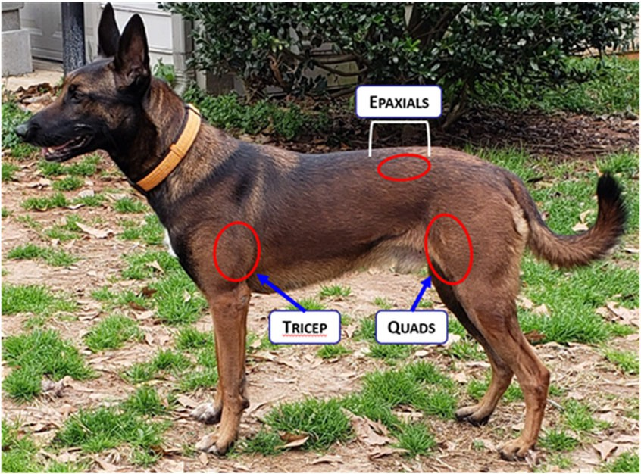
EMT/ADVANCED EMT/PARAMEDIC STANDING ORDERS PEARLS:
WARNING: CONTACT WITH THESE TOXINS CAN BE FATAL TO RESCUERS CONSIDER SCENE SAFETY AND DECONTAMINATION
- Assess for SLUDGEM symptoms (Salivation, Lacrimation, Urination, Defecation, GI Distress, Emesis, Muscle twitching/Miosis [constricted pupils]) and the Killer- Bs (Bradycardia, Bronchorrhea, Bronchospasm)
- Transport Police K9 with all windows of ambulance open, or ensure exhaust fan and ventilation system activated.
- Decontaminate entire ambulance after Police K9 transport
In unstable Police K9 with known organophosphate/carbamate poisoning:

- Remove Police K9 from contaminated area and perform decontamination as needed based on scene/call circumstances.
E
- Oxygen as appropriate
- Manage airway as appropriate, see Protocol K9.3
/
*Ventilatory support may be critical in these poisonings*
Police K9 Protocols
- Vigorous suctioning may be necessary
A
- Mark 1 or Duo-Dote kit (noted as auto-injector in table below)
*If already carried on the ambulance (not a required medication)*
/

P
Atropine | Lb | Kg | Dose (mg) | Min # auto- injectors
 | 40 | 18 | 3.6-9 | 2
 | 50 | 22 | 4.5-11.4 | 2
 | 60 | 27 | 5.4-13.5 | 2
 | 70 | 32 | 6.4-16 | 3
 | 80 | 36 | 7.2-18 | 3
 | 90 | 41 | 8.2-20.5 | 4

2-PAM Chloride | Lb | Kg | Dose (mg) | Min # auto- injectors
 | 40 | 18 | 180-360 | 2
 | 50 | 22 | 227-450 | 2
 | 60 | 27 | 270-540 | 2
 | 70 | 32 | 320-640 | 3
 | 80 | 36 | 360-720 | 3
 | 90 | 41 | 410-820 | 4

Adapted from NAVEMS Training, used with permission

Massachusetts Department of Public Health Office of Emergency Medical Services Statewide Treatment Protocols Effective by February 10, 2023

K9.9

Police K9 Heat Injury

EMT/ADVANCED EMT/PARAMEDIC STANDING ORDERS

  - Police K9 do not sweat. Their predominant cooling mechanism is by panting.
  - The progression of heat injury in the Police K9 can be quite rapid and

requires immediate intervention.
  - Causes are environmental, exertional or a combination of the two.
  - AVOID muzzles unless required for safety reasons; an open basket muzzle is the preferred muzzle in this case to allow for panting.

E
 | Core Temp (F)* | HR | MM | LOC | Panting** | Behavior/Performance
Mild (heat stress) | Varies 105-106 | Fast, strong | Moist, Pink | Alert | Heavily Controlled | Excessive thirst, discomfort with physical activity, slightly  decreased performance
Moderate (heat exhaustion) | 106-108 | Fast, Strong, or Weak | Tacky or Dry, Bright Red | Alert | Uncontrolled, Failure to Salivate | Weakness, anxiety, unwillingness to work, acts tired, unresponsive  to handler commands
Severe (heat stroke) | Usually  >108 | Weak | Dry Pale | Altered | Maybe | Vomiting, diarrhea, ataxia, head tremors, seizures, blindness,  abnormal pupil size
* Many canines are not trailed or tolerable of rectal temps; may use axillary temperature if a rectal temp is not achievable. Axillary temps are approximately 1-2 degrees F less than rectal

/ A
Police K9 Protocols
/
P

Treatment for all stages of heat illness includes:
- Remove the Police K9 from the heat source and stop their work/exercise.

Transport immediately and perform other actions en route.
- Begin cooling methods
- Monitor temperature (rectal or axillary), if trained and equipped
- Monitor for changes in mentation

Mild Heat Injury (heat stress)
- Cool by bringing to a shaded or lightly air-conditioned area. If no A/C available, use circulating fan to blow a light breeze by the Police K9
- As feasible, remove muzzles, harnesses, tactical gear, etc.
- Place on a cool surface to promote conductive cooling
- Offer cool water and encourage drinking
- Monitor vital signs every 5 minutes; if able to measure temperature, discontinue cooling efforts when core temp is 104F or less

Source: DHS Working Dog Handler Medical Care Manual 2017 Protocol Continues
Massachusetts Department of Public Health Office of Emergency Medical Services Statewide Treatment Protocols Effective by February 10, 2023

Police K9 Protocols K9.9

Moderate Heat Injury (heat exhaustion)
- Follow guidelines above and start active external cooling
  - Use air conditioning or cooling fans, if available, to reduce core body temperature
  - Place cold compress or wrapped in towels on the head and neck as well as the axillae and groin. Avoid placing ice packs on the limbs as this shunts hot blood back to the core
  - Douse or spray body with cold water; soak hair to skin with cold water and use fans or A/C to cool further.
- Monitor vital signs every 5 minutes; if able to monitor temperature, discontinue cooling efforts when core temperature drops below 104F
- Dry Police K9 off, place on a dry surface, if possible and avoid direct application of air on Police K9 from circulating fans or A/C
E
- If able to monitor temperature, and if body temperature drops below 100F (rebound hypothermia) consider passive warming by covering with blankets or other similar materials
Police K9 Protocols
/

Severe Heat Injury (heat stroke)
A
** This is a life-threatening condition**
- If able to monitor temperature, rapid cooling to a body temperature of 103.5-104F
/
  - Cool water (do not submerge in ice bath)
  - Soaking the Police K9 to the skin with cool water. Soak the entire Police K9 as
P
rapidly as possible through the hair, soaking the skin thoroughly and implement convective cooling with cooling fans or A/C.
- If able to monitor temperature, when temperature reaches 104 F, remove from the bath/water, dry hair and continue to monitor temperature, watch for rebound hypothermia, as above

NOTE: No single core temperature value defines heat-related illness for all Police K9s in all circumstances. Well-conditioned, acclimated Police K9 may reach peak core temperatures as high 106 - 108° F while working, yet display no behavioral or clinical signs of heat stress. Base clinical assessment on presence and progression of clinical signs over core temperature.

**Controlled panting: the Police K9 can stop panting with an alcohol-soaked gauze is put in front of the nose or when the Police K9 becomes interested in or distracted by something (i.e. toy, reward, noxious stimulus, verbal command).
**Uncontrolled panting: the Police K9 cannot stop panting even when offered a treat or reward or when exposed to alcohol-soaked gauze or other noxious stimuli.

Massachusetts Department of Public Health Office of Emergency Medical Services Statewide Treatment Protocols Effective by February 10, 2023

K9.10

Police K9 Anaphylaxis

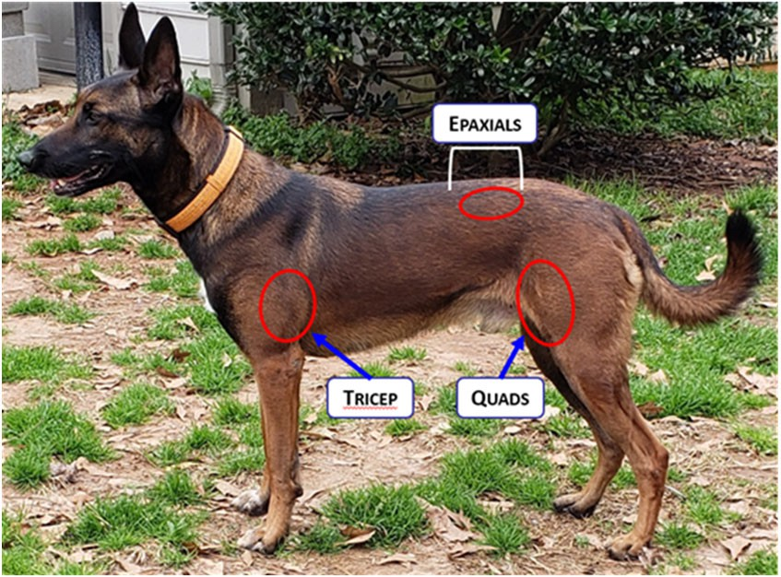
EMT/ADVANCED EMT/PARAMEDIC STANDING ORDERS
- Allow Police K9 to assume position of comfort
- Secure Police K9 with leash/rope
- Manage airway as appropriate
- Supplemental oxygen, as appropriate
- If anaphylaxis identified, administer epinephrine via auto-injector or IM using Check and Inject, dosed by Police K9 weight.
  - epinephrine 0.3 mg IM (Adult auto-injector) for Police K9s 20kg or greater
  - epinephrine 0.15 mg IM (Pedi auto-injector) for Police K9s less than 20kg
- May repeat IM epinephrine dose every 5-15 min x 3 if signs/symptoms continue or return despite initial treatment

E
/ A
Police K9 Protocols
/

P

Adapted from NAVEMS Training, used with permission

PEARLS
In allergic reactions with progression to anaphylaxis, clinical signs are most often associated with the cardiovascular (CV) and gastrointestinal (GI) systems. Respiratory signs may also develop, along with seizures and anxiousness, progressing to weakness and collapse.
Signs include:
- CV: tachycardia, weakness, weak pulses, mucous membrane color changes
- GI/GU: urinating, vomiting, and diarrhea that is often bloody
- Respiratory: increased respiratory effort, wheezes, and crackles

Massachusetts Department of Public Health Office of Emergency Medical Services Statewide Treatment Protocols Effective by February 10, 2023

