2.20 Home Hemodialysis Emergency Disconnect

EMT/ADVANCED EMT/PARAMEDIC STANDING ORDERS
Home Hemodialysis Emergency Disconnect
OVERVIEW
Some patients are now doing UNATTENDED (i.e. solo) home hemodialysis. In the event you respond to a scene where such a patient is unable to disconnect themselves from the machine, and no else is available who knows how to do so, follow this procedure to disconnect the patient for transport.
• 1.0 Routine Patient Care
- If time and patient condition permit, ALS backup should be called for BLS crews.
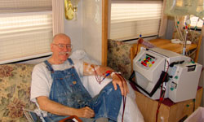
OFF-STOP
• IF you are trained in using HD shunt clamps, and such clamps are available, it is
acceptable to remove the HD needles from the patient’s shunt and apply clamps. If not,
this procedure should be followed, leaving the needles in situ as described above and
below.
• The dialysis machine will be left at the home.
• If you can, note (or photograph) any clinically relevant values on the machine’s readouts
(such as liters removed).
• For a patient with an AV shunt, the result of this procedure is that the patient still has
the dialysis needles in their AV fistula, ATTACHED to CLAMPED tubing, which is
wrapped with gauze to keep the needles and tubing next to the patient’s arm
(unless HD shunt clamps are used).
Procedure:
Procedure:
1. Push the STOP button on the front of the machine and unplug the machine’s power cord.
2. Identify and close the 4 clamps on the tubing. If clamps are not on the tubing, use Kelly
clamps or plastic clamps (which will usually be on or near the dialysis machine) to clamp off
the 2 tubes both above and below the Luer lock disconnects.
The disconnects are in the center of the pictures below.
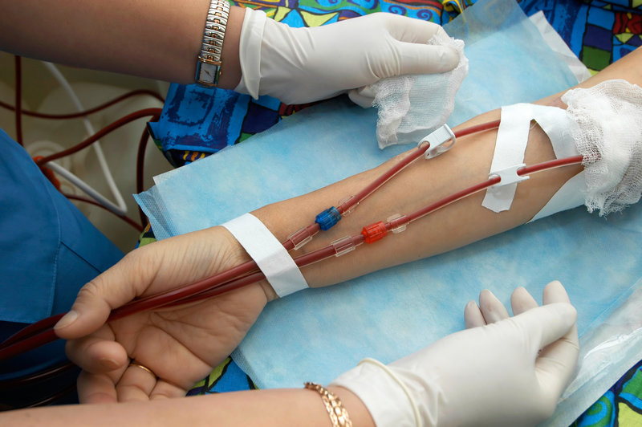

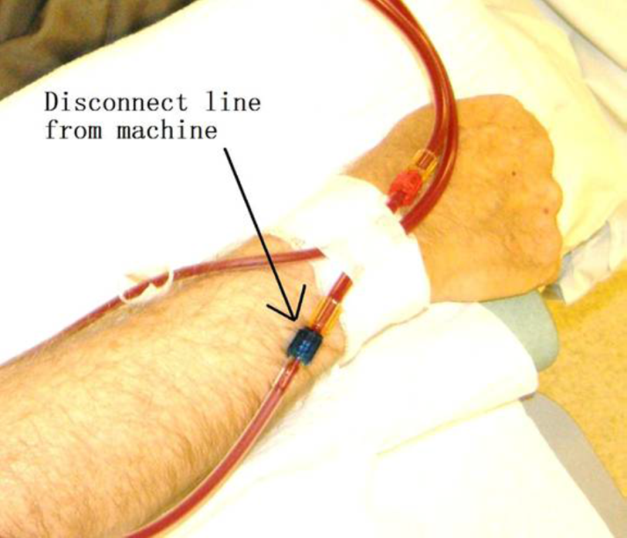

Procedure continues:
3. If you are trained to do so, and you have sterile caps or sterile syringes, or they are on or near the dialysis machine, then swab each disconnect end-connector with alcohol and attach
the cap or syringe.
4. You will now have two needle-tubing pieces still inserted into the patient’s fistula. GENTLY tape the tubing to the patient’s arm, then LOOSELY wrap gauze around the arm. DO NOT apply a pressure dressing.

If you accidentally pull a needle out of the fistula you will have to apply firm manual pressure (again, NOT a pressure dressing) to that bleeding point for 20 minutes – so likely will need a backup crew to provide medical care!

