APPLICANT QUESTIONS
Responses should be sent to DoN staff at DPH.DON@State.MA.US
While you may submit each answer as available, please
- List question number and question for each answer you provide
- Submit responses as a separate word document, using the above application title and number as a running header and page numbers in the footer
- When providing the answer to the final question, submit all questions and answers in one final document
- Submit responses in WORD or EXCEL; only use PDF’s if absolutely necessary. If “cutting and pasting” charts, provide them in a PDF so they can be clearly seen

- Provide the gender composition of the Emerson Hospital Patient Panel for FY19.

 | Male | Female
Emerson Patient Panel | 38.2% | 61.8%
Emerson Endoscopy Panel | 44.8% | 55.2%

- As noted in the application, 46% of the Emerson Hospital Patient Panel and 37.4% of the Emerson Endoscopy Patient Panel chose not to report their race/ethnicity. Describe the process for acquiring this information.
Race/ethnicity is a required field in Emerson’s patient registration system, MediTech; however, if a patient chooses not to report, there is an “unknown” option which is selected by the Patient Registration assistant. Therefore, while race/ethnicity information is requested during requested during patient registration, it is self-reported and optional. As a result, many patients skip over the question.
The ASC will continue to collect race/ethnicity during patient registration.
Given the limited race and ethnicity data provided by patients, Emerson relied on Sg2 Market Demographics to aid with its 2018 Community Health Needs Assessment. That data shows the Emerson service area is 82 % White Non-Hispanic, 10 % Asian and Pacific Islanders Non-Hispanic, 4 % Hispanic, and 2 % Black Non-Hispanic.

- The Applicant states that the Emerson Hospital endoscopy service provides routine, advanced, and urgent endoscopy, accommodating both inpatient and outpatient procedures.

1

759666.1

  - Provide a breakdown of endoscopy procedure volume by the following

Please see the below tables for the breakdown of endoscopy procedures in FY 2020.

    - Inpatient vs. Outpatient basis

 | Volume | Percentage
Inpatient | 614 | 15%
Outpatient | 3,463 | 85%
Total | 4,077 | 100%

    - Routine, Advanced, and Urgent basis

 | Volume | Percentage
Routine | 3,830 | 94%
Advanced | 146 | 4%
Urgent | 101 | 2%

- The proposed free-standing ASC will have two outpatient procedure rooms. Provide the data used to determine the number of procedure rooms needed at the ASC.
The Applicant determined the need for two rooms at the ASC based on historical volume at Emerson Hospital as well as additional factors indicating projected growth for endoscopy in the service area. With a fully staffed endoscopy service, Emerson Hospital performed approximately 4,500 outpatient procedures annually. This served as the basis for the Applicant’s projection for the first five operating years.
Additionally, the Applicant reviewed population projections for the service area, including the percentage of residents in the service area who will be aged 50 and over in the projected years. Specifically, the percent of the population aged 65 and over will reach nearly a quarter of the total population of the proposed service area.
The Applicant also considered recent updates to CRC screening guidelines for adults at average risk. At the time of the DoN filing, the American Cancer Society (“ACS”) had recommended screening beginning at age 45 through guidance announced in 2018. This change did not result in widespread insurance coverage for individuals aged 45-49¹ Since that time, however, the U.S. Preventative Services Task Force (“USPSTF”) has also announced updated guidance in agreement with the

¹ Amongst PE’s contracted payers, currently only Aetna covers routine screening colonoscopy for individuals of average risk beginning at age 45.
2

759666.1

lowered age (45 years) of routine screening for average risk adults. With the lower age recommended by ACS and the USPSTF, it is expected that payers will begin to recognize this guidance and update their payment policies to cover screenings beginning at 45, thereby increasing the number of individuals eligible for insurance coverage of CRC screening.² Based on the factors noted above, the Applicant determined that two procedure rooms would be needed to accommodate Emerson’s current outpatient endoscopy as well as projected demand. Therefore, the Applicant proposes an ASC with two procedures rooms.
It is important to note that once the ASC is open, Emerson will shift clinically appropriate procedures to the ASC. In turn, Emerson will close two of its four endoscopy procedures rooms. In effect, the Applicant will not be creating additional capacity within the service area. Procedures that cannot be performed at the ASC, including advanced, urgent and clinically complex procedures, will continue to be performed at Emerson in the remaining two procedure rooms at the hospital.

- In the application you provide the CRC screening rate in the service area, which is below the state average. The Proposed Project aims to also improve CRC screening rates in the region.
  - What evidence can you provide to show that lack of access to convenient and cost- effective colorectal cancer (CRC) screenings is contributing to lower CRC screening rates and that the Proposed Project will address the problem.

While the Affordable Care Act (the “ACA”) made two important changes in cost sharing for colonoscopies under Section 4104, cost barriers remain for many individuals. The first change under the ACA waived deductibles for screening and therapeutic colonoscopies. The second change removed coinsurance for screening colonoscopies, but not for therapeutic procedures. As a result of both changes, research found that although there was a significant increase in screening rates among men following the implementation of Section 1404 in 2011³ , cost still “may be an important barrier” to CRC screening for socioeconomically disadvantaged men and that the reduction in expected out-of-pocket costs was at least in part responsible for the increase in CRC screening rates following the ACA’s implementation.
Given that cost sharing still exists under the ACA, continued low screening rates are likely still attributable to the potential for patient cost sharing from therapeutic procedures. As mentioned above, the ACA did not bar insurers from requiring coinsurance for individuals

² The USPSTF’s updated guidance lowering the age of screening is a “B” recommendation meaning the Task Force has found “high certainty that net benefit is moderate or moderate certainty that net benefit is moderate to substantial”. Under the Affordable Care Act, insurers must “establish coverage policy consistent with USPSTF grade”. https://www.uspreventiveservicestaskforce.org/Home/GetFile/6/91/uspstfbrief2/pdf
³ https://www.healthaffairs.org/doi/full/10.1377/hlthaff.2015.0571#:~:text=51-
,Conclusion,those%20who%20were%20socioeconomically%20disadvantaged
3

759666.1

whose procedures are deemed therapeutic due to the removal of polyps. For many patients, colonoscopies are scheduled as routine screenings but result in the treatment of polyps during the procedure. Therefore, cost sharing may remain a barrier to CRC screening for patients. Through lower rates at the ASC, the Applicant seeks to lessen the potential cost sharing, in turn reducing potential cost barriers. Moreover, as guidelines move towards a lower age for coverage, more individuals will be eligible for insurance coverage for CRC screening. The Applicant believes access issues may be lessened for these reasons.

    - Is this the only barrier to accessing CRC screening or have other barriers been identified?
In addition to cost sharing requirements, insurer payment policies also limit when some individuals begin receiving CRC screenings. In 2018, the American Cancer Society updated their guidelines, lowering the age of first CRC screening to 45 for individuals with average risk. The recommendation was not adopted by the majority of government and commercial payers and currently most plans only cover routine screenings for average risk adults 50 year and older. As a result, many adults wait until the age when the procedure will be covered by their health insurance plan.

More recently, on October 27, 2020 the USPSTF proposed guidance in line with the American Cancer Society.⁴ Once the USPSTF’s guidance is finalized, insurers will be required to cover CRC screening beginning at age 45 in accordance with the ACA and the majority of payers will update their payment policies to align with the lower age for coverage.⁵ Previous barriers as a result of insurance coverage may be reduced overtime as more insurers align coverage to follow the USPSTF’s new guidance.

- How does Emerson Hospital track CRC screening for its Patient Panel? Include an explanation of the measure.

The DoN regulations define Patient Panel as the total number of individual patients, regardless of payer, seen by the Applicant or affiliated health care facility over the course of the most recent 36- month period. Given that the Applicant is a new provider and does not have a Patient Panel, it relied on Emerson Hospital’s Patient Panel as a proxy for need for the Proposed Project.
Accordingly, the Emerson Hospital Patient Panel reflects all patients who received services at the Hospital over the previous 36-month period. Separately, the Applicant provided the Emerson Hospital Endoscopy Patient Panel which reflect all patients who received endoscopy services at the Hospital over the previous 36-month period.

⁴ https://uspreventiveservicestaskforce.org/uspstf/draft-recommendation/colorectal-cancer-screening3
⁵ https://www.uspreventiveservicestaskforce.org/Home/GetFile/6/91/uspstfbrief2/pdf
4

759666.1

With respect to Emerson Hospital’s Endoscopy Department, patients are generally referred by their primary care provider (PCP) or GI specialist for endoscopy services. For preventive services, such as screening colonoscopies, the responsibility to recommend and refer patients lies with their PCP. Accordingly, most patients are referred for endoscopy services by their PCP. Some patients are referred by a specialist, including urology and gynecology, but very few patients are seen by Emerson without a referral due to the nature of the procedure. Because the patients are referred for services, Emerson Hospital’s Endoscopy Patient Panel includes a large subset of patients whose were referred by a primary care provider who is not a member of the Emerson Physician Hospital Organization (“PHO”). As a result, Emerson is unable to track screening rates for patients that are referred to its endoscopy service as the vast majority of referring providers are independent and not affiliated with Emerson Hospital, nor does the Hospital have access to the records of referred patients as Emerson Hospital does not serve as the patient’s medical home.

As Emerson Hospital performs the procedure and is not the referral source for screening, the Applicant relied on CRC screening data provided by the regional Community Health Network Areas (CHNA 7 and 15). However, the CHNAs cover towns that are not part of Emerson Hospital’s service area and thus the data is not a complete representation of screening rates for the towns served by the Hospital.

  - Will the Applicant use Emerson Hospital’s current CRC measure to demonstrate impact of the Proposed Project?

As described above, Emerson Hospital cannot accurately track CRC screening rates. Similarly, the ASC, as the provider of the screening procedure, will have the same limitations with respect to being a source for screening rates, rather than the source of preventative service recommendations or referrals.

  - What percentage of the Emerson Hospital Patient Panel met the screening recommendation for CRC?

Given the data source limitations discussed above, Emerson Hospital cannot determine what percentage of its Patient Panel met the CRC screening recommendation.

  - Describe other strategies that are being employed by Emerson Hospital to improve CRC screening rates for the Patient Panel as well as reducing risk factors for CRC in the community?

Over the past 18 months, Emerson Hospital has engaged with the community through a number of strategies to improve CRC screening through increased awareness and education.

Specific efforts include:
5

759666.1

- Health Works Magazine: Reaches approximately 140,000 households in Emerson’s total service area (primary, secondary, emerging)
  - Fall 2020 issue (page 5) - Reviewed several GI conditions and screening tools (See Attachment A)
  - Spring 2019 issue (page 9) - Information about importance of colonoscopies (See Attachment B)
- Direct Mail Trigger Campaign: Reaches approximately 25,000 individuals annually
  - Monthly direct mail and email campaign to individuals turning ages 50-55 in our total service area (primary, secondary, emerging) (See Attachment C)
- Podcast: Shared via our website, pushed out via social media, and available in app stores: https://radiomd.com/audio-player/emerson/item/41325-colon-cancer- screenings-latest-advances-and-ways-to-prepare

    - Will the ASC continue any of these efforts?
Yes, the ASC will continue to promote CRC screening through patient marketing campaigns as well as with physician education. PE and Emerson will continue to engage the community in an effort to increase awareness for CRC and the preventative measures available such as colonoscopy.

- Reporting on CRC in Massachusetts indicate disparities in routine screening and in cancer incidence and mortality.⁶
  - Did you review Emerson Hospital’s Patient Panel composition and historical utilization of endoscopy services, and evaluate disparities? If so, what disparities did it reveal along the following factors: race/ethnicity, gender, age, disability status, location, and/or payer mix/insurance status.

As discussed in Question 6, Emerson Hospital does not track or review its endoscopy patient panel for disparities given the incompleteness of the data available to the Hospital.

  - How will shifting endoscopy services from Emerson’s Endoscopy Department to the proposed ASC impact the demographic composition of the Patient Panel?

Most notably, the cost of services provided by the ASC will be lower than services performed in a hospital outpatient department. The lower cost of services may translate into potential savings for patients whose health insurance requires patient cost-sharing for the

⁶ Massachusetts Statewide 2017-2021 Cancer Plan https://www.mass.gov/doc/massachusetts-statewide-2017-2021-cancer-plan- 0/download A Profile of Health Among Massachusetts Adults, 2018 Results from the Behavioral Risk Factor Surveillance System. https://www.mass.gov/doc/a-profile-of-health-among-massachusetts-adults-2018/download
6

759666.1

service. The Applicant anticipates this will improve access to endoscopy for patients who currently face cost barriers.

- In order to understand continuity and coordination of care for Emerson endoscopy patients, describe post procedure follow-up, including linkages to the primary care provider and to specialists, and the process for sharing patient records.

Each patient is provided discharge instructions to aid their recovery including any prescriptions. Additionally, biopsy results are shared with the patient as well as their referring provider. For most patients, there is a referral from their PCP. Patients may also be referred by a specialist who would receive post-procedure results. Outside of referring providers, patients are able to request their records be sent to their provider of choice and furthermore, records will be available through the ASC’s electronic medical record, Centricity.

  - Explain how the ACO will facilitate advanced coordination of care for patients receiving endoscopy services at the ASC.
Emerson Hospital and Emerson PHO are part of the Partners ACO network as participating providers and facilities. However, Emerson Hospital does not direct care on behalf of the ACO, nor will the ASC. As an ACO provider, Emerson Hospital and the ASC will support care coordination at the direction of the ACO.
  - Further explain the process the ASC will employ in response to positive SDoH screens.

The ASC will have processes in place to help connect patients to appropriate resources around Social Determinants of Health (“SDoH”). Specifically, if issues or
concerns related to transportation are identified during the pre-procedure screening or on the day of procedure, patients will be provided options in order to facilitate transportation to and from their appointment. Other SDoH identified during the pre-screens or day-of appointment will be referred to Emerson Hospital Social Services. Additionally, this information will be captured in the patient’s medical record and shared with their primary care or referring provider as appropriate.

    - What assurances do you receive from local organizations that needs were addressed?
Emerson Hospital has built strong relationships and lines of communication with community organizations in its service area. The Hospital will continue to outreach to these organization as needed when needs are identified through SDoH screens. At this time, Emerson Hospital is focused on screening its MassHealth patients and is in the process of developing a strategic roadmap to expand SDoH screening for all patients. Eventually, screening will be required by all affiliated practices.
7

759666.1

However, despite partnerships with these local organizations, Emerson Hospital cannot be provided personal information by the organization without patient consent. As a result, it is not within the Hospital’s capability to follow-up with outside organizations to assess whether a patient’s needs were addressed.

- The application mentions a community forum and community questions concerning PET/CT services (pg.19).
  - Explain how the community forum satisfied the community engagement requirement during the development of the Proposed Endoscopy Project.

During the community forum on July 30, 2020, Emerson Hospital presented on both PET- CT and endoscopy services. The narrative should have more accurately stated:

At this forum, Emerson leadership presented an overview of the Proposed Project and the benefits of establishing an ASC through the Applicant. Community members asked questions regarding the DoN process generally and gave positive feedback about making gastrointestinal services more accessible in the community. Through the open meeting, the Applicant engaged patients, families and community members in thoughtful discussions regarding the Proposed Project.

  - Explain the source of the projections provided in the slide deck used for community engagement.⁷
The Applicant used Sg2, Claritas, OptumInsight, and CMS to review projections for gastrointestinal conditions and determine future utilization for endoscopy services. Specifically, the Applicant used Sg2 Analytics 2018 and 2019 and Sg2 Impact of Change® which is a forecast tool that projects patient demand and can model additional factors such as payment and policy changes, new technologies and readmission penalties. The Applicant also used Claritas Pop-Facts 2018 and 2019 which uses approximately 4,100 demographic variables, based on U.S. census and American Community Survey data, to provide current- year estimates and five-year projections. Additionally, projections were based on OptumInsight 2016 and 2017.
Lastly, the Application used CMS’s 2016 and 2017 Limited Data Sets for:
- Carrier,
- Denominator,
- Home Health Agency,
- Hospice, Outpatient; and
- Skilled Nursing Facility.

⁷ Emerson Service Area Outpatient GI Projection. Outpatient GI conditions are projected to grow 20% over 10 years in the Emerson Service Area
8

759666.1

- Describe Physicians Endoscopy’s role in improving access to high quality endoscopy services for the Patient Panel.

Physicians Endoscopy (“PE”) has extensive experience opening and managing single-specialty ASCs dedicated to providing endoscopy. ASCs are highly regulated health care facilities including state, federal, and industry oversight. PE provides its partnered centers with the training, tools, and resources needed to meet and maintain the highest quality and safety standards as set by regulatory bodies and industry leaders. Its partnered centers are staffed by board-certified gastroenterologists, clinicians, and non-clinical personnel who go through rigorous training upon hire and ongoing as required by state and federal law. The Applicant will have access to PE’s quality monitoring and improvement programs, and will in turn, be held to the standards set by PE in addition to those required by CMS and DPH.

9

759666.1

WORKS

FALL 2020

Foods and Recipes to Boost Your Immunity

Townsend Man Recovers After
+
Battling COVID-19

Allergies, Cold, Flu,
or COVID?

A LETTER FROM OUR PRESIDENT & CEO
FALL
2020

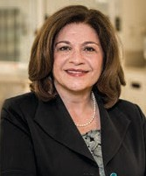
I hope you and your family are doing well during the busy
autumn season. While we all continue to
face challenges
brought on by the pandemic, I assure
you that Emerson is well-prepared to continue caring
safely for everyone in our community.

As we approach the holiday season
and winter in New England, remember to take good care of yourself and your loved ones. This issue is filled with
wellness tips and information that can improve your health and safety.
Whether you are wondering if your
sniffles might be allergies, a cold, flu, or COVID-19, or you have an exuberant new puppy in your family, there is
something for everyone. Be sure to check out the recipes to boost your immune system too!

We remain incredibly grateful for your unwavering support. As the pandemic continues, Emerson is here to provide you with the best medical care, safe
and close to home.

Be well,

Christine C. Schuster, RN, MBA
President and CEO

❱❱ THANK YOU FOR SUPPORTING EMERSON
Please visit emersonhospital.org/donate.

Honors for Stroke Care
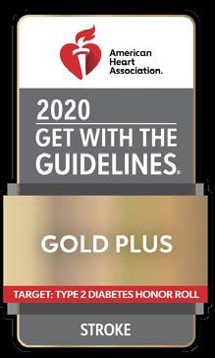
Emerson was honored by the American Heart Association for improving stroke care by promoting consistent adherence to the latest scientific treatment guidelines. Emerson was also acknowledged in a new category for ensuring patients with Type 2 diabetes receive up-to-date, evidence-based care when they are hospitalized with stroke. To learn more about stroke care at Emerson, visit emersonhospital.org/strokecare.

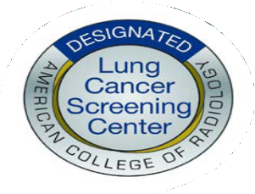
Lung Cancer Screening Designation
Emerson was recognized by the American College of Radiology as a Designated Lung Cancer Screening Center. This reflects the safe and effective low-radiation lung cancer screening available at Emerson. The screening can help identify lung cancer using the minimum amount of radiation. Find out if you can benefit from
this screening at emersonhospital.org/lungcancer.

New Digital Wellness Program Supports Youth

Emerson teamed up with Turning Life On, a local grassroots movement, to create a digital wellness program. Digital wellness is using technology in healthy ways to reduce negative impacts media can have on our health, relationships, safety, and privacy. The partnership focuses on educating families to make healthy choices. Tune in to our podcast series to hear tips from experts about digital wellness. If you are interested in creating ways to support digital wellness in the
community, visit emersonhospital.org/digitalwellness for information and to listen to the podcast.

IN THIS ISSUE
Townsend Man Recovers After Battling COVID-19
Allergies, Cold, Flu,
or COVID?
WHERE TO FIND US …
Connect, follow, and have a conversation with us on social media.

FACEBOOK
facebook.com/ EmersonHospital

INSTAGRAM
@EmersonHospital

YOUTUBE
youtube.com/ EmersonHospital

2 | H E A L T H W O R K S

Connected Youth: Loneliness in Children and Adolescents


veryone goes through times of loneliness—it is part of what makes us human. But when loneliness interferes with daily life or results in feelings of
E
hopelessness or suicidal thoughts, you should seek immediate medical or mental health care.
The adolescent years often exacerbate loneliness as teens identify who they are, discover their passions, and place increasing importance on socializing with peers. During the pandemic, many adolescents have experienced increased loneliness. According to the ROX Institute for Research & Training, 78% of girls in grades 5 to 8 feel lonelier and more isolated since the start of the pandemic.
The Auxiliary and Corporators of Emerson Hospital recently held a panel discussion to explore the topic of loneliness and resources to help teens. Following are some important takeaways:
What is loneliness?
Loneliness is a state of mind—it is the subjective feeling of being alone and not able to share things with other people. Different-age children present loneliness in different ways—younger children may act out or create imaginary friends. Teens may stay behind closed doors more often, or talk with parents more. They may feel sad and talk negatively about themselves. Do not worry alone. Contact your pediatrician. We are here to help you and your family.
—Amy Forrer, MD, Emerson Family Medicine, Maynard
If I see warning signs that my child is lonely, what should I do?
It is important to normalize their feelings. Teens have a heightened capacity to feel lonely as relationships become more prominent and they put higher expectations on relationships. Talk with your child, clinician, and school. Coaches, mentors, tutors, clergy, and other trusted adults are good too. Bring compassion to the conversation and help teens connect around areas of shared interests with peers.
LOCAL
RESOURCES
Center for Parents and
Teachers offers programs that encourage positive lifestyles for children and students.
centerforparentsand teachers.org

Ivy Child International provides universal mindfulness education
to children and communities.
ivychild.org

Grow a Strong Family offers
education to families affected by mental health issues.
growastrongfamily.org

Turning Life On empowers people with information they need for digital wellness.
turninglifeon.org

NATIONAL
RESOURCES
National Alliance on Mental Illness provides education,
support, and advocacy for those living with mental illness.
nami.org

Mental Health America
addresses the needs of those living with mental illness.
mhanational.org

National Suicide Prevention Lifeline
800-273-8255

❱❱ TO HEAR A
PODCAST of the entire panel, visit
emersonhospital
.org/loneliness.
—Bretton Mulder, PsyD, director of teen and adult programs, Massachusetts General Hospital/Aspire

We partner with families. You can call the guidance counselors at your high school at any time. Your child does not have to know that you reached out, but we can “work magic” in quiet ways to support your child.
—Laurie Hunter, PhD, superintendent, Concord Public Schools and Concord-Carlisle Regional School District

Talk with your child, but try not to force the conversation so it is awkward or uncomfortable. Be open and honest, do not keep things from your child. Make sure your child has a good relationship with adults at school.
—Ellie, local high school student

F A L L 2 0 2 0 | 3

5 Common
Digestive Disorders

Everyone has a rumbling stomach now and then. But some digestive
problems can be more serious—and cause

for concern.

4 | H E A L T H W O R K S

hat is important to know is that you are not alone.
Digestive disorders affect approximately one out of
W
every five Americans. Digestive symptoms should not be ignored. Talk with your doctor if you are experiencing discomfort. Here are some common conditions affecting the digestive system.
1.
Chronic Constipation
This condition occurs when you have fewer than three bowel
movements in one week, or stools that are hard, dry, and difficult to pass. When this

problem lasts three weeks or more, it is called chronic (or long-lasting) constipation. Call your primary care doctor if you are constipated for longer than three weeks.
Over-the-counter medicines or fiber supplements may help. Your doctor may recommend exercises to help you control the muscles involved in bowel movements.
2.
Gastroenteritis
Commonly called the stomach flu, gastroenteritis is an infection that
causes inflammation in the intestines.

Bacteria or parasites can cause gastroenteritis, but viruses are the most common cause. Sometimes the disease spreads through contaminated food.
Symptoms include vomiting, diarrhea, fever, and headache. Most people get better on their own. If you have gastroenteritis, drink lots of fluids to avoid dehydration.
3.

Gastroesophageal Reflux Disease (GERD)
Heartburn is the most common symptom of gastroesophageal reflux disease (GERD). The disease occurs when stomach acid, food, or liquid flows from the stomach backward up into the esophagus. (The esophagus
is the tube connecting the stomach and mouth.)
A good history is usually all that is needed to diagnose GERD. Endoscopy or X-rays can help confirm the diagnosis. Untreated GERD can cause serious problems, such as bleeding or chest pain, or even esophageal cancer.

Lifestyle changes, such as not eating for two hours before bedtime, can help relieve symptoms. Over-the-counter heartburn medications can also

be effective. If symptoms persist after two weeks of over-the-counter medication, contact your primary care provider.
Prescription medications or surgery may be
warranted for serious GERD.
4.

Hemorrhoids
Hemorrhoids, or swollen veins in the rectum, are very common.
They affect 75 percent of people older than 45. Some types of hemorrhoids can bleed or be painful, itchy, or tender. Other types are not painful. A telltale symptom is blood on the toilet paper or in the toilet after you have a bowel movement.
Hemorrhoids occur from straining to have a bowel movement, sitting on the toilet too long, or heavy lifting.
See your doctor if you think you may

have a hemorrhoid. The symptoms may be a sign of something more serious, such as cancer. Talk with your doctor before using
hemorrhoid medication.
5.

Peptic Ulcer Disease
A peptic ulcer is an open sore in the stomach
caused by acid. People used to think stress caused ulcers, but that is not true. Most often, ulcers
are due to a bacterial infection or taking nonsteroidal anti-inflammatory drugs (NSAIDs), such as ibuprofen or naproxen.
If you have an ulcer, your doctor may do a test to look for H. pylori, the type of bacteria that causes ulcers. Antibiotics can help clear up the infection. Pain in the upper abdomen is a common ulcer symptom, although some people with ulcers do not feel any pain.
A prescription medication known as a proton pump inhibitor is usually prescribed to treat ulcers.

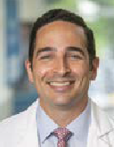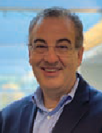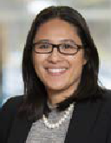CARING FOR PATIENTS AS PEOPLE: CONCORD GASTROENTEROLOGY ASSOCIATES

Michael DeSimone, MD

John Dowd, DO

Jennifer Nayor, MD

With a team of trusted, fellowship-trained physicians who specialize in digestive health, Emerson’s Concord
Gastroenterology Associates offers timely screenings, accurate diagnoses, and advanced medical and surgical care for the full range of routine and complex digestive disorders. You will find
that our physicians are accessible and welcoming. They are partners on your journey to good health.
Our aim is to treat patients as people—and focus on the
cause, not just the symptoms, of your digestive issues using the latest medical knowledge, advanced technology, and most
sophisticated surgical techniques—delivering a high level of personalized care that is close to home.
The office is located in the John Cuming Building at Emerson Hospital.
See your primary care provider for routine digestive health symptoms. When symptoms become more serious, you can
visit Concord Gastroenterology Associates. Appointments are often available within 24 hours. Call 978-287-3835 or visit emersonhospital.org/gastro to make an appointment.

❱❱ LISTEN TO A PODCAST about mind-gut health featuring Dr. Nayor at emersonhospital.org/
podcast.

F A L L 2 0 2 0 | 5

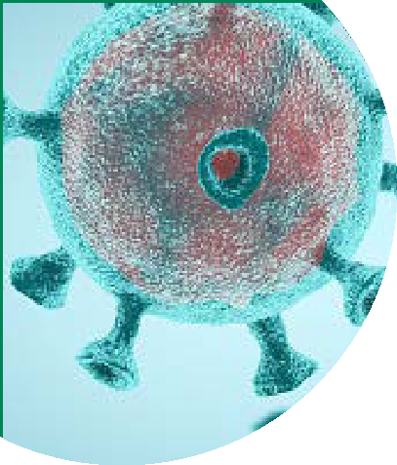Allergies, Cold, Flu, or COVID?
How to Tell the Difference
In today’s world, with every sneeze, cough, or tickle in the throat, many people wonder: Do I have COVID-19? For the millions of allergy sufferers
around the country, this question becomes a little more complex—allergies
or COVID-19, or perhaps cold or flu?
Use this handy chart to identify your symptoms and help determine what health issue you may be suffering from.

SYMPTOMS | Allergies | Cold | Flu | COVID-19
Body Aches | Rarely | √ | √ | √
Chills | No | No | √ | √
Fever | No | Rarely | √ | √
Headache | Sometimes | Sometimes | √ | Sometimes
Nasal Congestion | √ | √ | Sometimes | Rarely
Runny Nose | √ | √ | Sometimes | Rarely
Sneezing | √ | √ | Sometimes | Rarely
Itchy/Watery Eyes | √ | No | No | No
Dry Cough | Sometimes | √ | √ | √
Shortness of Breath | Sometimes | Sometimes | Sometimes | √
Wheezing | Sometimes | Sometimes | Sometimes | Rarely
Loss of Smell | Mild | Rarely | Rarely | √
Sore Throat | Sometimes | √ | √ | Sometimes
Nausea, Vomiting,  Diarrhea | No | Sometimes | Sometimes | Sometimes
❱❱ FOR ANY MEDICAL ISSUE, it is best to contact your physician or visit an urgent care center where medical experts can examine you and determine the best treatment. Emerson Hospital offers COVID-19 testing with a physician’s order. More information about testing can be found at emersonhospital.org/covidtest.
❱❱ INFORMATION PROVIDED BY SARA NARAYAN, MD, allergist with Allergy West. To learn more or make an appoint- ment with Allergy West, visit allergywest.com or call 978-619-5447.
❱❱ LISTEN TO A PODCAST featuring Sara Narayn, MD, with more tips on how to tell if you have allergies, COVID, or perhaps something else. Listen at emersonhospital.org/podcast.

6 | H E A L T H W O R K S

Have a Pandemic Puppy?

10 ways to prevent human injuries with your new best friend

hile exact numbers are difficult to assess, the anecdotal evidence is telling—everywhere it
W
seems there are puppies out and about with their new humans during this time of the pandemic. The phenomenon even has a name—pandemic puppies. People all over the world are getting new dogs to provide companionship, love, and a good reason to get outside and exercise. With all the joy a new pup can give its owners, Fido can also cause significant injuries to its owners if they are not careful. Keep these tips in mind to prevent injuries as you bond with your new puppy:

Hold on to the handle of the leash with the palm of your hand, fingers
1.
around the handle so that you can quickly let go of the leash if needed. Never wrap the leash around your arm or wrist. If your dog unexpectedly runs (which even the best-trained dogs do!), you may not have time to unwrap the leash. Many broken arms, wrists, legs, and concussions are the result of this common mistake. Consider using a harness instead of a leash, particularly if your pup is strong.

Always be aware of where your dog is when you use stairs. Make
2.
sure you hold the leash properly and the dog is close by your side as you navigate the steps. Otherwise, you run the high risk of getting knocked down or tripping over your dog as it traverses the stairs.

Never bike, skateboard, or use other equipment while you walk your
3.
dog. Always be on your feet on the ground.

Prevent deep scratches by keeping your dog’s nails short.
4.

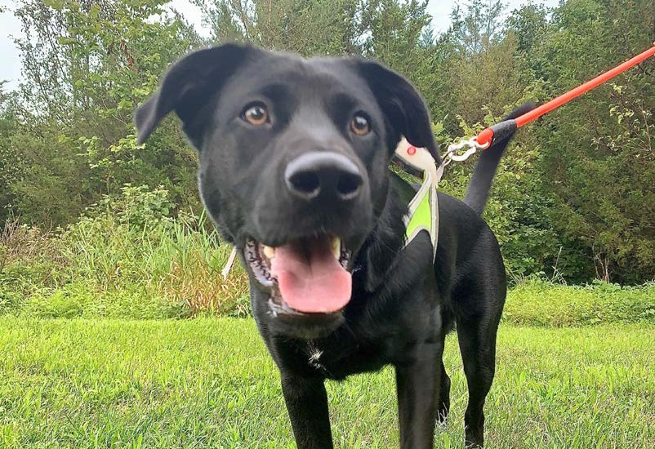
Train your pup not to jump and bite
to prevent injuring yourself and others.
5.

Leave dogs alone when they are eating—some dogs can be
6.
aggressive around food.

Make sure to supervise your dog closely when it is around children
7.
to ensure they are well-acquainted. Never leave your dog alone around infants.

With daylight hours decreasing and temperatures falling, be sure
8.
to stay safely away from vehicles and step carefully in snow and ice.

Ensure your dog is properly vaccinated to prevent the spread of
9.
illnesses.

Good hand hygiene is important for all pet owners. Wash your
hands with soap and water before and after you walk your dog, and especially after you appropriately dispose of their waste.
10.

While this article is about preventing human injuries with a dog, here is one cautionary “tail” while you get acclimated with your new dog during the pandemic: Keep wearing your facemask when you are out in the community with your dog—to keep yourself and others safe. However, keep all masks away from your dog. There have been reports of dogs eating masks, causing serious injury to their digestive systems.
Call your primary care physician or an orthopedic surgeon if you are injured and are not able to perform everyday activities and/or you have ongoing pain. Visit emersonhospital.org/orthopedics for information and to request an appointment.

❱❱ DO YOU HAVE A PANDEMIC PET? We would love to see! Share a photo on Facebook, Instagram, or Twitter and tag
@EmersonHospital.

F A L L 2 0 2 0 | 7

On the Run: Emerson’s Rehab Center Helps Those Injured During Pandemic Get Back in the Game

his spring, during the months of shutdown while the COVID-19 virus flared, people stayed home to flatten the curve. Millions of
T
people set out to achieve ambitious athletic goals during this time, such as running or biking long distances.
Meaghan Decker of Hudson, like many people, became injured while pursuing a goal during shutdown. She started running in early April as the virus peaked.
“I was angry and frustrated with the pandemic,” Meaghan says. “I went from 0 to 60 with my running. I ran to help my

physical and mental health during the anxious months of stay-home. I had a goal to run a half-marathon, but by May, my knees were hurting badly.”
She contacted Emerson’s Clough Family Center for Rehabilitative and Sports Therapies and began seeing staff physical therapist Nick Schumacher, PT, DPT, OCS, CSCS, twice a week at the Concord office.
“In a short time working with him, my knees got better quickly,” Meaghan says. “I am so excited to run again and do yoga and biking.
I appreciate that Emerson was there for me to recover and get me back to healthy living.”

“We see lots of people who were injured during the quarantine,” Nick explains. “Many of them are healthy and doing their part to flatten the curve. They started a new exercise program or athletic pursuit during the pandemic, but many did not have proper training, ramped up too fast, and became injured—some seriously. I worked with Meaghan to strengthen her quadriceps, calves, and hips, and taught her how to manage her pain. She, like all of our patients, was very excited when she could resume her athletics safely and without pain.”


❱❱ TO LEARN MORE about Emerson’s programs for athletes, visit emersonhospital.org/rehab or call 978-287-8200.
8 | H E A L T H W O R K S

Expert Care for Complex Issues:
Yeatts Urology Center Opens at Emerson
Urologic
Prostate
Stone disease
Erectile
❱❱ FOR MORE INFORMATION, please visit emersonhospital.org/urology
or call 978-287-8950.
Urinary tract infections
Incontinence in men and women
dysfunction
(kidney, bladder, and ureteral
stones)
enlargement
and obstruction
cancers
Emerson’s urologists see a full range of urologic conditions affecting men and women, including:
WHEN T O SEE A UR OL OGIS T

Infertility

he Yeatts Urology Center is now open at Emerson Hospital, providing patients with the most advanced treatments for a wide
T
range of urological conditions. The practice is home to Emerson Urology Associates, under the leadership of John Libertino, MD, and provides general urological care and highly specialized care, including complex urological surgery and cancer care.
“The level of expertise this team has is beyond what I have experienced at academic medical centers,” explains Dr. Libertino, director of the Urology Center. “Combined with Emerson’s superb complementary services and personalized care, the Yeatts Urology Center is the place to come for anyone who needs urological care.”
Take for example the experience of Judy Murtagh of North Chelmsford, who recently had bladder surgery.
“Due to a long history of bladder issues, I needed surgery,” she says. “Dr. Gee, who performed the surgery, took excellent care of me. I am very grateful for what he and the entire Emerson team did. The care from the physicians, nurses, and staff could not have been better.”
The new center is funded by the generosity of Ines and Fred Yeatts of Bedford.
“Dr. Libertino has cared for me for many years,” Fred explains. “The depth and breadth of what Emerson Urology Associates does is outstanding. The physicians are extremely knowledgeable, thorough, and thoughtful, and use the latest technologies for the best care. We are pleased to support the new Urology Center at Emerson Hospital.”

Jason Gee, MD
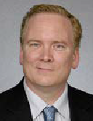
Urologic surgery; urologic oncology, specializing in cancers of the bladder, kidney, prostate, urethra, adrenal gland, and testis; continent diversions and reconstructive surgical procedures of the urinary tract
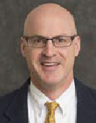
Paul Lafontaine, MD
Urinary incontinence; urinary tract infections; prostate, kidney, bladder, and testicular cancer; kidney stones; benign prostatic hyperplasia; vasectomy; vasectomy reversal

John Libertino, MD
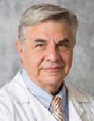
Urologic surgery; adrenal, renal, bladder, prostate, cancer, and testes cancer; continent diversions

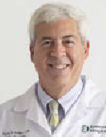
Stephen Schloss, MD
Urologic cancer, prostate disease, stone disease, erectile dysfunction, infertility incontinence, minimally invasive surgery, laparoscopic urologic surgery, vasectomy, microsurgical vasectomy reversal

❱❱ COMING SOON! A board-certified female urologist is joining the practice.

❱❱ TO SEE A VIDEO OF THE NEW CENTER featuring the physicians and a patient, scan this QR code:

F A L L 2 0 2 0 | 9

BREAST CENTER

Guiding Patients Through Their Journey
A Q&A with Emerson’s Breast Cancer Navigator

any people know Kerin Malley, BSN, RN, as “my right hand.” As Emerson’s Breast Cancer Navigator, she guides patients
M
through their journeys with breast cancer at Emerson Hospital and the Mass General Cancer Center at Emerson Hospital- Bethke. We sat down with Kerin to learn more about her role and how her work and compassion help patients during some of the hardest times of their lives.
What is a breast cancer navigator?
A breast cancer navigator is a person who guides and supports patients with breast cancer throughout their cancer journeys to ensure they have a smooth and successful experience. The navigator is a patient advocate, a point of contact for patients’ physicians, a support system for
patients and their family members, and a source for valuable community resources.
How do you help your patients?
I provide patients with information and education to reduce stress, help them understand their treatment options, empower them to participate in decision making related to their care, and ensure they complete all aspects of their treatment for the best possible outcomes. I help expedite appointments by working with staff across disciplines—including oncology and lab. I also advocate for patients so they receive timely access to necessary services, such as genetic counseling/testing, nutrition, social work, rehabilitation, and integrated services within the Emerson and Mass General communities.
What is a typical day like for you?
I meet people who are newly diagnosed with breast cancer and work with patients in various stages of their treatment. I attend appointments with patients, check in with them during their treatments and follow-up care, and schedule/coordinate their care in all areas, such as medical, infusion, and radiation oncology.

What is your philosophy on patient care?
My goal as a nurse navigator is to learn the physical, psychological, and social needs of my patients. I believe in patient- centered care; the patient’s needs, values, and preferences are the highest priority. I build relationships with each patient by listening, informing, and involving them in their care plan.

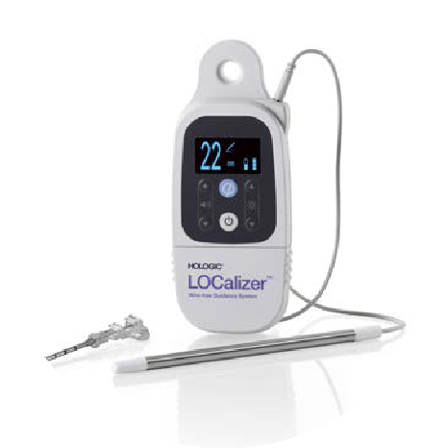Local Inventor Creates Medical Device for More Precise Lumpectomies
Nancy Confrey lives in Concord, had breast cancer in 2011 and 2013, and received radiation treatment at Emerson with Robin Schoenthaler, MD, radiation oncologist with Mass General Cancer Center at Emerson Hospital-Bethke. Based on her experience having two lumpectomies, and her career in
technology consulting, Nancy helped invent an FDA-cleared device used by surgeons around the world, called the LOCalizer.
The LOCalizer makes it more comfortable for patients having a breast lumpectomy and more precise for surgeons to remove cancerous areas in the breast. Elizaveta Ragulin Coyne, MD, FACS, and Andrea Resciniti, MD, FACS, surgeons at Emerson, use the device. Emerson is the first community hospital in the Boston area to use the LOCalizer.
The device uses RFID (radio frequency identification) tags for surgical guidance, removing the need for patients to have wires inserted in their breasts, which can be very uncomfortable,
unsightly, and difficult for patients emotionally.
“The tiny RFID tags serve as a guide when I perform lumpectomies. The cancer is often extremely small, so when the LOCalizer is placed in the breast tissue, it helps me be extra precise and remove only the cancerous areas. Patients who have the tags inserted say that it is much easier and more
comfortable than having the wires,” Dr. Ragulin Coyne explains.

The LOCalizer is inserted by a radiologist at Emerson in a short, painless procedure. The RFID tags are removed by the surgeon during the lumpectomy.
The LOCalizer makes a breast lumpectomy more comfortable for patients and more precise for surgeons.

10 | H E A L T H W O R K S

IN GREAT HANDS: A PATIENT’S STORY

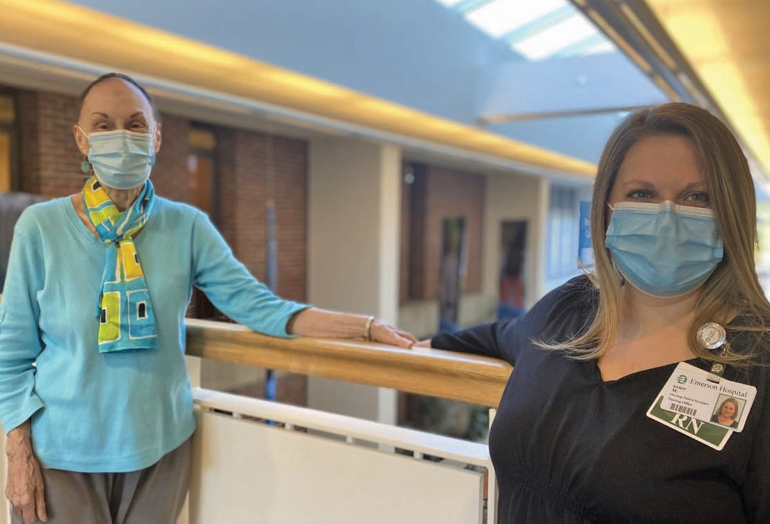
What is most fulfilling in your work?
The most fulfilling part of being a nurse and working with oncology patients are the relationships and connections I form with patients and their families. I also enjoy witnessing their courage and determination as they complete each stage of their treatment.
What are some things you want patients to know about getting care at Emerson? At Emerson, you are treated like family.
Every member of our comprehensive breast health team treats our patients as people, not as a diagnosis. We take the time to get to know you and nurture our relationships with you and your families. We are in this together.
What is your best tip for patients?
Ask questions and lean on your care team for support. We are here for you.

The Breast Cancer Navigator position at Emerson Hospital is funded in part through the Hans and Mavis Lopater Foundation.
Margaret Gottlieb, a retired high school math teacher who lives in Acton, was
diagnosed with breast cancer in November 2019. Since then, all of her
cancer care, including chemotherapy, a mastectomy, and immunology infusions, has been at Emerson.
Her care team includes Kerin Malley, BSN, RN, breast cancer navigator;
Elizaveta Ragulin Coyne, MD, FACS, surgeon; Uma Narayanasami, MD,
medical oncologist; Eriko Frank, LICSW, social worker; and infusion nurses
Stephanie Girourd and Lauren Roemer.
“I feel like my care team is one big, happy family,” Margaret says. “I have gotten to know them, and they have gotten to
know me.”
Margaret has a very special
relationship with Kerin. In her words:
“Kerin is like my right hand. You have a lot of appointments when you have
breast cancer. It is a scary time. During chemotherapy, both of my sons, who live in California, got to know Kerin well and she answered all of their questions. I
was not able to have my family with me for my mastectomy surgery because it was in April during the peak of the
F A L L 2 0 2 0 | 11
pandemic when visitors were not
allowed. But Kerin was with me every
step of the way. She met me at Emerson early in the morning on the day of my
surgery and sat with me. She kept me calm.
“She is always on the other end of a call, or available in person whenever I need her. She is very knowledgeable
about cancer care and medications. I was in great hands with Kerin and the rest of my care team at Emerson. Today, I feel
fabulous. I keep busy and look forward to reuniting with my family as soon as the
pandemic is over.”

❱❱ FOR INFORMATION ABOUT
EMERSON’S comprehensive breast health program, visit emerson
hospital.org/breasthealth.

❱❱ BREAST CANCER MYTH BUSTERS PODCAST
Learn from physicians with Emerson’s Breast Health Program about the latest in breast cancer. Listen at
emersonhospital.org/podcast.

in my own voice

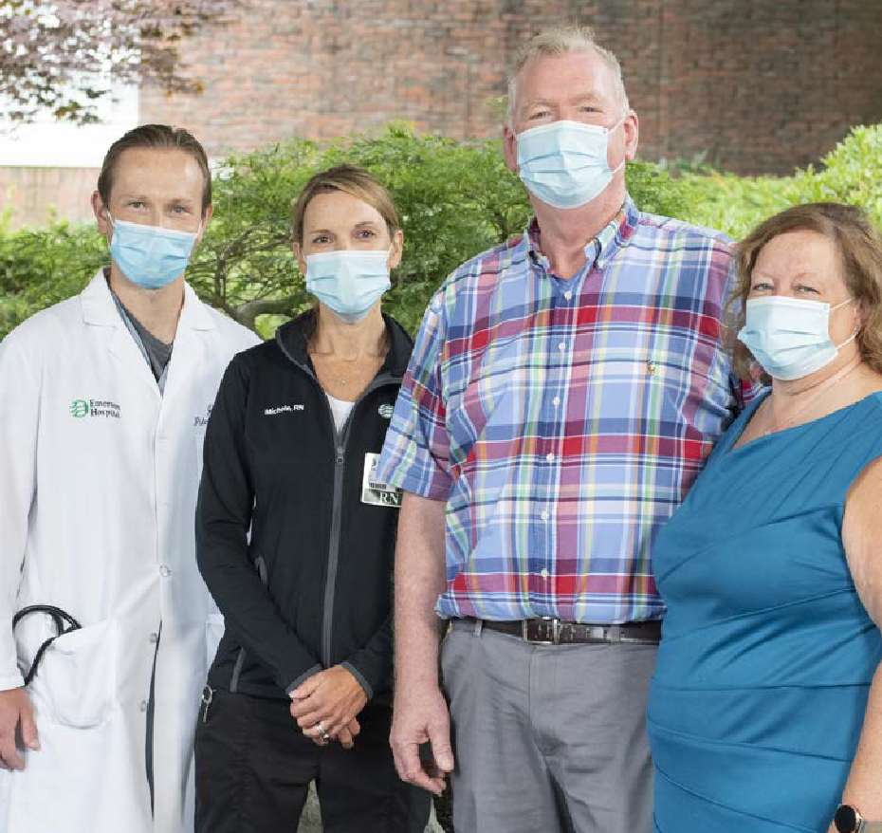Townsend Man Recovers After Battling COVID-19
From left, pulmonologist Julian Lel, MD, and critical care nurse Michele Fremault, RN, with Tim Crory and his wife, Sandy.

im Crory, a 60-year-old from Townsend, is grateful for the care he received at Emerson after he was stricken with COVID-19 in April.
T
During his hospital stay, he recognized the benefits of a community hospital.
“Starting April 17, I had a constant headache unlike anything I had before. A few days later, I knew something was very wrong with me. I was at work and told my boss I was going to get tested for
COVID-19. I have Type 2 diabetes and grew up with asthma, but I have not had an asthma issue in more than 10 years and was not on medication for it. Whatever was happening hit me real fast.
“I got tested at a drive-through site in Lowell and heard back a few hours later that I was positive. I quarantined in my house, and my wife was great throughout the whole experience. She brought me food through our bedroom door, and we wore masks and took a lot of precautions. By the end of the week, I was so short of breath I could not carry a conversation. On April 27, my wife called an ambulance and they took me to Emerson upon my request. They were planning to take me to a closer hospital, but I grew up in Littleton, my primary care physician is Dr. [James] Cohen at Westford Internal Medicine, and I trust the care at Emerson.
“A few hours after arriving at the

Emergency Department, I was admitted directly to Emerson’s Critical Care Unit [CCU]. I was aware of what was going on, but things got a little foggy at times. I

remember the doctors and nurses talked about intubating me. However, the day before the planned intubation, I started to get better. My doctor said that the proning*

I hope to never go through this again, but I could not be happier with the treatment at Emerson. Thank you for bringing me back from COVID-19 and showing me the meaning of community." —TIM CRORY
“
*Proning is a medical technique to turn a patient from their back to their stomach. Some studies show it can increase oxygen flow to patients with COVID-19, help reduce the need for a ventilator, and help them recover.

12 | H E A L T H W O R K S

helped keep me off of a ventilator and helped me get better. I was on oxygen all the time and slowly began to recover.
“After I was well enough to leave the CCU, I spent time on North 6, a medical floor that was caring for COVID-19 patients during the peak of the pandemic. I spent a few nights in a negative air pressure room to prevent the spread of airborne diseases, and then I was moved to a regular room.
“Finally, I was feeling better and was transferred to Emerson’s rehab floor, known as the TCU [Transitional Care Unit]. There, I received physical therapy and was weaned off oxygen. After a few days on the TCU, I was up and walking. I was happy that I did not have to go to another facility and could recover at Emerson. I had a roommate in the TCU I got to know pretty
“Today, I feel great. I do a lot of walking and went camping and biking with my family in July. My lungs are clear. I am back at work where we are constantly cleaning, wearing masks, and taking the pandemic very seriously. You cannot take it for granted. People think it is over, but you cannot take it lightly—it is a real thing.
“I learned the real meaning of a community hospital during my long stay at Emerson. Toward the end of my care, as I was feeling better, it was a nice situation. I got to know everyone—even the woman from nutrition who called me every day to order my meals. The people
who cleaned my room were kind— everyone was. My neighbor is a nurse at Emerson. She visited my wife and brought me things from home, which meant a lot. I see her now when I am out mowing my lawn, and we are happy to see each other healthy, outside the hospital. Another nurse at Emerson went to school with my son; she was a friendly face, too. I hope to never go through this again, but I could not be happier with the treatment at Emerson. Thank you for bringing me back from COVID-19 and showing me the meaning of community.”

well—he grew up in the area and we knew a lot of people in common, which was comforting when you are sick in the hospital and can connect with others.
“During this time, no visitors were
WELCOME NEW PHYSICIANS …
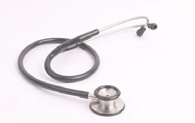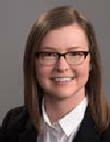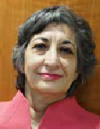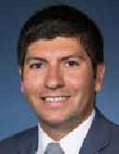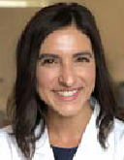Please welcome these new physicians who recently joined Emerson.

allowed in the hospital to prevent spread of the virus. I did not see my wife until I was discharged 29 days after. Emerson was great—they set me up with an iPad on a stand created from an IV pole. It was wheeled into my room so I could see my wife and our three sons. Seeing and hearing them on the iPad raised my spirits and helped me feel better.
“When I was discharged on May 25, the Emerson team celebrated me going home with a ‘Code Happy.’ As I was wheeled out of the hospital, my doctors, nurses, and other staff cheered me on as they clapped to the song ‘Happy’ by Pharrell Williams to send me off. Unexpectedly, my sister-in- law saw me leaving as she was coming in to the hospital for an appointment. My wife was at the hospital entrance ready to take me home—we had not seen each other since the day I left in the ambulance. It was very emotional.
ALLERGY
Cali Reynolds, MD
Allergy West
133 Littleton Road, Westford 978-619-5447

DERMATOLOGY
Elizabeth Lester, MD
Dermatology Associates
290 Baker Avenue, Concord 978-254-1600

INTERNAL MEDICINE
Noor A. Roomi, MD
Emerson Internal Medicine 131 Old Road to Nine Acre Corner, Concord
978-371-5386
OPHTHALMOLOGY
Poonam Doshi, MD
Lexington Eye Associates
21 Worthen Road, Lexington 781-876-2020

VASCULAR SURGERY
Edward Arous, MD, MPH The Vascular Care Group 54 Baker Avenue, Concord 978-369-4468

❱❱ LEARN MORE about these and other Emerson physicians at emersonhospital.org.

F A L L 2 0 2 0 | 13

RECIPES


Boosting Your Immunity for the Fall/Winter Season
By Kait Schuster

veryone is worried about getting sick this fall and winter. There are several steps you can take to stay healthy. Regular preventive
E
measures, such as handwashing, wearing a mask, social distancing, and avoiding people who are sick, can undoubtedly help reduce your risk for catching viral and bacterial infections. It is also essential to exercise and get a good night’s sleep.
Although you may not be able to entirely prevent all illnesses this season, a healthy immune system is one way to give your body extra protection.
While no supplement can cure or prevent disease, mounting evidence suggests eating certain foods can give your immune system a boost. “Foods are the best way to get the proper nutrients to enhance your immune system,” says Liz Berman, registered dietitian nutritionist at Acton Medical Associates. “Eating a balanced diet rich in lean protein, fiber, grains, and lots of colorful vegetables will help support your body’s immune system. Fill half your plate with vegetables and fruit, and the rest with protein-rich foods, like eggs, chicken, fish,

beans, and some whole grains, like brown rice or oats. It is good to limit processed food and sugar, too.”
Here are some foods that will help build up your immune system:
- Pumpkin, spinach, sweet potatoes, and carrots are all rich in Vitamin A, an essential nutrient for immune function. Spinach is my personal favorite. “It is
easy to add spinach to salads and smoothies, or for a warm side dish, sauté it with olive oil and garlic and squeeze some fresh lemon on top,” Liz says. “These vegetables are also a great way to add fiber to your diet.”
- Clementines, oranges, and grapefruits
are a great “grab and go” source of Vitamin C. Since your body does not naturally produce Vitamin C, it is vital to get the recommended amount through your diet. Red bell peppers, brussels sprouts, and broccoli are also excellent sources of Vitamin C. So, chop up some of those colorful vegetables and make a yummy stir-fry and serve over brown rice.
- Pumpkin seeds, toasted almonds, beans, lentils, and sprouted bread are a great source of Zinc, a mineral that can help boost white blood cells, which defend
against invaders. Sprinkle some seeds and nuts on your cereal and salads.
- Yogurt, kefir, sauerkraut, and miso soup are foods that contain probiotics, or “good bacteria,” which may promote a healthy digestive tract and immune
system. You can take probiotics in a hot or cold form, so it is easy to find something you like to get your daily allotment.
- Drink plenty of fluids. We all know that it is important to drink at least eight glasses of water a day. When the weather gets colder, sometimes that is hard to do. Try to
drink warm drinks, like noncaffeinated teas; ginger and vanilla honey chamomile are a couple of my favorites.
Boosting your immunity can be delicious, relaxing, and fun. Consistently taking good care of yourself is the best way to support your overall health. Here are some great fall recipes to get you started.

ABOUT THE AUTHOR: Kaitlin (Kait) Schuster lives in Sudbury and is a senior at Noble and Greenough School in Dedham, Massachusetts. She is an honors student, a nationally ranked squash player, and active in her school and community. She works hard at eating right and staying healthy and fit.



14 | H E A L T H W O R K S
❱❱ To hear more nutrition advice from Liz Berman, visit emersonhospital.org/podcast.


Roasted Root Vegetable Soup
INGREDIENTS
4 cups, peeled butternut squash 2 tablespoons olive oil cubes 1 tablespoon smoked paprika
2 parsnips, peeled and cut in 2-inch 1 teaspoon salt
pieces ½ teaspoon cayenne or pepper 1 sweet potato, peeled and cut in 2 tablespoons honey
2-inch pieces 1 cup plain whole milk yogurt
1 medium onion, quartered 4 cups low-sodium chicken broth
1 carrot, peeled and cut in Optional garnish: Roasted butternut 2-inch pieces squash seeds
8 cloves garlic, whole peeled
DIRECTIONS
- Preheat oven to 425 degrees and line a baking sheet with foil.
- Place the first 10 ingredients in a large bowl (butternut squash through cayenne) and toss until evenly coated in oil and spices. Scatter into a single layer on the baking sheet and roast until vegetables are caramelized and tender, about 30 to 35 minutes.
- Remove vegetables from the oven and place in a high-speed blender or food processor. Add honey and pulse until smooth.
- Pour mixture into a large soup pot and stir in the chicken broth and plain yogurt. Heat over medium-high heat until warmed through. Check for seasoning and adjust accordingly before serving.
Optional: Lightly roast the reserved butternut squash seeds in olive oil, salt, and pepper for five to six minutes while other vegetables are roasting to garnish soup before serving.
NUTRITION FACTS
Serving size: 8 ounces Calories: 160 calories Protein: 4 g (makes 8 servings) Carbohydrates: 28 g Fat: 5 g

*Adapted from The Lemon Bowl
Kait’s Healthy Snackin’ Bars
INGREDIENTS
- can (15 ounces) chickpeas, rinsed and drained
½ cup dates
½ cup almond slices 1 cup rolled oats
½ cup pumpkin puree
¼ cup maple syrup
- tablespoons coconut oil
½ teaspoon baking soda
2 teaspoons baking powder 2 teaspoons vanilla extract
1½ teaspoons cinnamon or pumpkin pie spices
Optional add-ins: dark chocolate chips, raisins, chopped walnuts, or pecans Toppings:
¼ cup rolled oats
¼ cup pumpkin seeds
¼ cup toasted coconut shreds
DIRECTIONS
- Preheat the oven to 350 degrees. Line an 8-by-8-inch pan with parchment paper, leaving a little overhanging the sides of the pan.
- Put all ingredients in a food processor and combine very well. Scrape the sides of the bowl a few times and let the food processor run until the mixture is very smooth. Fold in any add-ins you prefer.
- Spoon the mixture into the prepared pan. Sprinkle any toppings on top. Bake in the preheated oven for 15 minutes. Store in the refrigerator.
NUTRITION FACTS
Serving size: 1 bar (Makes 16 bars) Calories: 135 calories
Carbohydrates: 13 g
Protein: 11 g
Fat: 5 g
F A L L 2 0 2 0 | 15


133 Old Rd to Nine Acre Corner Concord, MA 01742
Nonprofit Org.
U.S. POSTAGE
PAID
Long Prairie, MN Permit No. 372

❱❱ IF YOU WOULD LIKE TO
SUBSCRIBE to our email newsletter, or if you prefer not to receive this publication in the future, please let us know by calling 978-287-3408 or visiting emersonhospital.org/newsletter.

Developed in partnership with Krames

EMERSONHOSPITAL.ORG

11135M

Winter Wellness Classes

This winter, the Steinberg Wellness Center for Mind and Body will offer over 25 classes and workshops, including:

Osteofitness Essentrics
Yoga for Building Bones Parkinson’s Movement Gentle Pilates
Qigong
Yoga & Meditation Tai Chi
Pilates for Parkinson’s Aston Kinetics
Gentle Yoga
Strength, Balance & Flexibility for Seniors
Barre Fitness and Yoga Stretch And more!

For course descriptions, schedules, and
to register, visit EmersonWellness.org or call 978-287-3777.

Most classes will be available online via Zoom and some small group classes will be available too!
The Wellness Center also offers private integrative therapies including acupuncture, muscular therapy, and massage. For appointments, call 978-287-3777.

h e a l t h w o r k s
Emerson Hospital
| Spring 2019

The right time for a knee replacement
LANCASTER MAN PLANS A BUSY SPRING

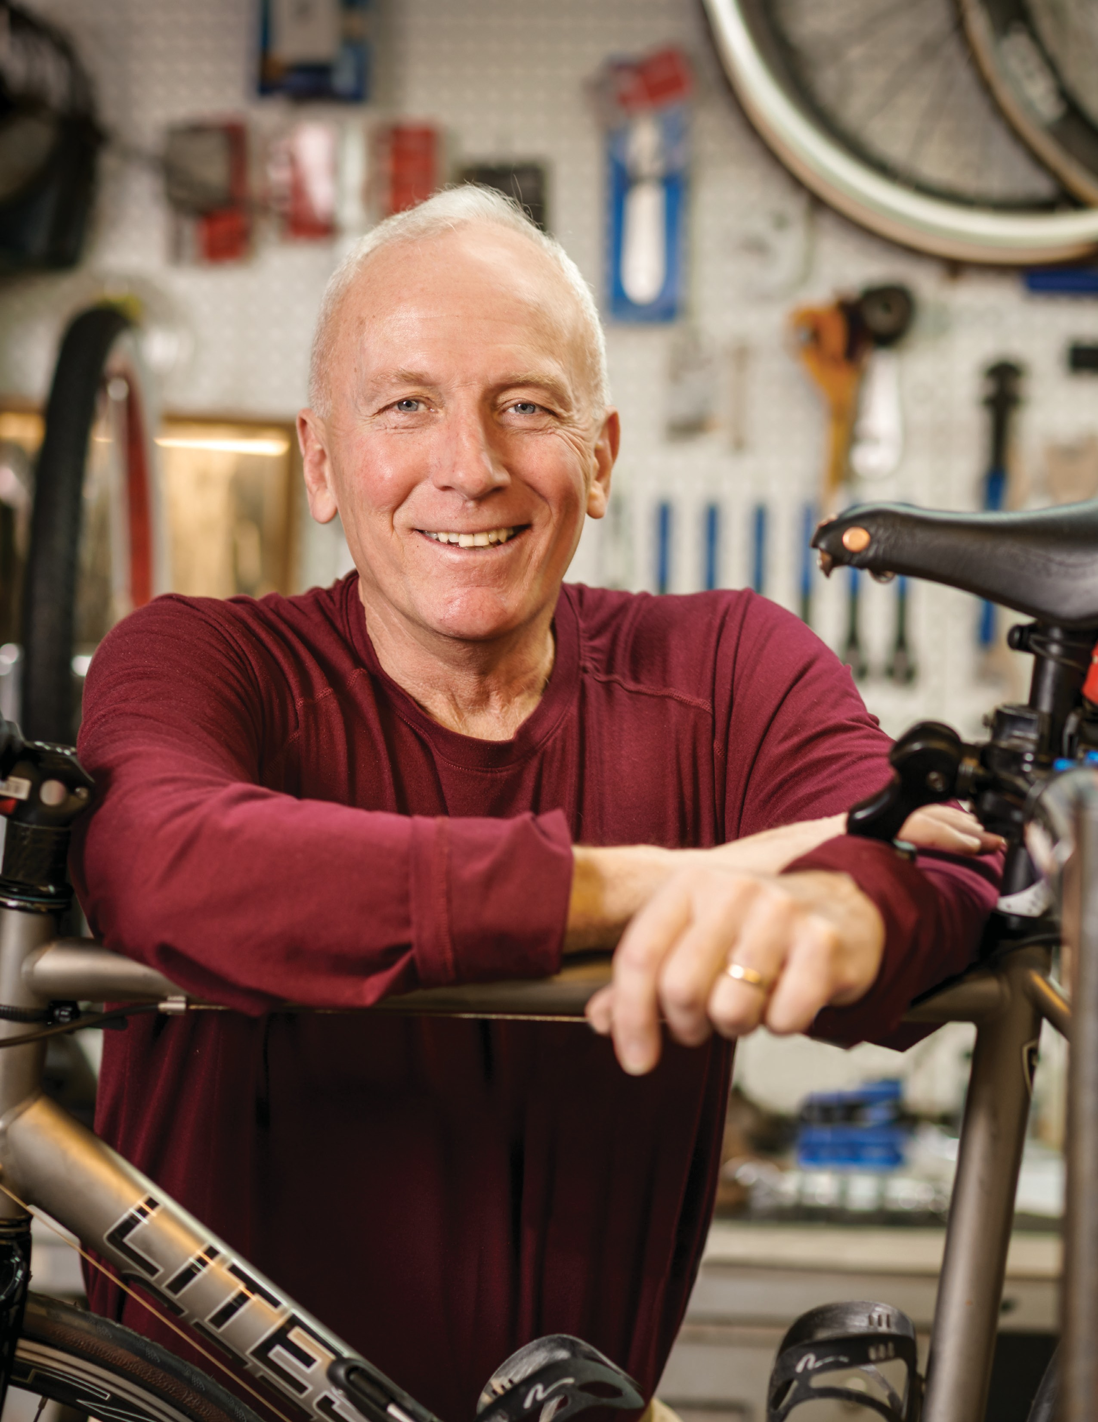Shoulders are the fastest-growing joint replacement surgery
After weight loss surgery, couple has a dramatic reunion
For most people, colonoscopy screen- ing now begins at 45
Precision radiation therapy is effective for lung cancer

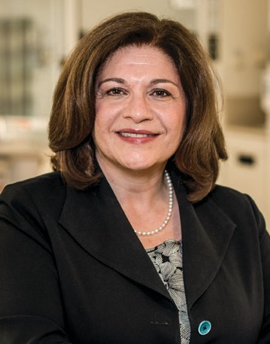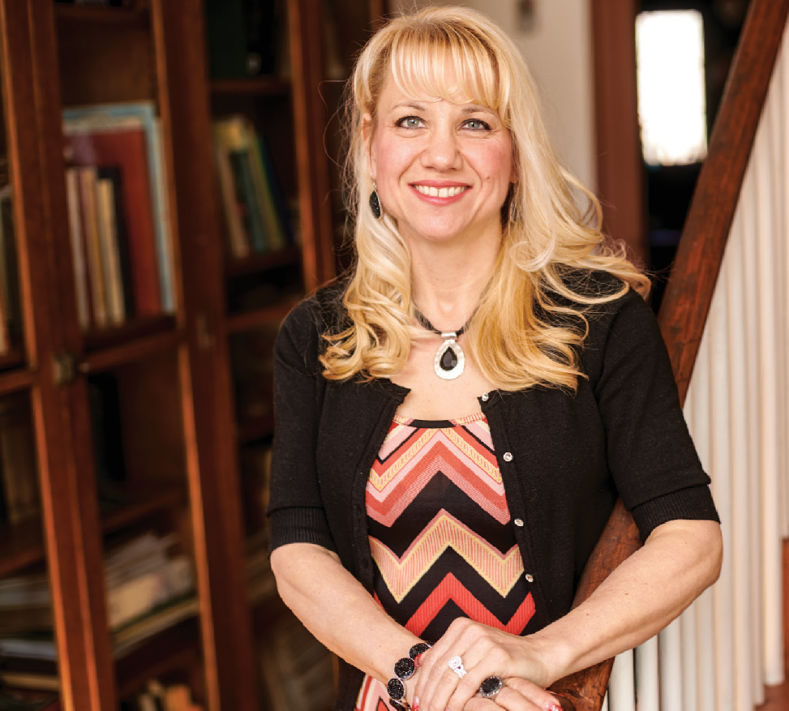Gastric bypass surgery leads to
A Letter from Christine Schuster
Dear Friends:
Innovations in surgical technique, pain manage- ment and rehabilitation have steadily trans- formed orthopedic surgery. As you will read
in this issue of HealthWorks, shoulder replace- ment surgery is now the most common joint replacement in the U.S., and many individuals are candidates for fast-track hip and knee replacements. Emerson’s expanded roster of highly trained, experienced orthopedic surgeons are here to provide you and your family with the most current treatments.
The Emerson Center for Weight Loss continues to help community residents find the solution for permanent weight loss. You will enjoy read- ing about a military couple’s happy reunion at Logan Airport after one of them lost more than 100 pounds thanks to successful gastric bypass surgery at Emerson. For so many individuals, this is the road back to good health.
Our Mass General Cancer Center at Emerson Hospital-Bethke continues to offer advanced treatment. That is certainly true of our radiation oncology department, where stereotactic body radiation therapy is now used to treat lung cancer. The precise, highly targeted therapy requires far fewer treatments than standard ra- diation. This is much appreciated by patients.
Here’s to a happy, healthy spring!
Christine C. Schuster, RN, MBA
President and CEO
Since having gastric bypass
surgery, Rosi Christensen has a different mindset, confidence and energy to play with her grandchild.
a major transformation
After a year, military couple has a dramatic reunion

Rosi Christensen decided to have gastric bypass surgery after she experienced a health scare. Armed with plenty of motivation and with her husband, Jeff, stationed overseas, Ms. Christensen committed to getting healthy and came to the Emerson Center for Weight Loss. After her surgery, she lost weight at a rate that impressed David Lautz, MD, bariatric surgeon and medical director. Now healthy, her confidence is at an all-time high.

Emerson Hospital is an acute care medical center in Concord with health centers in Groton, Sudbury and Westford and urgent care in Hudson and Littleton. It is well known for its medical and surgical special- ists, outstanding nursing care and patient-centered services, including Clough Birthing and Surgical Centers, Mass General Cancer Center at Emerson Hospital-Bethke and Clough Family Center for Rehabilitative and Sports Therapies.
emersonhospital.org
2

Few individuals who have weight loss surgery reach their weight loss goal in just seven months, but Ms. Christensen did. She had been overweight for 14 years and was being treated for a number of health conditions when she decided to change her life. “I told my primary care physician I wanted to have the surgery, and I was going to do it 100 percent,”
she recalls.
“Most people will get to 60-70 percent of their goal after a year,” notes Dr. Lautz. “We don’t see the kind of success Rosi had too often. She understood the surgery

is a tool—not a cure—and she did all the right things.”
It began with learning new eating habits. “I used to reward myself with food,” she says. “It’s how I dealt with stress.” The motivation was there: at age 43, weighing 222 pounds—and just over five feet tall—
Ms. Christensen wasn’t healthy. She was on heart medication, used a CPAP
machine for sleep apnea, was anemic and had acid reflux. There was something else: after losing 107 pounds, she under- stood her self-esteem had been low. “I didn’t realize how much I was holding myself back.”

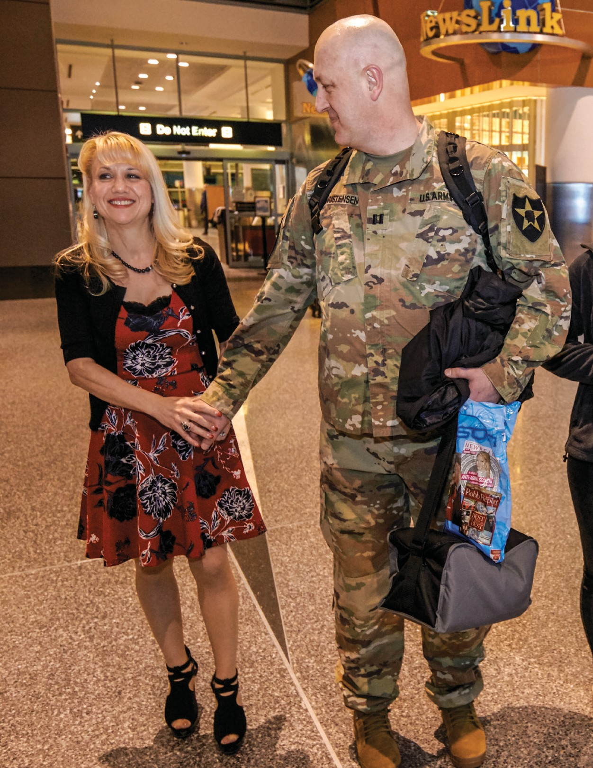
Then something happened that made Ms. Christensen decide to move ahead with effective treatment—not the dieting that she tried again and again—to achieve real weight loss. With her husband, Jeff, serving with the U.S. Army in South Korea, she got into bed one eve- ning at their Hanscom Air Force Base home and experienced heavy pressure on her chest. “I was scared,” she says. “What if I didn’t wake up the next morning, with two teenage daughters and my hus- band deployed overseas?”
Ms. Christensen registered for the next Emerson Center for Weight Loss information session and was soon making an appointment. “I was embarrassed because I hadn’t been able to lose weight on my own,” she says, “but I walked into the center, and everyone was so friendly and supportive. I was at ease right away. Dr. Lautz and his entire office have been amazing.”
She called her husband to tell him she decided to have gastric bypass surgery. “I was all about it,” says Captain Christensen. “Whatever Rosi needed to do to be around for a while. I want her to be happy and healthy. And I know that when she puts her mind to something, she’s all in.”

From size 18 to 0, with confidence soaring
Dr. Lautz performed her gastric bypass in June 2018, and Ms. Christensen says she proceeded to follow every instruction she was given. “I didn’t cheat on my diet, and I worked with a trainer,” she declares. The first few months weren’t easy, but she steadily lost weight. “After the surgery, two things helped a lot: I felt very little hunger, and I wasn’t physically able to eat the amount of food that I used to eat.”
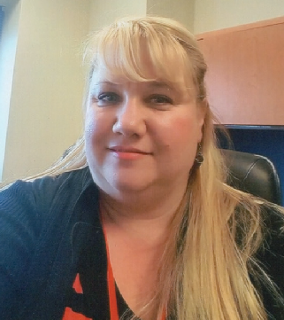
“Patients often ask about the phys- iological changes that result from weight loss surgery,” says Dr.
Lautz. “Because the surgery by- passes the intestine, it affects the hunger hormones, which changes one’s hunger drive. That’s the dif- ference between regular dieting and how someone eats after weight loss surgery.”
As she shed pounds, her health

When Jeff Christensen arrived home from a year serving overseas, his wife, Rosi, had lost more than 100 pounds.

Today, Ms. Christensen is off all medications, and her sleep apnea has resolved. Now she takes only a multivitamin. In January, she had plastic surgery to remove excess skin. “I had reached my weight
loss goal, and I knew that no exercise would take care of it,” she says. Dr. Lautz referred her to Paul Costas, MD, an Emerson plastic surgeon. “It went so well. When it was over, I felt complete.”
The next milestone was a big one: Captain Christensen was sched- uled to arrive home after serving one year in South Korea. The couple spoke regularly, but they did not use Skype or FaceTime. “Even before I saw Rosi in person, I could tell there was a difference in her,” he says. “When we talked, and she gave me updates, she seemed more alive. She got her spunk back.”

Before losing weight, Rosi was being treated for a number of health conditions.
problems disappeared. Dr. Lautz had referred her to Kay Lee Kim, MD, an Emerson cardiologist,
In February, she was standing at Logan Airport, smiling at him. “She looked like the Rosi from years before,” he says. “If I didn’t
know about her transformation, I would have walked right past her.”

to make sure the arrhythmia—heart palpitations—that scared her that night did not put her at risk for complications during gastric bypass surgery. “We are starting to see that many patients have heart arrhythmias directly related to their obesity,” he notes. “The good news is that when the weight comes down, the pressure on the heart disappears.”
Ms. Christensen’s transformation has been about more than going from size 18 to size 0 jeans. “I’m doing things I would never have done before. I went with a friend to the Red Sox parade last fall, and I took my first selfie!
“I’ve experienced an emotional change,” she says. “I have a different mindset. I have confidence now.”

To register for an information session, visit emersonhospital.org/ weightloss. 3

Orthopedic surgery at Emerson Hospital

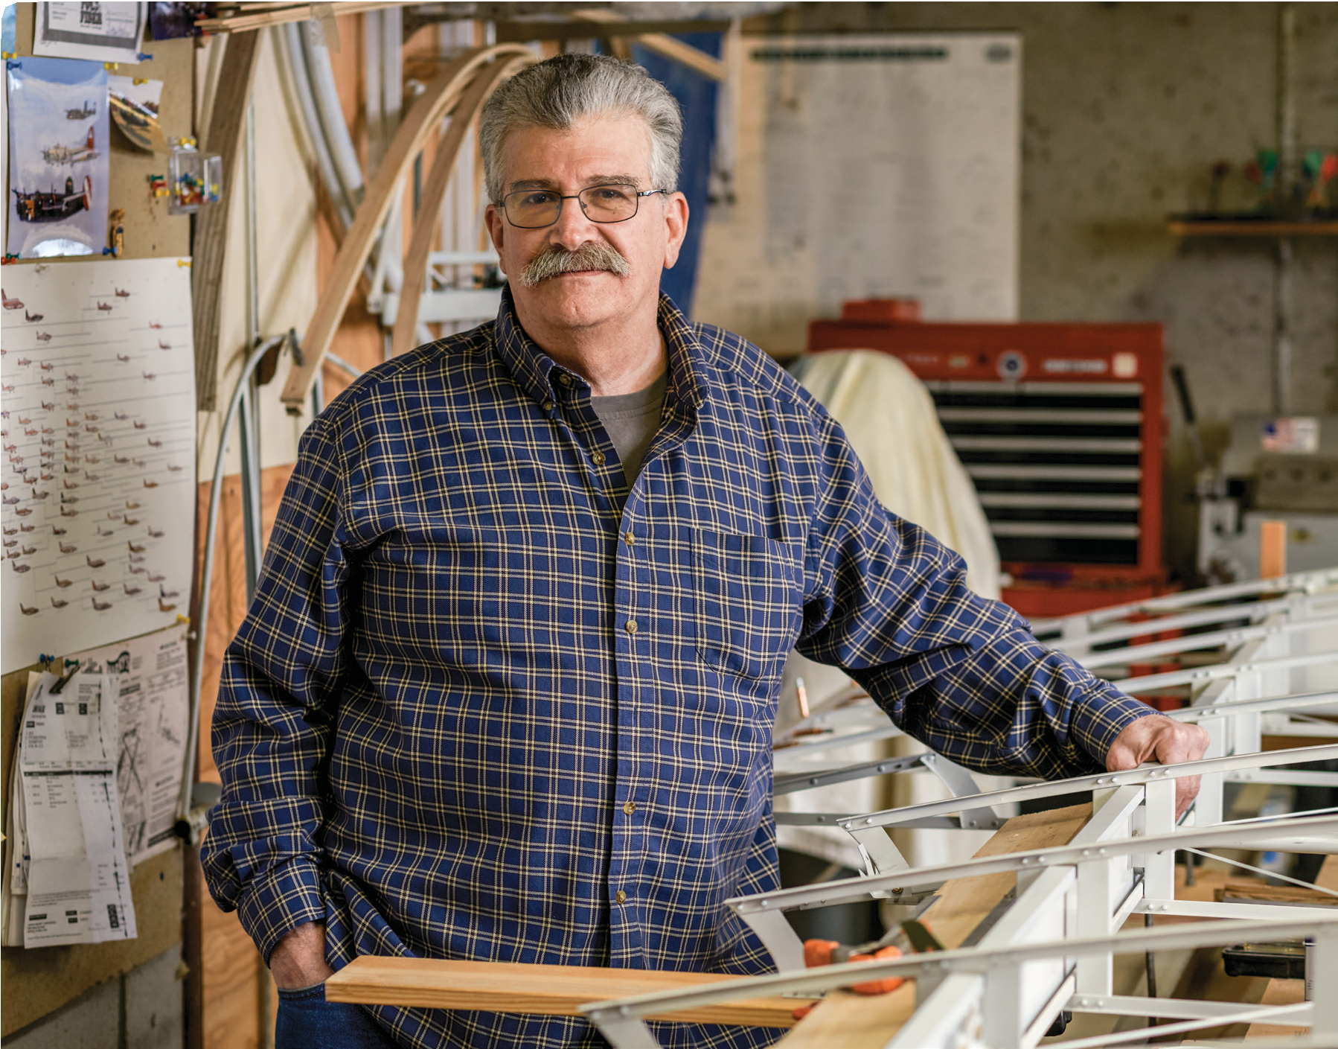Orthopedic surgery
has become progressively more effective and easier for patients. At Emerson Hospital, experienced orthopedic surgeons with impressive clinical exper- tise have been joined by new physicians. All pro- vide the most current ap- proach to musculoskeletal care and are supported by the Clough Family Center for Rehabilitative and Sports Therapies and Emerson Home Care.
David Peterson is busy in his workshop and will soon return to work.

Back to work
with two healthy shoulders
Shoulder replacement surgery is a success story

Some shoulders can be saved with surgery that repairs a rotator cuff or removes a bone spur. But when a shoulder cannot be saved, shoulder re- placement surgery may be the answer. It has been steadily refined to provide individuals with functioning shoulders and predictable improvement in pain and is the fastest-growing joint replacement surgery performed today.
piece of cartilage can tear away from the bone, leaving it exposed to bruising.”
Dr. Re examined Mr. Peterson’s shoulder and was straightforward. “He said I needed a shoulder replacement, and it would take the pain away,” says Mr. Peterson. “I said

David Peterson remembers the exact mo- ment he knew his left shoulder was seri- ously damaged. Despite living with chronic pain, the Acton resident, 64, continued to work as a carpenter—gripping tools, climb- ing ladders and lifting a 70-pound tool bag.
“The pain slowly snuck up on me and became the ‘normal,’” recalls Mr. Peterson. “Despite the pain, I never missed work. I kept moving and tried to take on lighter duties. After a while, it didn’t register.”
But one day, it did. “I was driving my van, and just turning the wheel caused sudden
pain. That was definitely the moment.” He made an appointment to see his primary care physician, Sandeep Jain, MD, who administered a cortisone shot and prescribed physical therapy. About a month later,
Mr. Peterson had an appointment to see Paul Re, MD, an Emerson orthopedic sur- geon who specializes in shoulder surgery.
“It’s not uncommon for patients to describe how a simple thing—like turning the wheel of his van—causes pain that has them seek- ing medical care,” says Dr. Re. “Over time, you can wear out the cartilage in a joint and, with a simple action, reach a threshold. A
‘you’re on.’ I knew I had to have the surgery, but I needed to buy some time so I could complete the job I was on.”
Ultrasound-guided cortisone injections did the trick. “Patients often ask what we can do to delay surgery,” notes Dr. Re. “Others ei- ther cannot have surgery or don’t want to have surgery. We can keep some people going for a while with cortisone injections or by performing minimally invasive surgery that loosens up the shoulder ligament.”
Mr. Peterson’s surgery was scheduled for May 2018. He wasn’t surprised when Dr. Re told him that his right shoulder was also in

4
4
4
4

Advances in sports medicine keep coming

Innovations in sports medicine continually shape how musculoskel- etal care is provided. For more than 20 years, surgery on knees and shoulders has been performed in a minimally invasive way. The re- sult is smaller incisions and shorter hospital stays.
“Minimally invasive surgery is possible because of technology— specifically, the tiny cameras we use during surgery to visualize the operation,” explains Peter Kok, MD, who specializes in sports medicine. “There is less soft tissue injury during surgery, which helps with pain.”
“Today patients benefit from better anesthesia and pain control, including regional nerve blocks and injectable medications,” notes Kyle Lavery, MD, one of Emerson’s newest sports medicine physi- cians. A focus on improved pain management has led to earlier weight bearing and rehabilitation.
Knees are vulnerable to injury and age. This is why treatment of car- tilage defects is a hot topic, Dr. Lavery adds. “The goal is to restore injured cartilage to preserve the native joint and potentially prevent the need for a joint replacement later.”
“We have some success with younger patients—typically when there has been a sports injury,” says Dr. Kok. “Currently, it is more of a challenge in someone with osteoarthritis. The technique of treating cartilage defects is being refined.”
Those who follow professional sports occasionally hear about the use of platelet-rich plasma (PRP) therapy—use of an individual’s own platelets to accelerate healing. “PRP is considered to be experi- mental at this time, but it is an area of active research,” says Dr.
Lavery. “Stem cells are also being studied as a way to treat and stim- ulate healing of diseased tendons, ligaments, muscles and cartilage.”
Sports medicine advances will continue—and benefit one and all. Sometimes, injury prevention is key. “We’re getting better on the rehab side, but since we know that female athletes are at greater risk for tearing their ACLs [anterior cruciate ligament], I suggest that female patients who play at a high level—varsity high school or college— attend a prevention course,” says Dr. Kok. The new Sports Medicine Division at Emerson’s Clough Family Center for Rehabilitative and Sports Therapies provides this training. “There is good evidence that, by learning how to land and jump safely, they will decrease their chance of injuring themselves.”

serious shape. It would be replaced once Mr. Peterson recovered from the first surgery.

Two surgeries and minimal pain
After enduring pain that affected his waking hours and disrupted his sleep, Mr. Peterson woke up after the surgery with no pain in his left shoulder. “I felt a little discomfort, but I didn’t need pain medication—not even Tylenol,” he says. “I just applied ice throughout my rehab.”
Dr. Re isn’t surprised when individuals re- port that they have minimal pain after shoul- der replacement surgery. “We address pain with regional anesthesia before the surgery is performed,” he explains, “but in these pa- tients, we replace painful surfaces with smooth ones—new shoulder components.
We’re not operating on raw, irritated ten- dons, so they experience a great deal of relief after surgery. That is partly to do with how long they’ve been in pain.”
Mr. Peterson stayed one night at Emerson and headed home to begin his rehab. “It went great,” he says. “I kept the shoulder immobilized, as Dr. Re instructed, and then returned to the physical therapist who had stretched the shoulder prior to my surgery.
She told me the range of motion was much better in the right shoulder. That was en- couraging as I headed back to Emerson for my second shoulder replacement.”
The second surgery, performed in December 2018, was even easier. “There’s no pain at all now,” says Mr. Peterson, who plans to re- turn to work in June but understands he will have some limitations. Like his father and grandfather—also carpenters—Mr. Peterson has clients who depend on him and are eager to see him back on the job. “I know I have to be careful not to overdo it.”
“Shoulder replacement surgery is being per- formed more often because improved shoul- der components and the refined surgical technique have made the surgery more suc- cessful, and also because of the aging popu- lation,” notes Dr. Re. “Many of these individuals are in their 70s or older, and they want to stay in their homes, so they need to be able to drive and cook.” Approximately 10 percent of Dr. Re’s pa- tients have both shoulders replaced.
In about half of cases, the shoulder lacks a healthy rotator cuff, and he performs reverse shoulder replacement surgery, which

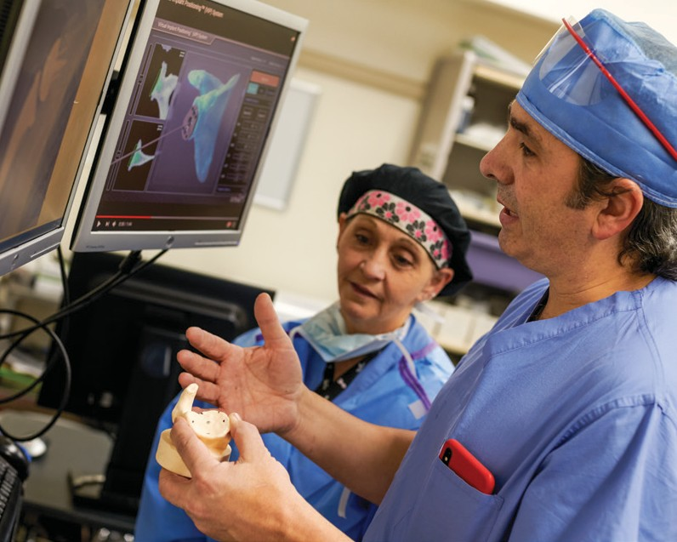
Paul Re, MD, and Karen Robinson, RN, review a 3D model prior to a reverse shoulder replacement.
reverses the location of the shoulder compo- nents. Dr. Re is one of very few surgeons outside of Boston using a CT-guided implant positioning system to plan patient-specific surgery.
Long before anyone attempted to perform hip or knee replacement surgery, the focus was on shoulder replacement—a way to keep the body’s most complicated joint working. Today, the shoulder is the fastest- growing joint replacement surgery.
“They are among my happiest patients,” says Dr. Re, “because they’re out of pain, and they’ve regained function.”
5
5
5
5
5

Orthopedic surgery at Emerson Hospital

As spring arrived, Ronald Millet was back on his bike thanks to successful knee replacement surgery at Emerson.
Setting more
Lancaster resident is back on the road

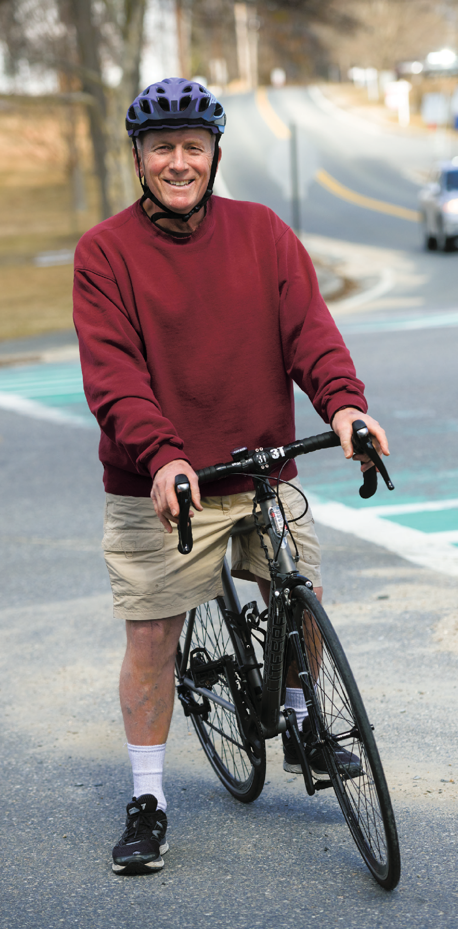

Ronald Millet didn’t dread knee replacement surgery; it was the period of required inactivity afterward that had him worried. The Lancaster resi- dent, 65, wanted to get back to his active lifestyle, which includes cycling 7,500 miles, on average, each year. He tried a variety of treatments to delay the inevitable, but once he started limping and couldn’t straighten his leg, he began research that led him
to Emerson Hospital.
A serious bike crash several years ago slowed Mr. Millet down, but only temporarily. “I was riding my bike at top speed when the handle- bars snapped off in my hands,” he recalls. “After rolling several times, I smashed my right knee on the pavement. It blew up to four times the normal size.”
His knee was never quite right after the crash, but he kept riding, playing hockey, hiking, snow-shoeing and cross-country skiing. “Three years ago, I noticed that my knee hurt if I skated, but only after skating,” says Mr.
Millet. An orthopedic surgeon diagnosed a
meniscus tear and performed minimally inva- sive surgery to repair it.
“That was when I heard the words ‘no carti- lage.’ He told me I would require a knee re- placement at some point. I thought I could plow through it, so I kept doing whatever I wanted to do.”
That doesn’t include sitting down too often. Since retiring from his job as a corrections program officer, Mr. Millet has two active part-time jobs—at a local bike shop and an

6
6

goals thanks to a knee replacement

orchard, where he does seasonal work. During fall cleanup at the orchard, all it took was one misstep to remind him that his knee was vulnerable.
“I stepped into a hole, and my knee blew up again,” he says. “I had it drained a couple of times and did physical therapy, but I knew I was in trouble. I was limping, and I couldn’t straighten my leg.” He began asking friends, neighbors and his sister—a nurse—about orthopedic surgeons who specialize in joint replacement surgery. “Everyone endorsed Dr. McInnis at Emerson.”
Mr. Millet made an appointment with John McInnis, MD, a Massachusetts General Hospital fellowship-trained hip and knee replacement surgeon. He hoped he could delay the surgery.
He was pleased when Dr. McInnis suggested buying some time before scheduling the pro- cedure. “There’s a right time to perform this operation,” says Dr. McInnis. “We expect patients to get 25 years from today’s knee implants. Ron already paid his dues by trying a number of different treatments and wearing a brace, but I thought cortisone injections could get him a few months of relief.”
They did, and Mr. Millet kept going. “I would limp to my bike, cycle pain-free, and then get off my bike and limp away,” he says. “Dr. McInnis told me I’d reach the point where I was begging to have the sur- gery done, and he was right. But first, I en- joyed the fall cycling season and working at the orchard.” His knee replacement was scheduled for just after Christmas 2018.

The first follow-up appointment: “music to my ears”
Heading into surgery, Dr. McInnis knew that Mr. Millet was physically fit. “The strength
“I knew that, after the surgery, Ron would do everything I asked him to do.”
– John McInnis, MD Orthopedic Surgeon

was there, so we didn’t worry about getting Ron teed up ahead of time,” Dr. McInnis ex- plains. “Some patients need to regain mo- tion and build back muscle before their surgery. This helps them handle their physi- cal therapy [PT] later.”
“The surgery went well,” says Mr. Millet. “I was uncomfortable the first day, but I was ready to walk that afternoon, when the phys- ical therapist came into my room with crutches.” After one overnight at Emerson, he headed home with plenty of motivation.
“One overnight is fine for younger and healthier individuals,” Dr. McInnis notes. “Our multi-modal approach to pain helps patients get moving and go home sooner, and getting out of bed the day of surgery helps prevent the potential development of blood clots.”
Staff from Emerson Home Care paid regular visits to monitor Mr. Millet’s vital signs and begin his PT. “They were all outstanding; I learned a lot from them,” he says. “By my first follow-up visit with Dr. McInnis, I was steadily increasing sessions on my lifecycle. Dr. McInnis examined my knee and said ‘you’re doing everything right.’ That was music to my ears.”

Setting goals for hiking
“Ron’s motion was excellent,” says Dr. McInnis. “He couldn’t straighten his leg be- fore his knee replacement, but just a few weeks afterwards, it was almost completely
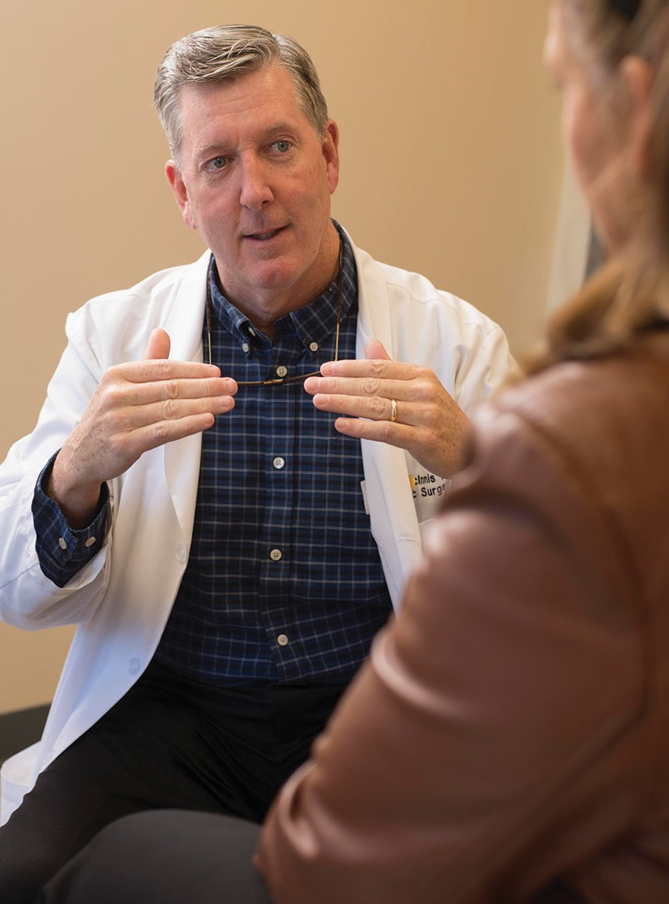

John McInnis, MD, says some patients need to regain mo- tion and build back muscle before their surgery.
straight. I knew that, after his surgery, Ron would do everything I asked him to do.”
From there, Mr. Millet was soon walking a couple of miles a day with his eye on the spring, when he will be cycling outdoors again. “I’ll stay mostly seated on my bike during climbs,” he says—a way to keep the strain off his knee. But his goals don’t stop there.
“I plan to hike all the 4,000-footers in New England,” Mr. Millet says. “There are 28 in New Hampshire alone, and I’ve hiked some of them already. I’ve been training in one way or another since I was a teenager. It doesn’t matter much what you do, but I believe you have to do something physical every day.”
His knee replacement will keep him going. “It was the right decision at the right time,” he says.

7
7
7
7

Orthopedic surgery at Emerson Hospital
Fast-track joint replacements
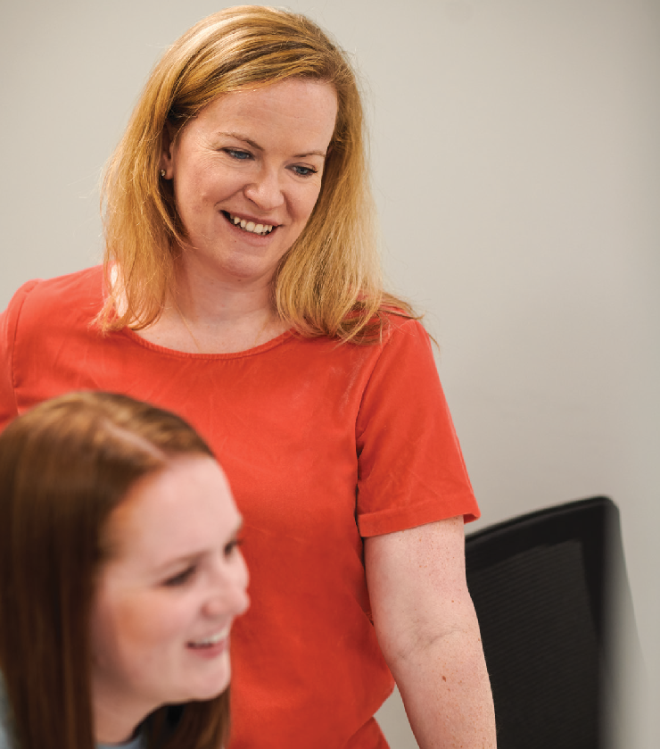are becoming more common

Those who are in good physical condition, have a support system at home and attend a joint replacement class are potential candidates for fast-track surgery, says
C. Brittany Boisvert, MD, orthopedic surgeon, shown with Kelsey Byron, PA.

Not everyone is a candidate, but certain individuals qualify for a fast-track approach to their hip or knee replacement surgery—that is, heading home on the evening of their surgery or the next morning.
There are a few items to consider when evaluating a patient for fast- track surgery, says C. Brittany Boisvert, MD, whose orthopedic surgery practice includes joint replacements, along with sports medi- cine. “The patient needs to be in good physical condition, meaning they exercise regularly,” she says. “Next, individuals with medical conditions—heart-related, pulmonary or sleep apnea—are not candi- dates for a short hospital stay. We need to watch them for a couple of days to be sure they do not develop any complications.”
Finally, a fast-track patient should have a support system at home. “Ideally, there is a family member who can come to their aid if they need help,” Dr. Boisvert notes. The best scenario is when the patient attends a joint replacement class at Emerson and brings a family member along.
“I encourage all patients to attend the class; that way, they under- stand the recovery process, including the use of walkers and canes, and how to prepare for surgery. Today, this includes showering with anti-bacterial soap prior to surgery. We want people to be familiar with everything that will happen before and after their surgery.”
Some individuals require additional preparation—losing weight— before their surgery can be scheduled. “Someone with a body-mass index [BMI] of 40 or above is at higher risk for a poor surgical out- come and certain complications,” says Dr. Boisvert. “We can work on it together, and I frequently refer patients to the Emerson Center

for Weight Loss. In some cases, a patient loses weight, their knee pain improves, and they don’t require a knee replacement.”
For those who do, a pre-surgical exercise program often helps. “We want patients to be primed and ready for their PT afterward, which is an important step to a good outcome.”

Orthopedic Surgeons at Emerson
Emerson Center for Specialty Care, 54 Baker Avenue, Concord
John Cahoy, MD, PhD 978-369-5391
Donald Driscoll, MD 978-369-5391 Dean Howard, MD 978-369-5391 Peter Kok, MD 978-369-5391
John McInnis, MD 978-369-5391 Paul Re, MD 978-369-5391
Emerson Urgent Care at Littleton, 830 Constitution Avenue
C. Brittany Boisvert, MD 978-371-5390 Kyle Lavery, MD 978-371-5390
Steve Manalan, MD 978-371-5390

Emerson Medical at Sudbury, 490 Boston Post Road
Allis Kim, MD 978-371-5390
Emerson Health Center Groton, 100 Boston Road
Allis Kim, MD 978-371-5390 Peter Kok, MD, 978-369-5391

Emerson Urgent Care at Hudson, 38 Highland Common East
Allis Kim, MD 978-371-5390
Emerson Health Center Westford, 110 Littleton Road
John Cahoy, MD, PhD 978-369-5391
Donald Driscoll, MD 978-369-5391 Dean Howard, MD 978-369-5391 Allis Kim, MD 978-371-5390
John McInnis, MD 978-369-5391 Paul Re, MD 978-369-5391
8
For more information, visit emersonhospital.org/ortho.

The doctor is in
Useful information from the Emerson medical staff
John Dowd, DO, Gastroenterologist
Colonoscopy screening needs to begin at age 45

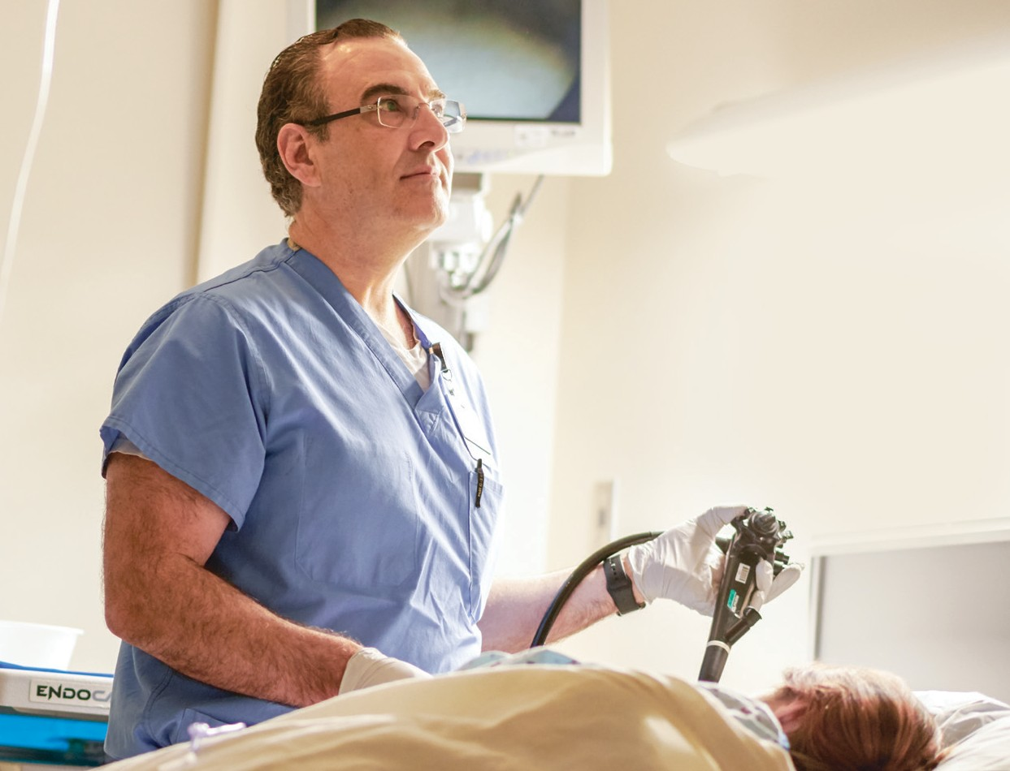Why is it now recommended that individuals with an average risk for colon cancer have their first colonoscopy at age 45?
We’ve seen an increased incidence of colon cancer in younger peo- ple during the last decade, and it has increased even more in the last five years. There are a host of contributing factors, including obesity, which now affects approximately 40 percent of adults. Our lifestyles are in desperate need of improvement: in general, we eat poorly— too many processed foods—and don’t exercise enough. We should be eating a plant-based diet and consume less meat. In May 2018, The American Cancer Society changed its long-standing recommen- dation that colonoscopy screening begin at age 45, instead of 50, for those with an average risk for colon cancer.
Are you concerned it will be a challenge to get younger people in for a baseline colonoscopy?
As people hear about the increased risk in those younger than age 50, I think they will come in for testing—especially here in
Massachusetts, where we have achieved a colorectal cancer screen- ing rate of 76 percent, which compares well with other states. The Centers for Disease Control has set a screening goal of 85 percent. Most health plans do not yet cover the cost of a colonoscopy for younger individuals. It typically takes some time for those changes to occur.
Are there efforts to make colonoscopies more pleasant?
Yes, mainly focused on decreasing the volume of prep—the drink required to clean out the colon. Some people don’t tolerate it well. However, in order to perform a high-quality colonoscopy, we need a colon that is cleansed of stool and debris. This allows us to identify polyps—potential cancer precursors—and remove them. This is how colonoscopy has decreased the rate of colon cancer in those who are screened and improves survival rates in those diagnosed. That is our goal: to prevent colon cancer.
After their first colonoscopy, many patients say to me “that was a piece of cake.” In fact, people sometimes wake up afterwards asking when the colonoscopy is going to begin. It was over before they knew it. The procedure itself is the easiest part. Although some peo- ple complain about the required prep and fasting, people who have had a colonoscopy are usually willing to come back again. This is especially true for those who receive a good report. They leave with piece of mind and don’t need to come back for ten years.
Where does home testing fit?
The best-known home test, Cologuard, is prescribed by a physician and checks for two things: genetic abnormalities in stool and for the

presence of blood. When we receive the report back, it simply says “positive” or “negative;” we don’t know which item is positive. As I tell patients, Cologuard is a cancer detection test, not a polyp detec- tion test. It is much better to prevent colon cancer by identifying and removing polyps than to be diagnosed with colon cancer and have to require treatment, typically surgery with or without chemotherapy.
As with all cancers, as the stage of colon cancer advances, your chance of survival is lower. Cologuard is not appropriate for some- one who has a family history of colon cancer or polyps, or has had polyps previously.
After their first colonoscopy, many patients say to me “that was a piece of cake.”
– john dowd, do

What percentage of individuals who have a screening colonoscopy will be found to have a polyp?
We expect to detect polyps in approximately 45 percent of women and 50 percent of men. The colonoscopy is the gold standard test against which the other tests are compared. They include imaging tests that use MRI or CT scans—known as virtual colonoscopy.
These tests require a prep to cleanse the colon, but they are not as sensitive as a colonoscopy.
No one questions the effectiveness of screening colonoscopy. It is why we encourage people to come in for their baseline test, now at age 45, and sooner if someone has a first-degree family member who had colon cancer. If that family member had colon cancer before age 60, you should begin screening at age 40. If the family member had colon cancer younger than that, you should come in ten years younger than the age when they were diagnosed.

For more information, visit emersonhospital.org/gastro.

9
9

Q your health questions answered by our experts.
emerso nAdvisor
I seem to be more forgetful lately. Should I be worried?

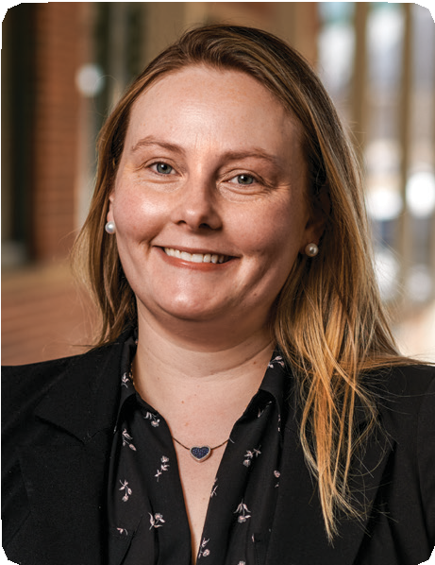
When an individual is concerned about their memory, my first interest is in their general health. Untreated high blood pressure, sleep apnea, high cholesterol and dia- betes all conspire to affect your memory. A recent 2019 study in the Journal of the American Medical Association provided evidence that lowering one’s blood pressure may reduce the risk of memory loss.
I also check the thyroid function and certain vitamin levels, as these can affect memory and are easily addressed, and I check for depression and anxiety, as
an individual’s primary care physician to control the risk factors that produce memory problems.
I will perform a careful screening for memory, language, abstract thinking, visual/spatial function and attention/ concentration. If more testing is needed, I may suggest an MRI, brain-wave testing or a neuropsychological evaluation. If everything looks okay, I will do my best to reassure the individual. If we continue to be concerned, I will make an individualized treatment plan with pos- sible further diagnostic testing.

well as alcohol and marijuana usage. Although I review

Q
the family history, there are very few genes for dementia
that are associated with memory loss. Often, I work with
claire carrazco, do
Neurologist
I’ve had a cold for more than a week. Why can’t I have an antibiotic?

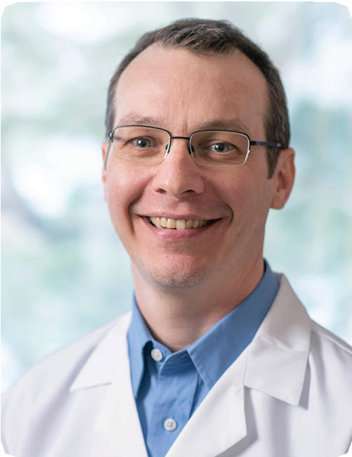
Colds usually last for three to ten days, but symptoms may persist for two to four weeks. These respiratory tract infections (RTI) are benign, self-limited—run a predictable course—are caused by a virus and benefit most from treating symptoms.
Antibiotics are used to treat bacterial infection. The inappropriate use to treat a viral RTI provides no benefit and only risks causing harmful side effects. Antibiotics can lead to nausea, vomiting, diarrhea, rashes, head- aches and more serious conditions, including heart
If someone is worried about a persistent cold, I suggest they come for an evaluation. I check their vital signs, per- form a physical exam and make sure they do not have a bacterial infection, such as strep throat or pneumonia. Both of these could benefit from antibiotic treatment.
Additionally, most sinus infections are actually caused by a virus and therefore don’t respond to antibiotics. Also, acute bronchitis typically lasts one to three weeks, usually results from inflammation caused by a virus and thus, antibiotics are not necessary.

problems and life-threatening allergic reactions. Frequent

antibiotic use also contributes to the development of antibiotic resistance.
Q
stephan goupil, do, phd
Emerson Family Medicine of Maynard

I heard that the HPV vaccine is now approved for adults up to age 45. Should I get it?

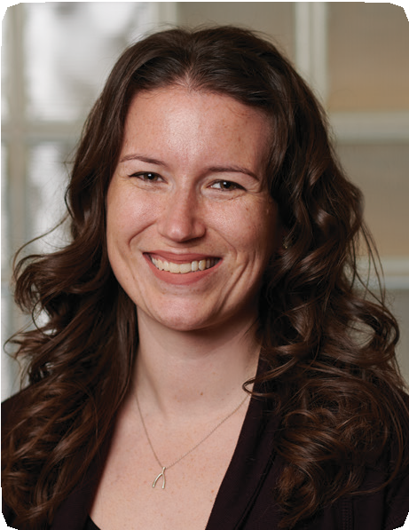
It is smart to do so, because the vaccine for the human papilloma virus (HPV) covers nine different high-risk strains, which can cause cancer and genital lesions in both women and men. Until now, the vaccine was only recommended for individuals up to age 26. We encour- age parents to make sure their sons and daughters receive it as kids—before they become sexually active. HPV is transmitted through sexual activity.
The vaccine can prevent up to 90 percent of HPV-
was first available, so I tell them it’s good news. Both women and men with new sexual partners would be wise to protect themselves and their partners by receiv- ing the vaccine.
Younger individuals require two shots; older individuals need three shots. Side effects, such as a reaction at the injection site, are rare. Not all health plans cover the cost of the vaccine, but that may change this year. Check with your health plan before making the appointment.

associated cancers of the cervix, vagina, vulva, anus,

penis and parts of the throat, as well as genital warts. Some of my patients missed out when the HPV vaccine
erin sienkiewicz, md
AFA Obstetrics and Gynecology

For more information on care at Emerson Hospital, call the toll-free Physician Referral Line: 877-9-EMERSON (877-936-3776) or visit the hospital’s website at emersonhospital.org.

10
10

Delivering targeted cancer treatment
Stereotactic body radiation therapy provides precision

Cancer treatment is steadily becoming more precise by targeting can- cer and avoiding healthy tissue. Stereotactic body radiation (SBRT) accomplishes this by directing multiple, thin radiation beams of varying intensities at a tumor, where they overlap and destroy cells. Patients at the Mass General Cancer Center at Emerson Hospital- Bethke are benefitting from this treatment.
It began as stereotactic radiosurgery—a way to treat brain tumors— and has found an expanding role in the treatment of other types of cancer. “We started treating lung cancer patients with SBRT earlier this year,” says John McGrath, MD, medical director of radiation on- cology. “SBRT is particularly effective for individuals who have small tumors, cannot have surgery—for example, because of poor lung function—or wish to avoid surgery.”
SBRT may be suggested when lung cancer has metastasized—that is, traveled to other sites in the body. A study published in 2016 showed that patients with three or fewer lung metastases who received SBRT had better post-treatment survival than those who received standard treatment.
“Patients are pleased when we tell them that SBRT requires only four or five treatments,” says Dr. McGrath. This is much easier than coming for the 30 or so treatments needed to deliver an effective dose with standard radiation therapy.
The pre-treatment planning session is essentially the same, but be- hind the scenes, radiation oncology staff spend additional time on the highly customized, precision planning that SBRT requires. When it comes to treating cancer in the chest, that includes performing 4D CT scanning. “The fourth dimension is the patient’s breathing,” Dr. McGrath explains. “This is especially important when cancer is lo- cated in the lower part of the lung—close to the heart—because

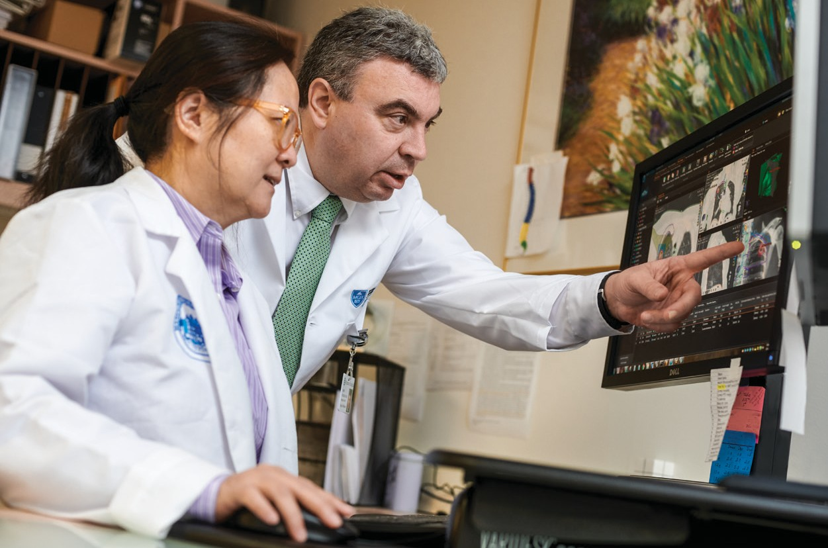
John McGrath, MD, medical director of radiation oncology, and Li Xiong, PhD, DABR, physicist, review a stereotactic body radiation therapy plan.

breathing can cause someone to move quite a bit.”
Before the first patient was treated with SBRT, Emerson’s physics team made sure the cancer center’s linear accelerator, which pro- vides radiation therapy, was ready. “This included measuring the beam itself,” says Dr. McGrath. “We are all aware that, with SBRT, we are providing powerful treatment to a very small area. In plan- ning a patient’s treatment, we draw a precise target volume that takes their breathing into account.”
Clinical research has shown that SBRT is effective in treating a num- ber of other types of cancer. “We plan to expand the use of SBRT to treat individuals with cancers that have spread to the liver and bone,” says Dr. McGrath.

Dr. McGrath brings his expertise to China

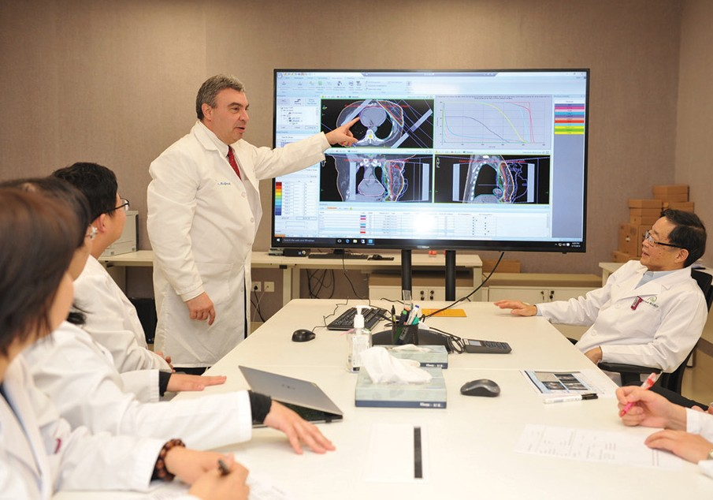A strategic collaboration between Mass General Hospital Cancer Center and Jiahui International Hospital (JIH) brought Dr.
McGrath to Shanghai, China, for two recent trips. “Last fall, I was asked to go to JIH to evaluate their radiation oncology program,” he explains. “They wanted help in running it similarly to ours.” As a generalist, in contrast to the subspecialists at the Mass General Cancer Center, Dr. McGrath has expertise that is a good fit for their needs at JIH.
Dr. McGrath conducted several mock con- sults with patients so that the radiation on- cologists could observe. “They are especially interested in how we treat our patients—that is, how we interact with patients and the
process we follow,” says Dr. McGrath.
He returned to JIH in January, when his radi- ation oncology colleagues were ready to see their first actual patients. “I helped them de- velop the simulation plans for treating two different patients, which included determin- ing the required radiation dosage,” he says.
Dr. McGrath participates in weekly confer- ence calls to discuss new patients with the staff at JIH. “I will continue to review their radiation oncology plans for new patients until they hire a medical director,” he ex- plains. Most of the staff at JIH speak English.
“Their goal is to create what we have here in the U.S. Fortunately, their linear accelerator

Dr. McGrath makes a presentation at Jiahui International Hospital.

is similar to ours at Emerson. At some point, I may help introduce them to SBRT.”
Dr. McGrath finds the work to be rewarding. “They’re very appreciative,” he says.

11
11

ENDOCRINOLOGY
OBSTETRICS AND GYNECOLOGY

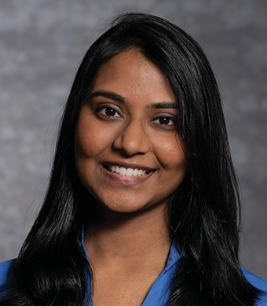Sravanthi Madala, MD Emerson Endocrinology Associates 131 Old Road to Nine Acre Corner John Cuming Building, Suite 270 Concord, 978-287-8520 emersonhospital.org
OnCall
Emerson Hospital is pleased to introduce the following new physicians.

Dr. Madala received her medical degree from the Medical College of Virginia and completed a residency in internal medicine at the University of Connecticut Medical Center. She completed a fellowship in endocri- nology, diabetes and metabolism at the Warren Alpert Medical School of Brown University.
Clinical interests: General endocrinology, diabetes, thyroid and parathyroid disease, adrenal and pituitary disorders, hyperlipidemia and endocrine hypertension
Diane Power, MD
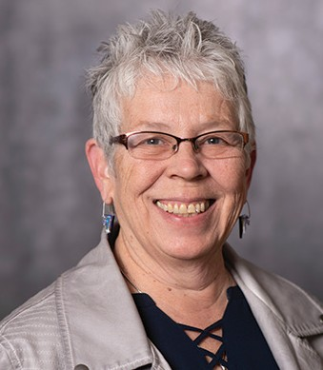AFA Obstetrics and Gynecology 131 Old Road to Nine Acre Corner John Cuming Building, Suite 830 Concord, 978-371-1396 afaobgyn.com
Dr. Power also sees patients in Leominster and Westford.

Dr. Power received her medical degree from the University of Massachusetts Medical School and completed a residency in obstetrics and gynecology at UMass Memorial Medical Center. She is board- certified in obstetrics and gynecology.
Clinical interests: Minimally invasive gynecological surgery, pelvic floor disorders, gestational diabetes and LGBT care

FAMILY MEDICINE

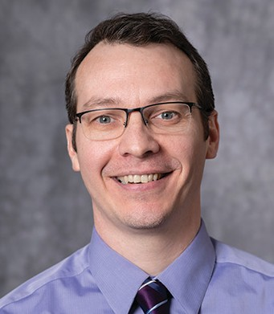Stephan Goupil, DO, PhD Emerson Family Medicine of Maynard 21 Main Street
Maynard, 978-318-1870 emersonhospital.org

Dr. Goupil earned his medical degree from the Philadelphia College of Osteopathic Medicine and completed a residency in family medicine at the Hahn- emann Family Health Center at UMass Memorial Medical Center. He received a PhD in biomedical sciences at the University of Connecticut. He is board- eligible in family medicine.
Clinical interests: General adult and pediatric medicine, evidence-based medicine, genomics and personalized medicine

INTERNAL MEDICINE
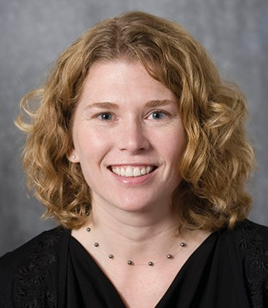Christine Beck, MD
Lincoln Physicians 80 Beharrell Street
Concord, 781-259-9292 lincolnphysicians.org

Dr. Beck earned her medical degree from Dalhousie University in Nova Scotia, Canada. She completed a residency in family medicine at Queen Elizabeth II Health Sciences Center. She is board-certified in family medicine and sees adult patients.
Clinical interests: Geriatrics and chronic disease management

Alan Moss, MD
OPHTHALMOLOGY
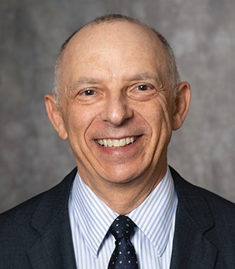D’Ambrosio Eye Care
255 Park Avenue, Suite 606
Worcester, 508-753-1032 dambrosio-eye-care-boston.com

Dr. Moss received his medical degree from the Univer- sity of Vermont College of Medicine and completed a residency in ophthalmology at Case Western Reserve University Hospitals, followed by a fellowship in glau- coma at Mount Sinai School of Medicine. He is board- certified in ophthalmology.
Clinical interests: Glaucoma
ORTHOPEDICS
Steve Manalan, MD Emerson Orthopedic Associates 830 Constitution Avenue
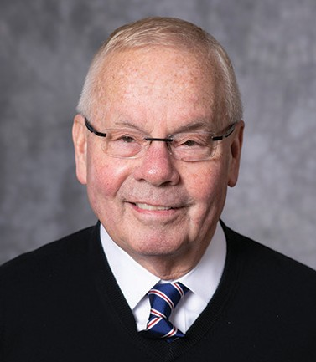Littleton, 978-371-5390 emersonhospital.org
Dr. Manalan sees hospitalized patients only.

Dr. Manalan earned his medical degree from Tufts University School of Medicine, completed an orthope- dics residency at the Harvard Combined Orthopaedic Residency Program and is board-certified in orthopedic surgery.

12



emerson hospital
Support Groups & Special Services

special services
support groups
Alcohol and Substance Abuse Support 978-287-3520
Cancer Caregivers Support Group 978-287-3428
Concussion Support Group 508-475-0032
Grief Support Group – Loss Due to Illness 978-287-3428
Infant and Pregnancy Loss 978-287-3422
Loss Due to Illness 855-774-5100
Melanoma Support 800-557-6352
New Mothers Group 978-429-8284
Oral, Head and Neck Cancer Support 978-287-3428
Parkinson’s Support 978-369-0419
Surgical Weight Loss Support 978-287-3532
Alzheimer’s Information 800-272-3900
Aphasia Conversation Group 978-287-8238
Breast Milk Donation 617-527-6263
CPR Education 978-287-3050
Cardiac Rehabilitation 978-287-3732
Care Dimensions (Hospice) 888-283-1722
Chronic Lung Disease Program 978-287-8300
Gambling Problems 978-287-3520
Health and Wellness Classes 978-287-3777
Heart Failure Program 978-287-8300
Home Health Service 978-287-8300

National Alliance on Mental Illness 781-982-3318

Nutritional Counseling 978-287-3782

Pediatric Intervention Team 978-287-3422

Physician Referral
877-9-EMERSON or 877-936-3776

Pulmonary – Better Breathers Club 978-287-3715

REACH (hotline for domestic violence) 800-899-4000

Speech and Language Screening for Preschoolers 978-287-8200

Sports Rehabilitation 978-287-8200

Volunteer Program 978-287-3200

Wound Care Center 978-287-8550

PEDIATRICS
PSYCHIATRY

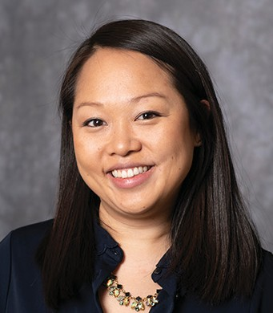Emily Proctor, DO
Pediatrics West 133 Littleton Road
Westford, 978-577-0437 pediatricswest.com
Dr. Proctor received her medical degree from Lake Erie College of Osteopathic Medicine. She completed a residency in pediatrics at Baystate Medical Center and is board-certified in pediatrics.
Clinical interests: Newborn medicine, preventive medi- cine, adolescent and sports medicine
Maria Arcia, MD
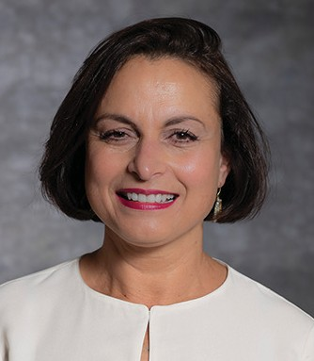Emerson Hospital
133 Old Road to Nine Acre Corner Concord, 978-369-1400
Dr. Arcia sees hospitalized adult patients only.

Dr. Arcia completed her medical degree at Faculdade de Medicina Universidade de Coimbra in Portugal. She completed a residency in psychiatry at St. Elizabeth’s Medical Center. She is board-certified in psychiatry and speaks English, Spanish and Portuguese.
Clinical interests: Obsessive-compulsive disorder and schizophrenia

PODIATRY

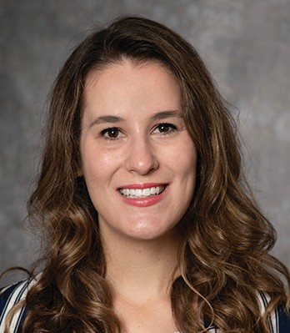Alissa Kuizinas, DPM
Concord Foot & Ankle
54 Baker Avenue, Suite 301
978-369-5282
concordfeet.com
Dr. Kuizinas earned her medical degree at Temple Uni- versity School of Podiatric Medicine. She completed a residency at Hoboken University Medical Center and
is board-certified in podiatry. She speaks English and Spanish.
Clinical interests: Reconstructive foot and ankle surgery, sports medicine, fractures and sprains

Michelle Dalencour, MD
URGENT CARE
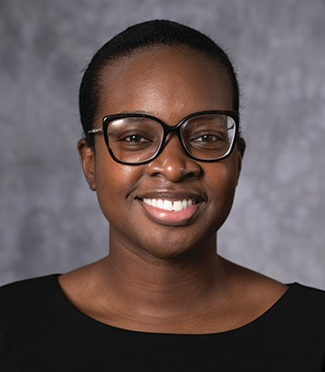Emerson Urgent Care at Hudson
38 Highland Common East, Hudson Emerson Urgent Care at Littleton 830 Constitution Avenue, Littleton
978-287-8990/emersonurgentcare.org
Dr. Dalencour received her medical degree from University of Massachusetts Medical School and completed a residency in family and social medicine at Montefiore Medical Center. She is board-certified in family medicine and fluent in Haitian Creole and medical Spanish.

13
131313

News from Emerson

Sports Medicine and Performance Division opens in Concord

The Clough Family Center for Rehabilitative and Sports Therapies keeps growing—now, with a new Sports Medicine and Performance Division, located at 310 Baker Avenue in Concord. The physical therapists and athletic trainers treat athletes of all levels in innova- tive ways, including working with groups and teams to achieve the best results. The beautiful new space features the latest equipment for performance training: squat racks, TRX, rowing machines and the Vasper cooling recumbent bike for optimized training and recovery. Learn more at emersonhospital.org/rehab.
A new therapy dog has joined the team

If you see a two-year-old chocolate lab in the halls of Emerson, say hello to Bayou, the newest member of the hospital’s pet therapy team. Bayou is owned and trained by Kate Stout, an Emerson
volunteer who is certified by the Pets and People Foundation in Acton. Kate and Bayou pay visits to patients and staff alike.
New painting exhibit at Emerson’s Sudbury facility


Carolyn Letvin’s sheep paintings are being exhibited at Emerson Medical at Sudbury through July 25 in a show entitled "Sheep- ish Visions." Ms. Letvin is an award-win- ning artist and teacher whose paintings and monotype prints have been included in many area and regional exhibitions,
including at Concord Art and ArtSpace in Maynard. An exhibit of paintings by Sid Pani, MD, at Emerson Primary Care Associates of Sudbury, begins in late July. Emerson Medical at Sudbury is located at 490 Boston Post Road (Route 20) in Chiswick Park.

Motivated to give—and to get involved
Lisa Harrell is an enthusiastic corporator



14

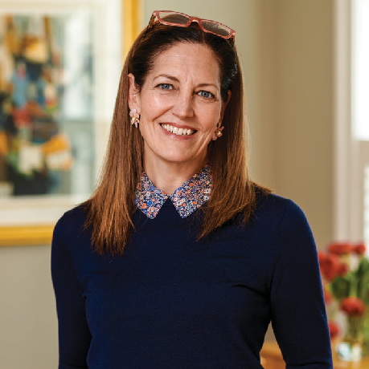
Lisa Harrell believes in what Emerson offers the community.

It didn’t take long for Lisa Harrell to get in- volved with Emerson. Soon after becoming a corporator last year, the Bedford resident was supporting the hospital’s Annual Appeal and volunteering at an important fundraising event, the Run~Walk for Cancer.
“That was the perfect introduction to Emerson,” says Ms. Harrell, a realtor at
Barrett Sotheby’s International Realty. “I assisted with on-site registration, and I handed out snacks at the finish line.”
Attending corporator breakfasts has made a strong impression. “We’re fortunate to have a hospital like Emerson in the community— one that provides high-quality care, as well as public health initiatives like the Youth Risk Behavior Survey, which provides par- ents and teachers with useful information.”
Ms. Harrell says she has plenty of motiva- tion to support Emerson. “As a family, we make donations to the Annual Appeal,” she notes. “Now that I’m involved with
Emerson, I believe in Emerson and what the hospital offers our community. I am willing to write a check, and I try to carve out the time to be a good ambassador, which in- cludes learning as much as I can.”
She serves as a corporate sponsor liaison for the Bedford Education Foundation (BEF). “The BEF treasurer is Bob Segel, the Emerson corporator and foundation board member who nominated me,” she explains.
Ms. Harrell may be busy with her realtor work, raising a daughter and serving as an enthusiastic Emerson corporator. However, she recently contacted the hospital’s volun- teer program and is eager to get started.
Five years after moving to the area from Chicago, she appreciates a region with much to offer, including good schools and person- alized care close to home. “I really love the bucolic scenery and, of course, the history.”

Please support the Emerson Hospital Annual Appeal

Your gift to Emerson’s Annual Appeal will be used to strengthen the clinical programs on which you, your loved ones and the entire community depend. To make a dona- tion to the hospital’s Annual Appeal, please visit emersonhospital.org or contact Diane Chellis at dchellis@emersonhosp.org or 978-287-3001.

In my
OWN
‘‘

voice

Roger Campbell
His instincts led him to Emerson’s Wellness Center

Five years ago, Roger Campbell realized he needed to get regular exercise. He joined a class at Emerson’s Steinberg Wellness Center for Mind and Body called Parkinson’s Movement, which is designed to improve balance, flexibility, move- ment range and rhythm. Although Mr. Campbell does not have Parkinson’s dis- ease, he enjoys the class, has made friends there and says he benefits physically and mentally. At the age of 100, he continues to follow his instincts: he knows that being active is essential to his good health.

“In my earlier years, I was always exercising, working out or playing sports. I’m from South Weymouth, but I moved to Concord 14 years ago to be near my son, Jeff, who’s on the Emerson Board of Directors. He told me about the wellness center and took me on a tour. He knew about the Parkinson’s Movement class.
“The class is only once a week, but it serves its purpose. Most importantly, it put me into a fixed routine. It became my habit; I don’t think I’ve missed two classes in five years. I do other exercises at home.

“After the class, I definitely feel looser, and I’m wide awake. Then I sleep well.”
– Roger Campbell

“Susanne Liebich is a fabulous instructor and a fabulous individual. She treats me like the others, but she knows I don’t have Parkinson’s. We all have something. I was diagnosed with prostate cancer years ago. I see my doctor regularly for that.
“After the class, I definitely feel looser, and I’m wide awake. Then I sleep well.
“I’ve become closely acquainted with the people in the class, and I’ve be- come acquainted with Parkinson’s disease. It can be a difficult disease. I’ve made friends with a few people who came to class in apparently good health, but in a few years, they’re not doing so well. It’s sad. I’ve developed sympathy for them.

Attending a weekly class benefits 100-year-old Roger Campbell in a number of ways—physically, mentally and socially.

“However, we have a lot of laughs in class. When I worked for John Hancock way back—before and after the war—they had a health department that dis- tributed books to the employees. I remember one was about how laughter is the best medicine: the more you laugh, the healthier you are. I never forgot that, and it comes to mind when we’re heading to the parking lot together after class, and everyone is laughing. I have a pretty good sense of humor. I’m an expert in one-liners.
“People wonder about me, because I’m 100, and I live alone in an apart- ment. But I’m not a lonely old man. My apartment building has people of all ages, including children. I’m watching them grow up. A lot of us head down to get the mail at 3:00 every afternoon. Also, I have a health aide and a couple of nurses who visit me, along with family, so I see people through- out the day.
“The truth of the matter is that the door never stops swinging, and the phone doesn’t stop ringing. And I’m out of breath. At the end of the day, I’m happy to get in bed.
“I think I have healthy habits. I don’t drink or eat dessert, I don’t go out with girls, and I don’t drive. I love music. I have a Google Assistant so that I can listen to everything from Billy Joel to symphonies. One thing I know is that my health wouldn’t be as good as it is if I didn’t take the Parkinson’s Movement class.
“When I tell people I’m 100, they have a hard time believing it. Maybe I should start cheating about my age. I might begin saying I’m 52.”
For more information on classes at the Steinberg Wellness Center for Mind and Body, please visit EmersonWellness.org or call 978-287-3777.

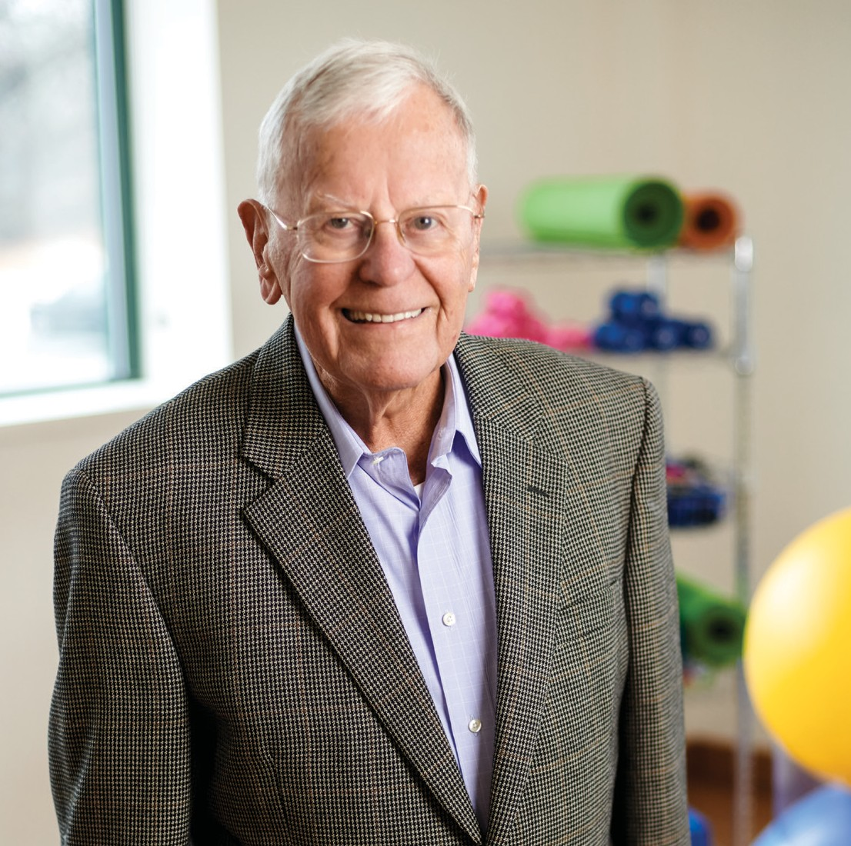

15



133 ORNAC, Concord, MA 01742
978-369-1400
emersonhospital.org

HealthWorks, published by Emerson Hospital, is mailed to residents in the hospital’s service area and is distributed to the employees and physicians’ offices affiliated with Emerson Hospital.
If you would prefer not to receive such mailings in the future, please let us know by calling 978-287-3458 or send an email to pr@emersonhosp.org.
Emerson Hospital President and CEO
Christine C. Schuster
HealthWorks Magazine editorial staff
Christine Gallery, Bonnie Goldsmith, Leah Lesser
Writer
Laura Duffy
Photography
Tony Rinaldo
Design and Printing
Fassino/Design and Signature Printing & Consulting
The information included here is intended to educate readers about health issues, but it is not a substitute for
Emerson Family Medicine is now open in Maynard
The new practice is located in “the heart of Maynard”

Emerson Family Medicine, located downtown, is a welcome sight for Maynard residents who are eager to have additional medical care nearby. The new practice, located in the former Walgreens at 21 Main Street, provides family medicine—primary care that welcomes everyone, regard- less of age.
“Family doctors are specially trained to care for all ages, from newborns to elders,” explains Linda Brown, MD, who is now accepting patients, along with Stephan Goupil, DO, PhD. Dr. Brown has a special interest in pediat-

consultation with a personal physician.
The mission of Emerson Hospital is to deliver high-quality care to our community that is safe, compassionate, accessible, appropriate, efficient and coordinated.
Linda Brown, MD, and Stephan Goupil, DO, PhD, are
accepting new patients of all ages at Emerson Family Medicine in Maynard.
rics and women’s health. Dr. Goupil
has a clinical interest in evidence- based, genomics and personalized medicine.

Join our online community at

and emersonhospital.org
There are benefits when one physician takes care of—and gets to know—the entire family, and even
generations of patients. “We are trained to deal with health holistically,” Dr. Brown notes. “If Mom is sick or Dad has been laid off, it affects the entire family. We are excited to bring family medicine to the heart of Maynard.”
The practice features an art gallery that will exhibit work that reflects the town and its residents.
To make an appointment at Emerson Family Medicine, please call 978-318-1870 or visit maynardfamilymedicine.org.

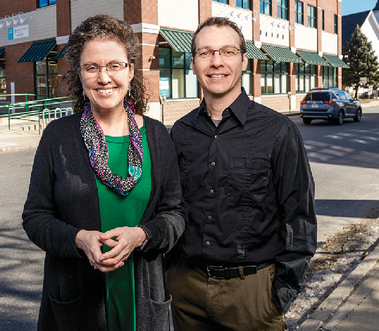

Front cover: Ronald Millet, a Lancaster resident who cycles 7,500 miles per year, on average, is back working at CK Bikes in Harvard after knee replacement surgery at Emerson.


COLONOSCOPIES HELP SAVE LIVES.
SCHEDULE YOURS TODAY!

A colonoscopy is the most effective screening for colorectal cancer. A colonoscopy performed by a gastroenterologist can detect early-stage cancer before symptoms occur when treatment is most effective.
Do not delay your care! Emerson Hospital has precautions in place to assure your health and safety at every visit, from strict cleaning protocols to personal protective equipment, and more.

We are safe, clean, and here for you!

To find a gastroenterologist or primary care doctor, visit
EmersonHospital.org/colon or call 1-877-936-3776.

Premium care. Personal touch.

AGE
ARE YOU AT RISK FOR COLORECTAL CANCER?

Most people who have colorectal cancer are over the age of 50. Those with certain risk factors should be tested sooner.


133 Old Road to Nine Acre Corner Concord, MA 01742

NONPROFIT ORG.
U.S. POSTAGE
PAID
LIONSHARE

FAMILY HISTORY

Nearly 1 in 3 people who develop colorectal cancer have other family members who have also had it.

LIFESTYLE

People who are overweight, smoke, drink heavily or are physically inactive have a higher risk of developing colorectal cancer.
To find a gastroenterologist or primary care doctor, visit EmersonHospital.org/colon
or call 1-877-936-3776.

If you do not wish to receive further Emerson Hospital mail, please let us know by updating your preferences at emersonhospital.org/preferences.



APPLICANT QUESTIONS
Responses should be sent to DoN staff at DPH.DON@State.MA.US
While you may submit each answer as available, please
- List question number and question for each answer you provide
- Submit responses as a separate word document, using the above application title and number as a running header and page numbers in the footer
- When providing the answer to the final question, submit all questions and answers in one final document
- Submit responses in WORD or EXCEL; only use PDF’s if absolutely necessary. If “cutting and pasting” charts, provide them in a PDF so they can be clearly seen

Interpretation and Translation Services

- How will patients receiving endoscopy services be made aware of the interpretation and language access and assistive services that are offered?
Access to language services is a foundational component of care for Physicians Endoscopy’s patients demonstrating limited English proficiency (LEP) and American Sign Language (ASL) needs. As with other PE centers, the Proposed ASC will contract with Language Line Solutions to provide access to 24/7 telephonic and video interpretation services for all LEP and ASL interpretation.

Patient barriers to care are assessed and identified pre-procedure upon scheduling the procedure. However, if needs are not identified pre-procedure, but present the day of the procedure, signage is present in the facility to assist identification of language or ASL needs and an interpreter will be made immediately available to assist through telephonic or video interpretation.

- How and by whom will patients be screened prior to the procedure to identify level of assistance needed? Registered nurses will assess patient needs and potential barriers to care 1-3 days pre-procedure.
  - Can you provide a copy of the screening document? Screening questions will be imbedded into the electronic medical record. Screening questions include but are not limited to:
    - Do you have any difficulty with reading or writing the English language?
    - Would you like to use an interpreter?
- How will interpreter and translation services be arranged for patients on the day of service if they have not been arranged ahead of time? Interpretation services will always be available and do not need to be scheduled in advance, though the Center will work to ensure patients feel comfortable requesting assistance at the time their procedure is scheduled.

- What vendor will be used to provide in-person interpreter services for persons with hearing impairment? Language Line Services will provide ‘video’ face to face ASL interpretation.

- Describe the process for assessing and providing language access for patients who are visually impaired. Patients with visual impairments/limitations will be offered the option of having an individual read the document(s) to them.
  - Are materials going to be read in the language the person requests? Yes

1
789655.1

Cultural Competence Training
- Describe how cultural competence training efforts are initiated and tracked, and how success is measured.

Orientation processes are in place to inform staff and licensed independent practitioners about the Center values, culture, and procedures. Sensitivity to cultural diversity based on their specific responsibilities are included in the orientation process, re-educated at least annually or more frequently as needed, and assessed on-going.

In addition to evaluating training completion, PE centers utilize SPH Analytics to conduct patient satisfaction surveys. The survey asks patients about their overall experience, including interactions with staff and their physician. Results are then benchmarked against all PE centers as well as other single-specialty endoscopy centers across the country. Furthermore, all patient complaints or concerns identified in a survey are immediately reviewed and investigated by PE staff. The same is true for complaints that are made outside of the survey.

Social Determinants of Health (SDoH) Screening
- Provide more information about SDoH screening processes during the pre-procedure screening or on the day of procedure.

As a provider of routine, non-urgent outpatient endoscopy, the Center’s staff will have limited interactions with patients given the episodic nature of care to be provided. Center staff will continue to screen patients ahead of their procedures, focusing on transportation, escort availability, and medication adherence. These areas are specific to endoscopy, for example, patients are unable to drive themselves home from appointments and must arrange for transportation. However, these questions do allow staff to assess additional needs. If a patient indicates poor medication adherence, staff are trained to ask about potential causes for the poor adherence, including trouble picking up or paying for prescriptions. These questions may lead staff to recommend financial counseling through the Center as well as external resources to connect the patient to the appropriate resource. All responses are recorded in the patient’s medical record with follow-up as needed with the patient’s primary care provider or referring physician.

  - Which domains will be covered in SDoH screening? The screening will focus on transportation, financial capacity, and personal safety.

  - What screening tool will you use? The screening tool is embedded in the Center’s electronic medical record.

  - Who will conduct SDoH screening and document the results of screening? A registered nurse will conduct the SDoH screening.

  - Have you established relationships with local organizations where patients with positive SDoH screens will be referred? The Applicant, through Emerson Hospital, will continue to build and strengthen existing relationships, as well as expand when deficiencies or limitations are identified.

2
789655.1

  - Is it possible to obtain patient consent to follow-up with referral organizations? Alternatively, the Applicant proposes that follow-up by the Applicant be with the patient and the patient’s primary care provider as needed.

3
789655.1

APPLICANT RESPONSES
Responses should be sent to DoN staff at DPH.DON@State.MA.US
While you may submit each answer as available, please
- List question number and question for each answer you provide
- Submit responses as a separate word document, using the above application title and number as a running header and page numbers in the footer
- When providing the answer to the final question, submit all questions and answers in one final document
- Submit responses in WORD or EXCEL; only use PDF’s if absolutely necessary. If “cutting and pasting” charts, provide them in a PDF so they can be clearly seen

- Provide current wait times for routine, advanced, and complex endoscopy procedures performed at the Emerson Hospital endoscopy department.

Wait times for routine procedures at Emerson Hospital vary for each of the Hospital’s three gastroenterologists. Patients - both physician-referred and self-referred - who do not express a preference for a particular physician, day, time, or gender of the rendering physician are scheduled for the next available appointment. Often, however, patients do express one or more preferences which account for the variation in wait time. Therefore, wait times at the Hospital vary between two and six weeks depending on the preferred time of the appointment or the preferred physician.

Advanced and complex procedures are time-sensitive and therefore are usually scheduled within one to two days, but no more than 10 days.

  - How will the Proposed Project impact wait times for routine endoscopy at the proposed ASC, and at the endoscopy department once the ASC becomes operational?
Emerson Hospital will close two of its four endoscopy procedure rooms once the ASC becomes operational. Accordingly, the Applicant does not anticipate an immediate change to wait times for routine endoscopy; however, routine outpatients will not be impacted by the need to reschedule due to inpatient or emergent cases. Moreover, inpatient cases may be able to be handled during regular hours of the day. Over time, wait times are anticipated to improve as the ASC will be focused on serving only routine cases which brings operational efficiencies.

- The Applicant states the proposed ASC will accommodate future volume based on projected demand in the service area for routine endoscopy.
  - Where do you anticipate the new volume will come from?
The Applicant anticipates increased demand and volume will come from three primary sources: (1) an aging population of the Applicant’s service area, (2) Emerson patients who chose the ASC for convenience, and (3) changes to insurance coverage. The first factor is

1

775196.1

the organic market growth driven by the aging demographic in the Emerson Hospital Service Area. Additionally, the Applicant seeks to retain Emerson patients who currently receive endoscopy services outside of the service area at academic medical centers because of the convenience that will be created by the proposed ASC. Lastly, the Applicant anticipates a moderate increase in cases as insurance companies and government payors update their payment policies to reflect the U.S. Preventative Services Task Force’s recommendation to begin routine colonoscopies at age 45.

- Will the proposed ASC provide financial counseling to ensure patients are informed of the costs of care prior to their procedure? A specific concern for endoscopy patients is surprise billing for colonoscopies (https://www.acpjournals.org/doi/pdf/10.7326/M20-2928)

Yes. The ASC will provide financial counseling to ensure patients are informed of the costs of care prior to their procedure. Patients are contacted in advance of their procedure to verify benefits, obtain prior authorization, if required, and to inform the patient of any out-of-pocket costs related to their procedure.

2

775196.1

APPLICANT QUESTIONS
Responses should be sent to DoN staff at DPH.DON@State.MA.US
While you may submit each answer as available, please
- List question number and question for each answer you provide
- Submit responses as a separate word document, using the above application title and number as a running header and page numbers in the footer
- When providing the answer to the final question, submit all questions and answers in one final document
- Submit responses in WORD or EXCEL; only use PDF’s if absolutely necessary. If “cutting and pasting” charts, provide them in a PDF so they can be clearly seen

1. The Application states Emerson Hospital will close two operating rooms in its endoscopy unit once the ASC is operational. What will happen with the space where the two rooms are located? Will the space be used for something else?

1

The hospital has not determined yet how this space may be used. It will follow DPH rules that apply at such time it has a plan for how the closed space would be used.

