Employer Resources for Keeping Teens Safe at Work*

Massachusetts Resources and Services
Child Labor Laws in Massachusetts Poster  This 11” x 17” poster, developed by the MA Department of Public Health’s Teens at Work Injury Surveillance and Prevention Project, provides a compilation of the state and federal child labor laws that govern the employment of minors in MA. Available in English and Spanish.  How to obtain: Contact the Teens at Work Injury Surveillance and Prevention Project at (617) 624-5632 or http://www.mass.gov/dph/teensatwork. | 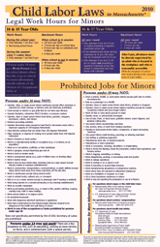
Employer Tips for Keeping Young Workers Safe on the Job
Created by the MA Department of Public Health’s Teens at Work Injury Surveillance and Prevention Project, this tip sheet includes ideas on improving the health and safety of the workplace.
How to obtain: Contact the Teens at Work Injury Surveillance and Prevention Program at (617) 624-5632 or http://www.mass.gov/dph/teensatwork.

Forklift Warning Sticker  Another tool created by the MA Department of Public Health’s Teens at Work Injury Surveillance and Prevention Project is this brightly colored, multi-lingual (English and Spanish) sticker that employers can place on hazardous equipment to alert all workers that no one under 18 years of age may legally operate that equipment.  How to obtain: Contact the Teens at Work Injury Surveillance and Prevention Project at (617) 624-5632 or visit the U.S. Department of Labor website: http://youthrules.dol.gov/posters.htm#Sticker. |  | 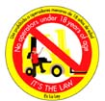
MA Department of Labor Standards On-site Consultation Program  The MA DOS offers free consultation services designed to help small employers recognize and control potential safety and health hazards at their worksites, improve their safety and health programs, and assist in training employees  How to obtain: To request a free occupational safety and/or health consultative visit, call the MA DOS at (617) 969-7177 or email them at masscon@state.ma.us.  For more information, visit their website  http://www.mass.gov/lwd/labor-standards/on-site-consultation-program/. |  | 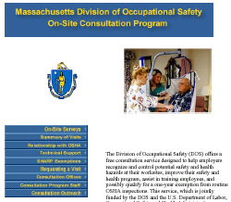
MA Dept. of Industrial Accidents Safety Training and Educational Grants  These grants are available, using a competitive process, to any employer that seeks to improve workplace safety. The only criterion is that the employer must provide workers’ compensation insurance for its employees. Grant applications are evaluated once a year by the DIA’s Office of Safety  How to obtain: Contact Gayann Wilkinson at the Department of Industrial Accidents, Office of Safety at (617) 727-4900 ext. 387 or visit the following webpage for more information on the grant and the application process, including the deadlines by which you must apply: http://www.mass.gov/dia/safety. |  | 
*Inclusion in this list does not constitute an endorsement.

Federal Government Resources
Web-based “eTools”  Created by the Occupational Safety and Health Administration (OSHA), eTools are stand-alone, interactive, web-based training tools on occupational safety and health topics. They are highly illustrated and utilize graphical menus. Some of the e-Tools that relate specifically to young worker health and safety include: “Teen Worker Safety in Restaurants,” “Youth in Agriculture,” and a “Dietary Module” for food service workers in health care settings.  How to obtain: These eTools can be accessed from the following webpage: http://www.osha.gov/dts/osta/oshasoft/index.html#eTools. For more information, contact OSHA at 1-800-321-OSHA or visit their main website: www.osha.gov. |  | 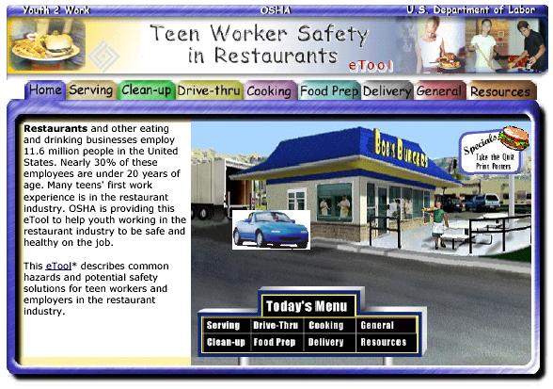
Employer’s Pocket Guide on Youth Employment  This pocket guide for employers, developed by the US Department of Labor, covers compliance with the federal laws, and tips for ensuring a safe workplace for teenagers, including ideas from other employers.  How to obtain: A pdf version of this guide can found on following webpage: http://www.youthrules.dol.gov/brochures.htm. For more information contact the U.S. Department of Labor, Wage and Hour Division at 1-866-487-9243 or visit the Department’s “Youth Rules” website: http://www.youthrules.dol.gov. | 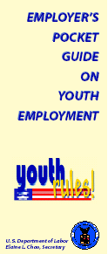
US DOL Fact Sheets  The US Department of Labor’s Employment Standards Administration has created several fact sheets for employers covering a wide range of topics on employing youth. These sheets provide quick and easy to read information on the child labor laws, wage and hour requirements and more.  How to obtain: Fact sheets on child labor issues can found on the following webpage: http://www.youthrules.dol.gov/factsheets.htm. Other fact sheets can be found by going here: http://www.dol.gov/esa/fact-sheets-index.htm. For more information contact the US Dept. Labor, Employment Standards Administration, Wage and Hour Division at 1-866-487-9243 or visit their main website: www.dol.gov/esa. | 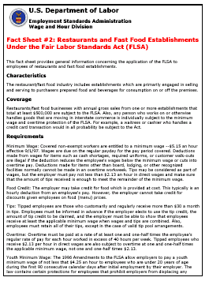
Best Practices Guide: Fundamentals of a Workplace First-Aid Program  OSHA has created a guide that identifies four essential elements for first-aid programs to be effective and successful and details the primary components of a first-aid program at the workplace. The guide also includes best practices for planning and conducting safe and effective first-aid training.  How to obtain: A pdf version of this guide can be found on the following webpage: http://www.osha.gov/pls/publications/pubindex.list. For more information, contact the OSHA at 1-800-321-OSHA or visit their website: www.osha.gov. | 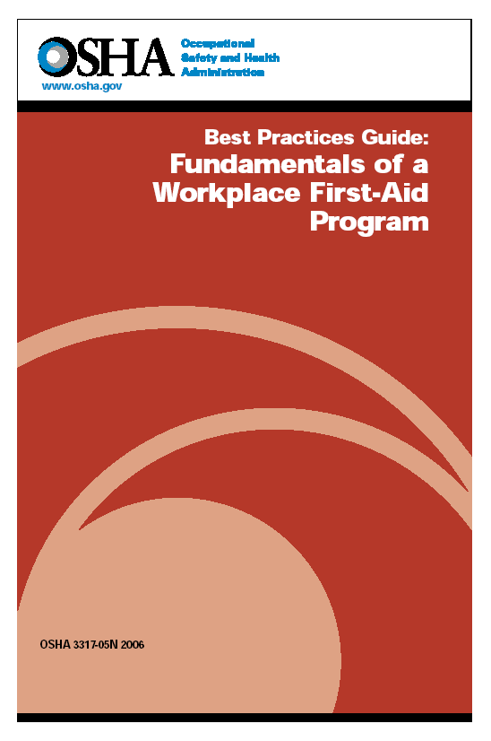
Warning Sticker  Designed by the US Department of Labor, this warning sticker is one that employers can place on hazardous equipment to alert all workers that no one under 18 years of age may legally operate that equipment.  How to obtain: Contact the US Department of Labor, Wage and Hour Division Office in Massachusetts at (617) 624-6700 to request stickers, or view and print them directly from the following link: http://youthrules.dol.gov/posters.htm#Sticker. | 

Resources from Other States
Tools for Orienting Worksite Supervisors About Teen Health and Safety  Compiled by the University of California Berkeley’s Labor Occupational Health Program, this information packet is for work site supervisors and includes tools to use in job training programs.  How to obtain: Contact the Labor Occupational Health Program, University of California Berkeley at (510) 642-5507 to request a copy, or visit the National Young Worker Safety Resource Center website for more information: http://socrates.berkeley.edu/~safejobs. |  |  | 
Keep Young Workers Safe – SafetyWorks! Tip  The Maine Department of Labor has created this tip sheet for employers to help them understand why young workers need extra protection and how employers can work toward improving the safety of their young workers.  How to obtain: A pdf version of the fact sheet can be viewed and printed from the following link: http://www.maine.gov/tools/whatsnew/attach.php?id=1725&an=1. For more information, contact the Maine Department of Labor, Safety Works Program at (207) 624-6400 or visit their main website: http://www.safetyworksmaine.com. |  |  | 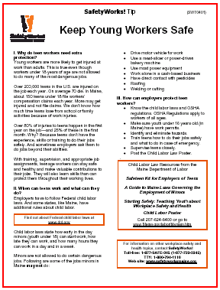
Youth Rules! Protecting the Working Teen  This 15-minute video, produced by the Illinois Onsite Safety and Health Consultation Program, is meant to assist employers in understanding their responsibilities for providing a safe and healthful workplace for teenaged workers as well as how to recognize and eliminate workplace hazards.  How to obtain: The video is available for download on the following webpage: www2.illinoisbiz.biz/osha/videos/videos1.htm. If you would like a free VHS copy of this video, or would like more information, contact the Illinois Onsite Safety and Health Consultation Program at 1-800-972-4216. |  |  | 
Rated R Sticker  Designed by the Washington State Department of Labor and Industries, this sticker can be used by employers to easily designate machinery that is off limits to workers under age 18.  How to obtain: You can order these stickers by calling (360) 902-5316 or e-mailing a request to: teensafety@lni.wa.gov. For more information, contact the Washington State Department of Labor and Industries at 1-800-547-8367 or visit their main website: http://www.lni.wa.gov/. |  |  | 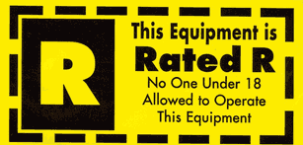
Inexperienced Workers - Fact Sheet  This fact sheet, produced by the Texas Workers’ Compensation Commission, is filled with valuable information on common workplace injuries, hazard recognition and remediation tips, and covers the use of personal protective equipment when hazards cannot be fully eliminated.  How to obtain: A pdf version can be printed from the following link: http://www.tdi.state.tx.us/pubs/videoresource/stpinexp.pdf. For more information, contact the Texas Workers’ Compensation Commission at 1-800-252-7031 or visit their main website: http://www.tdi.state.tx.us/wc/. |  |  | 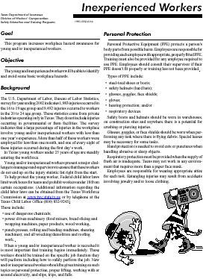
Resources from Outside the US
Dare to Care  A video and interactive training manual, developed by the Ontario Service Safety Alliance, provides new employees and their managers with information about health and safety in the workplace. It includes information on communication and being proactive. There are guides for restaurant, retail, vehicle sales, and hospitality industries.  How to obtain: These training tools can be order directly from the following webpage: http://www.ossa.com/content/products/young.cfm. For more information, contact the Ontario Service Safety Alliance at 1-888-478-6772 or visit their website: www.ossa.com. |  | 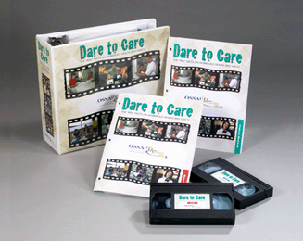
First 4 Weeks  Canada’s Industrial Accident Prevention Program has designed this interactive health and safety orientation and training kit to train supervisors to help train workers. This kit fully prepares supervisors with tools and strategies for training employees simply and effectively.  How to obtain: This training program can be ordered from the following webpage: http://www.iapa.ca/outreach_yw/yw_intro.asp. For more information, contact the Industrial Accident Prevention Program at 1-800-406-4272 or visit their main website: http://www.iapa.ca/home/home.asp. |  | 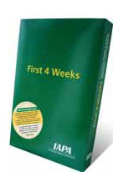

Resources from Outside the US - continued
Employing Young Workers: Tips for Supervisors and Tips for Employers  Developed by the Ontario Ministry of Labor, these tip sheets have advice for supervisors on how to improve the health and safety of their young workers and provide useful tips on how to provide effective supervision to teen workers.  How to obtain: Pdf versions of these tip sheets can found on the following webpage: www.labour.gov.on.ca/english/hs/tips/tips_supervisors.html. For more information, visit the “Work Smart Ontario” website of the Ontario Ministry of Labor: www.worksmartontario.gov.on.ca. |  | 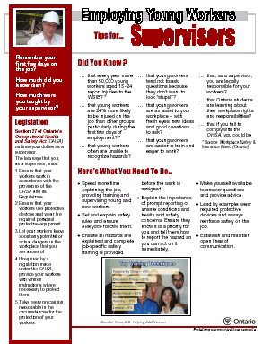
Three Steps to Effective Worker Education and Training  Designed for employers and supervisors, the Workers’ Compensation Board of British Columbia has put together a guide offering a 3-step framework based on orientation, education and training new and young workers on job safety.  How to obtain: A pdf version of this guide can be found on the following webpage: www2.worksafebc.com/Topics/YoungWorker/Resources-Employers.asp. For more information, visit the Workers’ Compensation Board of British Columbia’s website: www.worksafebc.com. |  | 
Safety on the Job is Everyone's Business: The Responsibilities of Employers, Supervisors and Workers  The Workers’ Compensation Board of British Columbia’s has created this pamphlet that covers the basics in training new workers on health and safety. Employer, supervisor, and worker responsibilities for developing and maintaining a safe workplace are outlined.  How to obtain: A pdf version of this pamphlet can be found on the following webpage: www2.worksafebc.com/Topics/YoungWorker/Resources-Employers.asp. For more information, visit the website: www.worksafebc.com. |  | 
The Supervisor  This video, produced by the Workers’ Compensation Board of British Columbia, is a documentary-drama that examines issues related to supervisor responsibility for workplace health and safety. The video depicts the emotional, legal, and financial consequences of a fictionalized workplace accident that leads to the death of a young worker.  How to obtain: This video can be ordered from the following webpage: www2.worksafebc.com/Topics/YoungWorker/Resources-Employers.asp. For more information visit the Workers’ Compensation Board of British Columbia’s main website: www.worksafebc.com. |  | 
Worker Orientation Checklist  Developed by the Workers’ Compensation Board of British Columbia, this simple checklist can be used by employers when training new and young workers on work health and safety.  How to obtain: A pdf version of this checklist can be found on the following webpage: www2.worksafebc.com/Topics/YoungWorker/Resources-Employers.asp. For more information, visit the main website of the Workers’ Compensation Board of British Columbia: www.worksafebc.com. |  | 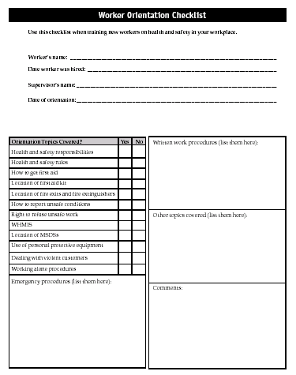

Agencies & Organizations
For questions about health and safety:
Occupational Safety & Health Administration  Andover Office - (978) 837-4460  Braintree Office - (617) 565-6924  Springfield Office - (413) 785-0123  www.osha.gov | Massachusetts Department of Public Health  Occupational Health Surveillance Program  Teens at Work Injury Surveillance and Prevention Project  (617) 624-5632  www.mass.gov/dph/teensatwork
For questions about wages or the child labor laws:
Massachusetts Office of the Attorney General  Fair Labor Division  (enforces the state child labor laws)  (617) 727-3465  www.mass.gov/ago | U.S. Department of Labor  Wage and Hour Division  (enforces the federal child labor laws)  (617) 624-6700  www.dol.gov/esa/whd
For questions about work permits: | For questions about workers’ compensation:
Massachusetts Department of Labor  Division of Occupational Safety  (617) 626-6952  www.mass.gov/dos/youth | Massachusetts Department of Labor  Department of Industrial Accidents  (800) 323-3249 x470  www.mass.gov/dia

