**End of the Pilot Program Era:**

**Data on Massachusetts Overdose Education and Naloxone Distribution Programs (2012-2023)**

**MA Department of Public Health**

Bureau of Substance Addiction Services

Bureau of Infectious Disease and Laboratory Sciences

**Boston University**

Biostatistics and Epidemiology Data Analytics Center (BEDAC)

Contents

2023 Participating Programs 3

Executive Summary 5

Looking into the future 5

Demographics 5

Use of Naloxone 5

OEND Naloxone Over Time 6

OEND Program Overdose Response Fast Facts (2023): 6

History of State-Funded Naloxone 7

Background on OEND Data Collection 9

Naloxone Numbers Over the Years 10

Use of Distributed Naloxone 11

Secondary Distribution 9

Naloxone Confiscation 10

Geography & Setting of Naloxone Distributions 11

Race and Ethnicity 13

Gender & Transgender Identity 15

Overdose Reports 16

Overdose Risk Factors 17

Relationships with First Responders 18

Conclusion & Next Steps 20

Appendix 1: Dictionary of Key Terms 21

Appendix 2: Breakdown of OEND Programs by Region 22

Appendix 3: Publications & Papers That Used OEND Data 23

Report Authorship & Gratitude 26

# 2023 Participating Programs

AIDS Project Worcester

AIDS Support Group of Cape Cod

Berkshire Harm Reduction

Boston Healthcare for the Homeless

Boston Public Health Commission (AHOPE)

Brockton Area Multi-Services, Inc. (COPE)

Commonwealth Land Trust

Fenway Health (ACCESS)

Greater Lawrence Family Health Center

Health Imperatives

Health Innovations (Healthy Streets)

Holyoke Health Center

Justice Resource Institute (Program RISE)

Learn to Cope

Lowell Community Health Center

Life Connection Center

Lowell House

Lynn Community Health Center

Manet Community Health Center

Multicultural AIDS Coalition

New North Citizens’ Council

North Shore Health Project (ONE STOP)

Seven Hills Behavioral Health

Stanley Street Treatment and Resources

Tapestry

Victory Programs, Inc.

**Note: a full “dictionary” glossary of relevant terms can be found in Appendix 1.**

# Executive Summary

## Looking into the future

1. Secondary distribution data allowed DPH to develop the [Community Naloxone Program](https://www.mass.gov/info-details/community-naloxone-program-cnp) (CNP), which allows non-SSPs to access free naloxone. DPH plans to expand CNP to include more programs that specifically do outreach to Black, Hispanic, and American Indian individuals.
2. It is common to travel to Boston to receive naloxone and/or use naloxone, especially for participants living in towns along the Commuter Rail. This insight will lead to the development of at-home naloxone mailers for rural areas.
3. “Dopesickness” occurred in 54% of overdoses, highlighting the need for compassionate overdose response.
4. 15% of overdose reporters had a negative interaction with first responders, indicating that there is still a major need for education of first responder groups.

## Demographics

**Race/Ethnicity of OEND Participants**

**Bar graph showing the percent breakdown of OEND participants by race/ethnicity as follows: 

- 0.4% are American Indian / Alaska Native, non-Latinx/non-Hispanic
- 0.8% are Asian, non-Latinx/non-Hispanic
- 11.7% are Black/African American, non-Latinx/non-Hispanic
- 0.2% are Hawaiian / Pacific Islander, non-Latinx/non-Hispanic
- 18.4% are Latinx or Hispanic
- 0.6% are multiracial, non-Latinx/non-Hispanic
- 0.8% are other, non-Latinx/non-Hispanic
- 67.2% are white, non-Latinx/non-Hispanic**

During the COVID-19 pandemic, Black/African American people were underrepresented in OEND programs compared to overdose death data. White participants were overrepresented in programs.

## Use of Naloxone

Secondary distribution-- participants receiving multiple doses of naloxone to share with others-- has led to increased naloxone in the community (30,000 doses/year). Since 2020, the practice has expanded, culminating in the Community Naloxone Program (CNP) in 2022, which significantly increased naloxone distribution through diverse community partners.

* 30% used last dose of OEND naloxone to respond to overdose
* 17x less likely to have naloxone confiscated in 2023 than in 2012

## OEND Naloxone Over Time

The OEND program saw a dramatic increase in naloxone distribution, from about 300 doses annually when DPH first funded it to over 160,800 doses in 2023, largely due to the expansion of local Board of Health approvals for SSPs. While the number of naloxone encounters also rose significantly, the onset of the COVID-19 pandemic in 2020 caused a temporary decrease in encounters, likely due to stay-at-home orders, fear of illness, and a new emphasis on secondary distribution.

**Number of Encounters with Participants & Naloxone Doses Distributed 2012-2023**

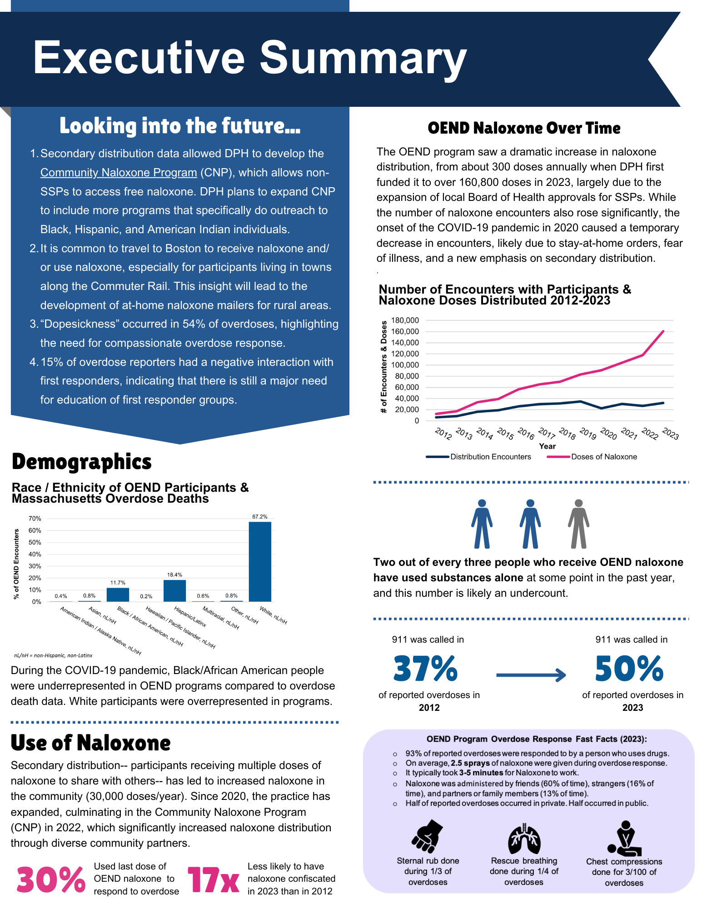

* Two out of every three people who receive OEND naloxone have used substances alone at some point in the past year, and this number is likely an undercount.
* 911 was called in 37% of reported overdoses in 2012
* 911 was called in 50% of reported overdoses in 2023

## OEND Program Overdose Response Fast Facts (2023):

* 93% of reported overdoses were responded to by a person who uses drugs.
* On average, 2.5 sprays of naloxone were given during overdose response.
* It typically took 3-5 minutes for Naloxone to work.
* Naloxone was administered by friends (60% of time), strangers (16% of time), and partners or family members (13% of time).
* Half of reported overdoses occurred in private. Half occurred in public.
* Sternal rub done during 1/3 of overdoses
* Rescue breathing done during ¼ of overdoses
* Chest compressions done for 3/100 of overdoses

# History of State-Funded Naloxone

The overdose reversal medication, naloxone hydrochloride, was approved by the U.S. Food and Drug Administration in 1971 to treat overdoses. In the decades to follow, this lifesaving medication would be used predominantly by first responders and in hospitals. During the HIV/AIDS crisis in the 1980s-90s, people who use drugs were at the forefront of the grassroots harm reduction movement to prevent the transmission of HIV and stop the loss of life. In the mid-90s, pioneers of the harm reduction movement liberated naloxone used by emergency responders for the purpose of peer-to-peer distribution. Harm reduction programs shared early findings and success with each other and demonstrated that people who use drugs are willing and able to rescue one another with naloxone in the event of an overdose.

In 2006, in response to an outbreak of fentanyl overdoses in Boston[1], Boston Emergency Medical Services piloted the use of intranasal naloxone (2mg/2mL) in the field. This led to the Boston Public Health Commission (BPHC) passing a public health regulation authorizing an overdose prevention program. This program included intranasal naloxone education and distribution to potential bystanders. The bystanders trained were people who use drugs and access services from the BPHC Syringe Service Program (SSP). Naloxone was also distributed by the Cambridge Cares About AIDS syringe services program in Central Square.

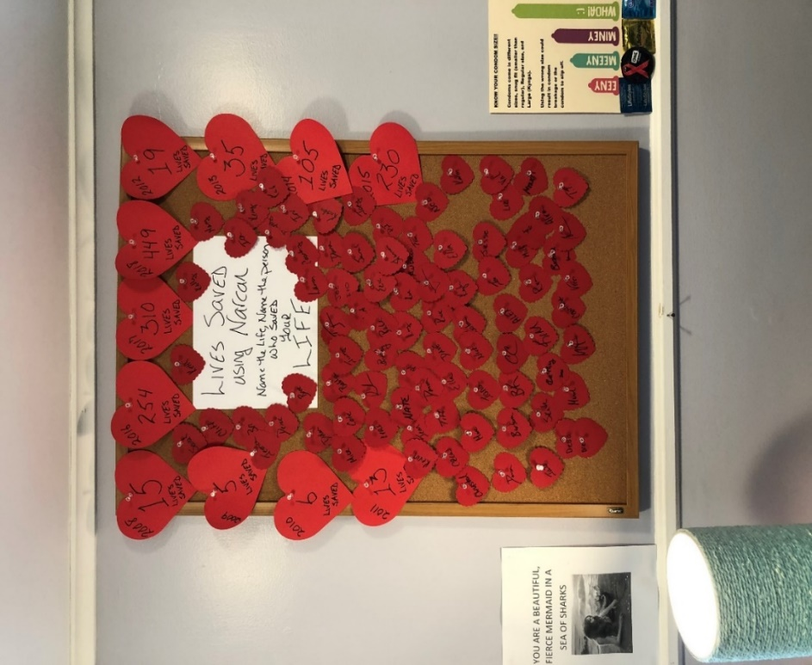

Image from Kim Powers, Access Hope. Access Hope is not a state-

funded OEND program but is an instrumental leader of Harm Reduction in MA.

The success of naloxone use in the Boston and Cambridge programs[2] led to the authorization of a statewide pilot. This pilot included six syringe service programs (SSPs), intranasal naloxone funded by the Department of Public Health (DPH), and a data collection component that would be used to create a body of evidence supporting this intervention. It also included a [community naloxone standing order](https://www.mass.gov/doc/standing-order-for-dispensing-naloxone-rescue-kits/download), which allows a broad range of service providers and programs to distribute naloxone directly to people at risk for overdose and their social networks. The initial years of the OEND program were fundamental for documenting the strengths of an overdose response strategy focused on empowering people who use drugs to have the training and tools they need to save a life.

The Overdose Education and Naloxone Distribution (OEND) program has expanded to include 26 programs across Massachusetts (MA) and has resulted in the distribution of over 900,000 doses of naloxone. Over the years, OEND program data has contributed greatly to policy change, addressing stigma against people who use drugs and increasing resource allocation to harm reduction and overdose response.

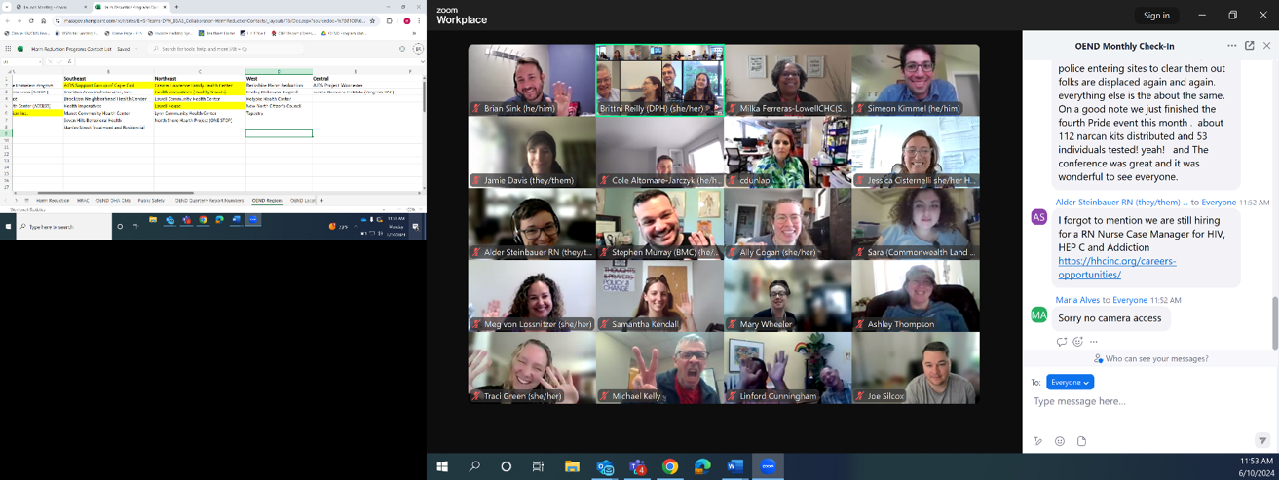

Harm Reduction program staff from across the state attend the monthly OEND check-in meeting, which transitioned to Zoom during the COVID-19 Pandemic.

The drug supply and its impact on overdoses in MA changed significantly since this program launched:

* From 2013 through 2023, fentanyl became widespread in the drug supply and is the predominant substance driving non-fatal and fatal overdoses in MA.
* This change in the drug supply led the state to declare the overdose crisis as a public health emergency in 2014.
* Fatal overdoses surged above 2000 per year in 2016 and have continued above 2000 per year ever since.

As the drug supply and characteristics of overdoses evolved, so too have the strategies and policies to address overdose:

* The state established a trust fund that helped offset overdose response supply costs for first responders.
* Easy-to-use nasal spray (Narcan®) entered the market in 2015.
* The state issued a pharmacy [naloxone standing order](https://www.mass.gov/doc/naloxone-standing-order-1/download), which permits pharmacists to dispense naloxone without a prescription from the pharmacy. In 2023, over 102,000 doses of naloxone were filled through the pharmacy.
* In 2018, the U.S. Surgeon General recommended the public learn how to use and carry naloxone, signaling widespread acceptance of this lifesaving tool.
* In 2023, multiple naloxone products were approved by the U.S. Food and Drug Administration for over the counter (OTC) use.

## Background on OEND Data Collection

As the OEND program grew and evolved, so did the programs’ data collection processes. Over the years, DPH and the participating programs engaged in routine reviews of the data collection tools, findings, and implications. In particular, the first 10 years of this program (2007-2017) demanded an iterative process that required collaborations between the harm reduction programs, DPH, and academic partners.

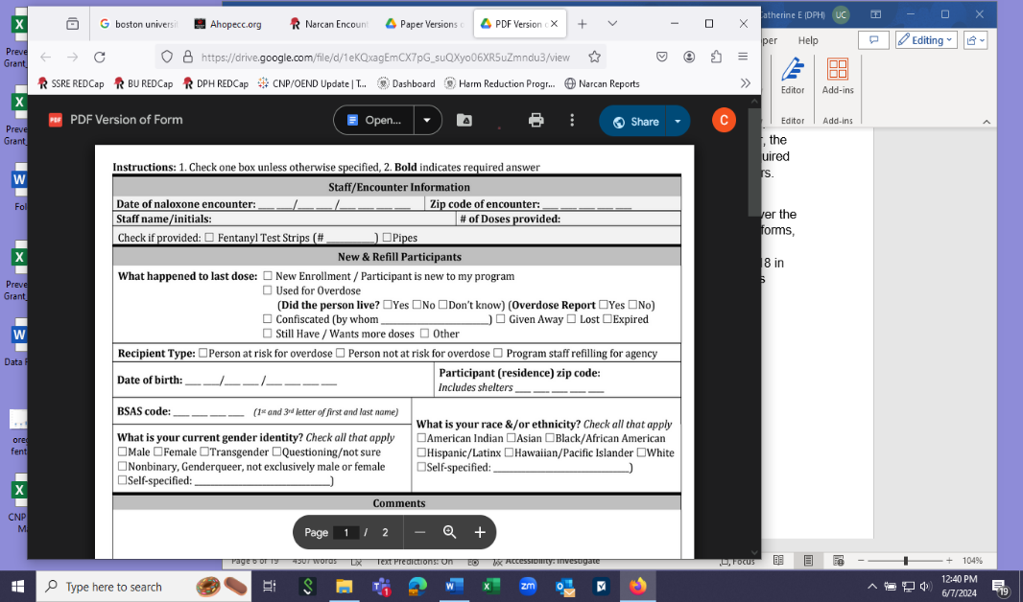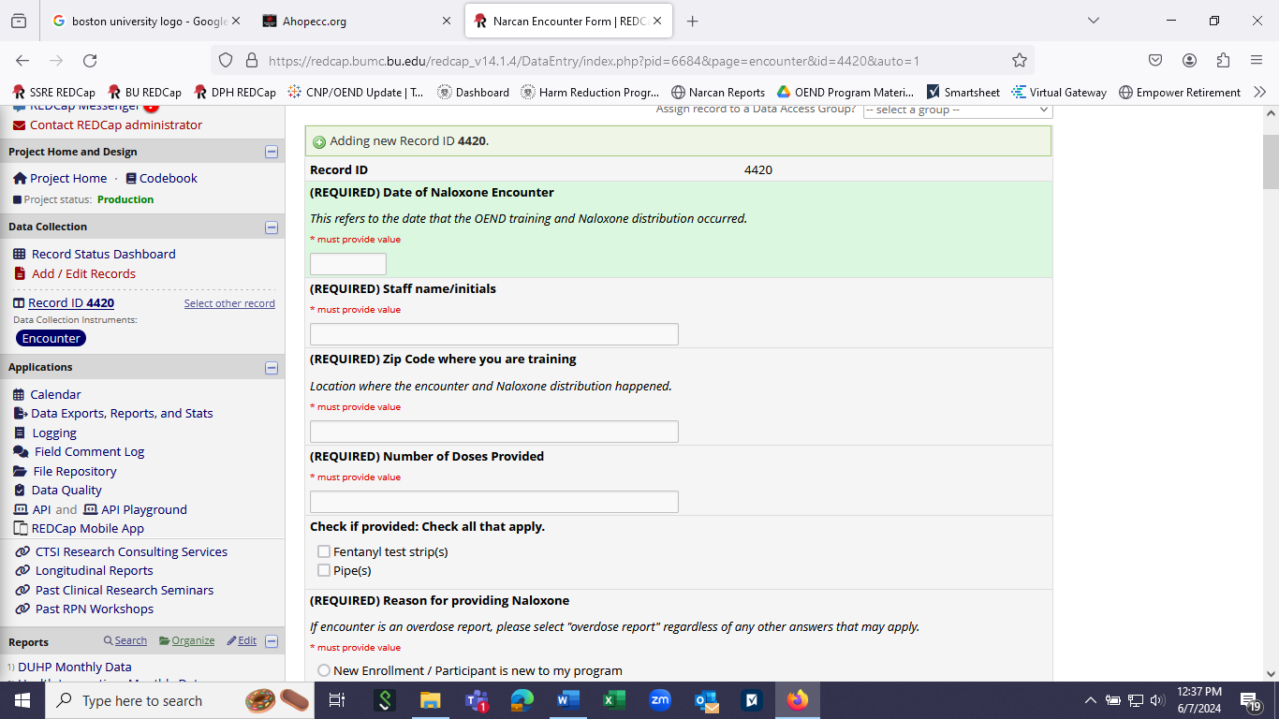

In the spirit of that iterative process, there have been many versions of the data collection form. New questions were introduced in response to emerging programs and research questions, and old questions were retired to reduce the accumulating burden of data collection. Initially, data was collected using scannable paper forms called telefilms, which were mailed to the state and then entered, cleaned, maintained, and stored in partnership with Boston University’s Biostatistics and Epidemiology Data Analytics Center (BEDAC). In 2018, programs transitioned to submitting electronic data using a secure REDCap system developed and maintained in partnership with BEDAC.

Data collection is time-consuming for staff, especially considering that effectively providing harm reduction services demands a low-barrier approach. To address the data burden on programs, DPH staff reviewed the OEND data form and reduced it by half in Spring 2023. Questions related to previously published results or that staff reported discouraged participants from receiving naloxone were removed.

The FDA approval of multiple naloxone products for OTC use and a robust body of published literature supporting the effectiveness of OEND programs led DPH to determine community naloxone distribution is a universally accepted public health strategy. Therefore, as of July 2024, DPH retired the investigative OEND dataset and integrating data collection into existing reporting structures for program surveillance.

This report presents data collected by DPH-funded OEND naloxone programs. It does not include naloxone received from pharmacies, purchased by programs (not state-funded), distributed via DPH’s Community Naloxone Program (2022 start date), or distributed by programs or individuals before DPH began funding the OEND program. Some sections of this report will look back to the first year of data available (2007); others will only look at more recent years, based on availability or relevance of data.

# Naloxone Numbers Over the Years

When DPH first began funding OEND, the program distributed about 300 doses a year. In 2023, OEND programs reported distributing over 160,800 doses of naloxone to individuals at risk of overdose and their social networks. The OEND program distributed over twelve times more naloxone in 2023 than a decade prior in 2012 (12,587 doses in 2012). The increase in naloxone distribution is most likely linked to the growing number of cities and towns with [local Board of Health approval to operate a SSP](https://malegislature.gov/Laws/GeneralLaws/PartI/TitleXVI/Chapter111/Section215) and thus able to receive funding from DPH’s Bureau of Infectious Diseases and Laboratory Sciences (BIDLS). The number of approvals has increased from five cities and towns in 2012 to almost 90 today! All but two of the cities and towns with approval to distribute syringes have an active, operating SSP funded by BIDLS.

Over time, there has been an increase in the number of encounters with OEND participants—OEND programs had almost four times more encounters in 2023 (32,116 encounters) than in 2012 (6,138 encounters). However, the number of encounters has not increased as rapidly as the number of doses distributed.

**Figure 1. Number of Encounters and Number of Doses Distributed Over Time**

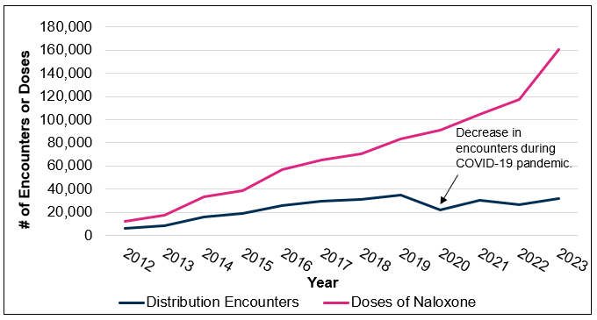

This graph shows that the number of encounters decreased in 2020 during the onset of the COVID-19 pandemic, while the number of doses continued to increase (Figure 1). The number of encounters may have decreased during the pandemic because: 1) stay-at-home orders prevented programs from operating normally or people from visiting programs 2) the fear of getting sick stopped people from going to in-person OEND services; or 3) secondary distribution was encouraged for the first time (see Secondary Distribution).

# Use of Distributed Naloxone

For returning participants, the OEND form included a question about the reason they returned to the OEND program for more naloxone. Reasons included using their last dose to respond to an overdose, giving it to someone else who needed it, or that their dose was lost, stolen, or confiscated. Sometimes, a participant may still have their last dose but needs more—for example, to store it in a new location or share it within their social network. Figure 2 breaks down the most common reasons participants report they are returning to a program.

**Figure 2. Participant-Reported Use of Last OEND Naloxone Dose (2023)**

A pie graph showing the percent breakdowns of how last naloxone doses were used, as follows: 
- 6.7% were lost
- 0.04% were stolen or confiscated
- 37.8% still had the dose but wanted additional doses
- 30.3% were used for an overdose
- 25.1% were given away

In 2023, OEND participants returning to programs and providing data reported using their last dose to respond to an overdose 30% of the time. In 2012, 54% of encounters reported that their last naloxone dose was used for an overdose. These are likely undercounts of the actual percent of naloxone used for overdose response. Underreporting of overdoses among participants or OEND staff entering data may be due to not wanting to relive traumatic experiences, not wanting to answer questions about the overdose, or sharing naloxone with others who ultimately used the naloxone to respond to an overdose but do not come to the program (secondary distribution).

Notably, in 2012, only 7% of participants reported giving their last dose away. In 2023, participants were twice as likely to give their last dose away than in 2012. This increase may reflect changes to harm reduction programs in response to the COVID-19 pandemic and the perceived stigma of receiving naloxone from a friend versus visiting a harm reduction program.

## Secondary Distribution

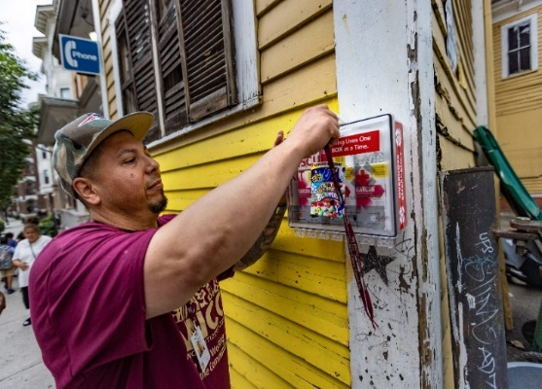

(source: Jesse Costa/WBUR)

Secondary Distribution is defined as one participant receiving multiple doses of naloxone to share with friends, family, or others who are at high risk for experiencing or witnessing an overdose. Before 2020, DPH discouraged secondary distribution to emphasize the engagement of people with the drug user health programming that the OEND sites were offering (including for data collection). The COVID-19 pandemic led DPH to support secondary distribution in adherence with social distancing guidance; secondary distribution was added to OEND forms in 2020. Secondary distribution allowed programs to increase naloxone in the community despite the decreased number of participants coming to programs (Figure 1). One study using OEND data showed no difference in harm reduction education and practices between untrained participants who received naloxone in a secondary distribution and those trained by OEND programs.[3]

There are many reasons, besides COVID-19, for participants to choose not to visit an OEND program. Barriers to at-risk individuals, such as stigma, lack of transportation, distance from the program or rurality, and language barriers prevent individuals from accessing an OEND program. As OEND grew, the loss of data about individuals receiving naloxone through secondary distributors was an acceptable trade-off necessary to promote low-barrier access to naloxone through their social networks.

**Community Feature: AIDS Support Group of Cape Cod (ASGCC) Partners with Fishermen**

The Fishing Partnership of Cape Cod (FP), a nonprofit dedicated to improving the health, safety and economic security of commercial fishermen and their families, began to include OEND as a part of their safety/CPR training in 2017 in response to a rise in overdoses on commercial fishing boats. ASGCC partners with FP to conduct OEND trainings for fisherman and provide bulk naloxone to FP staff, who secondarily distribute the naloxone. One of the most common questions asked is if the Good Samaritan Law applies while boats are in federal waters. AGCCC helped ensure the law holds in this situation. Through ASGCC’s training and advocacy with FP, all boats are now encouraged to use and carry naloxone without fear of prosecution.

* 336 doses were secondarily distributed by the Fishing Partnership in 2022.
* In 2023, FP joined DPH’s Community Naloxone Program, thanks to ASGCC.

Since 2020, OEND programs have distributed about 30,000 doses of naloxone each year through 300 unique secondary distributors. About one-third of unique naloxone distributors are individuals who are unaffiliated with a program and distribute naloxone to their social networks. Two-thirds of distributors are partner programs distributing naloxone to their participants. Data on secondary distributions to partners led DPH to implement the [Community Naloxone Program](https://www.mass.gov/info-details/community-naloxone-program-cnp) (CNP) in 2022, which allows non-SSPs to access naloxone, free of charge, to provide to their clients at risk of overdose. Most secondary distribution partners (see Figure 3) can now order naloxone directly from DPH. In 2023, CNP affiliates, including local health agencies, grassroot organizations, community nonprofits, treatment and recovery programs, and other organizations embracing harm reduction distributed over 104,600 naloxone doses (compared to only 16,500 when CNP began in 2022).

**Figure 3.** **Secondary Distribution Spaces Engaged by OEND Programs (2021-2023)**

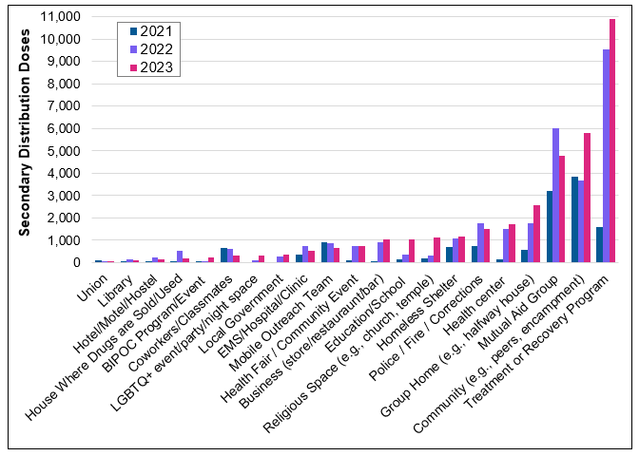

OEND has historically focused on providing naloxone to treatment and recovery spaces for secondary distribution. Since CNP began, many of these programs have begun ordering their naloxone directly from DPH. Moving forward, DPH will encourage these programs to establish pharmacy-based billing for patient naloxone to reduce costs and burden. This would create space for OEND programs and DPH to focus efforts on equity-based distribution, including to BIPOC and LGBTQ communities and events.

## Naloxone Confiscation

OEND participants reported only ten naloxone confiscations in 2023, making confiscations 17 times less likely in 2023 than in 2012. The decrease could be due to increased education about the benefits of naloxone and a reduction in stigma against people who use opioids. While this is a huge improvement, everyone in MA can legally carry naloxone, so there should ideally be zero doses confiscated.

**Groups that confiscated naloxone from OEND participants (2012-2023):**

* Police Departments (33%)
* Detox Programs (17%)
* Hospitals and Emergency Rooms (17%)
* Prisons (14%)
* Family Members (9%)
* Motel and Hotel owners (3%)
* Shelters (3%)
* Sober Houses (2%)

MA Title XV, Chapter 94C, Section 34A states that it is legal to possess naloxone. The decrease in naloxone confiscations over time is owed to advocates who have worked tirelessly to reduce the stigma of naloxone and harm reduction in MA.

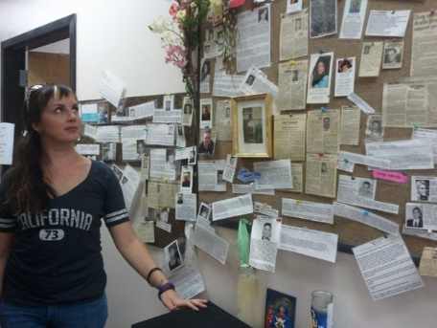

Mary Wheeler views “The Remembrance Wall’’ of those who have died from drug use. She directs two Healthy Streets Outreach Programs in the area. (source: Steven Rosenberg/Globe Staff)

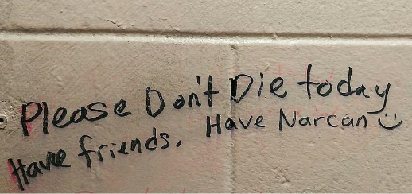

A message written in a bathroom stall in North Station, reminding visitors not to use alone and to carry naloxone. (2015)

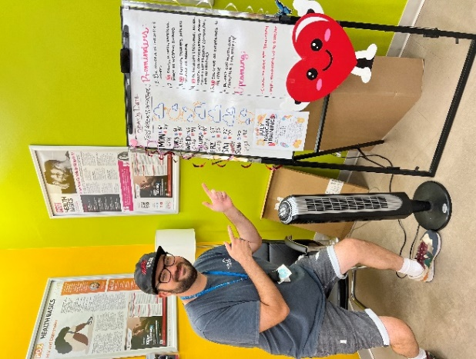

Grant Patch poses with Fenway ACCESS’ harm reduction drop in sign.

# Geography & Setting of Naloxone Distributions

About two-thirds of people receiving naloxone from an OEND Program are from a city or town where an OEND program operates (65.5%) (Figure 4). However, OEND programs have provided naloxone to people from across the United States. Participants have reported home zip codes from Montana, Texas, and Georgia. Non-resident use of services is especially common for people living in the New England states surrounding MA. Over 50 people from bordering zip codes came to MA OEND programs to receive services in 2023; it is unclear if they visited because of insufficient access to naloxone in their states or the nature of transient people, especially those living in cities/towns near the border.

**Figure 4. Rate of OEND Encounters per 100,000 Residents from MA Cities/Towns, Compared to Locations of OEND Programs (2023)** 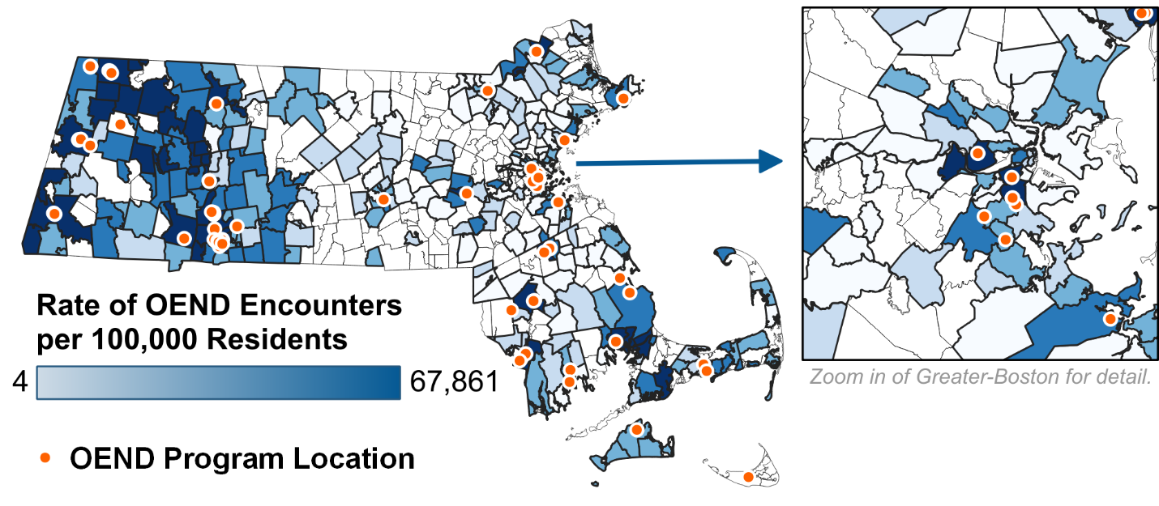

All regions saw increases in naloxone distribution since 2012 (Figure 5). However, during this period, Western MA, Southeastern MA, and Boston saw the largest increases, even when considering the number of people living in each region. These shifts could be due to increased local approvals for SSP services in these regions. Some large OEND programs have started in these regions, leading to increased naloxone distribution in those areas. As seen in Figure 4, since there are low to no rates of distribution in some rural communities, DPH plans to launch a new naloxone home mailer effort using SAMHSA resources.

**Why use a rate?** Rates allow us to account for the fact that some regions have more people than others. We can imagine what the naloxone numbers would be like if every region had the same number of people and compare the regions more accurately.

**Publication Coming Soon: Massachusetts Community Naloxone Network Study**

This study used OEND data to answer two questions facing DPH: 1) are naloxone kits used in overdoses in the same communities they were distributed in? and 2) does naloxone supplied appropriately meeting demand? For each encounter, the researchers identified the four Rs: 1) Residence (where participants live), 2) Registration (OEND site where participants pick up naloxone), 3) Rescue (where naloxone is used in an overdose), and 4) Refill (OEND site where participants refill naloxone). Initial results from the study found substantial migration between residence and rescue attempt stages, with most participants traveling to Boston to administer naloxone in an overdose and refill naloxone. The residence pattern of those traveling to Boston lined up with communities served by Boston’s commuter rail. Additionally, the number of kits per overdose death varied from 7.8 (areas that could use more naloxone) to 32.2 kits-per-death (exceeding expectations). (Levengood et al.)

**Figure 5. Annual Number and Rate of Naloxone Doses by Region Where Distribution Occurred (2012 vs. 2022)**

A graph that compares the number of doses and rate of doses distributed by region. For both number and rate of doses, the regions rank as follows from highest to lowest distribution:
- Western
- Southeast
- Boston
- Northeast
- Central

**\*A breakdown of OEND programs by region can be found in Appendix 2.**

In 2023, 69% of OEND naloxone distributions occurred in “community settings” (SSPs, shelters, recovery homes, prisons, hospitals, community meetings, recovery support centers, and health centers), the majority of which likely occurred at SSP locations, which also provide OEND services. An additional 17% of distributions were done during program outreach, including post-overdose support teams (POST). The final 14% of distributions occurred at addiction treatment centers. The settings where naloxone is distributed have remained consistent throughout the past decade.

Locations of all DPH Naloxone Programs can be found on our [**map!**](https://www.mass.gov/info-details/harm-reduction-program-locator)

# Race and Ethnicity

The collection of race/ethnicity data has been an important part of program reporting since the OEND program began. Since 2007, race/ethnicity reporting has expanded to allow participants to select more than one race and/or ethnicity. While the way the race and ethnicity questions are asked hasn’t changed much, programmatic changes have impacted the quality of this data over time. For example, since the COVID-19 pandemic, the quality of race/ethnicity data has consistently decreased, largely due to the expansion of secondarily distributed naloxone.

**Figure 6. Race/Ethnicity of OEND Encounters (2023)**

Bar graph showing the percent breakdown of OEND participants by race/ethnicity as follows: 

- 0.4% are American Indian / Alaska Native, non-Latinx/non-Hispanic
- 0.8% are Asian, non-Latinx/non-Hispanic
- 11.7% are Black/African American, non-Latinx/non-Hispanic
- 0.2% are Hawaiian / Pacific Islander, non-Latinx/non-Hispanic
- 18.4% are Latinx or Hispanic
- 0.6% are multiracial, non-Latinx/non-Hispanic
- 0.8% are other, non-Latinx/non-Hispanic
- 67.2% are white, non-Latinx/non-Hispanic

Figure 6 illustrates the racial / ethnic proportions of participants receiving naloxone kits in Massachusetts. Since 2007, the OEND program has expanded to meet the needs of a more diverse population, especially as overdose rates have increased for Black, Hispanic/Latinx, and American Indian/Alaska Native individuals.[4] For example, Multicultural AIDS Coalition was onboarded to OEND in 2022 and largely serves Black participants. Programs like Greater Lawrence Family Health Center and Tapestry have been leaders in OEND programming for Latinx participants. Most recently, New North Citizen’s Council opened a location in Indian Orchard— a traditionally underserved area of Springfield. Despite these significant achievements in OEND history, the racial/ethnic breakdown of OEND participants has not always reflected those who die of overdose death, indicating that there may still be room for improvement.

**New Publication: COVID-19 & Naloxone Access for Black and Hispanic People**

A 2024 publication from a team at Brown and Boston University used OEND data to uncover how the COVID-19 pandemic impacted opioid overdose deaths and naloxone access among different races and ethnicities. Their research found that after the beginning of COVID-19 (March 2020), Black people experienced an immediate increase in the rate of opioid overdose deaths. In contrast, rates of opioid overdose deaths remained constant for White and Hispanic populations. However, naloxone kit distribution remained relatively constant across all groups. There was no increase in naloxone kit distribution among Black populations to account for the increase in overdose deaths for this group. ([Zang et al.](https://onlinelibrary.wiley.com/doi/10.1111/add.16324))

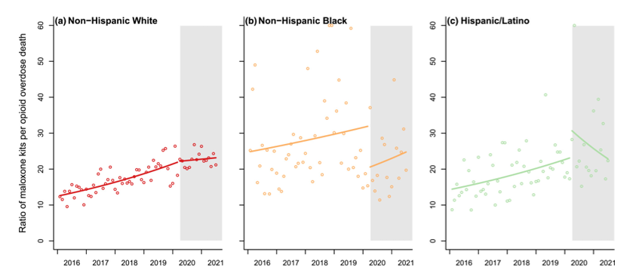

These graphs from the paper show that as soon as COVID hits (represented by the grey area), the non-Hispanic Black population sees a sudden drop in the number of naloxone kits received per overdose death (represented by the yellow line).

In 2024, DPH released the Strategic Plan to Advance Racial Equity. This new roadmap “publicly, formally, and emphatically declares that racism is an urgent public health threat that directly impacts residents across the Commonwealth of MA”. It affirms the commitment to centering health equity as the foundation of its mission to advance public health across the Commonwealth. DPH’s health equity framework leads with a racial-equity-centered intersectional approach to partnering with priority populations that experience the most deeply entrenched inequities in public health. Over the next three years, the BSAS Harm Reduction Unit plans to partner with the newly launched BSAS Office of Community Health and Engagement to identify organizations serving Black and Hispanic communities to increase overdose education and naloxone distribution.

# Gender & Transgender Identity

Approximately 0.4% of OEND participants identified as transgender in 2023 and no large increase was seen in transgender participants from 2012-2023. While gender breakdowns vary yearly, 53% of participants identified as Male in 2023 (Figure 7). Compared to substance use disorder treatment data and overdose death data, which each see a breakdown of approximately 70% male, OEND has higher percents of Females visiting programs. One prediction for this trend is that those who do not use drugs but visit an OEND program to receive naloxone (e.g., friends / family of people who use drugs, staff from the substance use field, or other potential bystanders) are more likely to identify as Female.[5]

**Figure 7. Reported Gender of Unique OEND Participants by Year (2012-2023)**

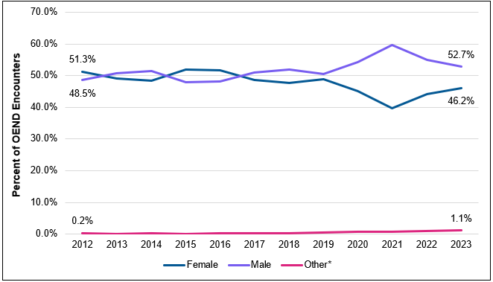

*Note: Other includes nonbinary, not exclusively male or female, and questioning.

OEND participants identifying as nonbinary, not exclusively male or female, questioning, or other genders increased by about 1% from 2012 to 2024. The gender and transgender variables for OEND services have been somewhat difficult to compare over the past ten years because the options available on OEND collection forms have continued to expand. Therefore, it is difficult to determine if the increase comes from expanded options and reduced stigma for reporting or an actual increase in non-binary, genderqueer, and other individuals accessing OEND programs.

# Overdose Reports

We suspect only a small portion of all overdoses occurring in the community are reported back to OEND providers each year. However, the overdose reports received from participants give DPH vital insight into how bystanders respond to overdoses. In 2022, DPH received 6,800 reports from OEND participants that program naloxone was used in an overdose. In 2023, about 14 times more overdoses were reported than in 2012; however, 2023 reports likely represent a smaller proportion of overdoses where naloxone was used due to reporting fatigue among both the community and data collection fatigue by OEND providers. Taking overdose reports takes time away from the participant reporting and the harm reduction staff, and it can be traumatizing for both.[6], [7], [8] Nearly all (97%) of OEND overdose reports were for nonfatal overdoses in 2023. Though not surprising, these numbers show the success of OEND programs – when people have and use naloxone, lives are saved.

**OEND Program Overdose Response Fast Facts (2023):**

* 93% of reported overdoses were responded to by a person who uses drugs.
* On average, **2.5 sprays** of naloxone were given during overdose response.
* It typically took **3-5 minutes** for Naloxone to work.
* Naloxone was administered by friends (60% of time), strangers (16% of time), and partners or family members (13% of time).
* Half of reported overdoses occurred in private. Half occurred in public.
* Sternal rub done during 1/3 of overdoses
* Rescue breathing done during ¼ of overdoses
* Chest compressions done during 3/100 of overdoses

OEND data on overdose response was used by DPH to develop the [YouCan](https://youcan.info/) initiative with the goal of increasing rescue breathing as a part of overdose response.

## Overdose Risk Factors

The OEND form included various questions on overdose risk factors until March 2023. The purpose of these questions was to 1) gain an understanding of overall substance use behaviors and other risks associated with overdose in MA, and 2) encourage OEND staff to engage in conversations about these topics with their participants.

Two out of every three people who receive OEND naloxone have used substances alone at some point in the past year, and this number is likely an undercount. Using alone is most common in the Northeast region of the state, where 83% of people report using alone. Approximately 60% of OEND participants in Western, Southeastern, and Central MA report using alone. OEND participants in Boston are the least likely to use alone (only 28% of participants).

**Figure 8. Frequency of Protective Behaviors Among OEND Participants**

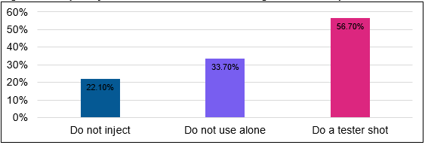

**Percent of OEND Participants Experiencing Overdose Risk Factors:**

* 51% experienced homelessness in the past year
* 15.5% were released from jail or prison in the past year*
  + *\*Note: OEND does not include naloxone given to those directly upon release from jail/prison or during incarceration. Additionally, all datapoints are self-reported and are almost certainly underestimated.*
* 42.7% participated in a recovery program in past year. 35.4% were actively being treated with MOUD.
* 82.8% had witnessed an overdose in their lives. 67.5% had survived an overdose.

**Community Feature: New Overdose Prevention Helpline (SafeSpot)**

Massachusetts Department of Public Health became the first state health department in the country to fund a virtual overdose detection service through an investment in the SafeSpot Overdose Hotline (previously known as the Massachusetts Overdose Prevention Helpline). This 24/7 service is utilized by people who are using drugs alone who may be at risk for overdose. With support from DPH, SafeSpot is staffed by paid, trained operators with personal lived and living experience with substance use and overdose. Since January 2023, the hotline has provided over 1,000 hours of monitoring of people at risk for overdose, supervised more than 2,700 use events, and successfully facilitated timely rescue at 13 overdoses which may have otherwise been fatal. Callers looking for help beyond remote spotting have been linked more than 80 times to harm reduction and treatment services including SSPs, naloxone, fentanyl test strips, medications for opioid use disorder, therapy, crisis and medical providers. For more information, click [here](https://safe-spot.me/) or call 800-972-0590.

While naloxone is a life-saving medication, dope sickness or opioid withdrawal symptoms can occur in individuals who have been revived with naloxone, especially if too many doses are given. About half of the overdose reports reported to OEND programs from 2012-2023 describe dope sickness after someone was revived with naloxone. One in three reports described irritability, one in 10 described vomiting, and approximately one out of every 17 described physical aggression (Figure 9).

**Figure 9. Post-Naloxone Withdrawal Symptoms Reported by OEND Participants who Reversed an Overdose (2012-2023)**

A bar graph showing the percent of participants reporting withdrawal symptoms after naloxone as follows: 
- 54% were Dopesick 
- 36% had no symptom
- 34% were irritable
- 11% vomited
- 6% were physically combative

These statistics reinforce the importance of a “[compassionate overdose response](https://www.healthmanagement.com/insights/webinars/compassionate-overdose-response-summit-and-naloxone-dosing-meeting/)” in prioritizing rescue breathing, only giving low doses of naloxone, and remembering that someone may feel unwell when their overdose is reversed.

## Relationships with First Responders

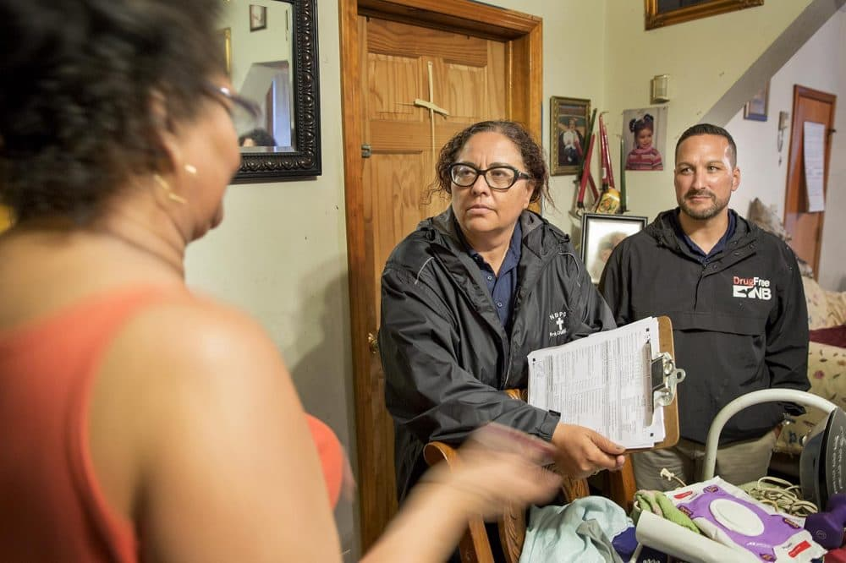

Connie Rocha-Mimoso (Seven Hills) & Pastor Casey meet with a client on a POST outreach visit. *(source: WBUR)*

DPH historically encouraged programs to include calling 911 in their training. Participants reported calling 911 in 50% of overdoses in 2023, compared to 37% in 2012. There are many reasons why someone may not call 911, such as fear of having warrants checked. Of those who interacted with first responders from 2012-2022, 15% had a negative experience, 45% had a positive experience, and 40% had a neutral experience. DPH will continue to work with first responders to ensure safe, positive situations for overdose responders, especially when extra medical attention is needed.

OEND programs have engaged community first responders through collaborations such as multidisciplinary Post Overdose Support Teams (POST), which bring naloxone and other desired resources to individuals and spaces where known overdoses occur. These interactions with overdose responders and survivors intend to increase positive relationships and encourage calling for help when an overdose occurs.[9]

**Figure 9. Help Seeking and Quality of First Responder Interactions (2012-2022)**

The first pie chart shows that 49.5% of participants called 911 when responding to an overdose. 

The second pie chart shows that 45% had a positive interaction, 40.3% had a neutral interaction, and 14.7% had a negative interaction with first responders after responding to an overdose.

**Grant to Enhance First Responder Training**

DPH was awarded SAMHSA’s five-year Grants to Prevent Prescription Drug/Opioid Overdose-Related Deaths (PDO) in 2022 to reduce overdose-related deaths by training first responders and implementing other novel overdose prevention strategies. DPH has subcontracted Northeastern University to implement the evidence-based [SHIELD Training Initiative](https://www.shieldtraining.org/home) to equip police and other first responders in Massachusetts with the tools needed to protect their own physical and mental well-being, while improving public safety and community relations when responding to overdose related incidents.

# Conclusion & Next Steps

By evaluating data collected by OEND programs over the pilot program stage, we can identify new projects that have emerged from this work, harm reduction program successes, and challenges that must be addressed. Findings from OEND data provide insight into the future of harm reduction and naloxone distribution in MA and beyond:

1. Thanks to secondary distribution (naloxone shared by a participant or partner organization among their community), doses of naloxone have continued to rise, even as encounters dipped during the COVID-19 pandemic
2. Secondary distribution data allowed DPH to develop the [Community Naloxone Program](https://www.mass.gov/info-details/community-naloxone-program-cnp) (CNP), which allows non-SSPs to access naloxone, free of charge.
3. Naloxone is 17 times less likely to be confiscated in 2023 than in 2012.
4. It is common to travel to Boston to receive naloxone and/or use naloxone, especially for participants living in towns along the Commuter Rail. This insight will lead to the development of at-home naloxone mailers.
5. During the COVID-19 pandemic, a greater percent of Black and Hispanic/Latinx people died of an overdose than were represented in OEND data, suggesting a need for increased OEND work within these communities.
6. About one third of returning participants used their last dose of naloxone to respond to an overdose. This is likely an undercount. 93% of reported overdoses were responded to by a person who uses drugs.
7. Rescue breathing was only performed in a quarter of overdoses, leading to the development of the [YouCan](https://youcan.info/) initiative.
8. Data showing that 66% of participants used drugs alone in the past year led DPH to fund the [SafeSpot](https://safe-spot.me/) overdose prevention hotline.
9. “Dopesickness” occurred in about half of overdoses, data which will help pave the way for the importance of compassionate overdose response.
10. 15% of overdose reporters had a negative interaction with first responders, indicating that there is still a major need for education of first responder groups.

To reduce data collection burden, OEND pilot data collection as it has been historically known ended in July 2024. In its place, programs will participate in reduced-effort surveillance data, as required by DPH’s federal funders. Additionally, programs will have the option to opt-in to Brandeis University’s Evaluation of Consumer Knowledge Survey Ongoing and Rapid (ECKS-O, ECKS-R), a study that pays participants to provide their experience with “ongoing” and emerging (“rapid”) harm reduction concerns. These surveys, informed by a community advisory board, will continue to provide DPH with data to make evidence-driven decisions with funding. As of 2024, equity of harm reduction resources and the emergence of xylazine are key topics to be explored. Finally, DPH is in the process of developing an online overdose field report survey that allows anyone who uses naloxone in MA to share their experience.

Thank you to the boots-on-the-ground OEND workers that have committed to years of data collection to create a body of research supporting the work you do.

# Appendix 1: Dictionary of Key Terms

* OEND = All Overdose Education and Naloxone Distribution (OEND) programs provide naloxone to participants at no cost and train individuals likely to witness an overdose (participants) on how to reduce overdose risk, recognize signs of an overdose, access emergency medical services, and administer intra-nasal naloxone.
* Syringe Services Programs (SSPs) = All DPH-funded SSPs are contracted through the BIDLS Office of HIV/AIDS. SSPs provide access to sterile injection equipment and syringe disposal services, as well as referrals to substance use disorder treatment, HIV and Hepatitis C (HCV) education, risk reduction counseling, HIV, HCV, and sexually transmitted infection (STI) testing.
* Drug User Health = Through the years, OEND programs have become more involved in other drug user health practices, such as wound care, housing support, food insecurity, and more.
* Participants = For this report, all people who receive OEND services are called “participants.”
* Encounters = all events where a participant receives naloxone from the OEND program are called “encounters.” A typical encounter will include 2-4 doses of naloxone being provided to a participant.
* Dose = A “dose” of naloxone is the standard amount of naloxone expected to be given to a person overdosing at one time. For example, for Narcan® brand naloxone given via the nose, a single dose is one pump (4mg) of the medication.
* Kit = Although this report exclusively uses number of naloxone “doses” as an indicator, sometimes, in other reports or materials, naloxone units will be counted as “kits.” One kit of naloxone is made up of two doses packaged together.
* New Enrollment vs. Returning = At a participant’s first encounter, they will be considered a “new enrollment,” but for each follow-up visit, they are considered a “returning” encounter.

# Appendix 2: Breakdown of OEND Programs by Region

|  |  |
| --- | --- |
| **OEND Program Name** | **Region** |
| AIDS Project Worcester | Central |
| AIDS Support Group of Cape Cod | Southeast |
| Berkshire Harm Reduction | Western |
| Boston Healthcare for the Homeless | Boston |
| Boston Public Health Commission (AHOPE) | Boston |
| Brockton Area Multi-Services, Inc. (COPE) | Southeast |
| Brockton Neighborhood Health Center | Southeast |
| Commonwealth Land Trust | Southeast |
| Fenway Community Health Center | Boston |
| Greater Lawrence Family Health Center | Northeast |
| Health Imperatives | Southeast |
| Health Innovations | Northeast |
| Holyoke Health Center | Western |
| Learn to Cope | Statewide |
| Lowell Community Health Center | Northeast |
| Lowell House | Northeast |
| Lynn Community Health Center | Northeast |
| Manet Community Health Center | Southeast |
| Multicultural AIDS Coalition | Boston |
| New North Citizens Council | Western |
| North Shore Health Project | Northeast |
| Program Rise | Central |
| Project Aware/SSTAR | Southeast |
| Seven Hills Behavioral Health | Southeast |
| Tapestry | Western |
| Victory Programs | Boston |

# Appendix 3: Publications & Papers That Used OEND Data

*Click the title to be taken to the link.*

[**Saved by the nose: bystander-administered intranasal naloxone hydrochloride for opioid overdose**](https://pubmed.ncbi.nlm.nih.gov/19363214/) **(2009)**

Authors: Maya Doe-Simkins, Alexander Y Walley, Andy Epstein, Peter Moyer

Primary result(s): After 15 months of the pilot opioid overdose prevention program, 385 participants were successfully trained and reported 74 overdose reversals.

[**Opioid overdose prevention with intranasal naloxone among people who take methadone**](https://www.sciencedirect.com/science/article/abs/pii/S0740547212001213#:~:text=Overdose%20education%20and%20naloxone%20distribution%20%28OEND%29%20is%20an,the%20previous%2030%C2%A0days%20in%20various%20settings%20in%20Massachusetts.) **(2013)**

Authors: Alexander Y Walley, Maya Doe-Simkins, Emily Quinn, Courtney Pierce, Ziming Xuan, Al Ozonoff

Primary result(s): For those who use methadone, a history of overdose, detox, incarceration, or polysubstance use pose as risk factors for overdose. OEND programs are effective and important in spaces for people who take methadone.

[**Opioid overdose rates and implementation of overdose education and nasal naloxone distribution in Massachusetts: interrupted time series analysis**](https://www.bmj.com/content/346/bmj.f174.full.pdf+html) **(2013)**

Authors: Alexander Y Walley, Ziming Xuan, H Holly Hackman, Emily Quinn, Maya Doe-Simkins, Amy Sorensen-Alawad, Sarah Ruiz, Al Ozonoff

Primary result(s): The implementation of OEND programs throughout communities in MA resulted in a lower rate of opioid overdose deaths.

[**Overdose rescues by trained and untrained participants and change in opioid use among substance-using participants in overdose education and naloxone distribution programs: a retrospective cohort study**](https://bmcpublichealth.biomedcentral.com/articles/10.1186/1471-2458-14-297) **(2014)**

Authors: Maya Doe-Simkins, Emily Quinn, Ziming Xuan, Amy Sorensen-Alawad, Holly Hackman, Al Ozonoff & Alexander Y Walley

Primary result(s): No differences were found in help-seeking, rescue breathing, staying with the victim, or overdose rescue behaviors in trained versus untrained rescuers—information is disseminated to untrained community members through the grapevine. There was no change in the number of days using heroin in the past month following OEND participation, suggesting that concerns about increased opioid use should not hinder the expansion of these programs.

[**Overdose Education and Naloxone Rescue Kits for Family Members of Individuals Who Use Opioids: Characteristics, Motivations, and Naloxone Use**](https://www.tandfonline.com/doi/full/10.1080/08897077.2014.989352) **(2015)**

Authors: Sarah M. Bagley, Joanne Peterson, Debbie M. Cheng, Charles Jose, Emily Quinn, Patrick G. O’Connor, & Alexander Y. Walley

Primary result(s): Most OEND family member participants are white female parents of individuals who use opioids. Most people attend OEND for the kit, followed by education and hearing about the benefits from others.

**[Lessons learned from the expansion of naloxone access in Massachusetts and North Carolina (2015)](https://www.cambridge.org/core/journals/journal-of-law-medicine-and-ethics/article/abs/lessons-learned-from-the-expansion-of-naloxone-access-in-massachusetts-and-north-carolina/8109EC1D98531E11F8B32D0814394522)**

Authors: Corey S Davis, Alexander Y Walley, Colleen M Bridger

Primary result(s): In the state of MA, existing naloxone access initiatives alongside key state legislative action allowed for greater expansion of naloxone distribution through prescription and through the social circles of people who use opioids.

[**Expanding access to naloxone for family members: The Massachusetts experience**](https://onlinelibrary.wiley.com/doi/10.1111/dar.12551) **(2017)**

Authors: Sarah M. Bagley, Leah S. Forman, Sarah Ruiz, Kevin Cranston, Alexander Y. Walley

Primary result(s): Family members represent 27% of OEND enrollees. Family members who do use and do not use drugs both have witnessed overdoses frequently and should be more integrated into OEND in MA. Family members who do not use drugs often receive naloxone at community meetings vs. those who do use drugs get them at OHA SSPs.

[**Factors associated with help seeking by community responders trained in overdose prevention and naloxone administration in Massachusetts**](https://www.sciencedirect.com/science/article/abs/pii/S037687161930290X?via%3Dihub) **(2019)**

Authors: Jamie K. Lim, Leah S. Forman, Sarah Ruiz, Ziming Xuan, Barry P. Callis, Kevin Cranston, Alexander Y. Walley

Primary result(s): Help seeking during overdoses by MA OEND enrollees was more likely among responders who did not use drugs and varied with responder and victim characteristics, such as the responder’s age, gender, and relationship to the victim. Help seeking reached 50% in 2016, highlighting the need for targeted interventions to encourage this behavior.

[**Local health departments and the implementation of evidence-based policies to address opioid overdose mortality**](https://pubmed.ncbi.nlm.nih.gov/32213045/) **(2020)**

Authors: Rachel Feuerstein-Simon, Margaret Lowenstein, Meghana Sharma, Roxanne Dupuis, Xochitl Luna Marti, Carolyn C Cannuscio

Primary result(s): Across 180 US counties with high OD mortality rates, an average of 250 kits were distributed through OEND programs (the period was not disclosed).

[**Community-based naloxone coverage equity for the prevention of opioid overdose fatalities in racial/ethnic minority communities in Massachusetts and Rhode Island**](https://onlinelibrary.wiley.com/doi/10.1111/add.15759) **(2021)**

Authors: Shayla Nolen, Xiao Zang, Avik Chatterjee, Czarina N. Behrends, Traci C. Green, Aranshi Kumar, Benjamin P. Linas, Jake R. Morgan, Sean M. Murphy, Alexander Y. Walley, Shapei Yan, Bruce R. Schackman, Brandon D. L. Marshall

Primary result(s): There was no significant difference in naloxone distribution among municipalities in MA by the percentage of non-white residents. In addition, municipalities with higher ratios of Black residents had a higher distribution of naloxone.

[**Targeting community-based naloxone distribution using opioid overdose death rates: A descriptive analysis of naloxone rescue kits and opioid overdose deaths in Massachusetts and Rhode Island**](https://www.sciencedirect.com/science/article/pii/S0955395921003406?via%3Dihub) **(2021)**

Authors: Xiao Zang, Alexandria Macmadu, Maxwell S Krieger, Czarina N Behrends, Traci C Green, Jake R Morgan, Sean M Murphy, Shayla Nolen, Alexander Y Walley, Bruce R Schackman, Brandon D Marshall

Primary result(s): Over time, the naloxone distribution to opioid overdose death ratio improved in MA. Additionally, urban municipalities generally had higher naloxone distribution than non-urban settings.

[**Changes to opioid overdose deaths and community naloxone access among Black, Hispanic and White people from 2016 to 2021 with the onset of the COVID-19 pandemic: An interrupted time-series analysis in Massachusetts, USA**](https://onlinelibrary.wiley.com/doi/full/10.1111/add.16324) **(2021)**

Authors: Xiao Zang, Alexander Y. Walley, Avik Chatterjee, Simeon D. Kimmel, Jake R. Morgan, Sean M. Murphy, Benjamin P. Linas, Shayla Nolen, Brittni Reilly, Catherine Urquhart, Bruce R. Schackman, Brandon D. L. Marshall

Primary result(s): The COVID-19 pandemic led to a significant surge in opioid overdose deaths among non-Hispanic Black people in MA, with no corresponding increase in naloxone distribution for this demographic. Furthermore, opioid overdose deaths remained stable for non-Hispanic White and Hispanic people, with a corresponding increase in naloxone distribution.

[**Characteristics of post-overdose outreach programs and municipal-level opioid overdose in Massachusetts**](https://www.sciencedirect.com/science/article/pii/S0955395923002116?via%3Dihub) **(2023)**

Authors: Simeon D. Kimmel, Ziming Xuan, Shapei Yan, Audrey M. Lambert, Scott W. Formica, Traci C. Green, Jennifer J. Carroll, Sarah M. Bagley, David Rosenbloom, Leo Beletsky, Alexander Y. Walley

Primary result(s): Linking overdose survivors to social services is crucial to the success of post-overdose programs, resulting in lower fatal opioid overdose rates as well as fewer opioid-related emergency responses.

**Coming soon: Massachusetts Community Naloxone Network Study**

Authors: Timothy W Levengood, Brandon D.L. Marshall, Xiao Zang, Bruce R. Schackman, Alexander Y. Walley, Sean M. Murphy, Ali Jalali, Shayla Nolen, Traci C. Green, Avik Chatterjee, Catherine Urquhart, Jake R. Morgan

Primary result(s): Soon to be published, this study finds substantial migration between residence and rescue attempt stages, with most participants traveling to Boston to administer naloxone in a rescue attempt and refill naloxone. The residence pattern of those traveling to Boston lined up with communities served by Boston’s commuter rail.

# Report Authorship & Gratitude

**2023 Participating OEND Programs**

AIDS Project Worcester

AIDS Support Group of Cape Cod

Berkshire Harm Reduction

Boston Healthcare for the Homeless

Boston Public Health Commission (AHOPE)

Brockton Area Multi-Services, Inc. (COPE)

Commonwealth Land Trust

Fenway Health (ACCESS)

Greater Lawrence Family Health Center

Health Imperatives

Health Innovations (Healthy Streets)

Holyoke Health Center

Justice Resource Institute (Program RISE)

Learn to Cope

Lowell Community Health Center

Life Connection Center

Lowell House

Lynn Community Health Center

Manet Community Health Center

Multicultural AIDS Coalition

New North Citizens’ Council

North Shore Health Project (ONE STOP)

Seven Hills Behavioral Health

Stanley Street Treatment and Resources

Tapestry

Victory Programs, Inc.

**Department of Public Health**

Hermik Babakhanlou-Chase

MaryKate Duska

Kate Lena

Chris Massad

Ben Plant

Brittni Reilly

Sarah Ruiz

Anu Sahu

Nicole Schmitt

Catie Urquhart

Emma Allen

Linda Goldman

Emily Levine

Thera Meehan

Monica Morrison

Denise Sanderson

Raesin Caine

Abby Kim

Deirdre Calvert

Ginger Gates

**Biostatistics and Epidemiology Data Analytics Center (BEDAC)**

Alan Labonte

Alice Bisbee

Amy Michals

Axin Hua

Brittany Parker

Carolyn Finney

Christine Chaisson

Doug Annis

Emily Sisson

Ethan Goldstein

Greg Patts

Jerry Coffman

Jingshun Yang

Kan Lu

Karen Fortu

Leah Forman

Maggie Shea

Maria Brito

Matt Bullard

Miles Avila

Minghua (Lily) Chen

Pei-Chi Kao

Srujana Kunapareddy

Tasha Watson

Vicky Shan

Xue Liu

Yige Cao

Yue Gu

**Boston Medical Center (BMC)**

Simeon Kimmel

Alex Walley

**Other Harm Reduction Leaders & Partners**

Kim Powers

Gary Langis

Maya Doe-Simkins

The 200+ Community Naloxone Programs that joined DPH since 2022

*To learn more about harm reductions leaders from MA, please see [Voices](https://www.voicesofharmreduction.com/) of Harm Reduction.

*Report data were collected and managed using REDCap electronic data capture tools hosted at Boston University.*[*1*](http://www.sciencedirect.com/science/article/pii/S1532046408001226)*,*[*2*](https://www.sciencedirect.com/science/article/pii/S1532046419301261)*REDCap (Research Electronic Data Capture) is a secure, web-based software platform designed to support data capture for research studies, providing 1) an intuitive interface for validated data capture; 2) audit trails for tracking data manipulation and export procedures; 3) automated export procedures for seamless data downloads to common statistical packages; and 4) procedures for data integration and interoperability with external sources.*

1. [Nonpharmaceutical Fentanyl-Related Deaths --- Multiple States, April 2005--March 2007](https://www.cdc.gov/mmwr/preview/mmwrhtml/mm5729a1.htm)
2. [Doe-Simkins M, Walley AY, Epstein A, Moyer P. Saved by the nose: bystander-administered intranasal naloxone hydrochloride for opioid overdose. Am J Public Health. 2009 May;99(5):788-91. doi: 10.2105/AJPH.2008.146647. PMID: 19363214; PMCID: PMC2667836.](https://ajph.aphapublications.org/doi/full/10.2105/AJPH.2008.146647)
3. [Doe-Simkins, M., Quinn, E., Xuan, Z. *et al.* Overdose rescues by trained and untrained participants and change in opioid use among substance-using participants in overdose education and naloxone distribution programs: a retrospective cohort study. *BMC Public Health* 14, 297 (2014).](https://doi.org/10.1186/1471-2458-14-297)
4. [Massachusetts Department of Public Health Current Overdose Data](https://www.mass.gov/lists/current-overdose-data)
5. [Bagley SM, Forman LS, Ruiz S, Cranston K, Walley AY. Expanding access to naloxone for family members: The Massachusetts experience. Drug Alcohol Rev. 2018 May;37(4):480-486. doi: 10.1111/dar.12551. Epub 2017 Apr 20. PMID: 28429378.](https://onlinelibrary.wiley.com/doi/10.1111/dar.12551)
6. [Kolla G, Khorasheh T, Dodd Z, Greig S, Altenberg J, Perreault Y, Bayoumi AM, Kenny KS. "Everybody is impacted. Everybody's hurting": Grief, loss and the emotional impacts of overdose on harm reduction workers. Int J Drug Policy. 2024 May;127:104419. doi: 10.1016/j.drugpo.2024.104419.](https://www.sciencedirect.com/science/article/pii/S095539592400104X?via%3Dihub)
7. [Kenny KS, Kolla G, Firestone M, Bannerman M, Greig S, Flores BF, Dodd Z, Strike C, Bayoumi AM. Frequency of fatal and non-fatal overdoses and response to grief and loss among people who inject drugs: An unexplored dimension of the opioid overdose crisis. Drug Alcohol Depend. 2022 Aug 1;237:109539. doi: 10.1016/j.drugalcdep.2022.109539. Epub 2022 Jun 16. Erratum in: Drug Alcohol Depend. 2022 Dec 1;241:109701. doi: 10.1016/j.drugalcdep.2022.109701.](https://www.sciencedirect.com/science/article/abs/pii/S0376871622002769?via%3Dihub)
8. [Schoenberger SF, Cummins ER, Carroll JJ, Yan S, Lambert A, Bagley SM, Xuan Z, Green TC, Cook F, Yule AM, Walley AY, Formica SW. "Wanna cry this out real quick?": an examination of secondary traumatic stress risk and resilience among post-overdose outreach staff in Massachusetts. Harm Reduct J. 2024 Mar 19;21(1):66. doi: 10.1186/s12954-024-00975-2.](https://harmreductionjournal.biomedcentral.com/articles/10.1186/s12954-024-00975-2)
9. [Scott W. Formica, Katherine M. Waye, Allyn O. Benintendi, Shapei Yan, Sarah M. Bagley, Leo Beletsky, Jennifer J. Carroll, Ziming Xuan, David Rosenbloom, Robert Apsler, Traci C. Green, Allie Hunter, Alexander Y. Walley, Characteristics of post-overdose public health-public safety outreach in Massachusetts, Drug and Alcohol Dependence, Volume 219, 2021, 108499, ISSN 0376-8716, https://doi.org/10.1016/j.drugalcdep.2020.108499.](https://www.sciencedirect.com/science/article/abs/pii/S0376871620306645?via%3Dihub)