Massachusetts Office of the Attorney General Symposium

Wholesale Market Design in a Low/No-Carbon Electricity System: visions for the future and how to get there

Federal Reserve Bank
600 Atlantic Ave, 3rd floor Boston, MA
October 24, 2019, 8:45 a.m. – 6:00 p.m.

Objective: Learn about and discuss the best long-term wholesale electricity market design options to support New England’s sustainable clean energy and climate goals and requirements, while ensuring reliability and reasonable electricity costs for customers.

AGENDA

8:45–9:15 | Check-in, coffee, & continental breakfast
9:15–9:30 | Welcome & introductory remarks (Attorney General Maura Healey) Strategy for Day (Facilitator: Dr. Jonathan Raab, Raab Associates)
9:30-11:00 | Panel One: Long-Term Wholesale Market Design Vision  Dr. Paul Joskow, Massachusetts Institute of Technology  Dr. William Hogan, Harvard Kennedy School  Dr. Susan Tierney, Analysis Group  Rob Gramlich, Grid Strategies, LLC  Steven Corneli, Strategies for Clean Energy Innovation  What wholesale market design construct(s) in New England will most effectively support an electricity system comprised exclusively of renewables and other zero/very low carbon resources (many/most of which have variable output, and near zero marginal cost to operate)?  - Will capacity markets (or another resource adequacy mechanism) still be needed in the long-term?  - Will there be a need to price carbon once we are in an electricity system comprised exclusively of renewables and other zero/very low carbon resources (or only during the transition to that end state)?  - How does your proposal respond to system changes such as: a) a significant increase in electricity demand due to electrification of buildings and transportation; and b) the rise of distributed energy resources?
11:00-12:15 | Facilitated working groups (3 groups of 10-12 people)
12:15-12:45 | Report out/Full-group discussion
12:45-1:15 | Lunch (catered)

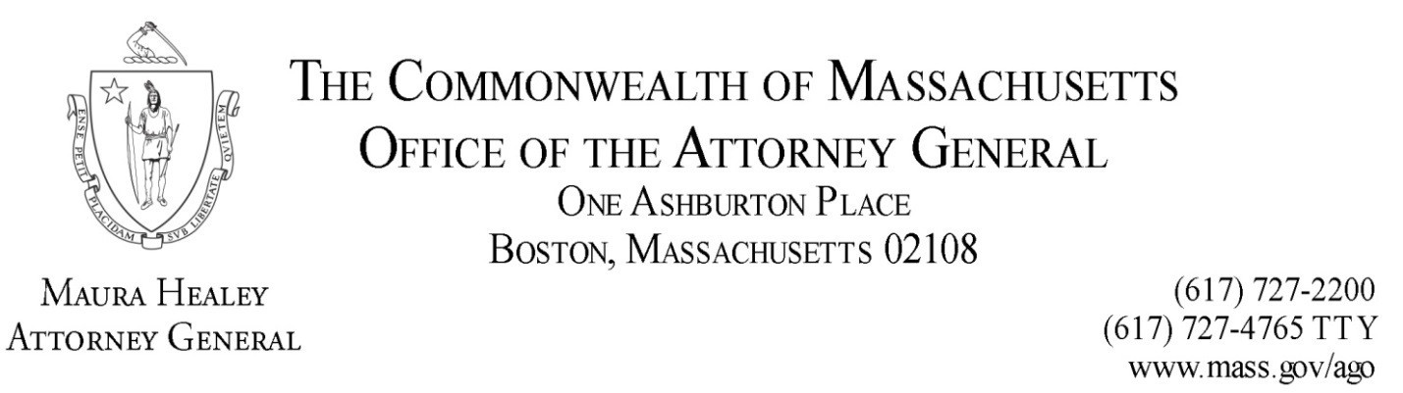

1:15 – 2:45 | Panel Two: Achieving the Vision; An Effective Transition—What Needs to Happen When  Dr. Robert Stoddard, Charles River Associates Dr. Karen Palmer, Resources for the Future Abigail Krich, Boreas Renewables, LLC  Peter Fuller, Autumn Lane Energy Consulting, LLC  John Moore, Natural Resources Defense Council, Inc.  How do we effectively transition the wholesale markets (during which gas will likely still be needed) to ensure that we achieve the long-term vision(s) discussed in the morning?  - What are the most significant things that need to happen to effectively transition our wholesale markets and when and by whom should they be done?  - Will capacity markets (or another resource adequacy mechanism) still be needed during the transition?  - Do we need to price carbon in the wholesale markets during this transition, and if so how?
2:45-4:00 | Facilitated working groups (3 groups of 10-12 people)
4:00-4:30 | Report out/Full-group discussion
4:30–4:45 | Closing remarks (AGO)
5:00-6:00 | Post symposium reception

