Case Study 4: Energy Conservation Project at Bridgewater State College
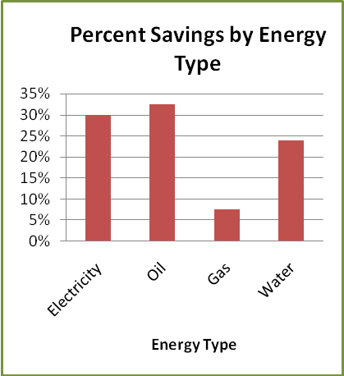
Beginning in March 2006, Bridgewater State College (BSC) contracted with Select Energy Services to complete a campus-wide energy efficiency overhaul of the college’s facilities. The initial cost of the project was $11 million; it will be paid out over 20 years. BSC is financing the project through the state’s Energy Performance Contracting Program, allowing the college to pay for the project with their estimated future energy savings.
The Energy Conservation Project applied energy efficient improvements to most buildings on the BSC campus. The most notable changes include the retrofitting of over 10,000 campus-wide light fixtures with energy efficient lamps, the replacement of HVAC ventilation units at Kelly Gym, the integration of a campus-wide Energy Management System (EMS), and the installation of a co-generation plant that will provide both electricity and hot water for the college’s athletic center.
The project is estimated to save BSC over $950,000 annually – approximately 25% of their typical energy bill. The project also serves to improve the quality of life on the BSC campus by minimizing the college’s impact on the surrounding environment.
The annual environmental benefits of the project include reductions in:
- CO₂ emissions of 2,766 metric tons
- SO₂ emissions of 10.65 metric tons
- NO_{X} emissions of 3.67 metric tons
Energy Type | FY 06 Consumption | Projected Savings
Electricity | 17,283,275 kWh | 4,769,996 kWh
Heating Oil | 821,595 gallons | 344,294 gallons
Natural Gas | 420,827 therms | 34,283 therms
Water | 31,922,585 gallons | 9,274,311 gallons

