Engagement Plan

The Engagement Plan is a tool for designing more inclusive and equitable community outreach and engagement. In the MVP 2.0 process, you will use this tool in step four to connect with and collaborate with community members to investigate social vulnerability and resilience in your community or region. While you will only be asked to submit your Engagement Plan with step four, you may also find it useful to use this tool at these points:

- In step five, when you are vetting your updated community resilience priorities with the community
- In step six, when you are vetting your Seed Project idea with the community
- In step seven, when you are developing your implementation plan (including your outreach and engagement approaches) for your Seed Project

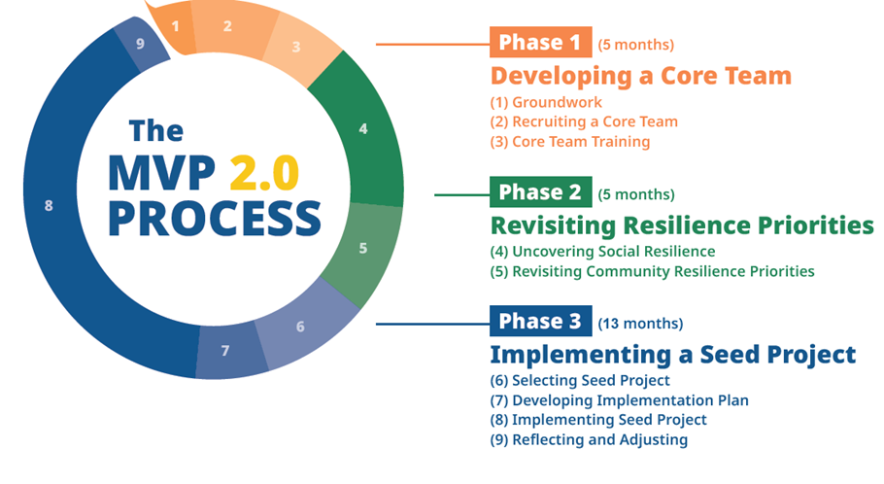
You may also find that it’s useful to use this tool for other initiatives in your community outside the scope of MVP 2.0, for example for future MVP Action Grant applications or other funding opportunities.

______________________________________________________________________

Context for Equitable Engagement
Climate change impacts do not affect all people and communities the same. Safe and secure housing, job opportunities, social connections, access to reliable internet, affordable food, and transportation options all help to buffer the impacts of climate change and make it easier to cope or adapt. Who has and doesn’t have access to these resources, as well as who faces greater exposure to climate hazards, is shaped by existing inequities, including systemic racism, accessibility barriers, political marginalization, and disinvestment. Unless climate solutions directly address these root causes of vulnerability, climate hazards will continue to reinforce existing inequities and cause disproportionate burdens.

Key to closing these equity gaps is ensuring that the people and communities experiencing the greatest climate risks inform, guide, and define climate resilience solutions that meet the specific needs of their communities. This requires building and sustaining strong community partnerships and relationships with community members and explicitly allocating resources to processes that are inclusive, culturally appropriate, and responsive to the specific needs of different community groups. Equity-centered engagement promotes shifts in governance and allows community members to use local knowledge, expertise, and lived expertise to co-lead community driven resilience planning with municipalities. The foundations and principles below provide some guidance for planning and implementing equity-centered processes and engagement. Generally speaking, the foundations are the “what & why” and the principles are the guidelines for “how.”

Foundations of Equity-Centered and Inclusive Community Processes
- Those who will be disproportionately impacted by climate change have a right to be involved in the decision-making process related to building their resilience.
- The contribution of EJ and other priority populations will influence the decisions made related to climate resilience planning.
- The lived expertise of those experiencing social vulnerability is recognized and valued in the process of defining problems, issues, and solutions.
- Outreach and engagement enthusiastically involves, collaborates with, and empowers EJ and other priority populations who will be affected by decisions made in the process.
- The information needed to actively participate as collaborators in a decision-making process is provided to members of EJ and other priority populations in ways they can most readily absorb and understand it and with enough time and support to make sense of it.
- The needs, concerns, goals, and assets of EJ and other priority populations are integrated into the decisions made. How this is done is transparent and communicated specifically to participants in these processes and the community at large.
- Engagement is relational and not transactional. The process aims to build and sustain relationships based on mutual respect and reciprocity.

Principles of Equity-Centered and Inclusive Community Engagement

1. Honor Local Knowledge and Leadership
Community members hold personal and local knowledge about the different strengths, issues, and opportunities that exist in their communities. Local knowledge provides important insight and context to the work that municipalities conduct.

- Diversify inclusion throughout the process. Diverse participation in planning and engagement processes and representation in decision-making bodies is key to upholding the foundations listed above. Seek to engage those historically not involved and partner with a diversity of people and groups in your outreach and engagement. In particular, focused attention and effort to integrate EJ and other priority populations into planning and action is important.

- Include before key decisions are made. The people who are most impacted should be involved in and lead decisions made about how to define problems or issues and what solutions look like and accomplish for the community.

- Start where people are. What is important to EJ and other priority populations may be different than what is important to municipal officials or people who do not live in those communities. Respecting people’s right to self-determination requires sharing – or even handing – control of decisions over to the people who have to live with – or are supposed to benefit from – those decisions. Power-sharing in this way also has the benefit of building trust.

- Honor lived expertise and already built capacity. Adopt an assets orientation that focuses on the strengths, talents, skills, resources, and capacities that are found in a group of people or place and center those assets in your engagement. For example, many communities have already experienced the impacts of climate change and other unprecedented crises, including the COVID-19 pandemic. Recognize the community-driven assets that have been developed in response, such as the creation of community spaces, mutual aid networks, or methods for sharing information. Consider how you can leverage such assets for engagement and how you can work with community groups and organizations to support and expand on their existing work in your planning process. Value lived expertise—knowledge that comes from direct experience—as critical insight for informing planning and decision-making.

- Use data and talk with people. Data included in sources like the U.S. Census are important to start understanding the characteristics of vulnerability in your municipality. The GEAR tool will provide you with access to some such data. However, prioritizing going into communities and talking to people is also essential; the data that is available on the people who live and work in the community may not be granular or detailed enough to fully understand the vulnerabilities people face, and it does not provide information on their priorities. Developing partnerships with local leaders who are working in an informal or formal capacity to support and advocate for the needs of people in their community (including understanding their needs, priorities, and competing pressures) can help provide connections to the community members you seek to engage and learn from. Allocate budget in your projects to compensate local leaders for their time and contributions.

2. Make Inclusion and Accessibility a Priority
Fostering inclusion and accessibility means making sure that all persons regardless of race, gender identity, ability, ethnicity, economic status, nationality, or sexual orientation feel welcomed, respected, and empowered in shaping decisions related to projects and planning for their community.
- Go where people are and where they feel safe. When reaching out to people who have traditionally been excluded from planning processes, prioritize going to where that community congregates or lives - and feels safe. This may include partnering with local organizations or community groups to attend or participate in existing events, or hosting pop-ups or talking to people in spaces where people gather—whether that’s at a park or playground, the local diner, or farmers market. In particular, consider partnering with social workers to find accessible meeting spots at schools, health clinics, or community organizations’ offices. However, it is important to recognize and respect when going into a community’s space is unwanted because of a lack of trust. In such cases, working with partners who are trusted by the community will help find ways to engage with respect and care.

- Abide by basic components of any meeting or engagement activity. These include:
  - Use accessible and people-centered language. Use clear and direct language that speaks to people’s experience, and define key words and concepts that may be unfamiliar. Avoid technical jargon, acronyms, and idioms that require specialized knowledge or that are harder to translate across cultures and languages. Adopt language that centers people first rather than the barriers or disadvantages an individual deals with in their life. (For example, use "people living with disabilities” instead of “disabled people,” or “people experiencing homelessness” instead of “homeless people.”)
  - Provide translation and interpretation. Make it common practice to translate materials into the most common languages spoken in your community other than English, and to provide language interpretation at events. When your primary focus is to reach a community who speaks a language other than English, hold the event in that language and provide interpretation for the English speakers. Many online platforms, such as Zoom, make live language interpretation possible by enabling separate audio channels for interpreters. There is a statewide contract municipalities may use to procure translation and interpretation vendors.
  - Expand accessibility for all abilities. Design documents that can be read by text-to-speech software for people who benefit from text being read aloud. Include closed captioning options in videos and online meeting platforms, and American Sign Language (ASL) interpretation when needed at in-person events. Many online platforms, such as Zoom, provide closed captioning options.
  - Include the whole family. For some people, an hour of participation requires finding childcare or is time taken away from dinner with family. Provide childcare and meals during meetings to make it easier for parents, older siblings, and other caregivers to participate. Consider partnering with community organizations or municipal recreation centers that could help provide facilities or childcare. Tailor conversations to include youth, and when relevant, design family-friendly activities for people of all ages to participate.
  - Hold events and engagement opportunities at different times. Hosting meetings at different times of the day, including weekends and evenings, provides more participation options to accommodate different work schedules. Also consider seasonal commitments like agricultural cycles and school schedules.
  - Make transportation easy for in-person events. Selecting locations that are near public transportation stops and/or accessible by biking or walking makes it easier for people with disabilities and people with limited transportation options, including youth, to participate. Consider providing transportation vouchers to reduce the cost burden, or organizing a carpool or shuttle service to provide transportation access.

- Respect the cultural practices of your neighbors. Equity-centered practice requires respecting and integrating the cultural practices of people of color, immigrants, and other marginalized groups. For example, this may mean that meetings begin with a meal and the agenda does not begin until the meal is over or that less material is covered than in a standard meeting. The additional time spent together provides the opportunity to build relationships outside of the specific project being worked on.

- Use multiple engagement formats and modes of communication. Using multi-pronged strategies will help boost participation and meet cultural needs of different groups. Offer hybrid or virtual options for people to join online, or live-stream events through local access television or on platforms like Facebook Live. Other engagement options like surveys that can be completed at any time may also be good options.

3. Foster Long-term Commitment
Equitable engagement is an ongoing process that involves developing relationships, shared understanding, and ways of working together based on mutual respect and trust. Rather than thinking about engagement as a discrete set of activities tied to a project, consider how interactions and collaborations build on past experiences, and how they contribute to stronger relationships moving forward.

- Recognize historic harms. Recognize the history of systemic bias and marginalization that has been perpetuated and has led to increased climate vulnerability for people living or working in your community. Experiencing these harms will influence how people react to and participate in your engagement activities. Finding ways to begin the process of redressing harm can sometimes feel overwhelming due to the enormity of the task. Starting small can help. All municipalities have various ways to tell history. These histories often get used as foundational narratives in documents like community plans, websites, and books or articles. However, most of these histories are one sided and tend to reinforce a single perspective. One action to consider includes forming a working group tasked with developing a more inclusive narrative. This could include working with Indigenous experts to understand their history of place and incorporating this perspective into the history of the town. This information could then be used on the website and any other future documents.

- Take time to build relationships. Many communities who have experienced long histories of exclusion, marginalization, and harm from government planning processes, including BIPOC communities, people with low-income backgrounds, and people living with disabilities, hold well-founded skepticism about participating in government-related projects. It may take time to repair relationships and build trust. If initial outreach efforts are not successful, consider working with community partners to understand what additional changes can be made or steps can be taken to build trust or to make the activity more valuable, inviting, or relevant to the community you are hoping to reach.

- Promote transparency. Transparency is critical to building and maintaining relationships. Lack of participation in engagement efforts can often be the result of community mistrust in government processes and feeling like their input and voices are not being heard. To address this problem, it is important to be clear about your engagement goals and how you expect to use the input provided by the community. Internally, it is also important to understand the staffing and financial resources that you have dedicated for engagement efforts to avoid overpromising to the public.

- Support mutually beneficial relationships. Work to understand how the municipality can support community needs and goals and show up for community efforts. Consider how any engagement activity can support an ongoing relationship, not purely information collection to serve the project’s goals. This could include:
  - Working with community leaders to identify ways to support community capacity, including strategies aimed at developing or accessing new skills, knowledge, social networks, resources, or funding sources that will make it possible to continue resilience work or advocate for resilience work even after a project ends.
  - Providing residents with greater clarity on local government functions, including why a particular department exists, how it serves the community, and how residents can advocate for or influence policy or program development.

- Integrate joy. Outreach and engagement should be designed to be joyful, fun, and foster hope. Climate resilience work is already hard. Relationship building is hard. Making it fun helps to get through the hard parts.

Developing Your Community Engagement Plan

Step 1: Identify your engagement goals

1.1 What step of the MVP 2.0 process, or what project, are you developing an engagement strategy for?

1.2 What are your goals for engaging or collaborating with community members at this step? Consider:
- What do you hope to understand better through the process?
- What do you hope to see come out of this process?
- What relationships do you hope might begin to develop or strengthen through this process?
- What do you anticipate are community members’ goals for participating in this process? (Consider: Is there a way to ask that as part of your outreach?)

1.3 How will engaging or collaborating with community members at this point shape the process or project moving forward? What decisions have already been made? Is there flexibility for community input to influence those decisions?

Step 2: Determine who should be involved

2.1 Who do you hope to reach through this engagement? Whose experiences, insight, or perspectives are important to hear at this point in the process? Use the data in the GEAR and the Social Resilience Roadmap as resources to identify who will be most impacted.

2.2 Given your answers to the question above, what are some of the best ways to reach the people or communities you hope to connect with through this engagement process? Consider:
- Organizations or community groups that may have connections or relationships, including the local school system, faith communities, neighborhood associations, local nonprofits, health clinics, social services, or clubs.
- Places where people congregate, including businesses, playgrounds and parks, or community spaces.
- Sources of information people rely on, including specific media outlets or word of mouth through specific networks.

2.3 How will engagement with the communities or groups listed above build on past interactions? How does it support or set the stage for future collaboration?

Step 3: Consider partnering

Oftentimes, working in partnership with someone or an organization who has strong existing relationships with the people you are hoping to reach can help in making the initial connection. The person or organization could be a local business owner who is open to hosting an event, a community-based organization who can collaborate on the outreach, or an informal community leader who may be able to invite people through word of mouth. Partners from and/or with strong relationships with Environmental Justice (EJ) and other priority populations may also be able to advise on the design of the outreach to make sure the event or activity is accessible, valuable, and culturally appropriate to the people you are hoping to reach.

For the MVP 2.0 process, your Core Team already has significant insight in connecting with specific populations in the community, thanks to the expertise of your community liaison team members. In some cases, your team’s community liaisons may also know or could recommend additional community partners who could be involved in the engagement activities to help reach more people in the specific community or support the goals your team has outlined. For example, a community partner may be a local artist who could guide a community art installation or a local restaurant owner who might host a dinner tailored to a specific culture. The following questions pertain to these additional partnerships.

3.1 What opportunities are there to work with a community partner to support this outreach and engagement?

3.2 If you plan to work with a community partner, how will the collaboration be structured? Consider the following:
- What are the expected roles and responsibilities?
- Will the partner be financially compensated? If so, is the compensation appropriate to the level of work?
- How will the partner be able to provide input, be heard, and be impactful in the design of the engagement and its outcomes?

Step 4: Identify your approach

Consider the table below. The five categories show different levels of community involvement in decision-making. As you move from left to right, the community plays a larger role in decision-making and the opportunity for the process to better address the root causes of vulnerability and support equitable outcomes increases. While there can be a time and place for all these levels of engagement, MVP encourages moving as close to level 5 as possible.
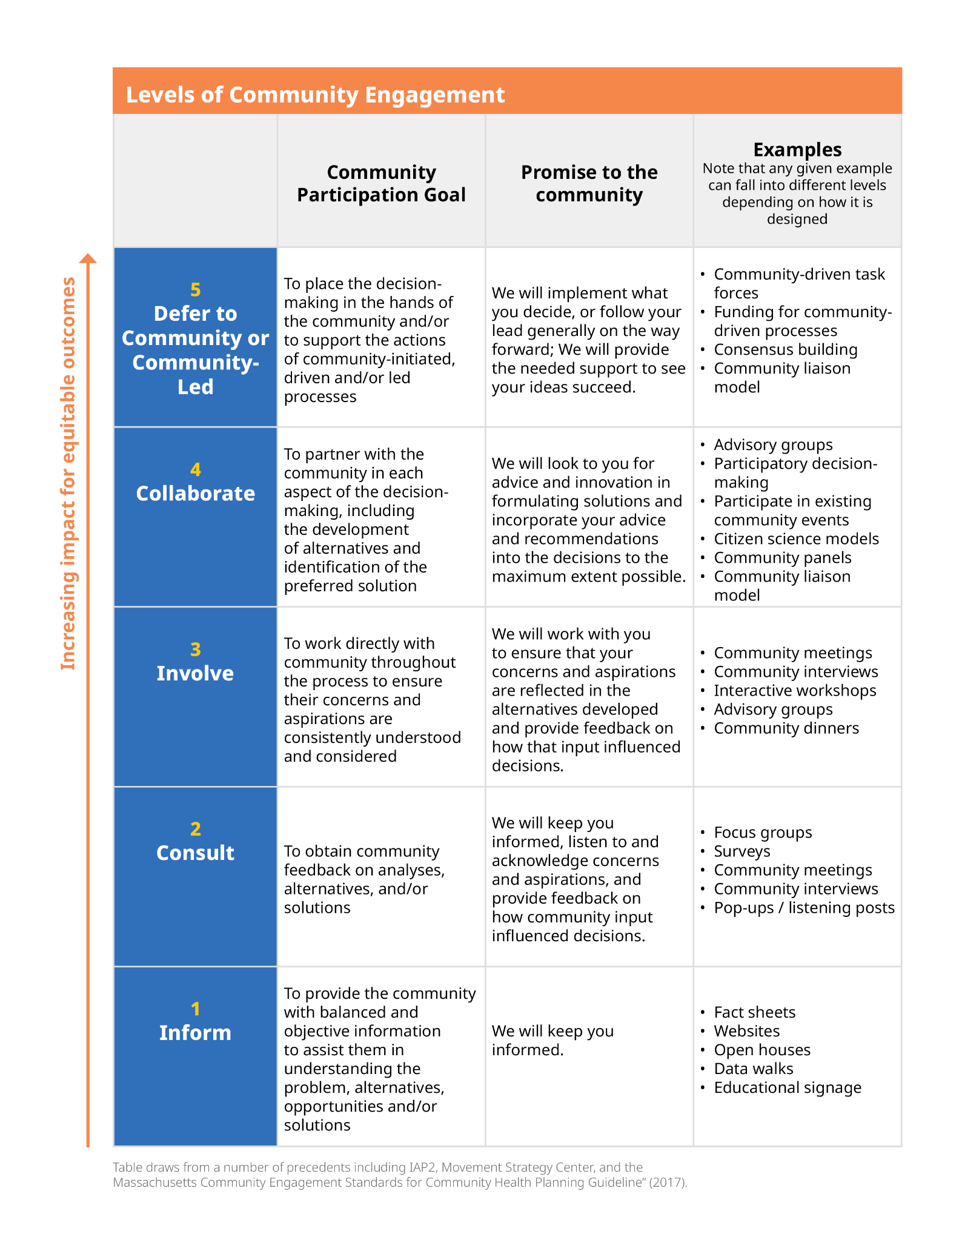

4.1 Based on your goals for community engagement, which level are you focused on in the table above? Consider your answers for Step 1 of the Engagement Plan, including the extent to which community input can shape decisions and the trajectory of the project.

4.2 What would need to be different to move further to the right in the table? What potential could that bring to the process or project, if any? Is there an opportunity to build that in?

4.3 Does that answer change your original engagement goals? If so, how so?

Step 5: Develop your activities

Based on all your answers above, what methods will your Core Team use for reaching out to, engaging, or collaborating with community members? Consider the ways that outreach and engagement efforts are interconnected but serve different purposes: Outreach efforts share information about a project, recruit community partners, and invite community members to participate in the process, while engagement entails the actual participation of community members in the project and act of providing input to influence a project. You’ll likely need both to meet your engagement goals. Check out the “Methods and Tools” table below for inspiration, and consider alternative and other creative approaches that may better meet your goals or community context. If you are working with an additional community partner, what do they recommend?

Inspiration: Methods and Tools | When could it be most useful?
Community dinners - Host a community dinner at a community space or a local business in order to discuss a particular topic over a shared meal. Tailor the meal to reflect the cultural preferences and practices of the community members participating. Or, consider a mobile dinner by bringing a food truck to a public space, a youth sporting event, or other activity as a way to talk to residents while coming together around food. | Step 4: Uncovering Social Resilience  Step 5: Revisiting Resilience Priorities Step 6: Selecting a Seed Project  Step 7: Seed Project Implementation Plan Future Action Grant
Storytelling or spoken-word - Host an event, or work with a community partner to host an event, focused on storytelling or spoken word poetry. Ask community members to share their stories about specific events, and identify lessons, experiences, and emotions from these stories. Use this as a basis for cultivating community, empathy, and understanding related to what people value in their community. | Step 4: Uncovering Social Resilience  Step 7: Seed Project Implementation Plan Future Action Grant
Community panels - Host a panel made up of community experts (community members speaking on behalf of their lived expertise) to discuss a project or a community resilience topic. Include breakout sessions for follow up discussions with participants. Provide panelists and participants with detailed information about the project and time to understand and discuss proposed recommendations. Allow participants to deliver written or verbal feedback directly to relevant decision-makers. | Step 4: Uncovering Social Resilience  Step 5: Revisiting Resilience Priorities Step 6: Selecting a Seed Project  Step 7: Seed Project Implementation Plan Future Action Grant
Community workshops - Gather community members to work together around a common purpose/goal. Consider a workshop structure that is non-hierarchical. Identify community experts who can support the design and facilitation of the workshop. Provide participants with detailed information about the project and time to understand and discuss proposed recommendations. Allow participants to deliver written or verbal feedback directly to relevant decision-makers. | Step 4: Uncovering Social Resilience  Step 5: Revisiting Resilience Priorities Step 6: Selecting a Seed Project  Step 7: Seed Project Implementation Plan Future Action Grant
Pop-up stand / listening posts - Set up a fun, family-friendly activity in a public space that shares information on a particular topic or project, creates conversation, and gathers community members ideas and questions. Consider crafts or games that get people talking or envisioning what they would like to see for the future of their community. Ensure that the pop-up designs and activities are relevant to local priorities and needs, and not imposed. | Step 4: Uncovering Social Resilience  Step 5: Revisiting Resilience Priorities Step 6: Selecting a Seed Project  Step 7: Seed Project Implementation Plan Future Action Grant  Outreach
Focus groups - Host a group discussion with 4-12 individuals centered on the exploration of a specific topic. Consider a variety of activities (e.g., open-ended questions, group ranking, videos, drawing, mind-mapping) to work through particular ideas. Focus groups are most effective when a skilled moderator can make individuals feel comfortable participating and adapt and manage to diverse group dynamics. | Step 4: Uncovering Social Resilience  Step 5: Revisiting Resilience Priorities Step 6: Selecting a Seed Project  Step 7: Seed Project Implementation Plan Future Action Grant
Community interviews - Meet with community members in-person, by phone, or by online video call to ask questions about their experiences on a particular topic. Consider hosting group interviews with community members who may have shared or complementary experiences. With appropriate permissions, consider compiling interviews into a video for further outreach like this intergenerational interview video project developed through an MVP project in Pelham. | Step 4: Uncovering Social Resilience  Step 5: Revisiting Resilience Priorities Step 6: Selecting a Seed Project  Step 7: Seed Project Implementation Plan Future Action Grant
Participating in existing community events - Join a regularly occurring event or meeting at a community-based organization, club or community group, neighborhood association, or other locations where people come together already to listen and learn about ongoing community initiatives or perspectives. Talk with leaders of those groups beforehand about whether it’s appropriate to attend, present, or facilitate a discussion about a project or process. Respect and defer to existing leaders and members of the group on how to approach the process. | Step 4: Uncovering Social Resilience  Step 5: Revisiting Resilience Priorities Step 6: Selecting a Seed Project  Step 7: Seed Project Implementation Plan Future Action Grant  Outreach
Surveys - Disseminate a survey to gather input, feedback, or ideas from community members. To increase accessibility, administer using multiple formats (e.g., digital, paper, and verbal) and offer the survey in multiple languages. Consider collecting information on who is filling out the survey in terms of race, age, income level, or other characteristics as needed to make sure the survey is reaching the intended people or communities. Consider creating ways to follow up with participants to share survey results or how the feedback shaped the process or project decisions. | Step 4: Uncovering Social Resilience  Step 5: Revisiting Resilience Priorities Step 6: Selecting a Seed Project  Step 7: Seed Project Implementation Plan Future Action Grant
Data walks - Print data on large posters and station them around a room. Invite participants to move from station to station and read and leave feedback on the posters. In a virtual setting, data walks can be carried out by breaking participants into small groups on virtual meeting platforms and having a facilitator share the poster with the participants on their screen. Use the event as an opportunity to share information, get feedback on initial findings, identify gaps in the data, and ground-truth the findings based on people’s lived experience. | Step 4: Uncovering Social Resilience  Step 7: Seed Project Implementation Plan Future Action Grant
Participatory mapping - Work with community members to integrate their local knowledge into maps in order to identify issues and opportunities. Text, audio, video, and images can all be used to integrate local knowledge. Structuring conversation around digital, paper, or 3D maps each contain their own set of benefits and drawbacks; consider what might work best for your audience. | Step 4: Uncovering Social Resilience  Step 7: Seed Project Implementation Plan Future Action Grant
Participatory neighborhood assessment - Collaborate with relevant community based organizations and coalitions to conduct a participatory neighborhood assessment. Work with community members to develop assessment techniques such as surveys and informational interviews to identify and solve issues within the neighborhood. Consider partnering with groups that have formal assessment experience (such as a local board or department of public health) so that community members can gain capacity and skills to conduct their own future assessments. | Step 4: Uncovering Social Resilience  Step 7: Seed Project Implementation Plan Future Action Grant
Community liaison model - Hire community leaders from and/or with strong relationships with EJ or other priority populations to lead outreach within the community and act as intermediaries between the community and the municipality in identifying and advocating for community needs. Offer fair pay to community liaisons and provide training in topics that support their outreach and role as a liaison. | Future Action Grant  Outreach
Photovoice - Provide a prompt to participants and ask them to capture images that respond to that prompt. Have individuals reflect on their images in groups to provide further context on their ideas. Consider access to technology as a potential barrier to participation; using disposable cameras is an option if engagement can span multiple days. | Step 7: Seed Project Implementation Plan Future Action Grant
Site visits or walking tours - Schedule a tour at a location or set of locations and integrate opportunities for education, knowledge-sharing, and networking among community members. Consider your audience and their ability to move or stand for long periods of time; offer alternative engagement options (e.g., bus tour) for accessibility. | Step 7: Seed Project Implementation Plan Future Action Grant
Demonstrations and trainings - Identify a skill that would be valuable to a group of people in the community and support community resilience. Host an event to provide a demonstration or training around that skill. Leverage pre-existing resources (e.g., lesson plans, kits, training offered by nonprofit organizations). Offer training in various formats and at different times; consider offering childcare or a training that is kid-friendly. | Step 7: Seed Project Implementation Plan Future Action Grant
Integration with school curriculum - Collaborate with schools, teachers, and after school programs to design field trips for students to learn about particular climate resilience topics. Include opportunities for service. Consider cost or transportation as a potentially limiting factor for some students to participate; identify strategies to counter these limitations. | Step 7: Seed Project Implementation Plan Future Action Grant
Plant sales - Partner with local nurseries, greenhouses, and farms to host a community plant sale. Highlight climate resilient plants and pollinators that are appropriate for your community’s planting zone in the sale. Feature both edible and non-edible plants at the sale. | Step 7: Seed Project Implementation Plan Future Action Grant
Site clean-ups and plantings - Gather community members and organizations to host a site clean-up and/or planting event. A site clean-up may include picking up trash and simple landscaping, such as raking leaves. Consider planting climate-resilient species at the site you are cleaning, if relevant. Added vegetation can help with cooling heat islands, managing stormwater runoff, and purifying air. | Step 7: Seed Project Implementation Plan Future Action Grant
Community service events - Organize community service events with community members and organizations. Consider what specific issues members in your community may need assistance in addressing that can also build capacity and create partnerships. This might include hosting a food drive for the local food bank or creating a program to assist neighbors with shoveling snow. | Step 7: Seed Project Implementation Plan Future Action Grant
Temporary public art installations - Engage local artists to create temporary public art installations. This could be through a community space, such as a library, or in a community park, especially if the art is interactive. Public art installations may also include temporary murals or street paintings. | Step 7: Seed Project Implementation Plan Future Action Grant
Youth art - Highlight youth artists in your community. This could be through temporary public art installations, an art contest with a specific community theme, or through the painting or decoration of approved public spaces. Partner with schools and after-school programs to connect with youth artists who may be interested. | Step 7: Seed Project Implementation Plan Future Action Grant
Community festivals and celebrations - Host a community festival or celebration. This could take many forms, including a block party, an agricultural fair, a craft or art fair, or an annual town-wide celebration. Partner with local vendors and restaurants to provide activities and food for attendees. | Step 7: Seed Project Implementation Plan Future Action Grant
Getting the word out
Educational signage - Create signs on the project site sharing information on the project, climate resilience benefits, and how to get involved | Outreach
Direct mailings - Send out direct mailings to all residences and businesses within the city or town with information on the project, ways to provide feedback, or ways to get involved | Outreach
​​Door-to-door - Distribute information (fact sheets / flyers / surveys) to residences and businesses within 500 feet of the project location; include a QR code for more information | Outreach
Posters - Hang posters in local businesses, community centers, or other publicly accessible venues; include a QR code for more information. | Outreach
Local news outlets - Create an ad or notice for local print newspapers or for local radio stations | Outreach
Social media - Publicize events, information, and links to surveys and polls through social media platforms | Outreach
Podcasts - Create or participate in a podcast to share context on the project, climate resilience efforts, and community resilience goals | Outreach
Community networks and local listservs - Collaborate with community leaders and CBOs to distribute digital flyers via neighborhood Facebook groups, WhatsApp group chats, and other listservs | Outreach
Project website - Create a website that hosts project information and updates, registration for/recordings of relevant meetings and events, surveys and other opportunities to collect feedback. | Outreach
Project hotline / drop-in hours - Set up a Google Voice number and include it on all project materials for community members to call and submit comment verbally. Set up drop-in hours for community members to speak directly to relevant decision makers. | Outreach
Phone tree - Set up a phone tree by designating a set of key callers to reach out to specific people or groups of people in the community via phone. These people then reach out to more people within their networks. Share a phone number for community members to call and hear project updates and submit comment via phone. | Outreach
Backpack mailers - Collaborate with the local school system to send home a “backpack mailer” to students and families. | Outreach

5.1 Outline your engagement activity(ies) below. Your engagement plan may involve more than one activity for engagement; feel free to copy and paste the table as many times as needed.

Engagement Plan
Activity 1
Engagement activity:
Partners:
Timeframe:
Budget:
Why was this activity chosen?
What will outreach look like? How will the people you hope to reach learn about the activity?
What will the engagement activity entail? How will community members share insight, learn new information, and/or shape decision-making through the activity?
How will this activity promote inclusion and accessibility for EJ and other priority populations, and specifically for the communities you hope to reach? Revisit the Guiding Principle “Promote Inclusion and Accessibility” for guidance in developing your answer.
How will this activity honor local knowledge and leadership? Revisit the Guiding Principle “Honor Local Knowledge and Leadership” for guidance in developing your answer.
How will this activity foster long-term commitment? Revisit the Guiding Principle “Foster Long-Term Commitment” for guidance in developing your answer.
How will you gauge whether the engagement activity is successful? Read “Step 6: Set up your engagement evaluation” and outline your approach for evaluating your engagement activity below.

Step 6: Set up your engagement evaluation

Evaluating your engagement process is critical to understanding whether your efforts are achieving the outcomes you intended, and for identifying how to improve your approach to be more effective in the future. Consider the three complementary approaches below; it’s recommended that you consider all three to evaluate your engagement efforts.

Approach 1: Outreach and engagement metrics
Defining a set of participation metrics is one way to measure the success of outreach and engagement efforts. As a reminder, outreach shares information about the project or an opportunity to get involved, whereas engagement entails the actual participation of community members in the project. This distinction is particularly important when evaluating whether your outreach efforts—particularly within communities that have historically been underrepresented or excluded from planning processes—are translating into opportunities for true engagement and collaboration. Having access to demographic information helps to evaluate how well you are reaching EJ and other priority populations throughout the project. Tracking these metrics also provides a baseline for comparing future engagement efforts. Consider the example metrics below.

Example Metrics
Outreach Metrics | Engagement Metrics
- Number of fliers/postcards sent to EJ neighborhoods  - Number of fliers/postcards printed and distributed in languages other than English | - Number of people who responded to the call to action on the flier/postcard using a link/QR code  - Number/percentage of participants that identified as member of an EJ or other priority population
- Number of community-based organizations’ meetings or public events where the project team presented or participated in discussions related to the project | - Number of people who participated in the meeting  - Number/percentage of participants that identified as member of an EJ or other priority population  - Number of people who signed up or followed up to be involved in future parts of the process
- Number of pop-ups at local community events or neighborhoods | - Number of people who stopped to get information about the project  - Number of people who participated in pop-up related surveys, comment, or mapping activities

What metrics could help you assess the success of your outreach and engagement efforts? What numbers do you hope to reach? Outline any participation metrics you plan to use to evaluate your engagement activity in the table in step 5.

Approach 2: Community evaluation
When designing your engagement activities, consider allocating time and tools to ask for community feedback. Receiving feedback from community members can help your Core Team assess whether the activities feel accessible, valuable, and effective for community members. You can conduct live polls at the end of engagement activities, provide hard-copy surveys, email follow-up forms, or share the number to a public line for participants to share feedback.

Evaluation Questions to Consider

- Was attendance representative of your community?
- Was the event conducted in an accessible location and at a time that is convenient for you?
- Were the purpose, goals, and timeline of the project clear to you?
- Was the quality of translation and interpretation services good?
- Did you feel comfortable raising concerns or questions during the event?
- Was the event easy to get to using your primary mode of transportation?
- Was it easy to receive information about the event?
- Do you believe this project is relevant to your community needs and priorities?
- Are you interested in staying engaged in the project?
- What would you like to see happen differently for future events?

Is there an opportunity to gather feedback from the community on the effectiveness of the engagement approach? If so, how will you go about doing that? If relevant, outline your plan to gather community feedback on your engagement activity in the table in step 5.

Approach 3: Other indicators of success
In addition to the participation metrics and the community’s evaluation, there are likely other ways to measure whether the engagement approach was effective in meeting your engagement goals. Consider the following questions below.

Evaluation Questions to Consider

- Did the engagement activities lead to material changes in the project? If so, how so?
- In what ways did these changes occur in response to needs or concerns highlighted by EJ and other priority populations?
- In what ways did the engagement activities result in more people, and particularly EJ and other priority populations, being involved in future phases of the project?
- Did you feel that the activities were successful in supporting your goals for relationship building? What makes you feel that way?

Reflect back on your engagement goals that you outlined in Step 1 of the Engagement Plan. How will you know if you are successful at reaching your goals? What questions (such as the ones above) could help your Core Team evaluate your success? Outline any questions you plan to use to evaluate your engagement activity in the table in step 5.

