Frequently Asked Questions After Sexual Assault

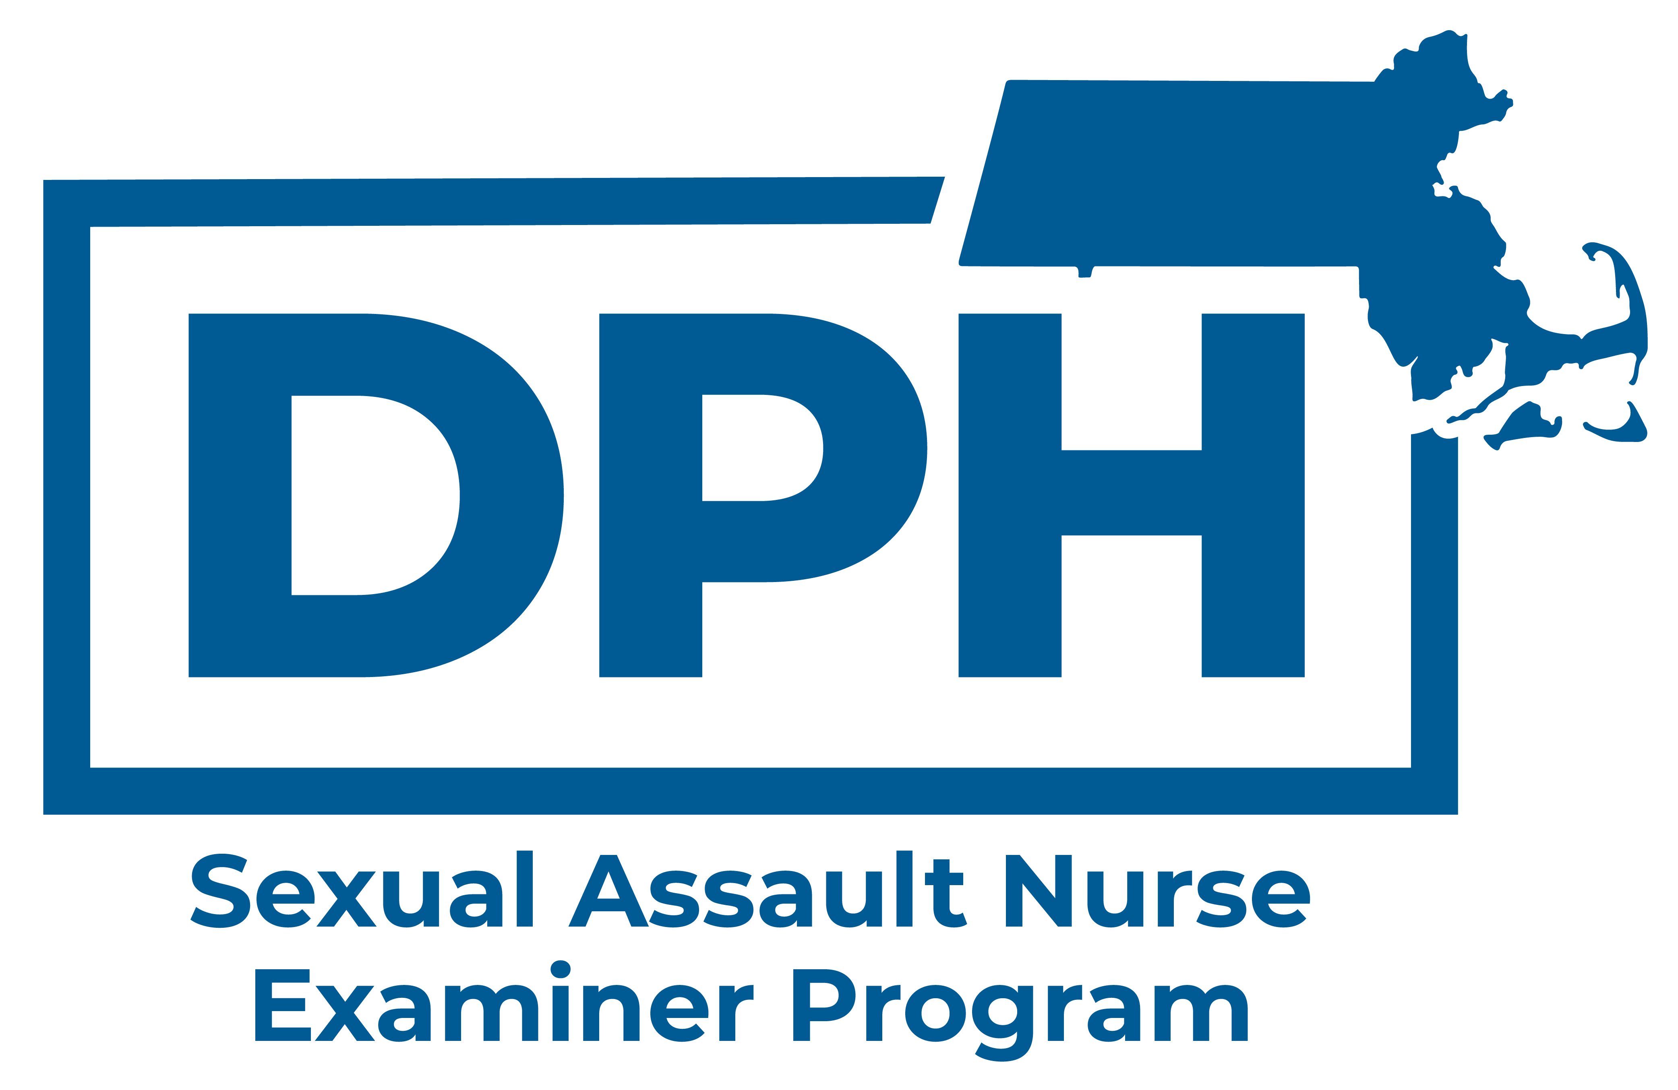

If you have been sexually assaulted, you may have questions about your options. The Massachusetts Sexual Assault Nurse Examiner (SANE) Program and Rape Crisis Centers across the state are here to help.
What is sexual assault?
Sexual assault is any type of sexual contact or behavior that occurs without consent. Sexual assault happens when a person is forced, coerced, pressured, or manipulated into any unwelcome sexual activity.
When and where should I get medical care?
If possible, seek medical care in a hospital Emergency Department as soon as you can. The sooner you get there after the assault, the more options you may have. You have the right to get medical care after a sexual assault without reporting anything to the police.
What medical care should I get?
- You can choose to receive ANY of the following:
  - A general physical exam to check for injuries and address any other health concerns.
  - Medications to help prevent pregnancy (if you are a person who can become pregnant).
  - Testing for and medications to help reduce the risk of sexually transmitted infections (STIs) such as gonorrhea, chlamydia, and HIV.
  - A forensic exam with evidence collection (this is a detailed head-to-toe exam looking for any possible injuries or physical evidence that may be found on your body after a sexual assault).
- For adult and adolescent patients, time-sensitive evidence collection can be done up to five days (120 hours) after the assault, whether or not you decide to report your assault to the police.
- A forensic exam could also include toxicology testing (urine and/or blood) for substances that you may have taken, or that were given to you without your knowledge/consent, related to your sexual assault.
For more information about forensic exams and evidence collection, scan the QR code

Will I have to pay for my medical care?
- If you receive care in an emergency department, the costs for your hospital care can be covered by a program called Victim Compensation.
- If you want, you may choose to use your health insurance, but you are not required to use it for this care.
- The hospital cannot bill you directly or charge you a co-pay for your care related to sexual assault.

What is a MA Sexual Assault Nurse Examiner (MA SANE)? And how can they help me?
- A MA SANE is a clinician (nurse, nurse practitioner, nurse midwife, or doctor) who has specialized training from the MA Department of Public Health (DPH) to provide sexual assault exams and forensic evidence collection.
- MA SANEs are independent clinicians who work for DPH. They do not work for law enforcement. They will keep your information confidential. However, if you choose to report your assault, the SANE or the Rape Crisis advocate can help you do that.
Where can I go to get care from a MA SANE?
MA SANEs care for patients in many of the hospitals across Massachusetts. You can find the SANE hospital closest to you here: mass.gov/sane
What is a Rape Crisis Advocate? And how can they help me?
A Rape Crisis Advocate (“advocate”) is a person who has been trained to provide support and information to someone who has been sexually assaulted — no matter how long ago the assault happened. You have the right to have an advocate if you would like and the hospital should call an advocate whenever a person who has been sexually assaulted comes in for care. They can be a support to you whether or not you choose a forensic exam.

