Guidance for Providers Required to Report on Covid-19 Enhanced Payments

On March 30, 2020 EOHHS announced a 10% provider enhancement based on average monthly billing (October-December) for Tier 1 and Tier 2 contracted providers. The first payments were issued in April (March payment) and paid monthly for the months of March, April, May and June.

Applicable providers: Certain Purchase of Service (POS) program providers and certain MassHealth Home and Community Based Services Waiver providers that contract with the Executive Office of Health and Human Services (EOHHS) and its agencies who were
continuing to serve members and clients during the COVID-19 state of emergency. These providers included:
Tier | Provider(s)
Tier 1 | - Residential Services (i.e. DDS, DCF, DMH, DYS, DPH)
Tier 2 | - In home services, Elder homecare, Family Support, and other health and human services providers delivering essential services to keep members/clients safe in their homes or residences and out of the hospital

In April as to mitigate surge expenses, EOHHS’ agencies increased the monthly enhancement for Tier 1 residential service providers for the months of May and June by an additional 15% for a total enhancement payment of 25% on average monthly billing (October-December). This additional enhancement was required to be spent on surge related expenses across the residential service system.

The following guidance should be used to complete the attached reporting on the 10% and 15% enhances payment. All providers that received these payments are required to complete the report.

At this time, EOHHS is not requiring back-up documentation to reported costs, but providers should be prepared to produce, invoices, payroll records and other documentation to support reported expenses as requested by EOHHS.

Reports must be submitted to EOHHSProviderCovidCost@mass.gov November 30, 2020 from the email address of the individual who has signatory authority to certify the report. This is the person listed in cell A28 on the EOHHS Spending Report Summary tab.

Please submit all questions to EOHHSProviderCovidCost@mass.gov.

EOHHS Spending Report Summary tab

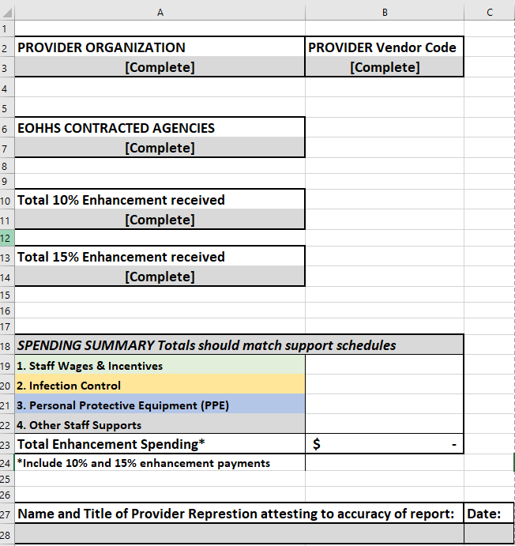

A3-Enter legal name of Provider

B3- Enter Commonwealth Vendor Code

A7- Enter list of EOHHS Agencies from which your organization received enhancement payments.

A11- Enter total amount of 10% enhancement payment received from all EHS sources.

A14- Enter total amount of 15% enhancement payment received from all EHS sources.

B19-B22- Enter total from corresponding detailed tab for each category support schedule.

A28-A29- Enter name of provider representation authorized to attest to report accuracy.

1. Staff Wages & Incentives
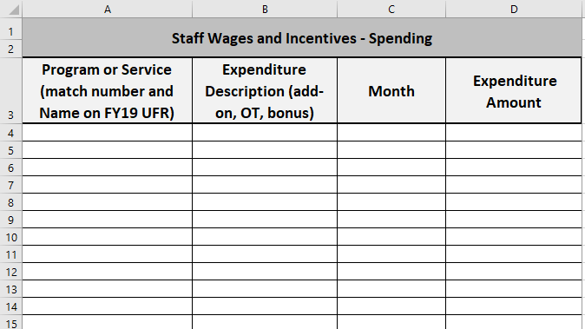

By month, enter the expenditures for each provider program for which you incurred Covid related staffing expense. Enter the description of the type of expense (e.g., wage differential add-on, over-time, signing bonus, additional direct care staffing).

2. Infection Control
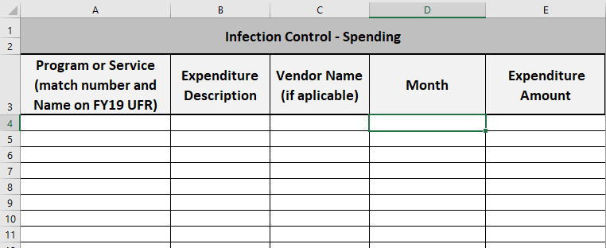

By month, enter the expenditures for each provider program for which you incurred Covid related infection control expense. Enter the description of the type of expense (e.g., site cleaning for prevention, site cleaning after an infection, staff testing and staff or client screening) and the vendor from with the services were purchased.

3. PPE
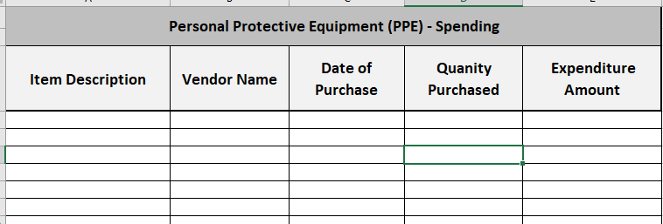

By item, enter the expenditures for each PPE item purchased. Enter the name of the vendor, quality and date purchased.

4. Other Covid Expenses
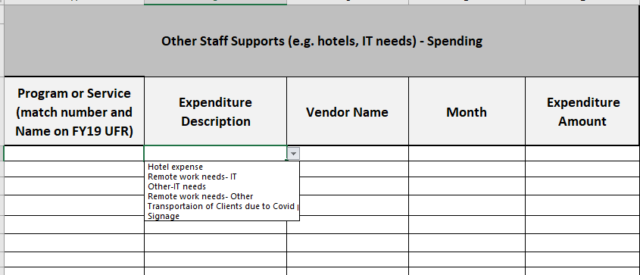

By month, enter the expenditures for each provider program for which you incurred Covid related expense that do not fall under staffing/wages, Infection Control or PPE. Enter the description of the type of allowable expense via the dropdown menu and the vendor from with the services were purchased.

