**INDOOR AIR QUALITY ASSESSMENT**

**Enoch Cobb Early Learning Center**

**and Kindergarten**

**549 West Main Street**

**Hyannis, Massachusetts**

Exterior view
Enoch Cobb Early Learning Center
and Kindergarten
549 West Main Street
Hyannis, Massachusetts


Prepared by:

Massachusetts Department of Public Health

Bureau of Environmental Health

Indoor Air Quality Program

February 2019

# BACKGROUND

|  |  |
| --- | --- |
| Building: | Enoch Cobb Early Learning Center and Kindergarten |
| Address: | 549 West Main Street, Hyannis, MA |
| Assessment Requested by: | Barnstable Public Schools (BPS) |
| Reason for Request: | Collaborative effort to perform general indoor air quality (IAQ) assessments throughout the Barnstable School District. |
| Date of Assessment: | January 25, 2019 |
| Massachusetts Department of Public Health/Bureau of Environmental Health (MDPH/BEH) Staff Conducting Assessment: | Cory Holmes, Environmental Inspector, IAQ Program accompanied by Michael Lambros, Deputy Director of Facilities, BPS |
| Date of Building Construction: | 2016 |
| Building Description: | Single-story, flat-roofed modular construction. |
| Windows: | Openable |

# METHODS

Please refer to the IAQ Manual and appendices for methods, sampling procedures, and interpretation of results (MDPH, 2015).

# RESULTS and DISCUSSION

The following is a summary of indoor air testing results (Table 1).

* ***Carbon dioxide*** levels were above the MDPH recommended level of 800 parts per million (ppm) in two-thirds of the areas surveyed, which indicates a lack of air exchange at the time of assessment. This is most likely due to the operation of mechanical ventilation components as well as limitations on outside air introduction, which is typical during winter months and explained further in the Ventilation section of this report.
* ***Temperature*** was within or close to the MDPH recommended range of 70°F to 78°F at the time of assessment.
* ***Relative humidity*** was below the MDPH recommended range of 40 to 60% in all areas tested the day of assessment, which is typical of conditions during the heating season.
* ***Carbon monoxide*** levels were non-detectable (ND) in all areas tested.
* ***Particulate matter (PM2.5)*** concentrations measured were below the National Ambient Air Quality (NAAQS) level of 35 μg/m3 in all areas tested.

## Ventilation

A heating, ventilating and air conditioning (HVAC) system has several functions. First it provides heating and, if equipped, cooling. Second, it is a source of fresh air. Finally, an HVAC system will dilute and remove normally-occurring indoor environmental pollutants by not only introducing fresh air, but by filtering the airstream and ejecting stale air to the outdoors via exhaust ventilation. Even if an HVAC system is operating as designed, point sources of respiratory irritation may exist and cause symptoms in sensitive individuals.

The heating, ventilation and air conditioning (HVAC) system is provided by rooftop air handling units (AHUs, Picture 1). Fresh air is drawn through intake vents on the AHUs and ducted to ceiling-mounted supply diffusers (Picture 2). By design, diffusers are equipped with fixed louvers that direct air along the ceiling to flow down the walls and create airflow. Air returns to the AHUs through ceiling or wall-mounted return vents (Picture 3) via ductwork.

At the time of assessment, digital thermostats (Picture 4) were set to fan “auto” which deactivates the HVAC system once the temperature set point is met (Picture 1). While the system is deactivated, no outside air is introduced or circulated. The BEH/IAQ Program recommends that thermostats be set to the fan “on” setting during occupied periods to provide continual air circulation and filtration. It is also important to note that outside air is typically limited (by pneumatically adjusting intake louvers) during cold/winter months to provide comfort and prevent the freezing of pipes, which can result in flooding/mold issues.

Without adequate supply and exhaust ventilation, excess heat and environmental pollutants can build up and lead to indoor air/comfort complaints. To maximize air exchange, the IAQ program recommends that both supply and exhaust ventilation operate continuously during periods of occupancy. In order to have proper ventilation with a mechanical ventilation system, the systems must be balanced after installation to provide an adequate amount of fresh air to the interior of a room while removing stale air from the room. It is recommended that HVAC systems be re-balanced every five years to ensure adequate air systems function (SMACNA, 1994).

## Microbial/Moisture Concerns

No water-damaged building materials were observed at the time of assessment.

## Other Conditions

Exposure to low levels of total volatile organic compounds (TVOCs) may produce eye, nose, throat, and/or respiratory irritation in some sensitive individuals. BEH/IAQ staff examined rooms for products containing VOCs. BEH/IAQ staff noted hand sanitizers, scented products, cleaners, and dry erase materials in use within the building. These products have the potential to be irritants to the eyes, nose, throat, and respiratory system of sensitive individuals.

The MDPH recommends pleated filters with a Minimum Efficiency Reporting Value (MERV) of 8, which are adequate in filtering out pollen and mold spores (ASHRAE, 2012). Filters should also be changed two to four times a year, or per the manufacturer’s recommendations.

Area rugs were observed in many classrooms (Table 1), some areas have carpet squares. Carpets should be cleaned annually (or semi-annually in soiled/high traffic areas) in accordance with Institute of Inspection, Cleaning and Restoration Certification (IICRC) recommendations, (IICRC, 2012). Regular cleaning with a high efficiency particulate air (HEPA) filtered vacuum in combination with an annual cleaning will help to reduce accumulation and potential aerosolization of materials from carpeting. Area carpets too worn to be effectively cleaned should be replaced. Area rugs should be rolled up and stored in a clean, dry place when rooms are not occupied during the summer months to prevent moistening due to condensation.

Note that the Environmental Protection Agency (EPA) conducted a National School Radon Survey in which it discovered nearly one in five schools had “…at least one frequently occupied ground contact room with short-term radon levels above 4 [picocuries per liter] pCi/L” (US EPA 1993). The BEH/IAQ Program therefore recommends that every school be tested for radon, and that this testing be conducted during the heating season while school is in session in a manner consistent with USEPA radon testing guidelines. Radon measurement specialists and other information can be found at [www.nrsb.org](http://www.nrsb.org) and <http://aarst-nrpp.com/wp>, with additional information at: <http://www.mass.gov/eohhs/gov/departments/dph/programs/environmental-health/exposure-topics/iaq/radon>.

# RECOMMENDATIONS

In view of the findings at the time of the visit, the following recommendations are made:

1. Operate the HVAC system to provide for *continuous* fresh air ventilation during occupied hours.
2. Use openable windows to supplement fresh air during temperate weather. Ensure all windows are closed tightly at the end of each day.
3. Consider closing classroom doors during occupancy to allow for more effective function of exhaust vents.
4. Consider adopting a balancing schedule of every 5 years for all mechanical ventilation systems, as recommended by ventilation industrial standards (SMACNA, 1994).
5. Reduce or eliminate the use of air fresheners, scented cleaners, hand sanitizers and dry erase materials to reduce irritation.
6. Change filters in HVAC units at least twice a year with MERV 8 or higher filters.
7. For buildings in New England, periods of low relative humidity during the winter are often unavoidable. Therefore, scrupulous cleaning practices should be adopted to minimize common indoor air contaminants whose irritant effects can be enhanced when the relative humidity is low. To control for dusts, a high efficiency particulate arrestance (HEPA) filter equipped vacuum cleaner in conjunction with wet wiping of all surfaces is recommended. Avoid the use of feather dusters. Drinking water during the day can help ease some symptoms associated with a dry environment (throat and sinus irritations).
8. Clean carpeting and rugs at least once per year according to IICRC recommendations (IICRC 2012). Area carpets too worn to be effectively cleaned should be replaced. Roll up and store are rugs in a clean, dry place during the summer.
9. Continue to utilize the US EPA’s (2000), “Tools for Schools”, as an instrument for maintaining a good IAQ environment in the building available at: <http://www.epa.gov/iaq/schools/index.html>.
10. The school should be tested for radon by a certified radon measurement specialist during the heating season when school is in session. Radon measurement specialists and other information can be found at: [www.nrsb.org](http://www.nrsb.org/), and <http://aarst-nrpp.com/wp>.
11. Refer to resource manuals and other related IAQ documents for further building-wide evaluations and advice on maintaining public buildings. Copies of these materials are located on the MDPH’s website: <http://mass.gov/dph/iaq>.

# REFERENCES

ASHRAE. 2012. American Society of Heating, Refrigeration and Air Conditioning Engineers (ASHRAE) Standard 52.2-2012 -- Method of Testing General Ventilation Air-Cleaning Devices for Removal Efficiency by Particle Size (ANSI Approved). 2012.

IICRC. 2012. Institute of Inspection Cleaning and Restoration Certification. Institute of Inspection, Cleaning and Restoration Certification. Carpet Cleaning: FAQ.

MDPH. 2015. Massachusetts Department of Public Health. Indoor Air Quality Manual: Chapters I-III. Available at: <http://www.mass.gov/eohhs/gov/departments/dph/programs/environmental-health/exposure-topics/iaq/iaq-manual/>.

SMACNA. 1994. HVAC Systems Commissioning Manual. 1st ed. Sheet Metal and Air Conditioning Contractors’ National Association, Inc., Chantilly, VA.

US EPA. 1993. Radon Measurement in Schools, Revised Edition. Office of Air and Radiation, Office of Radiation and Indoor Air, Indoor Environments Division (6609J). EPA 402-R-92-014. <https://www.epa.gov/sites/production/files/2014-08/documents/radon_measurement_in_schools.pdf>

US EPA. 2000. Tools for Schools. Office of Air and Radiation, Office of Radiation and Indoor Air, Indoor Environments Division (6609J). EPA 402-K-95-001, Second Edition. <http://www.epa.gov/iaq/schools/index.html>.

**Picture 1**

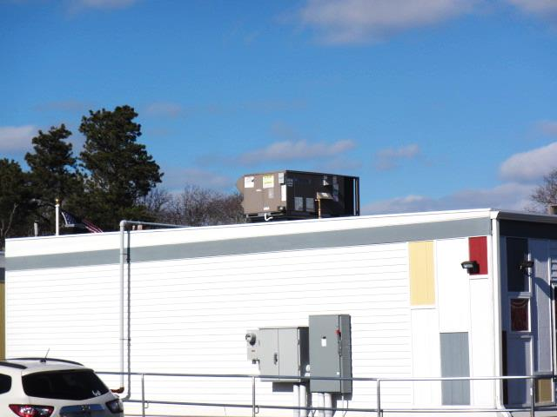

**Rooftop air handling unit (AHU)**

**Picture 2**

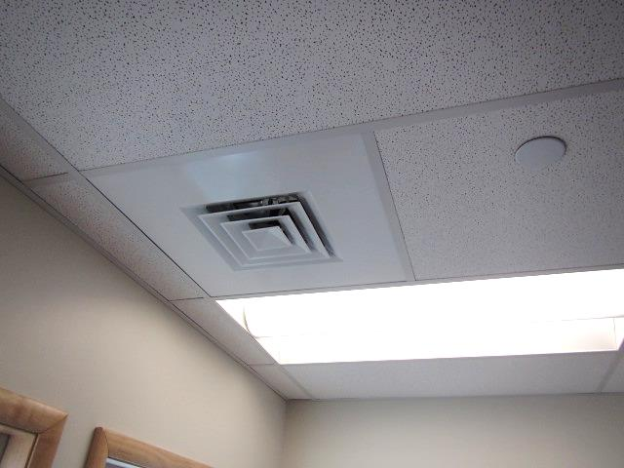

**Ceiling-mounted supply diffuser**

**Picture 3**

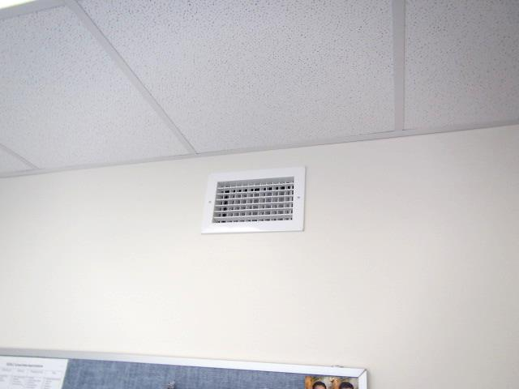

**Wall-mounted return vent**

**Picture 4**

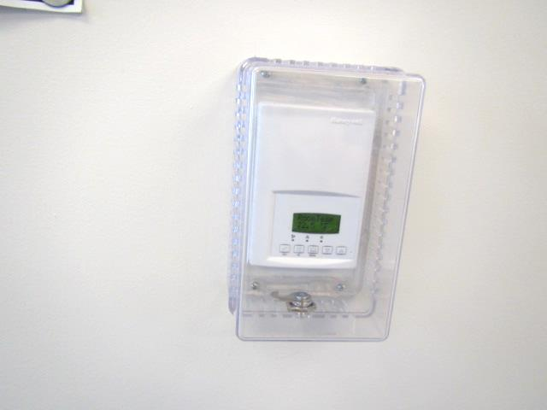

**Digital thermostat for HVAC system**

| **Location** | **Carbon**  **Dioxide**  **(ppm)** | **Carbon Monoxide**  **(ppm)** | **Temp**  **(°F)** | **Relative**  **Humidity**  **(%)** | **PM2.5**  **(µg/m3)** | **Occupants**  **in Room** | **Windows**  **Openable** | **Ventilation** | | **Remarks** |
| --- | --- | --- | --- | --- | --- | --- | --- | --- | --- | --- |
| **Supply** | **Exhaust** |
| Background (outside) | 393 | ND | 46 | 29 | 7 |  |  |  |  | Clear, cold, sunny, day after heavy rain |
| 1 | 910 | ND | 72 | 27 | 4 | 5 | Y | Y | Y | DO, area rug |
| 2 | 695 | ND | 71 | 24 | 5 | 1 | Y | Y | Y | DO, area rug |
| 4 | 845 | ND | 72 | 28 | 5 | 2 | Y | Y | Y | DO, area rug |
| 7 | 836 | ND | 72 | 27 | 4 | 5 | Y | Y | Y | DO, area rug |
| 24 | 704 | ND | 69 | 27 | 5 | 0 | Y | Y | Y |  |
| 25 | 1053 | ND | 70 | 31 | 6 | 0 | Y | Y | Y | Area rug |
| 28 | 810 | ND | 67 | 30 | 4 | 0 | Y | Y | Y |  |
| 30 | 790 | ND | 67 | 32 | 4 | 0 | Y | Y | Y | Carpet squares |
| Conference room | 830 | ND | 68 | 29 | 4 | 0 | Y | Y | Y |  |