WATER DAMAGE/MOLD INVESTIGATION

Enoch Cobb Early Learning Center
and Kindergarten
549 West Main Street
Hyannis, Massachusetts

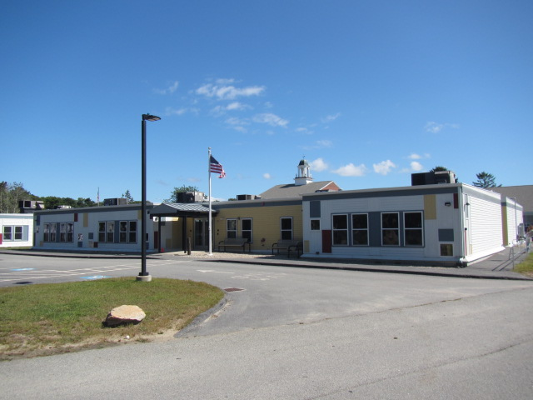

Prepared by:
Massachusetts Department of Public Health
Bureau of Environmental Health
Indoor Air Quality Program
October 2019

BACKGROUND
Building: | Enoch Cobb Early Learning Center and Kindergarten (ECELC)
Address: | 549 West Main Street, Hyannis, MA
Assessment Requested by: | Michael Lambros, Deputy Director of Facilities, Barnstable Public Schools (BPS)
Reason for Request: | Mold/water damage concerns
Date of Assessment: | September 17, 2019
Massachusetts Department of Public Health/Bureau of Environmental Health (MDPH/BEH) Staff Conducting Assessment: | Cory Holmes, Environmental Inspector, Indoor Air Quality (IAQ) Program.

Background and Discussion
The MDPH/IAQ Program was asked to examine remediation efforts from a pin-hole pipe leak in Room 8 of the ECELC. At the time of assessment, water had been shut off and the majority of water-damaged materials including a wooden cabinet, gypsum wallboard and insulation, had been removed (Picture 1). MDPH/IAQ Program staff noted dark staining indicating water damage/mold growth on particleboard flooring (Picture 1). Light surface mold was also observed on wooden framework (Pictures 1 and 2). Given these conditions the particleboard should be removed and replaced. The wooden framing can be lightly sanded and cleaned to remove any mold growth.
The US Environmental Protection Agency (US EPA) and the American Conference of Governmental Industrial Hygienists (ACGIH) recommends that porous materials (e.g., wallboard, carpeting) be dried with fans and heating within 24 to 48 hours of becoming wet (US EPA, 2008; ACGIH, 1989). If porous materials are not dried within this time frame, mold growth may occur. Wood is a semi-porous material; site-specific conditions determine if it needs to be removed or can be cleaned.

Conclusions/Recommendations
Based on the observations made during the visit, the following recommendations were made at the time of the visit and are reiterated below. In addition, subsequent to the MDPH/IAQ visit, it was reported that the BPS is planning to work with a professional flooding/water damage specialist to conduct remediation.
- Any remediation should be conducted in accordance with the US EPA’s “Mold Remediation in Schools and Commercial Buildings”, available at: http://www.epa.gov/mold/mold-remediation-schools-and-commercial-buildings-guide.
- Remove/replace water-damaged particleboard flooring and any remaining gypsum wallboard and insulation material (items should be placed in plastic bags for transport).
- Lightly sand any visible mold growth off the surface of wooden framing, clean thoroughly, and allow to dry. Workers need to wear proper protective equipment during this process.
- When performing activities that may generate large amounts of airborne dust/debris, seal off area (if possible) and deactivate HVAC system (or seal vents).
- Confirm leaks are fully repaired/properly insulated (if needed) prior to closing wall.
- Operate/flush out the HVAC system and change filters prior to reoccupancy. The MDPH recommends pleated filters with a Minimum Efficiency Reporting Value (MERV) of 8, which are adequate in filtering out pollen and mold spores (ASHRAE, 2012).
- Once remediation activities are concluded, clean all items and surfaces with a high efficiency particulate arrestance (HEPA) filter equipped vacuum cleaner combined with wet wiping prior to reoccupation.
- Refer to resource manuals and other related IAQ documents for further building-wide evaluations and advice on maintaining public buildings. Copies of these materials are located on the MDPH’s website: http://mass.gov/dph/iaq.

REFERENCES
ACGIH. 1989. Guidelines for the Assessment of Bioaerosols in the Indoor Environment. American Conference of Governmental Industrial Hygienists, Cincinnati, OH.
ASHRAE. 2012. American Society of Heating, Refrigeration and Air Conditioning Engineers (ASHRAE) Standard 52.2-2012 -- Method of Testing General Ventilation Air-Cleaning Devices for Removal Efficiency by Particle Size (ANSI Approved).
US EPA. 2008. Mold Remediation in Schools and Commercial Buildings. US Environmental Protection Agency, Office of Air and Radiation, Indoor Environments Division, Washington, D.C. EPA 402-K-01-001. http://www.epa.gov/mold/mold-remediation-schools-and-commercial-buildings-guide.

Picture 1
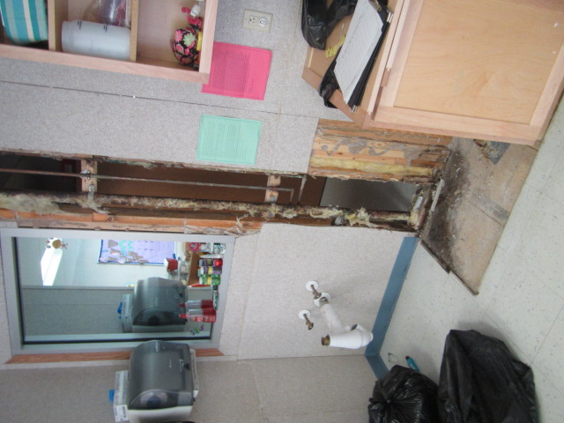
Area of leak in Room 8, note dark staining on floor indicating water damage/mold growth on particle board
Picture 2
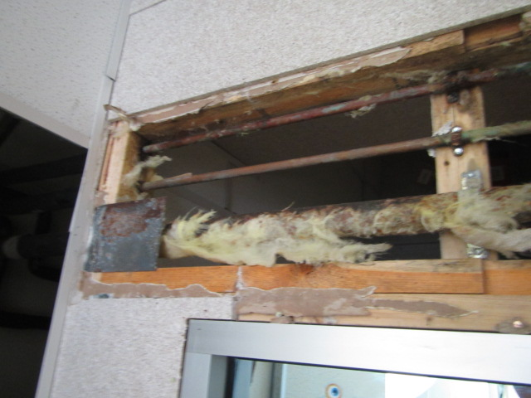
Leaking pipe, which was subsequently replaced

