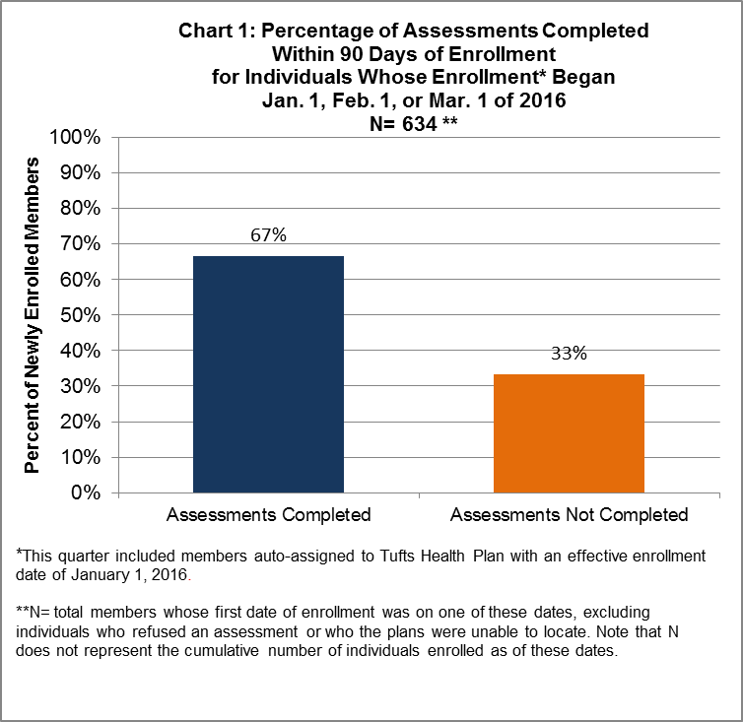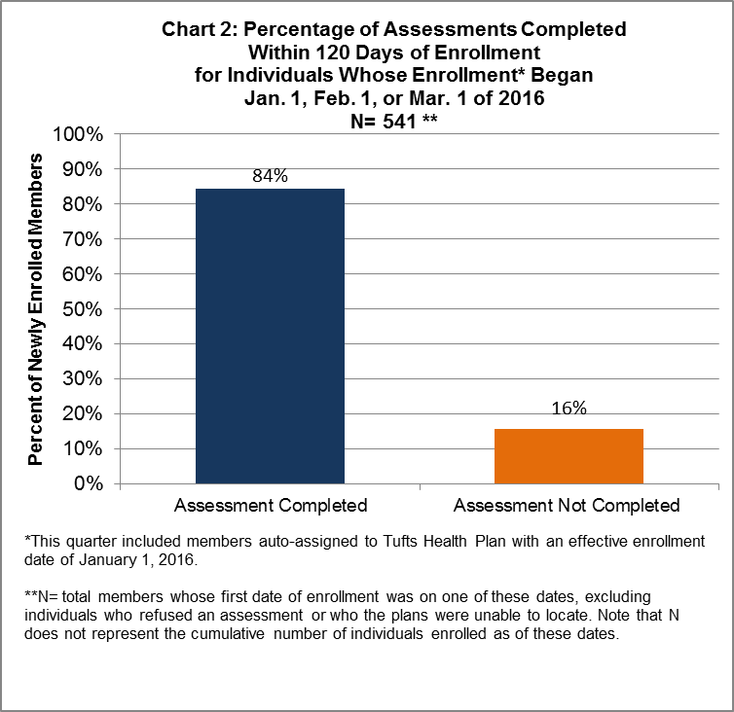
Chart 1 shows how One Care plans are performing with respect to the Core 2.1 measure from the demonstration reporting requirements. The Centers for Medicare & Medicaid Services (CMS) requires Medicare-Medicaid Plans participating in all capitated model demonstrations under the Financial Alignment Initiative to regularly report core measures, including Core 2.1.
The Core 2.1 measure tracks how many One Care members have had a comprehensive assessment within 90 days of their enrollment effective date into a One Care plan. This measure is cumulative based on monthly data submissions from the One Care plans, and for the period covered in this report includes members who enrolled as of January 1, February 1, or March 1 of 2016. The measure excludes members who were unwilling to participate in an assessment or who did not respond to at least three attempts to contact them (“unable to locate”). The Core reporting requirements document, including the specifications for the Core 2.1 measure, are posted on the MMCO website: http://www.cms.gov/Medicare-Medicaid-Coordination/Medicare-and-Medicaid-Coordination/Medicare-Medicaid-Coordination-Office/FinancialAlignmentInitiative/InformationandGuidanceforPlans.html This graph shows that 67% of members who enrolled in One Care during this time period, who the plan was able to locate, and who agreed to participate in an assessment, received a comprehensive assessment within 90 days of their first effective date of enrollment.
While it is not a measure required by CMS, Chart 2 shows how many members were assessed within 120 days. Note that because some members may choose to disenroll between their 90th and 120th day of enrollment (between their 3rd and 4th months), the total number of enrolled individuals (the denominator) is lower in Chart 2 than it is in Chart 1. Chart 2 demonstrates that One Care plans have continued to conduct assessments for members between their 90th and 120th day of enrollment; 84% of One Care members who enrolled during this time frame were assessed within 120 days (compared to 67% who were assessed within 90 days).
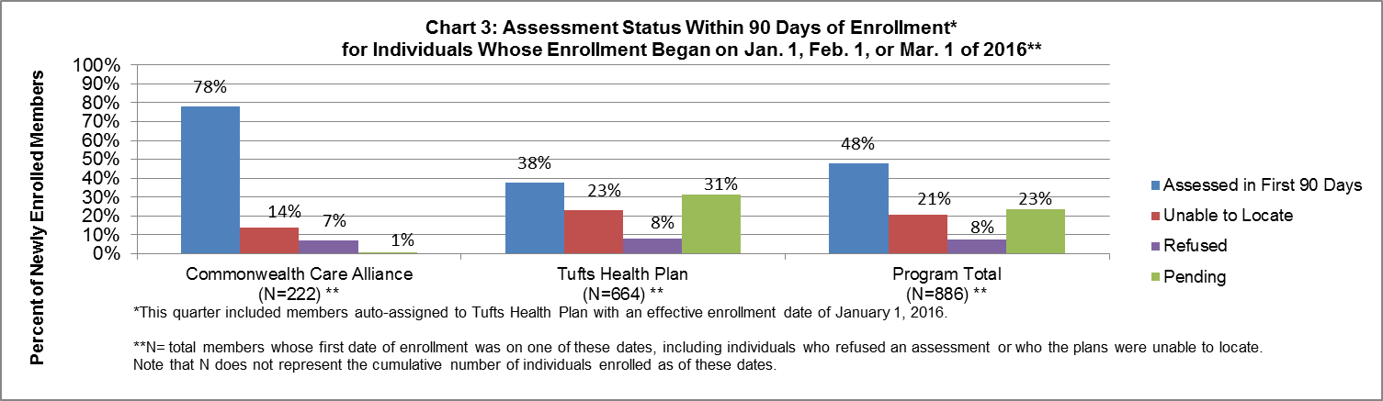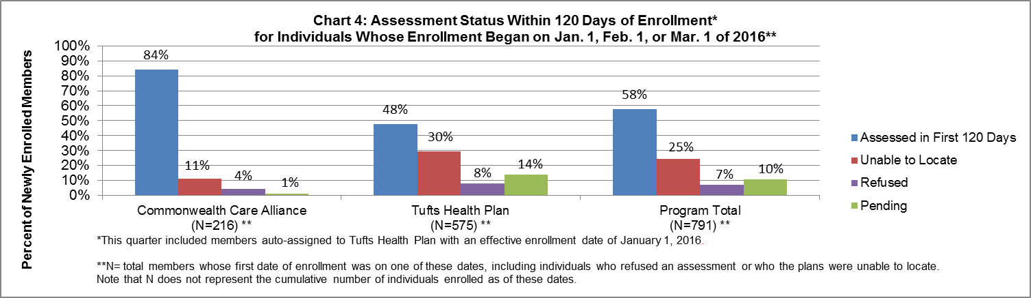
Charts 3 and 4 show the percentage of assessments completed out of the total number of One Care members with an enrollment date of January 1, February 1, or March 1 of 2016, including individuals who refused to participate in an assessment and members the plans were unable to locate (members who did not respond after three or more attempts to contact them). Charts 3 and 4 also break these percentages out by plan. The “pending” category includes members who have not yet had an assessment within 90 days or have not refused an assessment, and who the plan may have scheduled for an assessment. As with Charts 1 and 2, the number of enrolled members in Chart 4 is lower than in Chart 3 due to members who disenrolled between their 90th and 120th day of enrollment.
For example, Chart 3 shows that for members with January, February, or March 2016 effective enrollment dates, Commonwealth Care Alliance conducted assessments with 78% of those members within 90 days; made at least 3 outreach attempts to 14% of those members and did not receive a response; and received refusals from 7% of those members. In total, the plan met its contractual requirements for approximately 99% of members while approximately 1% of those members were in the “pending” category.
The charts show variation between each of the two plans in the number of members who were newly enrolled during this period (identified in the chart as “N”), and the status of members’ assessment completions. Note that this period includes members who were enrolled through auto-assignment to Tufts Health Plan effective January 1, 2016. These charts also show that the two One Care plans had members they were unable to locate with at least three contact attempts, although the actual numbers and percentages vary.
Chart 4 again demonstrates that the number of completed assessments increases by 120 days of enrollment, while the number of members whose assessments have been pending decreases. Tufts Health Plan experienced the largest increase in completed assessments, from 28% to 48%, with many members moving from the “pending category” to the assessed category. Note that an increase in the percentage of members who the plan was unable to locate indicates that the plan attempted to contact a member who was previously in the pending category, but the member did not respond to at least three attempts to contact them. One Care plans are expected to continue outreach to members they are unable to locate by attempting to contact them at least once every three months.

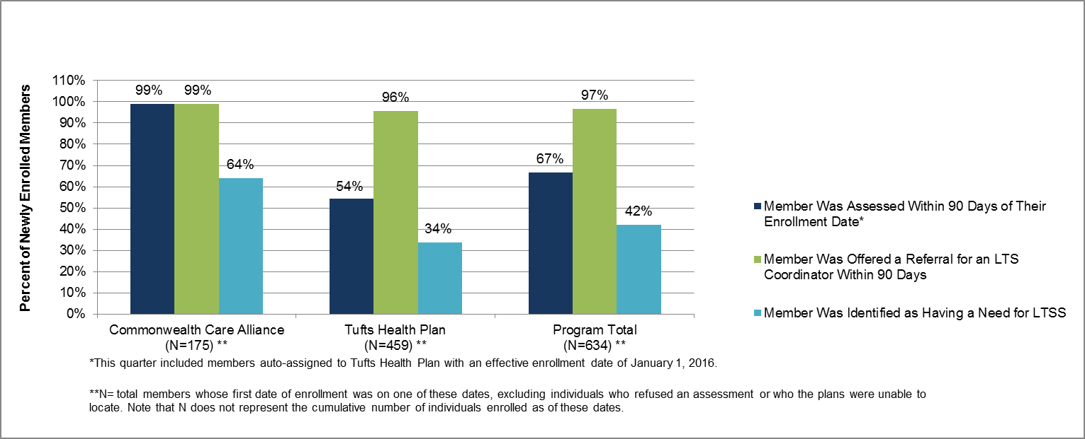 Chart 5 shows how many members whose effective enrollment dates were January 1, February 1, or March 1 of 2016 (the denominator for each column), received a comprehensive assessment within 90 days; how many were determined by the plan to be in need of LTSS; and how many members were offered a referral for an LTS For example, this chart shows that for members with January, February or March 2016 effective enrollment dates: Commonwealth Care Alliance assessed 99% of those members who they could locate and agreed to participate in an assessment within 90 days; Commonwealth Care Alliance reported offering a referral for an LTS Coordinator to 99% of those members; and 64% of those members were identified as having a need for LTSS.
Chart 5: Assessment Completion, Identified Long-Term Services and Supports (LTSS) Needs, and
Offering of a Referral for a Long-Term Supports (LTS) Coordinator Within 90 Days of Enrollment*
for Individuals Whose Enrollment Began Jan. 1, Feb. 1, or Mar. 1 of 2016**

The percentage of members who are offered a referral for an LTS Coordinator may actually be slightly higher than the percentage of those who received an assessment. For example, Tufts assessed 250 of the new members who they were able to locate within 90 days, all of whom were offered a referral for an LTS Coordinator. Tufts was also able to offer a referral for an LTS Coordinator to an additional 189 members for whom Tufts had not yet done a full assessment (or who may have refused an assessment), resulting in a percentage of 96% (where the total number of members whose first date of enrollment was during this time period, (excluding individuals who refused an assessment or who the plans were unable to locate), (459) is the denominator and the total number of members who were offered a referral for an LTS Coordinator (439) is the numerator).
The One Care plans are contractually required to offer a referral for an LTS Coordinator to all of their enrollees when they make contact with them (including members who may not yet have had an assessment or who they’ve spoken to but the member refused the assessment). In this time period, the number of people who were offered a referral for an LTS Coordinator was significantly higher than the number of people identified as having a need for LTSS. Members who initially decline a referral for an LTS Coordinator may request one at any time.
Note that enrollment in Chart 5 (the denominator) excludes members who were unwilling to participate in an assessment or who the plans were unable to locate, as with Charts 1 and 2.

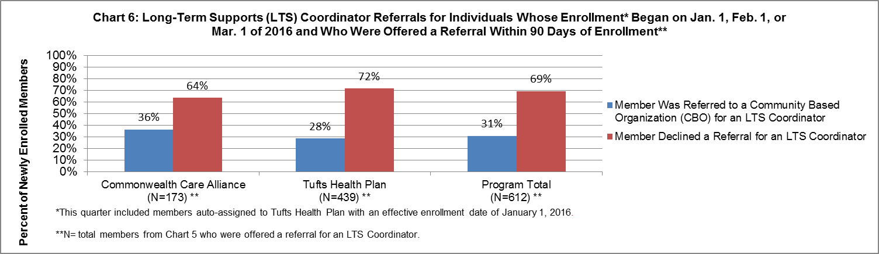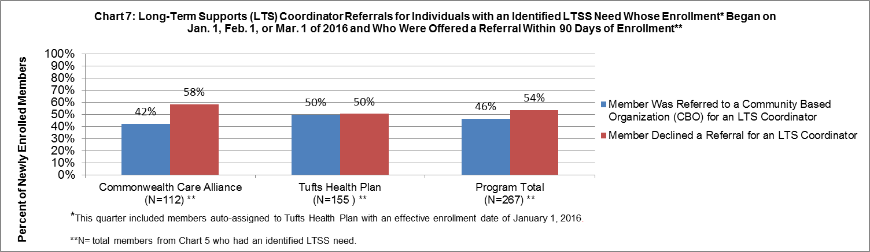
Chart 6 shows how many members, of the total who were offered a referral for an LTS Coordinator, either declined the offer of a referral or accepted and were subsequently referred to a Community Based Organization (CBO). Chart 7 shows how many of the members with an identified need for LTSS (Chart 5) either declined the offer of a referral for an LTS Coordinator, or accepted and were subsequently referred to a CBO.
As might be expected, these charts demonstrate that acceptance of a referral for an LTS Coordinator is much higher among individuals with an identified LTSS need, though some individuals with identified LTSS needs chose not to have a referral for an LTS Coordinator. It is important to understand that choosing not to receive a referral for an LTS Coordinator does not mean the member is not receiving LTSS. This chart is only looking at a member’s choice to accept a referral to an LTS Coordinator or not, and does not indicate receipt of LTSS.

The need for LTSS may be identified by the assessment, by the enrollee, by other Interdisciplinary Care Team (ICT) members, or by any other party as identified in Section 2.5C (4)(g) of the three-way contract: - At any time at an Enrollee’s request; - During Comprehensive Assessments for all Enrollees in C3 and F1 Rating Categories, and for all Enrollees in any Rating Category who request it; - When the need for community-based LTSS is identified by the Enrollee or ICT; - If the Enrollee is receiving targeted case management, is receiving rehabilitation services provided by the Department of Mental Health, or has an affiliation with any state agency; or - In the event of a contemplated admission to a long-term care facility
In One Care, all members who choose to have an LTS Coordinator are referred to an independent Community Based Organization (CBO) that is contracted with the member’s One Care plan to provide the plan’s members with LTS Coordinator services. This chart does not reflect how many members who were referred to the CBO actually met with an LTS Coordinator.

