

Environmental and Health Concerns in the Greendale Area of Worcester

Worcester, MA

April 2012

Bureau of
Environmental Health,
Community Assessment
Program

Massachusetts
Department Of
Public Health

TABLE OF CONTENTS

SUMMARY 1
I. Background and Statement of Issues 2
II. Environmental Concerns 3
III. The Incidence of Asbestos-Related Cancers in Census Tract 7301 6
IV. The Incidence of Other Cancers of Concern in Census Tract 7301 9
V. Non-Cancer Health Concerns 10
VI. Discussion 10
VII. Conclusions 12
VIII. Recommendations 13
IX. Public Health Action Plan 13
X. References 14
Tables 15
Figures 18
Appendix A 21

SUMMARY

Introduction: | This health consultation was conducted because a resident of Worcester contacted the Massachusetts Department of Public Health (MDPH) with concerns about cancer and other diseases and alleged historical dumping of asbestos and other chemicals at or near the Vellumoid facility located at 54 Rockdale Street in Worcester, MA.
Conclusion: | MDPH concludes that there is no unusual pattern of cancer incidence for the neighborhood closest to the Vellumoid facility (census tract 7301) for the types of cancer evaluated. Based on a review of available Massachusetts Department of Environmental Protection (MassDEP) files, MDPH found no information on improper disposal of asbestos on or near the Vellumoid property. MDPH reported that a groundwater plume from a historical oil release from a leaking underground storage tank on the Vellumoid property is contained within the Vellumoid property and should be closely monitored so as not to affect nearby residents.
Basis for Decision: | Cancer incidence rates from 2002-2006 for cancers of the lung/bronchus and kidney/renal pelvis as well as mesothelioma and multiple myeloma were approximately at or below expected rates in census tract 7301 and the city of Worcester. According to the MassDEP, they have no information in their records of improper disposal or burning of asbestos-containing materials at the Vellumoid property. Measures have been taken by a contractor to Vellumoid, Inc. to address a historical underground fuel leak that has resulted in a groundwater plume of oil; these measures have included paving over the affected area and installing groundwater monitoring wells. Based on a report filed at the MassDEP, the plume of fuel oil contamination is contained within the boundaries of the Vellumoid property. The site continues to be monitored through the Massachusetts Contingency Plan.
Next Steps: | The MDPH will share this report with the MassDEP Central Regional Office to recommend continued close monitoring of the groundwater plume of oil on the Vellumoid property so as to protect nearby residents.
For More Information: | If you have concerns about your health, you should contact  your health care provider. You may also call MDPH at  617-624-5757 with questions regarding this report.

I. Background and Statement of Issues
In October 2009, the Massachusetts Department of Public Health (MDPH), Bureau of Environmental Health (BEH) received a letter from a Worcester resident requesting an evaluation of health and environmental concerns in the “Greendale” area of Worcester, Massachusetts, on behalf of her family and neighbors. Residents’ concerns focused on a company operating in their neighborhood, Vellumoid, Inc. This company is a manufacturer of gasket and sealing materials for a wide variety of applications. The letter requesting assistance also mentioned a number of health concerns that the resident felt may possibly be related to living in the Greendale area, including an old asbestos dump on the Vellumoid property. MDPH/BEH conducted a health consultation to respond to the residents’ concerns.
To address these concerns, MDPH/BEH conducted the following:
- A review of the Massachusetts Department of Environmental Protection’s Bureau of Waste Site Cleanup (MassDEP/BWSC) online database and files pertaining to the Vellumoid facility.
- A review of cancer incidence statistics for the Greendale area (i.e., census tract) for particular types of cancer of interest to the requestor and for types of cancer known to be associated with asbestos exposure (given the concern about possible historical asbestos dumping).
- A discussion of risk factors associated with other health concerns, such as multiple sclerosis, that were mentioned in the request letter.

II. Environmental Concerns
To address the residents’ concerns about possible health impacts from reports of historical dumping and burning of asbestos at the Vellumoid site located at 54 Rockdale Street in Worcester, MDPH/BEH reviewed information available on the MassDEP/BWSC 21E online database and contacted BWSC staff to discuss the residents’ concerns. According to Worcester Registry of Deeds records, Vellumoid’s current facility on Rockdale Street has been in operation since at least 1961. Vellumoid, Inc. produces gaskets for automobiles, trucks, and other miscellaneous sealing applications. Figure 1 shows the location of the Vellumoid facility and the Greendale area of Worcester.
Under Chapter 21E of Massachusetts General Laws (M.G.L. c21E, 310 CRM 40.0000), the statewide hazardous waste program also known as the Massachusetts Contingency Plan (MCP), the MassDEP is authorized to enforce regulations governing the investigation and cleanup of oil and hazardous material releases, known as “21E releases or sites.”
According to documents available on the MassDEP website (http://www.mass.gov/dep/), Vellumoid, Inc. reported an oil leak from an underground storage tank to MassDEP in 1998; the leak of Number 6 fuel oil is suspected to have occurred in the late 1960s or early 1970s. The MassDEP Release Tracking Numbers (RTNs) assigned to the Vellumoid facility are RTN 2-12338 and 2-12996. We were unable to confirm, either through the BWSC’s online database or by contacting MassDEP staff, that asbestos burning and/or dumping occurred in the 1950s on the Vellumoid property; however, this time period was prior to passage of state and federal environmental laws that require reporting these types of activities.
In 1998, in response to the oil leak, a contractor to Vellumoid, Inc., D’Amore Associates, Inc., removed three of the four underground fuel storage tanks present on the property. Contaminated subsurface soil was left in place and the area was paved over to prevent any opportunities for exposure to oil-contaminated soil. The fourth tank was abandoned in place because of its proximity to the building. It should be noted that since the release pertained to Number 6 fuel oil, this soil was tested for petroleum-related chemicals and not for asbestos. [MDPH/BEH was not able to locate any sampling data related to asbestos on the Vellumoid property.]
In 1998, groundwater monitoring wells were put in place around the border of the property and, as a result, a plume of petroleum hydrocarbons (non-aqueous phase liquid or NAPL) was identified in the groundwater in March 2000, near the water table and within Vellumoid’s property boundaries. The depth to groundwater at the site is approximately 8 to 11 feet (Table 1, D’Amore Associate, October 2011). Semi-annual testing of the monitoring wells is now required to assure that the fuel oil in the groundwater will not impact surrounding properties beyond the boundaries of Vellumoid’s property (D’Amore Associates, October 2011).
The southern most boundary of the NAPL plume (that is, the leading edge of the plume) was first characterized by D’Amore Associates, Inc. to be at monitoring well 1 (MW1) and continued to represent the downgradient plume boundary until October 2009. In D’Amore Associates’ October 2009 status report, the configuration of the NAPL plume was reported to have changed; a thin layer of NAPL appeared in MW14, south and farther downgradient of MW1. MW14 is still within the property boundaries of Vellumoid (see Figure 2). This discovery led to the installation of two new onsite perimeter monitoring wells (MW21 and MW22).
As of an October 29, 2011 report by D’Amore Associates, Inc., the contractor reported that the most recent monitoring of groundwater indicated that the plume of No. 6 fuel oil has not impacted surrounding off-property areas (D’Amore Associates, Inc. October 29, 2011). However, because the boundaries of the plume have changed since it was initially characterized in June 2000, D’Amore Associates reported in its May 2011 status report that a pilot test was successfully carried out to plan for a groundwater treatment system should it be necessary to control further migration of the plume. Figure 2 shows the leading edge of the plume as of October 2011. D’Amore Associates reported that the pilot test demonstrated that, if the NAPL plume migrates farther downgradient, in a southerly direction, that a series of chemical oxidation injection wells could be installed to curtail any further movement of the plume. As of the latest status report, D’Amore Associates stated that the groundwater NAPL plume is contained within the boundaries of the Vellumoid property.
The nearest downgradient residential home is approximately 200 feet from the leading edge of the NAPL plume. The consultants did not address, specifically, the likelihood or estimated time it might take for the plume, if untreated, to reach this residence. Weasel Brook, which runs through a culvert along the eastern property line, and the quality of indoor air in a partial basement of a building at the Vellumoid facility are also being evaluated for possible impacts from the NAPL plume. The semi-annual evaluation of Weasel Brook consists of a visual examination of the brook for the presence of an oil sheen. Vellumoid, Inc. is also assessing semi-annually, through its contractor, whether indoor air monitoring of a partial basement on the Rockdale Street side of its facility is warranted, depending on the location of the groundwater plume. To date, no indoor air monitoring has been conducted. Because the depth to groundwater on the Vellumoid property appears to be relatively shallow (approximately 8 to 11 feet), the possibility of the intrusion of vapors from the plume into the indoor air should be carefully monitored. If the plume were to migrate off the Vellumoid property, this potential pathway of exposure would also need to be evaluated to prevent the inhalation of petroleum vapors in indoor air in buildings downgradient of the facility.
The Greendale neighborhood uses municipal drinking water from reservoirs outside the city of Worcester, hence, the Vellumoid site would not impact the drinking water used in the Greendale neighborhood. In addition, there are no known residential private drinking water wells in the Greendale area (Worcester City Water Department, personal communication, 2010). Thus, any potential offsite migration of contaminated groundwater would not impact drinking water quality.

III. The Incidence of Asbestos-Related Cancers in Census Tract 7301
Although historical information on reported asbestos disposal on the Vellumoid property could not be found, for the census tract in which the Greendale area is located, MDPH/BEH evaluated the incidence of cancer types that the medical literature indicate are most strongly associated with exposure to asbestos. These include cancer of the lung tissue itself and mesothelioma, a cancer of the thin membrane that surrounds the lung and other internal organs (ATSDR 2001). (MDPH/BEH also evaluated kidney cancer, a type of cancer where some evidence exists of an association with exposure to asbestos; kidney cancer was also of concern to the resident who contacted MDPH/BEH. Section IV includes an evaluation of kidney cancer incidence.)
Beginning in the 1970s, the health effects of asbestos were recognized and its industrial uses began to decline. During the period of its widespread use, people who worked with asbestos often breathed asbestos fibers into their lungs. Although the U.S. Environmental Protection Agency banned all new uses of asbestos in 1989, it is still found in many older homes, buildings, and automobile parts. Breathing asbestos is known to increase the risk of a number of diseases, primarily asbestosis (a chronic inflammatory respiratory disease), mesothelioma (a rare type of cancer), cancers of the lung and bronchus, and other respiratory diseases. It is important to note that asbestos that is undisturbed and intact does not pose a health threat.
Cancer is a term used to describe over 100 different diseases, each with its own risk factors and disease characteristics. The cancer types most strongly associated with asbestos exposure are mesothelioma and cancers of the lung and bronchus. Therefore, the incidence of these cancer types was analyzed in the census tract where Rockdale Street is located.
The Greendale area, including Rockdale Street, is located in census tract (CT) 7301.00. The census tract is the smallest geographic area for which cancer rates can be accurately calculated. An evaluation of mesothelioma as well as cancers of the lung and bronchus was conducted and standardized incidence ratios (SIRs) were calculated for the 5-year period of 2002-2006, the most recent data available at the time this analysis was begun. A standardized incidence ratio (SIR) is used to compare the reported or observed number of diagnoses, as reported to the Massachusetts Cancer Registry (MCR), to what would be expected based on the statewide cancer experience. (The MCR is part of the MDPH and is located within the Bureau of Health, Information, Statistics, Research, and Evaluation.) An SIR is the ratio of the observed number of cancer diagnoses to the number of expected cancer diagnoses. An SIR of 100 indicates that the number of cancer diagnoses in the population being evaluated is equal to the number expected, based on the statewide experience. An SIR greater than 100 indicates that more cancer diagnoses occurred than expected, while an SIR less than 100 indicates that fewer cancer diagnoses occurred than expected. For a more detailed explanation of how the SIR was calculated and how to interpret it, please see the attachment entitled Explanation of a Standardized Incidence Ratio (SIR) and 95% Confidence Interval.
The data provided by the MCR have been nationally recognized for their completeness and accuracy. The MCR collects information on an individual’s residential address at the time of their cancer diagnosis. If a former resident of the Greendale area was diagnosed with cancer while residing in the area, their diagnosis would be included in the MCR as a Worcester resident.
Mesothelioma is a rare type of cancer arising in the mesothelial cells of the pleura, peritoneum or pericardium, which are tissues that line the internal organs and cavities. According to the American Cancer Society (ACS), three out of four individuals diagnosed with mesothelioma are over 65 years of age. Mesothelioma is rare in people under age 55. The most well-established risk factor for mesothelioma is asbestos exposure and it accounts for 70-80% of diagnoses.
The incidence of mesothelioma in Worcester as a whole from 2002-2006 was less than expected with 6 diagnoses observed compared to 12.5 expected (SIR=48, 95% CI = 17-104; Table 1). The incidence of mesothelioma from 2002-2006 in CT 7301, where Rockdale Street is located, was approximately as expected with 1 diagnosis observed compared to less than 1 expected (0.5) (Table 2). The MCR has been collecting information on new cancer diagnoses since 1982. For the 25-year period between 1982 and 2006, there were two diagnoses of mesothelioma in CT 7301 versus approximately 2.1 expected. For both diagnoses, age at diagnosis was consistent with known age patterns at diagnosis for mesothelioma. Occupational asbestos exposure was confirmed for one of the two individuals diagnosed with mesothelioma.
Cancers of the lung and bronchus are the second most common type of cancer in both men and women. Smoking is the most important risk factor for lung and bronchus cancer. Approximately 85% to 90% of deaths from lung and bronchus cancer are thought to result from smoking. Exposure to asbestos, radon (a naturally occurring radioactive gas), and certain chemicals also increase the risk of cancers of the lung and bronchus. The risk of lung and bronchus cancer is significantly increased when exposure to any of the above mentioned substances is combined with smoking.
The incidence of lung and bronchus cancers in the city of Worcester from 2002 to 2006 was 667 observed diagnoses vs. 647 expected (SIR=103, 95% CI = 95 – 111; Table 1). Although the number of observed diagnoses was greater than the number expected, the difference is not statistically significant, meaning that it most likely represents natural variability in the numbers of observed diagnoses. For CT 7301, there were 20 observed diagnoses during this time period compared to 23 expected (SIR=88, 95% CI = 53-135; Table 2), resulting in a slightly lower incidence than expected. All but 2 of these individuals were current or former smokers, based on available tobacco use information reported to the MCR; tobacco use information was not available for two of the 20 individuals.

IV. The Incidence of Other Cancers of Concern in Census Tract 7301
The request for this evaluation also mentioned concerns about the occurrence of kidney cancer and cancer of the bone marrow (called multiple myeloma) in the Greendale area. The most well-established risk factors for kidney/renal pelvis cancer include smoking, advanced kidney disease, obesity, and certain hereditary conditions. Occupational exposure to asbestos, cadmium, certain organic solvents, and some herbicides may increase a person’s risk of kidney cancer, but these relationships are not entirely clear.
Multiple myeloma is a rare cancer of the plasma cells, which produce antibodies that circulate in the blood to help fight disease and are mainly found in the bone marrow. Major risk factors for multiple myeloma include certain pre-existing medical conditions and exposure to high-dose ionizing radiation (like the kind used in radiation treatment for cancer). Other possible risk factors for multiple myeloma include family history, certain pre-existing medical conditions (such as particular autoimmune diseases), exposure to particular viruses (such as hepatitis C), obesity, and occupational exposures to certain solvents, petroleum products, and employment in agriculture.
The incidence of kidney/renal pelvis cancer in Worcester for 2002-2006 was 121 observed diagnoses vs. 134 expected (SIR=91, 95% CI = 75-108; Table 2). For CT 7301, the incidence of kidney/renal pelvis cancer between 2002 and 2006 occurred approximately as expected with 5 observed diagnoses vs. 4.7 expected (SIR = 106, 95% CI = 34 – 248). The incidence of multiple myeloma in Worcester between 2002 and 2006 was 45 observed vs. 50 expected (SIR=90, 95% CI = 66-121). For CT 7301, the incidence of multiple myeloma was 3 observed diagnoses vs. 1.7 expected.
Overall, incidence rates for these two cancer types in CT 7301 and in the city of Worcester were about as expected or slightly lower. When the residence at diagnosis was mapped for these cancer types, cancer diagnoses followed population density patterns and there did not appear to be any unusual geographic or spatial patterns.

V. Non-Cancer Health Concerns
The resident also expressed concerns about possible diagnoses of multiple sclerosis (MS) in the area. MS is thought to be an autoimmune disease in which the immune system attacks the protective sheath (myelin) around nerve cells in the body. Although multiple sclerosis can occur at any age, it most often begins in people between the ages of 20 and 40. Women are more likely to develop multiple sclerosis than men, and Caucasians, especially those of Northern European ancestry, have a higher risk of MS.
Little is known about exactly what causes MS. At present, heredity is thought to play a role since the risk of MS is higher for people who have a family history of the disease. A variety of viruses have also been linked to multiple sclerosis including the Epstein-Barr virus, the virus that causes infectious mononucleosis. Additionally, people are more likely to develop multiple sclerosis if they have one of the following autoimmune disorders: Type 1 diabetes, thyroid disease, or inflammatory bowel disease.

VI. Discussion
A review of available environmental information about the Vellumoid property revealed the presence of an onsite non-aqueous phase liquid (NAPL) plume that to date has not migrated offsite. There is no record in MassDEP files of asbestos contamination in the area of review. Residents of the Greendale area, including Rockdale Street, are on public water and hence, there is no exposure opportunity to NAPL contaminants via drinking water. The nearest downgradient residence is approximately 200 feet from the plume and, at this time based on D’Amore Associates’ latest report, it appears that opportunities for exposure via vapor intrusion in the home from the NAPL in groundwater do not currently exist. It is our understanding that the facility operations will include groundwater treatment if the plume continues to migrate toward the site boundary.
The incidence rates of those cancer types with the strongest association with asbestos exposure (mesothelioma and lung and bronchus cancer) for the 2002-2006 time period were about as expected and/or slightly lower than expected in CT 7301 and in the city of Worcester as a whole. In addition, the incidence of kidney cancer occurred approximately as expected. Thus, based on the lack of environmental information about asbestos contamination and the review of cancers most likely associated with asbestos exposure, it seems unlikely that residents in the area had opportunities for exposure to asbestos in the past. Residents also expressed concerns about multiple myeloma. Review of the data for multiple myeloma showed that this cancer type occurred below the expected rate at the city level and slightly more often than expected at the census tract level (i.e. 3 individuals diagnosed with multiple myeloma while approximately 2 would have been expected). When residence at diagnosis was mapped for individuals with these types of cancer, the spatial distribution did not appear unusual and followed the population density pattern in the neighborhood. While these cancer rates do not take into account those individuals who may have been diagnosed with cancer after they moved away from the neighborhood, it is generally thought that if a common environmental factor in the neighborhood influenced cancer rates among past residents, it would also affect current residents similarly.
It is important to keep in mind that cancer is actually quite common. The American Cancer Society estimates that one in two males and one in three females will be diagnosed with some form of cancer in their lifetime. The most commonly diagnosed cancers for adult males include cancers of the prostate, lung and bronchus, and colon. The most commonly diagnosed cancer types in women include breast, lung and bronchus, and colon cancers.

VII. Conclusions
ATSDR, which partially funded this work, requires that overarching conclusion category statements be used to summarize the findings of a health consultation. Conclusion category statements are selected from site-specific conditions such as the degree of public health hazard based on the presence and duration of human exposure, contaminant concentration, the nature of toxic effects associated with site-related contaminants, the presence of physical hazards, and community health concerns.
Therefore, based on an evaluation of the available environmental data on the Vellumoid facility, cancer incidence data, and the exposure pathway analysis, ATSDR would conclude that:
- The incidence of cancers with the strongest association to asbestos exposure, specifically mesothelioma and lung and bronchus cancer, was approximately at or below expected rates for 2002-2006.
- Based on available MassDEP files, there is no evidence that historic improper disposal of asbestos occurred at the Vellumoid facility in the 1950s.
- With regard to the underground fuel storage tank leak in the late 1960s/early 1970s, the area on the Vellumoid property has been paved over to eliminate possible exposure opportunities via contact with contaminated soil. The site continues to be monitored and fuel contamination has remained within the boundaries of the Vellumoid property at the time of this report. In addition, area residents are serviced by municipal water, eliminating the contaminated groundwater as a potential source of drinking water.

VIII. Recommendations
- At this time, the MDPH does not recommend further investigation into cancer incidence in the Greendale area of Worcester.
- It is important that the oil plume in groundwater on the Vellumoid property continue to be closely monitored so as not to affect nearby residents. Because the groundwater on the Vellumoid property is relatively shallow, the potential for vapor intrusion into on-site and off-site buildings must be closely monitored. A copy of this report will be provided to the MassDEP Central Regional Office.

IX. Public Health Action Plan
The Public Health Action Plan contains a description of actions to be taken by the ATSDR and/or the MDPH subsequent to completion of this health consultation. The purpose of the Public Health Action Plan is to ensure that this health consultation not only identifies public health hazards, but also provides a plan of action designed to mitigate and prevent adverse human health effects resulting from exposure to hazardous substances in the environment. Included is a commitment on the part of the ATSDR/MDPH to follow up on this plan to ensure that it is implemented.
The public health actions that will be implemented by MDPH are as follows:
- A copy of this report will be provided to the MassDEP Central Regional Office to demonstrate MDPH/BEH’s support for continued, close monitoring of the groundwater plume of oil beneath the Vellumoid property so as not to affect nearby residents.

X. References

Agency for Toxic Substances and Disease Registry (ATSDR). Toxicological Profile for Asbestos. September 2001.

American Cancer Society. Kidney Cancer: Detailed Guide. Available at: http://www.cancer.org. 2009.

American Cancer Society. Lung Cancer – Non-Small Cell: Detailed Guide. Available at: http://www.cancer.org. 2009.

American Cancer Society. Lung Cancer –Small Cell: Detailed Guide. Available at: http://www.cancer.org. 2009.

American Cancer Society. Malignant Melanoma: Detailed Guide. Available at: http://www.cancer.org. 2009.

American Cancer Society. Multiple Myeloma: Detailed Guide. Available at: http://www.cancer.org. 2009.

D’Amore Associates, Inc. Class C Response Action Outcome Six-Month Status Report for 54 Rockdale Street, Worcester, RTN #2-12338 and 2-12996. October 29, 2011.

D’Amore Associates, Inc. Class C Response Action Outcome Six-Month Status Report for 54 Rockdale Street, Worcester, RTN #2-12338 and 2-12996. May 4, 2011.

D’Amore Associates, Inc. Class C Response Action Outcome Six-Month Status Report for 54 Rockdale Street, Worcester, RTN #2-12338 and 2-12996. April 27, 2010.

D’Amore Associates, Inc. Class C Response Action Outcome Six-Month Status Report for 54 Rockdale Street, Worcester, RTN #2-12338 and 2-12996. October 30, 2009.

Worcester City Water Department, personal communication, 2010.

Tables

Cancer Type
Obs
Exp
SIR
Obs
Exp
SIR
Obs
Exp
SIR
Mesothelioma
6
12.5
48
17
--
104
6
10.2
59
22
--
128
0
2.3
NC
NC
--
NC
Lung/Bronchus
667
647.6
103
95
--
111
342
317.3
108
97
--
120
325
330.3
98
88
--
110
Kidney/Renal Pelvis
121
133.6
91
75
--
108
68
79.8
85
66
--
108
53
53.8
99
74
--
129
Multiple Myeloma
45
49.8
90
66
--
121
26
27.2
96
62
--
140
19
22.7
84
50
--
131
Note:
SIRs are calculated based on the exact number of expected diagnoses.
Expected number of diagnoses presented are rounded to the nearest tenth.
Obs
= Observed number of diagnoses
95% CI
= 95% Confidence Interval
Exp
= Expected number of diagnoses
NC
= Not calculated
SIR
= Standardized Incidence Ratio
*
= Statistical significance
Data Source: Massachusetts Cancer Registry, Bureau of Health Information, Statistics, Research and Evaluation, Massachusetts Department of Public Health.
Total
Males
Females
TABLE 1
Cancer Incidence
Worcester, Massachusetts
2002-2006
95% CI
95% CI
95% CI
SIRs and 95% CIs are not calculated when the observed number is < 5.

Figures
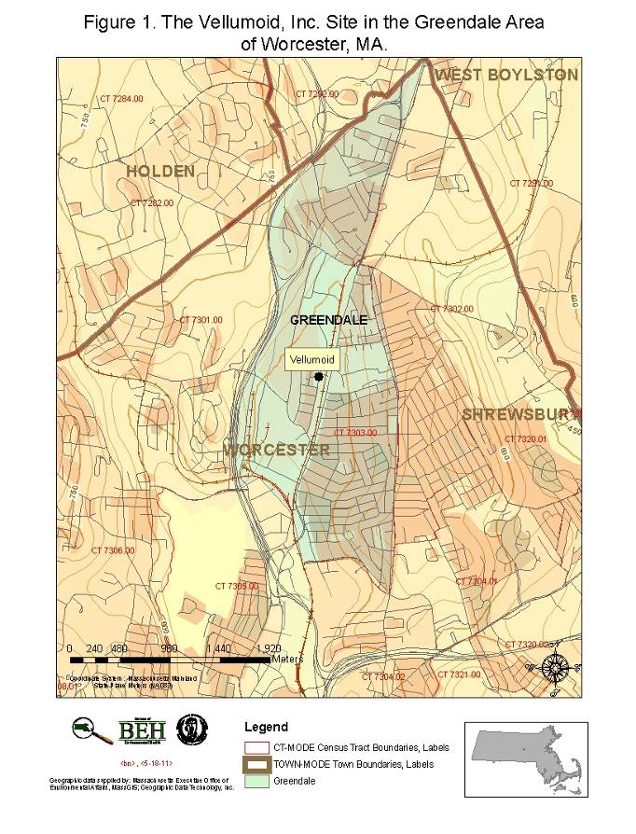
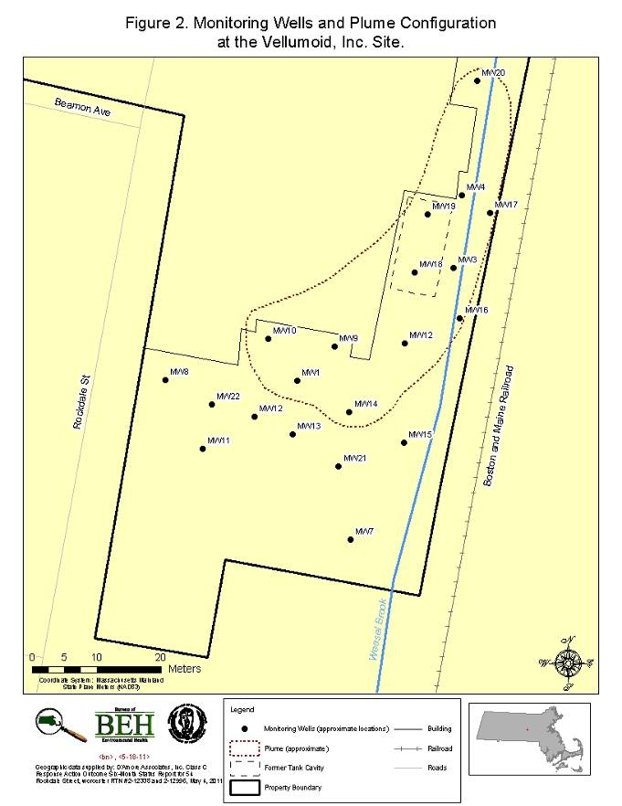

Appendix A
Explanation of a Standardized Incidence Ratio (SIR) and 95% Confidence Interval

To determine whether an elevation is occurring among individuals diagnosed with cancer in a community or census tract (CT), cancer incidence data are tabulated by gender according to eighteen age groups to compare the observed number of cancer diagnoses to the number that would be expected based on the statewide cancer rate.
Specifically, an SIR is the ratio of the observed number of cancer diagnoses in an area to the expected number of diagnoses multiplied by 100. Age-specific statewide incidence rates are applied to the population distribution of a community to calculate the number of expected cancer diagnoses. The SIR is a comparison of the number of diagnoses in the specific area (i.e., community or census tract) to the number of expected diagnoses based on the statewide rate. Comparison of SIRs between communities or census tracts is not possible because each of these areas has different population characteristics.
To calculate an SIR, it is necessary to obtain accurate population information. Population is interpolated based on U.S. census data for the community of interest. Midpoint population estimates are calculated for each time period evaluated. To estimate the population between census years, an assumption is made that the change in population occurs at a constant rate throughout the ten-year interval between each census.
A CT is a geographic subdivision of a city or town designated by the United States Census Bureau. Because age group and gender-specific population information is necessary to calculate incidence rates, the CT is the smallest geographic area for which cancer rates can be accurately calculated. Specifically, a CT is a smaller statistical subdivision of a county as defined by the U.S. Census Bureau. CTs usually contain between 1,500 and 8,000 persons and are designed to be homogenous with respect to population characteristics (U.S. DOC 2000).
An SIR of 100 indicates that the number of cancer diagnoses observed in the population evaluated is equal to the number of cancer diagnoses expected in the comparison or “normal” population. An SIR greater than 100 indicates that more cancer diagnoses occurred than expected and an SIR less than 100 indicates that fewer cancer diagnoses occurred than expected. Accordingly, an SIR of 150 is interpreted as 50% more diagnoses than the expected number; an SIR of 90 indicates 10% fewer diagnoses than expected.

Caution should be exercised, however, when interpreting an SIR. The interpretation of an SIR depends on both the size and the stability of the SIR. Two SIRs can have the same size but not the same stability. For example, an SIR of 150 based on four expected diagnoses and six observed diagnoses indicates a 50% excess in cancer, but the excess is actually only two diagnoses. Conversely, an SIR of 150 based on 400 expected diagnoses and 600 observed diagnoses represents the same 50% excess in cancer, but because the SIR is based upon a greater number of diagnoses, the estimate is more stable. It is very unlikely that 200 excess diagnoses of cancer would occur by chance alone. As a result of the instability of incidence rates based on small numbers of diagnoses, SIRs are not calculated when fewer than five diagnoses are observed for a particular cancer type.
To help interpret or measure the stability of an SIR, the statistical significance of an SIR can be assessed by calculating a 95% confidence interval (95% CI) to determine if the observed number of diagnoses is “statistically significantly different” from the expected number or if the difference may be due solely to chance (Rothman and Boice 1982). Specifically, a 95% CI is the range of estimated SIR values that has a 95% probability of including the true SIR for the population. If the 95% CI range does not include the value 100, then the study population is significantly different from the comparison or “normal” population. “Significantly different” means there is less than 5% percent chance that the observed difference (either increase or decrease) in the rate is the result of random fluctuation in the number of observed cancer diagnoses.

For example, if a confidence interval does not include 100 and the interval is above 100 (e.g., 105-130), then there is a statistically significant excess in the number of cancer diagnoses. Similarly, if the confidence interval does not include 100 and the interval is below 100 (e.g., 45-96), then the number of cancer diagnoses is statistically significantly lower than expected. If the confidence interval range includes 100, then the true SIR may be 100. In this case, it cannot be determined with certainty that the difference between the observed and expected number of diagnoses reflects a real cancer increase or decrease or is the result of chance. It is important to note that statistical significance alone does not necessarily imply public health significance. Determination of statistical significance is just one tool used to interpret cancer patterns in a community.

In addition to the range of the estimates contained in the confidence interval, the width of the confidence interval also reflects the stability of the SIR estimate. For example, a narrow confidence interval, such as 103-115, allows a fair level of certainty that the calculated SIR is close to the true SIR for the population. A wide interval, for instance 85-450, leaves considerable doubt about the true SIR, which could be much lower than or much higher than the calculated SIR. This would indicate an unstable statistic. Again, due to the instability of incidence rates based on small numbers of diagnoses, statistical significance is not assessed when fewer than five diagnoses are observed.
References
Rothman K and Boice J. 1982. Epidemiological Analysis with a Programmable Calculator. Boston: Epidemiology Resources, Inc. 1982.
U.S. DOC. 2000. Census of Population: General Population Characteristics, Massachusetts. U.S. Department of Commerce, Washington, DC: US Gov’t Printing Office.

This report was supported in part by funds from a cooperative agreement with the Agency for Toxic Substances and Disease Registry (ATSDR), U.S. Department of Health and Human Services. This document has not been reviewed and cleared by ATSDR.
Using slightly different population estimates or statistical methodologies, such as grouping ages differently or rounding off numbers at different points during calculations, may produce slightly different results.

