INDOOR AIR QUALITY ASSESSMENT

Executive Office of Health and Human Services Center
Shetland Park Office Complex
45 Congress Street
Salem, MA

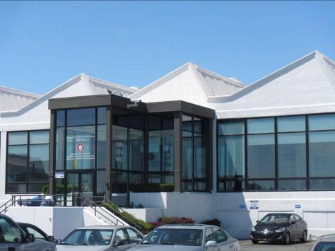

Prepared by:
Massachusetts Department of Public Health
Bureau of Environmental Health
Indoor Air Quality Program
June 2015

Background/Introduction
At the request of Virginia Platt, Project Manager, Division of Capital Asset Management and Maintenance (DCAMM), the Massachusetts Department of Public Health (MDPH), Bureau of Environmental Health (BEH) provided assistance and consultation regarding indoor air quality concerns at the Executive Office of Health and Human Services (EOHHS) service center located at 45 Congress Street, Salem, Massachusetts. This evaluation was conducted as part of enhanced efforts to assess the air quality of office space leased by Massachusetts state agencies pre- and post-occupancy. The EOHHS service center occupies a portion of a one-story building originally constructed as a large commercial textile factory. The office space assessed has undergone a complete renovation including interior walls/paint, dropped ceilings, floors, appliances, carpeting, and heating, ventilating and air conditioning (HVAC) systems. The majority of areas have carpet tiles. Windows are not openable.
On June 4, 2015, a visit was made to this building by Jason Dustin, Environmental Analyst/Inspector within BEH’s Indoor Air Quality (IAQ) Program. Ms. Platt and Deborah Kennedy, EOHHS Project Manager, accompanied Mr. Dustin throughout the assessment.

Methods
Air tests for carbon monoxide, carbon dioxide, temperature and relative humidity were conducted with the TSI, Q-Trak, IAQ Monitor, Model 7565. Air tests for airborne particle matter with a diameter less than 2.5 micrometers were taken with the TSI, DUSTTRAK™ Aerosol Monitor Model 8520. Total Volatile Organic Compounds (TVOC) were measured using a MiniRAE lite photoionization detector. BEH/IAQ staff also performed a visual inspection of building materials for water damage and/or microbial growth.

Results
The building has an employee population of 143 and approximately 400 members of the public visit daily. Tests were taken during normal operations and appear in Table 1.

Discussion

Ventilation
Carbon dioxide levels were above 800 parts per million (ppm) in 36 out of 45 locations, indicating less than optimal ventilation in most areas. It is important to note that a number of areas were empty/sparsely populated at the time of testing. Carbon dioxide levels would be expected to be higher with increased occupancy.
Thermostats control the heating, ventilating and air conditioning (HVAC) system. Thermostats have fan settings of “on” and “automatic”. The automatic fan setting on the thermostat activates the HVAC system at a pre-set temperature. Once a pre-set temperature is measured by the thermostat, the HVAC system is deactivated. All thermostats examined except for one were correctly set to the “on” position to provide for continuous ventilation. Since carbon dioxide levels were elevated in many areas (Table 1), this may indicate the need to increase the amount/percentage of outside air allowed into the AHU’s.
Air-handling units (AHUs) are mounted above the ceiling tiles and provide fresh air to the office space via air intakes ducted to the roof. AHUs are connected to ceiling-mounted supply air diffusers (Picture 1) and return/exhaust (Picture 2) vents via ductwork.
To maximize air exchange, the MDPH recommends that both supply and exhaust ventilation operate continuously during periods of occupancy. In order to have proper ventilation with a mechanical supply and exhaust system, the systems must be balanced to provide an adequate amount of fresh air to the interior of a room while removing stale air from the room. It is recommended that heating, ventilating and air-conditioning (HVAC) systems be re-balanced every five years to ensure adequate function (SMACNA, 1994). The HVAC system was reportedly balanced prior to occupancy.
Minimum design ventilation rates are mandated by the Massachusetts State Building Code (MSBC). Until 2011, the minimum ventilation rate in Massachusetts was higher for both occupied office spaces and general classrooms, with similar requirements for other occupied spaces (BOCA, 1993). The current version of the MSBC, promulgated in 2011 by the State Board of Building Regulations and Standards (SBBRS), adopted the 2009 International Mechanical Code (IMC) to set minimum ventilation rates. Please note that the MSBC is a minimum standard that is not health-based. At lower rates of cubic feet per minute (cfm) per occupant of fresh air, carbon dioxide levels would be expected to rise significantly. A ventilation rate of 20 cfm per occupant of fresh air provides optimal air exchange resulting in carbon dioxide levels at or below 800 ppm in the indoor environment in each area measured. MDPH recommends that carbon dioxide levels be maintained at 800 ppm or below. This is because most environmental and occupational health scientists involved with research on IAQ and health effects have documented significant increases in indoor air quality complaints and/or health effects when carbon dioxide levels rise above the MDPH guidelines of 800 ppm for schools, office buildings and other occupied spaces (Sundell et al., 2011). The ventilation must be on at all times that the room is occupied. Providing adequate fresh air ventilation with open windows and maintaining the temperature in the comfort range during the cold weather season is impractical. Mechanical ventilation is usually required to provide adequate fresh air ventilation.
Carbon dioxide is not a problem in and of itself. It is used as an indicator of the adequacy of the fresh air ventilation. As carbon dioxide levels rise, it indicates that the ventilating system is malfunctioning or the design occupancy of the room is being exceeded. When this happens, a buildup of common indoor air pollutants can occur, leading to discomfort or health complaints. The Occupational Safety and Health Administration (OSHA) standard for carbon dioxide is 5,000 parts per million parts of air (ppm). Workers may be exposed to this level for 40 hours/week, based on a time-weighted average (OSHA, 1997).
The MDPH uses a guideline of 800 ppm for publicly occupied buildings. A guideline of 600 ppm or less is preferred in schools due to the fact that the majority of occupants are young and considered to be a more sensitive population in the evaluation of environmental health status. Inadequate ventilation and/or elevated temperatures are major causes of complaints such as respiratory, eye, nose and throat irritation, lethargy and headaches. For more information concerning carbon dioxide, consult Appendix A.
Temperatures ranged from 66°F to 73°F. The MDPH recommends that indoor air temperatures be maintained in a range of 70°F to 78°F in order to provide for the comfort of building occupants. Most of the temperature readings below the MDPH recommended comfort guidelines were recorded in the area of rooms in the 1132-1176 range, most of which were interview rooms (Table 1). Temperature comfort complaints were expressed in these areas during the assessment. The thermostat serving this area should be examined and reprogrammed to maintain recommended temperatures. In many cases concerning indoor air quality, fluctuations of temperature in occupied spaces are typically experienced, even in a building with an adequate fresh air supply.
The relative humidity in the building ranged from 36 to 47 percent (Table 1) which were within or close to the MDPH recommended comfort range. The MDPH recommends a comfort range of 40 to 60 percent for indoor air relative humidity. Relative humidity levels in the building would be expected to drop during the winter months due to heating. The sensation of dryness and irritation is common in a low relative humidity environment

Microbial/Moisture Concerns
Water-damaged ceiling tiles were observed in a few areas (Pictures 3 and 4). Water-damaged ceiling tiles can indicate water penetration or leaks from HVAC components. They can provide a source of mold and should be replaced after a water leak is discovered and repaired.
Several windows along the front of the building appear to be leaking. Missing sections of window seals as well as signs of water staining on the laminate window sill were observed (Pictures 5 and 6, Table 1). Chronic water infiltration has the potential to moisten porous building materials leading to water damage, mold and associated odors.
A water leak from the HVAC system in the file room reportedly occurred one week prior to this assessment. A missing ceiling tile directly beneath an AHU with a condensate drip pan was observed (Picture 7). EOHHS staff reported that maintenance personnel have addressed the issue. No porous building materials or files appeared to be water-damaged. The area should continue to be monitored for leaks and the ceiling tile should be replaced.
Water coolers were observed in carpeted areas. Spills or leaks from these appliances can moisten carpeting. When possible, they should be placed in non-carpeted areas or on waterproof mats.
Plants were observed in some areas and in some cases were poorly-maintained, leading to microbial growth (Picture 8). Plants can be a source of pollen and mold, which can be respiratory irritants. Plants should be properly maintained and equipped with drip pans to prevent water damage to porous building materials. If drip pans become colonized with mold, they should be cleaned with an antimicrobial solution or replaced. Plants should also be located away from ventilation sources to prevent the aerosolization of dirt, pollen or mold.

Other Indoor Air Evaluations
Indoor air quality can be negatively influenced by the presence of respiratory irritants, such as products of combustion. The process of combustion produces a number of pollutants. Common combustion emissions include carbon monoxide, carbon dioxide, water vapor, and smoke (fine airborne particle material). Of these materials, exposure to carbon monoxide and particulate matter with a diameter of 2.5 micrometers (μm) or less (PM2.5) can produce immediate, acute health effects upon exposure. To determine whether combustion products were present in the indoor environment, BEH staff obtained measurements for carbon monoxide and PM2.5.

Carbon Monoxide
Carbon monoxide is a by-product of incomplete combustion of organic matter (e.g., gasoline, wood and tobacco). Exposure to carbon monoxide can produce immediate and acute health affects. Several air quality standards have been established to address carbon monoxide and prevent symptoms from exposure to these substances. The MDPH established a corrective action level concerning carbon monoxide in ice skating rinks that use fossil-fueled ice resurfacing equipment. If an operator of an indoor ice rink measures a carbon monoxide level over 30 ppm, taken 20 minutes after resurfacing within a rink, that operator must take actions to reduce carbon monoxide levels (MDPH, 1997).
The American Society of Heating Refrigeration and Air-Conditioning Engineers (ASHRAE) has adopted the National Ambient Air Quality Standards (NAAQS) as one set of criteria for assessing indoor air quality and monitoring of fresh air introduced by HVAC systems (ASHRAE, 1989). The NAAQS are standards established by the US EPA to protect the public health from six criteria pollutants, including carbon monoxide and particulate matter (US EPA, 2006). As recommended by ASHRAE, pollutant levels of fresh air introduced to a building should not exceed the NAAQS levels (ASHRAE, 1989). The NAAQS were adopted by reference in the Building Officials & Code Administrators (BOCA) National Mechanical Code of 1993 (BOCA, 1993), which is now an HVAC standard included in the Massachusetts State Building Code (SBBRS, 1997). According to the NAAQS, carbon monoxide levels in outdoor air should not exceed 9 ppm in an eight-hour average (US EPA, 2006).
Carbon monoxide should not be present in a typical, indoor environment. If it is present, indoor carbon monoxide levels should be less than or equal to outdoor levels. The day of the assessment, outdoor carbon monoxide concentrations were 1.0 ppm (Table 1) most likely due to vehicle traffic. Indoor levels were all non-detect (ND, Table 1). It may be advisable to post anti-idling signs in close proximity of the building and adjacent parking garage to avoid possible vehicle exhaust entrainment. M.G.L. chapter 90 section 16A prohibits the unnecessary operation of the engine of a motor vehicle for a foreseeable time in excess of five minutes (MGL, 1996). Local police and health agents are given the authority to enforce this law.

Particulate Matter
The US EPA has established NAAQS limits for exposure to particulate matter. Particulate matter is airborne solids that can be irritating to the eyes, nose and throat. The NAAQS originally established exposure limits to particulate matter with a diameter of 10 μm or less (PM10). According to the NAAQS, PM10 levels should not exceed 150 micrograms per cubic meter (μg/m³) in a 24-hour average (US EPA, 2006). These standards were adopted by both ASHRAE and BOCA. Since the issuance of the ASHRAE standard and BOCA Code, US EPA established a more protective standard for fine airborne particles. This more stringent PM2.5 standard requires outdoor air particle levels be maintained below 35 μg/m³ over a 24-hour average (US EPA, 2006). Although both the ASHRAE standard and BOCA Code adopted the PM10 standard for evaluating air quality, MDPH uses the more protective PM2.5 standard for evaluating airborne particulate matter concentrations in the indoor environment.
Outdoor PM2.5 was measured at 6 μg/m³ (Table 1). PM2.5 levels measured indoors ranged from ND to 6 μg/m³ (Table 1), which were below the NAAQS PM2.5 level of 35 μg/m³. Frequently, indoor air levels of particulate matter (including PM2.5) can be at higher levels than those measured outdoors. A number of activities that occur indoors and/or mechanical devices can generate particulate matter during normal operations. Sources of indoor airborne particulate matter may include but are not limited to particles generated during the operation of fan belts in the HVAC system, use of stoves and/or microwave ovens in kitchen areas; use of photocopiers, fax machines and computer printing devices; operation of an ordinary vacuum cleaner and heavy foot traffic indoors.

Volatile Organic Compounds
Indoor air concentrations can be greatly impacted by the use of products containing volatile organic compounds (VOCs). VOCs are carbon-containing substances that have the ability to evaporate at room temperature. Frequently, exposure to low levels of total VOCs (TVOCs) may produce eye, nose, throat and/or respiratory irritation in some sensitive individuals. For example, chemicals evaporating from a paint can stored at room temperature would most likely contain VOCs. In order to determine if VOCs were present, testing for TVOCs was conducted. Outdoor TVOC concentrations were ND on the day of the assessment (Table 1). No measureable levels of TVOCs were detected in the building during the assessment (Table 1).
There are several photocopiers in the building. Photocopiers can be sources of pollutants such as VOCs, ozone, heat and odors, particularly if the equipment is older and in frequent use. Both VOCs and ozone are respiratory irritants (Schmidt Etkin, 1992). Photocopiers, large printers, laminators, shredders and other office equipment that may produce VOCs, dusts and odors should be kept in well ventilated rooms, and should be located near windows or exhaust vents.
Some areas contained dry erase boards and related materials. Materials such as dry erase markers and dry erase board cleaners may contain VOCs, such as methyl isobutyl ketone, n-butyl acetate and butyl-cellusolve (Sanford, 1999), which can be irritating to the eyes, nose and throat.
Hand sanitizer was also observed in several areas (Table 1); these products may contain ethyl alcohol and/or isopropyl alcohol, which are highly volatile and may be irritating to the eyes and nose. Sanitizing products may also contain fragrances to which some people may be sensitive.
Cleaning products, air freshening sprays and scented products were also observed (Pictures 9 and 10, Table 1). Air fresheners and other air deodorizers contain chemicals that can be irritating to the eyes, nose and throat of sensitive individuals. Many air fresheners contain 1,4-dichlorobenzene, a VOC which may cause reductions in lung function (NIH, 2006). Furthermore, deodorizing agents do not remove materials causing odors, but rather mask odors that may be present in the area. Many cleaning products also contain chemicals that can be irritating to the eyes, nose and throat of sensitive individuals.

Other Conditions
Of note is the absence of any exhaust vent in the break room/kitchen. Exhaust vents which directly exhaust to the outside are recommended to remove moisture and odors from kitchen areas. At the time of the assessment, food odors were detected in the immediate area surrounding the break room.

Conclusions/Recommendations
In view of the findings at the time of the visit, the following recommendations are made:
- Increase fresh air supply for areas with carbon dioxide levels above 800 ppm. Dampers/louvers for the AHUs may need adjustment or other system parameters may need to be changed.
- Verify that all thermostats are set to the fan “ON” setting for continuous air filtration and ventilation.
- Install a dedicated exhaust vent for the kitchen area to remove moisture and odors.
- Reprogram thermostat(s) for areas where temperature is below the recommended guidelines (particularly interview rooms 1132-1141).
- For buildings in New England, periods of low relative humidity during the winter are often unavoidable. Therefore, scrupulous cleaning practices should be adopted to minimize common indoor air contaminants whose irritant effects can be enhanced when the relative humidity is low. To control for dusts, a high efficiency particulate arrestance (HEPA) filter equipped vacuum cleaner in conjunction with wet wiping of all surfaces is recommended. Avoid the use of feather dusters and brooms on carpeting. Drinking water during the day can help ease some symptoms associated with a dry environment (throat and sinus irritations).
- Investigate the source of the water leaks moistening ceiling tiles and repair. Continue to monitor the file room for active water leaks. Verify that the leaks have been repaired and replace water-damaged ceiling tiles.
- Determine the cause of the leaking windows (missing/damaged gaskets or seals, flashing, etc.) Make repairs to prevent chronic water damage to porous building materials.
- Place waterproof mats under all water coolers that are located directly on carpeting or relocate these appliances to non-carpeted areas.
- Plants should be properly maintained and equipped with drip pans to prevent water damage to porous building materials and be located away from ventilation sources to prevent the aerosolization of dirt, pollen or mold. Clean or replace any mold-colonized drop pans.
- Consider installing anti-idling signs along the front of the building and in the adjacent parking garage to discourage vehicles from running their engines unnecessarily since the exhaust has the potential to be entrained into the AHUs.
- Consider locating photocopiers and other office equipment to areas with good ventilation or localized exhaust.
- Consider discontinuing use of air fresheners/deodorizers to prevent exposure to VOCs.
- Refer to resource manuals and other related indoor air quality documents for further building-wide evaluations and advice on maintaining public buildings. Copies of these materials are located on the MDPH’s website: http://mass.gov/dph/iaq.

References
ASHRAE. 1989. Ventilation for Acceptable Indoor Air Quality. American Society of Heating, Refrigeration and Air Conditioning Engineers. ANSI/ASHRAE 62-1989.
BOCA. 1993. The BOCA National Mechanical Code/1993. 8th ed. Building Officials and Code Administrators International, Inc., Country Club Hill, IL. Section M-308.1.1.
MDPH. 1997. Requirements to Maintain Air Quality in Indoor Skating Rinks (State Sanitary Code, Chapter XI). 105 CMR 675.000. Massachusetts Department of Public Health, Boston, MA.
MGL. 1996. Stopped motor vehicles; Operation of Engine; Time Limit; Penalty. Massachusetts General Laws. M.G.L. c. 90:16A.
OSHA. 1997. Limits for Air Contaminants. Occupational Safety and Health Administration. Code of Federal Regulations. 29 C.F.R 1910.1000 Table Z-1-A.
Sanford. 1999. Material Safety Data Sheet (MSDS No: 198-17). Expo® Dry Erase Markers Bullet, Chisel, and Ultra Fine Tip. Sanford Corporation. Bellwood, IL.
SBBRS. 2011. Mechanical Ventilation. State Board of Building Regulations and Standards. Code of Massachusetts Regulations, 8th edition. 780 CMR 1209.0.
Schmidt Etkin, D. 1992. Office Furnishings/Equipment & IAQ Health Impacts, Prevention & Mitigation. Cutter Information Corporation, Indoor Air Quality Update, Arlington, MA.
SMACNA. 1994. HVAC Systems Commissioning Manual. 1st ed. Sheet Metal and Air Conditioning Contractors’ National Association, Inc., Chantilly, VA.
Sundell. 2011. Sundell, J., H. Levin, W. W. Nazaroff, W. S. Cain, W. J. Fisk, D. T. Grimsrud, F. Gyntelberg, Y. Li, A. K. Persily, A. C. Pickering, J. M. Samet, J. D. Spengler, S. T. Taylor, and C. J. Weschler. Ventilation rates and health: multidisciplinary review of the scientific literature. Indoor Air, Volume 21: pp 191–204.
US EPA. 2006. National Ambient Air Quality Standards (NAAQS). US Environmental Protection Agency, Office of Air Quality Planning and Standards, Washington, DC. http://www.epa.gov/air/criteria.html.
Picture

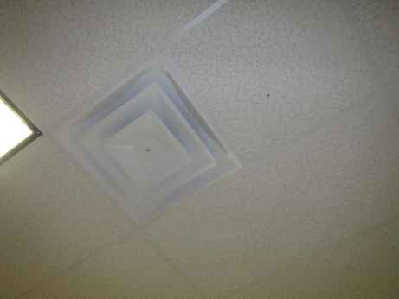

Ceiling-mounted supply air diffuser

Picture

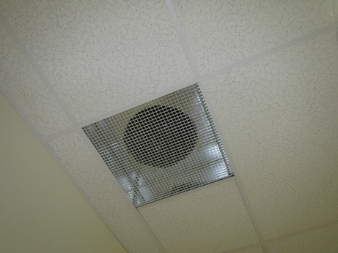

Return/exhaust vent
Picture

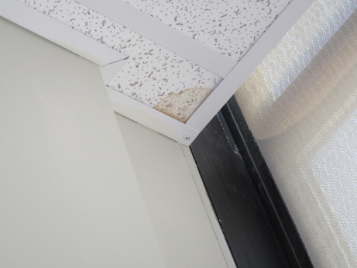

Water-damaged ceiling tile

Picture

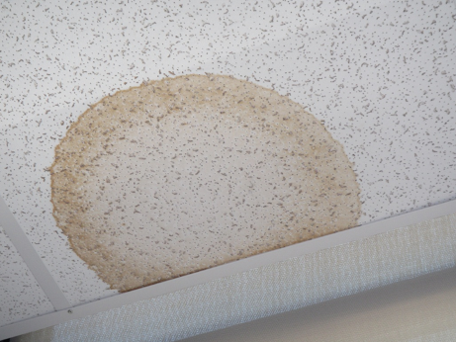

Water-damaged ceiling tile
Picture

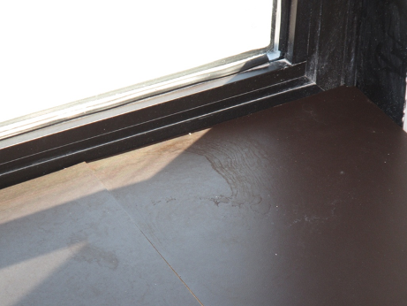

Missing window seal (corner) and water staining on sill

Picture

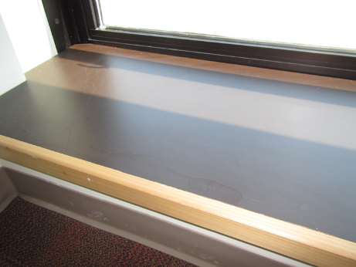

Water staining on window sill (arrow)
Picture

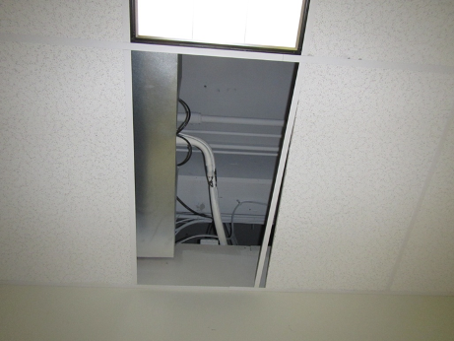

Missing tile where leak occurred in file room (note AHU drip pan above)

Picture

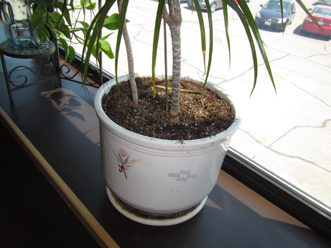

Plant with microbial growth in drip tray
Picture

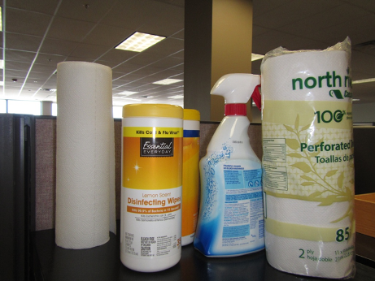

Cleaning products

Picture

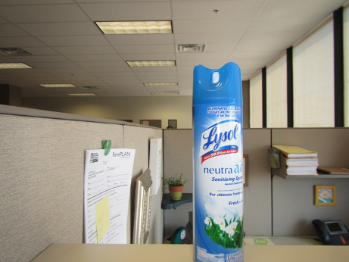

Disinfecting/deodorizing spray
Location | Carbon  Dioxide  (ppm) | Carbon Monoxide  (ppm) | Temp  (°F) | Relative  Humidity  (%) | VOCs  (ppm) | PM2.5  (µg/m³) | Occupants  in Room | Windows  Openable | Ventilation |  |  | Remarks
 |  |  |  |  |  |  |  |  | Intake | Exhaust
Background | 386 | 1.0 | 64 | 55 | ND | 6 |  |  |  |  |  | Clear, light SE wind
1001 | 945 | ND | 70 | 41 | ND | 2 | 0 | N | Y |  | Y | CPs, PE
1004 | 863 | ND | 71 | 41 | ND | 2 | 1 | N | Y |  | Y | HS
1009-1032 | 823 | ND | 72 | 40 | ND | 1 | 3 | N | Y |  | Y
1014-1038 | 803 | ND | 72 | 39 | ND | 1 | 3 | N | Y |  | Y
1017 | 870 | ND | 72 | 39 | ND | 1 | 1 | N | Y |  | Y
1018 | 767 | ND | 71 | 40 | ND | 1 | 3 | N | Y |  | Y
1020 | 879 | ND | 70 | 41 | ND | 1 | 2 | N | Y |  | Y | WD-CT
1022 | 785 | ND | 71 | 40 | ND | 1 | 0 | N | Y |  | Y | HS
1027 | 825 | ND | 71 | 39 | ND | 1 | 2 | N | Y |  | Y
1033-1036 | 825 | ND | 72 | 39 | ND | 2 | 2 | N | Y |  | Y | Plant
1042-1041 | 869 | ND | 72 | 39 | ND | 1 | 2 | N | Y |  | Y | PF, window leak
1048-1046 | 853 | ND | 72 | 39 | ND | 2 | 5 | N | Y |  | Y
1066-1064 | 855 | ND | 72 | 40 | ND | 1 | 3 | N | Y |  | Y
1073-1070 | 892 | ND | 72 | 40 | ND | 6 | 2 | N | Y |  | Y
1075-1053 | 828 | ND | 72 | 39 | ND | 2 | 2 | N | Y |  | Y
1079-1056 | 952 | ND | 72 | 40 | ND | 1 | 3 | N | Y |  | Y | HS, plush toys
1082-1059 | 831 | ND | 71 | 41 | ND | 1 | 3 | N | Y |  | Y
1088-1091 | 856 | ND | 72 | 40 | ND | 2 | 2 | N | Y |  | Y | HS, CPs
1092-1094 | 845 | ND | 72 | 40 | ND | 2 | 2 | N | Y |  | Y
1098-1099 | 854 | ND | 73 | 37 | ND | 2 | 3 | N | Y |  | Y
1132 | 854 | ND | 68 | 37 | ND | 1 | 1 | N | Y |  | Y | Cooler on this side. Thermostats may need re-programming, PE
1137 | 888 | ND | 69 | 40 | ND | 1 | 1 | N | Y |  | Y | PE
1138 | 852 | ND | 72 | 36 | ND | 1 | 0 | N | Y |  | Y | PE
1139 | 916 | ND | 66 | 39 | ND | 2 | 0 | N | Y |  | Y | Cooler temps., PE
1140 | 942 | ND | 66 | 41 | ND | 3 | 0 | N | Y |  | Y | Cooler temps., PE
1141 | 876 | ND | 68 | 39 | ND | 5 | 2 | N | Y |  | Y | PE
1151-1154 | 875 | ND | 71 | 47 | ND | ND | 4 | N | Y |  | Y | HS, deodorizer spray
1155-1157 | 847 | ND | 72 | 43 | ND | ND | 3 | N | Y |  | Y | HS
1158 | 793 | ND | 72 | 42 | ND | 2 | 0 | N | Y |  | Y | HS
1160 | 842 | ND | 73 | 37 | ND | 1 | 0 | N | Y |  | Y | No meeting in room for > 1hr, PE
1165-1183 | 823 | ND | 72 | 42 | ND | 2 | 7 | N | N |  | Y | Plants (some w/ no drip pan)
1168-1188 | 748 | ND | 72 | 41 | ND | 2 | 6 | N | Y |  | Y | HS
1171 Break Room | 896 | ND | 72 | 41 | ND | 2 | 9 | N | Y |  | Y | No insulation wrap on metal drain pipe, NC
1172 | 862 | ND | 73 | 37 | ND | 1 | 0 | N | Y |  | Y | PE
1176 | 981 | ND | 72 | 39 | ND | 1 | 1 | N | Y |  | Y | HS, PE
1179 | 601 | ND | 72 | 39 | ND | 1 | 0 | N | Y |  | Y | PE
1193-windows | 797 | ND | 73 | 40 | ND | 1 | 5 | N | Y |  | Y | PF, window leaks, HS, water-stained sill
1197-1205 | 755 | ND | 73 | 39 | ND | 1 | 4 | N | Y |  | Y | AI
1201-1208 | 786 | ND | 72 | 40 | ND | 1 | 3 | N | Y |  | Y
1202 | 854 | ND | 73 | 40 | ND | 1 | 1 | N | Y |  | Y | Window leak
1211 | 667 | ND | 71 | 39 | ND | 2 | 0 | N | Y |  | Y | Passive exhaust (PE) vents to hall from all offices; supply pressurizes
Break Room | 1088 | ND | 73 | 43 | ND | 3 | 4 | N | Y |  | Y | No direct exhaust vent, food odors, stuffy, NC
File Room | - | - | - | - | - | - | - | - | - |  | - | Water leak reported 1 week ago. AHU w/drip pan over area of missing tile. No porous water-damaged items found. Tile floor. Maintenance staff reportedly fixed leak.
Main Lobby/waiting area (front) | 1218 | ND | 73 | 41 | ND | 1 | 31 | N | Y |  | Y | Stuffy, body odors, Thermostat Fan set to “ON” as it should be
Main Lobby/waiting area (rear) | 1284 | ND | 73 | 41 | ND | 1 | 31 | N | Y |  | Y | Stuffy, body odors
Reception side | 871 | ND | 72 | 40 | ND | 4 | 2 | N | Y |  | Y

