INDOOR AIR QUALITY
POST-OCCUPANCY ASSESSMENT

Commonwealth of Massachusetts
500 Main Street
Hyannis, Massachusetts

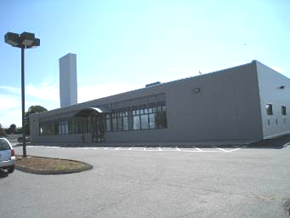

Prepared by:
Massachusetts Department of Public Health
Bureau of Environmental Health
Indoor Air Quality Program
September 2010

Background/Introduction
In response to a request from Vincent Laberinto, Project Manager, Office of Facilities Leasing and Planning, Executive Office of Health and Human Services (EHS), the Massachusetts Department of Public Health (MDPH), Bureau of Environmental Health (BEH), conducted post-occupancy air testing at the EHS Center located at 500 Main Street, Hyannis, Massachusetts. This air sampling was done to assess the indoor air quality of newly occupied office space leased by Massachusetts state agencies. On August 12, 2010, a visit to conduct indoor air quality testing was made by Cory Holmes, Environmental Analyst/Regional Inspector in BEH’s IAQ Program.
The building is a one-story office building that is occupied by the following Massachusetts state EHS agencies: Department of Transitional Assistance (DTA), Department of Mental Health (DMH), the Developmental Disability Services (DDS), the Massachusetts Rehabilitation Commission (MRC) and the Department of Children and Families (DCF). The center contains offices, open work areas, and conference/meeting rooms. The building has no openable windows.

Methods
Air tests for carbon dioxide, carbon monoxide temperature and relative humidity were taken with the TSI, Q-Trak, IAQ Monitor 7565. Air tests for airborne particle matter with a diameter less than 2.5 micrometers were taken with the TSI, DUSTTRAK™ Aerosol Monitor Model 8520. Screening for total volatile organic compounds was conducted using a Thermo Environmental Instruments Inc., Model 580 Series Photo Ionization Detector (PID). BEH staff also performed visual inspection of building materials for water damage and/or microbial growth.

Results
The tests were taken during normal operations. Test results appear in Table 1 and are listed by agency and occupants’ last name(s).

Discussion

Ventilation
It can be seen from Table 1 that carbon dioxide levels were below 800 parts per million (ppm) in all areas indicating optimal air exchange at the time of testing (Table 1). Fresh air is provided by a rooftop air handling unit (AHU) (Picture 1). Fresh air is drawn into the AHU through a bank of pleated air filters (Picture 2), heated or cooled and delivered to occupied areas via ducted air diffusers (Picture 3). Return air is drawn into an above ceiling plenum and ducted back to the rooftop AHU (Picture 4).
The Massachusetts Building Code requires a minimum ventilation rate of 20 cubic feet per minute (cfm) per occupant of fresh outside air or have openable windows in each room (SBBRS, 1997; BOCA, 1993). The ventilation must be on at all times that the room is occupied. Providing adequate fresh air ventilation with open windows and maintaining the temperature in the comfort range during the cold weather season is impractical. Mechanical ventilation is usually required to provide adequate fresh air ventilation.
Carbon dioxide is not a problem in and of itself. It is used as an indicator of the adequacy of the fresh air ventilation. As carbon dioxide levels rise, it indicates that the ventilating system is malfunctioning or the design occupancy of the room is being exceeded. When this happens, a buildup of common indoor air pollutants can occur, leading to discomfort or health complaints. The Occupational Safety and Health Administration (OSHA) standard for carbon dioxide is 5,000 parts per million parts of air (ppm). Workers may be exposed to this level for 40 hours/week, based on a time-weighted average (OSHA, 1997).
The MDPH uses a guideline of 800 ppm for publicly occupied buildings. A guideline of 600 ppm or less is preferred in schools due to the fact that the majority of occupants are young and considered to be a more sensitive population in the evaluation of environmental health status. Inadequate ventilation and/or elevated temperatures are major causes of complaints such as respiratory, eye, nose and throat irritation, lethargy and headaches. For more information concerning carbon dioxide, please see Appendix A.
Indoor temperature measurements ranged from 71°F to 73°F (Table 1), which were within the MDPH recommended comfort range. The MDPH recommends that indoor air temperatures be maintained in a range of 70 º F to 78 º F in order to provide for the comfort of building occupants. In many cases concerning indoor air quality, fluctuations of temperature in occupied spaces are typically experienced, even in a building with an adequate fresh air supply.
Relative humidity measurements ranged from 51 to 66 percent, the majority of which were within the MDPH recommended comfort range the day of the assessment (Table 1). The MDPH recommends a comfort range of 40 to 60 percent for indoor air relative humidity. Relative humidity levels in the building would be expected to drop during the winter months due to heating. The sensation of dryness and irritation is common in a low relative humidity environment. Low relative humidity is a very common problem during the heating season in the northeast part of the United States.

Microbial/Moisture Concerns
Water-damaged ceiling tiles were observed in the DDS work area, which can indicate leaks from the roof or plumbing system. Building management reported that tiles were damaged due to condensation from the air-conditioning system and that a service call had been placed to their HVAC vendor to investigate. Ceiling tiles should be replaced after a water leak is discovered and repaired.

Other Indoor Air Evaluations
Indoor air quality can be negatively influenced by the presence of respiratory irritants, such as products of combustion. The process of combustion produces a number of pollutants. Common combustion emissions include carbon monoxide, carbon dioxide, water vapor, and smoke (fine airborne particle material). Of these materials, exposure to carbon monoxide and particulate matter with a diameter of 2.5 micrometers (μm) or less (PM2.5) can produce immediate, acute health effects upon exposure. To determine whether combustion products were present in the indoor environment, BEH staff obtained measurements for carbon monoxide and PM2.5.

Carbon Monoxide
Carbon monoxide is a by-product of incomplete combustion of organic matter (e.g., gasoline, wood and tobacco). Exposure to carbon monoxide can produce immediate and acute health affects. Several air quality standards have been established to address carbon monoxide and prevent symptoms from exposure to these substances. The MDPH established a corrective action level concerning carbon monoxide in ice skating rinks that use fossil-fueled ice resurfacing equipment. If an operator of an indoor ice rink measures a carbon monoxide level over 30 ppm, taken 20 minutes after resurfacing within a rink, that operator must take actions to reduce carbon monoxide levels (MDPH, 1997).
The American Society of Heating Refrigeration and Air-Conditioning Engineers (ASHRAE) has adopted the National Ambient Air Quality Standards (NAAQS) as one set of criteria for assessing indoor air quality and monitoring of fresh air introduced by HVAC systems (ASHRAE, 1989). The NAAQS are standards established by the US EPA to protect the public health from six criteria pollutants, including carbon monoxide and particulate matter (US EPA, 2006). As recommended by ASHRAE, pollutant levels of fresh air introduced to a building should not exceed the NAAQS levels (ASHRAE, 1989). The NAAQS were adopted by reference in the Building Officials & Code Administrators (BOCA) National Mechanical Code of 1993 (BOCA, 1993), which is now an HVAC standard included in the Massachusetts State Building Code (SBBRS, 1997). According to the NAAQS, carbon monoxide levels in outdoor air should not exceed 9 ppm in an eight-hour average (US EPA, 2006).
Carbon monoxide should not be present in a typical, indoor environment. If it is present, indoor carbon monoxide levels should be less than or equal to outdoor levels. The day of the assessment, outdoor carbon monoxide concentrations were non-detect (ND) (Table 1). No measureable levels of carbon monoxide were detected in the building during the assessment (Table 1).

Particulate Matter
The US EPA has established NAAQS limits for exposure to particulate matter. Particulate matter is airborne solids that can be irritating to the eyes, nose and throat. The NAAQS originally established exposure limits to particulate matter with a diameter of 10 μm or less (PM10). According to the NAAQS, PM10 levels should not exceed 150 micrograms per cubic meter (μg/m³) in a 24-hour average (US EPA, 2006). These standards were adopted by both ASHRAE and BOCA. Since the issuance of the ASHRAE standard and BOCA Code, US EPA established a more protective standard for fine airborne particles. This more stringent PM2.5 standard requires outdoor air particle levels be maintained below 35 μg/m³ over a 24-hour average (US EPA, 2006). Although both the ASHRAE standard and BOCA Code adopted the PM10 standard for evaluating air quality, MDPH uses the more protective PM2.5 standard for evaluating airborne particulate matter concentrations in the indoor environment.
Outdoor PM2.5 was measured at 13 μg/m³ (Table 1). PM2.5 levels measured indoors ranged from 13 to 16 μg/m³ (Table 1), which were below the NAAQS PM2.5 level of 35 μg/m³. Frequently, indoor air levels of particulates (including PM2.5) can be at higher levels than those measured outdoors. A number of mechanical devices and/or activities that occur in buildings can generate particulate during normal operations. Sources of indoor airborne particulates may include but are not limited to particles generated during the operation of fan belts in the HVAC system, use of stoves and/or microwave ovens in kitchen areas; use of photocopiers, fax machines and computer printing devices; operation of an ordinary vacuum cleaner and heavy foot traffic indoors.

Volatile Organic Compounds
Indoor air concentrations can be greatly impacted by the use of products containing volatile organic compounds (VOCs) within the building. VOCs are carbon-containing substances that have the ability to evaporate at room temperature. Frequently, exposure to low levels of total volatile organic compounds (TVOCs) may produce eye, nose, throat and/or respiratory irritation in some sensitive individuals. For example, chemicals evaporating from a paint can stored at room temperature would most likely contain VOCs. In an effort to determine whether VOCs were present in the building, air monitoring for TVOCs was conducted. Outdoor air samples were taken for comparison. Outdoor TVOC concentrations the day of the assessment were ND (Table 1). Slight detections of TVOCs were measured (<1 ppm) ranging from 0.4 to 0.7 ppm were measured in a few areas (Table 1), which were likely attributed to odors from fresh paint, adhesives and new building furnishings (carpeting, desks/furniture, work space dividers, etc.).

Conclusions/Recommendations
In view of the findings at the time of the visit, the following recommendations are made:
- Ensure repairs are made to HVAC unit in DDS area. Replace water-damaged ceiling tiles. Monitor for further leaks. If wetting of ceiling tiles recurs, report to building management for prompt remediation.
- Change filters for air handling equipment as per the manufacturers’ instructions or more frequently if needed.
- Consider adopting a balancing schedule of every 5 years for all mechanical ventilation systems, as recommended by ventilation industrial standards (SMACNA, 1994).
- Refer to resource manual and other related indoor air quality documents located on the MDPH’s website for further building-wide evaluations and advice on maintaining public buildings. These documents are available at: http://mass.gov/dph/iaq.

References
ASHRAE. 1989. Ventilation for Acceptable Indoor Air Quality. American Society of Heating, Refrigeration and Air Conditioning Engineers. ANSI/ASHRAE 62-1989.
BOCA. 1993. The BOCA National Mechanical Code/1993. 8th ed. Building Officials and Code Administrators International, Inc., Country Club Hill, IL.
MDPH. 1997. Requirements to Maintain Air Quality in Indoor Skating Rinks (State Sanitary Code, Chapter XI). 105 CMR 675.000. Massachusetts Department of Public Health, Boston, MA.
OSHA. 1997. Limits for Air Contaminants. Occupational Safety and Health Administration. Code of Federal Regulations. 29 C.F.R 1910.1000 Table Z-1-A.
SBBRS. 1997. Mechanical Ventilation. State Board of Building Regulations and Standards. Code of Massachusetts Regulations. 780 CMR 1209.0
US EPA. 2006. National Ambient Air Quality Standards (NAAQS). US Environmental Protection Agency, Office of Air Quality Planning and Standards, Washington, DC. http://www.epa.gov/air/criteria.html.
Picture 1

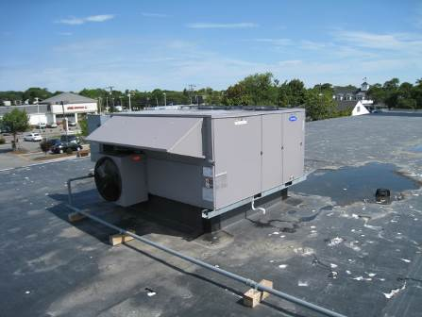

Rooftop Air Handling Unit

Picture 2

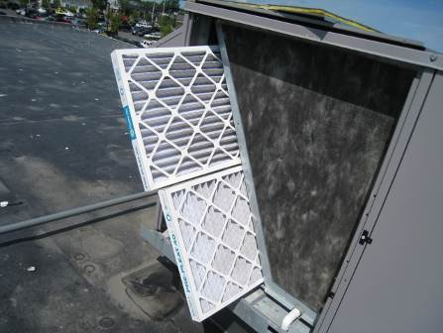

Bank of Pleated Air Filters Installed in Rooftop Air Handling Unit

Picture 3

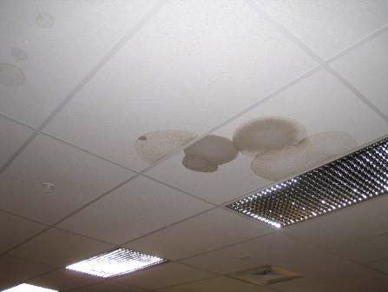

Water-Damaged Ceiling Tiles in DDS Area
Location | Occupants  in Room | Temp  (°F) | Relative  Humidity  (%) | Carbon  Dioxide  (ppm) | Carbon Monoxide  (ppm) | TVOCs  (ppm) | PM2.5 (ug/m3) | Windows  Openable | Ventilation |  | Remarks
Outside  (Background) |  | 78 | 54 | 366 | ND | ND | 13 |  |  |  | Warm, mostly sunny, moderate to heavy traffic
Conference Room D | 0 | 71 | 56 | 581 | ND | ND | 14 | N | Y | Y
Staff Support | 0 | 71 | 58 | 495 | ND | ND | 14 | N | Y | Y
DTA Kenny | 4 | 71 | 56 | 531 | ND | ND | 13 | N | Y | Y
DTA Hyatt | 3 | 71 | 54 | 509 | ND | ND | 14 | N | Y | Y
DTA Todd/Rideout | 4 | 71 | 52 | 439 | ND | ND | 14 | N | Y | Y
DTA Arnone | 3 | 71 | 51 | 442 | ND | ND | 14 | N | Y | Y
DTA 250/251 | 1 | 71 | 52 | 434 | ND | ND | 13 | N | Y | Y
DTA Barron-Stuart | 4 | 71 | 53 | 430 | ND | ND | 14 | N | Y | Y
DDS Wilson | 0 | 71 | 52 | 428 | ND | ND | 13 | N | Y | Y
DDS Petrie | 1 | 71 | 53 | 449 | ND | 0.4 | 14 | N | Y | Y | 2 WD CTs-HVAC leak
DDS Maher | 1 | 72 | 55 | 488 | ND | ND | 14 | N | Y | Y
DDS Vogt | 1 | 72 | 61 | 478 | ND | 0.7 | 13 | N | Y | Y
DDS Larrabee | 2 | 73 | 63 | 451 | ND | 0.6 | 14 | N | Y | Y
MRC Duddy | 1 | 73 | 65 | 469 | ND | 0.5 | 14 | N | Y | Y
MRC Mello | 0 | 73 | 65 | 471 | ND | 0.6 | 14 | N | Y | Y
MRC Jefferson | 1 | 72 | 65 | 468 | ND | 0.6 | 13 | N | Y | Y
MRC Ferrari | 1 | 73 | 66 | 445 | ND | 0.5 | 14 | N | Y | Y
MRC Jablonski | 2 | 73 | 66 | 459 | ND | 0.4 | 15 | N | Y | Y
Reception | 1 | 72 | 59 | 455 | ND | 0.5 | 15 | N | Y | Y
Conference Room B | 0 | 71 | 54 | 418 | ND | ND | 16 | N | Y | Y
Conference Room C | 4 | 71 | 55 | 542 | ND | ND | 15 | N | Y | Y
Conference Room A | 0 | 71 | 55 | 478 | ND | ND | 14 | N | Y | Y
DMH North/Stewart | 3 | 71 | 54 | 480 | ND | ND | 14 | N | Y | Y
DMH Bellmar/Donati | 1 | 71 | 55 | 469 | ND | ND | 14 | N | Y | Y
DMH Hartigan/Porter | 0 | 71 | 54 | 465 | ND | ND | 14 | N | Y | Y
DMH Office 243 | 2 | 72 | 54 | 478 | ND | ND | 13 | N | Y | Y
DMH Copy Center 265 | 0 | 72 | 53 | 423 | ND | ND | 13 | N | Y | Y
DMH Hartigan/Sawka | 1 | 71 | 53 | 429 | ND | ND | 14 | N | Y | Y

