Background

INDOOR AIR QUALITY
POST-OCCUPANCY ASSESSMENT

EOHHS Service Center
Department of Developmental Services
Massachusetts Rehabilitation Commission
1 Father DeValles Boulevard
Fall River, Massachusetts

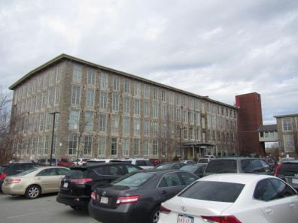

Prepared by:
Massachusetts Department of Public Health
Bureau of Environmental Health
Indoor Air Quality Program
March 2018
Building: | EOHHS Service Center, Department of Developmental Services (DDS) and Massachusetts Rehabilitation Commission (MRC)
Address: | 1 Father DeValles Boulevard, Fall River, MA
Division of Capital Asset Management and Maintenance (DCAMM) Project Manager: | Paul Burke
Date of Post-Occupancy Assessment: | February 23, 2018
Massachusetts Department of Public Health/Bureau of Environmental Health (MDPH/BEH) Staff Conducting Assessment: | Cory Holmes, Environmental Analyst/Inspector, Indoor Air Quality (IAQ) Program
Date of Building Construction/Renovation | Former stone mill building developed into an office park.
Building Description: | The recently renovated space is located on the 2nd floor and contains office space, open work areas, and interview and conference rooms. Most areas have carpet squares and dropped ceiling tiles.
Windows: | Most are not openable

Methods
Please refer to the IAQ Manual for methods, sampling procedures, and interpretation of results (MDPH, 2015).

IAQ Testing Results
The following is a summary of indoor air testing results (Table 1).
- Carbon dioxide levels were below the MDPH guideline of 800 parts per million (ppm) in all but one area, Conference Room 203.
- Temperature was within or very close to the recommended range of 70°F to 78°F.
- Relative humidity was below the recommended range of 40% to 60% in all but one area, which was reflective of outdoor conditions at the time of assessment.
- Carbon monoxide levels were non-detectable (ND) in all areas assessed.
- Fine particulate matter (PM2.5) concentrations measured were below the National Ambient Air Quality Standard (NAAQS) level of 35 micrograms per cubic meter (μg/m³) in all areas assessed.
- Total volatile organic compound (TVOC) levels were ND in all areas assessed.

Ventilation
The heating, ventilation and air conditioning (HVAC) system consists of two energy recovery ventilators (ERVs) that draw outside air through intake vents on the exterior wall (Picture 1). Air is distributed by a series of 15 heat pumps located above the ceiling tile system (Picture 2). The space utilizes a ducted supply system to deliver conditioned air via supply diffusers (Pictures 3 and 4). Return air is drawn through ceiling grates (Picture 5) into the ceiling plenum. Both the large/main work areas of the MRC and DDS had a multitude of supply vents but only one return grate located in the far corner of each space.
It was reported that the HVAC components include carbon dioxide sensors in conference rooms to activate an auxiliary exhaust system to aid in air exchange during large gatherings. It was not clear what “trigger” value the sensors were set to, in order to activate the system. At the time of assessment, the only reading above the MDPH guideline of 800 ppm (903 ppm) was in Conference room 203, which had 9 occupants. It should also be noted that these sensors need to be regularly maintained/calibrated in accordance with manufacturer’s instructions to ensure proper function.
The MDPH recommends pleated filters with a Minimum Efficiency Reporting Value (MERV) of 8, which are adequate in filtering out pollen and mold spores (ASHRAE, 2012). Filters should also be changed two to four times a year, or per the manufacturer’s recommendations. BEH/IAQ staff examined filters, which were a pleated MERV 8 filter (Pictures 6 and 7) that will reportedly be changed quarterly by in-house maintenance staff.

Microbial/Moisture Concerns
No evidence of water leaks or moisture to building materials was noted during the assessment. Indoor plants were observed in several areas (Table 1). Plants, soil, and drip pans can serve as sources of mold/bacterial growth. Plants should be properly maintained, over-watering of plants should be avoided, and drip pans should be inspected periodically for mold growth.

Recommendations
In view of the findings at the time of the assessment, the following recommendations are made:
- Contact HVAC engineer to ensure number/placement of exhaust/return grills for proper air exchange.
- Ensure a regular program/preventative maintenance system is instituted to ensure carbon dioxide sensor calibration and proper HVAC operation.
- Consider adopting a balancing schedule of every 5 years for all mechanical ventilation systems, as recommended by ventilation industrial standards (SMACNA, 1994).
- Continue with plans to change HVAC filters (using MERV 8 or higher filters) quarterly or as per the manufacturer’s instructions.
- Clean carpeting annually or semi-annually in soiled high traffic areas as per the recommendations of the Institute of Inspection, Cleaning and Restoration Certification (IICRC, 2012).
- Keep plants in good condition, avoid overwatering, and avoid placing them on porous items such as carpets or paper.
- Refer to resource manual and other related indoor air quality documents located on the MDPH’s website for further building-wide evaluations and advice on maintaining public buildings. These documents are available at http://www.mass.gov/dph/iaq.

References
ASHRAE. 2012. American Society of Heating, Refrigeration and Air Conditioning Engineers (ASHRAE) Standard 52.2-2012 -- Method of Testing General Ventilation Air-Cleaning Devices for Removal Efficiency by Particle Size (ANSI Approved).
IICRC. 2012. Institute of Inspection, Cleaning and Restoration Certification. Carpet Cleaning: FAQ. Retrieved from http://www.iicrc.org/consumers/care/carpet-cleaning.
MDPH. 2015. Massachusetts Department of Public Health. Indoor Air Quality Manual: Chapters I-III. Available at: http://www.mass.gov/eohhs/gov/departments/dph/programs/environmental-health/exposure-topics/iaq/iaq-manual/.
SMACNA. 1994. HVAC Systems Commissioning Manual. 1st ed. Sheet Metal and Air Conditioning Contractors’ National Association, Inc., Chantilly, VA.
Picture 1
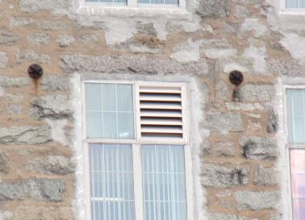
Outside air intake vent for ERV
Picture 2
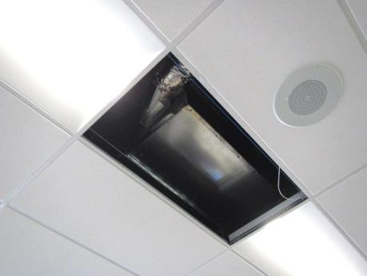
Heat pump located above ceiling tile system
Picture 3
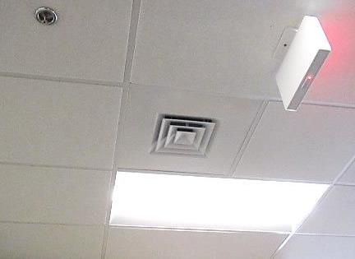
Multi-directional supply diffuser
Picture 4
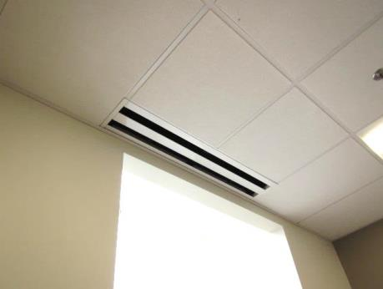
Slotted supply diffuser
Picture 5
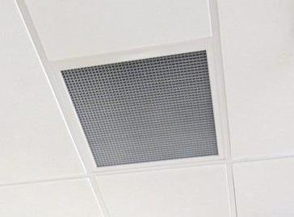
Return grate
Picture 6
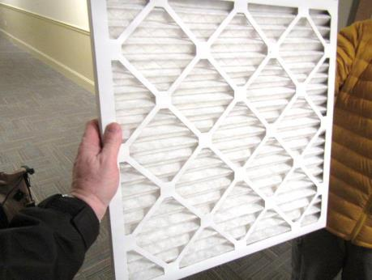
Pleated MERV 8 filter
Picture 7
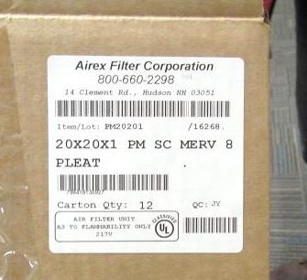
Pleated MERV 8 filters

Location | Carbon  Dioxide  (ppm) | Carbon Monoxide  (ppm) | Temp  (°F) | Relative  Humidity  (%) | PM2.5  (µg/m³) | TVOC  (ppm) | Occupants  in Room | Windows  Openable | Ventilation |  | Remarks
 |  |  |  |  |  |  |  |  | Supply | Exhaust
Background | 397 | ND | 53 | 31 | 4 | ND |  |  |  |  | Cloudy, cool, breezy
Lobby | 608 | ND | 68 | 41 | 5 | ND | 2 | N | Y | N
DDS
Reception | 711 | ND | 72 | 32 | 7 | ND | 3 | N | Y | N
207 Conference Room | 738 | ND | 73 | 30 | 6 | ND | 2 | N | Y | Y
208-211 | 670 | ND | 73 | 29 | 4 | ND | 2 | N | Y | N
212-215 | 694 | ND | 74 | 29 | 4 | ND | 1 | N | Y | Y | Cracked window pane, plants
216-219 | 677 | ND | 74 | 29 | 3 | ND | 0 | Y | Y | N
220-223 | 705 | ND | 74 | 29 | 4 | ND | 4 | Y | Y | N | Plants
224-227 | 677 | ND | 74 | 30 | 3 | ND | 2 | N | Y | Y | Broken CT
228 | 698 | ND | 73 | 31 | 2 | ND | 1 | Y | Y | Y | DO
229 | 674 | ND | 73 | 31 | 4 | ND | 1 | Y | Y | Y
230 | 685 | ND | 73 | 30 | 3 | ND | 0 | N | Y | Y | DO
231 | 704 | ND | 73 | 30 | 3 | ND | 0 | N | Y | Y | DO
232 | 712 | ND | 73 | 31 | 8 | ND | 1 | N | Y | Y | DO
233-234 | 705 | ND | 73 | 31 | 3 | ND | 0 | N | Y | Y
235 Small Conference Room | 651 | ND | 74 | 29 | 3 | ND | 0 | N | Y | Y
236 | 744 | ND | 74 | 30 | 3 | ND | 1 | N | Y | Y | DO
237 Storage | 689 | ND | 73 | 30 | 3 | ND | 0 | N | Y | N | DO
238 Storage | 643 | ND | 74 | 28 | 4 | ND | 0 | N | Y | N
239 Records Room | 675 | ND | 74 | 29 | 4 | ND | 2 | N | Y | N
MRC
Mail Room | 612 | ND | 71 | 30 | 10 | ND | 0 | N | Y | N
202 | 715 | ND | 72 | 31 | 7 | ND | 0 | N | Y | Y
203 Conference Room | 904 | ND | 72 | 35 | 9 | ND | 9 | N | Y | Y | DO
204 | 685 | ND | 72 | 31 | 6 | ND | 0 | N | Y | Y | DO
205 | 686 | ND | 72 | 32 | 7 | ND | 0 | N | Y | Y | DO
206 | 677 | ND | 71 | 31 | 5 | ND | 0 | N | Y | Y | DO
252 Kitchen | 604 | ND | 72 | 31 | 10 | ND | 2 | N | Y | Y
254 Conference Room | 588 | ND | 71 | 30 | 7 | ND | 0 | Y | Y | Y | Auxiliary exhaust
255 | 581 | ND | 72 | 30 | 11 | ND | 0 | Y | Y | Y
Server Room | 569 | ND | 70 | 31 | 12 | ND | 0 | N | N | N | Wall-mounted AC
258 | 523 | ND | 71 | 31 | 15 | ND | 0 | N | Y | N | DO
260 | 549 | ND | 71 | 31 | 16 | ND | 0 | N | Y | Y
261 | 528 | ND | 72 | 30 | 16 | ND | 1 | N | Y | Y
263-264 | 539 | ND | 71 | 31 | 16 | ND | 0 | N | Y | N
265-266 | 518 | ND | 71 | 30 | 18 | ND | 0 | Y | Y | N
267 | 529 | ND | 71 | 30 | 17 | ND | 1 | Y | Y | Y | DO
270-271 | 542 | ND | 71 | 30 | 16 | ND | 0 | N | Y | N
272-273 | 535 | ND | 71 | 31 | 15 | ND | 1 | N | Y | Y
274-275 | 527 | ND | 71 | 30 | 17 | ND | 0 | N | Y | N
276-282 | 532 | ND | 71 | 29 | 16 | ND | 0 | N | Y | N
278 | 516 | ND | 71 | 31 | 15 | ND | 0 | N | Y | N | PF, plants
279 | 530 | ND | 71 | 30 | 16 | ND | 0 | N | Y | N

