ODOR INVESTIGATION

Massachusetts Executive Office of Health and Human Services
Human Resources Department
600 Washington Street, 7th floor
Boston, Massachusetts

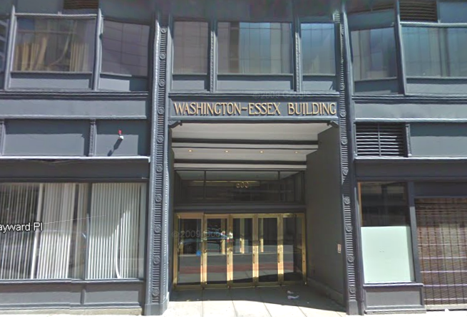

Prepared by:
Massachusetts Department of Public Health
Bureau of Environmental Health
Indoor Air Quality Program
May 2013

Background/Introduction
At the request of Marcy Little-Conley of the Executive Office of Health and Human Services, Human Resources Department (HHS), the Massachusetts Department of Public Health (MDPH), Bureau of Environmental Health (BEH) provided assistance and consultation regarding indoor air quality (IAQ) at the HHS office, located on the 7th floor of 600 Washington Street, Boston, MA. The assessment was prompted by odors and concerns of respiratory symptoms in the areas of the building occupied by Human Resources. On May 1, 2013 Mike Feeney, Director of BEH’s IAQ Program, visited the building. At that time, no specific source of the odor was identified and additional cleaning and ventilation were recommended. Mr. Feeney returned to the building on May 2, 2013, accompanied by Ruth Alfasso, Environmental Engineer/Inspector for BEH’s IAQ Program to conduct additional testing and assessment. By that time, the odor had been traced to a rotted orange in a trash bin, which had been removed by the time of the BEH/IAQ visit and the odor was dissipating. More information on this can be found in the volatile organic compounds (VOCs) section of this report.
The HHS offices are located on the seventh floor of 600 Washington Street, a high-rise building containing many other state offices. BEH/IAQ visits to other tenants and floors of this building have been conducted previously. The space, taking up a portion of the 7th floor, consists of offices and modular workstations with cloth-covered dividers (cubicles). Ceilings consist of suspended ceiling tiles. Flooring in the majority of areas consists of carpet squares. Windows appeared to be painted shut along the side of the building where the assessment was conducted.

Methods
Air tests for carbon dioxide, carbon monoxide, temperature and relative humidity were taken with the TSI, Q-Trak, IAQ Monitor 7565. Air tests for airborne particle matter with a diameter less than 2.5 micrometers were taken with the TSI, DUSTTRAK™ Aerosol Monitor Model 8520. Air testing for VOCs was conducted using a MiniRAE 2000 photoionization detector. BEH/IAQ staff also performed visual inspection of building materials for sources of odor, water damage and/or microbial growth.

Results
The HHS department has an employee population of approximately 20. The tests were taken during normal operations. Test results appear in Table 1.

Discussion

Ventilation
It can be seen from Table 1 that carbon dioxide levels were below 800 parts per million (ppm) in all areas tested, indicating adequate air exchange at the time of assessment. It is important to note that a number of areas were sparsely populated or unoccupied at the time measurements were taken, which may result in reduced carbon dioxide levels. Carbon dioxide levels would be expected to be higher with full occupancy.
Heating, ventilation and air-conditioning (HVAC) is provided by rooftop air-handling units (AHUs). Fresh air is drawn into the AHUs and delivered to occupied areas via ceiling-mounted air diffusers. Return air is drawn into the ceiling plenum via ceiling-mounted exhaust grates and directed back into the AHU.
To maximize air exchange, the MDPH recommends that both supply and exhaust ventilation operate continuously during periods of occupancy. In order to have proper ventilation with a mechanical supply and exhaust system, the systems must be balanced to provide an adequate amount of fresh air to the interior of a room while removing stale air from the room. It is recommended that HVAC systems be re-balanced every five years to ensure adequate air systems function (SMACNA, 1994). The date of the last balancing of these systems was not available at the time of assessment.
Minimum design ventilation rates are mandated by the Massachusetts State Building Code (MSBC). Until 2011, the minimum ventilation rate in Massachusetts was higher for both occupied office spaces and general classrooms, with similar requirements for other occupied spaces (BOCA, 1993). The current version of the MSBC, promulgated in 2011 by the State Board of Building Regulations and Standards (SBBRS), adopted the 2009 International Mechanical Code (IMC) to set minimum ventilation rates. Please note that the MSBC is a minimum standard that is not health-based. At lower rates of cubic feet per minute (cfm) per occupant of fresh air, carbon dioxide levels would be expected to rise significantly. A ventilation rate of 20 cfm per occupant of fresh air provides optimal air exchange resulting in carbon dioxide levels at or below 800 ppm in the indoor environment in each area measured. MDPH recommends that carbon dioxide levels be maintained at 800 ppm or below. This is because most environmental and occupational health scientists involved with research on IAQ and health effects have documented significant increases in indoor air quality complaints and/or health effects when carbon dioxide levels rise above the MDPH guidelines of 800 ppm for schools, office buildings and other occupied spaces (Sundell, J. et al., 2011). The ventilation must be on at all times that the room is occupied. Providing adequate fresh air ventilation with open windows and maintaining the temperature in the comfort range during the cold weather season is impractical. Mechanical ventilation is usually required to provide adequate fresh air ventilation.
Carbon dioxide is not a problem in and of itself. It is used as an indicator of the adequacy of the fresh air ventilation. As carbon dioxide levels rise, it indicates that the ventilating system is malfunctioning or the design occupancy of the room is being exceeded. When this happens, a buildup of common indoor air pollutants can occur, leading to discomfort or health complaints. The Occupational Safety and Health Administration (OSHA) standard for carbon dioxide is 5,000 parts per million parts of air (ppm). Workers may be exposed to this level for 40 hours/week, based on a time-weighted average (OSHA, 1997).
The MDPH uses a guideline of 800 ppm for publicly occupied buildings. A guideline of 600 ppm or less is preferred in schools due to the fact that the majority of occupants are young and considered to be a more sensitive population in the evaluation of environmental health status. Inadequate ventilation and/or elevated temperatures are major causes of complaints such as respiratory, eye, nose and throat irritation, lethargy and headaches. For more information concerning carbon dioxide, consult Appendix A.
Temperature readings in occupied areas ranged from 75º F to 77º F during the assessment, which were within the MDPH recommended comfort guideline (Table 1). The MDPH recommends that indoor air temperatures be maintained in a range of 70º F to 78º F in order to provide for the comfort of building occupants. In many cases concerning indoor air quality, fluctuations of temperature in occupied spaces are typically experienced, even in a building with an adequate fresh air supply.
The relative humidity measured during the assessment ranged from 30 to 34 percent (Table 1), which was below the MDPH recommended comfort range in all areas surveyed. The MDPH recommends a comfort range of 40 to 60 percent for indoor air relative humidity. Relative humidity levels in the building would be expected to drop during the winter months due to heating.

Microbial/Moisture Concerns
In order for building materials to support mold growth, a source of water exposure is necessary. No evidence of building leaks, plumbing leaks or water damage were observed in the office space.
Refrigerators and water coolers were observed to be located on carpeting (Picture 1). These appliances can leak or spill resulting in moistening of carpet. It is recommended that these items be located on a non-porous surface (e.g., tile, rubber, plastic).
Plants were observed in some areas (Table 1; Picture 2). Plants should be properly maintained and equipped with drip pans. Plants should also be located away from ventilation sources to prevent aerosolization of dirt, pollen or mold. Plants should not be placed on porous materials, since water damage to porous materials may lead to microbial growth.
The US Environmental Protection Agency (US EPA) and the American Conference of Governmental Industrial Hygienists (ACGIH) recommend that porous materials (e.g., carpeting, gypsum wallboard) be dried with fans and heating within 24 to 48 hours of becoming wet (US EPA, 2001; ACGIH, 1989). If not dried within this time frame, mold growth may occur. Once mold has colonized porous materials, they are difficult to clean and should be removed.

Other IAQ Evaluations
Indoor air quality can be negatively influenced by the presence of respiratory irritants, such as products of combustion. The process of combustion produces a number of pollutants. Common combustion emissions include carbon monoxide, carbon dioxide, water vapor and smoke (fine airborne particle material). Of these materials, exposure to carbon monoxide and particulate matter with a diameter of 2.5 micrometers (μm) or less (PM2.5) can produce immediate, acute health effects upon exposure. To determine whether combustion products were present in the indoor environment, BEH/IAQ staff obtained measurements for carbon monoxide and PM2.5.

Carbon Monoxide
Carbon monoxide is a by-product of incomplete combustion of organic matter (e.g., gasoline, wood and tobacco). Exposure to carbon monoxide can produce immediate and acute health affects. Several air quality standards have been established to address carbon monoxide and prevent symptoms from exposure to these substances. The MDPH established a corrective action level concerning carbon monoxide in ice skating rinks that use fossil-fueled ice resurfacing equipment. If an operator of an indoor ice rink measures a carbon monoxide level over 30 ppm, taken 20 minutes after resurfacing within a rink, that operator must take actions to reduce carbon monoxide levels (MDPH, 1997).
The American Society of Heating Refrigeration and Air-Conditioning Engineers (ASHRAE) has adopted the National Ambient Air Quality Standards (NAAQS) as one set of criteria for assessing indoor air quality and monitoring of fresh air introduced by HVAC systems (ASHRAE, 1989). The NAAQS are standards established by the US EPA to protect the public health from six criteria pollutants, including carbon monoxide and particulate matter (US EPA, 2006). As recommended by ASHRAE, pollutant levels of fresh air introduced to a building should not exceed the NAAQS levels (ASHRAE, 1989). The NAAQS were adopted by reference in the Building Officials & Code Administrators (BOCA) National Mechanical Code of 1993 (BOCA, 1993), which is now an HVAC standard included in the Massachusetts State Building Code (SBBRS, 2011). According to the NAAQS, carbon monoxide levels in outdoor air should not exceed 9 ppm in an eight-hour average (US EPA, 2006).
Carbon monoxide should not be present in a typical, indoor environment. If it is present, indoor carbon monoxide levels should be less than or equal to outdoor levels. On the day of assessment, outdoor carbon monoxide concentrations were non-detect (ND). No measureable levels of carbon monoxide were detected inside the building during the assessment.

Particulate Matter
The US EPA has established NAAQS limits for exposure to particulate matter. Particulate matter includes airborne solids that can be irritating to the eyes, nose and throat. The NAAQS originally established exposure limits to PM with a diameter of 10 μm or less (PM10). In 1997, US EPA established a more protective standard for fine airborne particulate matter with a diameter of 2.5 μm or less (PM2.5). The NAAQS has subsequently been revised, and PM2.5 levels were reduced. This more stringent PM2.5 standard requires outdoor air particle levels be maintained below 35 μg/m³ over a 24-hour average (US EPA, 2006). Although both the ASHRAE standard and BOCA Code adopted the PM10 standard for evaluating air quality, MDPH uses the more protective PM2.5 standard for evaluating airborne PM concentrations in the indoor environment.
PM2.5 levels measured in occupied areas ranged from 6 to 7 μg/m³ (Table 1), which were below the NAAQS PM2.5 level of 35 μg/m³. Frequently, indoor air levels of particulates (including PM2.5) can be at higher levels than those measured outdoors. A number of mechanical devices and/or activities that occur indoors can generate particulate during normal operations. Sources of indoor airborne particulates may include but are not limited to particles generated during the operation of fan belts in the HVAC system, use of stoves and/or microwave ovens in kitchen areas; use of photocopiers, fax machines and computer printing devices; operation of an ordinary vacuum cleaner and heavy foot traffic indoors.

Volatile Organic Compounds
Indoor air concentrations can be greatly impacted by the use of products containing VOCs. VOCs are carbon-containing substances that have the ability to evaporate at room temperature. Frequently, exposure to low levels of total VOCs (TVOCs) may produce eye, nose, throat and/or respiratory irritation in some sensitive individuals. For example, chemicals evaporating from a paint can stored at room temperature would most likely contain VOCs.
In an effort to determine whether VOCs were present in the building, including additional sources of odor and irritants, air monitoring for TVOCs was conducted. An outdoor air sample was taken for comparison. Outdoor TVOC concentrations were ND. No measureable levels of TVOCs were detected inside the building during the assessment (Table 1).
Please note, that the TVOC air measurements are only reflective of the indoor air concentrations present at the time of sampling. Indoor air concentrations can be greatly impacted by the use TVOC-containing products such as cleaners and deodorizing materials, and items which may off-gas TVOCs.
As mentioned above, the request for an IAQ assessment was prompted by reports of an odor in the Human Resources area. Staff in the areas described the odor as an alcohol or acetone (nail polish remover) and had described irritant symptoms. This odor had reportedly started occurring a few days before the first BEH/IAQ visit and appeared to be intensifying. At the time of the May 1, 2013 visit, no source of the odor was identified, however BEH staff noted a odor in this area. At the time of the return visit on May 2, 2013 it was reported to BEH/IAQ staff that the odor had been traced to a rotting orange in a trash bin that had not been emptied in several days. Prior to the May 2, 2013 BEH/IAQ visit, this waste receptacle had been emptied including the trash bag inside it. However, a faint orange odor was detected on the trash can itself, so it was also removed.
The peel of an orange contains several compounds with strong odors and potential irritant properties, including D-limonene. D-limonene has an odor threshold (can be detected by smelling) at as little as 8 parts per billion (ppb) (Cain et al, 2007). This is a lower concentration than can be measured by the MiniRAE photo ionization detector, which can detect concentrations down to about 0.1 ppm (100 ppb) but cannot be reliably used to quantify concentrations below 1 ppm.
As an orange breaks down through the action of yeasts, molds and other microorganisms, VOCs can be released, along with other products of degradation, including alcohols, sulfur compounds and mold spores. The operation of the ventilation systems in the building, along with air currents caused by foot traffic and the operation of photocopiers and other office equipment, can distribute the odor to areas not directly adjacent to the source. Prompt removal of spoiled food, and regular emptying of trash cans can prevent any reoccurrence of this condition.
Additionally, photocopiers were in use in several areas, including directly adjacent to occupied areas. VOCs and ozone can be produced by photocopiers, particularly if the equipment is older and in frequent use. Ozone is a respiratory irritant (Schmidt Etkin, 1992). Exhaust ventilation should be activated in these areas to help reduce excess heat and odors.
An open box containing a stack of glossy printed materials was observed in the area of concern, and other boxes possibly containing similar materials were noted in other locations in the office. The inks on these printed materials may off-gas VOCs and associated odors when present in large quantities. Large quantities of printed materials should be stored in closed boxes and away from occupied areas.

Conclusions/Recommendations
In view of the findings at the time of the visit, the following recommendations are made:
- Ensure that all trash is removed from the office areas at the end of each workday, and consider directly disposing of any organic material in kitchen areas instead of in cubicle bins.
- Continue operating all mechanical HVAC systems to provide fresh air during occupied periods.
- Consider adopting a balancing schedule of every 5 years for all mechanical ventilation systems, as recommended by ventilation industry standards (SMACNA, 1994).
- For buildings in New England, periods of low relative humidity during the winter are often unavoidable. Therefore, scrupulous cleaning practices should be adopted to minimize common indoor air contaminants whose irritant effects can be enhanced when the relative humidity is low. To control for dusts, a high efficiency particulate arrestance (HEPA) filter equipped vacuum cleaner in conjunction with wet wiping of all surfaces is recommended. Drinking water during the day can help ease some symptoms associated with a dry environment (throat and sinus irritations).
- Consider moving water dispensing equipment to areas with tiled floors instead of carpeting, or installing waterproof mats to prevent leaks/overflow from damaging carpet.
- Consider locating heavily-used photocopying equipment away from occupied areas and in areas with effective exhaust ventilation.
- Store large quantities of printed matter in closed boxes and away from occupied areas.
- Refer to resource manuals and other related indoor air quality documents for further building-wide evaluations and advice on maintaining public buildings. Copies of these materials are located on the MDPH’s website: http://mass.gov/dph/iaq.

References
ACGIH. 1989. Guidelines for the Assessment of Bioaerosols in the Indoor Environment. American Conference of Governmental Industrial Hygienists, Cincinnati, OH.
ASHRAE. 1989. Ventilation for Acceptable Indoor Air Quality. American Society of Heating, Refrigeration and Air Conditioning Engineers. ANSI/ASHRAE 62-1989.
Berry, M.A. 1994. Protecting the Built Environment: Cleaning for Health, Michael A. Berry, Chapel Hill, NC.
BOCA. 1993. The BOCA National Mechanical Code/1993. 8th ed. Building Officials and Code Administrators International, Inc., Country Club Hill, IL. Section M-308.1.1.
Cain, et. al. 2007. Cain, W.S., R. Schmidt and P. Wolkoff. Olfactory detection of ozone and D-limonene: reactants in indoor spaces. Indoor Air, Volume 17: pp 337–347.
MDPH. 1997. Requirements to Maintain Air Quality in Indoor Skating Rinks (State Sanitary Code, Chapter XI). 105 CMR 675.000. Massachusetts Department of Public Health, Boston, MA.
OSHA. 1997. Limits for Air Contaminants. Occupational Safety and Health Administration. Code of Federal Regulations. 29 C.F.R 1910.1000 Table Z-1-A.
SBBRS. 2011. Mechanical Ventilation. State Board of Building Regulations and Standards. Code of Massachusetts Regulations, 8th edition. 780 CMR 1209.0.
SMACNA. 1994. HVAC Systems Commissioning Manual. 1st ed. Sheet Metal and Air Conditioning Contractors’ National Association, Inc., Chantilly, VA.
Schmidt Etkin, D. 1992. Office Furnishings/Equipment & IAQ Health Impacts, Prevention & Mitigation. Cutter Information Corporation, Indoor Air Quality Update, Arlington, MA.
Sundell. 2011. Sundell, J., H. Levin, W. W. Nazaroff, W. S. Cain, W. J. Fisk, D. T. Grimsrud, F. Gyntelberg, Y. Li, A. K. Persily, A. C. Pickering, J. M. Samet, J. D. Spengler, S. T. Taylor, and C. J. Weschler. Ventilation rates and health: multidisciplinary review of the scientific literature. Indoor Air, Volume 21: pp 191–204.
US EPA. 2001. Mold Remediation in Schools and Commercial Buildings. US Environmental Protection Agency, Office of Air and Radiation, Indoor Environments Division, Washington, DC. EPA 402-K-01-001. March 2001.
US EPA. 2006. National Ambient Air Quality Standards (NAAQS). US Environmental Protection Agency, Office of Air Quality Planning and Standards, Washington, DC. http://www.epa.gov/air/criteria.html.
Picture 1

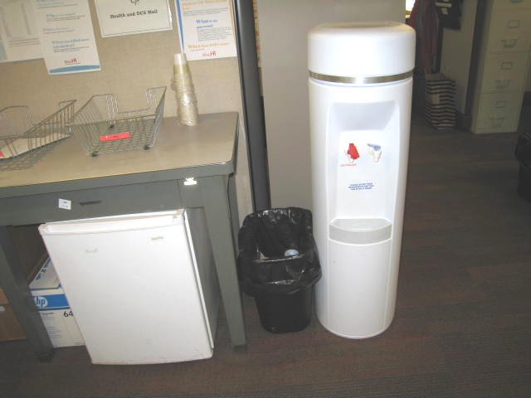

Refrigerator and water dispenser on carpet

Picture 2

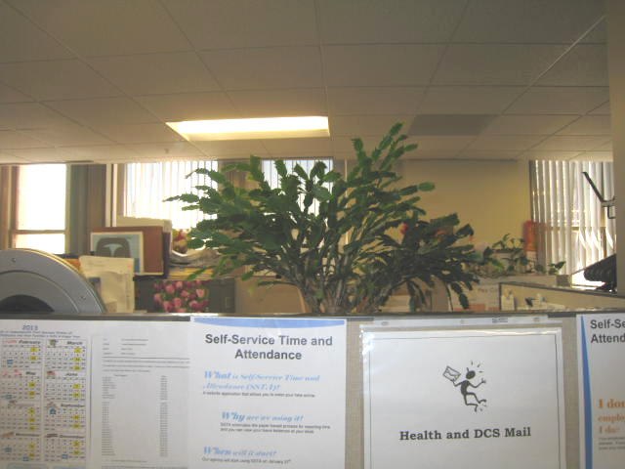

Plants in cubicle
Location | Carbon  Dioxide  (ppm) | Carbon Monoxide  (ppm) | Temp  (°F) | Relative  Humidity  (%) | TVOCs  (ppm) | PM2.5  (ug/m³) | Occupants  in Room | Windows  Openable | Ventilation |  |  | Remarks
 |  |  |  |  |  |  |  |  | Intake | Exhaust |  | Remarks
Background (outdoors) | 516 | ND | 71 | 30 | ND |  |  | N | Y |  | Y | Sunny
7088 | 649 | ND | 75 | 34 | ND | 7 | 0 | N | Y |  | Y | Plants
7089 | 618 | ND | 75 | 33 | ND | 7 | 0 | N | N |  | N
7091 | 701 | ND | 76 | 31 | ND | 7 | 0 | N | N |  | N
7092-7093 | 672 | ND | 76 | 30 | ND | 7 | 0 | N | Y |  | Y
7094-7097 | 674 | ND | 76 | 30 | ND |  | 3 | N | Y |  | Y | AP
7098-7101 | 672 | ND | 75 | 32 | ND |  | 3 | N | Y |  | Y | Plants
7103-7105 | 672 | ND | 76 | 30 | ND |  | 3 | N | Y |  | Y
7107 | 717 | ND | 77 | 30 | ND | 7 | 3 | N | Y |  | Y | Plants
7108 | 760 | ND | 77 | 30 | ND | 6 | 2 | N | Y |  | Y | Items
7110 | 678 | ND | 76 | 30 | ND |  | 0 | N | Y |  | Y | Wall hangings
7111 | 672 | ND | 76 | 30 | ND |  | 0 | N | Y |  | Y
7112 | 663 | ND | 76 | 30 | ND |  | 0 | N | Y |  | Y | PF
7113 | 677 | ND | 76 | 30 | ND |  | 0 | N | Y |  | Y

