INDOOR AIR QUALITY ASSESSMENT

EOHHS Service Center
300 Howard Street
2nd Floor Department of Children and Families
Framingham, Massachusetts

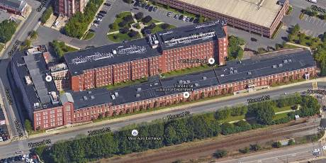

Prepared by:
Massachusetts Department of Public Health
Bureau of Environmental Health
Indoor Air Quality Program
February 2016

BACKGROUND
Building: | EOHHS Service Center, Department of Children and Families (DCF)
Address: | 300 Howard Street, 2nd Fl, Framingham, MA
Assessment Requested by: | Erin R. McCabe, EHS Facilities Deputy Director for Finance and Operations
Reason for Request: | Gas odors
Date of Assessment: | February 11, 2016
Massachusetts Department of Public Health/Bureau of Environmental Health (MDPH/BEH) Staff Conducting Assessment: | Cory Holmes, Environmental Analyst/Inspector, Indoor Air Quality (IAQ) Program
Date of Building Construction: | Pre-1900s
Building/Site Description: | DCF is located on the second story, of a former manufacturing plant that has been completely renovated into state offices.
Building Population: | Reportedly 9 individuals currently work in the affected area.
Windows: | Not openable

Executive Summary:
No significant public health concerns were identified during this visit. Air testing of constituents of concern (i.e., carbon monoxide, particulate matter (pm2.5) and total volatile organic compounds (TVOCs) were non-detect (ND) or below National Ambient Air Quality Standards (NAAQS). However odors were detected during the visit, which can be a source of irritation and should be further investigated/addressed as illustrated in this report.

METHODS
Please refer to the IAQ Manual and appendices for methods, sampling procedures, and interpretation of results (MDPH, 2015).

RESULTS and DISCUSSION
The following is a summary of indoor air testing result (Table 1).
- Carbon monoxide levels were non-detectable (ND) in all areas tested.
- Carbon dioxide levels were slightly above the MDPH recommended guideline of 800 parts per million (ppm) due to thermostats being set to fan “auto”, as well as the likely reduction of outside air intake due to subzero temperature conditions.
- Particulate matter (PM2.5) concentrations measured were below the National Ambient Air Quality (NAAQS) level of 35 μg/m³ in all areas tested.
- Total volatile organic compounds (TVOCs) were ND in all areas tested.
The office space consists of large open work area “sections” configured in a linear fashion. The odors were reported to be isolated to the middle office area section known as section 4 (Picture 1). Slight odors were detected upon crossing the threshold walking westerly from section 3 into section 4. The natural gas-like odors dissipated/were not detected upon entry crossing from section 4 into section 5.
The heating, ventilation, and air conditioning (HVAC) system consists of rooftop air-handling units (AHUs, Picture 2). Conditioned outside air is drawn in through intakes at roof level and distributed to occupied areas via ducted ceiling vents (Picture 3) and is returned to the AHUs by ducted ceiling- or wall-mounted return vents (Picture 2).
No obvious sources of gas/odors were identified within the office space, and odors were limited to section 4. The odor source is likely outside the office space, and may include but is not limited to:
- Gas/fuel burning in rooftop AHUs;
- Entrainment of gas/odors/exhaust from nearby sources on the rooftop;
- Sources/ductwork/pipes within the wall cavities (e.g., between sections 3 & 4); or
- Sources/ductwork/pipes above the ceiling tile system.

CONCLUSIONS and RECOMMENDATIONS
The following recommendations were made at the time of the assessment and are reiterated below:
- If possible, relocate symptomatic staff in the affected area to a different location until the problem has been resolved.
- Ensure the HVAC system for section 4 is thoroughly examined, cleaned, and repaired by a person or group of people with expertise in both plumbing and HVAC systems. Start with the unit on the roof:
  - Fully examine to ensure there are no fuel leaks;
  - Ensure combustion and related activities are well controlled and occurring in accordance with system requirements;
  - Examine all filtration to ensure it is installed and seated properly and of a suitable type; and
  - Ensure no breaches in the AHU system which may lead to odors.
- Examine the rooftop area around the unit for sources of odors including leaking gas pipes, exhaust vents, and improperly stored materials.
- Continue the examination with all associated ductwork as it enters the building. Use ladders or lifts inside section 4 to examine the fresh air distribution, return and exhaust system in its entirety, looking for cross connections, improperly set dampers, and breaches that may draw in odors from other areas.
- Test/inspect any gas piping in the building for leaks.
- Examine adjacent space. Occupants who have reported these odors also reported that when the occupants of the adjacent South Middlesex Opportunity Council (SMOC) Behavioral Health offices HVAC systems were turned off, the odors were not as prominent, so examination of this system may also be necessary.
- Consider adding a digital readout carbon monoxide detector to the space in a visible location. A unit is installed in the ceiling, but no real-time results from this are available unless the alarm is triggered.
- Ensure that thermostats are set to “fan on” during occupied periods for continuous air exchange.

REFERENCES
MDPH. 2015. Massachusetts Department of Public Health. Indoor Air Quality Manual: Chapters I-III. Available at: http://www.mass.gov/eohhs/gov/departm ents/dph/programs/environmental-health/exposure-topics/iaq/iaq-manual/.

Picture 1

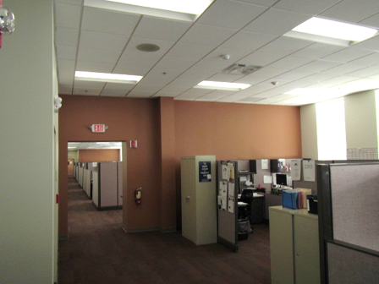

DCF Section 4 where odors were reported/detected
Picture 2
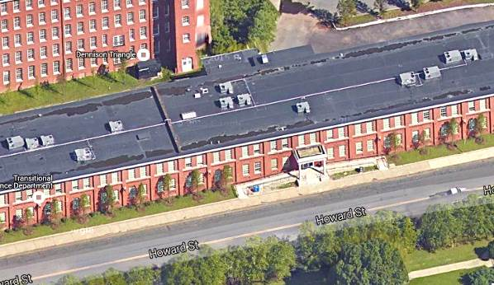

Rooftop air handling units
Picture 3
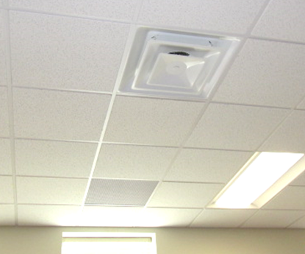
Return Vent
Supply Diffuser

Typical ceiling-mounted supply and return vents

Location | Carbon  Dioxide  (ppm) | Carbon Monoxide  (ppm) | TVOCs  (ppm) | PM2.5  (µg/m³) | Occupants  in Room | Windows  Openable | Ventilation |  |  | Remarks
 |  |  |  |  |  |  | Intake | Exhaust
Background | 429 | ND | ND | 4-16 |  |  |  |  |  | Cold, overcast moderate to heavy traffic/parking around the building
Section 3
2218-2219 | 874 | ND | ND | 1 | 0 | N | Y |  | Y | Thermostat fan “auto”, no odors
2232 | 833 | ND | ND | 1 | 3 | N | Y |  | Y | No odors
2234-2342 | 807 | ND | ND | 1 | 0 | N | Y |  | Y | Thermostat fan ‘auto”, no odors
Section 4
2352 | 837 | ND | ND | 2 | 3 | N | Y |  | Y | Slight ‘gas-like” odor detected
2358-2360 | 838 | ND | ND | 2 | 0 | N | Y |  | Y | Slight ‘gas-like” odor detected, CO alarm mounted on ceiling
2371 | 853 | ND | ND | 1 | 8 | N | Y |  | Y | Slight odors detected, thermostat fan “auto”
2381 | 839 | ND | ND | 2 | 0 | N | Y |  | Y
Kitchen 2251 | 846 | ND | ND | 1 | 2 | N | Y |  | Y
Section 5
2405 | 801 | ND | ND | 2 | 5 | N | Y |  | Y | No odors detected
2407 | 888 | ND | ND | 2 | 1 | N | Y |  | Y

