INDOOR AIR QUALITY
WATER DAMAGE ASSESSMENT

EOHHS Service Center
300 Howard Street
Framingham, Massachusetts

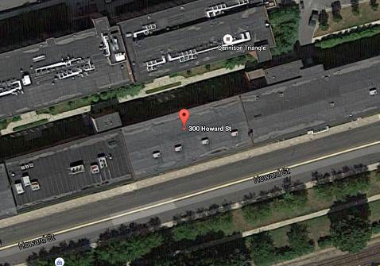

Prepared by:
Massachusetts Department of Public Health
Bureau of Environmental Health
Indoor Air Quality Program
September 2015

Background
Building: | EOHHS Service Center
Address: | 300 Howard Street, Framingham, MA
Assessment Requested by: | Erin R. McCabe  EHS Facilities Deputy Director for Finance and Operations
Date of Assessment: | August 17, 2015
BEH/IAQ Staff Conducting Assessment: | Michael Feeney, Director  Ruth Alfasso, Inspector
Date of Building Construction: | Pre 1900s
Reason for Request: | Water infiltration and mold concerns

Building Description: The Service Center occupies the lower two floors of a former manufacturing building originally built in the 1800s. The building had been used for office space for at least the previous 20 years and undergone a complete gut rehab prior to the current tenancy.
The space contains offices, open workstations, reception/waiting rooms, conference rooms, storage and kitchen areas. Ceilings consist of suspended ceiling tiles. Floors consist of wall to wall carpeting in the majority of areas. Windows are not openable.
Note that previous visits have been made to this building, including a post-occupancy assessment about a month after this EOHHS center tenancy began on July 10, 2015. A report on that visit is forthcoming.

Methods/Results
BEH/IAQ staff performed a visual inspection of building materials for water damage and/or microbial growth and inspection of the exterior for sources of water.

Discussion

Microbial/Moisture Concerns
This visit was prompted by reports of several leaks in the building over the last several weeks. Leaks have been preceded by heavy weather events on August 4 and 15, 2015, including hail and torrential rain. The following was observed:
- Water-damaged ceiling tiles on the second floor near windows along the south edge of the building (Pictures 1 through 3). Water had also been reported on a desktop in this area;
- Water-damaged and one visibly wet ceiling tile towards the middle of the building (Pictures 4 and 5);
- Water-damaged and mold-colonized gypsum wallboard on the lower level along the north side of the building (Pictures 6 and 7). Carpet squares had been removed in this area and some coving had been removed from the wall, but the wallboard had been wet long enough to grow mold.
The US EPA and the American Conference of Governmental Industrial Hygienists (ACGIH) recommend that porous materials be dried with fans and heating within 24 to 48 hours of becoming wet (US EPA, 2001; ACGIH, 1989). If porous materials are not dried within this time frame, mold growth may occur. Once mold has colonized porous materials, they are difficult to clean and should be removed and discarded.
The following conditions are likely contributing to water infiltration into the building.
- The northeastern edge of the roof is unfinished with exposed wood and unfolded/tacked in tar paper (Pictures 8 and 9), which would allow water infiltration from rain into the building interior in wind-driven rain.
- Windows on the southeastern side of the building appear to be sealed with spray foam (Picture 10), which is not a suitable material for use as window sealant.
- The exterior wall has a stepped, ornamental brick feature that is installed in a manner to create small ledges in the exterior wall. Mortar between seams between bricks in this feature deteriorated in several areas (Pictures 11 through 14) and appears to have been repaired inconsistently due to the presence of missing/deteriorated mortar. The brick ornamental feature appears to be at the same level as the floor of the office space that was water damaged due to the August 15, 2015 thunderstorm.
- As noted in the post-occupancy visit on July 10, 2015, the roof of this building has low spots that collect rainwater and roof drains that function poorly (Pictures 15 and 16).
It is important to note that Eastern Massachusetts experienced extreme weather condition in August 2015. Weather conditions on August 4, 2015 in the Framingham area included hail and heavy rain and winds gusting over 50 miles per hour (mph) from the west were recorded at the Worcester Airport (nws.gov). Weather on August 14, 2015 included heavy rain and thunderstorms. Over an inch and a half of rain was recorded at Worcester Airport on August 16, 2015 with winds gusting over 45 miles per hour from the west (nws.gov). The building was exposed to a significant amount of wind driven water as evidenced by flattened grass (Picture 17) and soil displaced onto a cement slab in a corner of the building along it north side near the water damaged office space. Flattened grass as well as soft, eroded, displaced soil suggests that a large quantity of water had accumulated in the corner of the exterior wall and rapidly drained over this area in a short period of time.

Conclusions/Recommendations
In view of the findings at the time of the visit, the following recommendations are made:
- Water-damaged/mold-colonized building materials should be removed in a manner consistent with recommendations found in “Mold Remediation in Schools and Commercial Buildings” published by the US Environmental Protection Agency (US EPA, 2001). Wallboard that has become mold-colonized should be removed to a level of a foot above where it was moistened.
- Develop a system to allow employees to report water infiltration/damage rapidly to applicable contacts in building management/maintenance.
- Consider systematically performing building walk-throughs following any severe weather to check for and remediate any leaks promptly. If possible, have the landlord perform these checks during weekends when needed to address problems when they occur during unoccupied periods.
- Have the areas shown in Pictures 8 and 9 on the roof finished/repaired as soon as possible.
- Investigate the function of the roof drains and drainage pipes (e.g., Pictures 2 and 17) and have repairs made as needed.
- Consider repairs to the roof of the building to improve drainage and reduce the chance of water infiltration.
- Investigate the integrity of the brickwork along the rear/north of the building and make repairs as needed.
- Improve drainage along the rear wall to prevent erosion.
- Replace spray-on insulating materials around windows as seen in Picture 10 with an appropriate permanent material.
- Refer to resource manuals and other related indoor air quality documents for further building-wide evaluations and advice on maintaining public buildings. Copies of these materials are located on the MDPH’s website: http://mass.gov/dph/iaq.

References
ACGIH. 1989. Guidelines for the Assessment of Bioaerosols in the Indoor Environment. American Conference of Governmental Industrial Hygienists, Cincinnati, OH.
US EPA. 2001. Mold Remediation in Schools and Commercial Buildings. US Environmental Protection Agency, Office of Air and Radiation, Indoor Environments Division, Washington, D.C. EPA 402-K-01-001. http://www.epa.gov/mold/mold_remediation.html
Picture 1
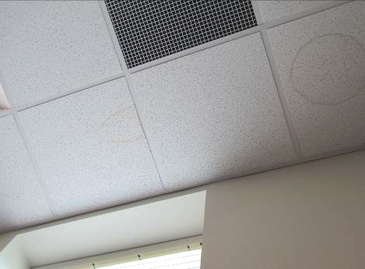
Stained ceiling tiles on front (south) side of the building
Picture 2
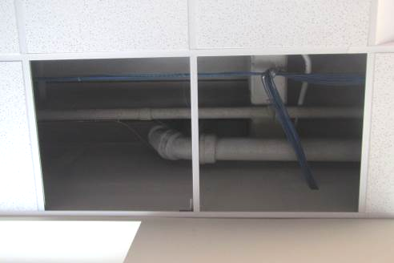
Removed ceiling tiles showing roof drain (large pipe, arrow)
Picture 3
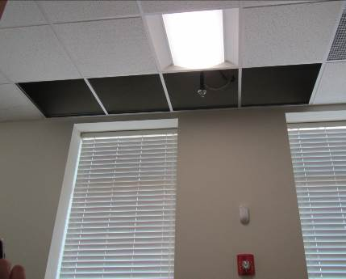
Removed ceiling tiles
Picture 4
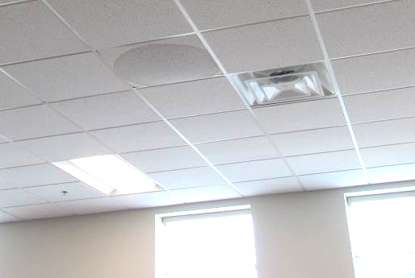
Visibly wet ceiling tile
Picture 5
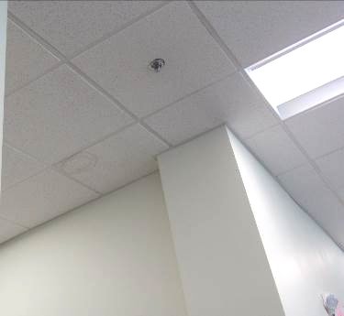
Stained ceiling tile in center of the second floor
Picture 6
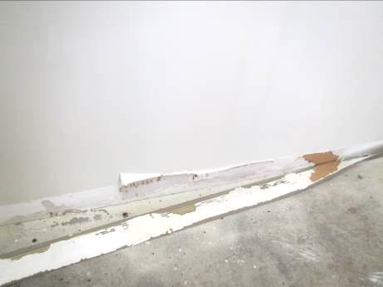
Water-damaged, mold-colonized gypsum wallboard behind removed coving on first floor
Picture 7
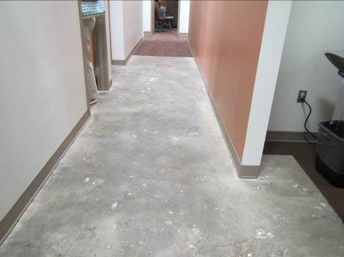
First floor hallway with carpet squares removed
Picture 8
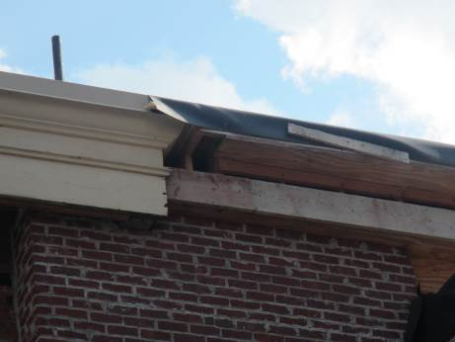
Unfinished/damaged roof along north side of building
Picture 9
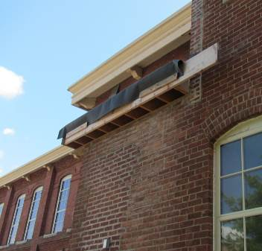
Unfinished/damaged roof
Picture 10
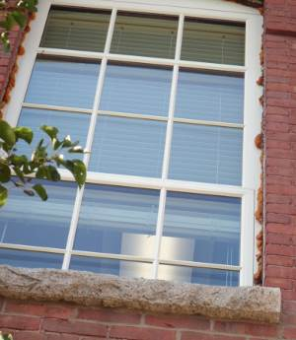
Spray foam used to seal windows on south side of building
Picture 11
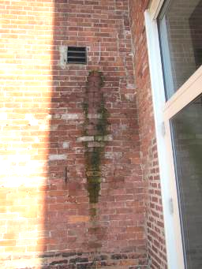
Discolored, damp brick wall
Picture 12
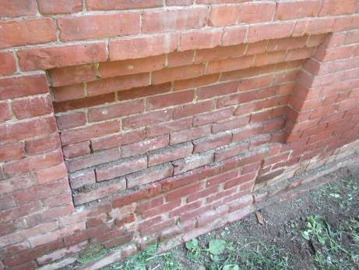
Stepped, brick ornamental feature with damp brickwork and missing mortar
Picture 13
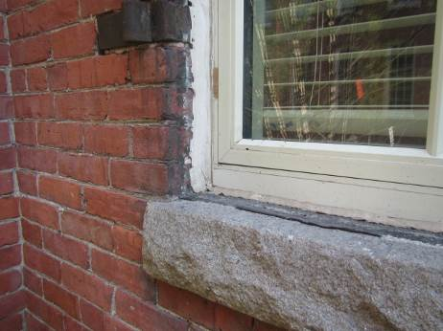
Damaged brickwork and old shutter hinge
Picture 14
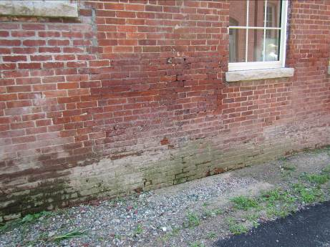
Damaged brickwork
Picture 15
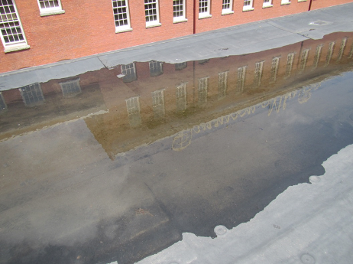
Water pooling on roof
Picture 16
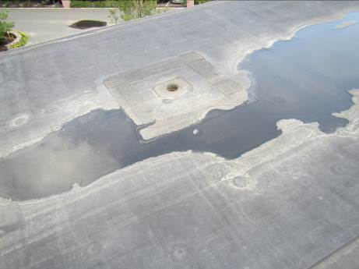
Water pooling around roof drain higher than the roof
Picture 17
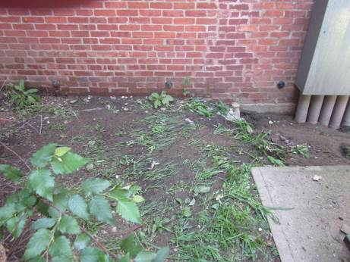
Flattened grass from fast-moving water
Picture 18
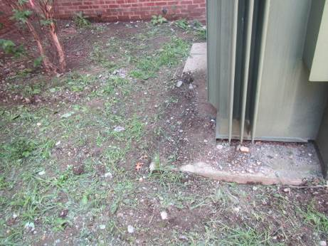
Flattened grass and displaced soil due to fast-moving water

