Background/Introduction

INDOOR AIR QUALITY ASSESSMENT

Executive Office of Health and Human Services
Human Resources
600 Washington Street, 2nd Floor
Boston, Massachusetts



Prepared by:
Massachusetts Department of Public Health
Bureau of Environmental Health
Indoor Air Quality Program
April 2010

In response to a request from Douglas Shatkin, Executive Office of Health and Human Services (EOHHS), Office of Human Resources, the Massachusetts Department of Public Health (MDPH), Bureau of Environmental Health (BEH) conducted an evaluation of the indoor air quality on the 2nd floor at 600 Washington Street, Boston, Massachusetts. On January 20, 2010, Michael Feeney, Director of BEH’s Indoor Air Quality (IAQ) Program, conducted an IAQ assessment. The primary purpose of the assessment was to evaluate potential sources of pollutants that could be contributing to respiratory problems reported by some occupants on this floor. Reports of cigarette smoke odors were also expressed.
The building was retrofitted into office space with the installation of an HVAC system above the suspended ceiling. With the exception of windows in the rear of the building, windows in the EOHHS space do not open.

Methods
Air tests for carbon monoxide, carbon dioxide, temperature and relative humidity were conducted with the TSI, Q-Trak, IAQ Monitor, Model 8551. BEH staff also performed visual inspection of building materials for water damage and/or microbial growth.

Results
The EOHHS headquarters has an employee population of approximately 100 and is visited daily by various members of the public as well as state and federal agencies. The tests were taken during normal operations and results appear in Table 1.

Discussion

Ventilation
It can be seen from Table 1 that carbon dioxide levels were below 800 parts per million (ppm) in all areas surveyed, which indicates adequate air exchange on the floor. Air-handling units (AHUs) on each floor provide fresh air to the building. AHUs are located in the ceiling, drawing air from outdoors through a series of vents located along the exterior wall of the building (Picture 1). Fresh air in occupied spaces is supplied by ceiling-mounted fresh air diffusers connected to AHUs via ductwork. Air is exhausted from the occupied space through ceiling mounted return vents connected to ductwork. In this configuration, the AHU becomes depressurized and draws air from the return air ducts and in turn, the occupied spaces.
Of note is the location of fresh air diffusers that appear to be directing airflow into a single office/cubicle. Unlike all other office/cubicles on the floor, this particular location has two fresh air diffusers that are directing air into the cubicle instead of one fresh air diffuser (Picture 2). This additional airflow can make the cubicle/office occupant uncomfortable; they may experience irritating symptoms as a result of being in direct airflow, which likely aerosolize normally occurring pollutants in the cubicle (e.g., dust and dirt).
To maximize air exchange, the MDPH recommends that both supply and exhaust ventilation operate continuously during periods of occupancy. In order to have proper ventilation with a mechanical supply and exhaust system, the systems must be balanced to provide an adequate amount of fresh air to the interior of a room, while removing stale air from the room. It is recommended that HVAC systems be re-balanced every five years (SMACNA, 1994). The date of the last balancing was not available at the time of the assessment.
The Massachusetts Building Code requires that each area have a minimum ventilation rate of 20 cubic feet per minute (cfm) per occupant of fresh outside air or openable windows (SBBRS, 1997; BOCA, 1993). The ventilation must be on at all times that the room is occupied. Providing adequate fresh air ventilation with open windows and maintaining the temperature in the comfort range during the cold weather season is impractical. Mechanical ventilation is usually required to provide adequate fresh air ventilation.
Carbon dioxide is not a problem in and of itself. It is used as an indicator of the adequacy of the fresh air ventilation. As carbon dioxide levels rise, it indicates that the ventilating system is malfunctioning or the design occupancy of the room is being exceeded. When this happens a buildup of common indoor air pollutants can occur, leading to discomfort or health complaints. The Occupational Safety and Health Administration (OSHA) standard for carbon dioxide is 5,000 parts per million parts of air (ppm). Workers may be exposed to this level for 40 hours/week, based on a time-weighted average (OSHA, 1997).
The MDPH uses a guideline of 800 ppm for publicly occupied buildings. A guideline of 600 ppm or less is preferred in schools due to the fact that the majority of occupants are young and considered to be a more sensitive population in the evaluation of environmental health status. Inadequate ventilation and/or elevated temperatures are major causes of complaints such as respiratory, eye, nose and throat irritation, lethargy and headaches. For more information concerning carbon dioxide, please see Appendix A.
Temperature readings in occupied areas were in a range of 70º F to 78º F, which were within the MDPH recommended comfort range on the day of the assessment. The MDPH recommends that indoor air temperatures be maintained in a range of 72º F to 76º F in order to provide for the comfort of building occupants. In many cases concerning indoor air quality, fluctuations of temperature in occupied spaces are typically experienced, even in a building with an adequate fresh air supply.
A lack of temperature control was expressed by occupants in numerous areas on the 2nd floor. Windows in the original section of the building were the original wood frame and significant drafts of cold air were noted around these frames (called air infiltration). Cold air infiltration through window systems can make temperature control in rooms difficult to maintain. This condition does not exist in the front of the floor where energy efficient windows were installed in place of the original window system. Reports of cold temperatures exist in areas with the original window system. Along the exterior walls beneath the windows of the office floors were large heating registers (Picture 3), which provide the majority of heating during winter months for the floor. In order for the window drafts to be tempered, the heating registers would warm the air directing the drafts upwards. For this system to work properly, the heat registers must be activated and the flow of heater fluid inside the heating coil properly regulated.
Relative humidity measurements ranged from 18 to 22 percent, which were below the MDPH recommended comfort guidelines. The MDPH recommends a comfort range of 40 to 60 percent for indoor air relative humidity. Relative humidity levels in the building would be expected to drop during the winter months due to heating. The sensation of dryness and irritation is common in a low relative humidity environment. Low relative humidity is a very common problem during the heating season in the northeast part of the United States.

Microbial Growth/Moisture Concerns
Plants were observed in several areas. Plants, soil and drip pans can serve as sources of moisture, which can initiate mold growth. Thus, plants should be properly maintained. Overwatering of plants should be avoided and drip pans should be inspected periodically for mold growth. Moreover, a few areas had water coolers installed over carpeting. Water spillage or overflow of cooler catch basins can result in the wetting of the carpet, which can lead to mold growth.

Other IAQ Evaluations
Building occupants expressed concerns about cigarette smoke odors that periodically are noticed in office space along the front of the building on the second floor. The fresh air intake for the second floor ventilation system is located on the front of the building (Picture 1). In an effort to alleviate this problem, the landlord has posted no smoking signs in the window directly below fresh air intakes (Picture 4). In addition to cigarette smoke, occupants also report odors thought to be the result of idling traffic. In order to address these concerns, the HVAC system should have more efficient filters to remove these odors from the air. Cigarette smoke and vehicle exhaust are irritants to the eyes, nose and respiratory system.
Also of note is noise from the ceiling mounted air-handling unit. An examination of the AHU found a dust pattern that would indicate a leak from the ductwork (Picture 5), which may account for the noise that was noticeable in workstations below this unit.

Conclusions/Recommendations
In view of the findings at the time of the visit, the following recommendations are made:
- Relocate or remove one of the fresh air diffusers depicted in Picture 1 to reduce the excessive airflow into the cubicle/office area.
- Install filters with increased efficiency in the HVAC system to reduce cigarette smoke and vehicle exhaust. If this measure does not reduce or eliminate cigarette smoke and/or vehicle exhaust odors in the occupied space, consideration should be given to moving the fresh air intake for this air-handling unit to another exterior wall not readily impacted by traffic or cigarette smokers.
- Examine each noisy air handling unit and ductwork for holes/spaces that may be causing excessive noise.
- Consider balancing mechanical ventilation systems every 5 years, as recommended by ventilation industrial standards (SMACNA, 1994). Balancing the HVAC system is important and will likely bring the majority of carbon dioxide levels with comfort limits.
- Ensure plants have drip pans. Examine drip pans periodically for mold growth and disinfect with an appropriate antimicrobial where necessary.
- Place plastic mats beneath water coolers.
- For buildings in New England, periods of low relative humidity during the winter are often unavoidable. Therefore, scrupulous cleaning practices should be adopted to minimize common indoor air contaminants whose irritant effects can be enhanced when the relative humidity is low. To control for dusts, a high efficiency particulate arrestance (HEPA) filter equipped vacuum cleaner in conjunction with wet wiping of all surfaces is recommended. Drinking water during the day can help ease some symptoms associated with a dry environment (throat and sinus irritations).
- Refer to resource manuals and other related indoor air quality documents for further building-wide evaluations and advice on maintaining public buildings. These materials are located on the MDPH’s website at http://mass.gov/dph/iaq.

References
BOCA. 1993. The BOCA National Mechanical Code-1993. 8th ed. Building Officials & Code Administrators International, Inc., Country Club Hills, IL.
OSHA. 1997. Limits for Air Contaminants. Occupational Safety and Health Administration. Code of Federal Regulations. 29 C.F.R. 1910.1000 Table Z-1-A.
SBBRS. 1997. Mechanical Ventilation. State Board of Building Regulations and Standards. Code of Massachusetts Regulations. 780 CMR 1209.0
SMACNA. 1994. HVAC Systems Commissioning Manual. 1st ed. Sheet Metal and Air Conditioning Contractors’ National Association, Inc., Chantilly, VA.

Picture 1

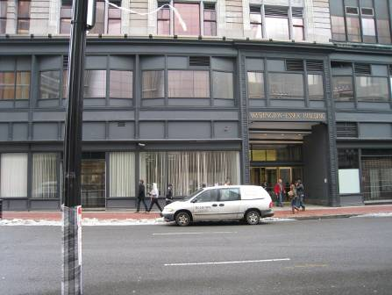

Fresh Air Intake, Note Car and Pedestrians

Picture 2

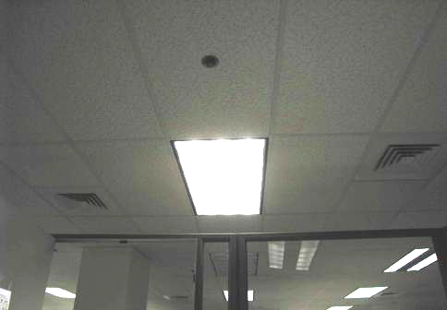

Two Air Diffusers Directing Air into One Office Cubicle
(View From Inside Office/Cubicle)
Picture 3

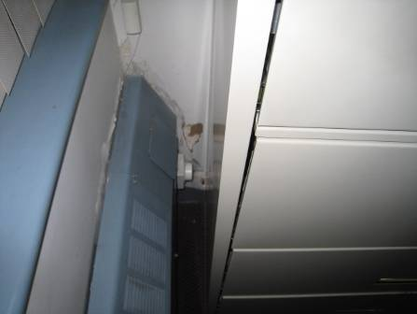

Heating Register in Office, Typical of Heating System on Second Floor

Picture 4

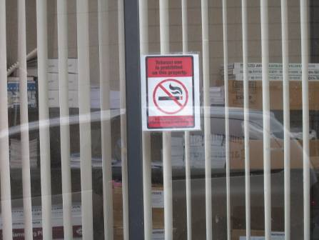

No Smoking Signs in the Window Directly Below Fresh Air Intake

Picture 5

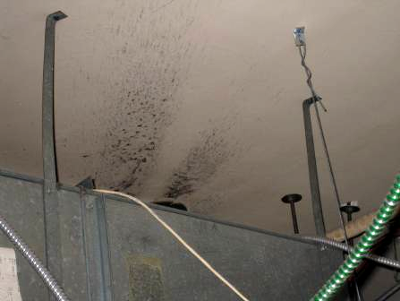

Dust Pattern on Ceiling above the Air Handling Unit Indicative of Air Leak
Location | Occupants  in Room | Temp  (°F) | Relative  Humidity  (%) | Carbon  Dioxide  (ppm) | Carbon Monoxide  (ppm) | Windows  Openable | Ventilation |  | Remarks
 |  |  |  |  |  |  | Supply | Exhaust | Remarks
Outside  (Background) |  | 40 | 39 | 342 | ND |  |  |  | Overcast, Heavy car traffic
2209 | 0 | 73 | 21 | 581 | ND | N | Y | Y | 2 fresh air supplies
2214 | 0 | 74 | 21 | 558 | ND | N | Y | Y | Door open
2215 | 0 | 76 | 19 | 534 | ND | N | Y | Y | Door open
2228 | 2 | 76 | 20 | 611 | ND | N | Y | Y
2232 | 3 | 76 | 20 | 623 | ND | N | Y | Y
2250 | 1 | 72 | 20 | 599 | ND | N | Y | Y | Door open
2200 | 2 | 72 | 22 | 600 | ND | N | Y | Y
2205 | 5 | 72 | 22 | 612 | ND | N | Y | Y | Door open  Water cooler on carpet
2165 | 2 | 73 | 22 | 582 | ND | N | Y | Y
2166 | 2 | 73 | 21 | 600 | ND | N | Y | Y
2157 | 3 | 72 | 21 | 568 | ND | N | Y | Y
2172 | 0 | 72 | 21 | 548 | ND | N | Y | Y
Reception | 1 | 73 | 21 | 607 | ND | N | Y | Y | Water cooler on carpet
2102 | 0 | 73 | 21 | 555 | ND | N | Y | Y | Door open
2103 | 0 | 72 | 18 | 455 | ND | N | Y | Y | Door open
2104 | 1 | 72 | 21 | 615 | ND | N | Y | Y
2105 | 1 | 73 | 21 | 564 | ND | N | Y | Y
2119 | 5 | 73 | 21 | 600 | ND | N | Y | Y
2117 | 2 | 74 | 20 | 564 | ND | N | Y | Y | Report of cigarette smoke
2118 | 3 | 74 | 18 | 542 | ND | N | Y | Y
2115 | 4 | 74 | 19 | 594 | ND | N | Y | Y
2128 | 4 | 74 | 19 | 566 | ND | N | Y | Y | Door open
2134 | 5 | 74 | 19 | 547 | ND | N | Y | Y | Loud air handling unit
2122 | 3 | 73 | 18 | 558 | ND | N | Y | Y
2025 | 2 | 73 | 20 | 573 | ND | N | Y | Y | Photo copier
2023 | 2 | 73 | 19 | 540 | ND | N | Y | Y
2014 | 2 | 73 | 19 | 541 | ND | N | Y | Y
2011 | 3 | 73 | 19 | 530 | ND | N | Y | Y
2009 | 3 | 73 | 20 | 614 | ND | N | Y | Y | Door open
2006 | 13 | 72 | 20 | 617 | ND | N | Y | Y | Floor fan on
2001 | 4 | 72 3 | 22 | 596 | ND | N | Y | Y | Soda machine  refrigerator
2133 | 4 | 73 | 20 | 559 | ND | N | Y | Y

