INDOOR AIR QUALITY FOLLOW-UP

MassAbility and other EOHHS offices
280 Merrimack Street
Lawrence, MA

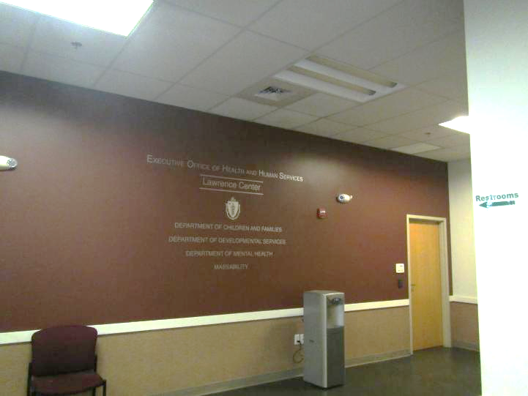

Prepared by:
Massachusetts Department of Public Health
Bureau of Climate and Environmental Health
Division of Environmental Health Regulations and Standards
February 2026

BACKGROUND
Building: | Lawrence EOHHS Office
Address: | 280 Merrimack Street, Lawrence, MA
Assessment Requested by: | Pedro Batista, EOHHS Facilities
Reason for Request: | Follow up from previous assessment
Date of Assessment: | February 18, 2026
Massachusetts Department of Public Health/Bureau of Climate and Environmental Health/Division of Environmental Health Regulations and Standards (MDPH/BCEH/EHRS) Staff Conducting Assessment: | Ruth Alfasso, Environmental  Engineer, EHRS
Building Description: | The EOHHS Center is located in a large former mill complex near the Lawrence Commuter Rail station. The EOHHS Center occupies space on the second and third floor. Other residential, retail, and office businesses are located in the building.
Windows: | Windows are not openable in this building.

BACKGROUND
This was a follow-up visit after elevated levels of carbon monoxide were found in the building during a visit on January 22, 2026. At that time, the elevated levels were traced to boiler exhaust from vent pipes outside windows on the 2nd and 3rd floor of the building. Repair efforts involve a multi-step process which has included so far: sealing off the impacted rooms with tape and signage, sealing of window frames and other gaps in the exterior wall with caulking material, and installation of carbon monoxide detectors. Plans are ongoing to extend the boiler exhaust pipes away from any occupied spaces. This visit was to determine whether the sealing was effective in lowering carbon monoxide levels in impacted areas and whether EHRS staff had any other suggestion during the interim before the boiler exhaust is relocated.

METHODS
Please refer to the IAQ Manual for methods, sampling procedures, and interpretation of results (MDPH, 2015). Mostly areas that had been impacted by the boiler exhaust were tested during this trip with a few others for comparison.

RESULTS AND DISCUSSION
The following is a summary of indoor air testing results (Table 1).
- Carbon dioxide levels were below the MDPH guideline of 800 parts per million (ppm) in unoccupied areas away from the areas impacted by the exhaust pipes. Carbon dioxide levels were above 800 ppm in the crowded waiting room on the 2nd floor and near the windows in areas impacted by the exhaust on the 3rd floor.
- Temperature was within the recommended range of 70°F to 78°F in almost all areas assessed.
- Relative humidity was below the MDPH recommended range of 40 to 60% in all areas assessed. This is reflective of outdoor conditions.
- Carbon monoxide in areas away from the exhaust pipes were all less than 1 ppm. Levels up to 1.4 ppm were measured in the areas next to the exhaust pipe. This is significantly lower than levels measured on January 22, 2026, which were as high as 21 ppm.
- Fine particulate matter (PM2.5) concentrations indoors were below the National Ambient Air Quality Standard (NAAQS) level of 35 μg/m³ in all indoor areas assessed. Levels outdoors were measured at 44 μg/m³ which is above the NAAQS level. Poor air quality was reported in many locations in Massachusetts on February 18, 2026, due to a temperature inversion (Channel 10 Boston, 2026), which traps pollutants near the ground. Adequate HVAC operation and filters in the building reduced the interior PM2.5 below NAAQS levels.

Products of Combustion and Ongoing Control Activities
During the visit on January 22, 2026, elevated levels of carbon monoxide were detected in some areas on both the 3rd and 2nd floor. The highest levels on each floor were recorded in rooms directly above an area where there are two large chiller units outside and several exhaust pipes from the boilers located in a lower level. During that visit room 2150 and adjacent areas had levels of 3-7 ppm carbon monoxide; the areas impacted on the 2nd floor were mainly the large dividable conference room where levels up to 21 ppm were measured, and adjacent areas with levels up to 7 ppm. Note that these areas also had higher levels of carbon dioxide than similarly unoccupied rooms on the same floor. Elevation of both carbon monoxide and carbon dioxide can be caused by exposure to products of combustion.
As mentioned in the results section above, carbon monoxide should not be present in a typical, indoor environment. If it is present, indoor carbon monoxide levels should be less than or equal to outdoor levels.
During the January 22, 2026 visit, EHRS staff recommended (in italics):
- That boiler operations be checked for excess emissions production. Boilers had been recently serviced. No additional information on boiler conditions was communicated to EHRS staff.
- Temporarily relocating occupants in the rooms directly above the exhaust, including the conference rooms. This was conducted shortly after the visit. The areas with significant impacts were also marked as out of order, and the doors to the rooms with doors were taped shut. Equipment for the kitchenette was partially relocated to support this.
- Investigating the air-tightness of windows, window assemblies, and the building envelope in the areas and sealing any gaps. While no drafts were noted during the January 22, 2026, visit, sealing around windows was conducted with a black caulking material.
- Using the HVAC system to pressurize the indoor space particularly in the areas of concern to reduce infiltration of air from the outside. This was not conducted and may not be possible.
- Adding exhaust controls to the boilers to increase removal of products of combustion. EHRS staff has not been told of any intention to change exhaust control on the boilers.
- Relocating the boiler exhaust vents by extending them above the building. This is still planned to be conducted, and if done should eliminate the infiltration of products of combustion.
As shown above, and in Table 1, levels of carbon monoxide were significantly lower on February 18, 2026, in the areas above the exhaust pipes than they had been on January 22, 2026, suggesting that sealing of the windows had been fairly effective in excluding outside air containing boiler exhaust. Levels of both carbon monoxide and carbon dioxide in the impacted rooms, however, were still higher than those in other unoccupied areas of the building that were tested. It is also important to note that the conditions measured on February 18, 2026, represent a snapshot of conditions in the building; under different wind and weather conditions, higher levels of carbon monoxide may be present in the areas tested. However, window sealing measures will protect occupants in the rest of the building until the repairs to the exhaust system are complete.
A slight oily odor was detected in the rooms where sealing around windows had been conducted. This is likely due to off-gassing of the caulking material and the lack of ventilation in these areas since the sealing was conducted a few days before.
Carbon monoxide detectors had also been added to several locations in the building. Some of these had been installed by building management (Pictures 1 and 2) and it wasn’t clear if they would produce an alarm locally, or only to the building management system. In addition, the location of these next to thermostats on interior walls will not measure a worst-case level of carbon monoxide; the highest levels were found directly adjacent to the windows. Additional carbon monoxide detectors found were consumer-grade plug-in instruments that may have been purchased by staff (Pictures 3 and 4). Most of these had a digital readout that was reading 0 on the visit on February 18, 2026. Product literature for a similar product by Kidde indicates that the peak level measurements on these will start to be displayed at 11 ppm of carbon monoxide (Kidde, 2026). Several of these were located in areas closer to the exterior wall with the exhaust pipes than the ones installed by building management.
It was also noted that the conference room on the 2nd floor is equipped with carbon dioxide read-outs, likely to help control fresh air in a room which may be empty at times and heavily-occupied at others, It was noted that these read-outs were at least 100 ppm of carbon dioxide lower than the TSI Q-trak instrument used by EHRS staff. These measurement devices need to be either calibrated or replaced periodically to ensure accuracy.
The exhaust pipes and chiller/cooling tower units outside the building were also examined. One of the chillers appeared to be on and operating during the February 18, 2026, visit as the fan was visibly turning. The other appeared to have a broken pipe. In comparison with a photograph taken on January 22, 2026, this damage appears to be recent (Pictures 5 and 6).

CONCLUSIONS/RECOMMENDATIONS
Conditions in the building for carbon monoxide have been significantly improved through sealing around windows. The following are additional recommendations for ongoing improvement:

Additional Recommendations:
- Continue with plans to extend boiler exhaust pipes beyond the occupied areas of the building.
- Continue to keep the affected rooms sealed and marked closed until the previous recommendation has been completed.
- Determine the function of the newly-installed carbon monoxide detectors next to thermostats and ensure they will warn occupants if needed.
- Continue to communicate with occupants on activities related to this remediation.
- Ensure any carbon dioxide monitors used to control the HVAC system are calibrated or replaced as needed.
- Make needed repairs to the chiller/cooling tower unit shown in Picture 6.
- Follow other recommendations from the January 2026 report.
- Refer to resource manual and other related IAQ documents located on the MDPH’s website for further building-wide evaluations and advice on maintaining public buildings. These documents are available at: http://mass.gov/dph/iaq.

REFERENCES
Channel 10 Boston. “What's going on with the air quality in Boston today?” Published February 18, 2026. https://www.nbcboston.com/news/local/why-is-air-quality-bad-today-boston-massachusetts/3901217/
KIDDE. 2026. Understanding Carbon Monoxide Levels. https://www.kidde.com/support/carbon-monoxide-alarms/co-levels-info
MDPH. 2015. Massachusetts Department of Public Health. Indoor Air Quality Manual: Chapters I-III. Available at: https://www.mass.gov/lists/indoor-air-quality-manual-and-appendices.

Picture 1
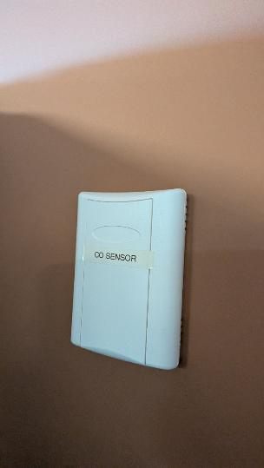
Carbon monoxide sensor installed by building management
Picture 2
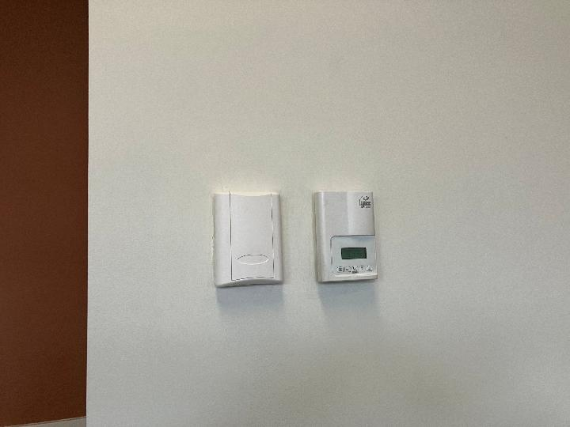
Carbon monoxide sensor installed by building management next to thermostat

Picture 3
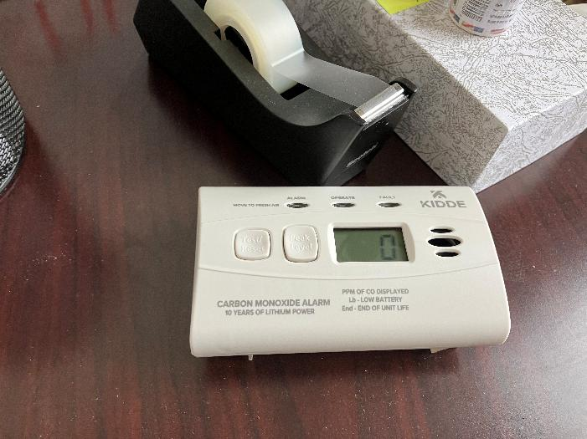
Consumer-style carbon monoxide detector with readout
Picture 4
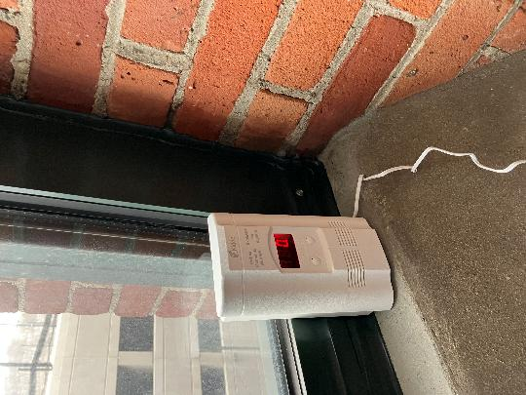
Consumer-style carbon monoxide detector with readout on windowsill (highest likelihood of elevated carbon monoxide)

Picture 5
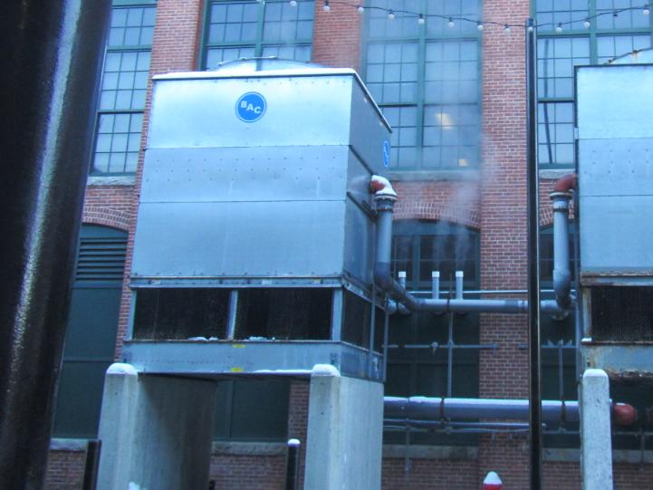
Chiller in front of boiler exhaust pipes, taken on January 22, 2026
Picture 6
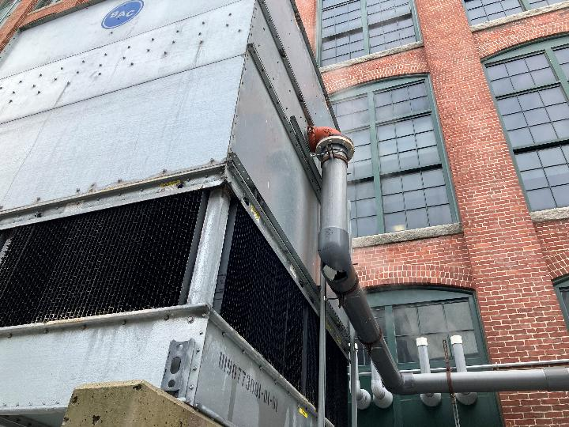
The same chiller on February 18, 2026, showing broken pipe elbow
Location | Carbon  Dioxide  (ppm) | Carbon Monoxide  (ppm) | Temp  (°F) | Relative  Humidity  (%) | PM2.5  (µg/m³) | Occupants  in Room | Windows  Openable | Ventilation |  | Remarks
 |  |  |  |  |  |  |  | Supply | Exhaust | Remarks
Background | 433 | ND | 45 | 53 | 44 |  |  |  |  | Cold and clear, note that inversion conditions resulted in poor outdoor air quality including elevated PM 2.5
2nd floor waiting | 917 | ND | 67 | 32 | 8 | >30 | N | Y | Y | Not carpeted
Outside DTA conference room | 714 | 0.3 |  |  |  | 0 | N | Y | Y | Control area
Outside office 1099 | 717 | 0.2 | 72 | 21 | 9 | 0 | N | Y | Y | Control area
Kitchen | 635 | 0.6 | 72 | 21 | 11 | 0 | N | Y | Y
Conference room left side | 734 | 0.7 | 71 | 21 | 11 | 0 | N | Y | Y | Steam from exhaust visible and one chiller on. Slight oil odor
Conference room right side | 770 | 1.2 | 70 | 23 | 10 | 0 | N | Y | Y | Slight oil odor
3rd floor waiting | 796 | 0.5 | 71 | 23 | 77 | 0 | N | Y | Y | Not carpeted
Cube 2152 | 814 | 0.6 | 72 | 21 | 5 | 0 | N | Y | Y | Plastic removed from cube
2150 | 834-1105 | 0.9-1.4 | 72 | 23 | 3 | 0 | N | Y | Y | Slight oil odor, several Kidde-brand CO detectors.

