INDOOR AIR QUALITY ASSESSMENT

MassAbility and other EOHHS offices
280 Merrimack Street
Lawrence, MA

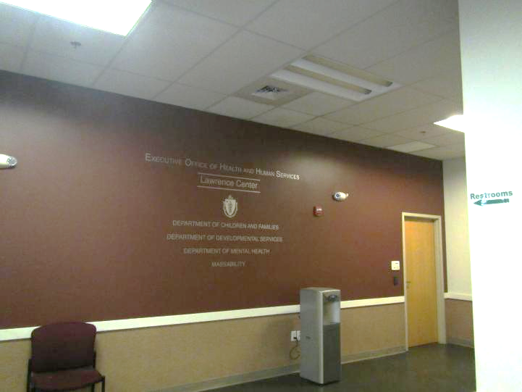

Prepared by:
Massachusetts Department of Public Health
Bureau of Climate and Environmental Health
Division of Environmental Health Regulations and Standards
January 2026

BACKGROUND
Building: | Lawrence EOHHS Office
Address: | 280 Merrimack Street, Lawrence, MA
Assessment Requested by: | Pedro Batista, EOHHS Facilities
Reason for Request: | General indoor air quality (IAQ) and musty odor concerns
Date of Assessment: | January 22, 2026
Massachusetts Department of Public Health/Bureau of Climate and Environmental Health (MDPH/BCEH) Staff Conducting Assessment: | Ruth Alfasso, Environmental  Engineer, EHRS
Building Description: | The EOHHS Center is located in a large former mill complex near the Lawrence Commuter Rail station. The EOHHS Center occupies space on the second and third floor. Other residential, retail, and office businesses are located in the building.
Windows: | Windows are not openable in this building.

Note that this building was visited by the IAQ unit in 2013 and 2022. Reports from these visits can be found on the IAQ unit website: https://www.mass.gov/info-details/indoor-air-quality-reports-cities-and-towns-l#lawrence.

METHODS
Please refer to the IAQ Manual for methods, sampling procedures, and interpretation of results (MDPH, 2015).

RESULTS AND DISCUSSION
The following is a summary of indoor air testing results (Table 1).
- Carbon dioxide levels were below the MDPH guideline of 800 parts per million (ppm) in most areas assessed, indicating typical work areas have adequate ventilation for occupancy. Levels above 800 ppm were noted in waiting areas which have high occupancy, and in rooms in one area on both the 2nd and 3rd floor, which will be discussed further in the Products of Combustion section below.
- Temperature was within the recommended range of 70°F to 78°F in all areas assessed.
- Relative humidity was below the MDPH recommended range of 40 to 60% in all areas assessed. This is reflective of outdoor conditions. Low relative humidity is common indoors during the heating season. Note that low relative humidity can lead to common symptoms such as: dry skin, lips, and scalp; dry/scratchy throats and noses (nose bleeds); exacerbation of asthma, eczema, or allergies; dry/irritated eyes; and irritation of respiratory tract.
- Carbon monoxide ranged from ND to 2 in most areas, but there were two areas with elevated carbon monoxide as high as 7 ppm on the 3rd floor, and 21 ppm on the 2nd floor which is discussed further in the Products of Combustion section below. Carbon monoxide should not be present in a typical, indoor environment. If it is present, indoor carbon monoxide levels should be less than or equal to outdoor levels.
- Fine particulate matter (PM2.5) concentrations measured were below the National Ambient Air Quality Standard (NAAQS) level of 35 μg/m³ in all areas assessed.

Ventilation
A heating, ventilating, and air conditioning (HVAC) system has several functions. First, it provides heating and, if equipped, cooling. Second, it is a source of fresh air. Finally, an HVAC system will dilute and remove normally occurring indoor environmental pollutants by not only introducing fresh air but also filtering the airstream and ejecting stale air to the outdoors via exhaust ventilation. Even if an HVAC system is operating as designed, point sources of respiratory irritation may exist and lead to symptoms in sensitive individuals.
Fresh air is provided by rooftop air-handling units (AHUs). Fresh air is drawn into the AHUs through a bank of filters, heated or cooled, and delivered to occupied areas via ducted supply diffusers (Picture 1). Return air is drawn into ceiling-mounted vents (Picture 2) and ducted back to the rooftop AHUs. Open areas and many offices have both supply and return vents, however offices in some areas were found to have only supply vents and no return vents (Table 1). This may limit air circulation in these areas.
To have proper ventilation with a mechanical supply and exhaust system, the systems must be balanced to provide an adequate amount of fresh air to the interior of a room while removing stale air from the room. It is recommended that HVAC systems be re-balanced every five years to ensure adequate air systems function (SMACNA, 1994). It is not known when the system was last balanced, but the system is reportedly balanced every time new equipment is installed.
The ventilation system should be on and operational to supply fresh air continuously during occupied periods. Without adequate fresh air supply and removal of stale air, common indoor air pollutants can build up and cause irritation. While the type of thermostat in use in the building (Picture 3) does not indicate if the system is operating, the operation of the system could be heard, and airflow was felt during the assessment.
Building staff reported that filters of a MERV 8 (Minimum Efficiency Rating Value of 8) rating are currently in use in the building and are changed at least 2 times a year. Higher MERV-rated filters had reportedly been installed to supply additional protection during return-to-work after COVID-19 pandemic lockdowns, but this caused stress on the equipment. The EHRS IAQ Unit recommends that filters should be at least MERV 8 which is sufficient to remove pollen and other airborne particles (ASHRAE, 2012), and that filters be changed at least 2 times a year.

Products of Combustion
As mentioned above, elevated levels of carbon monoxide were detected in some areas on both the 3rd and 2nd floor. The highest levels on each floor were recorded in rooms directly above an area where there are two large chiller units outside and several exhaust pipes from the boilers located in a lower level (Pictures 4 through 6). The rooms impacted on the 3rd floor were 2150 and adjacent areas where levels of 3-7 ppm carbon monoxide were measured; the areas impacted on the 2nd floor were mainly the large dividable conference room where levels up to 21 ppm were measured, and adjacent areas with levels up to 7 ppm. Note that these areas also had higher levels of carbon dioxide than similarly unoccupied rooms on the same floor. Elevation of both carbon monoxide and carbon dioxide can be caused by exposure to products of combustion.
An examination of the exterior of the building was conducted. Levels of carbon monoxide at ground level near the units shown in Picture 4 were normal, between not detected (ND) and 1 ppm. The chillers did not appear to be operating at the time of the visit, as they would not be needed during cold weather. Visible plumes of exhaust were present from the pipes leading to the boilers on the lower level and this exhaust is also visible outside the windows on the 2nd (Picture 6) and 3rd floor. While it is expected that the visible portion of the exhaust is composed of water vapor, exhaust can also include carbon monoxide, carbon dioxide, other gases, and particulate matter.
An agent of the building landlord was contacted and had a discussion with the EHRS and EOHHS staff on site regarding the boilers. The facility agent said that the boilers had been serviced recently. He did not think any abnormal operation was taking place but agreed to have someone look at the system to see if combustion was inefficient or if there were other issues that could lead to excess carbon monoxide being produced. The International Fuel Gas Code limit on boiler and furnace emissions of carbon monoxide is 400 ppm “air free”, which removes any impact from dilution (ICC, 2021). Measured emission requirements would therefore be lower.
Based on the measurements conducted inside the building, carbon monoxide and carbon dioxide are entering the building from this exhaust stream. Measurements of humidity (1% to 2% higher than nearby areas) suggest that moisture may also be entering, although not to a degree to impact the building interior.
As mentioned in the results section above, carbon monoxide should not be present in a typical, indoor environment. If it is present, indoor carbon monoxide levels should be less than or equal to outdoor levels. Elevated levels of carbon monoxide can lead to health effects, and at high enough levels, can cause death. Note that the US National Ambient Air Quality Standards (NAAQS) for carbon monoxide in outdoor air are 9 ppm measured over 8 hours, and 35 ppm measured over 1 hour (USEPA, 2025). Various guidelines and standards for carbon monoxide in indoor air exist, including:
- The Occupational Safety and Health Administration (OSHA) permissible exposure limit (PEL) for carbon monoxide is 50 ppm as an 8-hour time-weighted average (TWA) concentration (OSHA, 1997).
- The National Institute for Occupational Safety and Health (NIOSH) has established a recommended exposure limit (REL) for carbon monoxide of 35 ppm as an 8-hour TWA and 200 ppm as a ceiling (NIOSH 2019).
- MDPH’s regulations for the operation of ice rinks includes the following:
  - Action Air Levels for Carbon Monoxide shall be a single air sample exceeding 30 parts per million (ppm) for carbon monoxide.
  - Notification air levels shall be a single air sample exceeding 60 parts per million (ppm) or six consecutive air samples which exceed 30 parts per million (ppm) for carbon monoxide.
  - Evacuation air levels shall be a single air sample exceeding 125 parts per million (ppm) for carbon monoxide (MDPH, 2004).
- Kidde, a major manufacturer of carbon monoxide alarms, uses the following criteria for the alarm activating (KIDDE, 2026):
  - 40 ppm: 10 hours
  - 50 ppm: 8 hours
  - 70 ppm: 1 to 4 hours
  - 150 ppm: 10 to 50 minutes
  - 400 ppm: 4 to 15 minutes

Levels such as those found particularly in the 2nd floor conference room, while not immediately dangerous or above worker guidelines, are still concerning. Also note that OSHA and related limits are designed for use in industrial settings, not an office where exposure to carbon monoxide would not be expected. Given that carbon dioxide and potentially water vapor are also elevated in these areas, it is also not known if other constituents that were not measured for were elevated, including volatile organic compounds (VOCs) and nitrogen dioxides (NOx) which are also potential constituents of boiler exhaust.
The EHRS staff on site recommended that boiler operations be checked for excess emissions production. If the boiler is found to be operating normally and burning cleanly, additional steps need to be taken to reduce exposure to carbon monoxide and other products of combustion to the occupants of the building in the affected areas. This may include:
- temporarily relocating occupants in the rooms directly above the exhaust, including the conference rooms;
- investigating the air-tightness of windows, window assemblies, and the building envelope in the areas and sealing any gaps (note that no breeze or draft was noted in these rooms at the time of the visit);
- using the HVAC system to pressurize the indoor space particularly in the areas of concern to reduce infiltration of air from the outside;
- Adding exhaust controls to the boilers to increase removal of products of combustion;
- relocating the boiler exhaust vents by extending them above the building.

Note that no elevated levels of particulate matter (PM2.5) were measured in the building, including the area above the boiler exhaust. Particulate matter can also be produced by fuel burning equipment, but given the boilers use natural gas, high levels of particulate matter may not be produced. Or potentially the pathways allowing gases like carbon monoxide into the building are too small or tortuous to allow particulates to enter.

Water damage issues
A few water-damaged ceiling tiles were noted in the building (Picture 7; Table 1). These water-damaged tiles appear to be from the plumbing, HVAC, or sprinkler systems. None of the water-damaged tiles had dark staining indicating mold. Water-damaged ceiling tiles should be replaced once an issue has been identified and repaired.
Note that a water damage incident occurred in this building in July of 2025 caused by a leak or burst pipe from a 3rd floor restroom. Areas on both the 3rd and 2nd floors were impacted at the time. Cleanup was conducted by a commercial water damage restoration company and normal activities were resumed in the affected spaces within a few days. Another water damage issue in the building was reported to have occurred earlier in 2025 as well. No lingering odors, stains, or other issues were noted during the visit to this site from these incidents.
Plants and a small aquarium were noted in offices, cubicles, and common areas in the office (Pictures 8 and 9). These can lead to water damage, odors, and pests if not taken care of properly. Plants should be in good condition, not overwatered, and placed on non-porous drip pans. Dead plants, and plants on paper towels, were noted in the space. Aquariums need to be kept clean and odor-free.
Small refrigerators (Picture 10) and water dispensers were located in carpeted areas. Leaks or spills from these appliances can damage carpeting. Large refrigerators were located in break rooms. While most of these were clean and in good condition, some had spills inside. One appeared to be a very old unit and may not be in use; it was dirty inside (Picture 11; Table 1). All refrigerators in use need to be kept clean to prevent odors, and any non-functional or no longer needed units should be removed for proper disposal. Note that while refrigerators in this office building are not covered by the food code, it is good practice to have a thermometer in each refrigerator that is visible to ensure refrigerated food temperatures are kept at 5ºC (41ºF) or less (US FDA, 2022).
Food, food preparation equipment, and related items were found in many offices and common areas (Pictures 12 through 14). Food needs to be kept in tightly-sealed pest-proof containers when not currently in use. All crumbs and other food debris needs to be removed from surfaces and appliances such as toasters and microwaves to avoid attracting pests.

Other IAQ issues
The office spaces examined were mostly clean. However, dust, clutter, and items on the floor were found in several areas including offices and storage rooms (Pictures 15 and 16). Areas that have too many items on surfaces can be difficult for janitorial staff to clean. As noted in previous reports for this and similar buildings, there are gaps between the building wall and cubicle walls in some areas. These channels can collect debris and are often left out of regular cleaning (Picture 17). These areas should also not be used for storage.
Most areas in the building are carpeted. Carpeting needs to be cleaned regularly using a HEPA-equipped vacuum, and deep cleaned once or twice a year. Waiting areas and some high-traffic areas are not carpeted, however some high-traffic areas still have carpeting which can be difficult to keep clean. Some supply vents were noted to be dusty. These should be cleaned periodically.
Some cube tops and lights were covered with fabric (Picture 18). This material may not be allowed per the fire code. Any material that is allowed should be cleaned periodically to remove dust and odors.
While VOC testing was not conducted, products were in use in the office that can increase VOCs in the air. Items including hand sanitizers, cleaners, and scented products were noted (Pictures 18 and 19). Products with strong scents, including scent sprays and essential oils should not be used in a shared office space as many people are sensitive to fragrance compounds.

CONCLUSIONS/RECOMMENDATIONS
Most conditions in this building were normal for this time of year, however elevated levels of combustion products (carbon monoxide in particular) are of concern in a few offices on both the 2nd and 3rd floor. In view of the findings at the time of the visit, the following recommendations are made:

Ventilation recommendations
- Continue to operate supply and exhaust ventilation in all areas continuously during occupied periods.
- Have the HVAC system balanced every 5 years in accordance with SMACNA recommendations (SMACNA, 1994).
- Consider increasing both supply and exhaust ventilation to heavily-occupied areas such as waiting rooms and interview rooms.
- Ensure offices that do not have an exhaust vent have doors that are undercut enough to allow for airflow.
- Continue to change filters for HVAC units at least two to four times a year or as per the manufacturers’ recommendations using filters with a Minimum Efficiency Rating Value (MERV) of 8 or better.
- Periodically clean dust from supply and return vents and fans.
- For buildings in New England, periods of low relative humidity during the winter are often unavoidable. Therefore, scrupulous cleaning practices should be adopted to minimize common indoor air contaminants whose irritant effects can be enhanced when the relative humidity is low. To control dust, a high efficiency particulate arrestance (HEPA) filter equipped vacuum cleaner in conjunction with wet wiping of all surfaces is recommended. Avoid the use of feather dusters. Drinking water during the day can help ease some symptoms associated with a dry environment (throat and sinus irritations).

Products of combustion recommendations
- Have the boiler(s) checked for inefficient combustion and excess emissions production and repair if needed. If this does not fix the problem, the following may help:
  - Temporarily relocating occupants in the rooms above the boiler room.
  - Determining if windows, window assemblies, and the building envelope have gaps or are otherwise not weathertight and repair/seal;
  - Pressurizing the affected rooms using the HVAC system to reduce infiltration of air from the outside;
  - Modifying the boiler(s) to add exhaust controls to decrease emissions; and
  - Relocating the boiler exhaust vents by extending them above the building.
  - In addition, consider adding carbon monoxide detectors to the affected areas. An ultra-sensitive model with a digital readout may be helpful to see levels that do not meet the warning criteria, but are still of concern.

Water damage recommendations
- Replace water-damaged ceiling tiles.
- Ensure plants are well kept, not overwatered, and placed on waterproof drip pans that are cleaned periodically.
- Ensure aquariums are not a source of odors.
- Consider moving refrigerators and water dispensers to areas without carpeting or use a waterproof mat underneath.
- If refrigerators are no longer usable/in use they should be removed for proper disposal.
- Routinely clean food/liquid stains from the refrigerator and food residues from microwaves, toasters, coffee makers, or any other appliances used to prepare or heat food.
- Keep all food in pest-proof containers and avoid using food items for decoration.

Other recommendations
- Reduce clutter and ensure items have a location for proper storage.
- Make sure the gaps between cube walls and the exterior of the building are vacuumed periodically to remove debris. Avoid using these areas for storage.
- Consider if cloth covering cubicles and lights is acceptable under the fire code. If allowable, ensure these items are laundered periodically to remove dust and odors.
- Have the carpets vacuumed regularly and deep cleaned once or twice a year.
- Use VOC-containing products with good ventilation. Avoid products with strong scents or products the purpose of which is to impart a scent (e.g., essential oils, fragrance sprays, or scented candles)
- Refer to the previous IAQ reports for this building at https://www.mass.gov/info-details/indoor-air-quality-reports-cities-and-towns-l#lawrence for additional information.
- Refer to resource manual and other related IAQ documents located on the MDPH’s website for further building-wide evaluations and advice on maintaining public buildings. These documents are available at: http://mass.gov/dph/iaq.

REFERENCES
ASHRAE. 2012. American Society of Heating, Refrigeration and Air Conditioning Engineers (ASHRAE) Standard 52.2-2012 -- Method of Testing General Ventilation Air-Cleaning Devices for Removal Efficiency by Particle Size (ANSI Approved).
ICC, 2021. International Code Council. 2021 International Fuel Gas Code (IFGC), Appendix D.
KIDDE. 2026. Understanding Carbon Monoxide Levels. https://www.kidde.com/support/carbon-monoxide-alarms/co-levels-info
MDPH. 2004. Requirements to Maintain Air Quality in Indoor Skating Rinks (State Sanitary Code, Chapter XI). 105 CMR 675.000. Massachusetts Department of Public Health, Boston, MA. https://www.mass.gov/regulations/105-CMR-67500-state-sanitary-code-chapter-xi-requirements-to-maintain-air-quality-in-indoor-skating-rinks
MDPH. 2015. Massachusetts Department of Public Health. Indoor Air Quality Manual: Chapters I-III. Available at: https://www.mass.gov/lists/indoor-air-quality-manual-and-appendices.
NIOSH. 2019. National Institute for Occupational Safety and Health. NIOSH Pocket Guide to Chemical Hazards: Carbon Monoxide. https://www.cdc.gov/niosh/npg/npgd0105.html
OSHA. 1997. Limits for Air Contaminants. Occupational Safety and Health Administration. Code of Federal Regulations. 29 C.F.R 1910.1000 Table Z-1-A.
SMACNA. 1994. HVAC Systems Commissioning Manual. 1st ed. Sheet Metal and Air Conditioning Contractors’ National Association, Inc., Chantilly, VA.
US EPA. 2025. National Ambient Air Quality Standards (NAAQS). US Environmental Protection Agency, Office of Air Quality Planning and Standards, Washington, DC. Last updated on November 4, 2025
US FDA. 2022. 2022 Food Code. U.S. Department of Health and Human Services. U.S. Food and Drug Administration. College Park, MD January 18, 2023 Version. https://www.fda.gov/media/164194/download

Picture 1
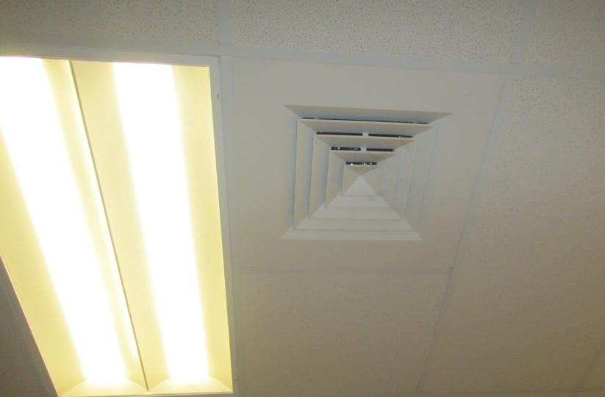
Supply vent in an office
Picture 2
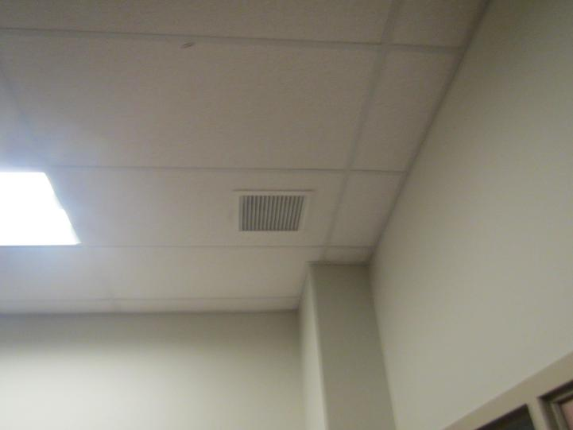
Return vent

Picture 3
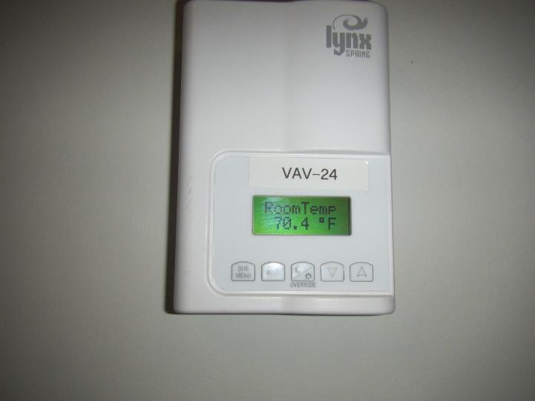
Office thermostat
Picture 4
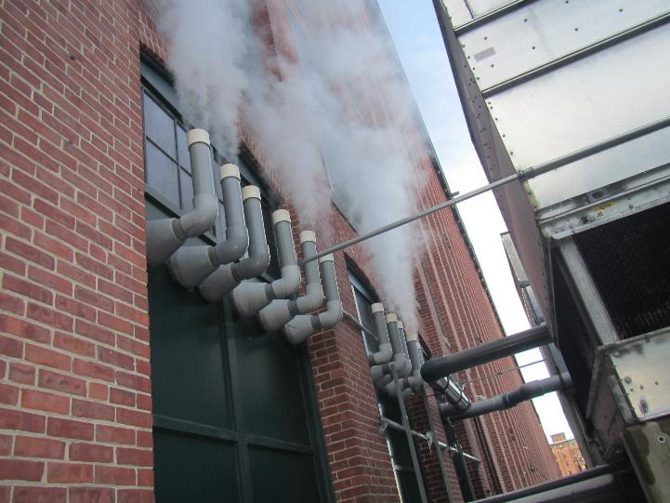
Boiler exhaust vents next to the building, chillers shown on the right of picture

Picture 5
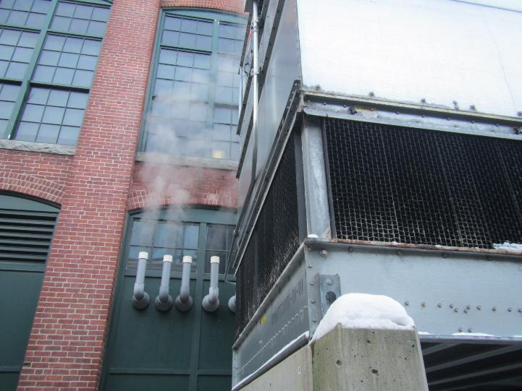
View of building showing boiler exhaust with chillers in the front and 2nd floor windows above

Picture 6
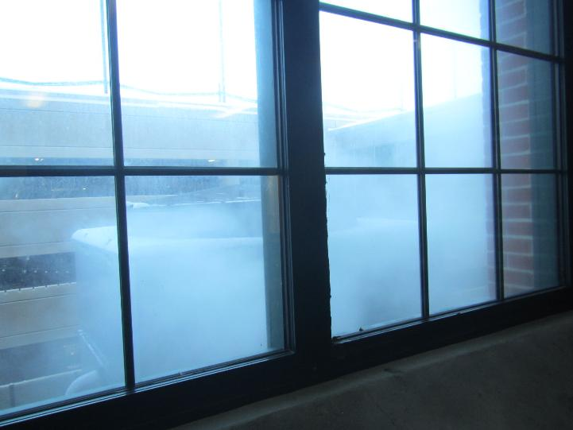
View looking out the window of the 2nd floor conference room with chiller visible through plume of boiler exhaust
Picture 7
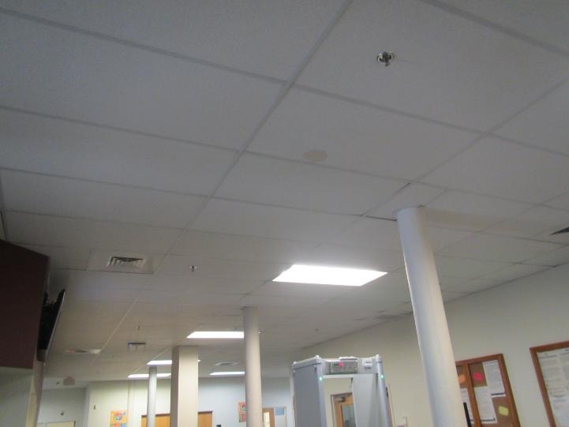
Water-damaged ceiling tile
Picture 8
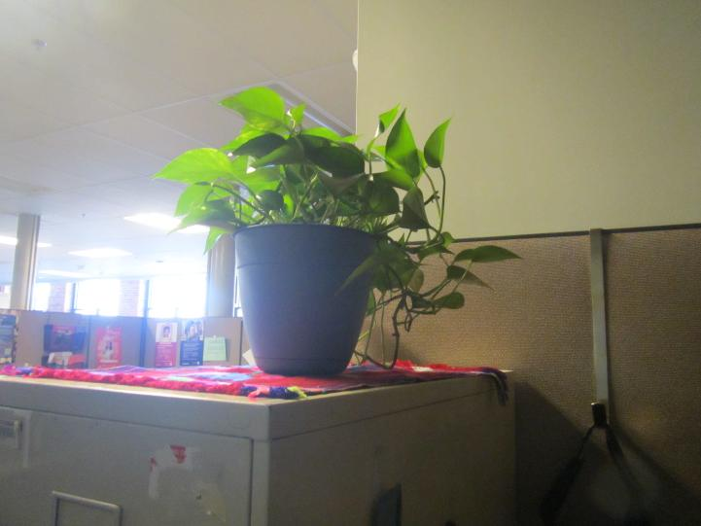
Plant in a cubicle area, note cloth (a porous material) underneath

Picture 9
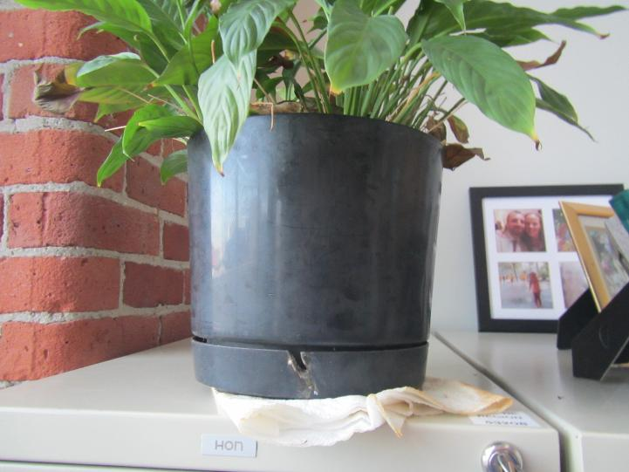
Plant with water-damaged paper towel underneath
Picture 10
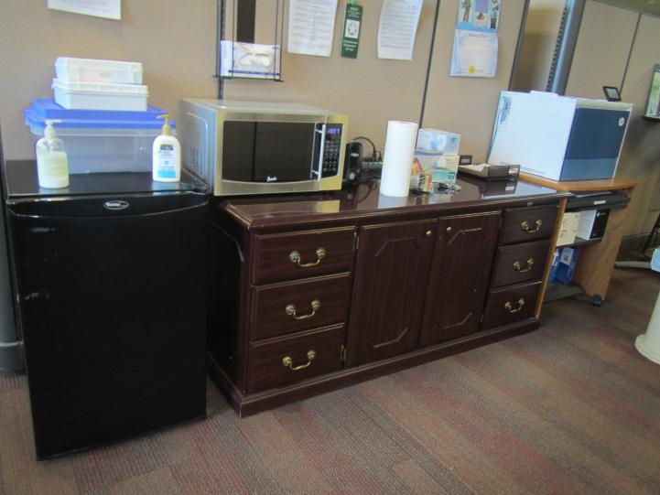
Refrigerator on carpet, and microwave

Picture 11
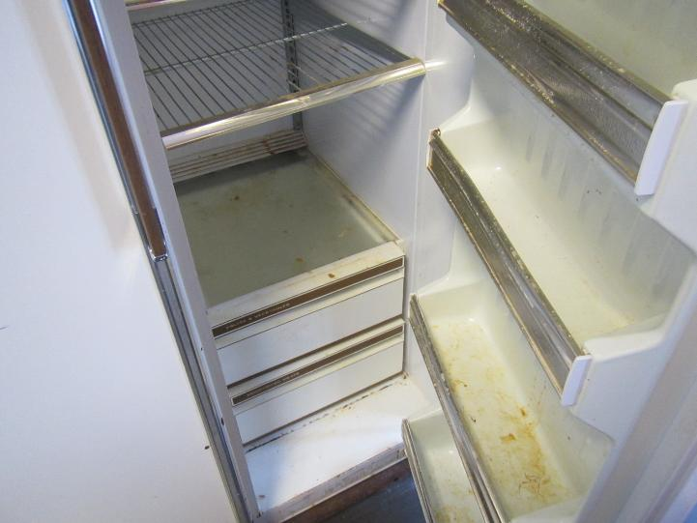
Inside of dirty refrigerator, possibly no longer in use
Picture 12
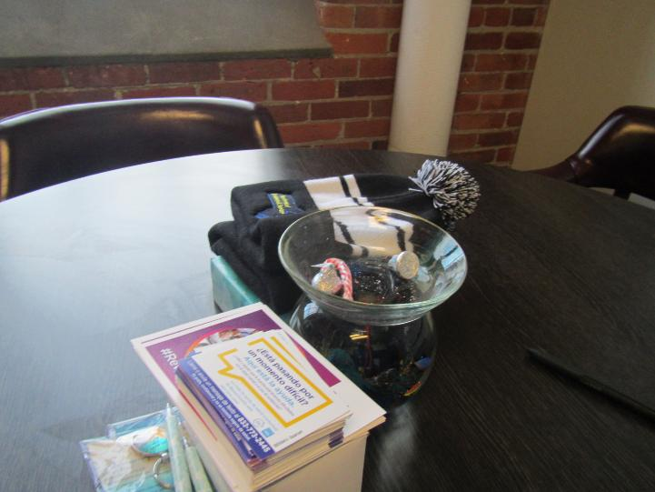
Open candy dish on a table

Picture 13
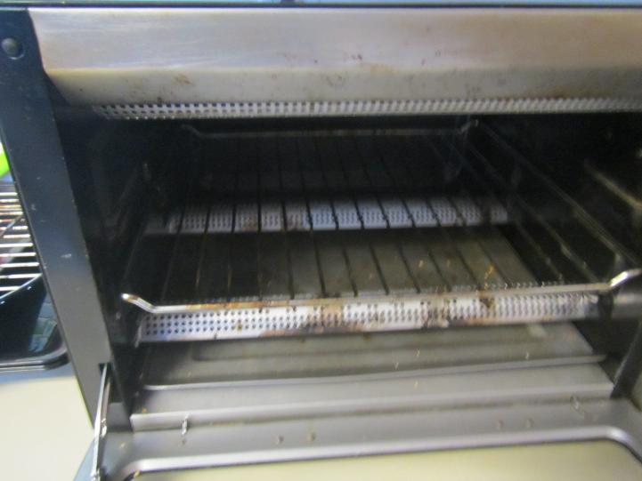
Toaster oven with crumbs/food debris
Picture 14
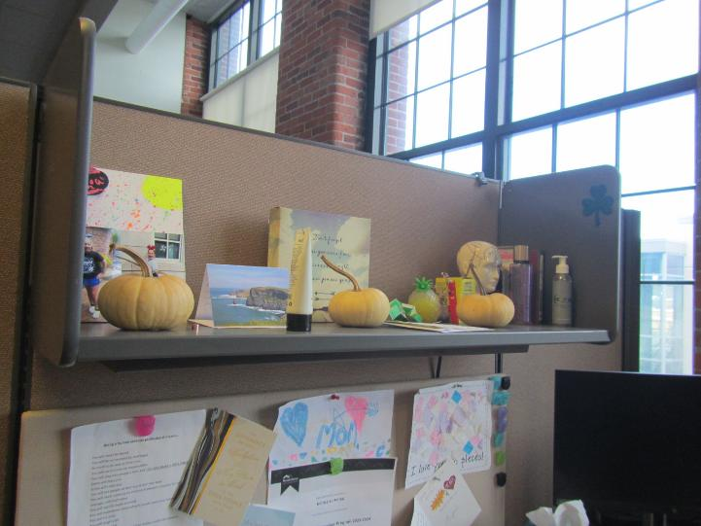
Mini-pumpkins on a shelf

Picture 15
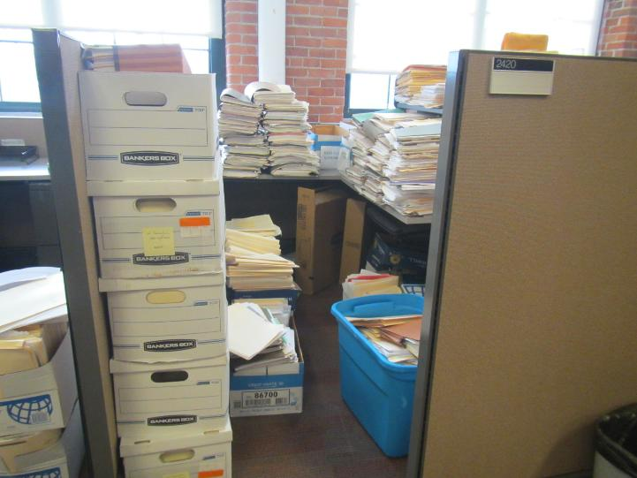
Cubicle used for storage of large amounts of paper and boxes
Picture 16
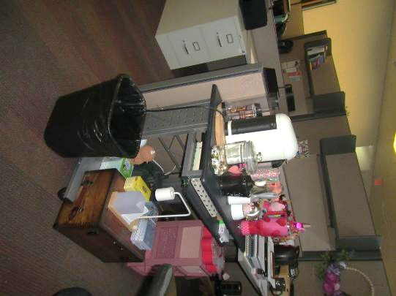
Break area with collection of items

Picture 17
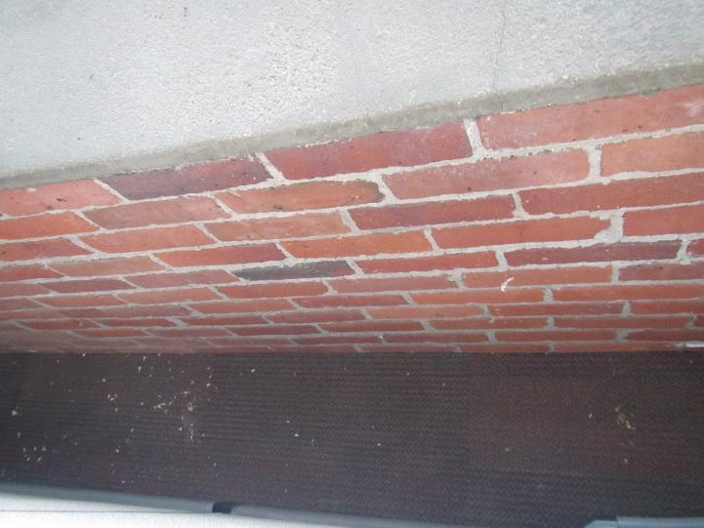
Debris in channel between cube wall and building wall
Picture 18
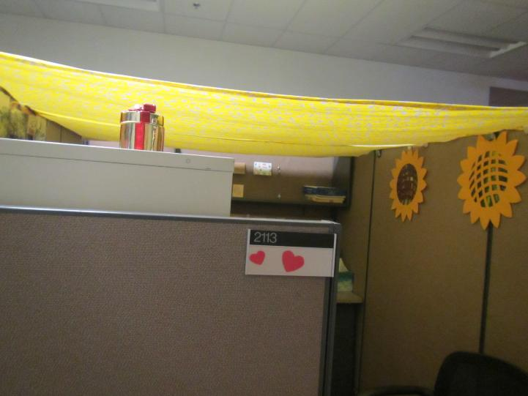
Cloth covering a cubicle

Picture 19
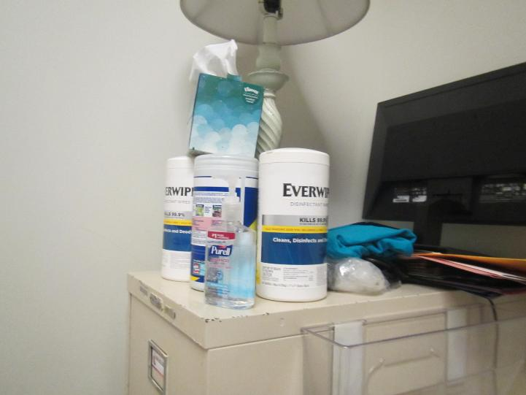
Hand sanitizers and cleaners
Picture 20
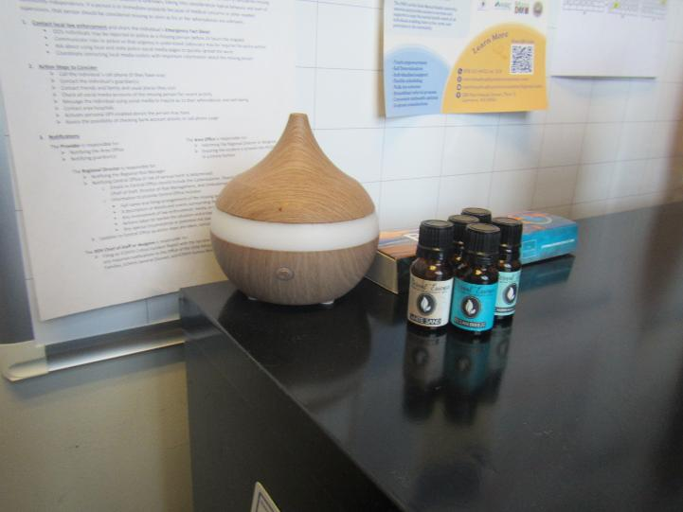
Scent diffuser and essential oils

Location | Carbon  Dioxide  (ppm) | Carbon Monoxide  (ppm) | Temp  (°F) | Relative  Humidity  (%) | PM2.5  (µg/m³) | Occupants  in Room | Windows  Openable | Ventilation |  | Remarks
 |  |  |  |  |  |  |  | Supply | Exhaust | Remarks
Background | 464 | 1 |  | 35 | 7 |  |  |  |  | Cold, clear, traffic
2110 | 618 | 2 | 71 | 19 | ND | 0 | N | Y | Y | WD CT near exhaust vent
2111 cubes | 638 | 1 | 70 | 19 | ND | 0 | N | Y | Y | Cloth over cube, plant
2114 | 675 | 1 | 72 | 19 | 1 | 0 | N | Y | N | Plant, sanitizer
2117 cubes | 657 | 1 | 72 | 18 | ND | 2 | N | Y | Y | Cloth over cube
2131 cubes | 668 | 1 | 72 | 18 | ND | 1 | N | Y | Y | Plants
2132 | 687 | 3 | 72 | 18 | ND | 0 | N | Y |  | PF, HS and cleaners
2150 | 967 | 7 | 71 | 22 | ND | 0 | N | Y | Y
2152 cubes | 729 | 4 | 70 | 21 | 1 | 0 | N | Y
2155 cubes | 744 | 3 | 70 | 21 | 1 | 0 | N | Y | Y | Items
2159 cubes | 710 | 3 | 71 | 20 | ND | 0 | N | Y | Y | Items PF
2162 cubes | 666 | 2 | 71 | 19 | 1 | 2 | N | Y | Y
2148 half wall | 675 | 2 | 72 | 18 | 1 | 1 | N | Y | Y
2147 half wall | 664 | 2 | 72 | 18 | 1 | 1 | N | Y | Y
2136 | 657 | 2 | 73 | 18 | ND | 1 | N | Y | Y
Reception | 640 | 2 | 72 | 18 | ND | 1 | N | Y | Y | Cloth over light
2103 | 631 | 2 | 72 | 18 | ND | 1 | N | Y | Y
2120 cubes | 641 | 2 | 73 | 18 | ND | 1 | N | Y | Y
2122 half wall | 650 | 2 | 73 | 18 | ND | 0 | N | Y | Y
2147 half wall | 666 | 2 | 73 | 18 | ND | 0 | N | Y | Y
2168 | 693 | 2 | 73 | 18 | ND | 1 | N | Y | Y | Plants
2171 cubes | 730 | 2 | 73 | 18 | ND | 1 | N | Y | Y | Plant
2172 | 637 | 2 | 74 | 18 | ND | 0 | N | Y | Y | Plant, one on paper
2174 | 644 | 2 | 74 | 17 | ND | 0 | N | Y | Y | Scent diffuser and essential oils, fridge, microwave, food
2200 cubes | 660 | 2 | 74 | 17 | ND | 0 | N | Y | Y | PF
2201 cubes | 667 | 2 | 74 | 18 | ND | 1 | N | Y | Y
2214 cubes | 685 | 2 | 74 | 18 | ND | 0 | N | Y | Y | Cleaners
2204 cubes | 799 | 2 | 73 | 18 | ND | 1 | N | Y | Y | Pumpkins on shelf
2217 | 647 | 2 | 73 | 18 | ND | 1 | N | Y | Y | Plants
Kitchen | 593 | 2 | 72 | 17 | ND | 1 | N | Y | Y | NC
0233 hoteling | 664 | 2 |  | 18 | ND | 0 | N | Y | Y
2211 cubes | 677 | 2 | 71 | 18 | ND | 0 | N | Y | Y | Cleaners
2231 | 639 | 2 | 72 | 18 | ND | 0 | N | Y | Y
2422 Legal conference room | 641 | 2 | 72 | 18 | ND | 0 | N | Y | Y
2416 | 626 | 2 | 73 | 17 | ND | 1 | N | Y | Y | Fridge
2420 |  |  |  |  |  |  | N | Y | Y | Storage room. Lots of paper and items in stacks
2415 | 605 |  | 73 | 17 | 1 | 1 | N | Y | Y
2414 cubes | 595 | 1 | 73 | 17 | 1 | 0 | N | Y | Y | Boxes on the floor, fridge, PF
2409 cubes | 610 | 1 | 74 | 17 | 1 | 0 | N | Y | Y | Dirty fridge (unused?), boxes
2407 | 6277 | 2 | 73 | 18 | 1 | 0 | N | Y | Y
2406 | 613 | 1 | 73 | 17 | 1 | 1 | N | Y | Y | Fridge, microwave, coffee maker, and toaster
2401 conference | 598 | 1 | 72 | 18 | 1 | 0 | N | Y | Y | DEM
2356 cubes | 601 | 1 | 72 | 18 | 1 | 0 | N | Y | Y
2352 cubes | 599 | 1 | 72 | 17 | 1 | 0 | N | Y | Y
2332 | 609 | 1 | 72 | 18 | 1 | 0 | N | Y | Y
2326 | 612 | 1 | 71 | 18 | 1 | 0 | N | Y | Y
2322 | 668 | 2 | 72 | 18 | ND | 1 | N | Y | Y | HS
Waiting area |  |  |  |  |  |  |  |  |  | Not carpeted
1340 | 693 | ND | 72 | 20 | 1 | 0 | N | Y | Y | Food, heater
1457 | 675 | ND | 72 | 19 | 1 | 0 | N | Y | N | HS, Lysol
1495 | 705 | ND | 72 | 20 | ND | 0 | N | Y | Y | HS, dead plants
1501 | 640 | ND | 73 | 19 | 1 | 0 | N | Y | Y | Heater, food
1488 | 597 | ND | 73 | 18 | 2 | 0 | N | Y | Y | Ajar ceiling tile
1493 cubes | 620 | ND | 74 | 18 | 1 | 0 | N | Y | Y
1475 | 632 | ND | 74 | 18 | ND | 0 | N | Y | Y | Hanging items (strings) from ceiling, decorations
Supply room |  |  |  |  |  |  | N | Y | Y | Items on floor
1452 cubes | 653 | ND | 73 | 19 | 2 | 1 | N | Y | Y
1426 cubes | 633 | ND | 72 | 19 | ND | 0 | N | Y | Y | Plants
1431 cubes | 643 | ND | 71 | 20 | ND | 0 | N | Y | Y | Cube used for storage
1389 cubes | 655 | ND | 71 | 19 | 1 | 0 | N | Y | Y | Plants, two WD CT
1481 cubes | 664 | ND | 71 | 20 | 1 | 2 | N | Y | Y
1365 | 660 | ND | 72 | 20 | 1 | 0 | N | Y | Y
1358 cubes | 683 | ND | 72 | 20 | ND | 1 | N | Y | Y | Food
1345 | 705 | ND | 72 | 20 | ND | 1 | N | Y | Y | Lotions and other products
1329 | 747 | ND | 72 | 21 | 1 | 3 | N | Y | Y | Food, plant
1306 | 667 | ND | 71 | 20 | ND | 0 | N | Y | N
1312 | 692 | ND | 71 | 20 | 1 | 0 | N | Y | N
DTA waiting | 822 | ND | 72 | 22 | 1 | MANY | N | Y | Y | WD CTs
1128 | 786 | 1 | 73 | 19 | 2 | 0 | N | Y | Y | WD CT
Conference | 672 | 1 | 73 | 18 | 2 | 0 | N | Y | Y
1141 | 645 | 1 | 74 | 18 | ND | 0 | N | Y | Y
1148 | 666 | 1 | 74 | 18 | 1 | 0 | N | Y | Y | Plant
1102 | 712 | 2 | 74 | 17 | 1 | 2 | N | Y | Y
1087 | 678 | 2 | 74 | 17 | 1 | 0 | N | Y | Y
1064 | 660 | 2 | 73 | 1 | 1 | 0 | N | Y | Y
1044 | 701 | 2 | 73 | 18 | 1 | 0 | N | Y | Y | Plants
Kitchen | 840 | 7 | 72 | 20 | 2 | 0 | N | Y | Y | NC, food equipment
Conference | 1025 | 13-21 | 72 | 22 | 2 | 0 | N | Y | Y | See outside/discussion
1012 | 870 | 4 | 73 | 19 | 2 | 0 | N | Y | Y
1016 | 858 | 2 | 73 | 20 | 10 | 0 | N | Y | N
1020 | 827 | 3 | 73 | 20 | 1 | 0 | N | Y | N
1006 | 850 | 3 | 74 | 19 | ND | 0 | N | Y | Y
1009 | 857 | 2 | 74 | 19 | 1 | 0 | N | Y | Y

