INDOOR AIR QUALITY FOLLOW-UP

MassAbility and other EOHHS offices
280 Merrimack Street
Lawrence, MA

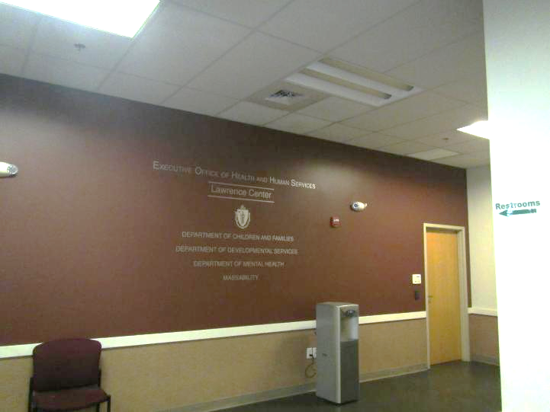

Prepared by:
Massachusetts Department of Public Health
Bureau of Climate and Environmental Health
Division of Environmental Health Regulations and Standards
March 2026

BACKGROUND
Building: | Lawrence EOHHS Office
Address: | 280 Merrimack Street, Lawrence, MA
Assessment Requested by: | Pedro Batista, EOHHS Facilities
Reason for Request: | Follow up from previous two assessments
Date of Assessment: | March 23, 2026
Massachusetts Department of Public Health/Bureau of Climate and Environmental Health/Division of Environmental Health Regulations and Standards (MDPH/BCEH/EHRS) Staff Conducting Assessment: | Ruth Alfasso, Environmental  Engineer, EHRS
Building Description: | The EOHHS Center is located in a large former mill complex near the Lawrence Commuter Rail station. The EOHHS Center occupies space on the second and third floor. Other residential, retail, and office businesses are located in the building.
Windows: | Windows are not openable in this building.

BACKGROUND
Elevated levels of carbon monoxide were found in the building during a visit on January 22, 2026. At that time, the elevated levels were traced to boiler exhaust from vent pipes outside windows on the 2nd and 3rd floor of the building.
Repair efforts have involved a multi-step process which included temporarily sealing off the impacted rooms with tape and signage, sealing of window frames and other gaps in the exterior wall with caulking material, installation of carbon monoxide detectors, and rerouting the ends of the boiler pipes. A return trip to the building was conducted on February 18, 2026, to see if the interim measures (caulking) had reduced the infiltration of products of combustion. During that visit, levels of carbon monoxide were significantly lower, suggesting that sealing of the windows had been fairly effective in excluding outside air containing boiler exhaust. Levels of both carbon monoxide and carbon dioxide in the impacted rooms, however, were still higher than those in other unoccupied areas of the building that were tested. The report issued at that time reiterated that conditions measured on February 18, 2026, represented a snapshot of conditions in the building; under different wind and weather conditions, higher levels of carbon monoxide might have been present in the areas tested.

METHODS
Please refer to the IAQ Manual for methods, sampling procedures, and interpretation of results (MDPH, 2015). Mostly areas that had been impacted by the boiler exhaust were tested during this trip with a few others for comparison.

RESULTS AND DISCUSSION
The following is a summary of indoor air testing results (Table 1).
- Carbon dioxide levels were below the MDPH guideline of 800 parts per million (ppm) in all indoor areas tested.
- Temperature was within the recommended range of 70°F to 78°F in almost all areas assessed.
- Relative humidity was below the MDPH recommended range of 40 to 60% in all areas assessed. This is reflective of outdoor conditions.
- Carbon monoxide levels in all indoor areas tested were ND.
- Fine particulate matter (PM2.5) concentrations indoors were below the National Ambient Air Quality Standard (NAAQS) level of 35 μg/m³ in all areas assessed.

Products of Combustion and Ongoing Control Activities
Between the February 18 visit and the March 23 visit, modifications were made to the exhaust pipes of the boilers. The ends of the boilers were turned to extend the exhaust point away from the building (Pictures 1 and 2). This appears to be increasing the dilution of the exhaust stream. A background measurement was taken outdoors outside of the range of the exhaust stream; it had no measurable carbon monoxide (ND), typical outdoor carbon dioxide, and low levels of PM2.5 (Table 1). A measurement taken at ground level below the exhaust pipes had higher carbon dioxide, higher humidity, and higher PM2.5 (Table 1) than the background level, however no carbon monoxide was detected in this location.
Measurements were taken in each of the rooms previously found to be impacted by boiler exhaust and adjacent areas for comparison (Table 1). No differences in measurements between formerly impacted areas and control areas could be discerned from the data collected, no carbon monoxide was detected, and all carbon dioxide and PM2.5 levels were well within the guidance used by EHRS for air quality in buildings.

CONCLUSIONS/RECOMMENDATIONS
Conditions in the building for carbon monoxide have been significantly improved through window sealing and adjustments to the boiler exhaust direction/location. The following ongoing recommendations will maintain good air quality and assist in detecting any other carbon monoxide exceedances:

Additional Recommendations:
- Determine the function of the carbon monoxide detectors installed next to thermostats and ensure they will warn occupants if needed.
- Add additional carbon monoxide detectors, preferably with a digital readout, to the walls adjacent to windows in the conference room and kitchen and ensure they are monitored and maintained so long as the building is occupied.
- Continue to communicate with occupants on any additional activities related to this remediation.
- Follow other outstanding recommendations from the January 2026 and February 2026 reports.
- Refer to resource manual and other related IAQ documents located on the MDPH’s website for further building-wide evaluations and advice on maintaining public buildings. These documents are available at: http://mass.gov/dph/iaq.

REFERENCES
MDPH. 2015. Massachusetts Department of Public Health. Indoor Air Quality Manual: Chapters I-III. Available at: https://www.mass.gov/lists/indoor-air-quality-manual-and-appendices.

Picture 1
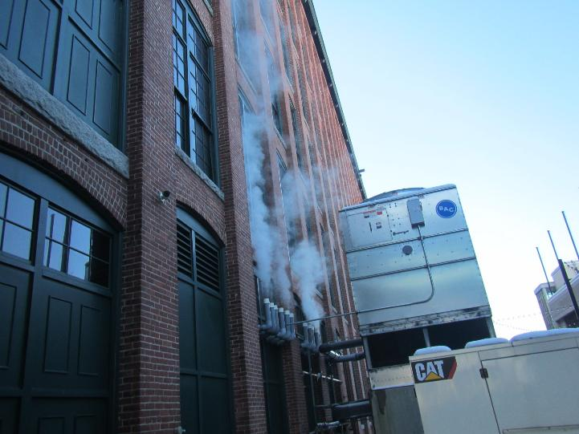
Chiller in front of boiler exhaust pipes, taken on January 22, 2026
Picture 2
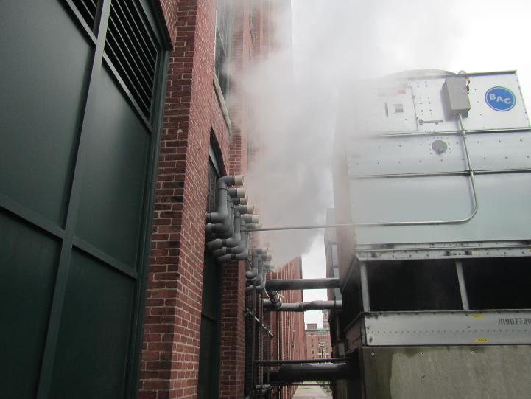
New configuration of boiler exhaust pipes, taken on March 23, 2026

Location | Carbon  Dioxide  (ppm) | Carbon Monoxide  (ppm) | Temp  (°F) | Relative  Humidity  (%) | PM2.5  (µg/m³) | Occupants  in Room | Windows  Openable | Ventilation |  | Remarks
 |  |  |  |  |  |  |  | Supply | Exhaust | Remarks
Background | 455 | ND | 39 | 66 | 3 |  |  |  |  | Cold, damp, snow showers
Under/next to boiler pipes | 797 | ND | 38 | 77 | 130 |  |  |  |  | Boiler exhaust billowing out above
2nd floor waiting | 701 | ND | 70 | 45 | ND | 8 | N |  |  | Not carpeted, control area
Outside 1034 | 600 | ND | 70 | 27 | ND | 0 | N | Y | Y | Control area
1034 Kitchen | 531 | ND | 69 | 27 | ND | 0 | N | Y | Y
Outside 1032 | 601 | ND | 72 | 26 | ND | 0 | N | Y | Y | Control area
1032 (left side of conference room) | 548 | ND | 71 | 27 | ND | 0 | N | Y | Y
1030 (right side of conference room) | 522 | ND | 69 | 27 | ND | 0 | N | Y | Y
Outside room 2150 | 613 | ND | 71 | 26 | ND | 0 | N | Y | Y | Control area
2150 | 571 | ND | 700 | 26 | ND | 0 | N | Y | Y
Cube next to 2150 | 603 | ND | 67 | 28 | ND | 0 | N | Y | Y
Cube 2156 | 630 | ND | 71 | 27 | ND | 0 | N | Y | Y | Control area

