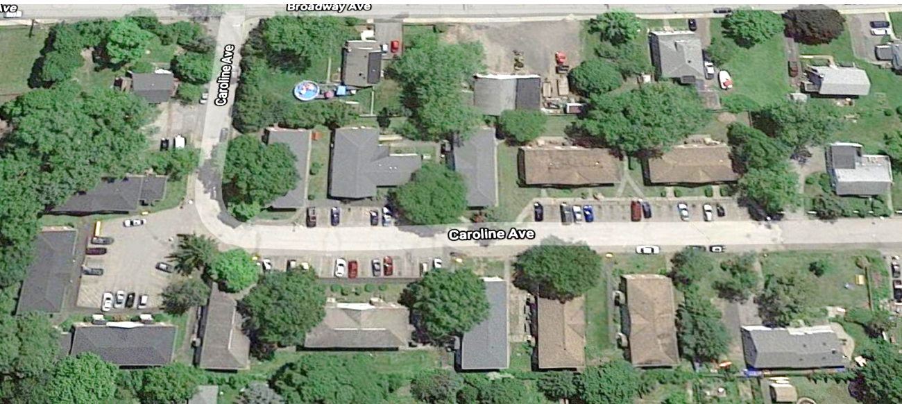  Insert Relevant and Beautiful Picture of the Project  Construction Notification for Residents  at Insert LHA Name & Development Name(s)  Project Name and number  Notification # and Date  This notice is provided to you for informational purposes only. We wanted you to be aware that a construction project will be taking place soon.  At the end of the project, you will have:  Note to designer - Insert plus items that the resident will have such as new windows, a new stove, etc.  We will begin construction at your development on Date of NTP Note to designer -Distribution of notice will happen directly before the anticipated NTP date. Do not use this for a project requiring Federal Documents be attached (far and few between)  What does that mean for you and your home? Note to Designer - Below are example types of descriptions. The descriptions will be as involved as the project requires and your scenario may not be represented by any of the selections below. Please write something that appropriately represents the needs of the residents. Even though this has overflowed here, try to stay on this page.  - The work will take place entirely at the exterior/interior of the building and no one will be required to enter your home.  - The contractor will/not need to enter your home during the project in order to brief description. You will receive a notice 48 hours before this occurs, so you will be well aware that this will happen and when.  - All items belonging to the resident on the building’s exterior should be removed prior to Date of XX/XX/202X.  - The work will/will not interrupt utility services to your dwelling unit. Note to designer – list service to be disturbed if any.  - Construction will occur between the hours of insert time a.m. and insert time p.m., Monday through Friday.  Please bear with us as we do this construction. We know that it may represent a significant inconvenience! Make sure to look out for any obstacles, barriers such as orange cones or caution tape. Avoid those obstacles! Note to designer – if you know f specific obstacles, please note.  If you will need to be out of your unit during the construction process you will receive a separate notice with the details related to how long you will need to be out of your unit and options for where you will be staying during that period. Note to designer – this statement has been reviewed by EOHLC Legal and is not to be revised. However, if no work will take place in the unit, please remove the statement.  Some of the above information may change during the construction, however, we are very interested in answering your questions and your concerns. You will also receive an updated notification if there are significant changes to work or schedule. Note to designer – produce an update if the project warrants one and request that the LHA distribute the notice. The XX Housing Authority will still send you notifications 48 hours prior to any contractor entering your home.  Note to Designer - The consultant will be responsible for printing the notice and giving it to the LHA for distribution. Printing is a reimbursable expense. Discuss with the Authority how many will be required. In addition, provide some copies for posting by the authority in public spaces.  If only a couple of units are to receive construction, the notice may only need to go to those units. The consultant and the LHA should determine if additional units should be notified, for instance if they will be affected by noise from construction. | The Project will begin construction on insert anticipated date  The anticipated completion of construction is add date of expected CSC  An informational session on how to add info such as use your ASHP will be held at the end of the project.  For Questions or Concerns  Name of LHA Staff  Telephone  Email
This notice should be used on all projects involving a designer, large or small. Please discuss with the EOHLC project Manager and the LHA if federal location laws are triggered.
If the development includes non-English speaking residents, please request that a translation be provided by EOHLC. To do this, send your request to the EOHLC project manager and request a translation.

