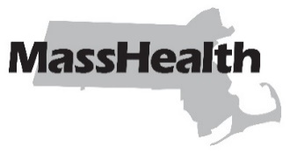
Eligibility Operations Memo 25-15
Commonwealth of Massachusetts
Executive Office of Health and Human Services
Office of Medicaid
www.mass.gov/masshealth
DATE: October 2025
TO: MassHealth Eligibility Operations Staff
FROM: Heather Rossi, Deputy Chief Operating Officer, Eligibility Policy and Implementation [signature of Heather Rossi]
RE: Universal Eligibility Requirement to Apply for Other Benefits Is No Longer Applicable

Background

MassHealth has required members and applicants to self-attest that they applied for, or provide proof of application for, certain other non-health care benefits (e.g., Social Security, retirement benefits, etc.) that they may be entitled to in order to qualify for MassHealth. This was a requirement under federal regulations at 42 CFR §§ 435.608 and 436.608. However, these regulations were eliminated effective June 3, 2025.

Policy Update

As of the date of this EOM and pursuant to federal law, MassHealth is eliminating the universal eligibility requirement that an individual apply for other benefits that they may be entitled to as a condition of MassHealth eligibility. MassHealth regulations at 130 CMR 503.008 and 517.007 will be updated later to reflect this change.
Staff should satisfy any outstanding requests for information that were based on the former requirement to apply for other benefits.

Please note: this change does not affect the separate requirement that all applicants and members must obtain and maintain health insurance available to them at no cost, including Medicare, in accordance with 130 CMR 517.008. All applicants and members are still required to complete Section 5 of the ACA-3 for third-party-liability purposes. Please see EOM 25-10 for more information on mandatory Medicare enrollment at age 65.

Questions?

Have your MEC designee contact the Policy Hotline.

MassHealth on Facebook MassHealth on LinkedIn MassHealth on X MassHealth on YouTube

