SOCIAL DETAILS:
TWITTER HANDLES TO FOLLOW | LINKS | HASHTAGS TO USE
@MassEMA  @EOPSS  @MassDPH  @FEMA  @FEMAregion1  @RedCrossMA | Website:  www.Mass.Gov/EPmonth  Press Release: https://bit.ly/2EEQVv4  Proclamation: https://www.mass.gov/doc/emergency-preparedness-month-proclamation-september-2020/download | #EPisEssential  #MAsaysThanks  #Prepare  #Preparedness  #EssentialWorkers  #ReadyMA
SOCIAL POSTS:
Feel free to use these social posts or use them to craft your own. Below you will also find several different images that you can use in your posts. During September, MEMA will be posting preparedness month messages daily on its Twitter and Facebook platforms – please help share the messages on your own accounts.
SAMPLE POSTS
@MassGovernor Baker has proclaimed September as Emergency #Preparedness Month in MA. [Link to Press Release]
We’re kicking-off #Preparedness Month in #MA with a public THANK YOU campaign for #EssentialWorkers. Find out how to join us in saying thanks to the people in the community who’ve done so much during the #covid19ma pandemic. www.Mass.gov/EPmonth #EPisEssential #MAsaysThanks
Who are the people in your community that have stepped up and made a difference during the #covid19ma pandemic? Take time to thank them during #Preparedness Month – find out how www.Mass.gov/EPmonth #EPisEssential #MAsaysThanks
Say thank you to an #EssentialWorker or organization whose #Preparedness is helping keep us safe during the #pandemic. www.Mass.gov/EPmonth #EPisEssential #MAsaysThanks
Essential workers and organizations have stepped up to help keep residents, families, and communities safe during the #COVID19MA pandemic. Fill out this certificate to thank an essential worker and tag your photo with #EPisEssential https://bit.ly/3bgIbXG
Pledge to prepare for emergencies large and small to protect yourself, those you love and essential workers, all while thanking an essential worker in your life!

Print, fill out, and present this certificate to an essential worker and tag a photo with #EPisEssential https://bit.ly/3bgIbXG
As we’ve seen this year, emergencies & disasters never take a day off that’s why taking small steps to improve your #Preparedness is so important. https://bit.ly/32LsQL2 #ReadyMA
Make a family emergency plan with the members of your household.

If you test positive for #COVID19, do you know where you would stay to isolate and recover to keep yourself and others safe? #MakeAPlan https://bit.ly/3bhaRQk
Plan for Your Unique Needs (1/2)
• If you’ll need assistance during a disaster, talk to family & friends & make a personal support network.
• If you have special medical needs, make a plan for someone to help you w/lifesaving equipment & meds.
http://bit.ly/2cI69zd
#ReadyMA #Preparedness
Plan for Your Unique Needs (2/2)
• Show friends how to use your medical equipment so they can help you in an emergency
• Develop backup plans for personal assistance services, or other forms of in-home assistance.
http://bit.ly/2cI69zd
#ReadyMA #Preparedness
Do you have your emergency kit stocked? Gather supplies to stay prepared in case of a disaster:

✅Face coverings, hand sanitizer, disinfecting wipes
✅Medication & a first aid kit
✅Items for kids and pets
✅Emergency cash
✅Food & water

More: http://bit.ly/29WZmBt
#ReadyMA #Preparedness
Emergencies can happen at any time. Make sure your family knows how to get in touch with each other if you are not all together or if normal communications systems are disrupted.
Make a family emergency plan: http://bit.ly/29R7Bwh
#ReadyMA #Preparedness
Besides #COVID19MA, what emergencies should you #prepare for in MA?
Floods, winter storms, hurricanes, power outages, tornadoes, extreme temps, & more.
Learn about specific hazards & how to prepare https://bit.ly/2YV3g58 #ReadyMA #Preparedness

Social Images:
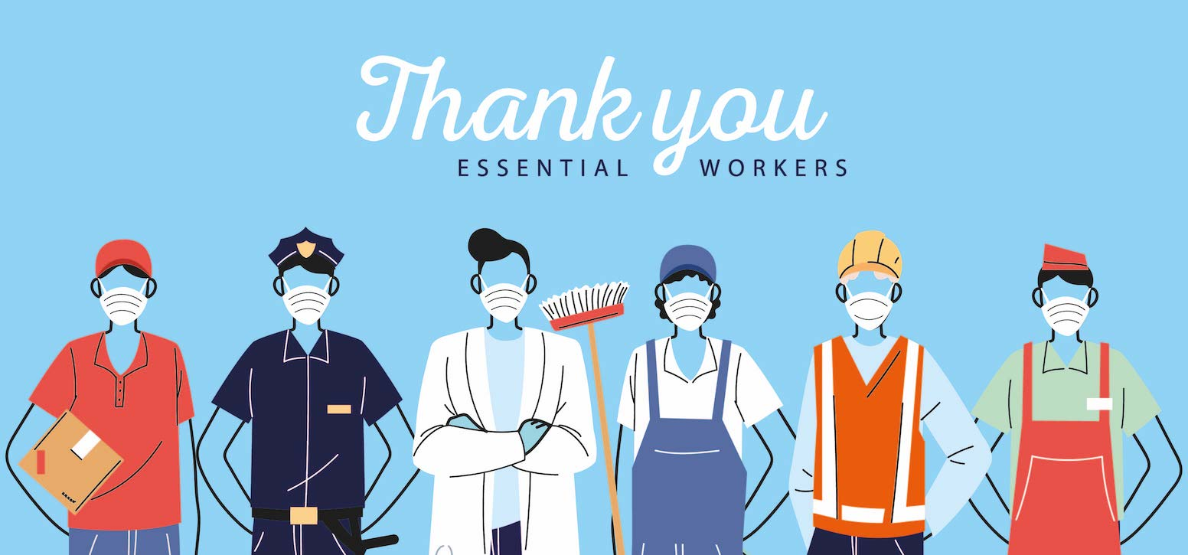 |  | 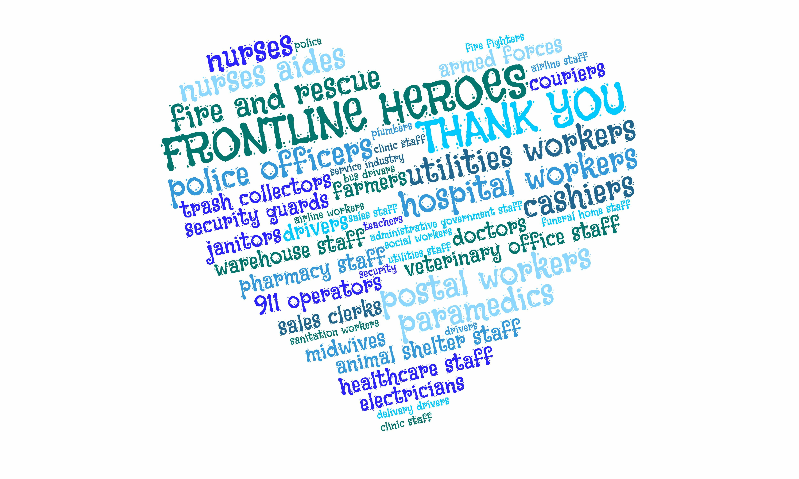
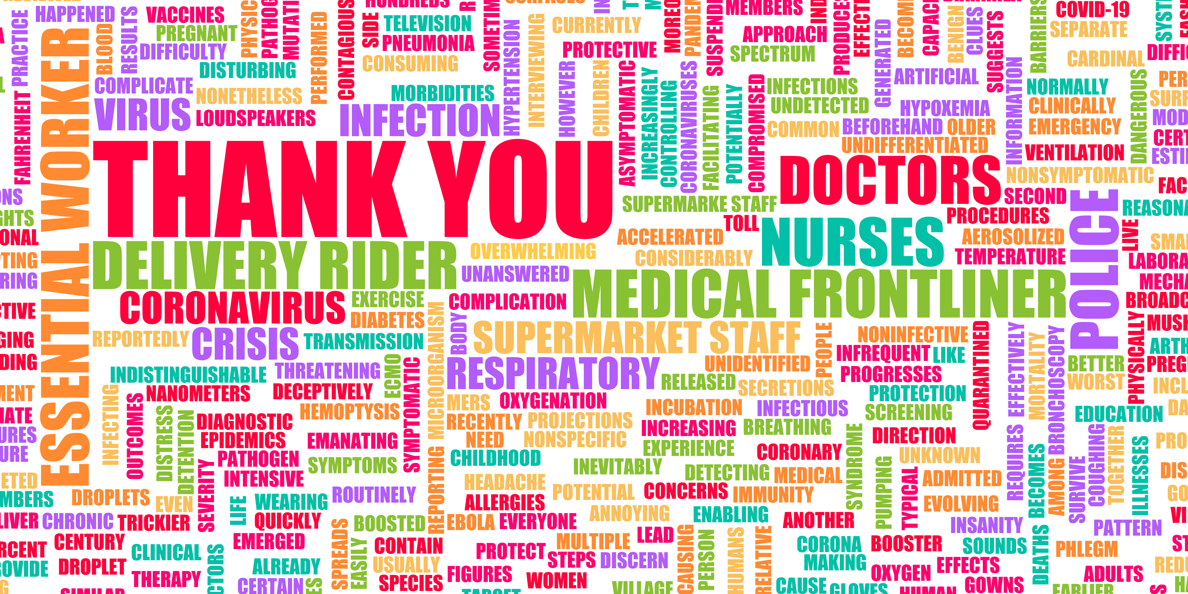 |  | 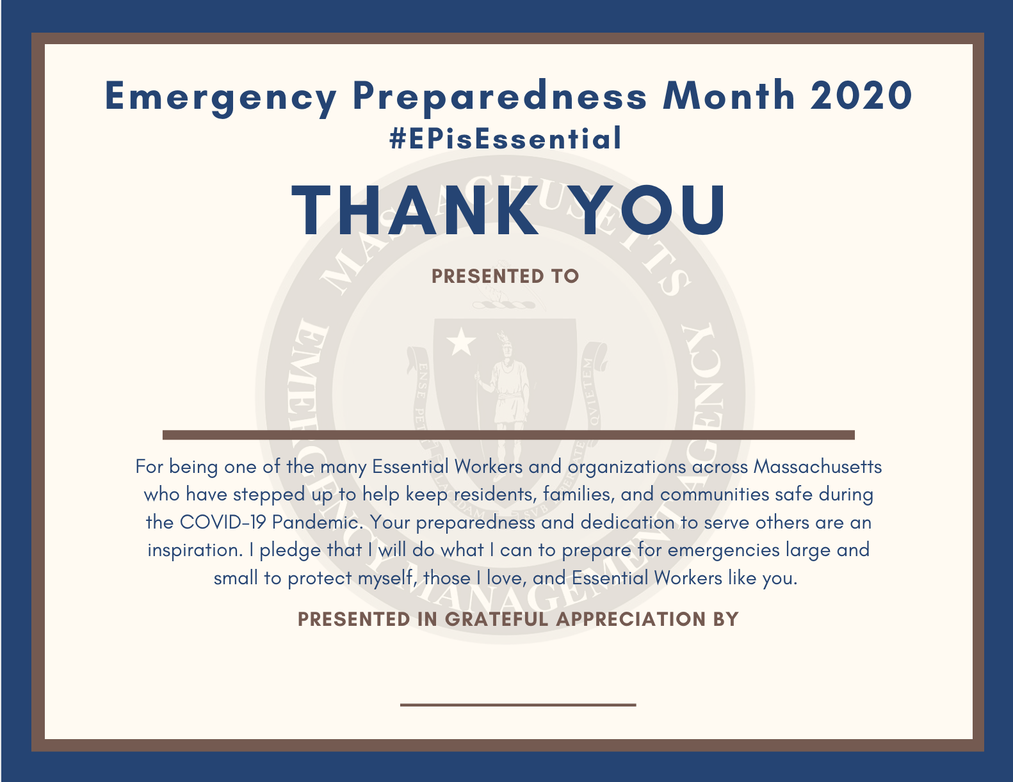
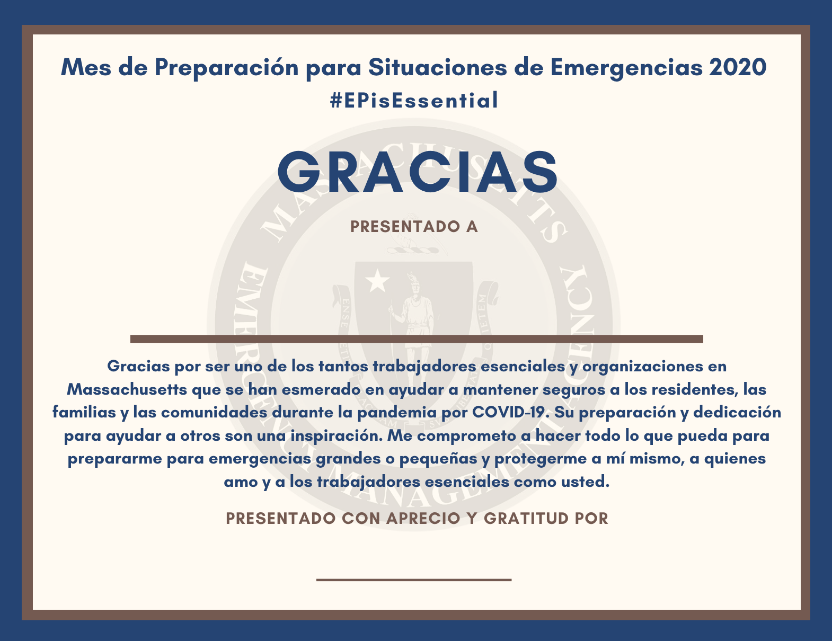 |  | 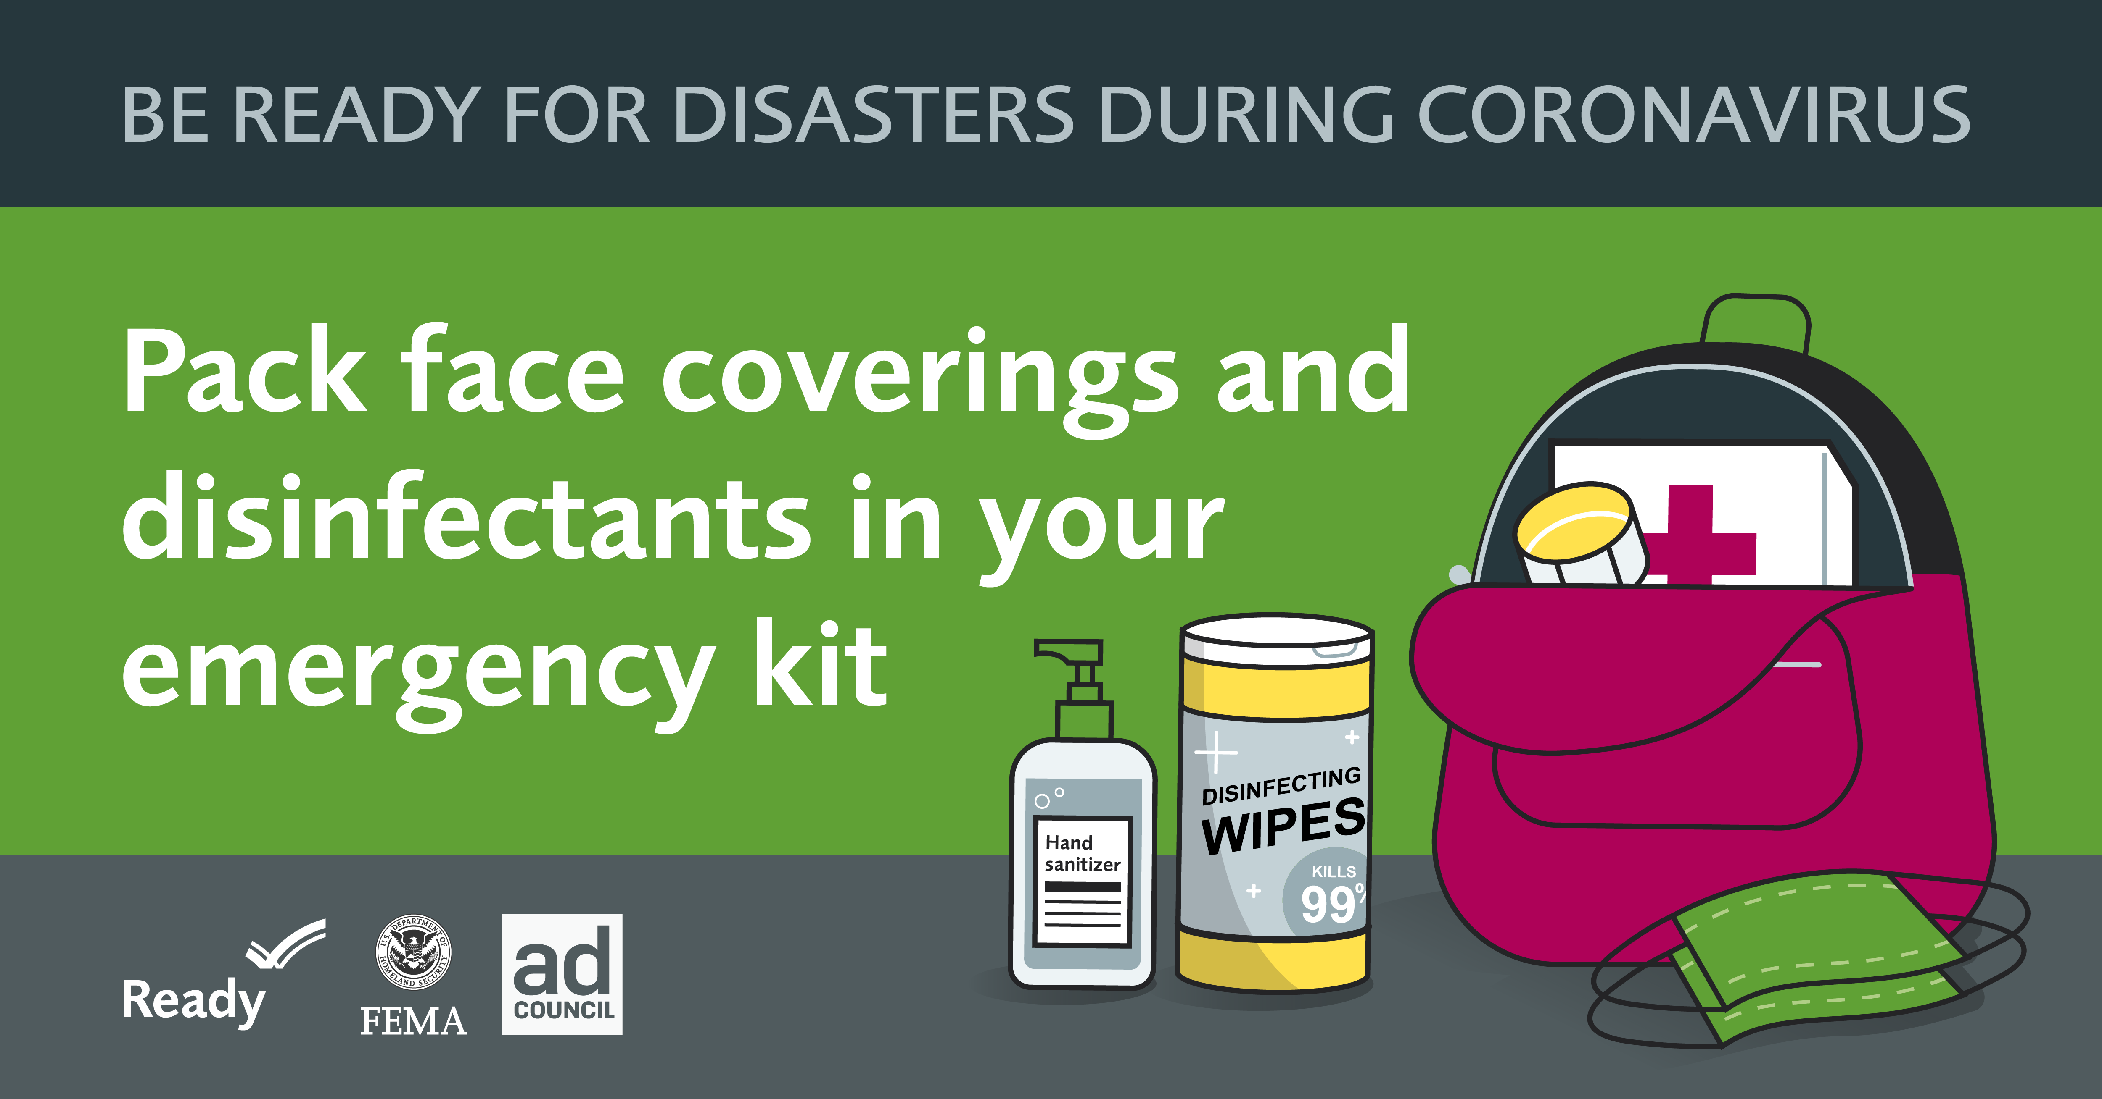
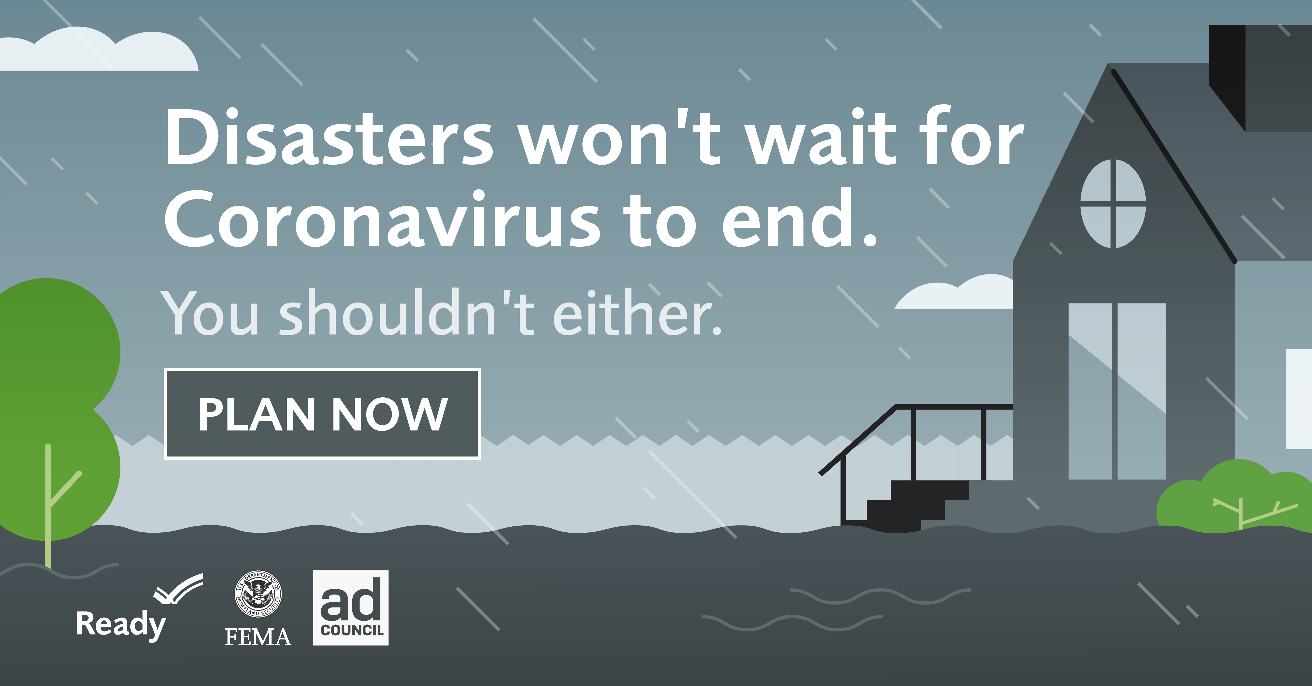 |  | 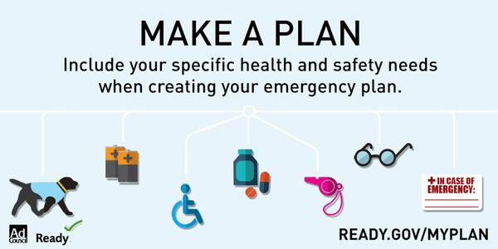
 |  | 