ENVIRONMENTAL CLAIM VERIFICATION

Findings and Recommendations to the
Massachusetts Operational Services Division

By Alicia Culver
Responsible Purchasing Network
July 2021

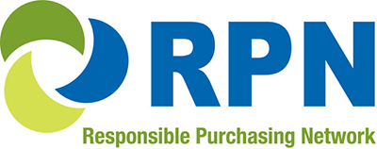

Table of Contents
Acknowledgements 3
Executive Summary and Recommendations 4
Introduction 7
Research Methods 8
Environmental Claim Verification Best Practices and Recommendations for Product Manufacturers, Vendors, Certifiers, and Aggregators 9
A. Environmental Claim Verification Practices of Product Manufacturers 9
Best Practice Examples for Product Manufacturers 9
Opportunities for Improvement for Product Manufacturers 14
Recommendations for Product Manufacturers 17
B. Environmental Claim Verification Practices of Vendors 19
Best Practice Examples for Vendors 20
Opportunities for Improvement for Vendors 27
Recommendations for Vendors 30
C. Environmental Claim Verification Practices of Third-Party Environmental Certifiers 32
Best Practice Examples for Third-Party Environmental Certifiers 33
Opportunities for Improvement for Third-Party Environmental Certifiers 36
Recommendations for Third-Party Environmental Certifiers 38
D. Environmental Claim Verification Practices of Certification Data Aggregators 40
Best Practice Examples for Certification Data Aggregators 43
Opportunities for Improvement for Certification Data Aggregators 43
Recommendations for Certification Data Aggregators 46
E. Recommendations for E-Procurement System Providers 47
F. Recommendations for the Massachusetts Operational Services Division 48
VI. Conclusion 52
Appendix – Understanding the Numbers 54

Acknowledgements
The Responsible Purchasing Network (RPN) is grateful for the opportunity to collaborate on the research and writing of this report with Julia Wolfe, Director of Environmental Purchasing for the Massachusetts Operational Procurement Division. This project was made possible by Green Purchasing Technical Assistance Funding from the National Association of State Procurement Officials (NASPO). We would like to thank Kelly Panciera, Principal of Green Spectrum Consulting, for editing and formatting assistance. We would also like to acknowledge the valuable contributions of the following individuals who shared their time and expertise with us as reviewers of this report prior to publication:
- Bridget Williams, PhD, Safer Choice Program, U.S. Environmental Protection Agency,
Office of Pollution Prevention & Toxics
- Brie Welzer, Director, Science and Standards Development, Green Seal
- Chris Geiger, PhD, Green Purchasing and Safer Pest Management Program,
San Francisco Department of the Environment
- Holly Elwood, Senior Advisor, Environmentally Preferable Purchasing Program,U.S. Environmental Protection Agency, Office of Pollution Prevention & Toxics
- Jenna Larkin, Environmental Protection Specialist, Environmentally Preferable Purchasing Program, U.S. Environmental Protection Agency, Office of Pollution Prevention & Toxics
- Jonathan M. Rivin, Materials Evaluation Specialist, Oregon Department of Environmental Quality
- Kathleen Egan, CEO and Co-Founder, ecomedes
- Kshirajaa Ramesh, Sustainability Coordinator, Maryland Department of General Services
- Lynn Rose, Programs Manager, Informed Green Solutions
- Maureen Barends, Director of Strategy Sourcing Services,
Massachusetts Operational Services Division
- Michael Glass, Principal, NextGen Supply Group
- Sandra Cannon, Technical Support, Sustainable Acquisition Program, U.S. Department of Energy, Sustainable Acquisition Program
- Susan Klosterhaus, PhD, Vice President, Science and Certification, Cradle to Cradle Products Innovation Institute

Executive Summary and Recommendations
This report tackles a common problem faced by contract managers, purchasers, and vendors: the process of verifying the environmental attributes of products is both time-consuming and unreliable. It identifies factors that make environmental claim verification challenging and create roadblocks to automate the process. It also highlights the ways in which some manufacturers and vendors have improved the labeling of environmentally preferable products (EPPs) in their offering and describes how third-party certifiers of EPPs – and, more recently, certification data aggregators – are creating online registries that enable users to quickly and reliably identify products that have earned a strong, multi-attribute ecolabel. And finally, it recommends actions each entity in the supply chain can take to make the process of verifying environmental claims easier and more accurate, saving time, and providing greater buyer confidence. While focusing on janitorial supplies, it reveals broader, systemic challenges with verifying the environmental attributes of products. Its recommendations can be applied more broadly as well.
Simply confirming the environmental certification status of products can be difficult, and verifying specific environmental attributes such as post-consumer recycled content is even harder. Many factors are contributing to this problem, including the following:
- EPP standards are not harmonized among product manufacturers, vendors, and contract managers. There are also inconsistencies in the ways manufacturers and vendors label their EPPs; as a result, contract managers and purchasers must learn how each company’s ecolabeling system works.
- The websites of product manufacturers and vendors often lack a complete and current downloadable spreadsheet, catalog, or brochure listing all of their EPPs in one place, or a way to efficiently and reliably search their websites to find them.
- Some environmental attribute information on product manufacturers’ and vendors’ websites is outdated, incomplete, confusing, vague, or inaccurate. Moreover, manufacturers and vendors have created their own ecolabel or EPP icon with little or no information about the environmental attributes of the products that have earned it.
- While environmental certifiers of janitorial supplies have created online product registries, users often need to check several certifiers’ websites to verify that a product is listed. Moreover, each certifier’s website is designed differently and lacks some information needed to streamline the EPP verification process (e.g., photos, UPCs, and static links for each product). In addition, the filters and search functions of the certifiers don’t work flawlessly.
- Many important environmental attributes (e.g., recycled content) are self-declared by manufacturers rather than being certified by a third party.
- Environmental certification aggregators (e.g., ecomedes and UL SPOT), which combine the registries of several certifiers, are relatively new time-saving resources that need to optimize their design, content, and functionalities (e.g., such as their search capabilities).
- Most e-procurement systems are not designed to identify EPPs or generate green spend reports.
This report is Massachusetts Operational Services Division’s first step in identifying the barriers and solutions to optimizing – and ultimately automating – environmental claim verification practices among all of the different types of stakeholders involved in the process. Going forward, MA OSD could:

- Facilitate an ongoing dialog among manufacturers, vendors, certifiers, contract managers, and other sustainable procurement professionals aimed at harmonizing the environmental claim verification information that is requested by purchasers and provided throughout the supply chain. This would:
- Reduce the number of information requests manufacturers need to respond to about the environmental attributes of their products.
- Make it easier for vendors to identify compliant products for bid submissions and catalogs as well as keep up with catalog updates and reporting requirements.
- Provide Massachusetts and other jurisdictions with a system to easily verify EPPs in bid submissions, catalogs, and sales reports.
- Increase the usability of the information provided in the online registries of certifiers and aggregators, which could reduce the number of requests for clarification they receive.
- Create incentives for vendors to expand their offerings of products with verified environmental attributes in order to capture more products on certifiers’ lists.
- Review and enforce vendor labeling and reporting requirements.

- Evaluate bidders’ experience verifying the environmental attributes of the products in their offering by awarding no-cost points to bidders that demonstrate they can accurately verify and clearly label products with environmental certifications and attributes listed in the contract specifications.
- Offer training and tools to vendors to help them more easily and reliably verify the environmental claims of products in their offering, including an updated Environmental Claim Verification and Reporting Template based on the findings of this report.
- Consider using an environmental certification data aggregator to streamline the environmental claim verification process. MA OSD could start by pilot testing each aggregators’ free online registry for content and usability, and assess the costs and benefits of contracting with one of them to create a customized registry for the State’s new green cleaning supplies contract. Massachusetts could also team up with other states – or ask NASPO – to cooperatively solicit this type of service or consider using an aggregator that offers its services by subscription through a third-party organization.
- Work with its e-procurement service provider to design useful EPP labeling and reporting features into the new system it is designing for the State.

Introduction
The Commonwealth of Massachusetts – like other jurisdictions – needs easily accessible, current, and reliable information on the environmental attributes of the wide array of products that are offered on its contracts. Contract managers need it to:
- Develop specifications and bid lists that feature environmentally preferable products (EPPs);
- Evaluate incoming bids to ensure that they comply with each contract’s minimum environmental specifications;
- Monitor vendor performance (either manually or by using a Vendor Report Management (VRM) system, which Massachusetts does); and
- Report their “green” spending results.
The thousands of users of Massachusetts’ statewide contracts also need clear and accurate labeling of EPPs to identify and ultimately purchase these items for their operations. Even vendors need this information to effectively respond to bid solicitations for EPPs, accurately point their customers to EPPs in their offering, and track their customer’s “green” spend over the life of their contract.
Contract managers, purchasers, and vendors are all similarly challenged by a system of environmental claim verification that is highly inefficient because it is not systematized, harmonized, or automated. Consequently, those who do try to verify the environmental attributes of products – even just determining whether a product has earned a third-party environmental certification – often face a burdensome task that involves manually collecting information on a product-by-product basis primarily from manufacturers and environmental certification organizations. Not only is this research time consuming, but it may also yield inaccurate, outdated, or conflicting results. Consequently, some states do not even attempt to verify environmental attributes and, instead, leave that task to their vendors – often unchecked.
One of the overarching problems associated with environmental claim verification is that there is a lack of harmonization of EPP standards among product manufacturers, vendors, and contract managers. Strong multi-attribute certifications are mixed in with single-attribute certifications and unverified environmental claims in bid specifications and on manufacturer and vendor websites and marketing materials. There is a compelling need to harmonize environmental purchasing standards. In addition, vendors need to be able to customize their environmental labeling systems so they comply with the different environmental specifications of various government agencies and businesses.
This report identifies many factors that make environmental claim verification unreliable and time consuming, including some that are creating roadblocks to automating the process. It also presents examples of the best ecolabeling practices of manufacturers, vendors, certifiers, and certification data aggregators. And finally, it recommends actions each of these entities – as well as e-procurement service providers and the Massachusetts Operational Services Division (MA OSD) itself – can take to facilitate development of a more efficient and reliable environmental claim verification system.
While this report focuses on janitorial supplies, its findings reveal broader, systemic challenges with verifying the environmental attributes of products; likewise, its recommendations can be applied to many other types of products purchased by Massachusetts and other jurisdictions.

Research Methods
To conduct this assessment, Responsible Purchasing Network (RPN), in collaboration with MA OSD:
- Interviewed and reviewed the websites of several manufacturers and vendors of janitorial supplies that are offered on two of Massachusetts’ statewide contracts:
- FAC 85: Environmentally Preferable Cleaning Products, Programs, Equipment and Supplies; and
- FAC 123: Facilities Maintenance, Repair and Operations Commercial Grade Products and Supplies.

- Interviewed staff and reviewed the websites of environmental certifiers, including Green Seal, U.S. Environmental Protection Agency’s Safer Choice Program, UL (which maintains the ECOLOGO certification program), and the Cradle to Cradle Products Innovation Institute (which maintains the Cradle to Cradle Certified Products Program) as well as aggregators of information from certifiers of green cleaning products, including ecomedes and UL (which maintains the UL SPOT database).
- Reviewed the Commonwealth’s existing e-procurement system, COMMBUYS, which was developed by Periscope Holdings, Inc. (PHI) and does not have an easy way to identify EPPs and discussed this problem with staff from the COMMBUYS Program.
- Received a demonstration from PHI about its ability to integrate EPP claim information into its next-generation platform (called Marketplace) and discussed with them and the State’s data management staff the new e-procurement system’s EPP display, filtering, and reporting capabilities.
- Interviewed and solicited information from other states as well as the U.S. Environmental Protection Agency’s Environmentally Preferable Purchasing Program about their research on this topic and strategies and resources they use to make the environmental claim verification process easier and more reliable.

Environmental Claim Verification Best Practices and Recommendations for Product Manufacturers, Vendors, Certifiers, and Aggregators
Below is an overview of the types of environmental claim information that is available from manufacturers, vendors, third-party certifiers, and certification data aggregators. These entities have developed a variety of ecolabeling systems to help contract managers and purchasing agents verify the environmental certifications and attributes of cleaning chemicals, janitorial paper products, and other types of janitorial supplies. For each of these entities in the supply chain, this report highlights best practice examples, identifies opportunities for improvement, and provides recommendations for optimizing environmental claim verification in that sector.

A. Environmental Claim Verification Practices of Product Manufacturers
Manufacturers are often the first place contract managers, purchasers, and vendors go to verify information about the environmental certification status and attributes of the products they are evaluating. Contract managers sometimes receive information on EPPs directly from manufacturers, although they more often rely on the information manufacturers provide to their vendors.
Best Practice Examples for Product Manufacturers
Information on the environmental attributes of products from manufacturers is often accurate – as they know their products better than anyone – although sometimes it is outdated or incomplete. Many manufacturers of cleaning chemicals, hand soaps, sanitary paper products, and other types of janitorial supplies have earned third-party certifications verifying that their products are among the safest for users and the environment. Accordingly, they have employed an array of strategies to help their vendors and customers quickly find the products in their offering that have been awarded an ecolabel (e.g., Green Seal, UL ECOLOGO, and/or Safer Choice) or have other environmental attributes (e.g., a high percentage of post-consumer recycled content or a low volatile organic compound (VOC) content).
Common ecolabeling practices of manufacturers are described below.
- The manufacturer has created a separate sustainability catalog or brochure listing all of its EPPs in one place. As long as the catalog or brochure is current, this practice can make environmental claim verification relatively easy and reliable, especially when it provides a photo of each product, lists the environmental certifications, and attributes of each product, and includes the manufacturer’s item number and the Universal Product Code (UPC) for each packaging configuration of the certified product. This type of resource enables contract managers and purchasers to easily match the products on their vendors’ price lists or websites to the manufacturer’s list of EPPs. Some manufacturers also explain why each product in their offering is considered environmentally preferable. Examples are described below.
- Betco’s Sustainability brochure displays the ecolabels of each of its certified cleaning, floor care, and hand soap products in its offering. It also describes the environmental certifications it recognizes, including Green Seal and UL ECOLOGO (two multi-attribute certifications). (Note: Betco also recognizes USDA Biobased (a single-attribute certification that is used extensively by the U.S. federal government, but not by Massachusetts because it does not address important health attributes). Betco’s brochure also lists the item number of each certified product: 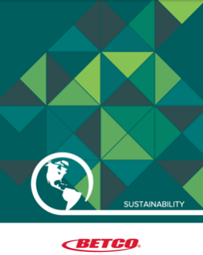
  - Diversey’s website features an Environmentally Certified Products brochure that displays the ecolabel each of its green cleaning products have earned (including Green Seal and UL ECOLOGO, two multi-attribute certifications that are specified by MA OSD). The brochure also lists each item’s product code, which helps purchasers match the EPP to products on their contract:
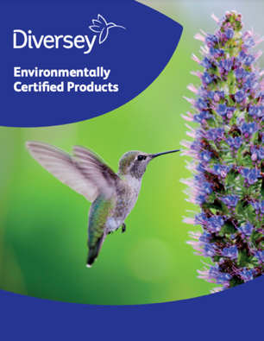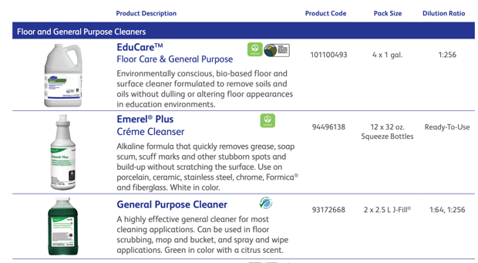
  - Hillyard’s Green Cleaning brochure lists all of the Green Seal-certified products in its offering, including cleaners, degreasers, floor maintenance chemicals, janitorial paper products, and hand soaps. It also provides background information on Green Seal certification, and lists each product’s packaging options, item number, dilution rate, etc:
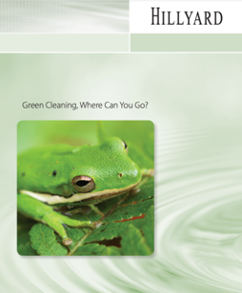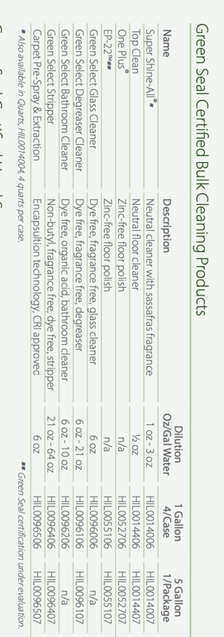
- Multi-Clean published a brochure, Class Act: Education Facility Maintenance, in February 2021 to market its green cleaning and facility maintenance products to schools. It highlights green cleaning chemicals as well as hard floor and carpet care products that are currently certified by Green Seal or the U.S. EPA’s Safer Choice Program:
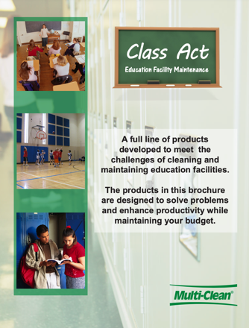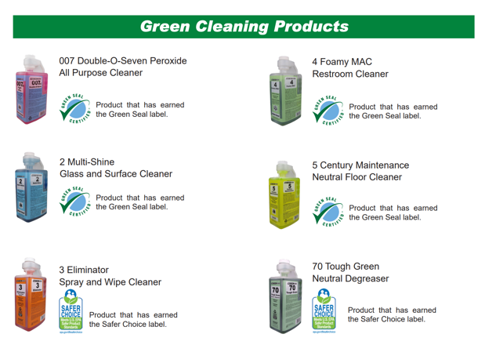

- The manufacturer posts photos of their EPPs on their website clearly showing the ecolabel(s) each product has earned. Being able to see the photo of the product with the ecolabel in it can give contract managers, buyers, and vendors confidence that the product they are evaluating matches the one that has been certified:
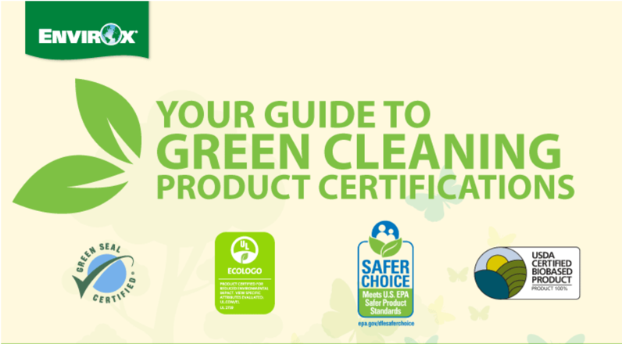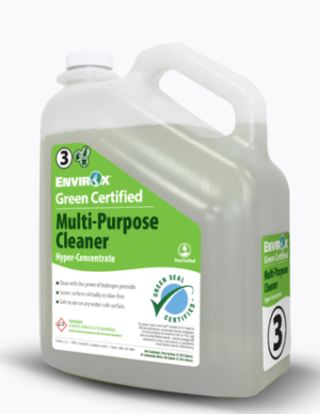
Sometimes the photo will also display important environmental attributes of the product such as the percentage of post-consumer recycled content.
- The manufacturer has incorporated a sustainability filter into its website to help users easily and reliably navigate to their environmentally preferable products. This type of filter can save purchasers and vendors time by enabling them to narrow their search to products with specific environmental certifications or attributes. Below are several examples of manufacturers whose websites include a sustainability filter:
  - Betco’s website has a “Sustainable” filter that pulls up only its green cleaning products, which makes it easy for users to find them when verifying environmental claims without having to sort through the company’s entire offering.
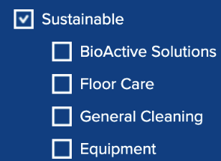
  - Spartan Chemical’s website has a Sustainability link that directs users to “featured products,” many of which have third-party environmental certifications such as Green Seal and/or Safer Choice. The website also enables users to sort items by product line, including separate links to its environmentally preferable Green Solutions and BioRenewables cleaning chemicals. In addition, it provides links to individual product brochures, which also list the ecolabels that each product has earned as well as the item number for each product.
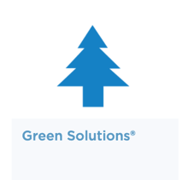
- The manufacturer lists the item’s environmental certifications and/or displays the ecolabel in the product description or name. Examples of descriptions are provided below:
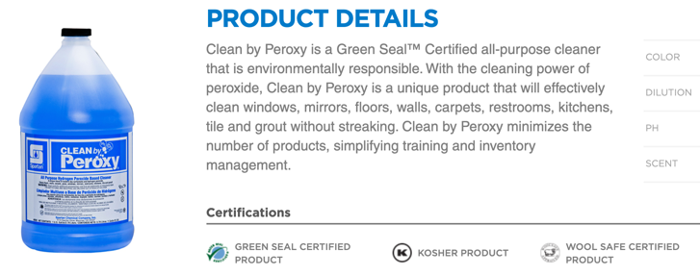
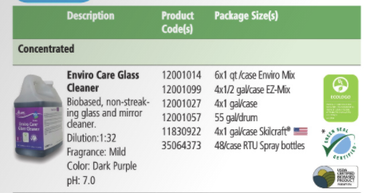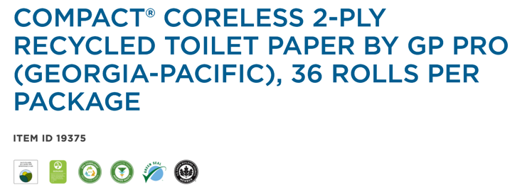
- The manufacturer provides a static link to documentation of each product’s environmental certification. By posting a static link to a certifier’s product page or certificate, a manufacturer is making it easy for its vendors and their customers to verify a product’s compliance with a bid specification that lists certain ecolabels as a mandatory requirement. Vendors can insert the static link when they are submitting bids, creating price sheets or sales reports, or responding to individual requests for EPP verification by contract managers and purchasers. A static link is also helpful to contract managers and purchasers, who can confirm compliance with their specifications with one click on the URL. Certification documents can sometimes be found along with a product’s Safety Data Sheets (SDSs) and/or Technical Data Sheets (TDSs). The certification document should have an expiration date; otherwise, it may be necessary to verify that it is current by checking the certifier’s registry. This is a sample certification document:
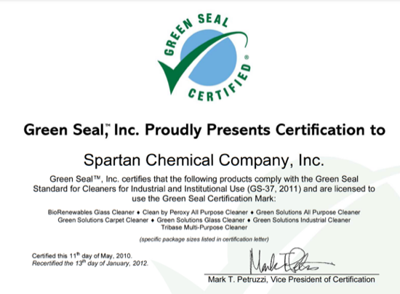

Opportunities for Improvement for Product Manufacturers
While many manufacturers have taken steps to make it easier for their suppliers and customers to identify and navigate to the EPPs in their offering, there is a compelling need for harmonization of environmental labeling among product manufacturers. Because of inconsistencies in the ways different manufacturers label the environmental attributes of their products, contract managers, vendors, and purchasers often have to fish around each manufacturer’s website to figure out how their ecolabeling system works and how EPPs are defined. Consequently, they may end up spending a significant amount of time manually studying each manufacturers’ website or asking each manufacturer to provide a list of EPPs meeting specific criteria on an as-needed basis.
In addition, on some manufacturers’ websites, it is particularly difficult to determine which products are EPPs or what qualifies them as environmentally preferable. For example:
- The manufacturer’s website does not have a current and complete list of EPPs that can be downloaded by vendors, contract managers, or purchasers. Without this, price lists identifying the environmental attributes of each product need to be hand curated for each contract by vendors or contract managers.
- The manufacturer’s website lacks a dedicated webpage, catalog, or brochure that provides information about all of its EPPs in one place. Without these, the website user must search around the manufacturer’s website to identify its EPPs – sometimes needing to review each product listing to find them. Ecolab’s website does this.
- The manufacturer’s website lacks a reliable filter or keyword search function that enables the user to quickly navigate to the manufacturer’s EPPs. For example, the manufacturer’s website does not pull up all certified products when a certifier or ecolabel name (e.g., Green Seal, Safer Choice, or UL ECOLOGO) is typed into the search box or when a filter for the certification is clicked.
- The environmental information listed for a product is vague (e.g., labeling a product with a green leaf icon without explaining what the icon means or stating the product has recycled content, but not saying how much or whether it is post-consumer recycled content).
- The manufacturer’s website does not show photos of their products. Without a photo, the website user may mistake a non-green product with an EPP that has a similar name.
Other problems with manufacturers’ photos include not displaying any or all of the ecolabel(s) the product has earned, or showing an ecolabel that is outdated or no longer awarded to that specific item. Two outdated labels that are sometimes found on manufacturers’ website photos of janitorial products include:
- U.S. EPA’s Design for the Environment (DfE) ecolabel, which was used to identify low-toxicity cleaning products until 2015, when it was changed to Safer Choice. Today, the DfE label is used exclusively for antimicrobial disinfectants. However, occasionally, the old DfE label is found on current photos of non-disinfecting cleaning products, although some of those products are now certified by the Safer Choice Program.
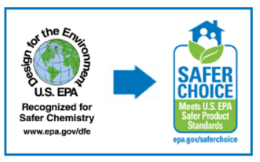
- The EcoLogo label, which has been revised at least twice over the past two decades. Its maple leaf design was used by the Canadian government’s Environmental Choice Program until the EcoLogo certification was acquired by UL and changed to UL ECOLOGO in 2010. The old EcoLogo labels are still found on photos of various types of cleaning products, although some of those products are now certified by UL ECOLOGO.
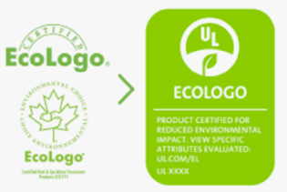
Some manufacturers fail to update their website and catalog photos when the certification status of a product changes. This can be confusing. For example, below is an example of a manufacturer’s website that shows one ecolabel (Green Seal) in the product photo and lists a different ecolabel (Safer Choice) in the product description. Currently, this product is on the Safer Choice list, but not on the Green Seal list.
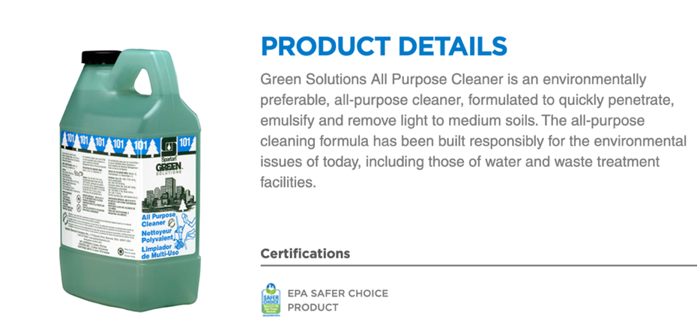
- The environmental attribute information on the manufacturer’s website appears to be out-of-date, listing names of certifications or ecolabels that were changed years ago (as described above) or linking to brochures or certification documents that are many years old. For example, 3M’s website states, “as many as 7 3M Cleaning Concentrates are Green Seal Certified.”
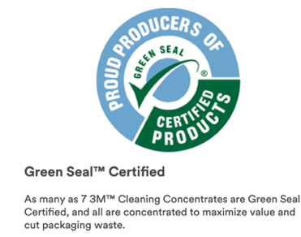
3M had posted a 2013 Environmentally Preferable Certifications brochure that identified eight Chemical Concentrates sold with the 3M Twist ’n Fill™ Chemical Management System certified by Green Seal:
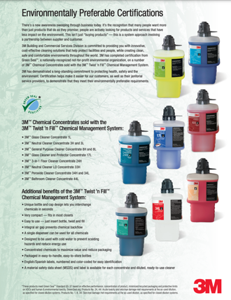
In contrast, the Green Seal registry currently lists 20 3M concentrated cleaning products certified under the GS-37 standard for industrial and institutional cleaners as well as one non-concentrated 3M griddle cleaner that is certified under Green Seal’s GS-52 standard for specialty cleaners for industrial and institutional use.
One reviewer of this report emphasized in their comments that, “Data freshness is very important in the evaluation of EPPs as manufacturers and certifiers are in constant motion making updates to their products and certifications.” Another reviewer explained that EPP data is often out of date because manufacturers lack sufficient resources to maintain it.
- The manufacturer has created its own ecolabel or uses a “green leaf” icon with little or no information about the environmental attributes of the products that have earned it. The use of manufacturer-created ecolabels is a “greenwashing” practice that is confusing to purchasers and vendors alike. Moreover, it undermines credible ecolabels and has contributed to a significant amount of consumer distrust of EPPs in the marketplace. One example of this is Betco’s “Green Earth” ecolabel. This company’s sustainability brochure explains that “all of its sustainable products are either third-party or Green Earth certified.” While this manufacturer has made an effort to evaluate its products to ensure they don’t contain certain chemicals of concern, products with an industry-created ecolabel do not meet Massachusetts’ environmental specifications, which require cleaning products to be certified by either Green Seal, UL ECOLOGO, or Safer Choice. (Note: At least one of the products with this manufacturer-created label is a degreaser, which is covered by the certifiers that MA OSD lists in its specifications.)

- The manufacturer’s definition of EPP is weaker than the State’s. Some manufacturers label products as “green” when they have a single-attribute certification (e.g., USDA Biobased or UL GREENGUARD), while the State requires a multi-attribute certification (e.g., Green Seal, UL ECOLOGO, or Safer Choice). This causes confusion when contract managers, buyers, and vendors try to determine if a product labeled as an EPP meets the State’s contract specifications.
Recommendations for Product Manufacturers
The most important action manufacturers can take to make environmental claim verification easier is maintaining a current, downloadable spreadsheet listing all of the EPPs in their offering. This would prevent contract managers, purchasers, and vendors from having to collect environmental attributes from manufacturers via phone calls, emails, etc. At a minimum, this EPP list would identify each product’s environmental certifications and Universal Product Codes (UPCs). In addition, manufacturers can facilitate environmental claim verification by:
- Getting as many environmental claims as possible verified by a credible third-party organization so that fewer environmental claims are self-declared and more EPPs are tracked by certifiers. Products for which there are multi-attribute standards should be certified against those. For other types of products, manufacturers can:
  - Pursue single-attribute certifications (e.g., Biodegradable Products Institute (BPI) certification for compostable bags or food service ware); or
  - Get important environmental claims (e.g., recycled content of trash bags) verified by a third-party certifier (e.g., Scientific Certification Systems (SCS) or UL). See sample SCS Recycled Content Certificate, right.
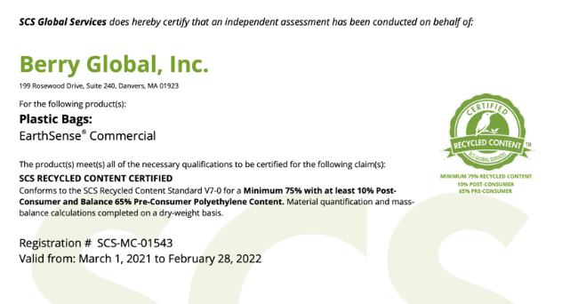
- Posting on its website a detailed environmental/health data sheet for each EPP in its offering. This can be accomplished by commissioning development of a third party-verified Environmental Product Declaration (EPD), which lists environmental attributes of a product, or Health Product Declaration (HPD), which lists health attributes such as avoidance of chemicals of concern or emissions test results. Both EPDs and HPDs are becoming common for green building supplies. One reviewer of this report suggested, “An Environmental Data Sheet should be like a safety data sheet (SDS) and ‘travel’ with the product. That way, we’d know that the information provided by the manufacturer is legitimate.” This information could be used by vendors, certifiers, and certification data aggregators.
- Having a dedicated webpage and/or catalog that helps contract managers, purchasers, and vendors quickly navigate to the EPPs in their offering. Manufacturers can also have a reliable EPP filter and keyword search feature that help users of their website and/or catalog quickly find EPPs with a specific green certification or attribute.
- Clearly and consistently labeling all EPPs on their website, highlighting the third-party certification(s) each product currently holds (with words and ecolabels) as well as its other environmental attributes (e.g., post-consumer recycled content, volatile organic compound (VOC) content, process chlorine-free bleaching, etc.). If a green icon is used, the manufacturer should explain what is behind it.
- Ensuring that the Universal Product Code (UPC) and manufacturer’s item number for each product is posted on their website and provided to the certifier so that the certification and unique product identifier can be tracked together as a digital footprint throughout the supply chain from manufacturer to certifiers, vendors, contract managers, and ultimately, purchasers.
- Providing a photo of each EPP that clearly shows its current ecolabel(s). Manufacturers can also list current certifications and attributes in the product description on their website and in their catalogs and other marketing materials.
- Collaborating with other manufacturers – perhaps through their trade associations – to develop a standardized format for providing environmental certification and attribute information to their vendors and customers.

B. Environmental Claim Verification Practices of Vendors
The Commonwealth of Massachusetts requires its approved vendors – also called suppliers, contractors, or distributors – to clearly label and provide documentation of the environmental certifications and attributes of products that are offered on its statewide contracts. Massachusetts Operational Services Division (MA OSD) has developed boilerplate language requiring its vendors to properly label the environmental attributes of products offered to the Commonwealth. It states:
“Environmental Benefit Claims/Labeling
Environmental benefit claims concerning products or services must be consistent with
the Federal Trade Commissions’ Guides for the Use of Environmental Marketing Terms. Product environmental claims are to include the industry standard the product meets
and certifier. Vendors must agree to offer and clearly label products with sustainability certifications and attributes, when available, within specific product categories. Documentation of the certification claimed by the vendor must be supplied upon request
if it is not publicly available for verification (on either the vendor’s or certifier’s website).
Vendors claiming environmental benefits of their products shall list the appropriate benefits or industry standard it meets in the quarterly sales reports, if applicable, or on separate annual reports.”
Consequently, vendors that are awarded statewide contracts are contractually obligated to maintain accurate and up-to-date environmental information in their catalogs, websites, ordering portals, and spend reports. Our interviews with Massachusetts’ vendors of green cleaning products revealed that they usually ask the manufacturers they represent to provide them with information about the environmental attributes of their products when the product is first entered into the vendor’s ordering system. After that, they typically do not update the environmental information of products unless they are asked about a specific product by a purchasing agent or contract user – even if the certification status of a product changes. Vendors sometimes inherit inaccurate, vague, outdated, or incomplete environmental information from product manufacturers and incorporate it into their website, price list, or catalogs.
The lack of an automated EPP claim verification system makes it time-consuming for vendors to respond to such requests, especially when they need to aggregate EPP information from multiple manufacturers. They often are going through a similar process as contract managers of manually collecting information by searching the websites of manufacturers and certifiers or by submitting product-specific requests to them via email or phone when they cannot find the information online. According to one of the State’s janitorial supplies vendors, environmental attribute information is “scattered, inconsistent, and often difficult to find because it is not in a central location.” Contract managers also have to figure out how EPP information from vendors can be integrated into their bid solicitation, contract management, and EPP reporting systems.
Since purchasing agents commonly rely on their vendors to identify EPPs in their offering, the challenges vendors face verifying the environmental attributes of products may result in inaccurate information being provided to them as well as contract managers and users. Specifically, the task of linking environmental certifications and attributes to items with specific product numbers sometimes leads to unreliable results – including cases where the vendor fails to label green products that have legitimate environmental attributes or incorrectly assigns an environmental attribute to a product.
Environmental labeling is particularly challenging for vendors that are small businesses and lack staff resources to verify the environmental attributes of the products in their catalogs.
Similar to manufacturers, each vendor has a different way of labeling their EPPs and because there is no common systematic approach, contract managers and users must learn them all.
One link in the environmental claim verification chain that is often broken is the ability to match a certification to a product using a unique identifying number. In order to automate the EPP verification process, contract managers need the Universal Product Code (UPC) or another unique identifying number that is used by all vendors along with the documentation that a product has earned at least one of the mandatory certifications listed in the bid specifications.
Below are some EPP labeling best practice examples of janitorial supplies vendors – and opportunities for improvement – based on interviews and reviews of their websites.
Best Practice Examples for Vendors
Some vendors of janitorial supplies – particularly larger companies – have made progress clearly labeling the EPPs in their offering. Specifically,
- The vendor includes a dedicated link on its website homepage to help customers quickly navigate to its EPPs so they don’t have to look through all of its products to find them. Examples of vendors doing this include:
- Clean Cut Solutions has a Green Products link prominently featured on its website home page that points users to several featured “green” cleaning product lines in its offering (although it lists the non-green products from these manufacturers as well). This vendor also has a link to the Massachusetts green cleaners contract FAC118 User Guide, which includes a price list of Massachusetts-approved products.
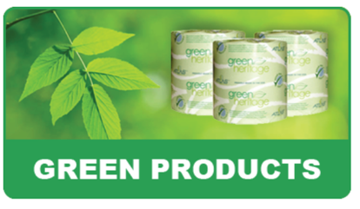
- W.B. Mason’s website has a GO GREEN link to all of its “green” products:

- The vendor has created a website filter to help its customers quickly navigate to its EPPs. Some website filters enable users to sort by product category, ecolabel, environmental attribute, etc. Several examples of this are provided below.
- EBP Supply Solutions’ website has a Green Products link that limits the user’s search to “Green/Sustainable Options”.
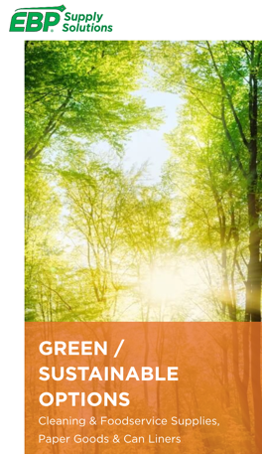
Once in that section of the website, the user can search for EPPs by product category.
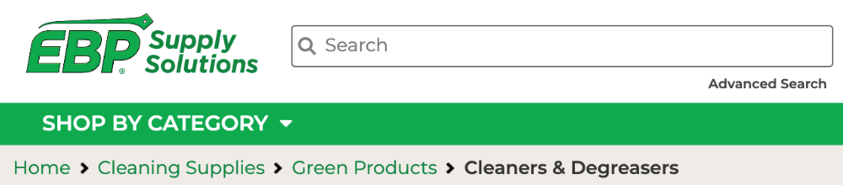
  - Fastenal’s website has a two-tiered Green Products filter that can be found under Special Interest. It enables users to search for all EPPs in a category and then further narrow their search to products with specific green certifications or other environmental attributes by checking specific “Green Certifications.” (Note: This includes some products with self-declared claims such as recycled content as well as some other non-certified items.)
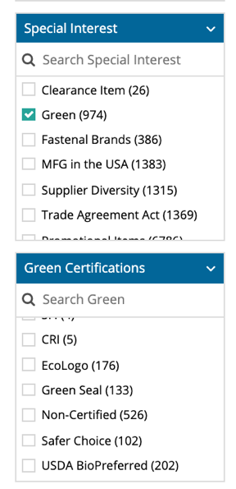
  - Grainger’s website also has a primary Green filter that enables users to identify all EPPs within each category as well as a secondary Green Certifications filter that can be used to search for products with specific environmental certifications (e.g., Green Seal, Safer Choice, and UL ECOLOGO). Other products that are labeled as EPPs may have uncertified claims.

  - W.B. Mason’s website has a GO GREEN filter that narrows the user’s search to “Green Items” and “Recycled” products that can be applied to each product category.
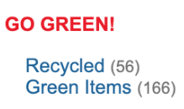
Some vendors’ websites have only a single-tiered EPP filter that limits the user’s search to EPPs within a product category but lacks a secondary filter to further narrow their search to products with specific environmental certifications or attributes. Consequently, the website user must look through the description of each EPP caught by the primary EPP filter to find products with the environmental certifications or attributes they are looking for.

Examples of these simpler, single-tier EPP filters are described below:
- Staples Advantage’s website has a Environmental filter that enables users to limit their search to have an environmental attribute. Details about each “environmental” is provided in its item description.
- MSC’s website has a single-tier Eco-friendly filter that narrows the user’s product search to EPP by category. The website user must then check each product’s description to determine its environmental certifications and attributes.
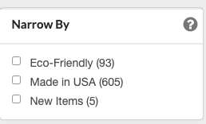
- The vendor has labeled all of the EPPs in its offering with a common symbol. Using a green icon makes it easy for contract managers, vendors, and purchasers to identify EPPs without having to do separate searches for products with various ecolabels and helps in the creation of green spend reports. Some vendors can create a tailored (i.e., “choice edited”) online ordering portal for a jurisdiction that only offers products (or labels EPPs) with certifications or attributes that have been pre-approved by the contract manager. This can prevent products with a green icon from being listed as EPPs or offered on contracts that are not considered green enough for Massachusetts or other jurisdictions. Examples of this EPP labeling practice are described below:
- Staples’ Eco-ID Sustainability Program tags products with “credible eco certifications and features that qualify for Eco-ID.” See icon, right.
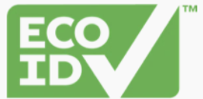
- Grainger, Fastenal, and W.B. Mason label the EPPs on their websites and catalogs with a green leaf symbol. (Note: It is crucial for vendors to describe the certifications or attributes a product has earned in order to be tagged with a green icon.)

- The vendor posts a current photo of the EPP on its website that clearly displays the ecolabel(s) it has earned. Many vendors do this EPP labeling practice, which helps contract managers and users confirm that the products they are being offered are the ones that have the desired environmental certifications. This helps contract managers and users differentiate between products when vendors offer both certified and non-certified products with similar names. (Note: It is important to ensure that the photo is current and lists the same ecolabel and environmental attributes that are in the product description.)
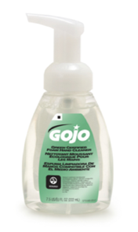
- The vendor lists the environmental certification(s) or attribute(s) of EPPs in the product name or item description. Some vendors use a consistent format that makes it easy for users of their website to determine why the product is considered an EPP, which helps with compliance monitoring and tracking of environmental benefits. Including the certification in the name can also enable it to be included in the price sheet, which typically lists product names, but not full product descriptions. Examples of this EPP labeling practice are provided below:
  - Carey Wiper and Supply includes “Green Seal Certified” in the item description, along with a photo of the product showing the Green Seal ecolabel.
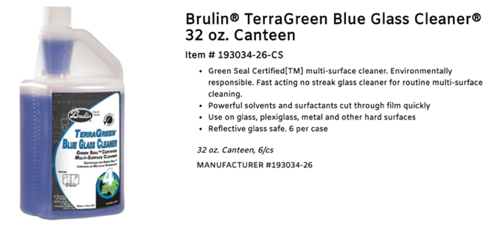
  - Grainger has embedded a Technical Specs box in each item description identifying its Green Certification or Other Recognition, which includes third-party certifications and self-declared environmental attributes such as recycled content. Grainger also sometimes lists the certification in a section of the Technical Specs called Standards.
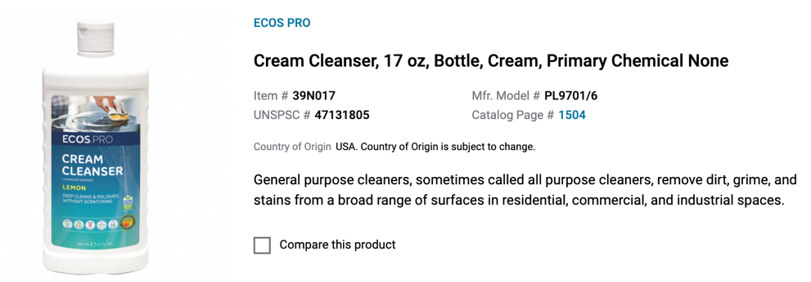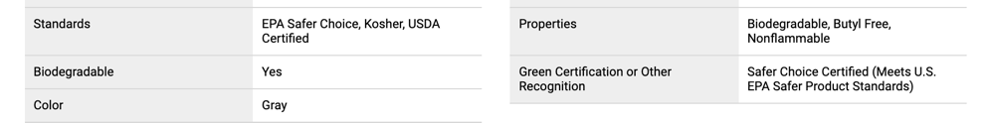
- The vendor displays the ecolabel(s) the product has earned on its product landing page or in its item description. While the certification ecolabel is most often visible in the product photo, some vendors insert it into product descriptions on their website or in separate catalogs or brochures. For example:
  - W.B. Mason sometimes displays the ecolabel on the product’s landing page, where basic information about the product is provided. From there, the website user can click a link to view additional product details.
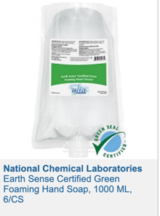
  - MSC Industrial Supplies sometimes lists a product’s environmental certification along with the certifier’s ecolabel under “Item Notes.”
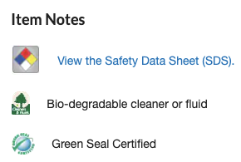

- The vendor links to current EPP information from the manufacturer (e.g., a sustainable products brochure, a technical data sheet, an Environmental Product Declaration (EPD), etc.) listing the environmental certifications and attributes of the products in the vendor’s offering.
- The vendor lists a unique product identifier – such as a Universal Product Code (UPC) or manufacturer’s item number – in the product description on its website and in its catalogs and “green” spend reports. This “digital fingerprint” enables the contract manager and purchasers to match products in the vendor’s information to those on environmental certifiers’ websites (if the same unique product identifier is listed there as well). (Note: If the vendor assigns and displays only its own product number such as a SKU, verification becomes more difficult because the digital link in the supply chain becomes broken. For more information about various types of product numbers, see section on “Understanding the Numbers” found in the appendix.)

Examples of vendor websites that list a manufacturer’s unique identifying number for some or all of their environmentally preferable janitorial supplies include:
  - EBP Supply lists the Manufacturer Item Number on its website along with a photo of the product showing the ecolabels it has earned. (Note: this vendor also listed another Item Number, which may be confusing.)
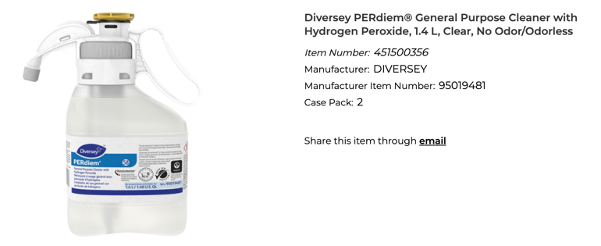
      - Ecolab lists the manufacturer item number as Mfg.# along with “Green Seal Certified” in the item description of at least one green cleaning product in its online e-catalog.
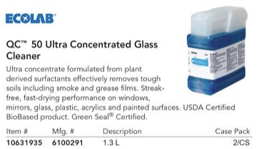
- The vendor can allow the contract manager to limit (or “choice edit”) its offering so purchasers can only access products meeting the ecolabel requirements specified in the contract. This reduces the need to train staff and allows for increased compliance with the jurisdiction’s sustainable procurement requirements. Exceptions can be made (at the request of the contract manager) in cases when the available items don’t meet the State’s performance needs. Several jurisdictions have mentioned that their vendors will block non-EPPs at their request.

- The vendor’s website links to a certification document from Green Seal, UL ECOLOGO, or another certifier. See example from the NextGen, formerly MD Stetson, website, right. (Note: The certification document should be current.)
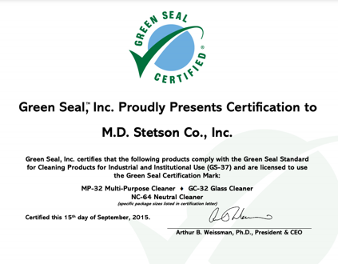
- The vendor has hired a sustainability program coordinator or an outside company to help them verify the environmental claims on their website and in their catalogs and sales reports. One vendor mentioned during our interviews that it has retained UL to periodically review its company’s environmental labeling practices. The other vendors we interviewed did not mention that their environmental claims were reviewed or verified by a third party, other than them looking on third-party certifiers’ websites when a contract manager or customer posed a question about a product’s environmental certifications or attributes.

- The vendor can provide a detailed “green” spend report, including environmental certification and attribute information about each product that was purchased using the contract. Grainger can generate a product-specific sales report in an Excel format that lists green certifications and other environmental attributes for each item purchased through a jurisdiction’s contract.

Opportunities for Improvement for Vendors
- Some vendors have websites that lack any type of detailed information about the products they offer (not just about the EPPs). Some vendors just list the brands of products in their offering. Noble Supply’s website is an example of this. Others do not have active or well-developed websites or don’t label the environmental attributes of their products.

- Some vendors do not have a catalog, webpage, search filter, or downloadable list of EPPs that contract managers and purchasers can use to find all of the vendor’s products with environmental certifications and other important environmental attributes in one place. Without this, they may have to look through the entire website to locate EPPs.

- Some vendors lack detailed information about what their EPP icon (e.g., their green leaf) really means. As one State contract user explained, “Purchasers are left with having to find and interpret this information. The green leaf is a symbol that is too vague and at times very misleading.”
- The EPP filter on some vendors’ websites is unreliable. Some FAC85 and FAC101 vendors have EPP website filters that do not capture all of the products with legitimate environmental certifications or attributes. More often, the EPP filters capture products that are not legitimately green. For example, Grainger’s Green filter identified 70 environmentally preferable degreasers; however, the detailed breakdown of these products only includes 44 products. In addition, four of these products are inappropriately listed as “green” on the basis that they are certified by the Biodegradable Products Institute (BPI); however, BPI only certifies compostable plastic, not degreasers. When the EPP filter is unreliable, the website user may not utilize it and resort to looking through the entire website to find EPPs with credible environmental claims.
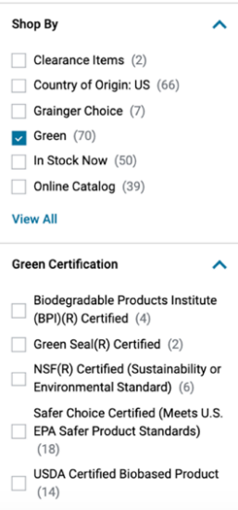
- The keyword search feature on some vendors’ websites is unreliable. While a keyword search using the name of an ecolabel should pull up products that have earned that certification, very often it yielded less valuable results instead. For example, see screenshot of a website that displayed a green-sealing product – and other green-colored products – when “Green Seal” was entered into the keyword search box.
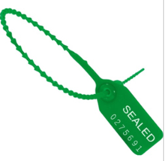
- Some vendors’ websites have environmental information that is either undated or outdated. For example, it lists old certifications such as EPA’s Design for the Environment (DfE), which was changed to Safer Choice in 2015 for all product categories except antimicrobials. The vendors we interviewed indicated that they – or the manufacturer – typically enter information about the environmental attributes of products only when it is first added to their offering. Often, they have no process for updating the information (even if the certification status changes) – although they are sometimes prompted to do so when questions are raised by a contract manager or customer. When a vendor’s website contains information that is undated, it is difficult for the contract manager or purchaser to determine if the information is current.
- Some vendors’ websites contain inaccurate or conflicting information about the environmental certifications and attributes of products in their offering. For example:
- Some vendors list environmental certifications or attributes that do not apply to that category. For example, as mentioned above, one vendor’s website identifies degreasers as environmentally preferable because they have a Biodegradable Products Institute (BPI) certification even though BPI does not certify degreasers. The product should be labeled USDA Biobased, instead. Grainger labels some of its cleaners as green, indicating the environmental standard as ROHS-compliant, referring to the European Union’s Restriction of Hazardous Substances (RoHS) Directive. However, the RoHS Directive only covers electronics, not cleaners.
- Some vendors’ websites have conflicting environmental certification information (e.g., one ecolabel in the item description and a different ecolabel on the photo of the product.) This example is of a webpage that lists Green Seal as the green certification for this product, but shows the U.S. EPA’s Design for the Environment (DfE) label on the photo of the product that is posted on the website. This information is both conflicting and outdated since none of Clorox’s cleaning products are currently certified by Green Seal (although some are certified by the EPA’s Safer Choice program). This conflicting labeling practice sometimes happens when manufacturers switch certifiers and only some of the EPP information is updated in the vendor’s system.
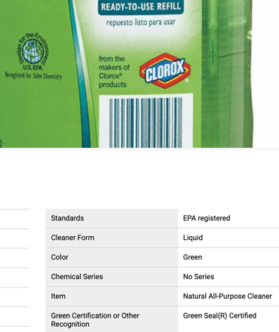
- Some vendors’ websites have environmental attribute information that does not match information from the manufacturer of that product. For example, the vendor claims a product has post-consumer recycled content while the manufacturer only says it has recycled content. (Note: it is particularly hard to verify uncertified environmental claims of products when the vendor is also the manufacturer because there is no separate manufacturer information to compare it to.)

- Some vendors label products as EPPs that have relatively weak or unsubstantiated (manufacturer self-declared) claims that don’t meet the jurisdiction’s environmental standards. When that happens, contract managers may need to screen these products out of vendors’ catalogs, price lists, and sales reports, which is time-consuming and may deem some vendors’ bids as unresponsive. See, for example, MSC Industrial Supply’s website, where an aerosol disinfectant is labeled as an eco-friendly product based on an unverified claim that it is a low-VOC product. Meanwhile, this product has a warning that it is hazardous and contains asthmagens (quaternary ammonium chloride compounds) and a chemical that is prohibited by Green Seal and Safer Choice because it can easily seep through the skin and poison organs (2-butoxyethanol).
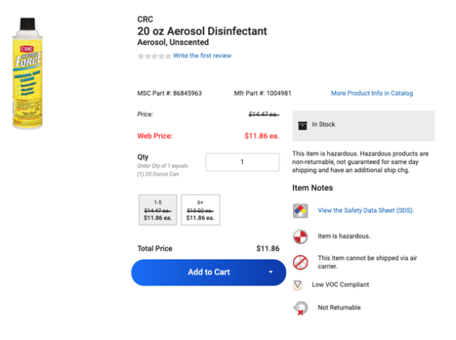
- Some vendors list their own vendor item number or SKU – rather than the manufacturers’ product number or the Universal Product Code (UPC) – in their website, price list, or sales reports. This makes it difficult for contract managers and purchasers to verify that the EPPs on the vendor’s website are the same products as those on manufacturers and environmental certifiers’ websites. In addition, if vendors only provide their company’s SKU in their sales reports, it may not match the product number in the purchasing agent’s system, which can prevent automation of the EPP verification process.

Recommendations for Vendors
Vendors play an important role in the supply chain because they are the direct point of contact for the purchasing entity. As such, they need to access up-to-date and accurate environmental information about the products in their offering and present it to contract managers and purchasers in a clear and user-friendly way. Like contract managers and purchasers, vendors should not have to continually search multiple manufacturers and certifiers’ websites (manually) to determine if a product has the third-party environmental certifications listed in the jurisdiction’s mandatory bid specifications. Vendors could save a lot of time by receiving environmental attribute information directly from third-party certifiers and/or certification data aggregators on an ongoing basis via a live feed (i.e., an API). This could remedy the common problem that the environmental information on some vendors’ websites is outdated or inconsistent with information from the product manufacturer or certifier. As one of the State’s vendors put it, “Certainly, a central database [of EPP information] is needed as vendors are all duplicating information for many products.”
This information can be used by vendors to:
- Clearly label EPPs on their website;
- Submit bids for contracts offering EPPs;
- Develop catalogs and price lists highlighting the environmental certifications and attributes of products in their offering; and
- Generate EPP sales reports.
The most important action vendors can take to make the environmental claim certification process easier and more reliable for contract managers and purchasers is to post on their website a downloadable list of all EPPs in their offering that includes details about the certification(s) each product has earned and other key verified environmental attributes (e.g., percentage of post-consumer recycled content, avoidance of chemicals of concern, etc.).
Vendors can also:
- Prominently display on its homepage an EPP brochure or link to an EPP webpage that points users to all of the EPPs in the vendor’s offering in one place.
- Create a reliable Green Products filter that enables users to narrow their search to EPPs by certification (Green Seal, Safer Choice, UL ECOLOGO, etc.), manufacturer, product category and sub-category, and other environmental attributes, etc.
- Incorporate a reliable keyword search feature into their website that pulls up all EPPs with ecolabels and other environmental attributes when the name of an applicable certifier, ecolabel, or environmental attribute is typed in.
- Provide an environmental data sheet or summary box describing the certifications and attributes of each EPP in their offering.
- Have the ability to customize their catalogs and sales reports at the request of the Contract Manager so that all products labeled as EPPs meet MA OSD’s or another jurisdiction’s environmental specifications.
- Display a current photo of each EPP with the ecolabel it has earned clearly visible and include the name of the ecolabel and verified environmental attributes in the product description.
- Provide a static link to the certifier’s product page – or to a certification document with an expiration date – for each EPP in its offering that has earned a strong multi-attribute third party certification to make it easy for the contract manager and purchasers to confirm that the product is currently certified.
- List the manufacturer’s unique identifying number (e.g., UPC) in their ordering system, price list, and sales reports (and not just a SKU that they assigned to the product).
Vendors can hire a sustainable purchasing manager or contract with an outside company to help them clearly and accurately label all of the EPPs in their offering. Adopting better EPP labeling practices could help vendors position themselves to more quickly and effectively respond to bid solicitations in which contract managers ask them to verify that their website makes it easy for contract users to identify EPPs and understand each product’s environmental attributes.
Vendors face a particular challenge because different jurisdictions define and specify EPPs differently. Therefore, it is important for them to be as transparent as possible about their EPP labeling practices and maintain flexibility about the products they offer in order to comply with these disparate standards.

C. Environmental Claim Verification Practices of Third-Party
Environmental Certifiers
Third-party certifiers play a crucial role in verifying environmental attributes of a wide array of products and services — particularly those found on contracts for janitorial supplies. Many contract managers, purchasers, and vendors rely on information from third-party certifiers to verify that cleaning and floor maintenance chemicals, hand soaps, janitorial paper products, and other types of janitorial supplies offered by their vendors are safe for workers and the environment.
Over the past decade, environmental product certifiers have made it increasingly easy for states and other jurisdictions to develop and manage contracts for cleaning supplies that protect human health and the environment. Contract managers often reference credible ecolabels in their contract specifications because third-party certifiers prevent “greenwashing” (i.e., false or unsubstantiated claims). In addition, they only need to confirm that a product currently holds an ecolabel that is listed as a mandatory requirement, while the certifier has the harder job of determining whether a product meets its complex technical standards.
There are four multi-attribute third-party certifiers of environmentally preferable janitorial supplies that are primarily referenced in mandatory specifications by the Commonwealth of Massachusetts in its FAC85 contract (see list of certifiers and their corresponding ecolabels below):
- Green Seal, a nonprofit organization;
- U.S. Environmental Protection Agency’s Safer Choice program;
- UL’s ECOLOGO program; and
- Cradle to Cradle Certified, a tiered ecolabeling program operated by the Cradle to Cradle Products Innovation Institute, an international nonprofit organization.
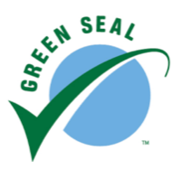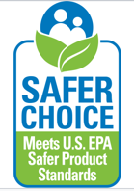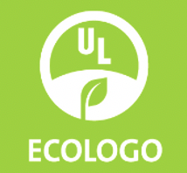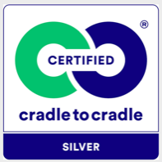
Each of these certifiers has developed strong, multi-attribute environmental and health standards for janitorial supplies and verifies through audits that the products they certify meet their rigorous requirements. These certifiers have also made great strides in designing website registries to help users identify the products that have earned their ecolabel. Most of the certifiers mentioned that they are continuously expanding their registry’s content and improving its functionality and usability.

Best Practice Examples for Third-Party Environmental Certifiers
Below are examples of environmental claim verification best practices of environmental product certifiers. Our assessment focused largely on the content and format of information that is currently on the websites of the four certifiers listed above. We evaluated each website’s functionality, which impacts users’ ability to quickly and reliably navigate to certified products in their registries and use the certifier’s data to verify vendor information in bids, catalogs, and sales reports. Each of the four environmental product certifiers we evaluated provide online registries of the products that have earned their certification. These registries are maintained to ensure they are current.
- All of the certifiers’ websites can filter products in the registry by various criteria (e.g., product category) – although the filtering capabilities vary by certifier. See table below summarizing each certifier’s website filtering capabilities.
Table 1: Comparison of Website Features of Four Environmental Product Certifiers
Website Filtering Capabilities | Green Seal | UL ECOLOGO  (UL SPOT) | Safer Choice | Cradle to Cradle
Can filter by manufacturer | Yes | Yes | No | No
Can filter by product category | Yes | Yes | Yes | Yes
Can filter by sub-category | No | Yes | Yes | Yes
Can filter by standard | Yes | Yes | N/A | Yes
Being able to filter the certifier’s registry helps users narrow their search to the products they are most interested in evaluating or purchasing.
- The online registries of all the environmental certifies we evaluated give users the ability to perform keyword searches to identify products with a specific manufacturer or product name.
- The certifier’s website provides a static link to a dedicated products page in their registry and/or to a downloadable certificate confirming that the product is currently certified. A static link for the certified product enables the vendor to simply paste that URL into price sheets, catalogs, and “green” spend reports so that contract managers and purchasers can find the certified product without having to do any searching on the certifier’s website. Below are examples of certifier websites that create static links or downloadable certificates for products in their registry:
  - Cradle to Cradle Certified provides a static link to each certified product in its two registries. It also enables users to access a downloadable certificate (with an expiration date). Vendors can provide either of these two forms of documentation to contract managers to verify that a product (or product line) is currently certified. See sample certification document, right. Cradle to Cradle Certified does a good job at listing the various product names that are covered under its certification in its certificates.
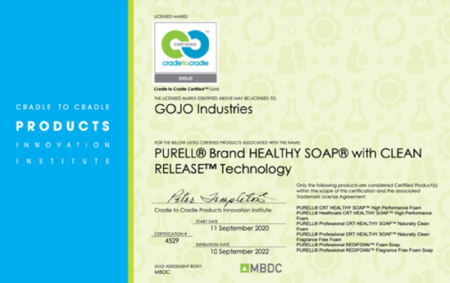
  - UL provides a static link and a downloadable certificate for each product with the UL ECOLOGO certification.
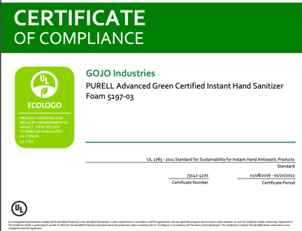
  - Green Seal provides a static link to a dedicated page for each certified product in its registry.

- The certifier’s website automatically generates an up-to-date spreadsheet listing all certified products that can be downloaded as needed or via an Application Programming Interface (API) as a “live feed” on an ongoing basis. According to the four certifiers we interviewed, all of them can provide an API to contract managers, vendors, certification data aggregators, and others, upon request. In addition, Safer Choice’s certification data can be automatically downloaded from its website via the U.S. EPA’s Envirofacts RESTful API.

APIs from certifiers can also be incorporated into vendors’ bid responses, price sheets, and green spend reports or used by contract managers to support their bid evaluation and contract monitoring functions. They are regularly used by certification aggregators (e.g., ecomedes, UL SPOT, etc.) and may be able to be incorporated into catalogs that are uploaded into e-procurement and online vendor reporting systems.
- The certifier’s registry lists the manufacturer’s item number – or the Universal Product Code (UPC) – of some or all of the products.
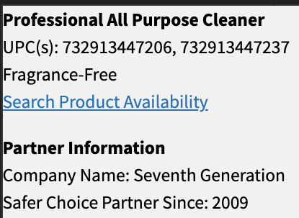
- The certifier’s registry indicates the dates that the certification started and expires, which helps purchasers have confidence that the certification is current. This information is typically found on each product’s dedicated page in the registry or in a downloadable certificate for each item.
- The certifier’s registry highlights whether the certified product has any environmental or health attributes the buyers should be aware of when making their purchasing decisions. For example, Safer Choice labels products that are fragrance-free, which can be an important positive product attribute for purchasers to consider, especially when choosing products for facilities with sensitive populations such as young children. On the negative side, Safer Choice notes when a manufacturer has missed its annual audit and Green Seal indicates whether a product only meets the standard when diluted.
- The certifier’s website has been translated from English into other languages. For example, the UL SPOT database is available in Chinese, French, Italian, Japanese, and Vietnamese while the Safer Choice product registry can be viewed in Spanish.
- The certifier’s registry identifies any optional criteria a product met in order to earn their label. Cradle to Cradle Certified, which is a tiered certification program, publishes scores for each product that are broken down into the five categories in its standard: Material Health, Material Reutilization, Renewable Energy/Carbon Management, Water Stewardship, and Social Fairness. However, its registry lacks detail about which specific criteria were met by each product.
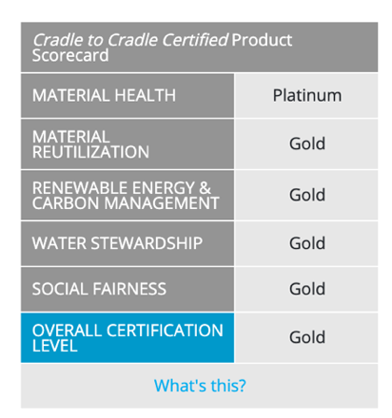
A good model (that applies to non-janitorial products) is the Electronic Products Environmental Assessment Tool (EPEAT) Registry, which enables users to search for products by the overall certification level (Bronze, Silver, or Gold) and see the optional criteria they earned to achieve it.

Opportunities for Improvement for Third-Party Environmental Certifiers
While each of the certifiers we evaluated has developed an online registry of certified products, their websites vary in their content and design. Consequently, contract managers, purchasers, and vendors must determine what information each website offers and how to navigate it, although it is much easier to learn how four certifiers’ registries work than to figure out the disparate ecolabeling practices of dozens of manufacturers and vendors of green cleaning products. Nevertheless, this lack of standardization of the various certifiers’ online registries makes it difficult to compare the information they provide and integrate it into digital bid solicitation, contract management, and sales reporting platforms. It also creates challenges for certification data aggregators, which are developing harmonized online registries that collect data from these and other certifiers.
Our assessment revealed that each certifier’s registry lacks some pieces of information that are needed to optimize it so that it can be easily used by contract managers to confirm that a product in a vendor’s bid, catalog, price sheet, or green spend report is the same as the one that is listed on the certifier’s registry. Below are opportunities for third-party certifiers of environmentally preferable janitorial supplies to improve their online registries.
- Not all certifiers publish a complete list of certified products – some just list brands rather than specific products. Unless all products in the brand are certified, the registry user won’t have sufficient information to determine which individual products are certified and which are not.
- All four of the certifiers’ registries lack unique identifying numbers for some or all of their certified products. It can be confusing when certifiers list product names without an identifying number (e.g., a UPC or manufacturer part number) because some manufacturers offer several products with a similar name, some of which are certified and others are not. An example is Simple Green: while some formulations are certified by Green Seal, others are certified by Safer Choice, and others are not certified at all. The Cradle to Cradle Innovation Institute lists neither the UPC nor the manufacturer part number in its Cradle to Cradle Certified registry.
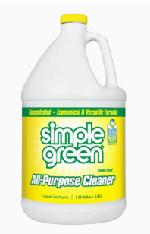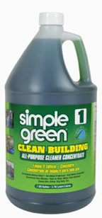
- Some certifiers lack photos for some or all of the products in their registry. For example, the Safer Choice website does not provide photos of any of its certified products, although it does provide a “Search Product Availability” link that does a Google search for the product name. This helps consumers find products with this name to buy, and often shows a photo of the product. However, using this for environmental claim verification is unreliable because it sometimes pulls up uncertified products with a similar name. Green Seal and UL provide photos for many of their certified cleaning products.
- Some of the certifiers’ online registries have filters that lack important features such as the ability to search by sub-category or manufacturer.
- None of the keyword search functions of the certifiers’ online registries worked flawlessly. For example, different results came up when the words “glass” and “glass cleaner” were typed into the search box of each registry. This underscores the need for reliable category and sub-category filters since users cannot rely on keyword searches to capture all products in a category or sub-category.
- Some of the certifiers’ online registries are unable to provide either a static link or a downloadable certificate for each certified product in the registry. For example:
  - Safer Choice only offers a URL to its entire registry. Consequently, the website user must go through the process of looking up each Safer Choice-certified product from scratch using that URL in order to verify that it is on the registry. This extra step can add significant amounts of time, especially when a contract manager needs to look up hundreds of products.
  - Green Seal’s website does not automatically generate a downloadable certificate for products in its registry, although this certifier can send one to the manufacturer.
- Most certifiers do not list all of the verified environmental attributes of the products in their registry such as the percentage of post-consumer recycled content (PCRC) in janitorial paper products. If there is a minimum percentage of PCRC required to earn the ecolabel, the purchaser will only know that a certified product met the minimum, but not whether it exceeded it and by how much. Verified environmental attribute information is valuable to contract managers and purchasers that want to compare certified products or calculate environmental benefits of their green purchasing efforts. Since certifiers typically collect environmental attribute information from manufacturers in order to verify compliance with their standard, they can easily report it in their product registry.

Recommendations for Third-Party Environmental Certifiers
One of the most important things certifiers can do to facilitate easy and reliable environmental claim verification is to work together with each other to harmonize the content and format of information that is provided so that multiple certifiers’ product registries can be seamlessly combined. Certifiers could also collaborate with certification data aggregators (described below) as well as other organizations (e.g., the Global Ecolabelling Network, ISEAL Alliance, RPN, and the Sustainable Purchasing Leadership Council) to promote certification information uniformity.
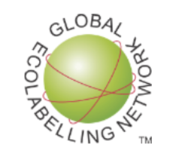
Harmonization of certification information would enable it to be more easily used by contract managers, purchasing agents, and vendors to confirm compliance with their jurisdiction’s environmental specifications. Standardization of certifier information is also needed to facilitate automation of the EPP verification process, including its use by e-procurement and online vendor reporting systems. Ideally, comparable information from certifiers would be incorporated into a spreadsheet that can be uploaded into e-procurement and vendor reporting systems, automating the EPP verification process.
In addition, certifiers could make an API available to the Commonwealth of Massachusetts and other jurisdictions that want to use it to ensure that the environmental attribute information provided by their vendors in bids, catalogs, and sales reports is accurate, current, and complete.
Certifiers of environmentally preferable products are encouraged to have an online product registry with the following features and capabilities:
- It lists all certified products (including products with private labels and alternate names).
- It lists a unique identifying number for each certified product (e.g., a UPC and manufacturer’s part number). Manufacturers could upload unique product identifiers into the certifier’s system and notify them if the numbers change (e.g., when new product packaging configurations are added).
- Users can reliably filter and keyword search for products in the registry by manufacturer, product category (cleaning chemicals versus janitorial paper products) and sub-category (glass cleaner versus floor cleaner), and rating (if the certification has a tiered rating system).
- It shows a current photo of all certified products that displays the certifier’s earned ecolabel.
- It provides a dedicated (static) link to each certified product (or to a downloadable certificate for each product) that can be provided to the vendor and contract manager, so they verify that the product is certified with one click rather than having to search through the certifier’s website for it.
- It indicates the certification start and end dates, highlighting or removing the listing once the certification expires or after a set amount of time (e.g., three years).
- The registry continually and automatically updates (listing the last time the list was updated) so that recently certified products are added and products that lose their certification are removed. A registry that is a pdf listing that is manually updated by the certifier is less desirable. (An example of this is the Forest Stewardship Council’s certified products list.)
Additional desirable information certifiers can incorporate into their product registry includes:
- An indication of which optional criteria the certified product met in cases when the certification is based in part or in full on non-mandatory criteria, and an ability to sort by optional criteria.
- A list of the key verified environmental attributes of each certified product including, for example, the percentage of post-consumer recycled content of janitorial paper products and plastic bags, the volatile organic compound (VOC) content (and SCAQMD compliance) of cleaning chemicals, and the absence of fragrances or other chemicals of concern in hand soaps and cleaning chemicals, etc. This would enable purchasers to compare products that earned a certifier’s ecolabel.
- A link to the current standard that is accessible free of charge so that contract managers and purchasers can review and evaluate the criteria used as the basis of the certification.
- Links to each product’s SDS, full ingredient disclosure (per CA law), technical data sheet, EPD and HPD, if available. When a product is a surface disinfectant or sanitizer, the certifier could list the product’s EPA registration number and link to its EPA-approved label.
- A translation of the website and registry from English into other languages (e.g., Spanish).
- Links to applicable environmental benefits calculators (e.g., the Paper Calculator) so purchasing agents can quickly calculate and report the environmental benefits of each certified product.

D. Environmental Claim Verification Practices of Certification Data Aggregators
When trying to verify the environmental attributes of products using information from third-party certifiers, contract managers and vendors often need to check multiple certifiers’ websites to determine if a product meets their specification. Aggregators solve this problem by compiling information from multiple certifiers onto one website platform, which is typically searchable for free. They also offer additional services for a fee, ranging from customization of a website to managing environmental labeling and reporting for a purchasing entity. One aggregator claims the cost of working with them is more than paid for by avoided staff time.
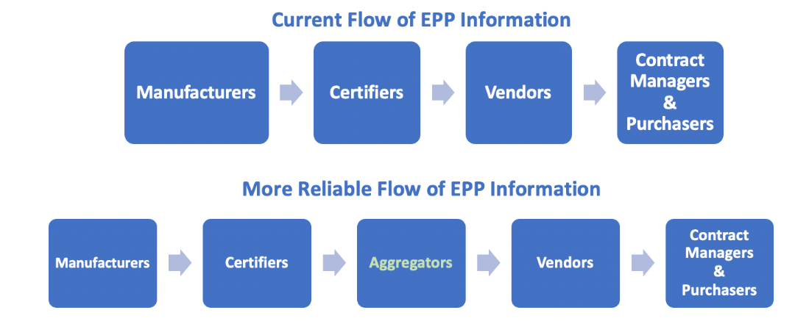
Two commonly used aggregators of environmental certification data for janitorial supplies are described below.
- Ecomedes manages “an Environmentally Preferred Product Engine” that provides information about a wide array of janitorial and building products that have earned multi-attribute certifications (i.e., ecolabels). For example, this “open resource for users across the contract ecosystem” lists low-toxicity cleaners, hand soaps, floor maintenance chemicals, and janitorial paper products from all four certifiers described above: Green Seal, UL ECOLOGO, Safer Choice, and Cradle to Cradle (C2C) Certified. Products with any of these certifications can be searched for individually or together by checking the box for each ecolabel. In addition, the ecomedes search engine “can be configured to track compliance of multi-item purchases.”

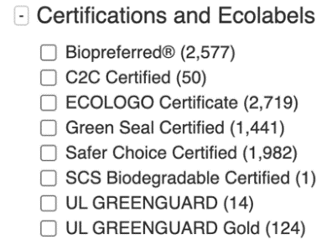
- Ecomedes’ searchable registry also lists products that have earned single-attribute certifications such as USDA Biobased Certified and UL GREENUARD Gold, which are weaker than the multi-attribute certifications listed above. They do not meet Massachusetts’ minimum environmental requirements for janitorial cleaning chemicals but may be considered additional desirable attributes. Many other product categories and certifiers are listed on the ecomedes website, although most products in this aggregator’s registry are green building materials.
Ecomedes has created an open-source platform called Sustainable Facilities Tool (SFTool) for the General Services Administration with product criteria supplied by the U.S. Environmental Protection Agency. It provides up-to-date information about EPPs that that are commonly purchased by the federal government as well as applicable federal acquisition regulations, guidance, and tools. This portal, which is “a comprehensive green purchasing resource designed for federal contracting personnel and program managers,” is custom configured to display only products that comply with the GSA’s Green Procurement Compilation.
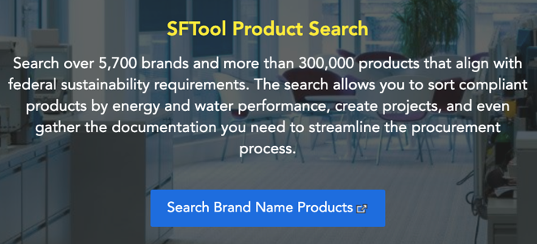
Ecomedes has also created another open-source platform called Empower Procurement Product Search for the California Energy Commission and its project partners. This website helps state agencies to find energy-efficient appliances, lighting bulbs, IT equipment, and more.
- UL is another aggregator that collects and displays information from both multi-attribute and single-attribute environmental certifiers of janitorial supplies, building materials, and many other types of products. Its aggregated registry of environmental certification information is the UL SPOT database. It includes information about products that have earned its own certifications (UL ECOLOGO and UL GREENGUARD Gold) as well as others (e.g., Safer Choice and USDA Biobased Certified) – but not Green Seal. The data can be filtered by product category, manufacturer, certifier, and more.
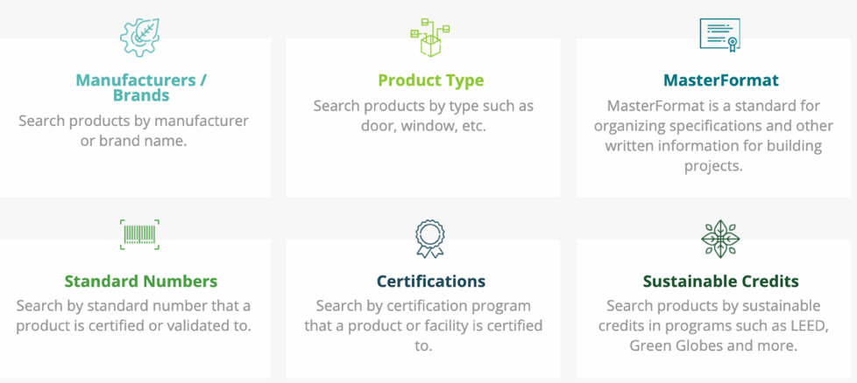
While ecomedes and UL SPOT are similar, there are small differences between their online registries that may be important to certain users. Below is a table comparing several key elements of these two aggregators’ websites, including information they provide and their search capabilities.
Table 2: Comparison of Website Features of Two Environmental Certification Data Aggregators
WEBSITE FEATURES | ECOMEDES | UL SPOT
Brand or Manufacturer Filter | Yes | Yes
Ecolabel Filter | Yes | Yes
Category Filter | Yes | Yes
Sub-category Filter | Yes | Yes
Reliable Keyword Search by Product Name | No | No
Reliable Keyword Search by Brand Name | No | Yes
Photos of Products on Website | Sometimes | Sometimes
Lists UPCs in Product Description | Sometimes | Sometimes
Lists Manufacturer’s Product Number | Sometimes | Sometimes
Links to Static URL for Certified Product | Yes | Sometimes
User Can Download Certificate | Yes | Yes
Note: We did not include other certification data aggregators (listed below) in this report:
- International Living Future Institute or mindful MATERIALS because their registries do not include very many janitorial supplies; and
- ProductBio, which is not an open-source platform and is only available fee-for-service.

Best Practice Examples for Certification Data Aggregators
Aggregators of environmental certification information (e.g., ecomedes and UL SPOT) are developing systems that organize and display data from multiple third-party certifiers into one portal. Using an aggregator can save contract managers, purchasers, and vendors time by eliminating the need to search several certifiers’ website registries to determine if a product has at least one of the certifications listed in a specification. Another benefit of aggregators is that they sometimes list all of the environmental certifications a product has earned so that purchasers can see if it has additional environmental or health attributes (e.g., if a product is certified by both Green Seal (multi-attribute, low toxicity) and UL GREENGUARD Gold (single-attribute, low-emitting).
Both of these aggregators have publicly accessible websites that provide information about the third-party certifications that a wide array of products have earned free-of-charge. Some aggregators offer fee-for-access to their information or charge to create a curated registry that includes only products meeting a purchasing entity’s criteria or to manage all its green purchasing contract monitoring and reporting. Also, some aggregators help vendors develop a complete list of EPPs in their offering when they are certified by different entities, a service that saves the vendors’ time.
Like certifiers, aggregators are designing product registries so users can easily find certified products by:
- Providing a static link to document the product’s certification. UL even creates a static link to certified products in its registry (UL SPOT) that are certified by other organizations whose websites don’t offer a static link to the certified product.
- Posting a photo of each product that clearly shows the environmental certification it has earned and/or the attributes it has.
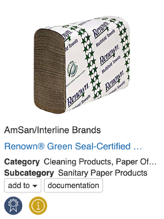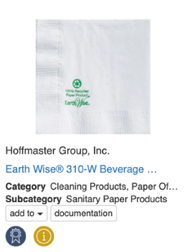

- Including reliable filters and search features that enable users to navigate certified products by various criteria including category, sub-category, manufacturer, certification, etc.

Opportunities for Improvement for Certification Data Aggregators
- Currently, the online registries of certification aggregators are somewhat difficult to use because there are overlapping category and sub-category names. Consequently, users need to make sure they checked all of the applicable boxes for the types of products they are searching for or evaluating. Also, some of the category and sub-category names seem duplicative or confusing. For example, there are dozens of sub-categories of cleaners on the ecomedes website, some of which seem very similar and could be combined. Aggregators and certifiers should consider using a standardized system (e.g., UNSPSC codes) to categorize products in their registries.
- Aggregators lack information from some certifiers of environmentally preferable janitorial supplies. This makes their registry less useful than it would be if it included all of the applicable certifications. For example, with respect to cleaners, UL SPOT lists products that are certified by
UL ECOLOGO, the Cradle to Cradle Products Innovation Institute, and Safer Choice, but not Green Seal. Ecomedes has all four multi-attribute certifiers’ registries that apply to cleaning products in its system. Both aggregators lack information on vacuums that are certified by the Green Label Plus Program and janitorial paper certified by the Forest Stewardship Council (FSC). See table, below.
Table 3: Comparison of Ecolabels Listed by two Environmental Certification Data Aggregators
Ecolabels Listed | ECOMEDES | UL SPOT
Green Seal | Yes | No
Safer Choice | Yes | Yes
UL ECOLOGO | Yes | Yes
Cradle to Cradle Certified | Yes (filters by level) | Yes (filters by level)
UL GREENGUARD GOLD | Yes | Yes
USDA BioPreferred | Yes, but not USDA Biobased Certified | Yes
FSC | Yes, but only office paper and building materials (not janitorial paper) | No
Green Label Plus | Yes, but only carpets (not vacuums) | Yes, but only carpets and adhesives (not vacuums)
Recycled Content Validation | Few | Some (SCS or UL Environmental Claim Validation)

- The categorization of products in the aggregator websites are confusing and yield unreliable results when searching for specific types of products. Below are two examples:
  - When searching for certified low-toxicity floor polish in ecomedes’ online registry, the user must apply several sub-category filters to find them all. This includes Floor Cleaners and Protectors; Industrial and Institutional Floor Care; Industrial and Institutional Specialty Products; Household Cleaners, General Purpose; and Building Finishes, Paints and Coatings. Similarly, to find all of the floor finish products in the UL SPOT database, the user must apply the filters for Cleaning Products, Floor Finish, Wood Finishing Products, Adhesives/Sealants, and Industrial/Institutional Products. Also, the Floor Finish sub-category includes products other than floor finish (e.g., floor finish remover, floor cleaners, and floor polish burnishers and mops.)
  - To find all of the multi-purpose cleaners in the ecomedes online registry, the user needs to look in several different sub-categories including: Cleaners; General Purpose Cleaners; Industrial and Institutional Products; Multipurpose Cleaners; and Household Cleaners, General Purpose. There are also multi-purpose cleaners listed in other categories such as Specialty Products and Glass Cleaners. Similarly, multi-purpose cleaners are listed under several sub-categories in the UL SPOT database including, for example: Cleaning Products, Industrial/Institutional Products, Bathroom Products, and Consumer Products.
- Aggregators do not have photos of every product and some products – especially janitorial paper products – do not show the packaging or ecolabel. Also, occasionally, the photo on the aggregator’s website shows an ecolabel that differs from the certification listed on the aggregator’s website. See example, from the ecomedes registry, which shows the Safer Choice label in the photo, but lists Green Seal in the Certifications and Standards section of the registry entry for this product.
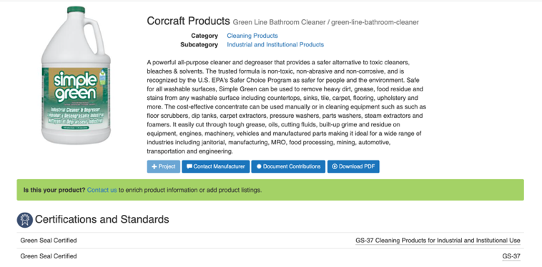
- Aggregators do not have unique identifying numbers for every product. The manufacturer’s item number and UPC help users match the product listed on the aggregator’s website to the one they are evaluating. Having the product’s unique identifying number along with current ecolabels is key to enabling an aggregator’s data to be used to automate the EPP verification process.

- Aggregators often list relatively weak certifications along with strong ones and treat them equally, leaving it up to users to decide which ones to accept. Single-attribute certifications (e.g., USDA Biobased or UL GREENGUARD Gold) do not meet Massachusetts’ minimum environmental standards for cleaning and floor maintenance chemicals. Therefore, it is important for the aggregator’s website to be customizable so only products that meet its contract specifications are displayed. Some aggregators can do this, usually for a fee.
- Aggregators often don’t provide information about specific environmental attributes of the products in their registry. For janitorial supplies this could include the percentage of post-consumer recycled materials and amount of volatile organic compounds (VOCs) the product contains. This information is usually verified by the certifiers that provide their data to aggregators. Without details about a product’s environmental attributes, purchasers know only that it meets the certifier’s minimum standards, but not if it exceeds it or by how much. Displaying environmental attribute information would help purchasers identify the greenest products in the aggregator’s registry and calculate the environmental benefits of their purchasing decisions.

- Accessing aggregator’s information – if customized – can be expensive. However, it can be offset by staff time savings.
Recommendations for Certification Data Aggregators
The most important action certification data aggregators can take to make environmental claim verification easier and more accurate is collaborating with certifiers and other aggregators to harmonize the information that is provided to them by certifiers. Aggregators are uniquely positioned to play a pivotal role in standardizing the content and format in which EPP data is displayed and filtered (e.g., using consistent category and sub-category names). This would make the user’s search experience far less challenging and more reliable.

As mentioned above, environmental certification data aggregators can be a reliable and time-saving resource for contract managers, purchasers, and vendors because they eliminate the need to check multiple websites to confirm that a product is currently certified. In order for an aggregator’s registry to be most useful, it would:
- Provide data for all specified ecolabels for each product category so that contract managers, purchasers, and vendors only need to look in one place for certification information.

- Provide an up-to-date list of all certified products in the registry as a spreadsheet that can be downloaded as needed – or accessed as a “live feed” on an ongoing basis via an Application Programming Interface (API). This aggregated list of products that have earned ecolabels and other environmental attributes could be used to verify information in a vendor’s bid submission, price list, or sales report (e.g., using a V look-up) and may ultimately be compatible with e-procurement and online vendor reporting systems.
- Include a unique identifying number such as the Universal Product Code (UPC) for each product in the registry so that it can be easily matched to products offered or sold by the jurisdiction’s vendors. (The registry could list the different UPCs for each package variation and private-label product.) One of the aggregators mentioned that they are already participating in an industry collaboration to promote consistent and standardized use of product identifiers.
- Provide a static link proving that each product in the registry is currently certified. This URL can be used by vendors to demonstrate compliance with contract specifications when they are submitting bids, creating catalogs and price lists, and generating sales reports.
- Include photos of all certified products, ideally with the ecolabel clearly displayed.
- Be customized to display only products with ecolabels or environmental attributes accepted by that jurisdiction. Some aggregators can do this, but there is often a cost to set it up and maintain it.
- Go beyond identifying the certifications that have been awarded to each product by collecting and displaying verified information about the environmental attributes of EPPs. This could include, for example, the percentage of post-consumer recycled content in the product (verifying compliance with EPA’s Comprehensive Procurement Guidelines) the VOC content of the product (verifying compliance with stringent VOC limits established by SCAQMD), etc. (Note: Some aggregators are already starting to list verified environmental attributes (such as the fragrance-free claims verified by Safer Choice), report recycled content, and link to other relevant documents such as Environmental Product Declarations (EPDs) and Health Product Declarations (HPDs) in their registry, although care needs to be taken to avoid intermingling verified and self-declared claims.)

E. Recommendations for E-Procurement System Providers
A growing number of states are utilizing new or improved e-procurement systems to facilitate their bid solicitation, contract management, and spend reporting on a single platform. Some e-procurement systems can identify EPPs for contract users and generate green spend reports. Historically, e-procurement systems have been used to track overall contract usage, but have not been designed to track individual transactions down to the product level.
For many years, Massachusetts has been using an e-procurement system (COMMBUYS) that was developed by a company called Periscope Holdings, Inc. (PHI). According to MA OSD, a benefit of using COMMBUYS is that it provides access to purchasing data.
“COMMBUYS serves as a data warehouse for your purchasing and procurement activities. With COMMBUYS, maintain an end-to-end archived procurement audit trail, electronically retaining detailed descriptions of items purchased, cost, and receipts of goods.”
Unfortunately, the COMMBUYS e-procurement system was not designed to be able to label EPPs or generate green spend reports. To make up for these deficiencies, MA OSD has worked with its vendors to create detailed price lists of approved EPPs on Massachusetts’ FAC85 statewide contracts (and other price agreements). It has also used a separate online vendor reporting system, B2Gnow, to document purchases of EPPs in quarterly sales reports. Recently, MA OSD has been exploring an upgrade to a new PHI e-procurement system (called Marketplace), which can identify EPPs and generate green spend reports. This system is in the design phase, with MA OSD looking at both data inputs and outputs (e.g., its display functionalities).
- Inputs
In an interview with PHI, we learned that its new e-procurement system relies on EPP information in the catalogs that are uploaded into the e-Marketplace system. This e-procurement system does not (yet) have the ability to identify EPPs on its own or process environmental attribute data provided by an outside source such as an API from a third-party certifier or aggregator. This means that the EPP criteria would be defined either by the vendor or the State (Contract Manager), depending on who has final approval authority for the catalog. One of the environmental certification data aggregators that reviewed this report noted that it has integrated with other e-procurement systems “by linking from their product detail page to our sustainability evaluation features.”

- Outputs
Some e-procurement systems can be designed to label EPPs and display them before non-EPPs when users do a product search. PHI indicated that its Marketplace platform will be able to tag and label EPPs identified by the vendor or MA OSD in the product catalog as an “Environmentally Preferable Product” including a “green” leaf or plant icon. The system also can list environmental attributes of products such as the percentage of post-consumer recycled content as long as that information is provided to them.
Ideally, in the near future, e-procurement systems will have the ability to:
- Display the ecolabel and name of the ecolabel each EPP has earned consistent with contract specifications.
- Identify EPPs with a uniform icon and the wording “Environmentally Preferable Products” or alternate wording at the State’s request.
- Block products that do not comply with the jurisdiction’s contract specifications.
- Include filters that help contract users navigate to EPPs in general and to products with specific ecolabels and environmental attributes (e.g., compliance with the State’s recycled content minimums, VOC limits, chemical restrictions, etc.).
- Report green spend consistent with environmental specifications for all e-procurement system transactions.

F. Recommendations for the Massachusetts Operational Services Division
This report is the first step in an effort to identify the barriers and solutions to optimizing – and ultimately automating – environmental claim verification practices among all the different types of stakeholders involved in the process.
Perhaps the most important thing the Massachusetts Operational Services Division (MA OSD) can do to promote further improvements in environmental claim verification practices is to facilitate an ongoing dialog among manufacturers, vendors, certifiers, aggregators, contract managers, and other sustainable procurement professionals aimed at harmonizing the type of environmental claim verification information that is requested by purchasers and provided throughout the supply chain.
In addition:
- MA OSD could do more to evaluate bidders’ abilities to accurately verify the environmental certifications and attributes of the products they offer on statewide contracts to promote compliance with its environmental specifications. To facilitate this type of Best Value Assessment, OSD could:

- Conduct an RFI and pre-qualify bidders to avoid slowing down the bid solicitation process.
- Ask vendors to verify environmental claims in the bid solicitation process for a limited number of products (e.g., the Market Basket List) so the State can evaluate each bidder’s processes for doing this.
- Develop boilerplate survey questions to assess bidders’ EPP labeling and reporting capabilities, including their use of current information provided directly from third-party environmental product certifiers and aggregators.
- MA OSD could work to further align information about the environmental certifications and attributes of products in its vendors’ catalogs that are uploaded into the state’s e-procurement and vendor report management (VRM) systems. To facilitate this process, MA OSD could provide vendors with an updated Environmental Claim Verification and Reporting Template based on the findings of this report.

- MA OSD could offer training to its vendors to help them more easily and reliably verify the environmental certifications and attributes of products they offer on Massachusetts’ statewide contracts. The training could present strategies and tools to make the environmental claim verification process easier and less time-consuming such as a review of the State’s online vendor report management (VRM) system, links to the online registries of applicable third-party certifiers and aggregators, and templates that help standardize the price sheet development and vendor sales reporting processes. This type of training can be incorporated into pre-bid meetings and repeated during the contract roll-out period when vendors are required to create price lists and catalogs that identify the environmental attributes of products in their offering.

- MA OSD could review its specifications to identify opportunities to further encourage bidders to offer products with verified environmental attributes to capture more products on certifiers’ lists. For example, Massachusetts’ specifications require trash bags to have at least 10% post-consumer recycled content (PCRC), which complies with the U.S. EPA’s Comprehensive Procurement Guidelines for that product category. However, because recycled content is rarely verified by third-party certifiers, purchasers often rely on manufacturers’ self-declared recycled-content claims. Requiring (or offering non-cost points for) trash bags that have UL ECOLOGO certification or verification of the minimum PCRC of trash bags by an organization such as UL or Scientific Certification Systems (SCS) – or in a third-party verified Environmental Product Declaration (EPD) – would enable purchasers to more quickly and reliably identify products that meet its specifications. Products with verified environmental attributes can be tracked by certifiers and ultimately by aggregators, vendor reporting systems, and e-procurement systems.
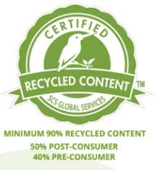
- MA OSD could review and enforce its vendor labeling and reporting requirements. According to at least one janitorial supplies vendor we interviewed, vendors don’t routinely review their EPP labeling unless a problem is flagged by a contract manager. Vendors can be regularly reminded that it is their responsibility to maintain accurate and up-to-date EPP information in their catalogs, websites, ordering portals, and spend reports and that there will be consequences for not doing so. The State could also develop and enforce standards (e.g., a minimum level of search capability for EPPs in the vendor’s online ordering system).
- MA OSD could use an aggregator of environmental certification data to streamline the process of verifying environmental certifications and attributes of products on its statewide contracts. This service would add value to these contracts by making it easier for State agencies, schools, local governments, and other contract users to identify EPPs when using these price agreements. The aggregated EPP verification information could be shared with contract users and vendors.
To start out, MA OSD could pilot test each aggregator’s free online registries for both content and usability and then provide them with specific feedback on how their websites can be improved. MA OSD could also assess the benefits and costs of contracting with one of the existing aggregators to create a website that would provide environmental certification and attribute information for the products that are offered on the State’s green cleaning supplies contract, including a “choice editing” feature that would allow only products that meet the MA OSD specifications to be listed unless an exception is granted by the contract manager.
Massachusetts could ask other states – or NASPO – to cooperatively solicit an environmental certification data aggregator service in order to make it more affordable for each participating state and harmonize the data content and format. Alternatively, MA OSD could consider using an aggregator that offers its services by subscription through a third-party organization.
- MA OSD could work with its current e-procurement vendor (PHI) to customize its e-procurement system so that it has user-friendly EPP labeling, blocking, filtering, and reporting features, including the ability to list EPPs before conventional products when the user conducts a search or tries to order a product. In the longer term, it can explore opportunities for PHI to communicate directly with certifiers and aggregators – receiving regular data updates via APIs – to assist in the EPP labeling and claim verification processes.

Conclusion
This report is the first step in an effort by the MA OSD to determine why environmental claim verification is so time consuming and unreliable for contract managers, purchasers, and vendors alike, and identify potential solutions that can make it easier and more accurate, with an ultimate goal of automating the process.
The most important factors contributing to the problem include a lack of harmonization of EPP definitions and ecolabeling practices throughout the supply chain. While many manufacturers and vendors have made progress labeling EPPs in their catalogs and on their website, it is sometimes outdated, confusing, inaccurate, incomplete, or vague. Certified green cleaning products are widely available and certifiers’ websites offer online registries of products that have earned their ecolabels. Nevertheless, contract managers, purchasers, and vendors often find themselves searching through multiple certifiers’ websites to verify that a product is currently certified. And sometimes they leave with questions about whether the products they find there are the same ones that are offered on statewide contracts because many products are missing a photo as well as a unique identifying number (such as a UPC or manufacturer product code). Each entity in the supply chain can take steps individually – and collectively – to solve this problem.
- Manufacturers and retailers can maintain a current list of EPPs in their offering that lists the ecolabel each product has earned along with the product’s UPC code. This list could be downloaded and used by contract managers to verify information in vendor’s bid submissions, ordering catalogs, and sales reports. They can also clearly, accurately, and consistently label all of their EPPs in their catalogs and create detailed environmental data sheets that include verified environmental information about each one.
- Certifiers can work together with each other and with certification data aggregators to harmonize the content, categorization, and format of their product registries so they can be seamlessly combined. Certifiers can also require manufacturers to provide photos and UPCs for all certified products to be listed on their registry.
- E-procurement service providers can design their systems to be able to identify and label EPPs and report green spend consistent with contract specifications. To automate the system, they may need to access data from certification data aggregators using an API to create a live feed of EPP verification data.
- MA OSD can continue to promote solutions to the problems identified in this report by facilitating a dialog among various players in the supply chain including other states. It can revise its specifications and offer no-cost points in the bid evaluation process to further encourage vendors to offer third-party certified products and improve their ecolabeling practices. It can also further evaluate the costs and benefits of accessing environmental claim verification information directly from EPP certifiers and data aggregators.

Appendix – Understanding the Numbers
One of the significant unresolved challenges of tracking the environmental certifications and attributes of products throughout the supply chain stems from the fact that different product identification numbers are used by manufacturers, vendors, certifiers, and even purchasers themselves. For example, while manufacturers typically assign a part number or list the product’s UPC, retailers often use a different, unrelated SKU or vendor item number. Certifiers sometimes list one of the manufacturer’s numbers or no number at all.
The use of different identifying numbers – or no numbers at all – by various entities in the supply chain creates uncertainty about whether a product that is listed as an EPP in a vendor’s bid, ordering catalog, or sales report is actually the product that has earned a third-party certification. This lack of consistency and standardization in the process that links environmental certification data to a specific product using a unique numerical identifier breaks the chain of information digitally flowing from various entities in the supply chain and creates a roadblock to automating this process.
Below are descriptions of the different types of numbers that are used to identify products:
- UPCs (Universal Product Codes) are assigned by the independent Global Standards Organization and are the most recognized Global Trade Identification Number (GTIN) in the United States. UPCs are primarily used by retailers and other vendors to track inventory digitally using the UPC's complementary bar code. UPCs are typically 12 digits long and are sometimes called a GTIN-12. UPCs are unique to specific products, so they can be used for tracking individual items. For more information on UPCs, see Shopify: What Is a UPC Code? Complete Guide for Retailers.
UPCs are listed by some manufacturers, vendors, and certifiers (e.g., Safer Choice). Below are several examples of entities in the cleaning products supply chain that are using UPCs.
- Manufacturers sometimes list UPCs on their websites, product marketing materials, and technical data sheets. See example, below.
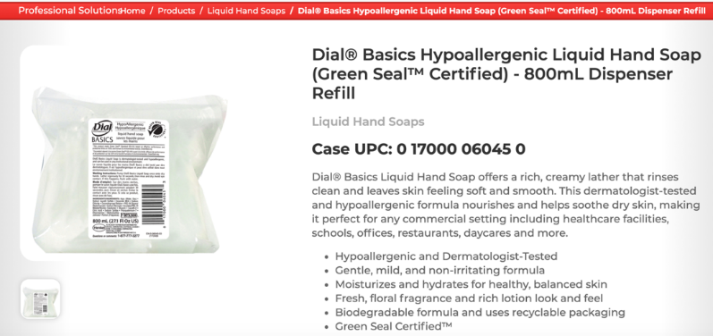
  - Vendors sometimes list UPCs on their websites or online catalogs but sometimes call them a SKU or something else.
  - Some certifiers (e.g., Safer Choice) and both of the certification data aggregators we evaluated (ecomedes and UL SPOT) are adding UPCs to their registries. Interestingly, the different aggregators sometimes list a different number of UPCs as well as different UPCs for the same product.
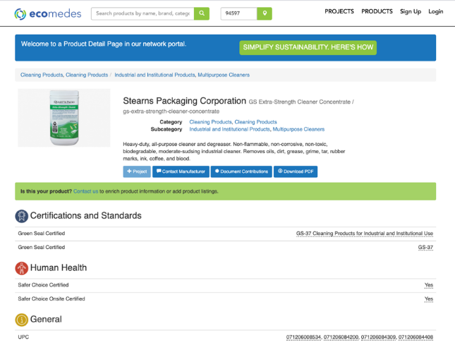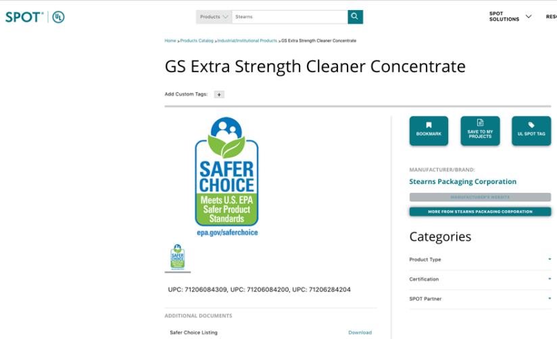
  - Manufacturer part numbers are developed by the product manufacturer and typically apply to a specific product or family of products. The term manufacturer part number is sometimes used interchangeably with manufacturer model number, item number, order number, or product code. Manufacturer part numbers are useful because they are typically the number consumers use to order a product. However, the same manufacturer part number is sometimes applied to multiple products. For example, the same cleaning product packaged in different-sized containers may simply have the same manufacturer part number. Other manufacturers may add numbers to the end of the part number to differentiate the same product in different packaging (e.g., adding -32 for a quart-sized container or -128 for a gallon). Suffixes may also be added to differentiate an individual unit from a case. Prefixes are sometimes added to designate the manufacturer (often with some or all of its name). There is no consistency with which either of these is done.
  - SKUs (which stands for Stock Keeping Units) are typically developed by retailers to track all of the products in their ordering system. Some SKUs are the same as the manufacturer part number – or some variation of it – adding a manufacturer code at the beginning or a unit of measure code at the end, for example. Other SKUs are completely different than the manufacturer's part number, like Grainger's ordering numbers. Unlike manufacturer part numbers and UPCs, SKUs should NOT be considered a reliable unique product identifier because the same product can be assigned different SKUs by different vendors.

Even some certifiers assign their own numbers to track products in their registry. For example, Green Seal does report the manufacturer item number when they have it. (Unfortunately, they equate SKU with the manufacturer part number, which is at the bottom of each listing.) However, Green Seal also assigns its own number, which is at the top of each listing and does correspond to any manufacturer number.
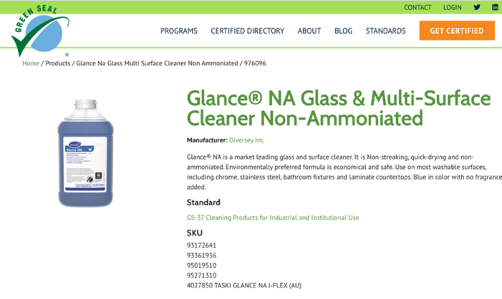

  - UNSPSCs (United Nations Standard Products and Services Codes) are standard eCommerce commodity codes that are used to classify products and services into categories based on the following hierarchy: Segment, Family, Class, Commodity, and Retail Function. The global UNSPSC classification system was developed by the United Nations Development Programme to facilitate spend analysis by government agencies in different countries. UNSPSCs only indicate which category a product is in; consequently, many similar products will have the same UNSPSC. Therefore, UNSPSCs cannot be used as unique identifiers of an individual product. Similarly, NAIC codes describe product categories and are not unique product identifiers. Therefore, they cannot be used to verify whether a specific product is an EPP.
Massachusetts Operational Services Division (MA OSD) “uses United Nations Standard Products and Services Codes (UNSPSC), a global products and services classification system, to categorize goods and services in the COMMBUYS Market Center. Contract managers use these codes when posting bids and vendors select UNSPSCs as part of their COMMBUYS Vendor Profiles to receive bid notifications that align with their businesses.” Years ago, MA OSD added two numbers to the end of the classification code to signify that a product was energy efficient or environmentally preferable. MA OSD allowed vendors to use this UNSPSC+EPP suffix during catalog development. The State hoped this would facilitate easier identification of EPPs in its e-procurement system. However, this practice was discontinued once MA OSD learned that all of its codes for EPPs would be lost due to a lag in updates from previous versions of the USPSCs in the e-procurement system. If the UNSPSCs could be current, there may be a way to add EPP codes to signify specific third-party certifications that comply with the Commonwealth’s specification requirements.
- Blockchain is “an open, distributed ledger that can record transactions between two parties efficiently and in a verifiable and permanent way.” It could be used by states and other jurisdictions to track EPP sales if environmental certifications can be tagged by blockchain technologies. It is something worth keeping an eye on as a long-term strategy to automate tracking of EPP transactions, although there may be logistical, cost, and environmental issues to consider such as high energy use of its servers.

We acknowledge that these examples of sustainable product brochures are not perfect and could be improved by omitting items with weak or unsubstantiated environmental claims that are mixed in with strong, verified claims. Nevertheless, they demonstrate the types of resources manufacturers have developed to help their customers easily identify their EPPs and understand their ecolabeling system. For more information on ways manufacturers can improve their EPP labeling, see the “Opportunities for Improvement” section below.
Please visit these web pages for information about U.S. EPA’s Design for the Environment label for antimicrobial products: - Design for the Environment Alternatives Assessments - EPA DFE Certified Disinfectants - Learn About Design for the Environment (DfE) Certification
Only Cradle to Cradle Certified products with a Silver level certification or higher are recommended.
There are other third-party certifications for cleaning products that are not referenced by MA OSD because they verify only a single environmental or health benefit. Examples include USDA Biobased Certified, which verifies products that contain at least a minimum amount of plant-based material, as well as UL GREENGUARD and SCS Indoor Advantage, which verify that a product has low emissions of formaldehyde and other volatile organic compounds.
^{,6} Although there is no separate manufacturer filter for the Safer Choice product registry, users can find certified products offered by a specific manufacturer using a keyword search or by clicking on the manufacturer name of a certified product in the registry, which will pull up all certified products by that manufacturer.
Green Seal’s Industrial and Institutional Cleaning Products category includes a wide array of product types such as cleaners, floor maintenance chemicals, and hand soaps. The only way to sort products is by using a keyword search, which is unreliable. Green Seal indicated that it is currently redesigning its Certified Products Directory to remedy this problem.
Cradle to Cradle Certified has two product registries: One includes products that meet sustainability criteria in five categories: (1) material health (i.e., toxics), (2) material reutilization, (3) renewable energy & carbon management, (4) water stewardship, and (5) social fairness. The other registry includes products that only meet the material health criteria.
Cradle to Cradle has two online registries: (1) its Cradle to Cradle Certified Products Registry; and (2) its Material Health Certificate Registry (for products that just meet its low-toxicity requirements).
The Global Ecolabelling Network (GEN) is an international nonprofit association of leading ecolabelling organizations whose mission is “to help protect the environment by improving, promoting, and developing the ecolabeling of green products and sustainable services.” GEN fosters “standards harmonization” among its members.
A Keyword Search in the ecomedes registry using a product name pulled up many products with different names. For example, when “Simple Green” was typed into the Search Box, >1700 products were listed. In contrast, only 24 products came up when the Brand Filter for Simple Green (Sunshine Makers, Inc.) was clicked.
A Keyword Search in the UL Spot database using a product name pulled up many products with different names. For example, when “Simple Green” was typed into the Search Box, ~900 products were listed. In contrast, only seven products came up when the Brand Filter for Simple Green (Sunshine Makers, Inc.) was clicked.
~2600 products came up when “Seventh Generation” was typed into the ecomedes registry using the Keyword Search function. Many of these products had a different brand name. In contrast, only 86 products came up when the Brand Filters for Seventh Generation and Seventh Generation, Inc. were clicked. In UL SPOT, 12 products came up when Seventh Generation was typed in using both the Keyword Search function and the Brand Filter.
The UL SPOT registry creates a downloadable certificate for UL-certified products, but not for the non-UL-certified products in this aggregator’s database.
After reviewing a draft of this report, Green Seal stated, “We will be updating our registry in the next few months and that number will go away.” It also noted that it has a “future goal of either providing serial numbers to each product certified or including certification dates in the product profile page.”
The Truth About Blockchain, Harvard Business Review, January-February 2017

