INDOOR AIR QUALITY ASSESSMENT

Erving Elementary School
28 Northfield Road
Erving, MA

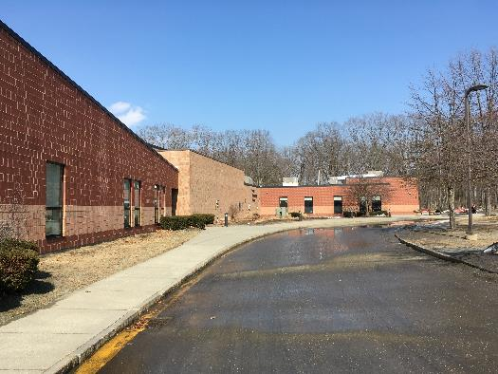

Prepared by:
Massachusetts Department of Public Health
Bureau of Environmental Health
Indoor Air Quality Program
May 2019

Background

Building: | Erving Elementary School (EES)
Address: | 28 Northfield Road, Erving, MA
Reason for Request: | General indoor air quality (IAQ)
Date of Assessment: | March 15, 2019
Massachusetts Department of Public Health/Bureau of Environmental Health (MDPH/BEH) Staff Conducting Assessment: | Michael Feeney, Director, IAQ Program
Building Description: | The EES is a one-story, brick building built in 1973 and renovated in 2001
Building Population: | Approximately 120 total students
Windows: | Some windows are openable

IAQ Testing Results
Please refer to the IAQ Manual for methods, sampling procedures, and interpretation of results (MDPH, 2015). The following is a summary of indoor air testing results (Table 1).
- Carbon dioxide levels were below the MDPH guideline of 800 parts per million (ppm) in all areas tested, indicating adequate air exchange in those areas.
- Temperature was within or close to the MDPH recommended range of 70°F to 78°F the day of the assessment. Occupants in a few areas expressed temperature complaints especially in perimeter classrooms.
- Relative humidity was mostly within the MDPH recommended range of 40 to 60% on the day of assessment.
- Carbon monoxide levels were non-detectable (ND) in all areas tested.
- Fine particulate matter (PM2.5) concentrations measured were below the National Ambient Air Quality (NAAQS) limit of 35 μg/m³ in all areas tested.

Ventilation
A heating, ventilating and air conditioning (HVAC) system has several functions. First it provides heating and, if equipped, cooling. Second, it is a source of fresh air. Finally, an HVAC system will dilute and remove normally occurring indoor environmental pollutants by not only introducing fresh air, but by filtering the airstream and ejecting stale air to the outdoors via exhaust ventilation. Even if an HVAC system is operating as designed, point sources of respiratory irritation may exist and cause symptoms in sensitive individuals.
Fresh air in the majority of classrooms is provided by unit ventilators (univents; Picture 1). Univents draw fresh air through a vent on the exterior wall (Picture 2). Air is mixed with return air from the room, filtered, heated (if needed), and delivered back to the room (Figure 1). A number of univents were obstructed by items placed on top or blocking the front of the units (Picture 3). Odorous items placed on univents can be heated and the odors distributed. Both the top and the return vent at the bottom need to be kept clear of obstructions for the units to operate as designed.
Univent filters are reported to be changed three times a year. In examining the filters, MDPH/IAQ staff determined the filters to be a type that provides minimal filtration. Pleated filters with a minimum efficiency reporting value (MERV) of 8 are recommended because they can adequately filter out pollen and mold spores (ASHRAE, 2012). Note, however, that an increase in filtration can cause stress on equipment. The univents should be evaluated to determine if the higher-rated filters will allow adequate function.
It is important to note that univents in some area of the building are nearly 20 years old. Efficient function of equipment of this age is difficult to maintain, since compatible replacement parts are often unavailable. According to the American Society of Heating, Refrigeration and Air-Conditioning Engineering (ASHRAE), the service life for the various components of the HVAC system is between 20 to 30 years, assuming routine maintenance of the equipment (ASHRAE, 1991).
In order to have proper ventilation with a mechanical supply and exhaust system, these systems must be balanced to provide an adequate amount of fresh air while removing stale air from a room. It is recommended that existing ventilation systems be re-balanced every five years to ensure adequate air systems function (SMACNA, 1994).

Microbial/Moisture Concerns
The New England area experienced an unprecedented period of extended hot, humid weather. According to the Washington Post, “[d]ata…show[s]…cities in the Northeast have witnessed such humidity levels for record-challenging duration...[i]ncluding Albany, Boston, Burlington Portland and Providence” during the summer of 2018 (WP, 2018). “Boston and nearby locations… [saw]…historic numbers of those warm nights with low temperatures at or above 70 degrees…Providence and Blue Hill Observatory have already broken their annual records” (WP, 2018). If a building does not have adequate exhaust ventilation and air chilling capacity to remove/reduce relative humidity from outside air, then hot, moist air can be introduced into a building and linger to increase occupant discomfort as well as possibly moisten materials that may lead to mold growth.
IAQ staff examined the building and found rippled wall-to-wall carpeting in a number of locations (Picture 4), which indicated water exposure. Rippled carpet indicates exposure to significant amounts of water vapor. Area that may be prone to this phenomenon are areas that allow for hot, moist air to enter the building in large amounts such as main entrances, classroom doors that do not have proper weatherstripping/door sweeps and univent fresh air intakes that are at ground level (Picture 5). All of these conditions can allow for hot, moist air to enter the building to moisten surfaces that have a temperature at or below the dew point.
Water-damaged window sills were note in a number of areas, as well as windows that have damaged gaskets to allow water vapor into the space between panes (Picture 6). Failing windows can be a source of water intrusion.
Rainwater runoff from west facing wall of the building drains onto a tarmac apron (Picture 7). The apron appears cracked in some places and appears to be sloped towards the slab and univent fresh air intakes (Picture 8), allowing rainwater to come into contact with the exterior wall junction. Over time, this can serve to be a moisture source that is captured by univents. Water against the foundation can also gradually undermine the integrity of the building envelope and provide a means of water entry into the building through capillary action through foundation concrete and masonry (Lstiburek & Brennan, 2001). Building occupants report that the tarmac is also prone to icing during the winter.
Indoor plants were observed in a few areas. Plants can be a source of pollen and mold, which can be respiratory irritants to some individuals. Plants should be properly maintained, equipped with non-porous drip pans, and should be located away from air diffusers to prevent the aerosolization of dirt, pollen and mold.
BEH staff noted gaps in some exterior doors where light could be seen penetrating. This is an indicator that these doors need to be fitted with tighter fitting weather stripping/door sweeps to prevent moisture, pests, and unconditioned air from infiltrating occupied areas.

Other IAQ Evaluations
Exposure to low levels of total volatile organic compounds (TVOCs) may produce eye, nose, throat, and/or respiratory irritation in some sensitive individuals. To determine if VOCs were present, BEH/IAQ staff examined rooms for products containing VOCs. BEH/IAQ staff noted hand sanitizers, scented cleaners, air fresheners, and dry erase materials in use within the building. All of these products have the potential to be irritants to the eyes, nose, throat, and respiratory system of sensitive individuals (e.g., asthmatics). Due to the pervasive use of these products in schools throughout Massachusetts, the MDPH has produced a guideline called “Clean Air Is Odor-Free” which is included as Appendix A.
In many areas, accumulated items including books, papers, and decorative items were observed on floors, windowsills, tabletops, counters, bookcases, and desks. Excess items on surfaces can make it more difficult for custodial staff to clean.
Carpets should be cleaned annually (or semi-annually in soiled/high traffic areas) in accordance with Institute of Inspection, Cleaning and Restoration Certification (IICRC) recommendations, (IICRC, 2012). Regular cleaning with a high efficiency particulate air (HEPA) filtered vacuum in combination with an annual cleaning will help to reduce accumulation and potential aerosolization of materials from carpeting.
Note that the Environmental Protection Agency (EPA) conducted a National School Radon Survey in which it discovered nearly one in five schools had “…at least one frequently occupied ground contact room with short-term radon levels above 4 [picocuries per liter] pCi/L” (US EPA 1993). The BEH/IAQ Program therefore recommends that every school be tested for radon, and that this testing be conducted during the heating season while school is in session in a manner consistent with USEPA radon testing guidelines. Radon measurement specialists and other information can be found at www.nrsb.org and http://aarst-nrpp.com/wp, with additional information at: http://www.mass.gov/eohhs/gov/departments/dph/programs/environmental-health/exposure-topics/iaq/radon.

Conclusions/Recommendations
Due to the timing of the carpet rippling, over the summer of 2018, it is likely that the carpeting was adversely affected by elevated humidity at that time. It is recommended to remove carpet in moisture-accumulation prone areas and replace with non-porous flooring such as tile. The IAQ Program offers to return to the building during hot, humid weather to identify areas prone to moisture accumulation inside classrooms.
While cleaning carpeting may help remove some microbiological contamination, this problem would be expected to reoccur during increased precipitation and prolonged hot, humid weather. Removal of carpeting, however, does not eliminate the excess relative humidity problem. For these reasons a two-phase approach is required, consisting of immediate (short-term) measures to improve air quality at the school and long-term measures that will require planning and resources to adequately address overall indoor air quality concerns.

The following short-term measures should be considered for immediate implementation:
- Render classroom exterior doors airtight by installing weatherstripping and door sweeps. Seal spaces between exterior doors and frames with an appropriate waterproof sealant.
- Operate all supply and exhaust ventilation equipment continuously during occupied hours.
- Remove items and furniture blocking fresh air supply vents.
- Ensure all windows and exterior classroom doors are tightly closed during the use of air conditioning.
- Check exhaust vents classrooms and restrooms for draw periodically and repair any non-operating motors/vents.
- Change filters for HVAC equipment 2-4 times a year. The MDPH recommends using pleated filters of Minimum Efficiency Reporting Value (MERV) of 8, which are adequate in filtering out pollen and mold spores (ASHRAE, 2012), if these can be used with current equipment.
- Regularly clean supply/return/exhaust vents and fans to avoid aerosolizing accumulated particulate matter. To clean ceiling grills, remove and wash.
- Examine records to ascertain the latest date of ventilation system balancing. If more than five years, consider consulting a ventilation engineer to re-balance the ventilation system. Consider adopting a balancing schedule of every 5 years for all mechanical ventilation systems, as recommended by ventilation industrial standards (SMACNA, 1994).
- Properly maintain plants, including drip pans, to prevent water damage to porous materials. Plants should also be located away from air diffusers to prevent the aerosolization of dirt, pollen, and mold.
- Eliminate or limit the use of products and equipment that contain VOCs (e.g., air fresheners, scented cleaning wipes, scented hand sanitizer, humidifiers/diffusers, etc.).
- Consider reducing the amount of items stored in rooms to make cleaning easier. Periodically move items to clean flat surfaces. Store porous items on shelving and away from walls.
- For buildings in New England, periods of low relative humidity during the winter are often unavoidable. Therefore, scrupulous cleaning practices should be adopted to minimize common indoor air contaminants whose irritant effects can be enhanced when the relative humidity is low. To control dusts, a high efficiency particulate arrestance (HEPA) filter equipped vacuum cleaner in conjunction with wet wiping of all surfaces is recommended. Drinking water during the day can help ease some symptoms associated with a dry environment (throat and sinus irritations).
- Consider adopting the US EPA (2000) document, “Tools for Schools”, as an instrument for maintaining a good IAQ environment in the building available at: http://www.epa.gov/iaq/schools/index.html
- Refer to resource manual and other related IAQ documents located on the MDPH’s website for further building-wide evaluations and advice on maintaining public buildings. These documents are available at: http://mass.gov/dph/iaq.

The following long-term measures should be considered:
- Examine the feasibility of re-paving the tarmac apron to have it slope away from the edge of the building. Once done, apply an appropriate sealant to the seam between the tarmac and building exterior wall.
- Consider replacing rippled carpet with tile.
- Given the age of the HVAC system, consideration should be given to having a ventilation engineer examine the HVAC system for upgrade or replacement.
- The school should be tested for radon by a certified radon measurement specialist during the heating season when school is in session. Radon measurement specialists and other information can be found at: www.nrsb.org, and http://aarst-nrpp.com/wp.

References
ASHRAE. 1991. ASHRAE Applications Handbook, Chapter 33 “Owning and Operating Costs”. American Society of Heating, Refrigeration and Air Conditioning Engineers, Atlanta, GA.
ASHRAE. 2012. American Society of Heating, Refrigeration and Air Conditioning Engineers (ASHRAE) Standard 52.2-2012 -- Method of Testing General Ventilation Air-Cleaning Devices for Removal Efficiency by Particle Size (ANSI Approved).
IICRC. 2012. Carpet Cleaning FAQ 4 Institute of Inspection, Cleaning and Restoration Certification. Institute of Inspection Cleaning and Restoration, Vancouver, WA.
Lstiburek, J. & Brennan, T. 2001. Read This Before You Design, Build or Renovate. Building Science Corporation, Westford, MA. U.S. Department of Housing and Urban Development, Region I, Boston, MA.
MDPH. 2015. Massachusetts Department of Public Health. “Indoor Air Quality Manual: Chapters I-III”. Available at: http://www.mass.gov/eohhs/gov/departments/dph/programs/environmental-health/exposure-topics/iaq/iaq-manual/.
SMACNA. 1994. HVAC Systems Commissioning Manual. 1st ed. Sheet Metal and Air Conditioning Contractors’ National Association, Inc., Chantilly, VA.
US EPA. 1993. Radon Measurement in Schools, Revised Edition. Office of Air and Radiation, Office of Radiation and Indoor Air, Indoor Environments Division (6609J). EPA 402-R-92-014. https://www.epa.gov/sites/production/files/2014-08/documents/radon_measurement_in_schools.pdf
US EPA. 2000. Tools for Schools. Office of Air and Radiation, Office of Radiation and Indoor Air, Indoor Environments Division (6609J). EPA 402-K-95-001, Second Edition. http://www.epa.gov/iaq/schools/index.html.
WP. 2018. ‘It’s been relentless’: Smothering summer humidity in the Northeast has crushed records. Washington Post, Washington, DC. https://www.washingtonpost.com/news/capital-weather-gang/wp/2018/08/30/its-been-relentless-smothering-summer-humidity-in-the-northeast-has-crushed-records/

Picture 1
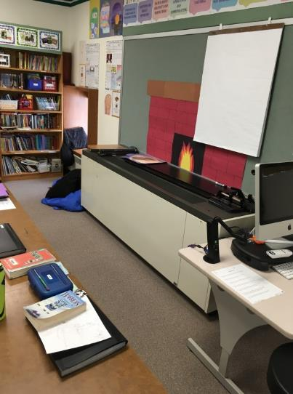
Univent
Picture 2
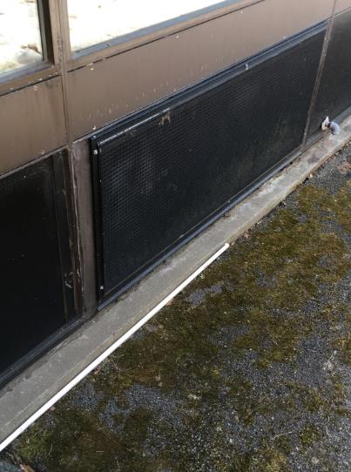
Univent fresh air intake
Picture 3
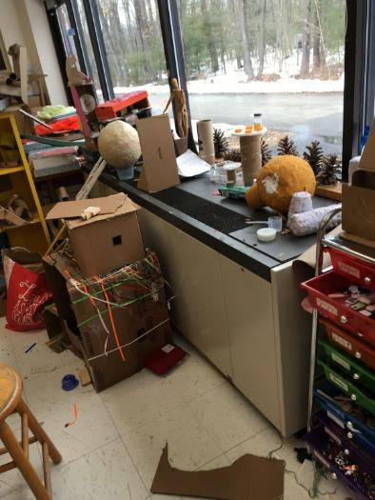
Univent obstructed with cardboard
Picture 4
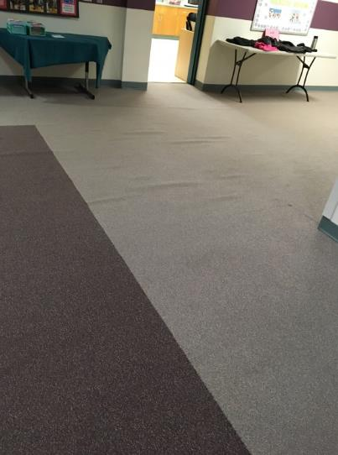
Rippled carpet in main entrance hall
Picture 5
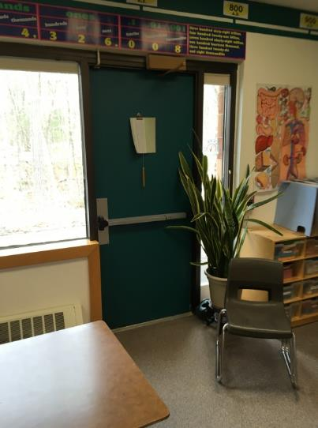
Exterior door in classrooms
Picture 6
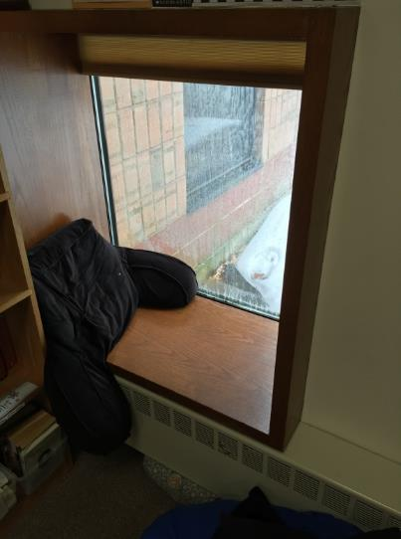
Failing energy efficient windows
Picture 7
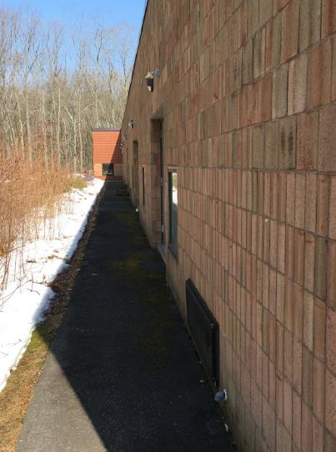
Apron along west exterior wall of building
Picture 8
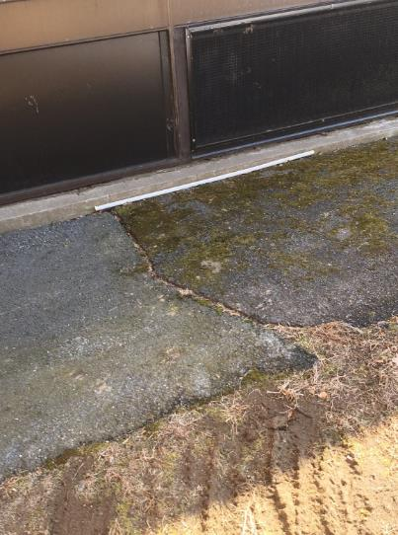
Apron appears to be sloped towards the building
Location | Carbon  Dioxide  (ppm) | Carbon Monoxide  (ppm) | Temp  (°F) | Relative  Humidity  (%) | PM2.5  (µg/m³) | Occupants  in Room | Windows  Openable | Ventilation |  | Remarks
 |  |  |  |  |  |  |  | Supply | Exhaust
Background (outside) | 315 | 2 | 66 | 57 | 17
Main Office | 577 | ND | 75 | 44 |  | 2 | Y | Y | Y | Rippled carpet
Main Hallway |  |  |  |  |  |  |  |  |  | Rippled carpet
Cafeteria | 603 | ND | 74 | 45 | 7 | 0 | Y | Y | Y
Kitchen | 613 | ND | 74 | 52 | 18 | 2 | Y | Y | Y
Conference Room | 520 | ND | 74 | 40 | 10 | 0 | N | Y | Y
Staff Room | 491 | ND | 73 | 40 | 6 | 2 | Y | Y | Y | Laminator, upholstered furniture
Science/Tech | 555 | ND | 67 | 52 | 11 | 0 | N | Y | Y
Computer Lab | 564 | ND | 69 | 48 | 5 | 0 | N | Y | Y
Technology | 523 | ND | 71 | 43 | 5 | 0 | N | Y | Y | Rippled carpet
Library | 453 | ND | 71 | 41 | 5 | 1 | N | Y | Y | Rippled carpet
Art Room | 409 | ND | 71 | 41 | 11 | 0 |  | Y | Y
Speech | 459 | ND | 72 | 39 | 5 | 1 | N | Y | Y
Psychologist | 551 | ND | 73 | 38 | 7 | 1 | Y | Y | Y
Gym | 411 | ND | 71 | 33 | 8 | 0 | N | Y | Y
101 | 488 | ND | 71 | 41 | 6 | 1 | Y | Y | Y | Pillows, rippled carpet
102 | 491 | ND | 70 | 44 | 6 | 4 | Y | Y | Y | Rippled carpet, supply blocked, plants
103 | 530 | ND | 71 | 40 | 5 | 0 | Y | Y | Y | Window leaks
104 | 546 | ND | 71 | 40 | 13 | 0 | Y | Y | Y | Supply blocked by books
105 | 698 | ND | 68 | 50 | 10 | 21 | Y | Y | Y
106 | 431 | ND | 69 | 44 | 7 |  | Y | Y | Y
107 | 511 | ND | 70 | 43 | 7 | 4 |  | Y | Y
108 | 523 | ND | 70 | 45 | 10 | 15 | Y | Y | Y
109 | 550 | ND | 71 | 46 | 8 | 9 | Y | Y | Y
110 | 415 | ND | 72 | 38 | 7 | 1 | Y | Y | Y
111 | 449 | ND | 72 | 40 | 9 | 1
112 | 499 | ND | 71 | 44 | 10 | 12 | Y | Y | Y
113 | 548 | ND | 70 | 45 | 12 | 14 | Y | Y | Y
116 | 411 | ND | 71 | 37 | 5 | 0 | N | Y | Y
117 | 488 | ND | 71 | 37 | 6 | 2 | N | Y | Y

