INDOOR AIR QUALITY ASSESSMENT

Erving Public Library
17 Moore Street
Erving, Massachusetts

Prepared by:
Massachusetts Department of Public Health
Bureau of Environmental Health
Indoor Air Quality Program
June 2018

BACKGROUND
Building: | Erving Public Library (EPL)
Address: | 17 Moore Street, Erving, MA
Reason for Request: | General indoor air quality (IAQ)
Date of Assessment: | April 19, 2018
Massachusetts Department of Public Health/Bureau of Environmental Health (MDPH/BEH) Staff Conducting Assessment: | Michael Feeney, Director,  IAQ Program
Date of Building Construction: | 1970’s
Building/Site Description: | EPL is a one-story vinyl-clad building with a peaked roof.
Windows: | Openable

BACKGROUND
It is the understanding of the IAQ Program that the EPL was the subject of a successful vote for replacement in May 2017 (Greenfield Recorder, 2017). In general, it will take several years for a new building to be constructed. Therefore the various recommendations in this report are geared towards improving/maintaining the conditions within the building to the extent possible while recognizing that the building will be replaced in the near future.

METHODS
Please refer to the IAQ Manual for methods, sampling procedures, and interpretation of results (MDPH, 2015).

RESULTS and DISCUSSION
The following is a summary of indoor air testing results (Table 1).
- Carbon dioxide levels were below the MDPH guideline of 800 parts per million (ppm) in all areas.
- Temperature was within the MDPH recommended range of 70°F to 78°F in occupied areas.
- Relative humidity was below the MDPH recommended range of 40 to 60% in 4 out of 6 occupied areas. This is typical during colder months in New England.
- Carbon monoxide levels were non-detect (ND) throughout all areas surveyed.
- Fine particulate matter (PM2.5) concentrations measured were below the National Ambient Air Quality Standard (NAAQS) level of 35 μg/m³ in all areas assessed.
- Total Volatile Organic Compounds (TVOCs): levels indoors were ND.

Ventilation
It can be seen from Table 1 that carbon dioxide levels were below 800 ppm in all areas surveyed. Fresh air is provided by openable windows as there is no mechanical fresh air ventilation in the building. The EPL utilizes an air handling unit (AHU) that recirculates air using ceiling-mounted air diffusers and floor-installed return vents (Picture 1). Accumulated debris was noted in the bottom of the floor return vent.

Other IAQ Evaluations
Rodents were reported as an occasional problem in the EPL. Of note was the existence of gaps in the front steps of the EPL (Picture 2), which serves as a means of entry for rodents into the building. Libraries can have infestations due to the fact that books can be bound using glue derived from animals. To address rodent infestation, the services of a licensed pest control professional should be used to develop a control program using the principles of Integrated Pest Management (IPM), which include exclusion of pests (e.g., tightly-sealed doors), removal of attractants (food and water) and harborage, and regular thorough cleaning. Rodent infestation can result in indoor air quality related symptoms due to materials in their wastes. Mouse urine contains a protein that is a known sensitizer (US EPA, 1992). A sensitizer is a material that can produce symptoms (e.g., running nose or skin rashes) in sensitive individuals after repeated exposure.
A three-step approach is necessary to eliminate rodent infestation:
- removal of the rodents;
- cleaning of waste products from the interior of the building; and
- reduction/elimination of pathways/food sources that are attracting rodents.
To eliminate exposure to allergens, rodents must be removed from the building. Please note that removal, even after cleaning, may not provide immediate relief since allergens can exist in the interior for several months after rodents are eliminated (Burge, 1995). Once the infestation is eliminated, a combination of cleaning and increased ventilation and filtration should serve to reduce allergens associated with rodents. In efforts to eliminate pest problems, baited traps were placed in a number of rooms.

RECOMMENDATIONS
In view of the findings at the time of the visit, the following recommendations are made:
- Clean debris from the floor-installed return vents.
- Permanently seal the space in the front steps.
- Use the principles of integrated pest management (IPM) to rid this building of pest. Activities that can be used to eliminate pest infestation may include the following activities.
  - Do not use recycled food containers. Seal recycled containers in a tight fitting lid to prevent rodent access.
  - Remove non-food items that rodents are consuming.
  - Stored foods in tight fitting containers.
  - Avoid eating at workstations. In areas were food is consumed, vacuum periodically to remove crumbs.
  - Regularly clean crumbs and other food residues from toasters, toaster ovens, microwave ovens and other food preparation equipment;
  - Examine each room and the exterior walls of the building for means of rodent access and seal appropriately. Holes as small as ¼” is enough space for rodents to enter an area. If doors do not seal at the bottom, install a weather strip as a barrier to rodents
  - Reduce harborages (e.g., cardboard boxes) where rodents may reside.
  - Refer to the IPM Guide, which can be obtained at the following Internet address: https://www.mass.gov/files/documents/2016/08/wk/ipm-kit-for-bldg-mgrs.pdf
- Refer to resource manual and other related indoor air quality documents located on the MDPH’s website for further building-wide evaluations and advice on maintaining public buildings. These documents are available at http://mass.gov/dph/iaq.

REFERENCES
ACGIH. 1989. Guidelines for the Assessment of Bioaerosols in the Indoor Environment. American Conference of Governmental Industrial Hygienists, Cincinnati, OH.
Burge, H.A. 1995. Bioaerosols. Lewis Publishing Company, Boca Raton, FL.
Greenfield Recorder. 2017. Erving town meeting OKs new library money. Greenfield Recorder, Greenfield, MA. http://www.recorder.com/ERVING-TM-9666623
MDPH. 2015. Massachusetts Department of Public Health, Indoor Air Quality Manual: Chapters I-III. Available at: http://www.mass.gov/eohhs/gov/departments/dph/programs/environmental-health/exposure-topics/iaq/iaq-manual/.
Picture 1
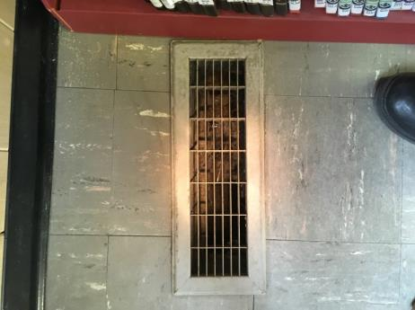
Floor return vent, note debris in vent
Picture 2
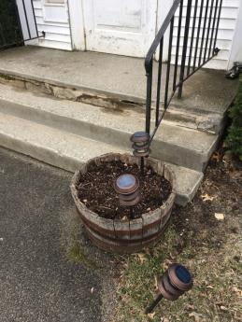
Gap in front steps
Location | Carbon  Dioxide  (ppm) | Carbon Monoxide  (ppm) | Temp  (°F) | Relative  Humidity  (%) | PM2.5  (µg/m³) | TVOCs  (ppm) | Occupants  in Room | Windows  Openable | Ventilation |  |  | Remarks
 |  |  |  |  |  |  |  |  | Intake | Exhaust
Background (outdoors) | 399 | ND | 54 | 35 | 4 | ND
Front desk in main room | 791 | ND | 70 | 45 | 1 | ND | 3 | Y | Y |  | Y
Children’s room | 766 | ND | 71 | 40 | 1 | ND | 0 | Y | Y |  | Y
Museum | 681 | ND | 70 | 37 | 2 | ND | 0 | Y | Y |  | Y
Kitchen | 682 | ND | 70 | 39 | 1 | ND | 0 | Y | Y |  | Y
Restroom | 724 | ND | 70 | 39 | 1 | ND | 0 | Y | Y |  | Y
Store room | 704 | ND | 70 | 39 | 2 | ND | 0 | N | N |  | N

