INDOOR AIR QUALITY ASSESSMENT

Erving Senior/Community Center
1 Care Drive
Erving, MA

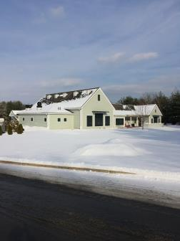

Prepared by:
Massachusetts Department of Public Health
Bureau of Environmental Health
Indoor Air Quality Program
February 2018

Background
Building: | Erving Senior/Community Center (ESC)
Address: | 1 Care Drive, Erving, MA
Reason for Request: | General IAQ assessment
Date of Assessment: | January 19, 2018
Massachusetts Department of Public Health/Bureau of Environmental Health (MDPH/BEH) Staff Conducting Assessment: | Michael Feeney, Director, Indoor Air Quality (IAQ) Program
Building Description: | Constructed as a one-story building on cement slab.
Building Population: | Approximately 4 employees, 20+ members of the public.
Windows: | Openable

Methods
Please refer to the IAQ Manual for methods, sampling procedures, and interpretation of results (MDPH, 2015).

IAQ Testing Results
The following is a summary of indoor air testing results (Table 1).
- Carbon dioxide levels were below 800 parts per million (ppm) in all occupied areas assessed, indicating adequate fresh air in the space.
- Temperature was within the recommended range of 70°F to 78°F in occupied areas assessed.
- Relative humidity was below the recommended range of 40% to 60% in all occupied areas assessed which is typical during the heating season.
- Carbon monoxide levels were measured at 3 ppm in all occupied areas assessed. Up to 6 ppm was measured outdoors.
- Fine particulate matter (PM2.5) concentrations measured were below the National Ambient Air Quality Standard (NAAQS) level of 35 μg/m³ in all occupied areas assessed.
- Volatile Organic Compounds were non-detectable in all occupied areas assessed.

Ventilation
A heating, ventilating, and air conditioning (HVAC) system has several functions. First, it provides heating and, if equipped, cooling. Second, it is a source of fresh air. Finally, an HVAC system will dilute and remove normally-occurring indoor environmental pollutants by not only introducing fresh air, but also filtering the airstream and ejecting stale air to the outdoors via exhaust ventilation. Even if an HVAC system is operating as designed, point sources of respiratory irritation may exist and cause irritant symptoms in sensitive individuals. The following analysis examines and identifies components of the HVAC system and likely sources of respiratory irritant/allergen exposure due to water damage, aerosolized dust, and/or chemicals found in the indoor environment.
The assessment results indicate that the ventilation system is providing adequate fresh air for the building’s occupancy. Note that many areas had low occupancy, which can reduce carbon dioxide levels. To maximize air exchange, the BEH recommends that mechanical ventilation systems operate continuously during periods of occupancy. Without the system operating as designed, normally occurring pollutants cannot be diluted or removed, allowing them to build up and lead to IAQ or comfort complaints.
The HVAC system draws fresh air through a vent in a gable at the front of the building (Picture 1). Rooms have ceiling-mounted supply and return vents that are connected to air-handling units (AHUs) located within the attic space of the building (Picture 2). Of note was the measurement of carbon monoxide in the building. If an outdoor source of products of combustion exists upwind from the building, it is possible for those pollutants to be captured by the HVAC system. Note that this building is located in the Millers River Valley, which is significantly below the level of the surrounding land. Under certain weather conditions, the Millers River Valley likely experiences a phenomenon known as temperature inversion. If a temperature inversion occurs, pollutants produced by various sources within the Millers River Valley will tend to stay close to the ground and accumulate. In this instance, a temperature inversion would account for the elevated levels of carbon monoxide measured both outdoors and within the building.

Microbial/Moisture Concerns
The building is reported to have a chronic problem with ice dams, particularly over doors that serve as emergency exits for the multipurpose room. Ice dams occur when snow in contact with the roof melts to form water on the upper section of the roof which is then refrozen on the lower portion of the roof to form blocks of ice. The roof is heated by air from the occupied spaces. The heated air warms the roofing material above water’s melting point (32°F). As water rolls down the sloped roof, it freezes into ice when it comes into contact with roof materials on the lower section of the roof that are below 32°F (Picture 3). This ice creates a blockage or dam, which then collects and holds melting snow or rainwater against the roof shingles. Pooling water can then penetrate through the roof materials via cracks and crevices, resulting in wetting of the interior of the building.
A combination of methods are typically used to prevent ice dams. The floor of the attic space is typically insulated to prevent air movement and heat loss from the occupied space. Often, ridge vents (installed along the roof ridge) are installed to allow for rapid exhaust of heat from the attic space. Soffit vents (located beneath the eave in the roof) also provide a source of cold outdoor air to replace the heated air that escapes through the ridge vent. This configuration allows heat to escape so that the attic space temperature is roughly equal to the outdoor temperature; this prevents roof materials from melting snow in contact with the roof. If attic insulation is inadequate, or ridge vents/soffit vents are sealed, then heat can accumulate in the roof peak and start the ice dam creation cycle.
The ESC building does not have ridge vents. It appears that air escapes from the attic space via gable vents (Picture 4). The use of gable vents in this situation may not provide enough venting and removal of heat for the following reasons:
- The attic space has a number of 90° turns, which create dead spots that inhibit free air movement within the attic space (Picture 5).
- The HVAC system is a heat source within the attic space that appears to be just beneath the roof peak.
- ESC staff reported that a study found numerous spaces in the floor insulation, which allows heat to escape from the occupied space into the attic.
Each of these conditions allows heat to accumulate in the peak of the roof, which then leads to the creation of ice dams.
As reported by ESC staff, the building has also experienced past water damage from leaking pipes in the ceiling. Of note are sprinkler pipes located in the attic space that are not affixed to a wall/ceiling or located above/near heating sources (Picture 6). Furthermore, the sprinkler pipes do not appear to have any insulation. In the experience of BEH/IAQ staff, sprinkler systems are usually located either in ceilings or within mechanical rooms. Given that the attic space is designed to remove heat to prevent ice dams as described previously, the temperature inside the attic is likely to be extremely cold in winter weather. The location of the sprinklers and lack of insulation may make the aforementioned pipes, if typically charged (filled with water), prone to burst in subfreezing conditions.
Garden areas around the edge of the building are covered in wood chips that appear to be on top of the slab/exterior wall junction (Picture 7). Wood chips over the wall slab junction can lead to a number of problems including:
- Moistening of the slab and exterior wall siding. which can deteriorate with continuous exposure to water.
- Becoming an attractant/harborage for carpenter ants and/or termites which then can enter the building structure under the exterior cladding or through other openings between the slab and exterior wall.
- Catch fire during dry seasons due to discarded cigarettes.
In general, the exterior wall and slabs should have sufficient drainage to remove rainwater shedding from the exterior walls. The use of mulch can prevent such drainage, which can over time lead to damage to the exterior of the building.

Conclusions/Recommendations
Based on the observations at the time of assessment, the following is recommended:
- Operate supply and exhaust ventilation continually when the building is occupied.
- Consider installing carbon monoxide detectors in several additional locations in the building to detect carbon monoxide buildup from either the HVAC system or outdoor combustion sources.
- Consider improving air circulation in the attic space to prevent ice dams. Such measures may include:
  - Improving insulation along the floor of the attic space to seal all potential spaces that allow for heat to enter the attic;
  - Installing ridge vents along the peak of the roof of the building that would allow for heat to readily escape the attic; and
  - Isolating/venting heating appliances in the attic to the greatest extent possible to prevent heat buildup.
- Examine whether the sprinkler pipes inside the attic crawlspace are charged with water. Determine if the pipes necessary with regard to the fire code. If necessary, consideration should be given to insulating the sprinkler pipes.
- Install appropriate insulation on water service and other piping if not already done.
- Remove mulch/woodchips from close proximity to exterior walls of the building. Consider replacing with stone or another material that would aid in draining of rainwater.
- Refer to resource manual and other related IAQ documents located on the MDPH’s website for further building-wide evaluations and advice on maintaining public buildings. These documents are available at: http://mass.gov/dph/iaq.

References
Encyclopædia Britannica, Inc. 2018. Temperature inversion, meteorology. https://www.britannica.com/science/temperature-inversion.
MDPH. 2015. Massachusetts Department of Public Health. Indoor Air Quality Manual: Chapters I-III. Available at: http://www.mass.gov/eohhs/gov/departments/dph/programs/environmental-health/exposure-topics/iaq/iaq-manual/.
Picture 1
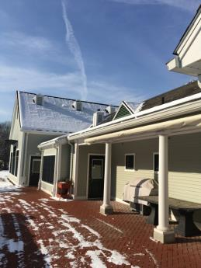

Fresh air gable vent

Picture 2
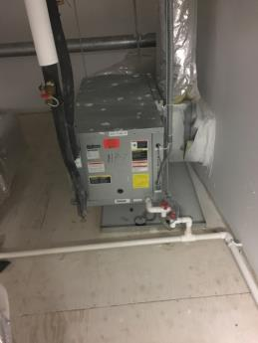

Air-handling unit (AHU)

Picture 3
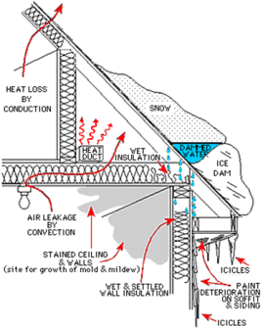
Cross section diagram of roof with an ice dam
(source: https://www.extension.umn.edu/environment/housing-technology/moisture-management/ice-dams/#what-is-an-ice-dam)

Picture 4
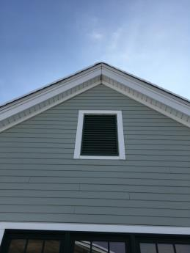

Gable vent

Picture 5

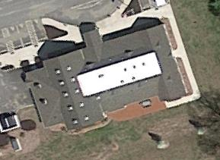
G
G
G
G

Roof of building showing approximate gable vent locations (“G”) which are at a 90° angle from roof center

Picture 6

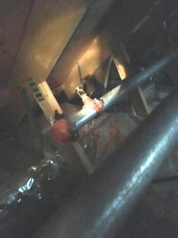

Sprinkler head and pipe inside of unheated attic space
Picture 7

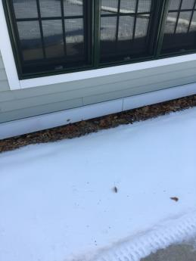

Mulch against exterior wall/slab junction

Location | Carbon  Dioxide  (ppm) | Carbon Monoxide  (ppm) | Temp  (°F) | Relative  Humidity  (%) | PM2.5  (µg/m³) | TVOCs  (ppm) | Occupants  in Room | Windows  Openable | Ventilation |  |  | Remarks
 |  |  |  |  |  |  |  |  | Intake | Exhaust
Background (outdoors) | 386 | 6 | 39 | 18 | 28
Living room | 674 | 3 | 77 | 15 | 3 | ND | 0 | Yes | Yes |  | Yes
Reception | 629 | 3 | 75 | 14 | 3 | ND | 1 | Yes | Yes |  | Yes
Director | 604 | 3 | 71 | 19 | 3 | ND | 1 | Yes | Yes |  | Yes
Arts room | 741 | 3 | 71 | 18 | 3 | ND | 2 | Yes | Yes |  | Yes
Arts storeroom | 690 | 3 | 71 | 18 | 3 | ND | 0 | No | Yes |  | No
Game room | 639 | 3 | 71 | 17 | 3 | ND | 0 | Yes | Yes |  | Yes
Storeroom | 607 | 3 | 71 | 17 | 3 | ND | 0 | No | Yes |  | Yes
Multipurpose room | 711 | 3 | 71 | 21 | 3 | ND | 7 | Yes | Yes |  | Yes
Kitchen | 780 | 3 | 72 | 21 | 3 | ND | 0 | No | Yes |  | Yes

Temperature inversion, a reversal of the normal behaviour of temperature in the troposphere (the region of the atmosphere nearest the Earth’s surface), in which a layer of cool air at the surface is overlain by a layer of warmer air (Encyclopædia Britannica, 2018).

