INDOOR AIR QUALITY ASSESSMENT

Erving Town Hall
12 East Main Street
Erving, MA

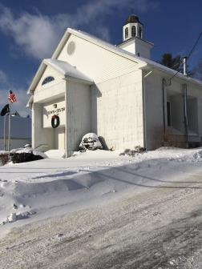

Prepared by:
Massachusetts Department of Public Health
Bureau of Environmental Health
Indoor Air Quality Program
February 2018

Background
Building: | Erving Town Hall (ETH)
Address: | 12 E. Main Street  Erving MA
Reason for Request: | General IAQ assessment
Date of Assessment: | January 5, 2018
Massachusetts Department of Public Health/Bureau of Environmental Health (MDPH/BEH) Staff Conducting Assessment: | Michael Feeney, Director, Indoor Air Quality (IAQ) Program
Building Description: | Originally constructed as a one-story school with a finished basement.
Building Population: | Approximately 8 employees
Windows: | Openable

Methods
Please refer to the IAQ Manual for methods, sampling procedures, and interpretation of results (MDPH, 2015).

IAQ Testing Results
The following is a summary of indoor air testing results (Table 1).
- Carbon dioxide levels were below 800 parts per million (ppm) in all occupied areas assessed, indicating adequate fresh air in the space.
- Temperature was mostly below the recommended range of 70°F to 78°F in occupied areas assessed.
- Relative humidity was below the recommended range of 40% to 60% in all occupied areas assessed.
- Carbon monoxide levels were non-detectable in all occupied areas assessed.
- Fine particulate matter (PM2.5) concentrations measured were below the National Ambient Air Quality Standard (NAAQS) level of 35 μg/m³ in all occupied areas assessed. Levels in the furnace room ranged above that level.
- Volatile Organic Compounds were non-detectable in all occupied areas assessed.

Ventilation
A heating, ventilating, and air conditioning (HVAC) system has several functions. First it provides heating and, if equipped, cooling. Second, it is a source of fresh air. Finally, an HVAC system will dilute and remove normally-occurring indoor environmental pollutants by not only introducing fresh air, but by filtering the airstream and ejecting stale air to the outdoors via exhaust ventilation. Even if an HVAC system is operating as designed, point sources of respiratory irritation may exist and cause symptoms in sensitive individuals. The following analysis examines and identifies components of the HVAC system and likely sources of respiratory irritant/allergen exposure due to water damage, aerosolized dust, and/or chemicals found in the indoor environment.
The assessment results indicate that the building is receiving adequate fresh air for the occupancy in the building. Note that many areas had low occupancy, which can reduce the creation of carbon dioxide. To maximize air exchange, the BEH recommends that a mechanical ventilation system operate continuously during periods of occupancy. Without the system operating as designed, normally occurring pollutants cannot be diluted or removed, allowing them to build up and lead to IAQ/comfort complaints.
The HVAC system in the ETH has no mechanical means to provide fresh air. Heat is provided by wall-mounted radiators (Picture 1). Various rooms within the ETH have supply and return vents that are connected to air handling units located at the rear of the building (Picture 2). Of note is the presence of an exhaust fan in the wall of the vault (Picture 3). It appears that this fan is drawing air from the vault and ejecting it into the hallway. In this configuration, any pollutants and/or odors in the vault is vented into the hallway.

Microbial/Moisture Concerns
A distinct musty odor was detected upon entering the vault. Water damage to walls, tiles and footings of shelves was noted inside the vault (Pictures 4 and 5). Adjacent bathrooms also show signs of repeated water penetration which is attributed to leaks through the foundation (Picture 6). As noted previously, it appears that the exhaust vent is venting the vault directly into the hallway. If materials become mold-colonized, the operation of this fan would serve to spread mold odors and associated pollutants into occupied spaces.
The lower levels had several walls which appeared to have a “ghosting” effect (Picture 1). The walls affected were primarily exterior walls located on the west side of the building. This ghosting effect is typically the result of either small particulate accumulation on surfaces of opposing electrical charge, or chronic moisture that may occur from inadequate insulation of the exterior/interior wall cavity. This accumulation can be cleaned to remove the streaking.
Chronic moisture may be the result of condensation on GW which is in contact with an unconditioned space such as the exterior wall via a thermally conducting material such as metal bracing or nails. There may be several factors contributing to the ghosting effect on lower level GW in the ETH. Before GW is installed, insulation and a vapor barrier are generally required to resist accumulated moisture and condensation due to water vapor from penetrating into the exterior walls. IAQ staff has observed many different buildings where the insulation and vapor barrier is either not present or not installed correctly. Of note was a condition found in the restroom in the northeast corner of the lower level. This wall had an inspection door open where the water service enters the building (Picture 7). And inspection hole was opened in the GW above the water meter to observe water pipes (Picture 8). On the day of inspection the outdoor temperature was 10°F. A significant draft of cold air was coming from the wall interior. On the day of assessment, the prevailing winds were from a westerly direction during the entire day (Weather Underground, 2018). The prevailing winds were on the opposite side of the building from where the water service enters the building. Based on this observation, it would appear that wind-driven air enters and can readily pass to the opposite side of the building, which indicates that there is little if any insulation inside the wall cavity. This condition cannot be verified without opening up walls to inspect for proper vapor barrier installation but may be a contributing factor.
If chronic moisture is suspected, the wall cavities should be inspected more thoroughly during unoccupied hours to ensure that hidden mold is not present. Mold-colonized materials cannot be cleaned and will need to be remediated in a manner consistent with recommendations found in the US EPA document, “Mold Remediation in Schools and Commercial Buildings” (USEPA, 2008).
A lower area has wall-to-wall carpeting (Picture 9). It is likely that the lower level was constructed to have tile floors that do not have slab insulation or vapor barriers. This type of floor can be prone to generating condensation in hot, humid weather, since the slab would have a temperature that is below the dew point. If the floors are covered with carpeting, condensation can moisten it and lead to mold colonization. It is not recommended to use wall-to-wall carpeting in below-grade areas, particularly on floors that are on slab in contact with soil/sand.
The US Environmental Protection Agency (US EPA) and the American Conference of Governmental Industrial Hygienists (ACGIH) recommends that porous materials (e.g., wallboard, carpeting, ceiling tiles) be dried with fans and heating within 24 to 48 hours of becoming wet (US EPA, 2008; ACGIH, 1989). If porous materials are not dried within this time frame, mold growth may occur. Once mold has colonized porous materials, they are difficult to clean and should be removed. Under these conditions, it is very likely that carpeting throughout the building is water-damaged/mold-colonized, resulting in the odors detected.

Conclusions/Recommendations
Based on the observations made during this assessment, the BEH makes the following recommendations:
- Examine the feasibility of venting the vault to the outdoors.
- Consideration should be given to removing the wall-to-wall carpet in the lower level. Use a floor covering that is non porous.
- Examine the foundation and exterior wall for openings around utility services and seal any found with a fire-rated sealant.
- The wall cavity of the GW with ghosting on the lower level should be examined for water damage. Consider consulting with a building engineer for options to improve insulation inside the wall cavity.
- The source that is causing the water penetration in the restrooms/vault needs to be identified and remediated to prevent further damage to town records. If the source of water cannot be remedied, consideration should be given to storing the town records at an alternative location.
- Refer to resource manual and other related IAQ documents located on the MDPH’s website for further building-wide evaluations and advice on maintaining public buildings. These documents are available at: http://mass.gov/dph/iaq.

References
ACGIH. 1989. Guidelines for the Assessment of Bioaerosols in the Indoor Environment. American Conference of Governmental Industrial Hygienists, Cincinnati, OH.
MDPH. 2015. Massachusetts Department of Public Health. Indoor Air Quality Manual: Chapters I-III. Available at: http://www.mass.gov/eohhs/gov/departments/dph/programs/environmental-health/exposure-topics/iaq/iaq-manual/.
US EPA. 2008. “Mold Remediation in Schools and Commercial Buildings”. Office of Air and Radiation, Indoor Environments Division, Washington, DC. EPA 402-K-01-001. September 2008. Available at: http://www.epa.gov/mold/mold-remediation-schools-and-commercial-buildings-guide.
Weather Underground, The. 2018. Weather History for Orange, Massachusetts, January 5, 2018. Available at: https://www.wunderground.com/history/airport/KORE/2018/1/5/DailyHistory.html?req_city=&req_state=&req_statename=&reqdb.zip=&reqdb.magic=&reqdb.wmo=

Picture 1
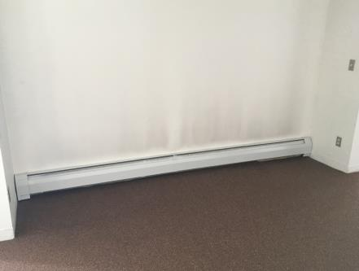
Wall-mounted radiators
Note stain on wall above radiator, called “ghosting”

Picture 2

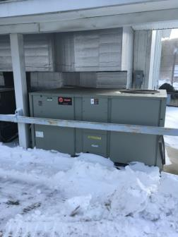

Air conditioning system

Picture 3

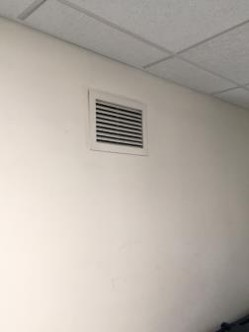

Vault exhaust fan

Picture 4

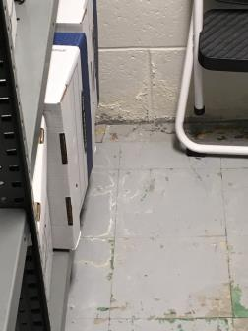

Water-damaged wall and floor tile in vault

Picture 5

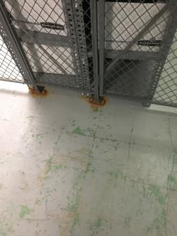

Corroded security barrier footings in vault

Picture 6

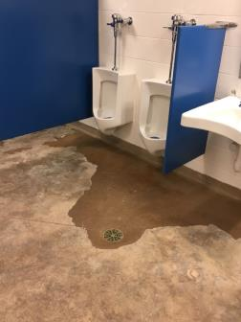

Water-damaged floor in restroom

Picture 7

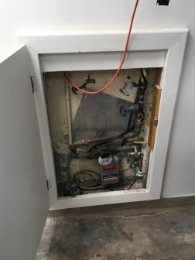

Access door for water service in restroom

Picture 8

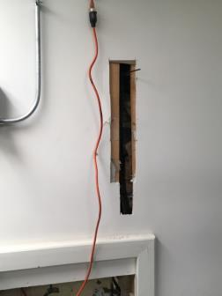

Hole in wall exposing pipe above water service access door

Picture 9

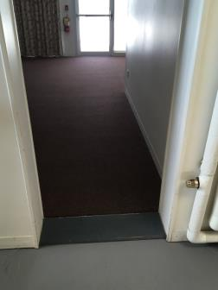

Wall-to-wall carpeting in the lower level

Location | Carbon  Dioxide  (ppm) | Carbon Monoxide  (ppm) | Temp  (°F) | Relative  Humidity  (%) | PM2.5  (µg/m³) | TVOCs  (ppm) | Occupants  in Room | Windows  Openable | Ventilation |  |  | Remarks
 |  |  |  |  |  |  |  |  | Intake | Exhaust
Background (outdoors) | 358 | ND | 10 | 15 | 4 | ND
Select board | 491 | ND | 70 | 9 | 2 | ND | 2 | Y | Y |  | Y
Hallway and elevator | 475 | ND | 69 | 9 | 2 | ND | 0 | N | Y |  | Y
Upper hallway | 458 | ND | 68 | 8 | 2 | ND | 0 | N | Y |  | Y
Town clerk | 532 | ND | 68 | 9 | 2 | ND | 1 | Y | Y |  | Y
Emergency management | 437 | ND | 64 | 8 | 2 | ND | 0 | N | Y |  | Y | Musty odor
Lower level meeting room | 421 | ND | 64 | 8 | 2 | ND | 0 | N | Y |  | Y | Musty odor  Ghosting on walls

