The Commonwealth of Massachusetts
Executive Office of Health and Human Services
Department of Public Health
250 Washington Street, Boston, MA 02108-4619

November 15, 2023

Maura Healey
Governor
Massachusetts State House
24 Beacon St.
Boston, MA 02133

Kim Driscoll
Lieutenant Governor
Massachusetts State House
24 Beacon St.
Boston, MA 02133

Dear Governor Maura Healey,

On September 22, 2023, you instructed Health and Human Services (HHS) Secretary Kate Walsh, Undersecretary for Health Dr. Kiame Mahaniah and Department of Public Health (DPH) Commissioner Dr. Robert Goldstein to conduct a review of access to essential health services in the North Worcester County Area and develop a plan to support or improve access where needed.

In response, please find enclosed a report from the Department of Public Health entitled “North Worcester County Area Essential Services Review, 2023.”

Sincerely,

Robert Goldstein, MD, PhD
Commissioner
Department of Public Health
Governor’s Mandate
The following report is hereby issued pursuant to Governor Maura Healey’s order issued on September 22, 2023, as follows:

Conduct a review of access to all essential health services in the North Worcester County Area and develop a plan to support or improve access where needed. This will include a review of hospital services, community-based care, and social supports. It will also include consultation and collaboration with providers and community leaders in the area to ensure that access to critical services is protected following the closure of the Leominster inpatient maternity unit.

Executive Summary

At the direction of Governor Healey, the Department of Public Health (DPH) has completed a review and assessment of available health care services in the North Worcester County Area. Geographically, the North Worcester County Area has hospitals, pharmacies, end stage renal disease facilities, substance use disorder services, and community health centers, but the region lacks services outside of the MA-2 corridor. As part of its effort to more completely capture accessibility of health services, DPH and the Executive Office of Health and Human Services (EOHHS) hosted listening sessions in the region and heard frustration and concern from community members about the barriers they faced accessing services. Several community members expressed concern about the lack of mental health and substance use disorder services in the North Worcester County Area. Community members emotionally shared the increase in prevalence of mental health conditions like depression in the past few years and the difficulty they have experienced trying to access treatment for themselves and their loved ones as the availability of providers and their service capacity has not grown to meet the demand. Transportation concerns were highlighted with specific examples provided. These included cases where the lack of transportation options for getting to and from health care facilities resulted in reliance upon calling 911 for non-emergent transports to health care facilities, which community members felt was the only reliable option for them to avoid entirely deferring care. With the closure of health care services in the North Worcester County Area, community members expressed concerns about the need for ambulance services to travel farther to hospitals which results in fewer ambulances and EMS personnel being available to provide necessary emergency patient care and transport. Finally, commenters expressed anger and concern that DPH did not have the authority to prevent a closure of services and requested additional power for DPH to do so.

Based on this review, DPH recommends:

- Hospitals and other healthcare providers in the region, along with EOHHS, should consistently convene a region-based approach to delivering essential services including prenatal care, primary care, mental health care, and substance use disorder care.
- EOHHS should continue to engage UMass Memorial Health Care, the system anchored by the only regional Academic Medical Center, on ways to increase their presence in communities across the region.
- The Secretary of the Massachusetts Department of Transportation and the Commissioner of Public Health should convene a stakeholder taskforce to identify resources needed to implement Goal 3 of the Montachusett Regional Planning Commission’s Pathway to 2050 (to promote and seek equitable transport for all) so residents can safely and efficiently travel to health care provider appointments.
- Increase community-based management of persons with chronic conditions by funding inclusive home health programs for the elderly and mobile integrated health (MIH) start-up and operational costs.
- Stabilize equitable care across the birthing continuum, through implementation of recommendations from the Review of Maternal Health Services, 2023 Report.
- Review essential service closure process and update statutes and regulations to better protect patient safety, expand community information and engagement, and sustain access to services overtime.
- Create pathways for providers to recruit, retain, and support staff working in currently licensed adult and pediatric mental health inpatient beds and consider transitioning a portion of the currently licensed geriatric psychiatric beds to adult psychiatric beds.
- Support clinical staffing recruitment and retention in the region by expanding financial incentives to health care staff and by addressing poor access to affordable housing and childcare in the region.
- Require urgent care centers to accept all insurance products.
- Promote increased use of telehealth, home-based care, and mobile care in the region.

Methodology

This report profiles the health care services and gaps in access in the North Worcester County Area based upon information gathered by the Department from the Essential Services closure process of the maternal newborn unit at HealthAlliance Clinton, Leominster Campus and the pediatric unit at Heywood Hospital; from available data sources; and from in-person listening sessions held in October 2023 in three communities across the North Worcester County Area including Athol (N=12), Fitchburg (N=17) and Leominster (N=35).

“Essential Services” are defined in 105 CMR 130 (Hospital Licensure) as ambulatory care services, birth center services, burn units, cardiac surgery, continuing care nursery services, coronary care units, dialysis services, emergency services, intensive care units, maternal and newborn services, medical/surgical services, neonatal intensive care units, pediatric intensive care units, pediatric services, psychiatric services, rehabilitation services, satellite emergency facilities, special care nursery services, and substance use disorder services. However, this definition only applies in the hospital setting and is not inclusive of community-based health services that may be “essential” to communities. As such, this report will review the broader available health care system capacity including primary care, community health centers, community behavioral health centers, pharmacies, end stage renal dialysis facilities, substance use disorder services, urgent care, emergency medical services, hospital services, and long-term care services.

This report incorporates many data sources available to the Department of Public Health (DPH) including:
- Census data
- Shortage Designation Management System
- Community Health Center Providers
- Board of Registration of Pharmacies
- Bureau of Substance Addiction Services (BSAS) Licensed Substance Use Disorder Providers
- Syndromic Surveillance (SyS) data
- Massachusetts Ambulance Trip Record Information System
- Hospital Inpatient, Observation, and Emergency Discharge data from the Centers for Health Information and Analysis (CHIA)
- Staffing and occupancy as reported to the DPH’s WebEOC
- Licensure data from the Division of Health Care Facility Licensure and Certification
- Centers for Medicare and Medicaid Services (CMS) Nursing Home Compare
- DPH Nursing Home Survey Performance Tool

Introduction

In May 2023, UMass Memorial’s HealthAlliance Clinton at Leominster campus submitted its intent to close its maternal newborn inpatient services. The announcement and subsequent closure prompted significant community concern about access to health care in the North Worcester County Area. This service closure was followed by the Heywood Hospital announcement that they would be ending their licensed pediatric inpatient service. While the hospital had not cared for any admitted pediatric patients since before the COVID-19 pandemic, the formal closure of this unit was still a concern to the community. This prompted Governor Healey to direct the Executive Office of Health and Human Services (EOHHS), the Secretariat comprised of 11 agencies and the MassHealth program that is responsible for promoting the health of Massachusetts residents, and Department of Public Health (DPH), the agency that promotes wellness and equity and oversees a wide range of professions and services related to health care, to conduct a review of essential health services in the North Worcester County Area to ensure that Massachusetts residents, particularly in rural and underserved communities, have access to high-quality health care and to understand barriers in accessing services in the region. Additionally, on October 2, 2023, Heywood Healthcare Inc. filed for Chapter 11 bankruptcy. As the region’s key hospitals respond to continued financial pressure and changes in service utilization, this review of essential services in the area is timely and important.

At the outset, and as described more fully below, it is important to note that most of the communities in North Worcester County are rural, and rural communities face particular challenges in obtaining and maintaining access to health care services. Across the United States, small community hospitals have been struggling to remain financially viable for decades, particularly in rural areas. Between January 2010 and October 2023, 150 rural hospitals have closed or converted (i.e. no longer provide inpatient care), including one in Massachusetts (North Adams Regional Hospital). In a nationwide analysis of rural hospitals, Kaiser Family Foundation (KFF; an independent source for health policy research, polling, and journalism) found that 41% of rural hospitals had negative operating margins in 2019. Federal COVID-19 relief funds bolstered these facilities through the pandemic, but they now face significant staffing shortages, increased supply costs, and other financial demands. Researchers have also found that when hospitals in rural areas close, physicians and surgeons leave those communities – leading up to, during, and for years after the closure. State and federal support of many kinds – including transportation, affordable housing, childcare, and economic development – is needed to stabilize health care access as part of community life in vulnerable rural areas.

This report presents a profile of North Worcester County and each major type of health care provider active in the region, along with successes and challenges of each provider type. It summarizes themes from the community listening sessions before presenting findings, conclusions, and recommendations. EOHHS and DPH look forward to working with health care providers, community members, and other government leaders to act on recommendations as quickly as possible.

The North Worcester County Area

For this report, DPH defined the North Worcester County Area as comprising Community Health Network Area 9 and four additional communities, which makes up a total of 31 municipalities in Worcester, Middlesex, and Franklin counties: Ashburnham, Ashby, Athol, Ayer, Barre, Berlin, Bolton, Clinton, Fitchburg, Gardner, Groton, Hardwick, Harvard, Hubbardston, Lancaster, Leominster, Lunenburg, New Braintree, Oakham, Orange, Pepperell, Phillipston, Princeton, Royalston, Rutland, Shirley, Sterling, Templeton, Townsend, Westminster, Winchendon (see Appendix). The majority of these municipalities (81% or 25/31) have been designated as rural level 1 or 2 by DPH’s Office of Rural Health (Table 2).

The North Worcester County Area had a shared population of about 144,579 individuals in calendar year 2022 (Table 3), accounting for 2.1% of the total population in Massachusetts. There are an estimated 58,804 households, with an average household size of 2.4 and an average family size of 3.1. Of these households, 28% have at least one child under age 18 and 29% have at least one person aged 65 and over. Ninety percent of individuals in this area aged 25 and older received a high school degree or higher, and 27% received a bachelor degree or higher. About 14% of the population not living in an institutional setting have one or more disabilities. Eighty-nine percent of the total population are native-born citizens and 6% are naturalized citizens. As compared to the Massachusetts population, more households have at least one child under age 18 and native-born citizens while fewer households have one person aged 65 years and over and residents aged 25 and older that have received a bachelor degree in the North Worcester County Area.

The population in the North Worcester County Area has grown in the last 10 years, particularly in the age groups under 50 years old. This influx has also brought more diverse residents. In 2010, 86% of residents were white, non-Hispanic and by 2020, 78% of residents were white, non-Hispanic. This change was driven particularly by an increase among people identifying as Multi-Race – (482% increase, from 4,500 to 26k) as shown in Figure 1.
Figure 1. North Worcester County Area population by race 2010 and 2020

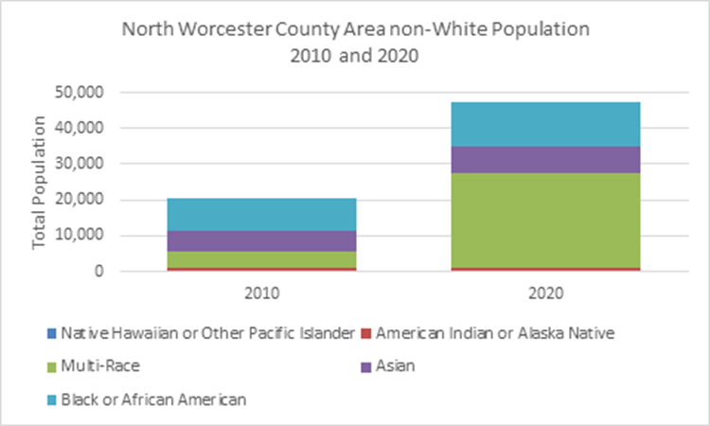

The North Worcester County Area was historically known as an industrial region that had paper, machinery, clothing, and furniture mills. Since the 1960s, these industries have relocated and left the region. As a result, the number of persons living at or below the poverty level is higher than the Massachusetts average. As an example, in 2022 14.6% of Fitchburg residents and 14.1% of Gardner residents live at or below the federal poverty level as compared to only 10.4% statewide.

Provider Types in North Worcester County

Providing healthcare in the North Worcester County Area are 695 primary care physicians, six community health center sites, 38 retail pharmacies, two End Stage Renal Dialysis Facilities, 39 BSAS-licensed SUD services and one additional office-based addiction treatment provider, three urgent care centers, 79 ambulance services, five acute care hospitals, and 16 long-term care facilities. This report will describe these services in detail.

Primary Care

DPH’s Primary Care Office utilizes the Shortage Designation Management System (SDMS) to manage health workforce data and to apply for Health Professional Shortage Areas (HPSAs) and Medically Underserved Areas/Populations (MUA/Ps). In order to qualify as an HPSA the region’s overall primary care providers need to provide care to 3,500 or more patients per provider. There are no primary care practices operating in 7 of the 31 communities (23%): Hardwick, Hubbardston, New Braintree, Oakham, Royalston, Rutland, and Templeton.

Figure 2: Primary Care Provider Locations in North Worcester County Area and Patients per Provider by Community
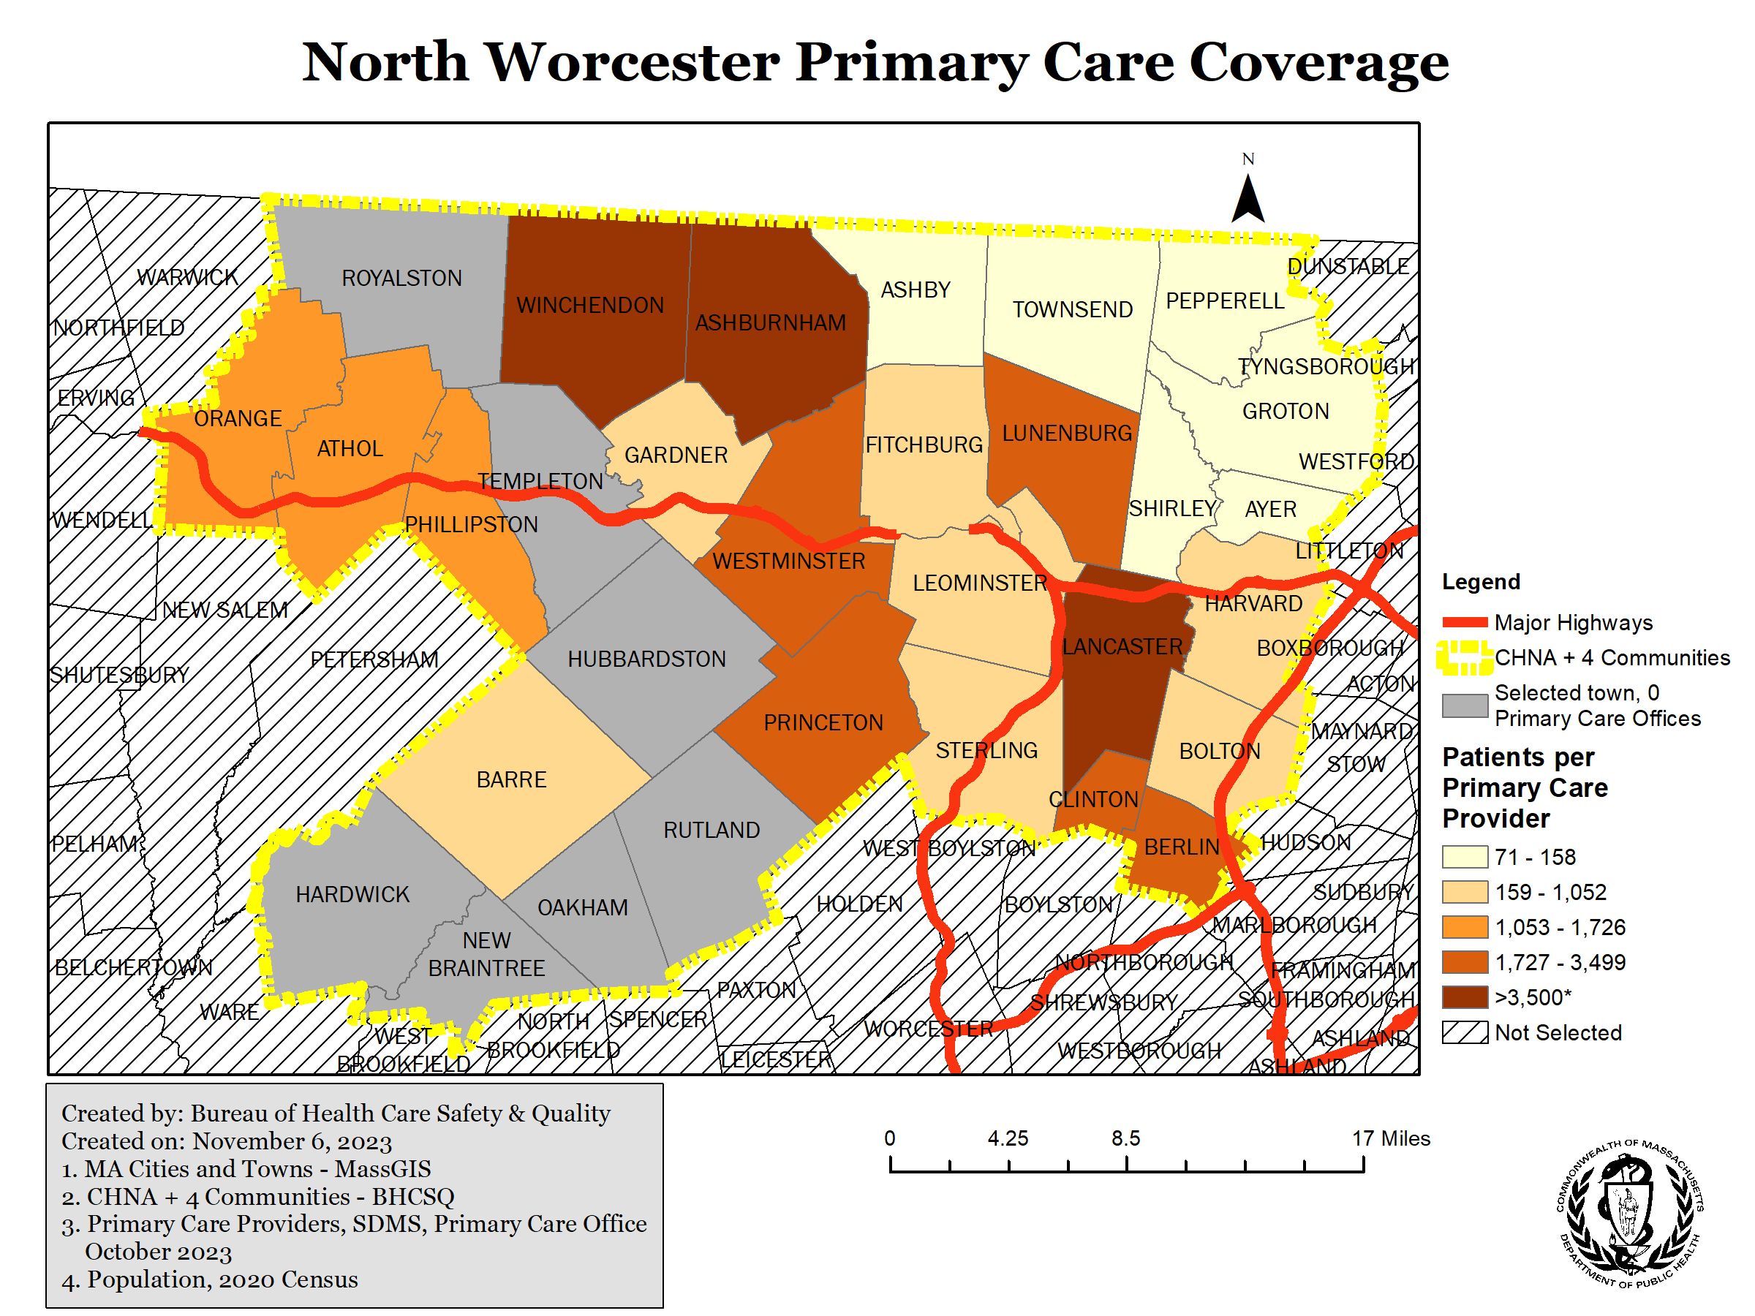

University of Massachusetts Memorial Medical Center supports a family medicine residency in Fitchburg where physicians in training learn how to provide primary care.

Successes:
The North Worcester County Area includes several geographic and facility-based HPSAs, as determined by HRSA. As designated HPSAs, facilities have additional recruitment and reimbursement options including the National Health Service Corps, the Nurse Corps Scholarship, the Nurse Corps Loan Repayment program, and CMS Bonus payments. Participants from HPSAs are also given preference is several HRSA Bureau of Health Professions Title VII and VIII Training Grants. Additionally, federal law provides DPH with the authority to assist facilities within HPSAs and MUA/Ps with physician recruitment by supporting a waiver request for physicians with a J-1 visa. These federal initiatives provide crucial supports in this area and other areas across Massachusetts. Additionally, Massachusetts has its own Loan Repayment Program for Health Professionals – Component A is applicable to providers within HPSAs.

Challenges:
Even with these incentives in place, just less than a quarter of communities in this region do not have a primary care office within them. Additionally, existing primary care offices face long wait times for new and existing appointments due to low staffing caused by difficulties with recruitment and retention in more rural areas. Three communities have patient-to-provider ratios above the qualifying threshold for an HPSA (3,500 patients: 1 provider): Ashburnham (3,950:1), Lancaster (4,200:1), and Winchendon (4,900:1). The next system refresh is scheduled for 2024, and DPH’s Primary Care Office is working closely with care providers and communities to ensure that data in the SDMS are up to date to allow for appropriate HPSA classification.

Community Health Centers

The community health centers in the North Worcester County Area are mostly concentrated in the larger cities and towns: Fitchburg, Gardner, and Leominster, with one in Orange.

Community Health Connections (CHC) has five health center sites in three towns as well as mobile services:
- ACTION Community Health Center
130 Water Street, Fitchburg, MA
- Fitchburg Community Health Center
326 Nichols Road, Fitchburg, MA
- Greater Gardner Community Health Center
175 Connors Street, Gardner, MA
- Leominster Community Health & Urgent Care Center
165 Mill Street, Leominster, MA
- South Gardner Community Health & Urgent Care Center
529 Timpany Boulevard, Gardner, MA

CHC offers walk-in and scheduled urgent care services at its Leominster and South Gardner sites. CHC has a number of specialty services to meet the needs of the community, including:
- Infectious Disease treatment services for Hepatitis B, Hepatitis C, and HIV positive patients,
- Mobile dental program called Caring for Kids which provides dental services at local schools,
- Migrant Worker Health Program which provides medical, dental and behavioral health services at local farms,
- Health services for Fitchburg State University,
- Spravato® (Esketamine) clinic for patients experiencing treatment-resistant depression, and
- Dedicated COVID-19 Vaccination Team that coordinates community vaccination clinics throughout the service area.

In October 2023, CHC launched its Children’s Behavioral Health program for patients aged 5-20, offering individual and group therapy (with psychological services), psychiatry, play therapy, expressive therapy, and therapeutic mentoring. CHC reported that by the end of October over 200 children are being served by this program.

In 2022, CHC served 28,426 patients through 119,504 in-person and telehealth visits. During 2022, CHC served 17,562 medical patients, 13,199 dental patients, 2,424 behavioral health patients, 312 substance use disorder patients, and 2,724 vision patients. In 2022, CHC served 3,873 patients diagnosed with hypertension, 1,973 patients with diabetes, 894 patients with asthma, 80 patients with HIV, and 156 prenatal care patients. CHC facilitates care for prenatal patients at Heywood Hospital in lieu of providing these services onsite.

CHC reports that 7,100 (25.0%) of their patients qualified for Public Housing Primary Care (PHPC), 3,128 (11.0%) qualified for Health Care for the Homeless (HCH), and 11,843 (41.7%) reported income at or below 100% of the Federal Poverty Guideline. In 2022, 4,750 of CHC’s patients (16.7%) identified their preferred language for care and communications as Spanish, and 1,641 (5.7%) as Brazilian Portuguese. These two communities have increased by over 400 patients each within the past year. Overall, 6,772 (23.8%) of CHC’s patients self-identify as being best served in a language other than English.

Community Health Center of Franklin County has two sites-one in Greenfield and one in Orange. In calendar year 2022 Community Health Center of Franklin County saw 7,912 individual patients across all sites:
- Total Medical Care services: 17,910 in-person visits, 2,854 virtual visits for 5,739 patients
- Total Dental services: 9,920 visits (only 13 were virtual) for 3,096 patients
- Mental Health services: 1,030 in-person visits, 1,089 virtual visits for 349 patients.
- Diabetes education: 322 in-person, 90 virtual for 141 patients

Community Behavioral Health Centers

Community Behavioral Health Centers (CBHCs) are licensed clinics that are state-designated to be one-stop shops for a wide range of mental health and substance use services and treatment. Clinical and Support Options Inc. (CSO) and Community Health Link (CHL) serve as the CBHCs for the North Worcester County Area. CSO operates CBHC sites in Athol and Gardner that provide open access, including walk-ins, to outpatient, urgent, and emergency behavioral health care. CHL operates a CBHC site in Leominster. In October 2023, CSO reported 33 new clinic encounters in Athol and 33 new clinic encounters in Gardner and CHL reported 32 new patient clinic encounters in Leominster. For mobile crisis interventions in October these providers reported 5 in Athol, 26 in Gardner and 106 in Leominster.

At all three of the listening sessions, access to mental health was repeatedly raised as a strong concern by attendees. Community members emotionally shared the increase in prevalence of mental health conditions like depression in the past few years and the barriers they have experienced trying to access treatment for themselves and their loved ones as the availability of providers and services has not grown to meet the demand.

Successes:
EOHHS has demonstrated strong commitment to supporting Community Health Centers through multiple recent initiatives. In 2022, MassHealth increased Community Health Center rates by ~$120 million per year. EOHHS has also made significant workforce investments for providers practicing in CHCs and other community-based settings, including over $40 million in awards in 2023, and over $50 million more between 2023 and 2027. In 2023, MassHealth launched a new, flexible funding model to pay primary care providers called “primary care sub-capitation,” increasing investment for primary care providers by ~$115 million annually and further enabling team-based care models to increase behavioral health services in the primary care setting and reduce provider burnout.

Challenges:
The Massachusetts League of Community Health Centers found that new patients are waiting nearly 80 days to see a primary care provider at their member sites. Community health centers report experiencing an ongoing shortage of primary care physicians and difficulty recruiting and retaining workers from other higher-paying providers. Industry leaders appealed to the Legislature in June 2023 for an infusion of funding to support staff recruitment and retention, capital funding, and training pipeline programs.
Pharmacies

There are 38 retail pharmacies located in the North Worcester County Area, 31 of which are chains such as CVS, Walgreens, or co-located within a grocery store. Seven pharmacies are independent pharmacies. Eighteen of the selected 31 towns and cities have no retail pharmacies in the city or town. Rite Aid, CVS, and Walgreens have signaled the upcoming closure of over 1,500 stores across the U.S. amid rapidly changing financial performance in the sector following COVID-19 spending, growing competition from retail giants and online sales, and staffing shortages.

Figure 3. Map of North Worcester County Area Pharmacies
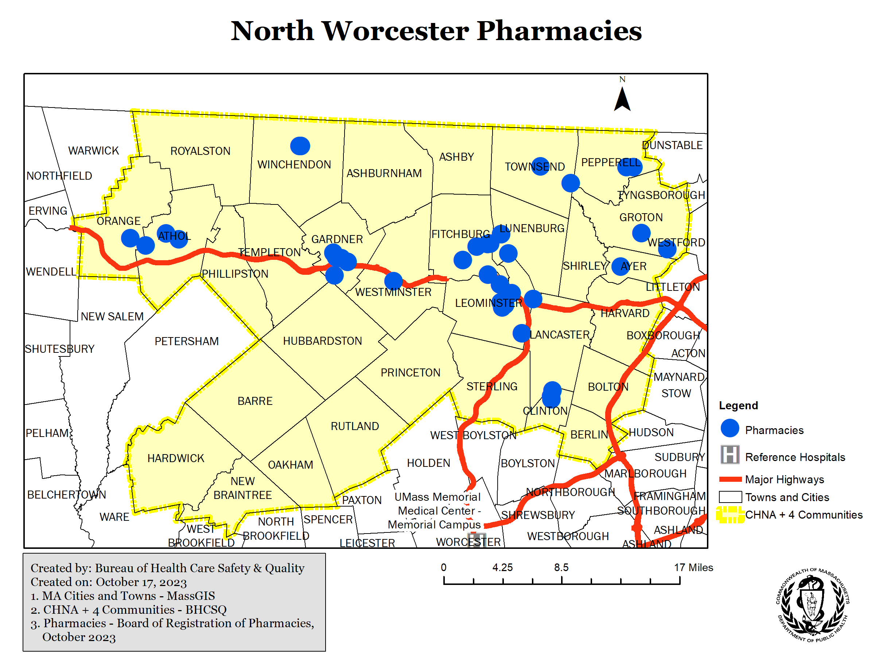

End Stage Renal Dialysis Facilities (ESRDFs)

There are two ESRDFs in the region: Leominster Dialysis LLC, which has 12 stations, and Physicians Dialysis in Fitchburg, which has 18 stations. Both ESRDFs have received four out of five stars as both an overall and quality rating from CMS. The Fitchburg ESRDF can accommodate patients who want treatment after five o’clock in the evening. At the Leominster ESRDF, 21% of adult patients had a catheter (tube) left in a vein for at least 3 consecutive complete months, for their regular hemodialysis treatments while at the Fitchburg ESRDF it was 15%; the state average is 18% of patients.

Successes:
Dialysis care in this region receives high quality ratings from CMS.

Challenges:
The two ESRFs are located in the two largest communities in the North Worcester County Area and so patients living outside of Fitchburg and Leominster must travel up to thirty minutes each way three times per week to reach these sites.

Substance Use Disorder Services

There are 39 Bureau of Substance Addiction Services (BSAS) licensed substance use disorder (SUD) services in the North Worcester County Area. There are 6 adult residential programs, 1 family residential program, and 3 acute services providers, which comprise a total of 302 treatment beds. Additionally, there are 22 outpatient services, 3 services associated with correctional facilities, and 4 Opioid Treatment Programs (OTPs). There is one office-based addiction treatment (OBAT) provider located in Barre. Additionally, in this area there are treatment clusters (Leominster, Fitchburg, Gardner), but there are also great distances between SUD services with no public transportation. Seventeen of the selected towns have no SUD services.

Figure 4. Map of North Worcester County Area Substance Use Disorder Services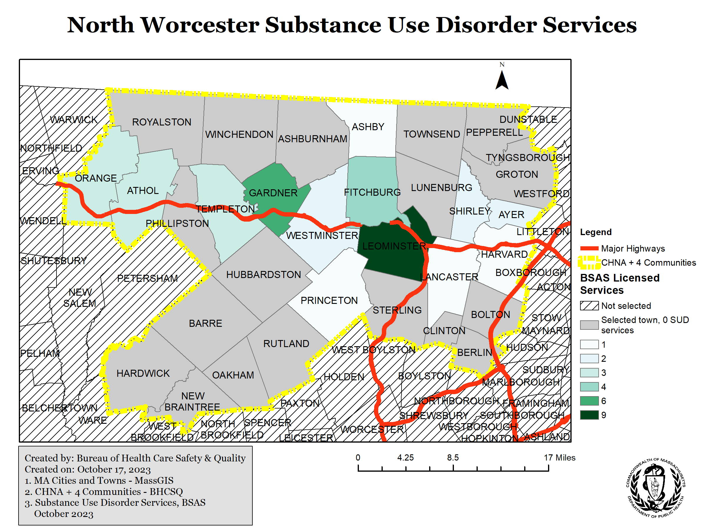

Successes:
BSAS has successfully expanded SUD treatment into the houses of correction within the North Worcester County Area – expanding access to care for a particularly vulnerable population.

Challenges:
While there are a wide range of substance use disorder services in the North Worcester County Area, most towns do not have a program and so patients need to travel to access services.

Urgent Care

DPH monitors urgent care utilization using Syndromic Surveillance (SyS) data. When residents from the North Worcester County Area communities use urgent care facilities, they tend to go to HealthAlliance Leominster Urgent Care (35% of visits captured in SyS Data), Heywood Urgent Care (32%), and Heywood Tully Walk-In Care Center in Athol (25%). Otherwise, residents seek care in nearby communities including Westford, Greenfield, and Amherst. Since the DPH SyS dataset does not capture all visits that occur at urgent care locations in Massachusetts, this is not a complete list of the places the North Worcester County Area community residents seek care, but does indicate where urgent care services are concentrated for these patients,

- HealthAlliance Leominster Urgent Care had, from January 1 to September 30, 2023, 12,256 total visits: 9,350 adult visits and 2,906 pediatric visits. About 1/5 of these visits were for broad acute respiratory concerns.

- Heywood Urgent Care had 11,233 total visits: 8,044 adult and 3,189 pediatric visits. Broad acute respiratory complaints were the most common condition, but only comprised about 5% of these visits.

- Heywood Tully Walk-In Care Center had 8,524 total visits: 6,060 adult and 2,464 pediatric visits. Similar to Heywood Urgent Care, broad acute respiratory complaints were the most common condition that DPH investigated, but only comprised about 5% of visits overall.

DPH does not currently have data on urgent care services in the city of Worcester to be able to compare the reasons for visits across the county.

Successes:
Urgent care provides vital access to timely care that does not warrant an emergency department visit and cannot be addressed through the overburdened primary care system. Both Heywood and HealthAlliance have associated urgent care centers which help reduce the burden of unnecessary emergency department visits.

Challenges:
Currently, under state law not all urgent care centers are subject to DPH licensure so there is a lack of oversight including quality metrics, volume monitoring, and assessments of access to care. Urgent care centers that are outside of licensure requirements may not accept all health insurances and so are not an affordable option for all persons residing in the community. The data collected in SyS gives us some insight into the role of urgent care centers in the broader health care system, but there are still significant gaps in data. Consistent oversight mechanisms and data collection would be an advantage of a uniform urgent care licensure requirement, which is not currently required by statute.

Emergency Medical Services

The North Worcester County Area was served by a total of 79 ambulance services, comprised of municipal and private ambulance services, for emergency calls where a patient was transported between January 1 and September 30, 2023. Depending primarily on population size, towns in the region had anywhere from 5 to 18 individual ambulance services respond to and transport patients for emergency calls. The service responding to a call is determined by multiple factors, including the town’s Service Zone Plan (which is approved by DPH), ambulance service licensure, mutual aid back-up agreements, and accordance with the EMS Statewide Treatment Protocols. Due to the unpredictable nature of call volumes, ambulance services may respond to neighboring communities as a mutual aid response even if the location is outside of their regular service area.

Between January 1 and September 30, 2023, nearly 75% of emergency runs in the North Worcester County Area were conducted by municipal ambulance services. This varies from the rest of Massachusetts, where municipal EMS services accounted for about 55% of all emergency runs. The high volume of emergency runs conducted by the Leominster Fire Department, which upgraded its ambulance license from the Basic level to the Paramedic level in 2022, may account for some of the proportional difference in municipal and private ambulance service volume between the North Worcester County Area and the rest of the state.

More than 85% of all emergency runs are transported to the five local hospitals, with more than a third of patients transported to HealthAlliance Leominster. This finding was consistent for runs involving suspected cardiac arrest or stroke, where seconds are essential. Destination choice is determined largely by the EMS Statewide Treatment Protocols as well as a patient’s clinical presentation and condition. In all cases, less than 15% of emergency runs went to destinations other than the North Worcester County Area hospitals underscoring that these five hospitals are crucial as emergency destinations for the area (approximately 1% went to UMass Memorial Campus, 1% went to Emerson, and 13% went to another destination).

Median response and transport times for the North Worcester County Area are consistent with the rest of the state during the time period examined. The median response time for the North Worcester County Area was 5 minutes (IQR 5 mins.), while the median for the rest of the state was 6 minutes (IQR 4 mins.).

The median transport time was 9 minutes for both the North Worcester County Area and the rest of the state (IQRs 9 and 8 minutes, respectively). Some towns in the North Worcester County Area had substantially greater transport times (e.g. New Braintree, Barre, Hardwick, and Oakham), which seems generally consistent with the town’s distance to the five core hospitals in the area. See the map below for median transport times by town.

At the Leominster listening session one community member raised concerns that residents without access to transportation are calling “911” for transports to the hospital because it is their only means to get there and it unnecessarily taxes the health care system. Another community member verbalized concerns that when patients are transported to UMass Memorial Medical Center in Worcester, an ambulance is not able to respond to emergencies in its home community for several hours and so it leaves residents at risk for worse outcomes.

Figure 5. Map of North Worcester County Area EMS Transport Times
Successes:
Overall, the North Worcester County communities appear to have sufficient ambulance coverage. The median transport time for the region is consistent with the rest of the state, and the median response time is slightly faster. All of the acute care hospitals in the region have emergency departments and are able to receive patients via ambulance; these hospitals receive more than 85% of the emergency run volume originating in cities in the North Worcester County Area.

Challenges:
Although transport times for the overall region are consistent with the rest of the state, communities farthest away from the hospitals along the Route 2 corridor (e.g., New Braintree, Hardwick, Barre, Oakham) have substantially greater transport times than communities closer to Route 2.

Currently, there is also a lack of mobile integrated health services (MIH) in the North Worcester County area. Expanding MIH services in the region, in which EMS services in collaboration with hospital or other clinical providers manage patient care in the home, could help avoid unnecessary hospitalizations and emergency department trips via ambulance by helping specific patient populations manage complex and/or chronic conditions in their homes. In an academic study of an MIH program in Massachusetts, surveyed patients reported perceived higher-quality care via MIH compared to traditional ED settings, with 9 out of 10 patients treated by MIH providers reporting excellent or very good quality.

UMass Memorial currently operates an MIH program based in Worcester, which provides
in-home care with clinical oversight and telehealth visits along with coordination of any further services such as vital sign measurement, assessment, IVs, and diagnostic tests. The program also assesses high risk or high needs patients seeking care, through partnerships with Worcester EMS, UMass ACO, Worcester Internal Medicine Geriatrics, and UMass Hospital at Home.

Hospital Data

There are five acute care hospitals within the North Worcester County Area (from West to East): Athol Memorial Hospital, Heywood Hospital, HealthAlliance – Leominster, HealthAlliance – Clinton, and Nashoba Valley Medical Center. These hospitals provide critical care to their surrounding communities, accounting for a total of 41,654 inpatient visits, 871 live births, 139,051 ED visits, and 7,082 observation stays on average per year from federal fiscal years 2018-2022. Overall, this region’s hospital licenses include 27 intensive care unit (ICU) beds (14.9 beds per 100,000 population), 11 maternal beds, 248 med/surg beds, 5 pediatric beds, and 72 psychiatric beds – including 60 geriatric psych beds co-licensed by DMH (Table 16). Hospitals in the region are licensed to provide ambulatory care, urgent care, emergency services, hospice services, medical control, maternal/newborn services, and primary stroke services. Residents of this area need to seek care at other hospitals for more complex needs such as: neonatal intensive care units (NICU), pediatric intensive care units (PICU), special care nursery, hospital-based dialysis, and certified trauma centers. This section of the report will describe each hospital individually, and then provide conclusions and recommendations for the region to ensure appropriate access to high-quality and comprehensive health care services across the region.

Athol Memorial Hospital is owned by Heywood Healthcare Inc, and is a federally designated Critical Access Hospital. Athol Memorial Hospital has the highest rating from CMS; a five star score. The hospital’s rates of readmission for patients with heart failure, pneumonia and COPD are no different than the national average and the rate of patients leaving without being seen in the emergency department are 3%, which is lower than the Massachusetts average of 5%. The next closest hospital is Heywood Hospital, which is a 20-minute drive time from Athol Memorial Hospital. Heywood Hospital is also owned by Heywood Healthcare. Heywood Hospital receives three out of five stars from CMS; of note they perform lower on mental health metrics than the rest of the state. Of the patients hospitalized at Heywood Hospital for mental illness, 31.8% received follow-up care from an outpatient mental healthcare provider within 7 days of discharge while 34% did statewide; by 30 days after discharge, 68.4% had received follow-up care. Additionally, CMS reports that only 24% of follow-up care providers for psychiatric patients treated at Heywood Hospital reported receiving a complete record of their inpatient psychiatric care and plans for follow-up within 24 hours of discharge, while 70% of follow-up care providers do statewide.

The next closest hospital, aside from Athol Memorial Hospital, is Health Alliance Leominster Campus – about a 20-minute drive time. Health Alliance Leominster is owned by UMass Memorial Health System, as is the Health Alliance Clinton campus. Health Alliance’s two campuses received a three out of five-star rating from CMS. CMS reported that 9% of patients left the emergency department without being seen, which is much higher than the statewide average of 5%. Also, 69% of patients’ follow-up care provider received a complete record of their inpatient psychiatric care and plans for follow-up within 24 hours of discharge, which aligns with the state average of 70%. The easternmost hospital in this region is Nashoba Valley Regional Medical Center. It is owned by Steward Healthcare. This hospital received a three star out of five star rating from CMS; they reported that 1% of patients left without being seen in the emergency department and 67% of patients’ follow-up care provider received a complete record of their inpatient psychiatric care and follow-up plan within 24 hours of discharge. The next closest hospitals are Emerson Hospital and Lowell General Hospital – both a 25 – 30-minute drive time from Nashoba Valley Regional Medical Center.

Like most hospitals in the Commonwealth, these five hospitals operated at a loss during federal fiscal year 2022; similar to other hospitals in the state, operating margins have improved in the latest available reporting from CHIA. Looking at ED encounters for January 1 – September 30, 2023, over 80% of ED encounters for residents of the North Worcester County Area occurred at one of these five hospitals or UMASS Memorial University Campus. Most of the five hospitals are moderate in quality, with one high performing facility – Athol Memorial Hospital.

Beginning in 2020, hospitals have been federally required to report daily metrics to the WebEOC database, including the number of beds staffed and occupied by service type as of the time of reporting. It is important to note that these data represent a snapshot of staffing and occupancy at the time of reporting and therefore may not reflect variation that may occur between shifts. Data from federal fiscal year 2023 show that some hospitals in the North Worcester County Area have not been staffing and utilizing all of their licensed adult medical-surgical beds. In particular, Heywood Hospital on average has been staffing 60% of their licensed beds and Nashoba Valley Medical Center has been staffing 24%. Heywood Hospital and Nashoba Valley Medical Center, on average, have also been staffing ICU beds below their licensed bed capacity, with Heywood at 54% and Nashoba Valley Medical Center at 57%. These metrics are critical as hospitals respond to surge situations such as COVID-19, DPH can support load balancing across hospitals such that hospitals do not have to use surge space, but instead smaller hospitals can “staff up” existing licensed space.

While each hospital or community may not provide all “essential services” as defined in 105 CMR 130, those services are available within a regional care model, provided referrals are made to higher level institutions and back down to community hospitals as appropriate.

Table 1. Hospital Essential Service Availability in North Worcester County Area, November 2023
Service | Athol Memorial Hospital | Heywood Hospital | Health Alliance Leominster | Health Alliance Clinton | Nashoba Valley Regional Medical Center | By Referral
Ambulatory Care | Yes | Yes |  | Yes | Yes
Birth Center Service |  |  |  |  |  | None available in region
Burn Unit |  |  |  |  |  | Available at UMass Memorial University Campus
Cardiac Surgery |  |  |  |  |  | Available at UMass Memorial University Campus
Continuing Care Nursery |  |  |  |  |  | None available in region, but higher level of care is available
Coronary Care |  |  | 10 (combined ICU) |  |  | Also available at St Vincent and both UMass Memorial campuses in Worcester
Dialysis |  |  |  |  |  | Available outpatient at 2 ESRDFs or at UMass Memorial
Emergency Services | Yes | Yes | Yes | Yes | Yes
ICU |  | 11 | 10 (combined CCU) |  | 6
Maternal/Newborn |  | 11  level IA |  |  |  | UMass Memorial: 65 level III  Emerson Hospital: 24 level II  St Vincent: 26 level II
Med/Surg | 21 | 73 | 87 | 21 | 46
Neonatal Intensive Care Unit |  |  |  |  |  | Available at UMass Memorial Campus
Pediatric Intensive Care Unit |  |  |  |  |  | Available at UMASS Memorial University Campus
Pediatric |  |  |  |  | 5 | Available at UMass Memorial University Campus and St Vincent
Psychiatric |  | 32 (20 geriatric) |  | 20 geriatric | 20 geriatric | There are 308 additional psychiatric beds available in Worcester
Rehabilitation |  |  |  |  |  | Available at Fairlawn Rehab Hospital in Worcester
Satellite Emergency |  |  |  |  |  | None needed as all hospitals provide emergency services
Special Care Nursery |  |  |  |  |  | Available at UMass Memorial and Emerson Hospital
Substance Use Disorder |  |  |  |  |  | Available at outpatient settings and at Adcare Hospital of Worcester

Successes:
The hospitals in North Worcester County Area offer substantial inpatient and emergency services. Additional services are available either as outpatient services or within a nearby referral radius including the city of Worcester.

Challenges:
Hospitals are not able to consistently staff all licensed capacity, which constrains their ability to provide services and accept retrotransfers and referrals from academic medical centers like UMASS Memorial Hospital in Worcester. Health Alliance Leominster reported that staffing challenges led to their decision to close the maternal newborn unit. A regionalized health system depends on robust bidirectional referrals as appropriate for patient care. Additionally, all hospitals in the North Worcester County Area operated at a loss in state fiscal year 2022 necessitating additional service changes, such as the closure of the licensed pediatric service at Heywood Hospital.

Long-Term Care Providers

In the North Worcester County Area there are 13 nursing homes and 3 rest homes as depicted in Figure 4 below. These facilities range in size from 25 to 168 beds, which is relatively small compared to facilities in the rest of the state. The nursing homes vary in quality from DPH Nursing Home Survey Performance Tool score of 100-128, 11 of which are above state average of 116 and CMS ratings vary from 1-5 stars. All of these facilities have most recent reported occupancy of over 70%. From October to December 2022, only 4 of the 13 nursing homes met the state required minimum staffing levels of 3.58 hours per resident days, 0.508 RN hours per resident days, demonstrating staffing concerns. Of the 9 nursing homes that have not met the state required minimum staffing levels, most have surpassed 3 hours per resident days. The nursing homes ranged from 55% Medicaid days to 100% Medicaid days, and 0-23% Medicare days in 2022. The region capacity was reduced by 45 total beds (3%) due to the regulatory requirement implemented in 2022 that there be no more than two beds per room. One nursing home in the area, Quabbin Valley Healthcare, has a Dementia Special Care Unit.

Figure 6. Map of North Worcester County Area Long-Term Care Facilities
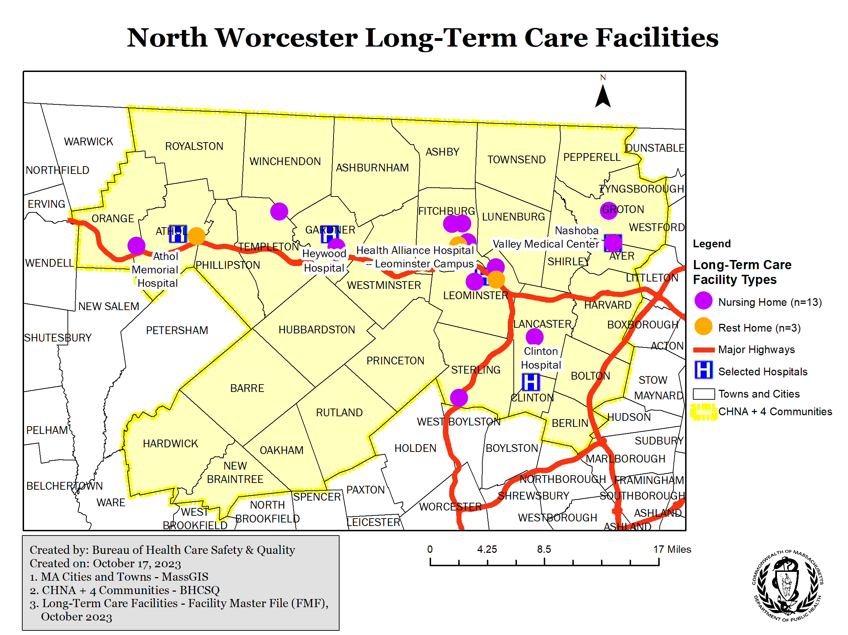

Previous Efforts to Identify Community Needs

The two hospital groups in the area, Heywood Hospital and HealthAlliance completed community health needs assessments in 2021. The community health needs assessments provide a comprehensive summary of the health status of the community that each hospital services and the identified health service needs for the future. The Heywood Hospital report observed that there are more Veterans in the over-18 population in their service area (9.2%) as compared to other regions of the state (5%). Neither community health needs assessment emphasized collaboration across hospitals in the region as a mechanism to support access to essential services.

Listening Session Themes

In-person listening sessions were held in three communities across the North Worcester County Area, specifically in Athol, Fitchburg and Leominster, in October 2023. Approximately, 64 individuals attended the three listening sessions.

Common themes were presented at the three listening sessions by the community members in attendance. The common themes centered around transportation, mental health and substance use disorder services, EMS, and the Hospital Essential Services closure process overall.
- Transportation concerns centered around lack of transportation options for getting to and from health care facilities and more reliance upon calling 911 for non-emergent transports to health care facilities or deferring care. Community members noted limited hours and lack of connected transportation across various towns in the region.
- Several community members expressed concern about the lack of mental health and substance use disorder services in the North Worcester County Area.
- With the closure of health care services in the North Worcester County Area, community members expressed concerns about the need for ambulance services to travel farther to hospitals which results in fewer ambulances and EMS personnel being available to provide necessary emergency transport and patient care.
- Commenters expressed concern that DPH could not stop a closure of hospital services, and requested additional authority for DPH to prohibit service closures.

Beyond these common themes, one community member shared that there are opportunities to offer and increase home care services in the region as a means to meet the health care needs of the community rather than focusing on facility-based services.

Conclusion

At the direction of Governor Healey, DPH has completed a review and assessment of available health care services in the North Worcester County Area. This area has experienced rapid population growth in the last 10 years, particularly among younger and more diverse populations. In comparison to federal metrics, the North Worcester County Area does not have sufficient primary care practitioners such that these areas may qualify as Health Provider Shortage Areas. Some of the community health centers in the North Worcester County Area are currently designated as HPSAs, and the North Quabbin HPSA includes the selected communities of Athol, Orange, Phillipston, Royalston, and Winchendon.

A commonly used measure of access to care is appropriate ED utilization. It is generally expected that the population accessing ED care should match the community population. In the North Worcester County Area, the population is about 22% people of color, but 27% of ED discharges are among POC. This indicates inadequate and inequitable access to primary care. Since the North Worcester County Area contains several HPSAs, there may not be sufficient primary care providers to refer ED users to for more routine care.

Geographically, the North Worcester County Area lacks services outside of the MA-2 corridor, including more traditional community-based services such as primary care, prenatal care, pharmacies and substance use disorder services. The dearth of these kinds of providers suggests the need for additional investment in telehealth, home-based care, and mobile care in the North Worcester County Area.

Additionally, the five community hospitals in the North Worcester County Area are facing financial challenges. While Athol Hospital is a designated Critical Access Hospital, the remaining four facilities do not receive sufficient support to provide essential services in this rural setting on a financially secure basis. Community hospitals often close the less profitable services first, including pediatrics and maternal newborn care – both of which have closed in the last year in North Worcester County Area. Additional financial resources are needed to bolster the operations of these vital community hospitals.

Across all settings, there is a significant health care staffing shortage in the North Worcester County Area. This is not unique to this area, as health care in all settings is facing work force shortages and burn out following the COVID-19 pandemic. Existing and new programs aim to address these issues – such as the Massachusetts Loan Repayment Program and the newly announced Scholarship program for nursing education in community colleges. However, the cost of housing and lack of access to childcare makes working in these areas unaffordable and more must be done to entice health care workers to move to rural areas and work at community hospitals – rather than large academic centers in urban hubs.

DPH’s role in health care facility operation is to support, through regulatory standards and oversight, provision of high-quality and safe clinical care while also balancing accessibility of services to communities across the Commonwealth. At the same time, DPH is required to oversee closure of essential services which, as noted earlier, is a regulatory term pertaining mostly to hospital inpatient services. It is important to note the Department’s role in the closure of hospital or other services and facilities, such as long-term care facilities, is to review and monitor facility’s plans for safe patient transfer and ongoing access to services regionally. DPH does not oversee or regulate hospital financial or business operations.

The listening sessions in the North Worcester County area provided useful insight into the need for ongoing community-level access to routine care (e.g., primary care, mental health care), as the Commonwealth collectively experiences the regionalization of specialty services. Feedback from the local community highlights the need for local leaders and healthcare institutions to engage regularly to discuss local and regional care needs and how best to support resident access. More complete information about changes in how health care services are and can be safely provided, conditions that present challenges to patient safety, and challenges facing hospitals the community depends on could enhance the effectiveness of the essential services closure process when it needs to occur,

Recommendations

- Hospitals and other healthcare providers in the region, along with EOHHS, should consistently convene a region-based approach to delivering essential services including prenatal care, primary care, mental health care, and substance use disorder care.
- Health systems and providers should routinely engage community members regarding needed supports to accessing timely, comprehensive care access.
- DPH and EOHHS will actively engage to promote regional planning, and monitor and oversee the essential health services closure process during and after service closure.

- EOHHS should continue to engage UMass Memorial Health Care, the system anchored by the only regional Academic Medical Center, on ways to increase their presence in communities across the region.
- As the provider of most complex care for the region, UMass Memorial Health Care should continue to engage with communities and the region and with EOHHS on ways to increase its community presence and support the community hospitals and larger health care provider network. Ways to establish and then maintain community presence include:
- Share and schedule clinical staff from the academic medical center, including specialty providers in cardiology, maternal fetal medicine, neurology, and oncology, at community hospitals and providers on an ongoing basis
- Support physician, nurse, and other clinician training in the community hospitals and primary care practices and establish training sites for recovery coaches, community health workers and other clinical roles
- Provide infrastructure support by disseminating clinical care protocols to community hospitals
- Engage in agreements with each hospital in the region to provide virtual consultation for specialists like 24/7 stroke care.

- The Secretary of the Massachusetts Department of Transportation and the Commissioner of Public Health should convene a stakeholder taskforce to identify resources needed to implement Goal 3 of the Montachusett Regional Planning Commission’s Pathway to 2050 (to promote and seek equitable transport for all) so residents can safely and efficiently travel to health care provider appointments.
- The Montachusett Regional Planning Commission has developed a comprehensive plan to address transportation needs of the region in The Pathway to 2050 plan; it includes two objectives under Goal 3 that directly impact essential healthcare: increase access to transit options through improved dissemination of available transit options and improve transit service operations for all trip destinations/purposes and users.
- The Secretariats should convene a stakeholder taskforce that includes the Montachusett Regional Planning Commission to identify the best ways to increase service operations to health care providers in the region. DPH will support the stakeholder taskforce with available data

- Increase community-based management of persons with chronic conditions by funding inclusive home health programs for the elderly and mobile integrated health (MIH) start-up and operational costs.
- UMASS Memorial currently operates an MIH program based in Worcester and should consider expanding the program to address needs identified in the North Worcester County area. This could potentially be done in partnership with HealthAlliance Clinton and Leominster Hospitals, which are already part of the UMASS Memorial System. DPH should support providers seeking to operate an MIH program.
- PACE (Program for the All-Inclusive Care of the Elderly) is a national model of care that provides older adults and their caregivers innovative health care and support so that they can live safely in the community. PACE is not available in all communities in the North Worcester County Area. The Executive Office of Elder Affairs (EOEA) and MassHealth should support the expansion of home health programs that can provide intensive support into this region.

- Stabilize equitable care across the birthing continuum, through implementation of recommendations from the Review of Maternal Health Services, 2023 Report.
- Incent certified nurse midwives to work in the region by ensuring that MassHealth and all private insurers reimburse midwives at the same level as physicians for the same service.
- Support the expansion of prenatal care delivery in the two community health centers in the region.
- Support expanding postpartum care to new moms and babies by supporting home visiting services so that all new moms and babies have home visiting services.
- As a result of the closure of maternity services at Health Alliance Leominster, there are now only 11 maternal/newborn beds in the North Worcester County Area. However, before the closure, there were 22.925 equivalent full time certified nurse midwives and OB/GYNs that practice in these communities, which is equal to 302 providers per 10,000 live births in 2022. This is well above the federal definition of full access to maternity care – which is only 60 providers per 10,000 births. While no maternity service deserts exist in Massachusetts, our goal is to provide high quality and accessible maternal services throughout the state. DPH should update birth center regulations to more easily support the development and operation of a birth center in the region.

- Review the essential service closure process and update statutes and regulations to better protect patient safety, expand community information and engagement, and sustain access to services overtime.
- Require earlier and more robust community engagement on the part of the hospital during the essential service closure process as well as continued engagement with the community after the essential service has closed.
- Require hospitals to submit historic utilization data and financial data in an effort to provide more transparency to the Commonwealth on the financial health of the hospital.
  - While hospitals do provide utilization data to DPH during the essential services closure process, these data are often present day and not a historic lookback making it challenging to identify utilization trends.
- Require hospitals to submit more robust materials explaining patient safety and quality of care concerns whenever these issues are part of the reasons for closure of an essential health service, and ensure that these are part of the community engagement process.
- Review procedures for monitoring hospitals’ plans for supporting continued access to essential services over time.
- Better define regionally-necessary services, informed by regional planning efforts convened by EOHHS with providers in the area, and provide a pathway to maintain access to care deemed necessary for the region.

- Create pathways for providers to recruit, retain, and support staff working in currently licensed adult and pediatric mental health inpatient beds and consider transitioning a portion of the currently licensed geriatric psychiatric beds to adult psychiatric beds.

- Support clinical staffing recruitment and retention in the region by expanding financial incentives to health care staff and by addressing poor access to affordable housing and childcare in the region.
- Expand existing loan forgiveness programs for health care staff that work within the region by adding the North Worcester County Area as a qualifying zone for the Massachusetts Loan Repayment Program and the Nursing Education Loan Repayment Program.
- Many nursing programs, including Fitchburg State College and Mount Wachusett Community College, are currently limited in their capacity to provide nursing education due to a lack of clinical instructors and professors. Clinical adjunct faculty are paid an hourly rate for the hours they are actively teaching and a small number of preparation hours. Similar limitations are found in other health care fields such as surgical technicians, mental health clinicians, respiratory therapists, and physical therapy assistants. The Commonwealth should explore options for supporting clinical adjunct faculty with payment for additional hours for preparation time.
- Over the next year, DPH’s Primary Care Office will be preparing for the next National System Data Update by working closely with all Geographic and Population HPSA sites, including the Automatic HPSAs/ Community Health Centers, to ensure they are providing HRSA with the most up to date provider information via the SDMS. The higher the HPSA score, the higher the probability they will qualify for additional federal healthcare workforce funds. The Healthcare Workforce Center as a whole relies on HPSAs to facilitate our Massachusetts Loan Repayment Program as well as the Conrad 30 Visa Waiver program. DPH is invested in bringing valuable resources to areas like the North Quabbin area.
- DPH’s Primary Care Office will continue to collaborate with the National Health Service Corp District Regional Office and the State Office of Rural Health, to encourage communities to apply as National Health Service Corp (NHSC) sites. This is yet another pathway for communities with health professions shortages to access federal resources that supports recruiting and retaining health professionals to their medical practices. Through placement opportunities for recipients of the NHSC Scholars Program, who have their salary paid for by the NHSC, and offering student loan repayment options to help retain staff in communities with high medical staff turnover, sites can enhance recruiting and retaining their healthcare workforce and sustaining quality care for their patient population.

- Require urgent care centers to accept all insurance products
- DPH will consider options for requiring any entity to be licensed by the Department as a clinic if the entity is (i) providing urgent care services or is (ii) maintained under a name including the words “urgent care” or which suggests that urgent care services are provided.
  - Consider requiring as a condition of clinic licensure that entities providing urgent care services must accept MassHealth.
- Licensing and regulating all entities providing urgent care services will create a standard for patient safety and increase access to all populations.
- A change in statute might be required to implement this recommendation.

- Promote increased use of telehealth, home-based care, and mobile care in the region.

Additional Considerations

A critical challenge to staffing in Massachusetts is the high cost of housing. Massachusetts should invest in affordable housing throughout the state, but specifically near health care providers to support and attract practitioners to the area. The Healey-Driscoll Administration’s sweeping Affordable Homes Act would make great strides in increasing the housing stock and availability in Massachusetts. Additional carve outs should be considered for health care workers, particularly in rural settings like the North Worcester County Area. As examples, municipal and state funding could be used to subsidize housing for healthcare workers, through mechanisms such as tax rebates for landlords who rent to health care workers, rental subsidies for health care workers, and tax deductions. The newly formed Housing Advisory Council should consider strategies to incentivize health care workers to move to more rural and underserved areas.

Additionally, the state should review occupancy of local community colleges and other state schools, such as Fitchburg State. Rhode Island College is converting some empty dormitories into apartments to provide affordable housing to health care workers and teachers. Similar partnerships should be explored in Massachusetts.

As facilities continue to fill vacancies with travel nurses and health care staff, care should be taken to ensure affordable and available short -term housing for health care staff coming from out of state to work temporarily.

Finally, staff cannot work when they cannot find childcare. There is a childcare crisis in Massachusetts with insufficient providers and high cost. The state should explore co-locating childcare in or near health care facilities and support care providers to offer discounted or free childcare to health care staff.

In recent news, California Governor Gavin Newsom signed into law a slow increase of the minimum wage for health care workers – increasing to $25 over the next decade. Also in California, after about 75,000 Kaiser Permanente workers went on strike for three days, a $25 minimum wage was part of their tentative deal. As cost of living is also high in Massachusetts, the Commonwealth should explore the potential impact of a higher minimum wage for healthcare workers, including any potential benefits on workforce retention and any impact on overall cost of care.

Addendum
Table of Contents
Defining the Geographic Area
Community Data 1
Table 2. Selected Communities Rural Definitions from State Office of Rural Health
Table 3. Summary Census Data
Table 4. Select Population Metrics in the North Worcester County Region from the US Census – American Community Survey 2
Outpatient Data 4
Table 5. Primary Care: Licensed Independent Providers by Town
Emergency Medical Services 4
Table 6. Emergency run counts by ambulance service for North Worcester County Towns 1/1/2022-9/30/2023
Table 7. Count of unique ambulance services that responded to at least one emergency incident in North Worcester County Towns 1/1/2022-9/30/2023
Table 8: Count and percentage of emergency calls responded to by municipal and private ambulance services in North Worcester County Towns 1/1/2022-9/30/2023
Table 9: Count and percentage of emergency calls responded to by municipal and private ambulance services across the rest of MA 1/1/2022-9/30/2023
Table 10: Count and percentage of emergency runs to North Worcester County Area and Nearby Hospitals 1/1/2022-9/30/2023
Table 11. Count and percentage of emergency runs with suspected cardiac arrest to North Worcester County Area and Nearby Hospitals 1/1/2022-9/30/2023
Table 12. Count and percentage of emergency runs with suspected stroke to North Worcester County Core and Nearby Hospitals 1/1/2022-9/30/2023
Table 13. Median response and transport times in minutes for emergency calls in North Worcester County Towns vs. the rest of MA 1/1/2022-9/30/2023
Table 14. Median response and transport times in minutes for emergency calls by North Worcester County Area and Nearby Hospitals 1/1/2022-9/30/2023
Table 15. Median response and transport times in minutes for emergency calls by North Worcester County Town 1/1/2022-9/30/2023
Hospital Data
Table 16. Current licensed beds and services at area hospitals
Table 17. Current licensed beds and services at reference hospitals
Table 18. Average Daily Beds Occupied, Staffed, and Licensed by Hospital in Federal Fiscal Year 2023
Table 19. Syndromic Surveillance ED Visit Counts January 1-September 30, 2023

Long-Term Care Data
Table 20. Long-term care providers, licensed beds, occupancy

Defining the Geographic Area

DPH worked to define the geographic region of North Worcester County Area and reviewed previous efforts to define service areas. The Department considered three possible service area classifications: the Community Health Network Areas, the Executive Office of Health and Human Service Regions, and the Health Policy Commission Inpatient Hospitalization Service Area Regions.
Community Health Network Areas

The Department established the Community Health Network Area (CHNA) initiative in 1992. The original initiative involved all 351 towns and cities through 27 CHNAs. Since then, some CHNAs have become inactive while others have morphed into different areas. For the purposes of identifying an appropriate region for this report, the Department first focused on CHNA 9, the Community Health Network of North Central Massachusetts which includes the communities of Ashburnham, Ashby, Ayer, Barre, Berlin, Bolton, Clinton, Fitchburg, Gardner, Groton, Hardwick, Harvard, Hubbardston, Lancaster, Leominster, Lunenburg, New Braintree, Oakham, Pepperell, Princeton, Rutland, Shirley, Sterling, Templeton, Townsend, Westminster and Winchendon.

Figure 1. North Worcester County Area Hospitals and CHNA Region

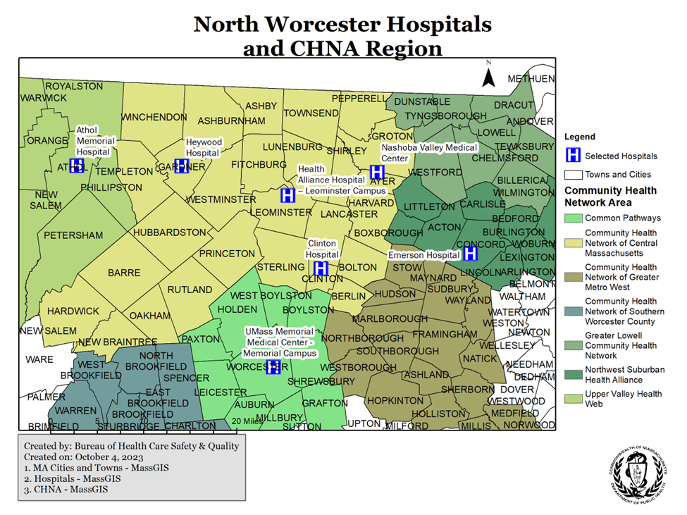

Executive Office of Health and Human Services Regions

These regions are defined by the Executive Office of Health and Human Services (EOHHS) and used by the Department for statistical care coordination and administrative purposes. The regions are Western, Central, Northeast, Metro West, Boston and Southeast; they are based on geographical groupings of cities and towns. The North Worcester County Area is included in the Central region.

Figure 2. North Worcester County Area Hospitals and EOHHS Regions
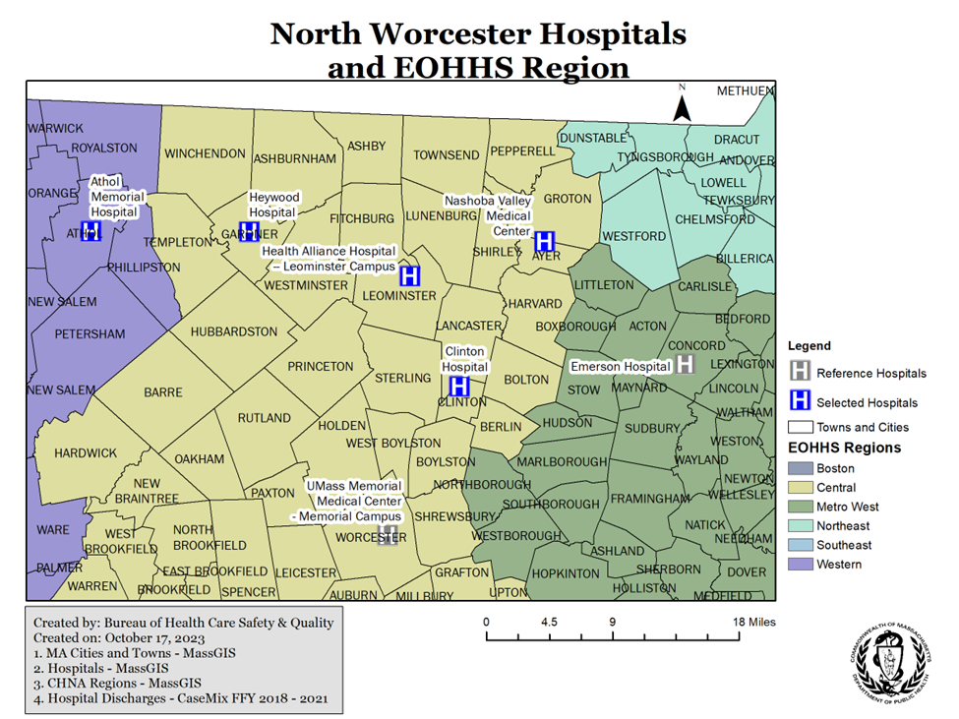

Health Policy Commission Regions

In 2013 the Health Policy Commission (HPC) engaged in an effort to define geographic regions to use for cost trends analysis that could be used to better understand health and health care spending variation between areas. HPC developed 15 geographic regions based on patterns of patient travel for hospital inpatient care that were derived from the Hospital Service Areas (HSAs) defined by the Dartmouth Atlas. Figure 3 shows that the North Worcester County Area is part of the Central Massachusetts Region that extends from the Commonwealth’s NW to Southern borders.

Figure 3: North Worcester County Area Hospitals and HPC Region

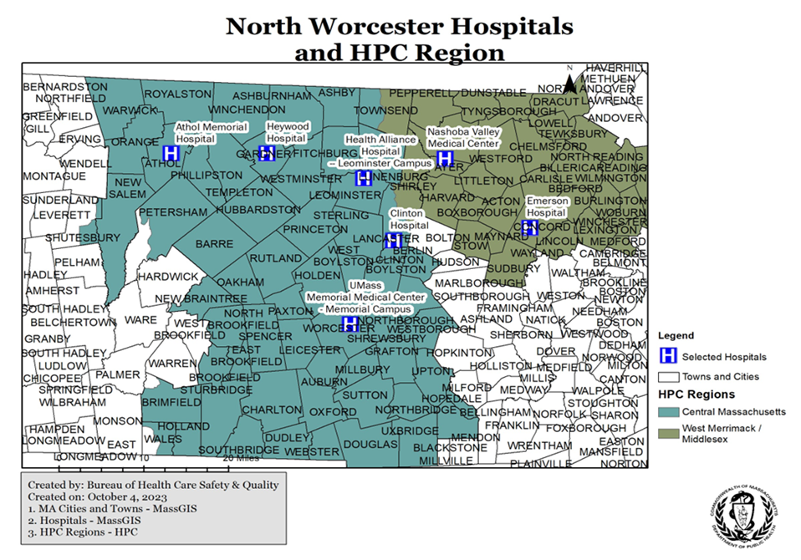

After analyzing the three possible service area classifications, the Department selected the CHNA framework to best concentrate on the North Worcester County Area health needs. Both the EOHHS region and HPC region framework included the City of Worcester and Southern Worcester County and, as such, were not focused enough. In order to incorporate all of Heywood Healthcare, the Department sought to add Athol Memorial Hospital to this report and subsequently reviewed the communities of residence for patients discharged from this hospital. Four communities outside of the Community Health Network of North Central Massachusetts CHNA region were identified as having at least fifty percent of their resident hospitalizations at Athol Memorial Hospital and as a result were added to the inclusion area for the purposes of this report. The four communities are Athol, Orange, Phillipston and Royalston. The final region used in this report consists of communities in CHNA 9 with the addition of the four communities and will be referred to throughout the report as the North Worcester County Area.

Community Data

Table 2. Selected Communities Rural Definitions from State Office of Rural Health
County | Towns | Population Size | Population Density | % Rural Popn | SRH/CAH/ RHC | Current Rural Definition V3 - 2017 | Cluster
Worcester | Ashburnham | 6,081 | 158.5 | 90.1% | N | Rural Level 1 | North Central
Middlesex | Ashby | 3,074 | 129.7 | 88.2% | N | Rural Level 1 | North Central
Worcester | Athol | 11,584 | 358.7 | 100.0% | Y | Rural Level 2 | North Quabbin
Middlesex | Ayer | 7,427 | 832.6 | 4.0% | Y | Rural Level 1 | 495 Corridor
Worcester | Barre | 5,398 | 121.8 | 100.0% | N | Rural Level 1 | East Quabbin
Worcester | Berlin | 2,866 | 221.0 | 65.4% | N | Rural Level 1 | 495 Corridor
Worcester | Bolton | 4,897 | 245.5 | 94.2% | N | Rural Level 1 | 495 Corridor
Worcester | Clinton | 13,606 | 2,408.1 | 0.0% | Y | Rural Level 1 | North Central
Worcester | Fitchburg | 40,318 | 1,448.7 | 7.6% | N | Urban
Worcester | Gardner | 20,228 | 916.1 | 4.9% | N | Urban
Middlesex | Groton | 10,646 | 325.0 | 38.1% | N | Urban
Worcester | Hardwick | 2,990 | 77.5 | 100.0% | N | Rural Level 2 | East Quabbin
Worcester | Harvard | 6,520 | 246.6 | 76.4% | N | Rural Level 1 | 495 Corridor
Worcester | Hubbardston | 4,382 | 106.7 | 100.0% | N | Rural Level 1 | North Central
Worcester | Lancaster | 8,055 | 293.2 | 31.7% | N | Rural Level 1 | North Central
Worcester | Leominster | 40,759 | 1,414.8 | 3.1% | N | Urban
Worcester | Lunenburg | 10,086 | 380.9 | 30.3% | N | Urban
Worcester | New Braintree | 999 | 48.1 | 100.0% | N | Rural Level 2 | East Quabbin
Worcester | Oakham | 1,902 | 91.3 | 100.0% | N | Rural Level 1 | East Quabbin
Franklin | Orange | 7,839 | 223.4 | 100% | N | Rural Level 2 | North Quabbin
Middlesex | Pepperell | 11,497 | 508.7 | 42.4% | N | Urban
Worcester | Phillipston | 1,682 | 69.4 | 100.0% | N | Rural Level 2 | North Quabbin
Worcester | Princeton | 3,413 | 96.4 | 100.0% | N | Rural Level 1 | North Central
Worcester | Royalston | 1,258 | 30.1 | 100.0% | N | Rural Level 1 | North Quabbin
Worcester | Rutland | 7,973 | 227.2 | 57.3% | N | Rural Level 1 | East Quabbin
Middlesex | Shirley | 7,211 | 454.7 | 26.7% | N | Rural Level 1 | 495 Corridor
Worcester | Sterling | 7,808 | 254.9 | 60.2% | N | Rural Level 1 | North Central
Worcester | Templeton | 8,013 | 251.3 | 49.0% | N | Rural Level 1 | North Central
Middlesex | Townsend | 8,926 | 272.1 | 51.9% | N | Rural Level 1 | North Central
Worcester | Westminster | 7,277 | 205.4 | 55.7% | N | Rural Level 1 | North Central
Worcester | Winchendon | 10,300 | 239.4 | 42.1% | Y | Rural Level 1 | North Central
Data source: https://www.mass.gov/info-details/state-office-of-rural-health-rural-definition

Table 3. Summary Census Data
Town | Housing Occupancy Rate | Percent People of Color (Including Hispanic or Latino of Any Race) | Population Numeric Change from Previous Decade | Population Percent Change from Previous Decade | Population Rank | Population Total | Race NH White
ASHBURNHAM | 85% | 9% | 234 | 4% | 229 | 6315 | 5726
ASHBY | 93% | 9% | 119 | 4% | 276 | 3193 | 2913
ATHOL | 92% | 12% | 361 | 3% | 163 | 11945 | 10475
AYER | 94% | 24% | 1052 | 14% | 196 | 8479 | 6437
BARRE | 94% | 10% | 132 | 2% | 241 | 5530 | 4996
BERLIN | 96% | 11% | 292 | 10% | 278 | 3158 | 2796
BOLTON | 96% | 13% | 768 | 16% | 240 | 5665 | 4903
CLINTON | 95% | 29% | 1822 | 13% | 133 | 15428 | 10943
FITCHBURG | 92% | 45% | 1628 | 4% | 36 | 41946 | 22918
GARDNER | 93% | 21% | 1059 | 5% | 92 | 21287 | 16726
GROTON | 96% | 15% | 669 | 6% | 173 | 11315 | 9646
HARDWICK | 89% | 9% | -323 | -11% | 282 | 2667 | 2438
HARVARD | 94% | 22% | 331 | 5% | 220 | 6851 | 5344
HUBBARDSTON | 95% | 8% | -54 | -1% | 261 | 4328 | 3965
LANCASTER | 94% | 25% | 386 | 5% | 199 | 8441 | 6309
LEOMINSTER | 95% | 36% | 3023 | 7% | 33 | 43782 | 28039
LUNENBURG | 95% | 14% | 1696 | 17% | 166 | 11782 | 10087
NEW BRAINTREE | 94% | 6% | -3 | 0% | 324 | 996 | 939
OAKHAM | 97% | 10% | -51 | -3% | 294 | 1851 | 1675
ORANGE | 91% | 12% | -270 | -3% | 212 | 7569 | 6635
PEPPERELL | 96% | 12% | 107 | 1% | 169 | 11604 | 10266
PHILLIPSTON | 83% | 9% | 44 | 3% | 298 | 1726 | 1568
PRINCETON | 97% | 9% | 82 | 2% | 269 | 3495 | 3192
ROYALSTON | 79% | 6% | -8 | -1% | 315 | 1250 | 1176
RUTLAND | 96% | 12% | 1076 | 14% | 193 | 9049 | 7993
SHIRLEY | 96% | 26% | 220 | 3% | 215 | 7431 | 5488
STERLING | 96% | 9% | 177 | 2% | 208 | 7985 | 7230
TEMPLETON | 93% | 9% | 136 | 2% | 205 | 8149 | 7384
TOWNSEND | 97% | 12% | 201 | 2% | 192 | 9127 | 8066
WESTMINSTER | 93% | 10% | 936 | 13% | 201 | 8213 | 7387
WINCHENDON | 92% | 13% | 64 | 1% | 179 | 10364 | 8981

Table 4. Select Population Metrics in the North Worcester County Region from the US Census – American Community Survey
Metrics | Estimates | Percent
HOUSEHOLDS BY TYPE
Total households | 58,804
Married-couple household | 24,192 | 41.14%
With children of the householder under 18 years | 8,999 | 15.30%
Cohabiting couple household | 5,575 | 9.48%
With children of the householder under 18 years | 1,723 | 2.93%
Male householder, no spouse/partner present | 12,406 | 21.10%
With children of the householder under 18 years | 621 | 1.06%
Householder living alone | 8,704 | 14.80%
65 years and over | 2,416 | 4.11%
Female householder, no spouse/partner present | 16,631 | 28.28%
With children of the householder under 18 years | 3,259 | 5.54%
Householder living alone | 9,640 | 16.39%
65 years and over | 4,843 | 8.24%
Households with one or more people under 18 years | 16,446 | 27.97%
Households with one or more people 65 years and over | 17,089 | 29.06%
Average household size | 2.4
Average family size | 3.1
SCHOOL ENROLLMENT
Population 3 years and over enrolled in school | 31,485
Nursery school, preschool | 1,976 | 6.28%
Kindergarten | 1,810 | 5.75%
Elementary school (grades 1-8) | 12,620 | 40.08%
High school (grades 9-12) | 6,426 | 20.41%
College or graduate school | 8,653 | 27.48%
EDUCATIONAL ATTAINMENT
Population 25 years and over | 102,085
Less than 9th grade | 3,787 | 3.71%
9th to 12th grade, no diploma | 6,616 | 6.48%
High school graduate (includes equivalency) | 32,373 | 31.71%
Some college, no degree | 21,088 | 20.66%
Associate's degree | 11,059 | 10.83%
Bachelor's degree | 17,782 | 17.42%
Graduate or professional degree | 9,380 | 9.19%
High school graduate or higher | 91,682 | 89.81%
Bachelor's degree or higher | 27,162 | 26.61%
VETERAN STATUS
Civilian population 18 years and over | 115,520
Civilian veterans | 7,883 | 6.82%
DISABILITY STATUS OF THE CIVILIAN NONINSTITUTIONALIZED POPULATION
Total Civilian Noninstitutionalized Population | 142,607
With a disability | 20,216 | 14.18%
Under 18 years | 28,842 | 20.22%
With a disability | 1,662 | 1.17%
18 to 64 years | 91,252 | 63.99%
With a disability | 11,433 | 8.02%
65 years and over | 22,513 | 15.79%
With a disability | 7,121 | 4.99%
PLACE OF BIRTH
Total population | 144,579
Native | 129,370 | 89.48%
Born in United States | 122,059 | 84.42%
State of residence | 99,508 | 68.83%
Different state | 22,551 | 15.60%
Born in Puerto Rico, U.S. Island areas, or born abroad to American parent(s) | 7,311 | 5.06%
Foreign born | 15,209 | 10.52%
U.S. CITIZENSHIP STATUS
Foreign-born population | 15,209
Naturalized U.S. citizen | 8,737 | 57.45%
Not a U.S. citizen | 6,472 | 42.55%

Outpatient Data
Table 5: Licensed Independent Providers by Town

Town | Certified Nurse Midwife | Family Practice | General Practitioner | Internal Medicine | Obstetrics and Gynecology | Pediatrics | Total Primary Care Providers | Population 2020 | Patients : 1 Provider
Ayer |  |  | 1 |  |  |  | 1 | 33916 | 33916
Lancaster |  | 1 |  | 1 |  |  | 2 | 33764 | 16882
Princeton |  | 1 |  |  |  |  | 1 | 13980 | 13980
Winchendon |  | 3 |  |  |  |  | 3 | 41456 | 13818.67
Berlin |  |  |  | 1 |  |  | 1 | 12632 | 12632
Ashburnham |  | 2 |  |  |  |  | 2 | 25260 | 12630
Lunenburg |  | 3 | 1 |  |  |  | 4 | 47128 | 11782
Westminster |  | 3 |  |  |  |  | 3 | 32852 | 10950.67
Clinton |  | 1 |  | 3 |  | 2 | 6 | 61712 | 10285.33
Phillipston |  |  |  |  |  | 1 | 1 | 6904 | 6904
Athol | 3 | 6 |  |  |  |  | 9 | 47780 | 5308.889
Orange |  | 7 |  | 1 |  |  | 8 | 30276 | 3784.5
Bolton |  | 4 |  | 1 | 1 |  | 6 | 22660 | 3776.667
Harvard |  | 7 |  | 1 |  |  | 8 | 27404 | 3425.5
Gardner |  | 14 |  | 4 | 3 | 4 | 25 | 85148 | 3405.92
Fitchburg | 1 | 29 | 1 | 12 |  | 8 | 51 | 167784 | 3289.882
Barre |  | 7 |  |  |  |  | 7 | 22120 | 3160
Sterling |  | 7 |  | 1 |  | 7 | 15 | 31940 | 2129.333
Leominster | 7 | 32 |  | 23 | 9 | 18 | 89 | 175128 | 1967.73

Emergency Medical Services

Table 6. Emergency run counts by ambulance service for North Worcester County Towns 1/1/2022-9/30/2023
Service Name | Run Count
Leominster Fire Dept. | 8546
Fitchburg Emergency Medical Services | 5836
Gardner Fire Department | 3728
Medstar Ambulance Inc. | 3333
Athol Fire/Ems (Town Of) | 3120
Wood's EMS | 2946
Ayer Fire Department | 2423
Winchendon Ambulance Svc. | 2091
Clinton Fire Dept. Ambulance Svc. | 1890
Sterling Fire Department Ambulance | 1840
Fitchburg Fire Department | 1724
Orange Fire Dept. | 1505
Townsend Fire-EMS Department | 1474
Barre Fire Department | 1301
Pepperell Fire Department | 1291
Lunenburg Fire Dept. | 1282
Wood's Ambulance Inc. | 1280
Lancaster Fire & EMS | 1268
Groton Fire Department | 1059
Rutland Fire Dept. Ambulance Svc. | 1035
Shirley Ambulance Svc. | 882
Westminster Fire Department | 814
Templeton Fire Dept. | 768
Ashburnham Fire Dept. | 696
Devens Fire Rescue | 560
Berlin Emergency Rescue Squad | 507
Harvard Ambulance Service | 452
Hubbardston Fire Department | 451
Ashby Fire/EMS | 327
West Brookfield Rescue Squad | 209
Princeton Firefighters Emerg. Med. Svc. | 205
Bolton Fire-EMS | 175
Medstar EMS | 151
Patriot Ambulance Inc. | 127
Phillipston Fire Department | 122
Holden Fire Department | 77
Umass Memorial Life Flight | 67
Paxton Fire Department | 67
Ware Fire Dept. | 62
Vital Emergency Medical Services & Emergency Medical Transport | 45
Westford Fire Dept. | 37
Littleton Fire Dept. | 32
Life Star (Air) | 18
Boston Medflight | 18
West Boylston Fire Dept. | 16
Northfield Ems | 16
Coastal Medical Transportation Services | 11
Pioneer Valley Ambulance | 11
Massachusetts State Police Academy | 9
Stow Emergency Med. Svc. (Town Of) | 7
Boylston Fire Department | 7
Professional Ambulance And Oxygen Service | 6
Westborough Fire Dept. | 4
Boxborough Fire Dept. | 4
American Medical Response Of Mass | 4
Brewster Ambulance Service | 3
Lifeline Ambulance Service | 3
Beauport Ambulance Service | 3
Spencer Rescue & Emergency Squad Inc. | 3
Pridestar Ambulance Service & Trinity Ems | 2
Armstrong Ambulance Svc. | 2
Leicester Emergency Medical Svc. | 2
Community Ems Inc. | 2
Cataldo Ambulance Svc. | 2
K's Personal Transport | 2
South Shore Hospital | 1
Auburn Fire/Rescue | 1
Fallon Ambulance & Fallon Emergency Medical Svc | 1
Lawrence General Paramedic Services. | 1
Ashland Fire Dept. | 1
Turners Falls Fire Department | 1
Oak Bluffs Ambulance Service | 1
Stoughton Fire Dept. | 1
Arlington Fire Department | 1
Concord Fire Dept. | 1
East Brookfield Fire Department | 1
North Brookfield EMS | 1
Umass Memorial EMS | 1
South Hadley #1 Fire District | 1

Table 7. Count of unique ambulance services that responded to at least one emergency incident in North Worcester County Towns 1/1/2022-9/30/2023
Incident Town | Count of unique ambulance services
Leominster | 18
Fitchburg | 17
Gardner | 17
Ayer | 15
Westminster | 14
Lancaster | 13
Lunenburg | 13
Barre | 12
Bolton | 12
Athol | 11
Clinton | 11
Shirley | 11
Harvard | 10
Rutland | 10
Sterling | 10
Groton | 9
Hubbardston | 9
Orange | 9
Princeton | 9
Templeton | 9
Winchendon | 9
Ashburnham | 8
Pepperell | 8
Townsend | 8
Berlin | 7
New Braintree | 7
Oakham | 6
Phillipston | 6
Royalston | 6
Ashby | 5
Hardwick | 5

Table 8. Count and percentage of emergency calls responded to by municipal and private ambulance services in North Worcester County Towns 1/1/2022-9/30/2023
Ambulance Service Type | Run Count | Percent of Runs
Private | 13875 | 24.8
Municipal | 42099 | 75.2

Table 9. Count and percentage of emergency calls responded to by municipal and private ambulance services across the rest of MA 1/1/2022-9/30/2023
Ambulance Service Type | Run Count | Percent of Runs
Private | 595872 | 44.4
Municipal | 747181 | 55.6

Table 10. Count and percentage of emergency runs to North Worcester County Area and Nearby Hospitals 1/1/2022-9/30/2023
Hospital | Run Count | Percent of Runs
Health Alliance Clinton-leominster | 22345 | 39.9
Heywood Hospital | 11804 | 21.1
Nashoba Valley | 6277 | 11.2
Other Facility | 5920 | 10.6
Athol Memorial Hospital | 5031 | 9.0
Health Alliance Clinton | 3420 | 6.1
Emerson Hospital | 628 | 1.1
UMass Memorial | 549 | 1.0

Table 11. Count and percentage of emergency runs with suspected cardiac arrest to North Worcester County Area and Nearby Hospitals 1/1/2022-9/30/2023
Hospital | Run Count | Percent of Runs
Health Alliance Clinton-Leominster | 130 | 35.1
Heywood Hospital | 89 | 24.1
Nashoba Valley | 59 | 15.9
Health Alliance Clinton | 38 | 10.3
Athol Memorial Hospital | 28 | 7.6
Other Facility | 26 | 7.0

Table 12. Count and percentage of emergency runs with suspected stroke to North Worcester County Core and Nearby Hospitals 1/1/2022-9/30/2023
Hospital | Run Count | Percent of Runs
Health Alliance Clinton-Leominster | 344 | 35.4
Nashoba Valley | 163 | 16.8
Heywood Hospital | 143 | 14.7
Other Facility | 127 | 13.1
Athol Memorial Hospital | 105 | 10.8
Health Alliance Clinton | 87 | 8.9
Emerson Hospital | 3 | 0.3
UMass Memorial | 1 | 0.1

Table 13. Median response and transport times in minutes for emergency calls in North Worcester County Towns vs. the rest of MA 1/1/2022-9/30/2023
Area | Median Response Time | IQR Response Time | Median Transport Time | IQR Transport Time
Rest of MA | 6 | 4 | 9 | 8
North Worcester County | 5 | 5 | 9 | 9

Table 14. Median response and transport times in minutes for emergency calls by North Worcester County Area and Nearby Hospitals 1/1/2022-9/30/2023
Hospital | Median Response Time | IQR Response Time | Median Transport Time | IQR Transport Time
Athol Memorial Hospital | 5 | 4 | 8 | 6
Emerson Hospital | 6.5 | 6 | 21 | 7
Health Alliance Clinton | 5 | 4 | 5 | 4
Health Alliance Clinton-Leominster | 5 | 4 | 8 | 6
Heywood Hospital | 5 | 4 | 7 | 8
Nashoba Valley | 5 | 5 | 10 | 7
Other Facility | 7 | 7 | 22 | 13
UMass Memorial | 7 | 6 | 27 | 13

Table 15. Median response and transport times in minutes for emergency calls by North Worcester County Town 1/1/2022-9/30/2023
Town | Median Response Time | IQR Response Time | Median Transport Time | IQR Transport Time
NEW BRAINTREE | 14 | 5 | 34 | 10
BARRE | 8 | 6 | 28 | 9
HARDWICK | 14 | 7 | 26 | 11
OAKHAM | 11 | 3 | 26 | 4
PRINCETON | 10 | 10 | 22 | 8
ASHBY | 10 | 7 | 21 | 8
RUTLAND | 5 | 5 | 20 | 4
TOWNSEND | 5 | 4 | 19 | 6
ROYALSTON | 14 | 8 | 18 | 10
HUBBARDSTON | 8 | 6 | 17 | 8
HARVARD | 9 | 6 | 15 | 7
PEPPERELL | 6 | 4 | 14 | 4
ASHBURNHAM | 6 | 6 | 13 | 8
BOLTON | 6 | 7 | 13 | 9
STERLING | 5 | 3 | 13 | 7
BERLIN | 6 | 4 | 12 | 5
TEMPLETON | 9 | 5 | 12 | 4
WINCHENDON | 4 | 4 | 12 | 3
LUNENBURG | 7 | 4 | 11 | 5
ORANGE | 5 | 4 | 11 | 3
WESTMINSTER | 4 | 4 | 11 | 5
PHILLIPSTON | 8 | 6 | 10 | 7
SHIRLEY | 5 | 4 | 10 | 4
FITCHBURG | 4 | 3 | 9 | 4
GROTON | 6 | 5 | 9 | 7
LANCASTER | 7 | 6 | 8 | 6
AYER | 4 | 4 | 7 | 7
ATHOL | 4 | 4 | 5 | 4
GARDNER | 4 | 3 | 5 | 2
LEOMINSTER | 5 | 3 | 5 | 4
CLINTON | 5 | 4 | 4 | 4

MATRIS Data Notes:

Source: Massachusetts Department of Public Health MATRIS V3. Extracted 10/16/23.

Data includes emergency runs where patient was transported by EMS and where the incident city and destination could be reliably identified

Ambulance services are required to enter data into MATRIS
per A/R 5-403 Statewide EMS Minimum Dataset.

Data are required to be submitted within 7 days; however, actual submission timeframes vary by ambulance service.

Response time is defined as the time in minutes between when the ambulance was notified to when it arrived at the incident scene.

Transport time is defined as the time in minutes between when the ambulance left incident scene and when it arrived at the destination.

Suspected cardiac arrests are identified based on the NEMSIS case definition, which uses ICD codes and text strings to identify incidents where any symptom or impression is cardiac arrest, cardiac arrest occurred prior to EMS arrival, and the etiology is presumed cardiac, or blank or cardiac arrest occurred after EMS arrival, and the etiology is presumed cardiac (NEMSIS Case Definition - Cardiac Arrest).

Suspected strokes are identified based on the NEMSIS case definition, which uses ICD codes and text strings to identify incidents where any symptom or impression is stroke, or stroke scale score is positive, or stroke protocol is used, or a stroke destination team pre-arrival alert or activation is performed (NEMSIS Case Definition - Stroke).

Hospital Data
Table 16. Current licensed beds and services at area hospitals
Beds and Services | Athol Memorial Hospital | Heywood Hospital | Health Alliance Clinton-Leominster | Health Alliance Clinton-Clinton | Nashoba Valley Medical Center | Total In Region
ICU |  | 11 |  |  | 6 | 17
ICU/CCU (Combined) |  |  | 10 |  |  | 10
Maternal Newborn |  | 11 | 19 beds discontinued 9/23 |  |  | 11
Medical/Surgical | 21 | 73 | 87 | 21 | 46 | 248
Pediatric Service |  | 7 beds discontinued July 2023 |  |  | 5 | 5
Psychiatric |  | 32 |  | 20 | 20 | 72
Service: Ambulatory Care | Licensed to provide service indicated | Licensed to provide service indicated |  | Licensed to provide service indicated | Licensed to provide service indicated | Licensed to provide service indicated
Service: Emergency Services | Licensed to provide service indicated | Licensed to provide service indicated | Licensed to provide service indicated | Licensed to provide service indicated | Licensed to provide service indicated | Licensed to provide service indicated
Service: Hospice Service | Licensed to provide service indicated |  |  |  |  | Licensed to provide service indicated
Service: Medical Control | Licensed to provide service indicated | Licensed to provide service indicated |  |  | Licensed to provide service indicated | Licensed to provide service indicated
Service: Primary Stroke | Licensed to provide service indicated | Licensed to provide service indicated | Licensed to provide service indicated | Licensed to provide service indicated | Licensed to provide service indicated | Licensed to provide service indicated
Well Infant Bassinet |  | 13 |  |  |  | 13

Table 17. Current licensed beds and services at reference hospitals
Beds and Services | Emerson Hospital | UMASS Memorial – Memorial Campus
CCU | 7 | 14
ICU | 7 | 9
Maternal Newborn | 24 | 65
Medical/Surgical | 70 | 187
Neonatal ICU |  | 27
Pediatric Service | 11
Psychiatric (Locked) | 31
Service: Ambulatory Care | Licensed to provide service indicated | Licensed to provide service indicated
Service: Chronic Dialysis |  | 2
Service: Emergency Services | Licensed to provide service indicated | Licensed to provide service indicated
Service: Hospice Service |  | Licensed to provide service indicated
Service: Medical Control | Licensed to provide service indicated | Licensed to provide service indicated
Service: Primary Stroke | Licensed to provide service indicated
Special Care Nursery | 5 | 22
Well Infant Bassinet | 24 | 47

Hospital Profiles:

Athol Memorial Hospital
It is a small (21 bed) community high public payer hospital. It has a 5-star rating from CMS and has 149 affiliated clinicians. Among their Emergency Department (ED) visits, 85% of the patients seen were from communities in the North Worcester County Area. In 2023 to date, it was the 6th most commonly visited ED for residents in this area. They have had over 6,500 adult visits and 1,000 pediatric visits in the ED this year, including over 500 visits for broad mental health conditions and over 50 visits due to SUD and overdose. In FFY 2022, it averaged about 48% occupancy and had a total of 523 inpatient discharges, with an average length of stay of about 7 days. Athol’s operating and total margins in FFY 22 were the lowest in region at -18.8%, after including COVID-19 relief funds. In 2019, about 2/5 rural hospitals had negative operating margins in the US. This hospital most commonly treats COPD, heart failure, and pneumonia.

Heywood Hospital
It is the bigger of the two Heywood Healthcare sites, with 127 beds. This includes a 20-bed geriatric psych unit that is co-licensed by DMH. It has a 3-star rating from CMS and 250 affiliated clinicians. Among its Emergency Department (ED) visits, 84% of the patients seen were from communities in the selected area. In 2023 to date, it was the 2nd most commonly visited ED for residents in this area. They have had over 15,000 adult visits and 2,700 pediatric visits in the ED this year, including over 1,400 visits for broad mental health conditions and over 120 visits due to SUD and overdose. In FFY 2022, it averaged about 42% occupancy and had a total of 3,752 inpatient discharges, with an average length of stay of about 5 days. The hospital’s operating and total margins in FFY 22 were -12.6% and -12.8%, respectively. This hospital most commonly treats neonatal birth, COPD, and normal vaginal deliveries.

Health Alliance Leominster
Due to reported chronic staffing challenges, Leominster recently closed its 19 maternity beds. It currently has 97 beds. Among their Emergency Department (ED) visits, 90% of the patients seen were from communities in the selected area. In 2023 to date, it was the most commonly visited ED for residents in this area. They have had over 25,000 adult visits and 3,000 pediatric visits in the ED this year, including over 2,200 visits for broad mental health conditions and 150 visits due to SUD and overdose.
Health Alliance Clinton
Clinton is a small campus, with 41 beds – 20 of which are acute inpatient psychiatric beds comprising a 20 bed geriatric psychiatric unit that is dually licensed by DMH. Notably, Clinton is the southernmost hospital in the included geographic area and is near the center of an area bounded by I-495, I-290, I-190, and Route 2. Among their Emergency Department (ED) visits, 81% of the patients seen were from communities in the selected area. In 2023 to date, it was the 4th most commonly visited ED for residents in this area. They have had over 8,000 adult visits and 1,600 pediatric visits in the ED this year, including over 400 visits for broad mental health conditions and over 30 visits due to SUD and overdose.
Clinton and Leominster campuses are reported together to CHIA and CMS; this paragraph will describe both hospitals. In Federal Fiscal Year (FFY) 2022, these hospitals averaged about 92% occupancy and had a total of 7,660 inpatient discharges, with an average length of stay of about 5 days. Health Alliance’s operating and total margins in FFY 22 were -14.7% and -17.5%, respectively. This hospital most commonly treats septicemia & disseminated infections, heart failure, and major depressive disorder. These facilities have a 3-star rating from CMS and 648 affiliated clinicians.
Nashoba Valley Regional Medical Center
It currently has 77 beds. This includes a 20-bed geriatric psych unit that is co-licensed by DMH. It has a 3-star rating from CMS, and 140 affiliated clinicians. Among their Emergency Department (ED) visits, 76% of the patients seen were from communities in the selected area. In 2023 to date, it was the 5th most commonly visited ED for residents in this area. They have had over 8,000 adult visits and 1,100 pediatric visits in the ED this year, including over 500 visits for broad mental health conditions and over 30 visits due to SUD and overdose. In FFY 2022, it averaged about 84% occupancy and had a total of 1,874 inpatient discharges, with an average length of stay of about 6 days. The hospital’s operating and total margins in FFY 22 were -0.9%. This hospital most commonly treats major depressive disorders, COPD, and hip joint replacement

Table 18 Average Daily Beds Occupied, Staffed, and Licensed by Hospital in Federal Fiscal Year 2023
Hospital Name | Occupied | Staffed | Licensed
Adult Medical/Surgical
Athol Memorial Hospital | 13.6 | 15.9 | 21.0
Health Alliance-Clinton Campus | 10.4 | 12.4 | 21.0
Health Alliance-Leominster Campus | 81.2 | 82.3 | 87.0
Heywood Hospital | 41.4 | 43.6 | 73.0
Nashoba Valley Medical Center | 8.2 | 11.0 | 46.0
Pediatric Service
Athol Memorial Hospital | 0.0 | 0.0 | 0.0
Health Alliance-Clinton Campus | 0.0 | 0.0 | 0.0
Health Alliance-Leominster Campus | 0.0 | 0.0 | 0.0
Heywood Hospital | 0.0 | 0.0 | 7.0
Nashoba Valley Medical Center | 0.0 | 0.0 | 5.0
Pediatric Intensive Care Unit (PICU)
Athol Memorial Hospital | 0.0 | 0.0 | 0.0
Health Alliance-Clinton Campus | 0.0 | 0.0 | 0.0
Health Alliance-Leominster Campus | 0.0 | 0.0 | 0.0
Heywood Hospital | 0.0 | 0.0 | 0.0
Nashoba Valley Medical Center | 0.0 | 0.0 | 0.0
Intensive Care Unit (ICU) + Coronary Care Unit (CCU)
Athol Memorial Hospital | 0.0 | 0.0 | 0.0
Health Alliance-Clinton Campus | 0.0 | 0.0 | 0.0
Health Alliance-Leominster Campus | 9.6 | 10.0 | 10.0
Heywood Hospital | 4.2 | 6.0 | 11.0
Nashoba Valley Medical Center | 3.2 | 3.4 | 6.0
Maternal-Newborn
Athol Memorial Hospital | 0.0 | 0.0 | 0.0
Health Alliance-Clinton Campus | 0.0 | 0.0 | 0.0
Health Alliance-Leominster Campus | 6.7 | 19.5 | 19.0
Heywood Hospital | 2.8 | 11.9 | 11.0
Nashoba Valley Medical Center | 0.0 | 0.0 | 0.0
Neonatal Intensive Care Unit (NICU)
Athol Memorial Hospital | 0.0 | 0.0 | 0.0
Health Alliance-Clinton Campus | 0.0 | 0.0 | 0.0
Health Alliance-Leominster Campus | 0.0 | 0.0 | 0.0
Heywood Hospital | 0.0 | 0.0 | 0.0
Nashoba Valley Medical Center | 0.0 | 0.0 | 0.0
Psychiatric
Athol Memorial Hospital | 0.00 | 0.00 | 0.00
Health Alliance-Clinton Campus | 16.24 | 18.66 | 20.00
Health Alliance-Leominster Campus | 0.00 | 0.00 | 0.00
Heywood Hospital | 17.61 | 19.78 | 32.00
Nashoba Valley Medical Center | 11.11 | 12.27 | 20.00
Emergency Department
Athol Memorial Hospital | 4.6 | 12.0 | Bed counts not licensed
Health Alliance-Clinton Campus | 6.1 | 19.7 | Bed counts not licensed
Health Alliance-Leominster Campus | 34.7 | 45.2 | Bed counts not licensed
Heywood Hospital | 11.3 | 24.9 | Bed counts not licensed
Nashoba Valley Medical Center | 11.2 | 13.3 | Bed counts not licensed

Table 19: Syndromic Surveillance ED Visit Counts January 1-September 30, 2023
Visit Count (Percent residents of selected towns) | Athol Memorial Hospital |  | Heywood Hospital | Health Alliance –Leominster Campus |  | Health Alliance –Clinton Campus | Nashoba Valley Medical Center |  | Total in Region
ED Only | 8,219 |  | 16,448 | 22,167 |  | 11,370 | 9,302 |  | 67,506
Admitted/Inpatient | 875 |  | 5,001 | 6,025 |  | 722 | 3,018 |  | 15,641
Total | 9,094 |  | 21,449 | 28,192 |  | 12,092 | 12,320 |  | 83,147
Visit Count |  | UMASS Memorial Medical Center (University and Memorial) |  |  | Emerson Hospital |  | Total in Reference
ED Only |  | 76,384 |  |  | 20,094 |  | 96,478
Admitted/Inpatient |  | 27,009 |  |  | 6,014 |  | 33,023
Total |  | 103,393 |  |  | 26,108 |  | 129,501

Long-Term Care Data
Table 20. Long-term care providers, licensed beds, occupancy
Facility | Town | Licensed Beds | Occupancy | Dementia Special Care Unit (Yes/No) | MA Nursing Home Survey Performance Tool Score (max: 132, average 116) | CMS Five-Star Rating
QUABBIN VALLEY HEALTHCARE | ATHOL | 142 | 87% | Yes | 116 | 2
APPLE VALLEY CENTER | AYER | 123 | 95% | No | 108 | 1
FITCHBURG HEALTHCARE | FITCHBURG | 152 | 91% | No | 120 | 3
FITCHBURG REHABILITATION AND NURSING CENTER | FITCHBURG | 79 | 75% | No | 117 | 2
HIGHLANDS, THE | FITCHBURG | 168 | 91% | No | 125 | 4
GARDNER REHABILITATION AND NURSING CENTER | GARDNER | 124 | 85% | No | 119 | 3
WACHUSETT MANOR | GARDNER | 96 | 98% | No | 100 | 1
SEVEN HILLS PEDIATRIC CENTER | GROTON | 83 | 98% | No | 123 | 5
RIVER TERRACE REHABILITATION AND HEALTHCARE CTR | LANCASTER | 82 | 95% | No | 121 | 5
KEYSTONE CENTER | LEOMINSTER | 74 | 89% | No | 117 | 1
LIFE CARE CENTER OF LEOMINSTER | LEOMINSTER | 133 | 80% | No | 121 | 2
STERLING VILLAGE | STERLING | 143 | 88% | No | 119 | 4
ALLIANCE HEALTH AT BALDWINVILLE | TEMPLETON | 94 | 82% | No | 128 | 5
APPLEWOOD-A HOME FOR ELDERS | ATHOL | 32 | 94% | No | N/A | N/A
PENNY LANE ASSISTED CARE | FITCHBURG | 26 | 92% | No | N/A | N/A
VILLAGE REST HOME | LEOMINSTER | 25 | 96% | No | N/A | N/A

https://www.mrpc.org/sites/g/files/vyhlif3491/f/uploads/draft_no_1_gos.pdf
DPH SyS data includes electronic health record data for all Massachusetts emergency department (ED) visits for population health analysis in near real time. SyS data were queried to identify ED visit trends among patients residing in the North Worcester County Area communities as well as trends in visits at ED locations within the North Worcester County Area. For each of the following facilities, the proportion of ED visits made up by North Worcester County Area residents, the total number of adult and pediatric ED visits and counts of visits associated with broad mental health or substance use disorder and overdose definitions are included.
https://www.mass.gov/news/governor-healey-orders-statewide-maternal-health-review-to-ensure-equitable-care-in-all-communities
https://www.bostonglobe.com/2023/10/02/business/central-mass-health-care-system-heywood-health-files-bankruptcy/
https://www.shepscenter.unc.edu/programs-projects/rural-health/rural-hospital-closures/; note that encouragingly North Adams Regional Hospital has filed a determination of need (DON) application to reopen as a critical access hospital.
https://www.kff.org/health-costs/issue-brief/rural-hospitals-face-renewed-financial-challenges-especially-in-states-that-have-not-expanded-medicaid/
https://www.healthaffairs.org/doi/full/10.1377/hlthaff.2019.00916
The Department established the Community Health Network Area (CHNA) initiative in 1992 as a way to focus public health engagement in meaningful groupings. CHNA 9 is the Community Health Network of North Central Massachusetts.
A municipality in Massachusetts is considered rural if it meets one of the following criteria: Meets at least one of three federal rural definitions at the sub-county level (Census Bureau, OMB, or RUCAs), and/or Has a population less than 10,000 people and a population density below 500 people per square mile, and/or Has an acute care hospital in the town that meets the state hospital licensure definition of a small rural hospital (SRH), or is a certified Critical Access Hospital (CAH). Rural towns are also classified into two categories of rurality. Towns classified as rural level one meet fewer rural criteria than towns considered rural at level two. https://www.mass.gov/doc/rural-definition-detail-0/download#:~:text=Rural%20towns%20are%20also%20classified,isolated%20from%20urban%20core%20areas
https://data.census.gov/table?q=DP02&moe=false
2011-2019: Population Estimates 2011-2019, version 2020, Massachusetts Department of Public Health, Bureau of Climate and Environmental Health. Version 2020 years 2018-2019 apply updates from U.S. Census Bureau’s
http://www.ci.fitchburg.ma.us/439/Fitchburg-History
https://www.census.gov/quickfacts/fact/table
https://bhw.hrsa.gov/workforce-shortage-areas/shortage-designation/scoring
https://www.mass.gov/doc/benefits-of-health-professional-shortage-areas-0/download
https://data.hrsa.gov/tools/shortage-area/hpsa-find, accessed October 18, 2023
https://www.mass.gov/doc/benefits-of-health-professional-shortage-areas/download#:~:text=These%20include%20National%20Health%20Service,the%20Medicare%20Surgical%20Bonus%20programs.
Fitchburg Community Health Center is a part of the Massachusetts League of Community Health Centers HPSA.
CHC Annual Report 2022
https://www.bostonglobe.com/2023/06/20/metro/community-health-centers-push-state-support-amid-workforce-shortages/
Gregg, Aaron and Peiser, Jaclyn. (2023, October 22). Drugstore closures are leaving millions without easy access to a pharmacy. The Washington Post. https://www.washingtonpost.com/business/2023/10/22/drugstore-close-pharmacy-deserts
https://www.medicare.gov/care-compare/?providerType=DialysisFacility
This dataset collates electronic health record data for a subset of Massachusetts urgent care locations for population health analysis in near real time.
To identify emergency department and ambulatory care visits for respiratory illnesses associated with poor air quality DPH uses a definition that includes chief complaint terms and diagnosis codes for acute bronchitis, emphysema, chronic obstructive airway disease, chronic obstructive lung disease, chronic obstructive pulmonary disease, asthma, bronchasthma, reactive airway disease, acute respiratory distress syndrome, difficulty breathing, chest tightness, dyspnea, shortness of breath and wheezing. This methodology was developed by the NSSP Community of Practice in collaboration with Council of State and Territorial Epidemiologists in collaboration and the National Center for Environmental Health
Response time is defined as the time in minutes between when the ambulance was notified to when it arrived at the incident scene.
Transport time is defined as the time in minutes between when the ambulance left incident scene and when it arrived at the destination.
https://www.ajmc.com/view/patient-perceptions-of-in-home-urgent-care-via-mobile-integrated-health
In response to the hardships associated with running rural hospitals, the Centers for Medicare and Medicaid Services (CMS) created the Critical Access Hospital (CAH) designation in 1997 in response to over 400 rural hospital closures in the 1980s and 1990s. CAH designation enables facilities to receive significantly enhanced Medicare payments, and in some states, additional percentages from Medicaid reimbursement, implement more flexible staffing, and access Flex Program resources – among other benefits. This package of supports enables hospitals designated as a CAH to reduce their financial vulnerability while providing necessary care to the community.
﷟ https://www.medicare.gov/care-compare/?redirect=true&providerType=Hospital
Birth centers provide prenatal, labor, and delivery care to low-risk pregnancies and must be licensed under a hospital or clinic.
Hospital regulations require that maternal/newborn services are designated at either Level 1 (community-based), Level II (community-based with a special care nursery) or Level III(neonatal subspecialty services)
A patient who is required transfer to a more acute level facility for diagnosis or treatment not available in the community hospital, who no longer requires these services, and is transferred back to the community hospital or to another hospital with the level of service meeting his or her needs.
The DPH Nursing Home Survey Performance Tool has a maximum score of 132.
Athol Hospital and Heywood Hospital COMMUNITY HEALTH NEEDS ASSESSMENT https://www.ummhealth.org/sites/umass-memorial-hospital/files/Documents/About/Community_benefits/211222Final%20HA%20CHNA_v2_dec2021.pdf
https://www.healthaffairs.org/doi/full/10.1377/hlthaff.2021.00160
https://www.mrpc.org/sites/g/files/vyhlif3491/f/uploads/draft_no_1_gos.pdf
H.985/S.672, An Act increasing access to maternal postpartum home visiting services is under consideration in the legislature and is consistent with this recommendation.
https://www.marchofdimes.org/peristats/reports/massachusetts/maternity-care-deserts
https://www.bostonglobe.com/2022/12/20/metro/ric-could-provide-affordable-apartments-teachers-nurses/?event=event12
https://www.mass.gov/news/healey-driscoll-administration-unveils-4-billion-affordable-homes-act-to-increase-production-and-lower-costs
https://www.bostonglobe.com/2022/12/20/metro/ric-could-provide-affordable-apartments-teachers-nurses/
https://apnews.com/article/california-health-care-workers-minimum-wage-274c712eec29573731a479bc7ef9b452
https://www.npr.org/sections/health-shots/2023/10/13/1205788228/kaiser-permanente-strike-contract-deal-reached
Community Health Network Areas (CHNA) Configuration | Mass.gov
https://www.mass.gov/doc/b3-regions-of-massachusetts/download
CMS Care Compare, https://www.medicare.gov/care-compare/redirect=true&providerType=Hospital, accessed October 19, 2023
Defined as Broad Mental Health Definition (CDC Mental Health v1) The purpose of this query is to identify visits among persons experiencing mental illness in emergency departments and ambulatory healthcare settings. This includes capturing visits where there are acute mental health crises (i.e., the sole or primary reason for the visit is only related to mental health) as well as visits where mental health conditions are present (defined as coded in the discharge diagnosis or mentioned in the chief complaint text) but may not be the sole reason for the visit.
Definition can be found here: https://cdn.ymaws.com/www.cste.org/resource/resmgr/pdfs/CDC_All_Drug_v2.pdf
https://www.kff.org/health-costs/issue-brief/rural-hospitals-face-renewed-financial-challenges-especially-in-states-that-have-not-expanded-medicaid/, accessed October 19, 2023
CMS Care Compare, https://www.medicare.gov/care-compare/redirect=true&providerType=Hospital, accessed October 19, 2023
CMS Care Compare, https://www.medicare.gov/care-compare/redirect=true&providerType=Hospital, accessed October 19, 2023
CMS Care Compare, https://www.medicare.gov/care-compare/redirect=true&providerType=Hospital, accessed October 19, 2023

