EVALUATION OF INDOOR ENVIRONMENTAL CONDITIONS AND POTENTIAL HEALTH IMPACTS
Essex Agricultural and Technical School
Automotive Shop, Science Building, Extension Hall
Maude Hall, Smith Hall, Barns, Greenhouses,
and Underground Tunnel Structures
562 Maple St,
Hathorne, MA

Prepared by:
Massachusetts Department of Public Health
Bureau of Environmental Health
November 2014
Contents
Background/Introduction 1
EATS Indoor Air Quality Assessment 3
IAQ Sampling Methods 4
IAQ Results and Discussion 4
Ventilation 4
Microbial/Moisture Concerns 9
Other IAQ Evaluations 11
Evaluation of Other Environmental Concerns 20
Athletic Fields at NSTHS and East Street Field 20
Removal of Contaminated Soil at EATS 23
Team Water Cooler Containers 25
2011 Bostik Explosion 25
Medical Records Review 27
Comprehensive Efforts to Identify Students with Vocal Tics 27
Medical Records Review Methods 28
Results of Medical Records Review 30
Participation 30
Evaluation of Available Medical Records 31
Discussion 33
Conclusions 36
Recommendations 37
Short-Term Recommendations 37
Long-Term Recommendations 40
References 41
Figures 44
Pictures 47
Tables 58

Appendices 66
Appendix A: Carbon Dioxide and its Use in Evaluating Adequacy of Ventilation in Buildings 67
Appendix B: Mercury Action Levels 75
Appendix C: East Street Field Health Consultation Report 78
Appendix D: Letter and Consent Form Mailed to Physicians 96

Background/Introduction
In late fall 2012, the Massachusetts Department of Public Health, Bureau of Environmental Health, (MDPH/BEH) was contacted by Peter Mirandi, Health Director for the Town of Danvers, requesting technical assistance regarding reports of vocal tics and repetitive hiccups reported among female students who attended either Essex Agricultural and Technical High School (EATS) or North Shore Technical High School (NSTHS), located in Danvers and Middleton, respectively. As an initial step, MDPH/BEH staff met with school and local health officials from Danvers and Middleton to gather more detailed information and propose a plan to investigate. MDPH/BEH agreed to conduct investigations and to work with attending physicians to identify and confirm the number of children who had been diagnosed with neurological vocal tics or other vocal disorders to provide a review of their medical records. The purpose of the medical record review was to identify any common factors (environmental or non-environmental) that may have contributed to the development of the reported neurological vocal tics and/or disorders.
Subsequent to the initial meeting in December 2012, MDPH/BEH was also contacted directly by several parents of affected children who expressed their concerns. Anecdotal information provided by parents indicated that there were approximately one to two dozen female students who had developed vocal tics including chronic hiccup-like symptoms within the previous year and one-half with what appeared to be increasing frequency. Parents reported that many of the affected girls participated in team sport activities (e.g. soccer) through the merged athletic programs associated with both schools.
In February 2013, the MDPH/BEH Associate Commissioner/Director Suzanne K. Condon and Meg Blanchet, Assistant Director of the Bureau’s Environmental Toxicology Program, met with a group of parents of affected children, as well as school and local health officials from Danvers and Middleton, to discuss their planned approach for investigating the prevalence of vocal symptoms among the students and to learn more about any specific environmental concerns. Based on feedback provided by parents at this meeting, MDPH/BEH recommended the following investigation activities in addition to the medical records review:
- Conduct several environmental assessments that involved indoor air quality evaluations and visual inspections (e.g. for the presence of mold) in school buildings and property areas at both EATS and NSTHS that are accessible to students.
- Investigate reports made by parents of student access to an underground tunnel system located on or near the EATS campus.
- Investigate the nature and location of contaminated soil discovered during construction of new buildings at EATS.
- Evaluate available environmental information for athletic fields located at NSTHS and the East Street Field in Middleton where affected students practice sports.
- Investigate drinking water provided in large water cooler containers to sports teams during athletic events.
- Evaluate whether a March 2011 explosion that occurred at the Bostik Corporation in Middleton could have resulted in a common exposure to students exhibiting vocal tics.

This report describes results of indoor air quality (IAQ) assessments conducted at several buildings at the EATS, 562 Maple Street in the Hathorne Village of Danvers, Massachusetts. In addition, this report includes results of investigation activities conducted by MDPH/BEH in response to other specific environmental concerns raised by parents, and results of the medical records review. An earlier IAQ report summarizing investigations of other buildings at EATS was issued in July 2013 and is available on the MDPH/BEH website at http://mass.gov/dph/iaq. A third IAQ report summarizing investigations of NSTHS is being released concurrently with this report under separate cover and is also available on the MDPH/BEH website.

EATS Indoor Air Quality Assessment
On May 22, 2013, a visit was made to the EATS campus by Ruth Alfasso, Environmental Engineer/Inspector, Cory Holmes and Sharon Lee, Environmental Analysts/Inspectors, in BEH’s IAQ Program. The IAQ Program conducted air sampling for carbon monoxide, volatile organic compounds (VOCs) and mercury vapor, as well as general IAQ parameters (e.g. temperature, carbon dioxide, relative humidity) in each building.
The EATS campus consists of more than 20 buildings that are accessible to students (Picture 1). This assessment provides information on conditions observed in student-accessible areas not previously assessed, including the automotive shop (AMS) and Science Buildings, Extension, Maude and Smith Halls, barns, greenhouses, and some underground tunnel structures reported by concerned parents. The EATS buildings were constructed at various times, but for the most part larger building construction is of brick. Classrooms typically have openable windows. The barns are wooden construction used for animal housing and equipment storage. The greenhouses are steel-framed structures with glass and plastic window components.

IAQ Sampling Methods
Air tests for carbon dioxide, carbon monoxide, temperature, and relative humidity were conducted with the TSI, Q-Trak, IAQ Monitor, Model 7565. Air tests for airborne particle matter with a diameter less than 2.5 micrometers were taken with the TSI, DUSTTRAK™ Aerosol Monitor Model 8520. Air testing for total volatile organic compounds (TVOCs) was conducted using a MiniRAE 2000 photo ionization detector (PID). Air tests for mercury vapor were conducted using a Lumex Mercury analyzer RA-915+. BEH/IAQ staff also performed a visual inspection of building materials for water damage and/or microbial growth.

IAQ Results and Discussion
The school serves approximately 500 high-school-age students and has approximately 50 staff members. Tests were taken during normal operations, and results appear in Table 1.

Ventilation
It can be seen from Table 1 that carbon dioxide levels were above 800 parts per million (ppm) in 1 of 5 areas in the AMS, 3 of 4 areas in Maude Hall, 6 of 15 in the Science Building, and 9 of 20 areas in Smith Hall, indicating poor air exchange in a number of areas at the time of the assessment. Carbon dioxide levels in all areas of the Extension Hall, the greenhouses, and the Red and Sheep Barns were below 800 ppm. It is important to note that some areas were sparsely populated or had doors open to hallways or the outdoors, which can greatly reduce carbon dioxide levels. Carbon dioxide levels would be expected to increase with higher occupancy and closed windows and doors.
Fresh air to some classrooms in Maude Hall and the Science Building is supplied by unit ventilator (univent) systems (Picture 2). A univent draws air from the outdoors through a fresh air intake located on the exterior wall of the building. Return air from the classroom is drawn through an air intake located at the base of the unit (Figure 1). Fresh and return air are mixed, filtered, heated and provided to classrooms through an air diffuser located in the top of the unit. Many univents were found deactivated at the time of assessment (Table 1). In addition, some univents were found obstructed by furniture and other items that had been placed on top of air diffusers and/or in front of return vents along the bottom of the units (Picture 3). Univents must remain free of obstructions and be allowed to operate while rooms are occupied.
Note that univents are original equipment, more than 35 years old. Function of equipment of this age is difficult to maintain, since compatible replacement parts are often unavailable. According to the American Society of Heating, Refrigeration and Air-Conditioning Engineers (ASHRAE), the service life for a unit heater, hot water or steam is 20 years, assuming routine maintenance of the equipment (ASHRAE, 1991). Despite attempts to maintain the univents, the operational lifespan of the equipment has been exceeded. Maintaining the balance of fresh air to exhaust air will become more difficult as the equipment further ages and as replacement parts become increasingly difficult to obtain.
Exhaust ventilation for classrooms in Maude Hall and the Science Building is provided by wall-mounted exhaust vents ducted to rooftop motors. Some wall-mounted exhaust vents were blocked at the time of the assessment. As with supply ventilation, exhaust ventilation must be free of blockages and allowed to operate while the building is occupied.
Fresh air to some classrooms and offices in Smith Hall is supplied through ceiling-mounted supply vents from an air handing unit (AHU) (Picture 4). Many classrooms in Smith Hall lacked mechanical supply or exhaust ventilation. Existing gravity dependent ventilation equipment has been sealed in these areas (Pictures 5 and 6). Instead, the majority of spaces in Smith Hall rely on openable windows for fresh air.
Window-mounted air conditioners (ACs) were observed in some areas on the campus. These ACs can be used to supply a limited amount of fresh air when operated in outside air mode, with or without cooling. Another source for air exchange includes transoms located above classroom doors in Smith Hall; some transoms were open during the assessment (Picture 7). Transoms can be used to provide cross-ventilation (Figure 2). When window ACs are in use to provide cooling, however, doors, windows, and transoms should remain shut to prevent the infiltration of hot, humid outside air into conditioned spaces.
Other buildings examined during the assessment -- the AMS, Extension Hall, two greenhouses and two barns -- did not have any mechanical ventilation, instead relying on open doors/windows, and in the case of the greenhouse, slatted louvers in the side of the building, for fresh air. These buildings do not contain traditional classrooms or offices, but contain workshops, storage areas, animal housing, and greenhouse plants/supplies.
To maximize air exchange, the MDPH recommends that both supply and exhaust ventilation operate continuously during periods of occupancy. In order to have proper ventilation with a mechanical supply and exhaust system, the systems must be balanced to provide an adequate amount of fresh air to the interior of a room while removing stale air from the room. It is recommended that HVAC systems be re-balanced every five years to ensure adequate air systems function (SMACNA, 1994). The date of the last balancing of mechanical ventilation systems was not available at the time of the assessment.
Minimum design ventilation rates are mandated by the Massachusetts State Building Code (MSBC). Until 2011, the minimum ventilation rate in Massachusetts was higher for both occupied office spaces and general classrooms, with similar requirements for other occupied spaces (BOCA, 1993). The current version of the MSBC, was promulgated in 2011 by the State Board of Building Regulations and Standards (SBBRS), and adopted the 2009 International Mechanical Code (IMC) to set minimum ventilation rates. Please note that the MSBC is a minimum standard that is not health-based. At lower rates of cubic feet per minute (cfm) per occupant of fresh air, carbon dioxide levels would be expected to rise significantly. A ventilation rate of 20 cfm per occupant of fresh air provides optimal air exchange resulting in carbon dioxide levels at or below 800 ppm in the indoor environment in each area measured. MDPH recommends that carbon dioxide levels be maintained at 800 ppm or below. This is because most environmental and occupational health scientists involved with research on IAQ and health effects have documented significant increases in indoor air quality complaints and/or health effects when carbon dioxide levels rise above the MDPH guidelines of 800 ppm for schools, office buildings and other occupied spaces (Sundell et al., 2011). The ventilation must be on at all times that the room is occupied. Providing adequate fresh air ventilation with open windows and maintaining the temperature in the comfort range during the cold weather season is impractical. Mechanical ventilation is usually required to provide adequate fresh air ventilation.
Carbon dioxide is not a problem in and of itself. It is used as an indicator of the adequacy of fresh air ventilation. As carbon dioxide levels rise, it indicates that the ventilating system is malfunctioning or the design occupancy of the room is being exceeded. When this happens, a buildup of common indoor air pollutants can occur, leading to discomfort or health complaints. The Occupational Safety and Health Administration (OSHA) standard for carbon dioxide is 5,000 parts per million parts of air (ppm). Workers may be exposed to this level for 40 hours/week, based on a time-weighted average (OSHA, 1997).
The MDPH uses a guideline of 800 ppm for publicly occupied buildings. A guideline of 600 ppm or less is preferred in schools due to the fact that the majority of occupants are young and considered to be a more sensitive population in the evaluation of environmental health status. Inadequate ventilation and/or elevated temperatures are major causes of complaints such as respiratory, eye, nose and throat irritation, lethargy and headaches. For more information concerning carbon dioxide, consult Appendix A.
Temperatures ranged from 68°F to 69°F in the AMS, 67°F to 72°F in Extension Hall, 67°F to 71°F in Maude Hall, 67°F to 72°F in the Science Building, 71°F to 75°F in Smith Hall, 62°F to 63°F in the greenhouses, and 69°F in the two barns. Temperature ranges for the classroom/office areas were within or close to the MDPH recommended range (Table 1). The MDPH recommends that indoor air temperatures be maintained in a range of 70°F to 78°F in order to provide for the comfort of building occupants. In many cases concerning indoor air quality, fluctuations of temperature in occupied spaces are typically experienced, even in a building with an adequate fresh air supply. In addition, it is difficult to control temperature and maintain comfort without operating the ventilation equipment as designed (e.g., univents/exhaust vents deactivated/obstructed).
Relative humidity measurements ranged from 56 to 63 percent in the AMS, 49 to 72 percent in Extension Hall, 45 to 68 percent in Maude Hall, 54 to 62 percent in the Science Building, 42 to 60 percent in Smith Hall, 75 to 76 percent in the greenhouses, and 63 percent in the two barns. Relative humidity ranges for the classroom/office areas were within or above the MDPH recommended range (Table 1). The MDPH recommends a comfort range of 40 to 60 percent for indoor air relative humidity. Relative humidity measured in most areas is reflective of outdoor relative humidity, which was measured at 53 percent at the time of assessment.
Relative humidity measurements above background may also indicate that the ventilation system is not operating effectively to remove occupant-generated moisture from the building. Moisture removal is important since higher humidity at a given temperature reduces the ability of the body to cool itself by sweating; “heat index” is a measurement that takes into account the impact of a combination of heat and humidity on how hot it feels. At a given indoor temperature, the addition of humid air increases occupant discomfort and may generate heat complaints. If moisture levels are decreased, the comfort of the individuals increases. Note that several areas tested, including the greenhouses and reptile/bird rooms, are deliberately kept at an elevated relative humidity.
Relative humidity levels in the buildings would be expected to drop during the winter months due to heating. The sensation of dryness and irritation is common in a low relative humidity environment. Low relative humidity is a very common problem during the heating season in the northeast part of the United States.

Microbial/Moisture Concerns
Water-stained and missing ceiling tiles were observed in classrooms and hallways in the Science Building, particularly in the library, and in Maude Hall (Picture 8; Table 1). Water-damaged ceiling tiles can provide a source of mold and should be replaced after a water leak is discovered and repaired.
Water-stained carpeting was observed in a number of areas (Table 1). Small refrigerators and water coolers were observed to be located directly on carpet (Picture 9). Leaks or spills from this equipment can contribute to staining, moisten carpet and potentially lead to microbial growth.
The US EPA and the American Conference of Governmental Industrial Hygienists (ACGIH) recommends that porous materials be dried with fans and heating within 24 to 48 hours of becoming wet (US EPA, 2001; ACGIH, 1989). If porous materials are not dried within this time frame, mold growth may occur. Water-damaged porous materials cannot be adequately cleaned to remove mold growth. The application of a mildewcide to moldy porous materials is not recommended.
The bird, fish, and reptile areas had aquariums and standing pools of water for animals. Aquariums and terrariums were also observed in the Science Building and Smith Hall. Aquariums, terrariums, and pools need to be properly maintained and cleaned to prevent microbial/bacterial growth and associated odors.
In the AMS, a window AC unit was found stuffed with rags in an attempt to reduce noise and drafts. Window ACs can generate condensate and the opening in which the rags are used can allow them to become moistened with rainwater. If the rags are moistened repeatedly, they can be a source of mold growth and odors.
Plants were observed in some classrooms and offices (Table 1). Plants should be properly maintained and equipped with drip pans. Plants should also be located away from ventilation sources to prevent aerosolization of dirt, pollen or mold. Plants should not be placed on porous materials, since water damage to porous materials may lead to microbial growth.
An indoor garden was observed in the hallway of the Science Building (Picture 10). The garden should be maintained to prevent water leakage, which can damage building materials. Care should also be taken to prevent insects from inhabiting the soil.

Other IAQ Evaluations
Indoor air quality can be negatively influenced by the presence of respiratory irritants, such as products of combustion. The process of combustion produces a number of pollutants. Common combustion emissions include carbon monoxide, carbon dioxide, water vapor and smoke (fine airborne particle material). Of these materials, exposure to carbon monoxide and particulate matter with a diameter of 2.5 micrometers (μm) or less (PM2.5) can produce immediate, acute health effects upon exposure. To determine whether combustion products were present in the indoor environment, BEH/IAQ staff obtained measurements for carbon monoxide and PM2.5.

Carbon Monoxide
Carbon monoxide is a by-product of incomplete combustion of organic matter (e.g., gasoline, wood and tobacco). Exposure to carbon monoxide can produce immediate and acute health effects. Several air quality standards have been established to address carbon monoxide and prevent symptoms from exposure to these substances. The MDPH established a corrective action level concerning carbon monoxide in ice skating rinks that use fossil-fueled ice resurfacing equipment. If an operator of an indoor ice rink measures a carbon monoxide level over 30 ppm, taken 20 minutes after resurfacing within a rink, that operator must take actions to reduce carbon monoxide levels (MDPH, 1997).
The American Society of Heating Refrigeration and Air-Conditioning Engineers (ASHRAE) has adopted the National Ambient Air Quality Standards (NAAQS) as one set of criteria for assessing indoor air quality and monitoring of fresh air introduced by HVAC systems (ASHRAE, 1989). The NAAQS are standards established by the US EPA to protect the public health from six criteria pollutants, including carbon monoxide and particulate matter (US EPA, 2006). As recommended by ASHRAE, pollutant levels of fresh air introduced to a building should not exceed the NAAQS levels (ASHRAE, 1989). The NAAQS were adopted by reference in the Building Officials & Code Administrators (BOCA) National Mechanical Code of 1993 (BOCA, 1993), which is now an HVAC standard included in the MSBC (SBBRS, 2011). According to the NAAQS, carbon monoxide levels in outdoor air should not exceed 9 ppm in an eight-hour average (US EPA, 2006).
Carbon monoxide should not be present in a typical, indoor environment. If it is present, indoor carbon monoxide levels should be less than or equal to outdoor levels. Outdoor carbon monoxide concentrations were non-detect (ND) at the time of assessment (Table 1). No measureable levels of carbon monoxide were detected inside any of the buildings during the assessment (Table 1).

Particulate Matter
The US EPA has established NAAQS limits for exposure to particulate matter. Particulate matter includes airborne solids that can be irritating to the eyes, nose and throat. The NAAQS originally established exposure limits to PM with a diameter of 10 μm or less (PM10). In 1997, US EPA established a more protective standard for fine airborne particulate matter with a diameter of 2.5 μm or less (PM2.5). The NAAQS has subsequently been revised, and PM2.5 levels were reduced. This more stringent PM2.5 standard requires outdoor air particle levels be maintained below 35 μg/m³ over a 24-hour average (US EPA, 2006). Although both the ASHRAE standard and BOCA Code adopted the PM10 standard for evaluating air quality, MDPH uses the more protective PM2.5 standard for evaluating airborne PM concentrations in the indoor environment.
Outdoor PM2.5 concentration the day of the assessment was measured at 20 μg/m³. PM2.5 levels measured inside all buildings ranged from 10 to 78 μg/m³ (Table 1). Apart from the measurement of 78 μg/m³ in the bird room inside the Extension Hall, all indoor and outdoor PM 2.5 levels were below the NAAQS PM2.5 level of 35 μg/m³. Frequently, indoor air levels of particulates (including PM2.5) can be at higher levels than those measured outdoors. A number of activities that occur indoors and/or mechanical devices can generate particulate during normal operations. Sources of indoor airborne particulates may include but are not limited to particles generated during the operation of fan belts in the HVAC system, use of stoves and/or microwave ovens in kitchen areas; use of photocopiers, fax machines and computer printing devices; operation of an ordinary vacuum cleaner and heavy foot traffic indoors.
Birds produce dander from feathers and particulates from dried fecal waste, which may become airborne due to their movement. Bird wastes can be allergenic and a source of diseases if the birds are not healthy. Increasing ventilation, particularly allowing for some sort of exhaust from this room, may help lower the particulates in this room; however air velocities need to be kept relatively low to protect the birds from drafts as well as avoid creating more airborne debris. Increased cleaning of cages and surfaces with wet wiping or high efficiency particulate arrestance (HEPA) filtered vacuums may also be helpful.

Volatile Organic Compounds (VOCs)
Indoor air concentrations can be greatly impacted by the use of products containing VOCs. VOCs are carbon-containing substances that have the ability to evaporate at room temperature. Frequently, exposure to low levels of total VOCs (TVOCs) may produce eye, nose, throat and/or respiratory irritation in some sensitive individuals and are associated with various neurological symptoms, such as headache, numbness and lethargy. For example, chemicals evaporating from a paint can stored at room temperature would most likely contain VOCs. In order to determine if VOCs were present, testing for TVOCs was conducted. No measureable levels of TVOCs were detected in background/outdoors (Table 1).
TVOCs were ND in most areas tested; however, low levels in the range of 1 to 1.8 ppm were detected in a few areas, including the engine areas of the AMS, one room in Maude Hall, the Science Building and Smith Hall and the Red Barn (Table 1). In many of these areas, equipment was present that used fuel, which contributes to the TVOC measurements for these areas. Low levels of VOCs in the indoor environment may also be due to the use of cleaners/deodorizers, personal care products, paint, dry erase markers and other common indoor sources.
There are several work rooms in the building containing photocopiers. Photocopiers can be sources of pollutants such as VOCs, ozone, heat and odors, particularly if the equipment is older and in frequent use. Both VOCs and ozone are respiratory irritants (Schmidt Etkin, 1992). Photocopiers should be kept in well-ventilated areas, and should be located near windows or exhaust vents.
Many classrooms contained dry erase boards and related materials. In some areas, dry erase material debris was collected on the marker tray. Materials such as dry erase markers and dry erase board cleaners may contain VOCs, such as methyl isobutyl ketone, n-butyl acetate and butyl-cellusolve (Sanford, 1999), which can be irritating to the eyes, nose and throat.
Air fresheners/deodorizers and scented candles were observed in some areas (Table 1). Air fresheners contain VOCs that can be irritating to the eyes, nose and throat of sensitive individuals. Many air fresheners contain 1,4-dichlorobenzene, a VOC which may cause reductions in lung function (NIH, 2006). Deodorant materials do not remove materials causing odors, but rather mask odors which may be present in the area.
Cleaning products and hand sanitizer were observed in some areas. These products contain chemicals that can be irritating to the eyes, nose and throat of sensitive individuals. These products should be properly labeled and stored. Additionally, a Material Safety Data Sheet (MSDS) should be available at a central location for each product in the event of an emergency. Consideration should be given to providing teaching staff with school-issued cleaning products and supplies to prevent any potential for adverse chemical interactions between residues left from cleaners used by the schools facilities staff and those left by cleaners brought in by others.
Operable fume hoods are critical to providing control and removal of fumes and vapors from experiments that may produce airborne products. If the school curriculum requires the use of fume hoods, these fume hoods should be inspected and calibrated as per manufacturer’s recommendations.

Mercury Vapor
Mercury (Hg) is a naturally occurring metal that has several forms. Elemental mercury (also known as metallic mercury) is a shiny, silver-white, odorless liquid at room temperature. If heated, it is a colorless, odorless vapor. When elemental mercury is spilled or a device containing mercury breaks, the spilled mercury can vaporize and become an invisible, odorless, toxic vapor. Exposure to elemental mercury primarily occurs by inhaling mercury vapors that are released into air. Although elemental mercury is not readily absorbed by the skin or stomach, people can also be exposed to elemental mercury vapors when mercury is handled. Sources of mercury in buildings can typically include exhaust from vehicles/furnaces; broken fluorescent light bulbs, thermometers, thermostats, barometers and sphygmomanometers (blood pressure cuffs). MDPH has also responded to spills of science chemicals or materials mentioned above. These types of materials can be found in classrooms/schools and public buildings across the state.
Mercury also occurs naturally in the environment and can be found at low levels in air. Mercury levels have been measured at levels between 0.010 and 0.020 µg/m³ in outdoor, urban settings and 0.006 µg/m³ in ambient, non-urban settings (ATSDR, 1999). Background levels of mercury outside the EATS were measured at 0.017 µg/m³. Indoor mercury levels ranged from 0.002 to 0.093 µg/ m³. Factors that may contribute to these background mercury levels include the fossil-fueled lawn and field care equipment and traffic near the EATS.
The U.S. Agency for Toxic Substances and Disease Registry (ATSDR) has also established suggested action levels for mercury indoors (Appendix B). The MDPH recommends that buildings with mercury spills indoors be remediated/cleaned to where mercury air vapor levels are below 1 µg/m³ within the relevant breathing zone of occupants based upon ATSDR guidance. Mercury levels in all areas sampled were in a range 0.002 to 0.093 µg /m³, well below the ATSDR suggested action level of 1 µg/m³.
Short-term exposure to high levels of elemental mercury vapors may cause effects including, but not limited to: nausea, vomiting, diarrhea, increases in blood pressure or heart rate, skin rashes, eye irritation, metallic taste in the mouth, and irritant effects to the respiratory system and lung (such as coughing and sore throat). Longer-term health effects depend on the amount and length of time of exposure to elemental mercury. Higher exposures to mercury can result in a range of health effects, including effects to the central nervous system and liver and kidney damage.
Fluorescent light fixtures were missing covers in a number of areas (Picture 11). Fixtures should be equipped with access covers installed with bulbs fully secured in their sockets. Breakage of glass can cause injuries and may release mercury and/or other hazardous compounds.

Other Conditions
Other conditions that can affect indoor air quality were observed during the assessment. In some classrooms and offices, items were observed on windowsills, tabletops, counters, bookcases and desks (Table 1). The large number of items stored in classrooms provides a source for dusts to accumulate. These items (e.g., papers, folders, boxes) make it difficult for custodial staff to clean. Items should be relocated and/or be cleaned periodically to avoid excessive dust build up. In addition, these materials can accumulate on flat surfaces (e.g., desktops, shelving and carpets) in occupied areas and subsequently be re-aerosolized causing further irritation.
Chalk dust was observed to be accumulated in chalk trays (Picture 12). This material can be irritating to the respiratory tract and eyes if it becomes airborne. Chalk and dry erase trays should be cleaned regularly to prevent the build-up of materials.
A number of personal and wall-mounted fans in classrooms and common areas were observed to have accumulated dust/debris (Picture 13). Re-activated fans can aerosolize dust accumulated on fan blades/housing. Exhaust vents were also found to be dusty in some areas (Table 1). Backdrafting from deactivated exhaust equipment can result in aerosolized dust.
Window-mounted or portable AC units are equipped with washable filters. These filters should be cleaned/changed periodically as per manufacturer’s instructions to avoid the build-up and re-aerosolization of dirt, dust and particulate matter. As stated previously, AC units are often equipped with a “fan only” or “exhaust open” setting. In this mode of operation, the unit can provide air circulation by delivering fresh air without cooling if needed.
Some areas, particularly Extension Hall and the barns, are used to house animals, which may produce odors and particulates (such as described for the bird room above). Dogs are present in some classrooms. Animals, animal wastes, and items used to care for animals should be kept clean to prevent a buildup of aerosolizable particles, allergens and odors, as well as for the health of the animals themselves.

Underground Structures
As reported by concerned parents, students reportedly have access to a tunnel system located on or near the EATS campus. EATS staff identified two tunnel systems, which appear to be remnants of the former Essex County Tuberculosis Sanatorium (ECTS) facility. The buildings of the ECTS were razed in 1976 (Gray, n.d.). It appears that following demolition, the steam pipe tunnels that serviced the ECTS campus were abandoned in place and the ends of each tunnel were sealed with boulders and dirt. Since 1976, the soil around the tunnel ends has eroded creating openings that provide a means for individuals to enter the tunnels. BEH/IAQ staff were led to several known tunnel openings that exist in a wooded area north of the EATS campus (Picture 14). The first tunnel access was completely filled with water (Picture 15). Equipment was lowered to just above the water level in order to take air measurements for environmental pollutants of concern at the surface level of the water. No air readings for environmental pollutants above background/outdoor measurements were detected in the first tunnel access.
The second tunnel system is accessible by two openings. The first opening is a drop down through a hatchway (Picture 16). Given the narrowness and the height of the drop into the tunnel, BEH/IAQ staff did not access the tunnel from this opening. Equipment was lowered into the tunnel for air sampling. No readings for environmental pollutants above background/ outdoor measurements were detected in the first access point to the second tunnel.
The second access point for the second tunnel was partially buried due to settling of rocks and soil (Picture 17). BEH/IAQ staff gained access and noted that the interior wall of the tunnel had spray-painted graffiti (Picture 18), indicating previous access to the tunnel. Environmental pollutants for the second tunnel were below background/outdoor measurements. Although no unusual levels of airborne pollutants were detected in the tunnel access points, access to these tunnels should be restricted to prevent possible injury from sliding debris.
In addition, a large pile of waste material was observed that appeared to be abandoned pipe insulation (Picture 19). Based on the appearance and location, it is likely that this material contains asbestos. The material appears to have been abandoned in place. Asbestos exposure is associated with chronic lung disease (asbestosis) or a certain type of cancer (mesothelioma). Individuals who have accessed this tunnel should consider consulting with their health care provider regarding possible asbestos exposure.

Evaluation of Other Environmental Concerns
In addition to the IAQ investigations and medical records review, MDPH/BEH agreed to investigate several specific environmental concerns raised by parents who wondered about the possibility of common factors associated with activities shared among the EATS and NSTHS students exhibiting vocal tics/chronic hiccup symptoms. Specifically, to address concerns about the students’ use of outdoor athletic fields located at both NSTHS and at the East Street Field in Middleton, MDPH/BEH obtained and evaluated available information on the use and maintenance of these fields, including information on what pesticides or other products have been applied to the fields. In response to questions regarding the nature and extent of contaminated soil discovered during EATS construction, MDPH/BEH reviewed records available from the Massachusetts Department of Environmental Protection (MassDEP). In follow-up to specific concerns raised at the 2013 parents meeting relative to water in large team water cooler containers filled at NSTHS and consumed by students during athletic events, MDPH/BEH collected two water samples and had them analyzed for drinking water contaminants. To address concerns regarding potential exposures associated with the March 2011 explosion at the Bostik facility located in Middleton, MDPH/BEH reviewed available data and evaluated whether it could be relevant to potential exposure among students experiencing vocal tics/chronic hiccups.

Athletic Fields at NSTHS and East Street Field
As noted above, several parents reported that most of the students exhibiting vocal tic/chronic hiccup symptoms play on the schools’ sports teams that have spent time on athletic fields at NSTHS and East Street Field in Middleton. To follow-up on concerns expressed by some parents that time spent on these fields could be associated with vocal tics/chronic hiccups, MDPH contacted school and local health officials to learn more about the overall use and maintenance of these fields, including the application of pesticides or other products, to determine if further investigational activities (e.g. testing of fields) might be warranted. Additional details regarding these fields are provided in the NSTHS IAQ report (released under separate cover) and in the East Street Field Health Consultation Report located in Appendix C.
According to NSTHS officials, the school fields are used for a variety of student sporting activities, team practices and game events that include physical education classes and sports programs (e.g. soccer, baseball, softball, football). NSTHS physical education classes use the school fields during the school day, and team sports programs consisting of students from both EATS and NSTHS use the fields during the afternoons, evenings and weekends.
As required by state regulations, NSTHS has an Integrated Pest Management (IPM) plan designed to achieve pest control in an environmentally responsible manner through a combination of multiple pest control measures that minimize the reliance on chemical pesticides. When pesticide applications are necessary, the plan calls for the selection of pesticide products that pose the least amount of risk. State regulations also require that pesticides not be applied to outdoor school properties when students are present, that signage be posted at conspicuous access points, and that the school ensures students remain off the treated area(s) for at least eight hours.
According to NSTHS officials, only fertilizers have been applied to the athletic fields during the school year and historically; no pesticides have been applied on the fields during the academic year. Any necessary chemical applications to the fields typically occur in mid to late July by a licensed pesticide applicator who is required to follow the IPM plan. In July 2012 and 2013, two pesticide products were applied on outdoor school grounds (including fields) at NSTHS to control weeds, and another product was applied for grub control. MDPH/BEH reviewed the available product information for these pesticides. The active ingredients of the pesticide products used on the NSTHS grounds are also commonly used throughout Massachusetts and the U.S. for athletic fields and also for many other commercial and private residential lawn settings (i.e. imidachloprid, glyphosate, dimethylamine salt of 2,4-dichlorophenoxyacetic acid, quinclorac, Dicamba). These products are designed to be absorbed by the plant material and upper soil within a short period of time and little to no residue is expected shortly after their application.
In response to parent concerns about students with vocal tics/chronic hiccups using East Street Field, MDPH/BEH conducted a site visit and evaluated available environmental data. East Street field, located at 131 East Street in Middleton, is a multi-use recreational field owned and operated by the Town of Middleton. The field is located adjacent to the former East Street landfill which received official closure certification from MassDEP in 2001. Offsite soil was brought in to construct the recreational fields. Local youth and adult sports leagues, along with high school sports teams, began using the field in 2005. Review of available environmental data for the closed landfill area indicated that exposure opportunities to constituents detected in adjacent surface waters are unlikely to result in health effects, particularly given the low potential for actual contact with surface waters that are difficult to access due to dense vegetation and location. Subsurface gas samples (under the landfill cap) also did not reveal any detections of landfill related constituents indicating that gas generated by the closed landfill is not reaching the nearby field.
Although not applied directly to the grass of the playing fields, ground spray pesticide applications have been conducted periodically in the area of NSTHS, East Street Field, and throughout the region by the mosquito control district to reduce the risk of mosquito-borne illnesses (i.e. West Nile Virus and Eastern Equine Encephalitis). The pesticide products associated with mosquito control applications are also listed in the IPM plans (and are subject to the plan’s notification requirements). Ground spraying activities are conducted with truck mounted sprayers and typically occur close to the roads and outside fences. In 2012, ground spraying in the vicinity of NSTHS consisted of two applications of the pesticide Duet in August and September. In 2013, ground spraying of Duet in the vicinity of NSTHS occurred in August. Ground spraying of Duet also occurred in the vicinity of East Street Field in August and September 2012 and in September 2013. Another pesticide product, Suspend SC, was also applied to brush and woodland areas (habitats where mosquitos may reside) lining the East Street Field as a barrier control for mosquitoes in September 2013. Given the time of application (after activities at the field ceased for the day), low concentrations of the active ingredients applied, and rapid breakdown of the product in the environment, adverse health effects from these applications would not be expected.

Removal of Contaminated Soil at EATS
Some parents expressed concern about ongoing construction activities at EATS and the excavation and off-site disposal of contaminated soils discovered on the school property. Based on information available from MassDEP, there are several areas on the EATS property where petroleum contaminated subsurface soils have been identified and investigated resulting in soil excavation and removal activities. In September 2012, during excavation of footings for the new Animal Science Building, oily soils were discovered which prompted environmental sampling (CDW, 2013). Results of sampling indicated the presence of fuel oil contaminated subsurface soils which were required to be removed before the area was backfilled with dense grade material to the elevation of the proposed Animal Science Building. During the soil excavation activities, ambient air monitoring for VOCs was conducted with no exceedances and visual dust monitoring did not result in the need to halt work due to excessive dust or other air quality issues. Contaminated soils removed from this area were transported off site for proper disposal in November 2012.
Petroleum contaminated subsurface soils have also been identified and remediated in other localized areas on school property, such as those areas impacted by leaking underground storage tanks (USTs). For example, removals of subsurface soils contaminated with fuel oil from former USTs occurred at Berry Hall and Smith Hall in 1998 and 1992 respectively (CDW, 2012). Given that the contaminated soils identified in these areas were located beneath buildings and below the ground surface, it is unlikely that students would have had sufficient opportunities for direct contact with these soils prior to remediation. In addition, based on a review of the MassDEP records for these and other petroleum constituent releases, no impacts to groundwater or the indoor environments of buildings were noted. Further, during the IAQ inspections conducted at EATS, no odors were observed or reported in Berry Hall, Smith Hall or other campus buildings that would suggest any indoor air quality impacts associated with former USTs. Measured TVOCs were non-detect in most buildings tested and although slight levels were detected in a few areas (including at Smith Hall; Table 1), these detections were likely attributed to use of cleaning products, dry erase markers, or other common indoor sources.

Team Water Cooler Containers
At the February 2013 parents meeting, drinking water provided to athletes in large team water containers (e.g. 10 gallon water coolers) during the shared sports activities was identified as being a possible common factor among some of the students who were reported as having vocal tics and chronic hiccups. In response to these specific concerns MDPH spoke with school officials at NSTHS responsible for managing drinking water provided for athletic activities and learned there are approximately 25 large team water cooler containers that are cleaned, filled, and rotated on a regular basis for sporting events. All water cooler containers are filled from the same water tap which is supplied by municipal water and none of the water containers are specifically assigned to one particular team.
In June 2013, MDPH collected two water samples; one from a randomly selected large filled team 10 gallon water cooler container and another from the supply tap where the water containers are filled. Both water samples were delivered to a private analytical lab where they were analyzed for a suite of regulated drinking water contaminants including metals, volatile organic compounds, and semi-volatile organic compounds (e.g. pesticides). No drinking water contaminants were detected in either of the water samples.

2011 Bostik Explosion
Shortly after 7:30 pm on March 13, 2011, an explosion and fire occurred at Building 9 at the Bostik Company Adhesive and Sealant manufacturing facility located at 211 Boston Street in Middleton (US EPA, 2011; MassDEP, 2011; GEI, 2011). The cause of the explosion was not immediately known, but due to the nature of chemicals used and stored at the facility, there was initial concern about the potential release of hazardous materials. Numerous first responders and HazMat teams responded to the incident, as did the MassDEP and the U.S. Environmental Protection Agency (U.S. EPA).
During the event, MassDEP determined the winds were from the west (blowing east) at a fairly constant rate of 3.5 to 4 mph which was consistent with information from a nearby weather station located in Boxford. MassDEP conducted ambient air monitoring both at the facility and immediately off-site on Boston Street. MassDEP and Fire Services HazMat teams also conducted remote air monitoring in neighborhood areas located easterly and northeasterly of the facility (approximately 1000 feet downwind of Bostik). Surface water sampling was also conducted at the Ipswich River just downstream from the facility. Based on the sampling conducted, MassDEP determined that no significant levels of chemicals were identified in the air or water samples collected in the Ipswich River or in neighborhood air (MassDEP, 2011). During the event, toluene was detected in the ambient air at the facility, but was not detected on Boston Street (US EPA, 2011). No volatile organic compounds were detected in air at the facility or off-site the following day (US EPA, 2011; MassDEP, 2011).
Thus, based on the available information and results of sampling conducted both during and immediately following the Bostik explosion no significant offsite detections of chemicals in either air or water associated with the explosion were measured. In addition, NSTHS, EATS, and East Street Field are all located between 1.7 and 3.8 miles from Bostik, well beyond the geographic area determined to be most impacted and cleared immediately after the event.

Medical Records Review

Comprehensive Efforts to Identify Students with Vocal Tics
Similar to most state health departments, Massachusetts does not have a registry or surveillance system to track new diagnoses of neurological tic disorders such as vocal tics. As a result, readily available statistics on the incidence of this health outcome in cities and towns throughout the Commonwealth do not exist. In an effort to identify all possible cases of students who attend EATS and NSTHS and who have been diagnosed with vocal tics including chronic hiccups, MDPH/BEH worked with the Massachusetts Board of Registration in Medicine (BORIM) to reach out to medical providers in the more than 50 communities where students attending the two schools may live and the city of Boston. In addition MDPH/BEH also reached out to medical specialists at the Pediatric Environmental Health Specialty Unit (PEHSU) at Children’s Hospital in Boston to determine if students from these two schools had presented with these symptoms.
Based on input regarding catchment areas from PEHSU physicians at Children’s Hospital as well as from feedback received from participants at the parent meeting, MDPH worked with BORIM to distribute letters to over 2600 attending physicians, encompassing more than a dozen medical specialties. Letters to physicians described the MDPH/BEH investigation and requested their assistance in identifying any patients they may treat with an acquired vocal disorder, such as vocal tics or chronic hiccups, and that attend either EATS or NSTHS. Physicians were asked to discuss the MDPH/BEH investigation with the parent of any patients diagnosed with the outcomes of interest to determine their interest in participating and to provide a copy of an enclosed Authorization for Disclosure of Medical Records consent form that, with signature, allows MDPH/BEH to obtain and review their patient’s medical records. The parent or guardian would need to complete the consent form (or patients age 18 or older complete and sign their own form) and return it to MDPH/BEH. Copies of the letter and consent form sent to physicians are included in Appendix D.
Letters were initially distributed to the physicians in March 2013. Follow-up outreach was conducted to the same physicians list in May 2013. In addition to the outreach to area physicians, a copy of the MDPH consent form was also provided directly to parents who attended the February meeting and/or who contacted MDPH/BEH directly after learning about the investigation from other parents, school officials or through one of three MDPH/BEH investigation updates that were distributed to both school communities.

Medical Records Review Methods
Once a signed Authorization for Disclosure of Medical Records consent form was received from parents (or patients if age 18 or older) who agreed to participate in the investigation, MDPH/BEH contacted the physicians and/or health care facilities listed on the consent form to request copies of medical records. The physicians and/or health care facilities were responsible for copying and submitting the records to MDPH/BEH.
All medical records received by MDPH/BEH were reviewed by the Bureau’s Chief Medical Officer, Dr. Jonathan Burstein. The purpose of the medical records review was to both confirm the diagnosis of vocal tics or chronic hiccups, and to determine if there were any common factors (either environmental or non-environmental) among them that may have contributed to the development of these symptoms.
Tics are brief, repetitive movements (motor tics) or sounds (vocal tics). Simple tics include such sounds or movements as eye blinking, head turning, muscle tensing, throat clearing, barking and hiccupping, while complex tics include repeating parts of words or phrases, facial grimacing and adjusting or picking at clothing (Bagheri MM 1999). The diagnosis of a tic disorder is dependent on the duration of symptoms (American Psychiatric Association (APA) 2000). A chronic tic disorder is diagnosed if an individual has had either a motor or vocal tic for over a year. A transient tic disorder is diagnosed if a motor or vocal tic is present for less than a year (American Psychiatric Association 2000).
Tic disorders are believed to be the most common movement disorder in children and are typically more common in males than females (Cubo, 2012; Knight et al., 2012; Intellihealth, 2004; Lanzi et al., 2004; Gadow et al., 2002; Snider et al., 2002; Behrman et al., 2000). Estimates of the prevalence of tic disorders in children vary throughout the literature; it is thought that between 2% and 24% of schoolchildren have experienced a simple or complex motor or vocal tic during their lifetime, with some prevalence estimates among schoolchildren reaching 46% (Cubo, 2012; Knight et al., 2012; Bitsko et al., 2011; Robertson, 2006, Bruun and Budman, 2005; Penn Health, 2004; Shapiro et al., 1988). Tourette’s Syndrome is the most studied tic disorder in Western populations and has also been reported in a variety of population groups all over the world (Cubo, 2012, Robertson 2006). Prevalence estimates for vocal tics alone do not seem to be well understood due to the challenges associated with diagnosis, overlapping symptoms, and the use of different epidemiologic methods (Walkup, et al., 2010) but appear to be less common than the prevalence of motor tics (Knight et al, 2012; Bagheri et al., 1999).
Tics are classified as either primary (those with an unknown origin) or secondary. The cause of primary tic disorders is unknown although they are thought to arise through a complex combination of genetic predisposition and environmental factors (Bagheri et al., 1999). Possible environmental factors suggested in the literature include an infectious agent or complications during pregnancy (Walkup et al., 2010; Bagheri et al, 1999; Robertson, 2000). It has been suggested that pediatric autoimmune neuropsychiatric disorders associated with streptococcal infections (PANDAS) may play a role in development of tic disorders, although further research is needed to confirm this (Robertson, 2000; Bagheri et al., 1999). Examples of conditions that could cause secondary tic disorders include head trauma, stroke, encephalitis, carbon monoxide poisoning, and Huntington’s disease (Bagheri et at., 1999). Certain drugs may also unmask tic disorders, including amphetamines, cocaine, and certain anticonvulsants (Cardoso and Jankovic, 1993; Bagheri et al., 1999). It is unclear if stimulant medications for treatment of comorbid conditions (e.g. ADHD) will unmask tic disorders or increase the severity of tic symptoms in some individuals (Bagheri et al., 1999; Law and Schachar, 1999). Anxiety, stress, or fatigue can exacerbate tic symptoms (Bagheri et al., 1999).

Results of Medical Records Review

Participation
A total of 15 families had originally contacted the MDPH/BEH with concerns about their child’s vocal tic or chronic hiccup symptoms either by phone or through attendance at the parent meeting in February 2013. Four additional families contacted MDPH/BEH in response to receiving the department’s investigation updates that were distributed to the school communities in May and August. Based on anecdotal information reported to MDPH/BEH by parents via phone or at the parent meeting, all but one of the 19 students reported as having vocal tics/chronic hiccups symptoms were female.
All families who contacted MDPH/BEH were invited to participate in the medical records review and an Authorization for Disclosure of Medical Records consent form was provided.
As mentioned, extensive outreach to more than 2600 physicians and specialists in more than 50 communities was conducted in March and again in May 2013. MDPH/BEH was contacted by several physicians who had received the mailing, who had questions about the investigation, or who reported having adult patients with these symptoms who lived in other areas and were not affiliated with the two schools in any way.
In response to these outreach efforts, between May and October 2013, MDPH/BEH received signed medical records consent forms for slightly less than 50% (n=9) of the fifteen students reported as having vocal tics/chronic hiccups, which allowed MDPH/BEH to obtain and review their medical records. Consent for MDPH/BEH to request records from multiple medical care providers and specialists was provided for the majority of the nine participants.

Evaluation of Available Medical Records
The nine students who participated in the review of medical records by the Bureau’s Chief Medical Officer ranged in age from 15 to 18 years. Review of the medical records for these nine individuals indicated that all nine were documented as having vocal tics, most typically described as hiccups, yelps, or grunts. No motor tics were described. The onset of vocal tics for all but one individual was reported to have occurred sometime within the previous year (i.e. 2012). One of the individuals had been experiencing vocal tic symptoms for approximately four years. For one individual, vocal tic symptoms were reported to be eased at night, and in another, they ceased during school vacation.
Although participation in school sports teams was reported in the records for eight of the nine individuals, no common medical factors were identified among the group that would suggest a common neurological, mechanical, infectious, or toxic etiology based on the information contained in the medical records. One of the nine individuals has had a previously diagnosed chronic tic disorder (Tourette’s Syndrome) for approximately four years. Two other individuals had a possible predisposition for vocal tics (i.e. personal/family history of seizures) although the medical records did not specifically describe these as being associated with the vocal tics.
None of the medical records reviewed identified a known exposure or specific agent of environmental or infectious concern for these nine individuals. Although exposure to some environmental agents (e.g. heavy metals, pesticides) can result in neurological effects (e.g. visual or muscular effects in worker populations) in humans at higher doses of exposure, it would be unusual for motor or vocal tics to occur in isolation of other more prominent neurological effects. Based on information reported in the medical records, no other such neurological effects were identified, and seven of the nine individuals were screened for other neurological effects (e.g. liver or kidney damage) with no abnormal results reported. Six of the nine individuals had specific lab results that ruled out recent or current strep infection and no other infectious conditions were reported (e.g. meningitis, encephalitis). Four of the six individuals had documented orthopedic injuries but none had head injuries noted in the medical records. Based on information in the medical records, no new medications possibly attributed to unmasking tic symptoms were introduced to these nine individuals’ regimens prior to the onset of vocal tic symptoms.

Discussion
This report provides results for the May 22, 2013 IAQ investigation of indoor environmental conditions in student-accessible areas at EATS not previously assessed (i.e., the automotive shop (AMS) and Science Buildings, Extension, Maude, and Smith Halls, barns, greenhouses, and underground tunnel structures). Based on these results, no substances that are likely to have neurological effects (e.g., carbon monoxide, VOCs, or mercury) were found at levels that would be associated with health impacts based upon the scientific/medical literature. Previous indoor environmental inspections, including air testing, conducted by the MDPH IAQ Program at other buildings on the EATS campus on March 26, 2013 also identified no significant environmental factors at the school that would be expected to result in potential neurological effects. No environmental pollutants were detected in air above background levels in the abandoned tunnels and thus it is unlikely that exposure to chemical contaminants would result in any neurological symptoms. However, as recommended to the EATS representative that accompanied MDPH on the site visit, the insulation-like material observed in one of the tunnels should be evaluated by a licensed asbestos inspector to determine whether it contains asbestos and access to the tunnels should be restricted to prevent any exposure and/or physical injuries (i.e. from sliding rocks). Asbestos exposure is specifically associated with chronic lung disease (asbestosis) or a certain type of cancer (mesothelioma) and thus, any individual who entered the tunnel in the past should consider consulting with their health care provider regarding possible asbestos exposure. MDPH/BEH staff also identified various conditions that can affect indoor air quality and comfort parameters of building occupants. A number of specific recommendations (e.g. maximize air exchange in buildings) are provided in the recommendations section later in this report to address these indoor environmental issues.
Based on the two IAQ investigations conducted at EATS and a third at NSTHS on May 31, 2013, no environmental conditions or indoor air quality results were identified at either school that would indicate the presence of a common environmental risk factor expected to result in neurological effects to students, including those experiencing vocal tic/chronic hiccups symptoms.
Further, several concurrent investigations into other possible environmental factors expressed as concerns by parents of students who contacted MDPH did not identify any unusual exposure opportunities as being associated with school attendance or participation in school sports teams, or were otherwise unique to the students with vocal tics/chronic hiccups. A detailed review of field maintenance practices, history of pesticide applications, and the patterns of use for sporting activities at both NSTHS and East Street Field, did not indicate anything unusual about these fields that would suggest their use could play a primary causative role. Further investigation (e.g. environmental testing) of these fields is not recommended. Although it has been reported that some students with vocal tic/repetitive hiccup symptoms have spent significant time on NSTHS fields, many other students have also regularly used these fields with no similar symptoms being reported. Notably, the East Street Field is also regularly used by many other residents of Middleton for a variety of recreational activities and sporting events with no reports of similar vocal tic/chronic hiccup symptoms among other groups. In addition, field maintenance practices at NSTHS and East Street Field are typical of what occurs at other schools and recreational fields throughout Massachusetts. Implementation of the IPM plans applicable to both fields helps to reduce chemical/pesticide use and, when required, pesticide products are required to be applied in ways that restrict access and minimize exposure opportunities for students and other members of the public using the fields.
In addition, based on a review of information obtained from MassDEP regarding soil removal actions at EATS, historical releases of fuel oil to subsurface soils were remediated in several localized areas on school property (e.g., beneath school buildings), however student exposure or direct contact with these contaminated soils would not be expected. Samples of water provided in large refillable water cooler containers for use by school sport teams were collected from NSTHS by MDPH and analyzed for a suite of regulated drinking water contaminant (e.g. metals, volatile organic compounds, pesticides) with no detections. Finally, a review of available information and environmental sampling results following the 2011 Bostik explosion did not suggest any likely exposure impacts that could be uniquely associated with the onset of vocal tics/chronic hiccups among some EATS and NSTHS students.
Although prevalence estimates vary in the scientific literature, it is thought that between 2% and 24% of schoolchildren have experienced a simple or complex motor or vocal tic during their lifetime, with some prevalence estimates for tic disorders among schoolchildren reaching 46% (Cubo, 2012; Knight et al., 2012; Robertson, 2006; Bitsko et at., 2011; Bruun and Budman, 2005; Penn Health, 2004; Shapiro et al., 1988). As noted above, a systematic surveillance system for the reporting of tic disorders does not exist in Massachusetts, however a crude prevalence estimate suggests that if all 19 students originally reported to MDPH/BEH as having vocal tics/chronic hiccups were confirmed, that would suggest a prevalence estimate of 2%. After conducting extensive outreach to over 2600 physicians and specialists in more than 50 communities and also providing consent forms directly to parents upon request, MDPH was able to obtain and review medical records for nine students reported as having vocal tics/chronic hiccups while attending either EATS or NSTHS, resulting in a crude prevalence of 1%.

Conclusions
In summary, based on the results of the indoor and ambient environmental investigations conducted at EATS and NSTHS and related properties, evaluation of several additional environmental exposure concerns raised by parents, and results of the medical records review, no environmental exposure factors were identified as being specifically associated with school attendance or participation in sports teams, or were otherwise unique to the students experiencing vocal tics/chronic hiccups. Further, the crude prevalence estimate for individuals with confirmed vocal tics/chronic hiccups at the schools is estimated at 1% which appears consistent with prevalence estimates for tic disorders available in the scientific/medical literature. Finally, based on the review of the available medical records, all nine of these individuals were confirmed as experiencing vocal tics (i.e. hiccups, yelps, or grunts) with some variation in frequency of occurrence. The onset of vocal tic symptoms occurred within the previous year (2012) for eight of the nine individuals; one of the individuals has experienced vocal tics for approximately four years and was diagnosed with a chronic vocal disorder. Based on anecdotal information reported to MDPH by parents of children who did not participate in the medical records review, the onset of vocal tic/chronic hiccup symptoms also occurred in their children sometime within the previous year (i.e. 2012).
Three of the nine individuals who participated in the medical records review had at least one possible predisposition for vocal tics (i.e. previous Tourette’s Syndrome diagnosis, or personal/family history of seizure disorders), and none of the other six individuals had any potential risk factors for vocal tics reported in their medical records. Other than specific mention of participation in sporting events reported in the medical records for eight of the nine students, no common factors were indicated that would suggest a common neurological, mechanical, infectious, or toxic etiology for vocal tics. In addition, no other symptoms or effects that would be indicative of a toxic exposure (e.g. liver or kidney damage) were identified in any of the medical records reviewed.

Recommendations
As noted above, based on observations and air measurements taken during the May 22, 2013 IAQ visit at EATS, substances that are likely to have neurological effect (e. g., carbon monoxide, VOCs, or mercury) were not found at levels associated with health impacts based upon the scientific/medical literature. However, BEH/IAQ staff did identify various conditions that can affect IAQ/comfort of building occupants and suggest a number of specific recommendations.
It is important to note that a new building is being constructed at EATS that will house the majority of students and classroom activity. Recommendations provided in this report are designed to improve the indoor environmental conditions in the existing buildings in the interim. Some of the conditions listed in this report can be remedied by actions of building occupants. Other remediation efforts will require alteration to the building structure and equipment. For these reasons, a two-phase approach is recommended. The first consists of short-term measures to improve air quality and the second consists of long-term measures that will require planning and resources to adequately address overall IAQ conditions.

Short-Term Recommendations
- Determine whether the material found in the tunnel contains asbestos. If so, remediate the material in a manner consistent with federal and state asbestos management and disposal laws. One method would be to properly seal all entrances to these tunnels and manage the materials in place.
- Operate all ventilation systems throughout the buildings, including univents and AHUs, continuously during periods of occupancy to maximize air exchange.
- Use openable windows to supplement fresh air in classrooms during occupancy. If thermal comfort is a concern, consider opening windows between classes and during unoccupied periods. Care should be taken to ensure windows are closed at the day’s end to prevent freezing of pipes during winter months.
- Consider operating window-mounted and portable ACs in the “fan only” or “fresh air” mode to introduce outside air by mechanical means.
- Ensure AC filters are cleaned/changed as per manufacturer’s recommendation, or more frequently as necessary.
- Work with an HVAC engineering firm to adjust/repair univents and exhaust vents to improve air exchange in classrooms.
- Remove all blockages/items from the surface of univent air diffusers and return vents (along front/bottom) as well as from exhaust vents to ensure adequate airflow.
- For buildings in New England, periods of low relative humidity during the winter are often unavoidable. Therefore, scrupulous cleaning practices should be adopted to minimize common indoor air contaminants whose irritant effects can be enhanced when the relative humidity is low. To control dusts, a high efficiency particulate arrestance (HEPA) filter equipped vacuum cleaner in conjunction with wet wiping of all surfaces is recommended. Avoid the use of feather dusters. Drinking water during the day can help ease some symptoms associated with a dry environment (throat and sinus irritations).
- Examine areas of leakage and ensure any water-damaged ceiling tiles and wall materials are repaired and/or replaced. Examine the area above ceiling tiles for mold growth. Disinfect areas of water leaks with an appropriate antimicrobial, as needed.
- Maintain aquariums, pools and other sources of water properly to prevent odors and microbial growth.
- Ensure indoor plants are equipped with drip pans. Examine drip pans periodically for mold growth and disinfect with an appropriate antimicrobial, as needed. Move plants away from the air stream of mechanical ventilation equipment.
- Consider moving water dispensing equipment to areas with non-porous flooring or place on non-porous mat to protect against spills.
- Increase exhaust ventilation and cleaning in the bird room to reduce levels of particulates.
- Clean chalk and dry-erase marker trays of accumulated dust and debris regularly using a damp cloth and/or HEPA vacuum.
- Clean accumulated dust and debris periodically from the interior of univents, exhaust vents, and blades of personal and ceiling fans.
- Ensure chemical hoods are cleaned and calibrated as per manufacturer’s recommendation if they are used in the school’s curriculum.
- Store cleaning products properly and out of reach of students. All cleaning products used at the facility should be approved by the school department with MSDSs available at a central location.
- Refrain from using air fresheners or other air deodorizers to prevent exposure to VOCs.
- Consider adopting the US EPA (2000) document, “Tools for Schools”, as an instrument for maintaining a good indoor air quality environment in the building. This document is available at: http://www.epa.gov/iaq/schools/index.html.
- Refer to resource manual and other related indoor air quality documents located on the MDPH’s website for further building-wide evaluations and advice on maintaining public buildings. These documents are available at: http://mass.gov/dph/iaq.

Long-Term Recommendations
- Consult with an HVAC engineering firm for a plan to replace ventilation system components. Take into consideration the current and likely future uses of building/space to determine the placement of supply and exhaust ventilation to maximize airflow and removal of pollutants and odors, including dedicated exhaust ventilation in areas where copy machines, laminators, kilns, chemicals, and food preparation equipment are used.
- Consult with an engineering firm to determine if any or all portions of building roofs should be replaced.

References
ACGIH. 1989. Guidelines for the Assessment of Bioaerosols in the Indoor Environment. American Conference of Governmental Industrial Hygienists, Cincinnati, OH.
American Psychiatric Association (APA), Task Force on DSM-IV. Diagnostic and Statistical Manual of Mental Disorders DSM-IV-TR. 4th ed. Text revision ed. Washington, DC: American Psychiatric Association, 2000.
ASHRAE. 1989. Ventilation for Acceptable Indoor Air Quality. American Society of Heating, Refrigeration and Air Conditioning Engineers. ANSI/ASHRAE 62-1989.
ASHRAE. 1991. ASHRAE Applications Handbook, Chapter 33 “Owning and Operating Costs”. American Society of Heating, Refrigeration and Air Conditioning Engineers, Atlanta, GA.
ATSDR. 1999. Toxicological Profile For Mercury. Agency for Toxic Substances and Disease Registry, Atlanta, Georgia.
Bagheri MM, Kerbeshian J, and Burd L. 1999. Recognition and Management of Tourette’s Syndrome and Tic Disorders. Am Fam Physician. 59(8):2263-2274.
Behrman RE, Kliegman R, and Jenson H. 2000. Nelsome Textbook of Pediatrics. 16th ed. Philadelphia, PA: WB Saunders Company.
Bitsko, RH, Leeb R, Perou R, Visser S. Bridging the Gap Between Tourette Syndrome and Public Health. [2011, June 7]. http://www.cdc.gov/NCBDDD/tourette/documents/Bridging the GapTSandPH.pdf.
BOCA. 1993. The BOCA National Mechanical Code/1993. 8th ed. Building Officials & Code Administrators International, Inc., Country Club Hills, IL.
Bruun RD and Budman CL. 2005. The Natural History of Gilles de la Tourette Syndrome. In Roger Kurlan (ed.), Handbook of Tourette’s Syndrome and Related Tic and Behavioral Disorders. New York, NY: Marcel Dekker. P 24.
Cardoso F and Jankovic J. 1993. Movement Disorders. Neurologic Clinics. 11(3):625-38.
CDW. 2012. Phase I – Initial Site Investigation: Essex Agricultural and Technical High School, Building 18. CDW Consultants, Inc. December 14, 2012.
CDW. 2013. Release Abatement Measure Completion Report: Former Field Office, Milk Barn and Rodent Lab, Essex Agricultural and Technical High School. CDW Consultants, Inc. January 4, 2013.
Cubo, Esther, MD, PhD. Review of Prevalence Studies of Tic Disorders: Methodological Caveats. Tremor and Other Hyperkinetic Movements. The Center for Digital Research and Scholarship, Columbia University Libraries. May 18, 2012.
Gadow KD, Nolan EE, Sprafkin J, and Schwartz J. 2002. Tics and Psychiatric Comorbidity in Children and Adolescents. Dev Med Child Neurol. 44(5):330-8.
GEI 2011. Release Notification and Immediate Response Action Plan: Bostik-Middleton (RTN 3-29862). GEI Consultants, May 12, 2011.
Gray, J. n.d. Essex Sanatorium, Middleton, Massachusetts: History. Retrieved from http://www.danversstateinsaneasylum.com/sanhistory.html.
Intellihealth. 2004. Tics. Found at www.intellihealth.com. Accessed on 11.11.2013.
Knight T, Steeves T, Day L, Lowerison M, Jette N, Pringsheim T. 2012. Prevalence of Tic Disorders: A Systematic Review and Meta Analysis. Pediatric Neurology. 47:77-90.
Lanzi G, Zambrino CA, Termine C, Palestra M, Ginevra OF, Orcesi S, Manfredi P, and Beghi E. 2004. Prevalence of Tic Disorders among Primary School Students in the City of Pavia, Italy. Arch Dis Child. 89:45-47.
Law SF and Schachar RJ. 1999. Do Typical Clinical Doses of Methylphenidate Cause Tics in Children Treated for Attention-Deficit Hyperactivity Disorder? Am Acad Child Adolesc Psychiatry. 38(8): 944-51.
MassDEP. 2011. After Incident Report: Middleton - Bostik Chemical Facility Explosion. MassDEP Field Assessment and Support Team. March 2011.
MDPH. 1997. Requirements to Maintain Air Quality in Indoor Skating Rinks (State Sanitary Code, Chapter XI). 105 CMR 675.000. Massachusetts Department of Public Health, Boston, MA.
NIH. 2006. Chemical in Many Air Fresheners May Reduce Lung Function. NIH News. National Institute of Health. July 27, 2006. http://www.nih.gov/news/pr/jul2006/niehs-27.htm
OSHA. 1997. Limits for Air Contaminants. Occupational Safety and Health Administration. Code of Federal Regulations. 29 C.F.R 1910.1000 Table Z-1-A.
Robertson MM. 2000. Tourette Syndrome, Associated Conditions and the Complexities of Treatment. Brain. 123:425-462.
Robertson MM. 2006. Attention Deficit Hyperactivity Disorder, Tics, and Tourette’s Syndrome: the Relationship and Treatment Implications. A Commentary. European Child & Adolescent Psychiatry. 15:1-11.
Sanford. 1999. Material Safety Data Sheet (MSDS No: 198-17). Expo® Dry Erase Markers Bullet, Chisel, and Ultra Fine Tip. Sanford Corporation. Bellwood, IL.
SBBRS. 2011. Mechanical Ventilation. State Board of Building Regulations and Standards. Code of Massachusetts Regulations, 8th edition. 780 CMR 1209.0.
Schmidt Etkin, D. 1992. Office Furnishings/Equipment & IAQ Health Impacts, Prevention & Mitigation. Cutter Information Corporation, Indoor Air Quality Update, Arlington, MA.
Shapiro AK, Shapiro SE, Young JG, Feinberg TE. 1988. Measurements in Tic Disorders. Gilles de la Tourette Syndrome. New York, NY: Raven Press; 451-480.
SMACNA. 1994. HVAC Systems Commissioning Manual. 1st ed. Sheet Metal and Air Conditioning Contractors’ National Association, Inc., Chantilly, VA.
Snider, L.A., Seligman, L.D., Ketchen, B.R., Levitt, S.J., Bates, L.R., Garvey, M.A. Swedo, S.E. Tics and Problem Behaviors in School Children: Prevalence, Characterization, and Associations. 2002. Pediatrics 110;331.
Sundell, J., H. Levin, W. W. Nazaroff, W. S. Cain, W. J. Fisk, D. T. Grimsrud, F. Gyntelberg, Y. Li, A. K. Persily, A. C. Pickering, J. M. Samet, J. D. Spengler, S. T. Taylor, and C. J. Weschler. 2011. Ventilation rates and health: multidisciplinary review of the scientific literature. Indoor Air, Volume 21: pp 191–204.
US EPA. 2000. Tools for Schools. Office of Air and Radiation, Office of Radiation and Indoor Air, Indoor Environments Division (6609J). EPA 402-K-95-001, Second Edition. http://www.epa.gov/iaq/schools/tools4s2.html.
US EPA. 2001. “Mold Remediation in Schools and Commercial Buildings”. Office of Air and Radiation, Indoor Environments Division, Washington, DC. EPA 402-K-01-001. March 2001. Available at: http://www.epa.gov/iaq/molds/mold_remediation.html.
US EPA. 2006. National Ambient Air Quality Standards (NAAQS). US Environmental Protection Agency, Office of Air Quality Planning and Standards, Washington, DC. http://www.epa.gov/air/criteria.html.
US EPA 2011. Removal and Emergency Response Sites: Bostik Explosion, Middleton, MA. http://www.epa.gov/region1/removal-sites/BostikExplosion.html.
University of Pennsylvania Health System (Penn Health). 2004. Transient Tic Disorder. http://www.pennhealth.com. Accessed on 11.20.13.
Walkup, J.T., Ferrao, Y., Leckman, J.F., Stein, D.J., Singer, H. Tic Disorders: Some Key Issues for DSM-V. 2010. Depression and Anxiety. 27:600-610

FIGURES

Figure 1: Unit Ventilator (Univent)
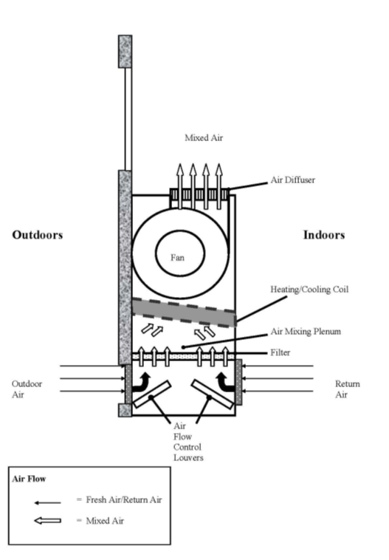

Figure 2: Cross Ventilation in a Building Using Open Windows and Doors/Transoms

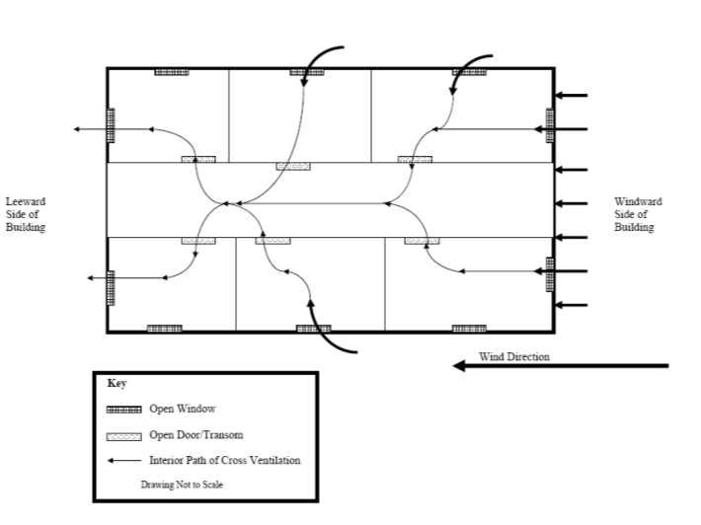

PICTURES

Picture
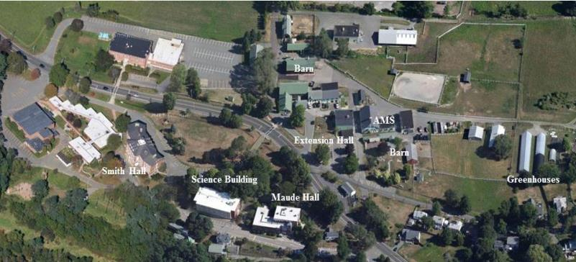

Campus map showing buildings investigated in this report
Picture

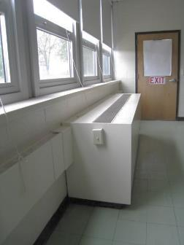

Classroom uninvent, note switch activation allowing easy deactivation

Picture

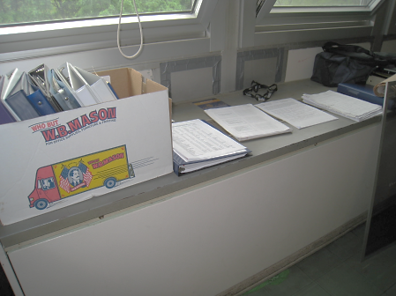

Classroom univent, note materials placed on top of diffuser preventing air flow

Picture

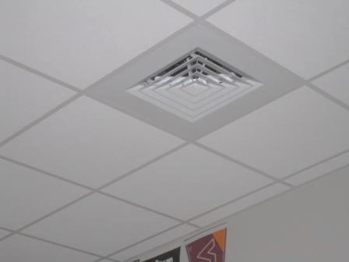

Ceiling-mounted supply vent

Picture

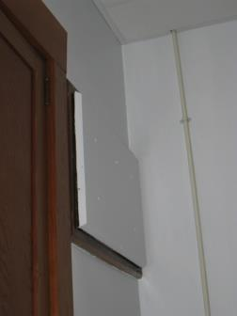

Sealed heating vent

Picture

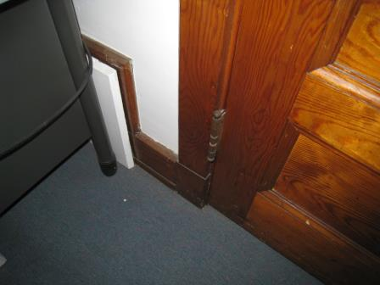

Sealed gravity exhaust vent (arrow)

Picture

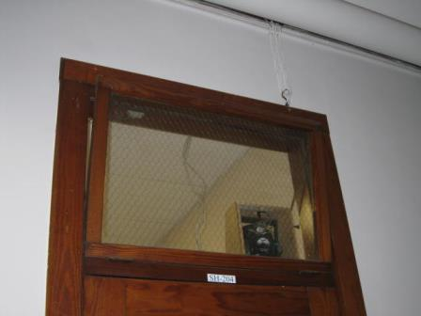

Transom

Picture

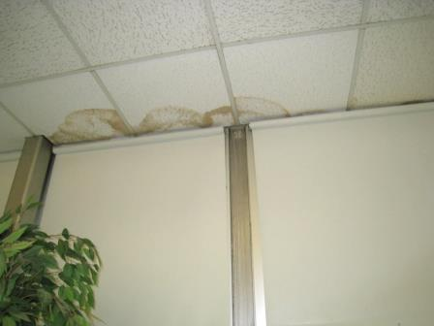

Water-damaged ceiling tiles above windows

Picture

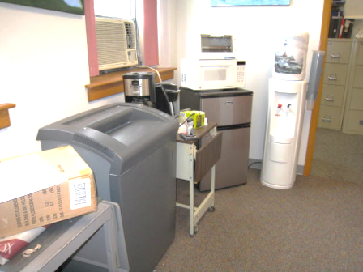

Water cooler and fridge on carpet

Picture

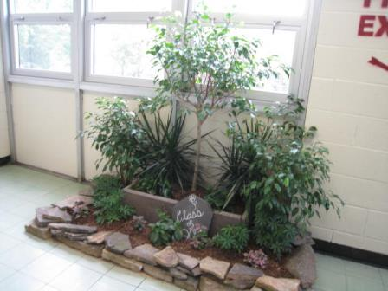

Garden located in hallway

Picture

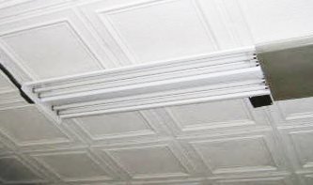

Missing light cover

Picture

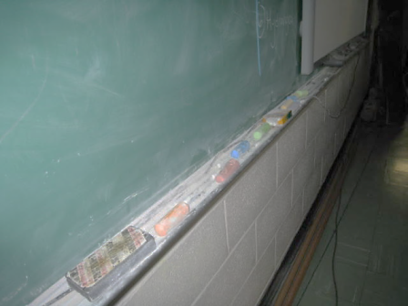

Chalk dust in trays

Picture

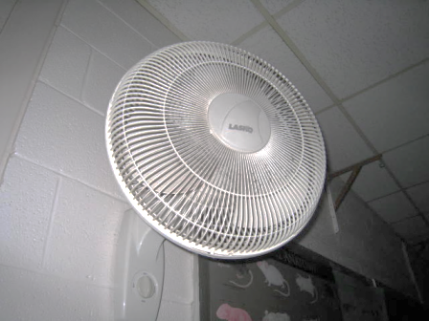

Dust accumulated on fan blades and cover

Picture

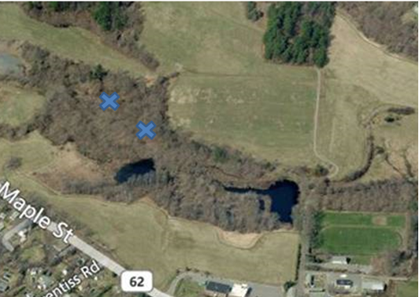

Approximate location of tunnels

Picture

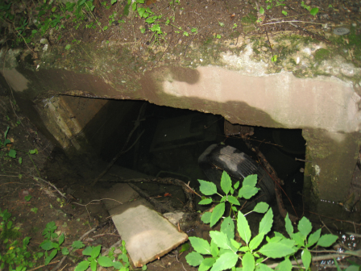

First tunnel, opening filled with water

Picture

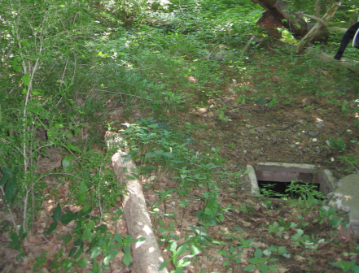

Second tunnel, first access

Picture

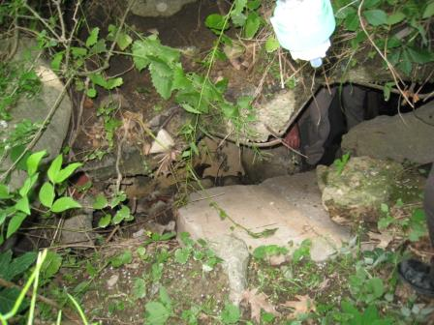

Second tunnel, second access
Picture

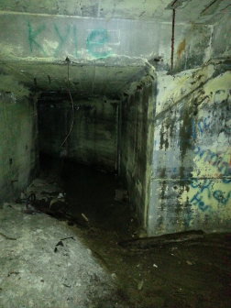

Spray-painted graffiti, indicating access to tunnel

Picture

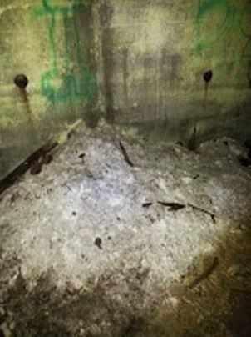

Mound of suspected asbestos

TABLES

Location | Carbon  Dioxide  (ppm) | Carbon Monoxide  (ppm) | Temp  (°F) | Relative  Humidity  (%) | PM2.5  (µg/m³) | Hg  (µg/m³) | TVOCs  (ppm) | Occupants  in Room | Windows  Openable | Ventilation |  | Remarks
 |  |  |  |  |  |  |  |  |  | Intake | Exhaust
Background | 405 | ND | 66 | 53 | 20 | 0.017 | ND |  |  |  |  | Overcast
Automotive Shop (AMS)
AMS 02 (arbor workshop) | 470 | ND | 68 | 60 | 20 | 0.030 | ND | 0 | N | N | N | Door open, planting equipment, holes in wallboard and ceiling
AMS 03 | 729 | ND | 68 | 59 | 23 | 0.032 | 1.2 | 0 | N | N | N | Engines and engine repair equipment
AMS 05 engine | 477 | ND | 68 | 61 | 25 | 0.023 | 1.3 | 0 | N | N | N | Large doors openable, vehicles
AMS 101 | 1077 | ND | 68 | 63 | 18 | 0.032 | ND | 17 | Y | N | N sealed | DEM, items, window AC- insulated with rags
AMS Wood Shop | 578 | ND | 69 | 56 | 22 | 0.026 | ND | 0 | Y | N | N | Room not used except by staff and infrequently, wood, shavings and machine items
Extension Hall
EH 01 (bird room) | 712 | ND | 72 | 72 | 78 | 0.034 | ND | 0 | Y | N | N | ~ 15 caged birds
EH 03 (small mammals) | 798 | ND | 72 | 49 | 22 | 0.032 | ND | 0 | Y | Y window AC | N | Caged mammals, PF
EH 06 (reptile) | 537 | ND | 71 | 69 | 18 | 0.043 | ND | 0 | Y | N | N | PF dusty, heat lamps, open water tanks
EH 07 | 503 | ND | 67 | 60 | 28 | 0.027 | ND | 0 | Y 2 open | N | N | I MT, X-ray room
EH B03 (fish) | 428 | ND | 70 | 57 | 21 | 0.027 | ND | 0 | Y | N | N | Many aqua, fish and supplies
Maude Hall
MH 112 | 748 | ND | 71 | 45 | 14 | 0.035 | 1 | 0 | Y | N | N | Window AC on, CPs, missing light cover
MH 118 | 919 | ND | 71 | 61 | 21 | 0.035 | ND | 18 | Y  1 open | N | N | PF on, DEM, WD CTs
MH 124 | 1010 | ND | 67 | 68 | 21 | 0.032 | ND | 17 | N | Y |  | Plants, PF, dog
MH 124 inner | 881 | ND | 70 | 59 | 16 | 0.035 | ND | 0 | N | Y  UV | N | Window AC off, 2 WD-CT, DO
Science Building
SB 104 | 559 | ND | 67 | 62 |  | 0.023 | ND | 0 | Y | Y  UV off | N | PF, ~30 computers
SB 106 | 631 | ND | 69 | 57 | 10 | 0.023 | ND | 0 | N | Y | N | PF, DO
SB 200 | 566 | ND | 70 | 58 | 14 | 0.017 | ND | 5 | Y  3 open | Y  UV off |  | Aqua, PF dusty
SB 202 | 739 | ND | 71 | 56 | 12 | 0.021 | ND | 1 | Y  2 open | Y  UV off |  | Plants, PF, DEM, aqua
SB 204 | 1162 | ND | 70 | 59 |  | 0.030 | 1.4 | 0 | Y | Y  UV off | Y | DEM, aqua, NC, PF dusty
SB 205 | 1051 | ND | 71 | 58 |  | 0.040 | ND | 0 | Y | Y  UV | Y off | Sinks, PF dusty, DEM, chemical flame cabinet
SB 209 | 1267 | ND | 71 | 59 | 10 | 0.028 | ND | 0 | Y | Y  UV off | Y wall off | DEM, PF, CPs
SB 2nd floor women’s toilet |  |  |  |  |  |  |  |  | Y  open |  | Y off | AT
SB 302 | 884 | ND | 72 | 57 | 15 | 0.037 | ND | 1 | Y | Y off | Y | PF dusty, terrarium, DEM
SB 303 | 809 | ND | 69 | 57 | 12 | 0.063 | ND | 1 | Y | Y  UV off | Y off | Plants, DEM, DO
SB 304 | 778 | ND | 71 | 54 | 11 | 0.034 | ND | 1 | Y  open | Y |  | DEM, DO
SB 306 | 684 | ND | 69 | 55 | 13 | 0.093 | ND | 0 | Y | Y  UV | Y UV exhaust, off | Plants, CD, DEM
SB 307 | 885 | ND | 71 | 55 | 14 | 0.041 | ND | 1 | Y | Y  UV | Y UE | WD CT and carpeting in hallway outside
SB faculty kitchen | 709 | ND | 70 | 59 | 10 | 0.024 | ND | 2 | N | N |  | DO, PC, 2 WD-CT
SB info lab | 660 | ND | 69 | 61 |  | 0.026 | ND | 11 | N | N | N | FCU, computers, PF
SB library | 702 | ND | 67 | 61 | 10 | 0.024 | ND | 5 | Y | Y UV | Y UE | 10 WD-CT
Smith Hall
SH 102 Nurse’s |  | ND | 72 | 55 | 19 | 0.001 | ND | 2 | Y | N | N | AP, NC, fridge
SH 102 resting area | 916 | ND | 72 | 53 | 22 | 0.001 | ND-0.7 | 2 | Y | N | N
SH 106 | 465 | ND | 71 | 53 | 8 | 0.010 | ND | 0 | Y | N | N
SH 108 alumni office | 708 | ND | 75 | 48 | 13 | 0.019 | ND | 2 | Y | N | N | PC, window AC, PF
SH 113 (N.Chesna) | 553 | ND | 73 | 53 |  | 0.018 | ND | 1 | Y | N | N | Window AC
SH 113 (S.Mcwillerson) | 715 | ND | 73 | 53 |  | 0.018 | ND | 1 | Y | N | N | Plants, AP, portable AC
SH 113 Main Room | 539 | ND | 72 | 53 |  |  |  | 0 | Y | Y | Y | Fridge, shredder, microwave, water dispenser on carpet
SH 201 | 1645 | ND | 74 | 52 | 18 | 0.021 | ND | 7 | Y |  | Y | Window AC (off) carpet, DEM
SH 202 | 1327 | ND | 74 | 45 | 15 | 0.043 | ND | 1 | Y | N | N | Window AC on, PF, DEM
SH 204 | 1404 | ND | 75 | 55 | 16 | 0.022 | ND | 24 | Y |  | Y | Window AC (off), DEM, carpet
SH 207 | 1326 | ND | 75 | 50 | 10 | 0.032 | ND | 1 | Y | N | N | Window AC off
SH 208 | 669 | ND | 73 | 40 | 11 | 0.024 | ND | 2 | Y | N |  | DEM, window AC on, computers,
SH 209 | 1541 | ND | 74 | 51 | 20 | 0.034 | ND | 4 | Y | N | N | DEM, window AC on
SH 210 | 2013 | ND | 75 | 55 | 16 | 0.013 | 1.3 | 9 | Y | Y blocked | Y blocked | Window AC off, DEM
SH 211 | 1334 | ND | 75 | 50 | 14 | 0.031 | ND | 3 | Y | N | N | Window AC off
SH 213 | 1271 | ND | 73 | 53 | 17 | 0.031 | ND | 6 | Y | N | N | Window AC on
SH 219 | 907 | ND | 73 | 49 | 16 | 0.019 | ND | 3 | Y |  | Y | Window AC, fridge, microwave, WD-CT,
SH facility manager’s office | 733 | ND | 75 | 48 | 10 | 0.019 | ND | 0 | N | Y | Y | Fridge, aqua, DO
SH hallway first floor | 627 | ND | 71 | 54 | 13 | 0.013 | ND | 0 | N | N | N
SH IT director’s office | 782 | ND | 75 | 42 | 7 | 0.002 | ND | 0 | Y | N | N | DO
SH Norkiewicz office | 647 | ND | 75 | 48 | 11 | 0.019 | ND | 1 | Y | N | Y | Window AC, DO
SH SB01 | 1338 | ND | 72 | 60 | 15 | 0.007 | ND-0.6 | 9 | Y | Y | Y | DEM
SH SB02 guidance | 998 | ND | 71 | 57 | 14 | 0.009 | ND | 3 | Y | Y | Y | Water cooler on carpet
SH SB03 | 1164 | ND | 73 | 55 | 17 | 0.007 | ND | 2 | N | Y | Y
SH SB04 | 799 | ND | 70 | 54 | 12 | 0.010 | ND | 2 | Y | Y | Y | Odor, DEM
SH SB05 | 1000 | ND | 71 | 56 | 15 | 0.004 | ND | 0 | N | Y | Y | DO
SH SB06 | 1095 | ND | 73 | 53 | 17 | 0.011 | ND | 2 | Y | Y | Y | Fridge, microwave
SH SB08 | 644 | ND | 72 | 53 | 13 | 0.011 | ND | 1 | Y | N | N | DEM, DO
SH SB13 | 585 | ND | 72 | 52 | 16 | 0.012 | ND | 0 | Y | N | N | PF, microwave, fridge
Outbuildings and Barns
Greenhouse 33 | 400 | ND | 62 | 75 | 23 | 0.023 | ND | 0 | Y | N | N | Walls have openings to outside, plants and potting materials
Greenhouse 34 | 391 | ND | 63 | 76 | 27 | 0.025 | ND | 0 | Y | N | N | Walls have openings to outside, plants and potting materials
Red Barn | 461 | ND | 69 | 63 | 25 | 0.022 | 1.8 | 0 | N | N | N | Equipment
Sheep Barn | 403 | ND | 69 | 63 | 25 | 0.021 | ND | 0 | Y | N | N | DO

APPENDICES

Appendix A: Carbon Dioxide and its Use in Evaluating Adequacy of Ventilation in Buildings

Carbon Dioxide and its Use in Evaluating Adequacy
of Ventilation in Buildings

The Bureau of Environmental Health’s (BEH) Indoor Air Quality (IAQ) Program examines indoor air quality conditions that may have an effect on building occupants. The status of the ventilation system, potential moisture problems/microbial growth and identification of respiratory irritants are examined in detail, which are described in the attached report. In order to examine the function of the ventilation system, measurements for carbon dioxide, temperature and relative humidity are taken. Carbon dioxide measurements are commonly used to assess the adequacy of ventilation within an indoor environment.
Carbon dioxide is an odorless, colorless gas. It is found naturally in the environment and is produced in the respiration process of living beings. Another source of carbon dioxide is the burning of fossil fuels. Carbon dioxide concentration in the atmosphere is approximately 250-600 ppm (Beard, 1982; NIOSH, 1987).
Carbon dioxide measurements within an occupied building are a standard method used to gauge the adequacy of ventilation systems. Carbon dioxide is used in this process for a number of reasons. Any occupied building will have normally occurring environmental pollutants in its interior. Human beings produce waste heat, moisture and carbon dioxide as by-products of the respiration process. Equipment, plants, cleaning products or supplies normally found in any building can produce gases, vapors, fumes or dusts when in use. If a building has an adequately operating mechanical ventilation system, these normally occurring environmental pollutants will be diluted and removed from the interior of the building. The introduction of fresh air both increases the comfort of the occupants and serves to dilute normally occurring environmental pollutants.

An operating exhaust ventilation system physically removes air from a room and thereby removes environmental pollutants. The operation of supply in conjunction with the exhaust ventilation system creates airflow through a room, which increases the comfort of the occupants. If all or part of the ventilation system becomes non-functional, a build up of normally occurring environmental pollutants may occur, resulting in an increase in the discomfort of occupants.
The MDPH approach to resolving indoor air quality problems in schools and public buildings is generally two-fold: 1) improving ventilation to dilute and remove environmental pollutants and 2) reducing or eliminating exposure opportunities from materials that may be adversely affecting indoor air quality. In the case of an odor complaint of unknown origin, it is common for BEH staff to receive several descriptions from building occupants. A description of odor is subjective, based on the individual’s life experiences and perception. Rather than test for a potential series of thousands of chemicals to identify the unknown material, carbon dioxide is used to judge the adequacy of airflow as it both dilutes and removes indoor air environmental pollutants.
As previously mentioned, carbon dioxide is used as a diagnostic tool to evaluate air exchange by building ventilation systems. The presence of increased levels of carbon dioxide in indoor air of buildings is attributed to occupancy. As individuals breathe, carbon dioxide is exhaled. The greater the number of occupants, the greater the amount of carbon dioxide produced. Carbon dioxide concentration build up in indoor environments is attributed to inefficient or non-functioning ventilation systems. The Occupational Safety and Health Administration (OSHA) standard for carbon dioxide is 5,000 parts per million parts of air (ppm). Workers may be exposed to this level for 40 hours/week, based on a time-weighted average (OSHA, 1997).
Carbon dioxide can be a hazard within enclosed areas with no air supply. These types of enclosed areas are known as confined spaces. Manholes, mines and sewer systems are examples of confined spaces. An ordinary building is not considered a confined space. Carbon dioxide air exposure limits for employees and the general public have been established by a number of governmental health and industrial safety groups. Each of these standards of air concentrations is expressed in parts per million (ppm). Table 1 is a listing of carbon dioxide air concentrations and related health effects and standards.
The MDPH uses a guideline of 800 ppm for publicly occupied buildings (Burge et al., 1990; Gold, 1992; Norback, 1990; OSHA, 1994; Redlich, 1997; Rosenstock, 1996; SMACNA, 1998). A guideline of 600 ppm or less is preferred in schools due to the fact that the majority of occupants are young and considered to be a more sensitive population in the evaluation of environmental health status. Several sources indicate that indoor air problems are significantly reduced at 600 ppm or less of carbon dioxide (ACGIH, 1998; Bright et al., 1992; Hill, 1992; NIOSH, 1987). Inadequate ventilation and/or elevated temperatures are major causes of complaints such as respiratory, eye, nose and throat irritation, lethargy and headaches.
Air levels for carbon dioxide that indicate that indoor air quality may be a problem have been established by the American Society of Heating, Refrigerating and Air-conditioning Engineers (ASHRAE). Above 1,000 ppm of carbon dioxide, ASHRAE recommends adjustment of the building’s ventilation system (ASHRAE, 1989). In 2001, ASHRAE modified their standard to indicate that no more than 700 ppm above the outdoor air concentration; however 800 ppm is the level where further investigation will occur.
Carbon dioxide itself has no acute (short-term) health effects associated with low level exposure (below 5,000 ppm). The main effect of carbon dioxide involves its ability to displace oxygen for the air in a confined space. As oxygen is inhaled, carbon dioxide levels build up in the confined space, with a decrease in oxygen content in the available air. This displacement of oxygen makes carbon dioxide a simple asphyxiant. At carbon dioxide levels of 30,000 ppm, severe headaches, diffuse sweating, and labored breathing have been reported. No chronic health effects are reported at air levels below 5,000 ppm.
Air testing is one method used to determine whether carbon dioxide levels exceed the comfort levels recommended. If carbon dioxide levels are over 800-1,000 ppm, the MDPH recommends adjustment of the building's ventilation system. The MDPH recommends that corrective measures be taken at levels above 800 ppm of carbon dioxide in office buildings or schools. (Please note that carbon dioxide levels measured below 800 ppm may not decrease indoor air quality complaints). Sources of environmental pollutants indoors can often induce symptoms in exposed individuals regardless of the adequacy of the ventilation system. As an example, an idling bus outside a building may have minimal effect on carbon dioxide levels, but can be a source of carbon monoxide, particulates and odors via the ventilation system.
Therefore, the MDPH strategy of adequate ventilation coupled with pollutant source reduction/removal serves to improve indoor air quality in a building. Please note that each table included in the IAQ assessment lists BEH comfort levels for carbon dioxide levels at the bottom (i.e. carbon dioxide levels between 600 ppm to 800 ppm are acceptable and <600 ppm is preferable). While carbon dioxide levels are important, focusing on these air measurements in isolation to all other recommendations is a misinterpretation of the recommendations made in these assessments.

Table 1: Carbon Dioxide Air Level Standards
Carbon Dioxide  Level | Health Effects | Standards or Use of Concentration | Reference
250-600 ppm | None | Concentrations in ambient air | Beard, R.R., 1982  NIOSH, 1987
600 ppm | None | Few indoor air complaints, used as reference for air exchange for protection of children | ACGIH, 1998; Bright et al., 1992; Hill, 1992; NIOSH 1987
800 ppm | None | Used as an indicator of ventilation adequacy in schools and public buildings, used as reference for air exchange for protection of children | Mendler, 2003  Bell, A. A., 2000; NCOSP, 1998;  SMACNA, 1998; EA, 1997;  Redlich, 1997; Rosenstock, 1996; OSHA, 1994; Gold, 1992;  Burge et al., 1990; Norback, 1990 ;  IDPH, Unknown
1000 ppm | None | Used as an indicator of ventilation inadequacy concerning removal of odors from the interior of building. | ASHRAE, 1989
950-1300 ppm* | None | Used as an indicator of ventilation inadequacy concerning removal of odors from the interior of building. | ASHRAE, 1999
700 ppm (over background) | None | Used as an indicator of ventilation inadequacy concerning removal of odors from the interior of building. | ASHRAE, 2001
5000 ppm | No acute (short term) or chronic (long-term) health effects | Permissible Exposure Limit/Threshold Limit Value | ACGIH, 1999  OSHA, 1997
30,000 ppm | Severe headaches, diffuse sweating, and labored breathing | Short-term Exposure Limit | ACGIH, 1999  ACGIH. 1986
* outdoor carbon dioxide measurement +700 ppm

References
ACGIH. 1986. Documentation of the Threshold Limit Values. American Conference of Governmental Industrial Hygienists. Cincinnati, OH.
ACGIH. 1998. Industrial Ventilation A Manual of Recommended Practice. 23rd Edition. American Conference of Governmental Industrial Hygienists. Cincinnati, OH.
ACGIH. 1999. Guide to Occupational Exposures-1999. American Conference of Governmental Industrial Hygienists, Cincinnati, OH.
ASHRAE. 1989. Ventilation for Acceptable Indoor Air Quality. American Society of Heating, Refrigeration and Air Conditioning Engineers. ANSI/ASHRAE 62-1989.
ASHRAE. 1999. Ventilation for Acceptable Indoor Air Quality. American Society of Heating, Refrigeration and Air Conditioning Engineers. ANSI/ASHRAE 62-1999.
ASHRAE. 2001. Ventilation for Acceptable Indoor Air Quality. American Society of Heating, Refrigeration and Air Conditioning Engineers. ANSI/ASHRAE 62-2001.
Beard, R.R. 1982. Chapter Fifty-two, Inorganic Compounds of Oxygen, Nitrogen, and Carbon. Patty’s Industrial Hygiene and Toxicology, Vol. IIc. 3rd ed. Clayton, G. D. & Clayton, F. E., eds. John Wiley & Sons, New York, NY.
Bright, P.; Mader, M.; Carpenter, D.; and Hermon-Cruz, I.Z. 1992. Guideline for Indoor Air Surveys. Brooks Air Force Base, TX. Armstrong Laboratory, Occupational and Environmental Health Directorate. NTIS AL-TR-1992-0016.
Burge, H. and Hoyer, M. 1990. Focus On … Indoor Air Quality. Appl. Occup. Environ. Hyg. 5(2):88.
EA. 1997. Indoor Air Quality. Environment Australia, Department of the Environment, Sport and Territories, Canberra, Australia. www.environment.gov.au/soe/1996/publications/technical/pubs/12indora.pdf
Gold, D. 1992. Indoor Air Pollution. Clinics in Chest Medicine. 13(2):224-225.
Hill, B.; Craft, B.; and Burkart, J. 1992. Carbon Dioxide, Particulates and Subjective Human Responses in Office Buildings without Histories of Indoor Air Quality Problems. Appl. Occup. Environ. Hyg. 7(2): 101-111.
IDPH. Unknown. Illinois Department of Public Health Guidelines for Indoor Air Quality. Illinois Department of Public Health, Springfield, Il. http://www.idph.state.il.us/envhealth/factsheets/indoorairqualityguide_fs.htm
Mendler, S. and Odell, W. 2003. Indoor Air Quality for the EPA. ArchitectureWeek. April 16, 2003. http://www.architectureweek.com/2003/0416/environment_1-2.html
NCOSP. 1998. Workplace Requirements for Safety & Health, Indoor Air Quality 3.3.3. NC Office of State Personnel, Raleigh, NC. www.osp.state.nc.us/emprsk/safety/handbook/5-9.pdf
NIOSH. 1987. Guidance for Indoor Air Quality Investigations. Cincinnati, OH. National Institute for Occupational Safety and Health, Hazards Evaluations and Technical Assistance Branch, Division of Surveillance, Hazard Evaluation and Field Studies.
Norback, D.; Torgen, M.; and Edling, C. 1990. Volatile Organic Compounds, Respirable Dust, and Personal Factors Related to Prevalence and Incidence of Sick Building Syndrome in Primary Schools. British Journal of Industrial Medicine. 47:740.
OSHA. 1994. Occupational Safety and Health Administration. Indoor Air Quality (Proposed Regulation), Federal Register 59:15968-16039, (1994) Appendix A.
OSHA. 1997. Limits for Air Contaminants. Occupational Safety and Health Administration. Code of Federal Regulations. 29 C.F.R 1910.1000 Table Z-1-A.
Redlich, C.; Sparer, J.; and Cullen, M. 1997. Sick-building Syndrome. Lancet. 349:1016.
Rosenstock, L. 1996. NIOSH Testimony to the U.S. Department of Labor on Air Quality, Appl. Occup. Environ. Hyg. 11(12):1368.
SMACNA. 1998. Indoor Air Quality: A Systems Approach. 3rd ed. Sheet Metal and Air Conditioning Contractors’ National Association, Inc, Chantilly, VA. National Association, Inc.

Appendix B: Mercury Action Levels

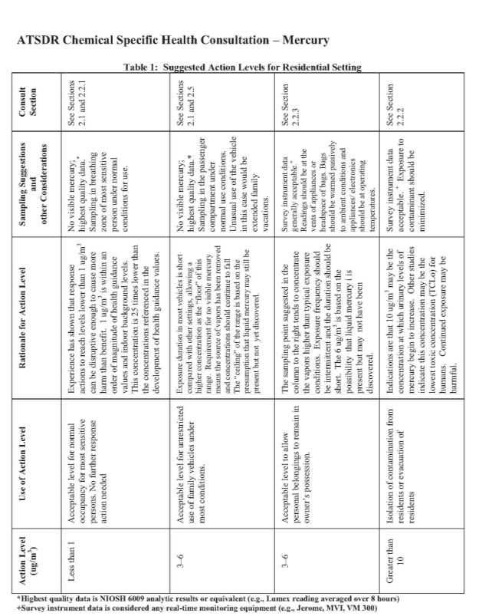
Source: http://www.atsdr.cdc.gov/emergency_response/Action_Levels_for_Elemental_Mercury_Spills_2012.pdf

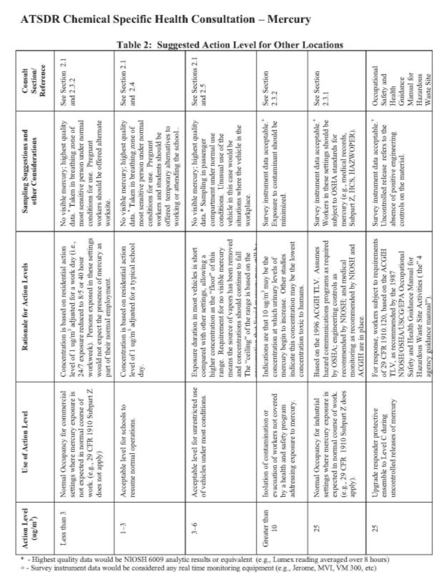
Source: http://www.atsdr.cdc.gov/emergency_response/Action_Levels_for_Elemental_Mercury_Spills_2012.pdf

Appendix C: East Street Field Health Consultation Report

Massachusetts
Department Of
Public Health

Health Consultation:
Evaluation of Monitoring Data for
East Street Landfill,
Middleton, Essex County, Massachusetts

November 2014

Bureau of
Environmental Health,
Community Assessment
Program

- BACKGROUND AND STATEMENT OF ISSUES
In response to a request by several concerned parents, the Massachusetts Department of Public Health (MDPH), Bureau of Environmental Health (BEH), evaluated the potential for health impacts associated with the use of the East Street recreational fields (ESF), located adjacent to the closed East Street landfill in Middleton. Community concerns about the occurrence of vocal tics and chronic hiccups among local high school students using the recreation fields prompted this request.
In response, MDPH/ BEH reviewed available environmental data for East Street Field. MDPH/BEH also conducted a site visit at the field with the director of the local Health Department and the director of the Department of Public Works for the town of Middleton, MA.
The Town of Middleton owns and operates the 131 East Street property, which includes the closed landfill and a multi-use recreational field. The capped landfill, 17 acres in size, reaches an elevation of 97 feet at its highest point. Along its western side, the landfill is bordered by a multi-use recreational field (which reportedly had been historically used for farming and has no history of waste disposal), a parking lot, and residential properties. A storm water retention pond and a fire pond abut the landfill’s northern side while wooded wetlands and grassland surround its southern and eastern sides (Figure 1). The closed landfill is maintained and accessible, with a gravel road leading to the top and a maintenance road encircling the landfill perimeter.
In 2001, the Massachusetts Department of Environmental Protection (MassDEP) issued a closure certification for the landfill site which indicated the site was “closed”, meaning that the facility was deactivated in compliance with the approved facility final closure plan and applicable closure requirements. In 2008, to prepare for a reconstruction of ESF, a new detention pond to capture precipitation and runoff was constructed on the southwestern corner of the site. A circuit of swales directs surface water on the landfill’s surface to drainage pipes. Surface water flows from drainage pipes into the retention and detention ponds on the northwestern and southwestern corners of the landfill respectively. The surface water collection system is reportedly effective in preventing runoff from reaching the recreational fields and adjacent properties (personal communication with Bob Labossiere; Director, Middleton Department of Public Works; May 6, 2013). To construct the recreational fields, off-site soil was brought in.
In addition to the thick vegetation, the forested wetlands that border these surface water bodies minimize opportunities for visitors to access them.
The landfill’s impermeable cap prevents water from entering the area containing waste. Maintaining low moisture content within the landfill diminishes microorganisms’ capability to produce large volumes of subsurface gas. However, the impermeable cap may create an opportunity for horizontal migration of subsurface gases to surrounding areas. Three landfill gas monitoring probes lie along the eastern side of the soccer field within the recreational field. CDM, an environmental consulting company, collects subsurface soil gas samples semi-annually from the three landfill gas probes lining the soccer field. These samples allow CDM to determine if landfill gas is migrating laterally and to prevent any explosive hazards related to methane production.
Two baseball diamonds and a soccer field located on a 4.5-acre parcel of land west of the landfill comprise the multi-use recreational field referred to as East Street Field. Approximately 250 feet from the base of the landfill, a steep upward slope along the eastern side of the soccer field separates this field from the maintenance road encircling the landfill’s base.
The town of Middleton’s Department of Public Works maintains the field, irrigating it with town water dispensed from a fire truck, as there are no facilities or water sources located at the field (personal communication with Bob Labossiere; Director, Middleton Department of Public Works; May 6th, 2013). Local youth and adult sports leagues, along with high school sports teams, began using the fields in 2005 (personal communication with Derek Fullerton; Middleton Health Director; April 9, 2013). Local women’s high school soccer teams from North Shore Technical School and Essex Agricultural School started using the fields for practice in 2010 and 2012, respectively.
- ENVIRONMENTAL SAMPLING DATA
MDPH evaluated available environmental sampling data for surface water and soil gas. Surface water samples were collected from the following locations (see Figure 1): the retention pond along the northern border of the landfill (SW-1), Nichol’s Brook (SW-2) south of the landfill, and a portion of wetland referred to as Wolcott’s Island (SW-3). Samples were analyzed for dissolved metals, volatile organic compounds (VOCs), semi-volatile organic compounds, and other field parameters. Soil gas probes are also located along the side of the soccer field and are monitored for potential offsite migration of landfill soil gas. These data were also reviewed.
Although groundwater data for the area were available, there is no exposure opportunity to groundwater from use of the ESF, and hence, these data were not evaluated.
MDPH also evaluated information about pesticide applications conducted at the fields to address specific concerns about possible exposure to pesticides.
- METHODS OF EVALUATING MONITORING DATA
MDPH performed a screening evaluation of available data from May 2010 through November 2012, a period of 2.5 years. The screening process allows the health assessor to identify substances requiring further evaluation to determine if they pose a threat to human health. MDPH compares measured concentrations of substances detected in environmental media to established screening or comparison values published by the U.S. Agency for Toxic Substances and Disease Registry (ATSDR).
The ATSDR comparison values (CVs) are specific concentrations of chemicals in environmental media (i.e., air, soil, or water) that are used by health assessors to identify environmental contaminants that require further evaluation. Comparison values are developed based on health guidelines and assumed exposure situations that represent conservative estimates of human exposure. Comparison values are set well below levels that are known or anticipated to result in adverse health effects. Contamination levels detected in environmental media that are less than a comparison value are not likely to pose a health concern. Concentrations detected in environmental media above a comparison value do not necessarily indicate that a health threat is present, but rather indicate the need for further evaluation by assessing opportunities for exposures or possible health effects.
Because no CVs exist for surface water, CVs for drinking water were used as an initial screen in this health consultation. If an ATSDR comparison value was not available for a specific contaminant, surface water results were compared to Regional Screening Levels developed by the United States Environmental Protection Agency (EPA) Region 3 (USEPA 2013a; ATSDR 2013) or to USEPA Health Advisories for constituents in drinking water.
Use of drinking water guidelines is a conservative approach because exposure opportunities to constituents in drinking water would be expected to be much higher than to constituents in surface water at this site.
In addition, surface water results were compared to Massachusetts Maximum Contaminant Levels (MCLs) for municipal drinking water supplies. The Massachusetts MCLs are standards to regulate contaminants in public drinking water supplies. MCLs apply to drinking water provided by public water systems, and hence are a conservative (protective) standard to use for comparison with surface water sampling results. Several constituents are not regulated by an MCL as they do not pose health concerns in general; for these, MDPH compared constituent concentrations to a Massachusetts Secondary Contaminant Level (MSCL) or a MassDEP Office of Research and Standards Guideline (ORSG) for drinking water. SMCLs are derived to address aesthetic properties of drinking water quality, such as taste, odor, or color.
For subsurface soil gas, MDPH compared the concentrations to the Lower Explosive Limit (LEL) and concentrations listed in ATSDR’s landfill gas primer for soil gas monitoring (ATSDR 2006).
No sampling data were available for pesticides used at the fields. However, MDPH/BEH contacted local officials to evaluate whether and what pesticides had been used in order to evaluate potential exposure opportunities to individuals using the ESF.
- RESULTS
Surface Water
A total of 12 constituents were detected at least once in a surface water sample (Table 1). Of these, chloride and sulfate concentrations were less than the secondary MCLs that are based on aesthetic issues, and hence are not considered of health concern. Detections of six other constituents (acetone, barium, cadmium, copper, iron, and nitrate-nitrogen) were below any available health-based comparison value for drinking water. Cyanide (0.007 ppm) was slightly above the CV of 0.006 ppm but well below the drinking water standard for public water supplies of 0.2 ppm. Arsenic was detected at a concentration of 0.006 ppm, less than the drinking water standard for public water supplies of 0.01 ppm but above ATSDR’s comparison values based on arsenic’s potential to pose a risk of cancer. Finally, manganese was detected at a concentration of 2.24 ppm, which was above the EPA health advisory for this metal in drinking water of 0.3 ppm. Although some of these constituents exceeded health-based comparison values, these screening values were derived assuming daily exposure through drinking 2 liters of water a day for a lifetime. All the surface waters sampled are difficult to access (based on our site visit), and it is highly unlikely that anyone using the ESF would actually have opportunities to be exposed to constituents in these surface waters. Thus, given the very infrequent opportunities for direct contact with these surface waters and the low number of constituents that exceeded a health-based standard for drinking water supplies (i.e., daily consumption over a lifetime), we would not expect health effects to result based on evaluating potential exposure opportunities to constituents in surface water at ESF.
Landfill Gas
MDPH reviewed the results of landfill gas monitoring for five sampling events: May and November 2010, November 2011, and April and November 2012. There were no detections of VOCs, methane, or hydrogen sulfide, all of which are associated with landfill gases.

Pesticide Use
MDPH evaluated available information about pesticide applications conducted at the fields to address specific concerns about this issue. The Northeast Mosquito Control District, an organization operating under the State Reclamation and Mosquito Control Board, treated ESF in August and September 2012 and September 2013 in response to threats related to Eastern Equine Encephalitis (EEE) and West Nile Virus (WNV), two mosquito-borne viruses that can cause serious illness.
Pesticide applications were made at the ESF on August 22 and September 7, 2012, and on September 18, 2013. All applications were reportedly made after 8:15 PM or after activities on the field that day ceased. Applications were conducted using a truck mounted sprayer using an ultra-low volume method, meaning that the concentration of the active ingredients was low relative to the large area that the application covered.
DUET and Suspend SC pesticides are targeted to kill adult mosquitoes. Based upon information reviewed, DUET was applied to the air at ESF in August and September of 2012 and in the parking lot area during the September 2013 application. Suspend SC was applied to brush and woodland (habitats where mosquitoes may reside) areas lining ESF and the landfill as a barrier control for mosquitoes in September 2013.
These pesticides have active ingredients (e.g., sumithrin) that belong to a class of compounds called pyrethroids, synthetic versions of pyrethrins which are produced by the chrysanthemum flower. These products are commonly used around the U.S. to control mosquitoes and break down quickly in the environment. Two other active ingredients (piperonyl butoxide and 1,2-propanediol) are added to the product to increase the ability of the pyrethroid compounds to kill mosquitoes. Studies to date do not suggest that these products, as applied, will result in any measureable long-term effects. Given the time of application (after activities at the field ceased for the day), low concentrations of the active ingredients applied, and rapid breakdown of the product in the environment, we would not expect adverse health effects from these applications.

- DISCUSSION

MDPH/BEH evaluated environmental data available for the East Street Fields. Results of surface water sampling revealed that exposure opportunities to constituents detected in surface water are unlikely to result in health effects, particularly given the low potential for actual contact with surface waters that are difficult to access due to dense vegetation and location. Subsurface gas samples also did not reveal any detections of landfill-related constituents, indicating that gas generated by the closed landfill is not reaching the nearby ESF. Finally, three pesticide applications conducted in August and September 2012 and September 2013 to address threats related to EEE or WNV were conducted during evening hours when the field was not in use, were of products that break down quickly in the environment, and involved active ingredients that are not likely to pose long-term health concerns. Thus, review of available data for the East Street Fields does not suggest health impacts from potential chemical contaminants in the environment of the fields.
- CONCLUSION
MDPH/BEH does not recommend any further environmental sampling efforts beyond those already conducted as part of the long-term landfill closure monitoring.

- REFERENCES
Agency for Toxic Substance and Disease Registry (ATSDR). 2005. Public Health Assessment Manual. Atlanta: U.S. Department of Health and Human Services. January 2005.
Agency for Toxic Substances and Disease Registry (ASTDR). Landfill Gas Primer. 2006. An Overview for Environmental Health Professionals. [Online] [Accessed in April 2013]. Available from: http://www.atsdr.cdc.gov/HAC/landfill/html/ch2.html.
Agency for Toxic Substances and Disease Registry (ATSDR). 2013. Drinking Water Comparison Values from ATSDR’s Sequoia CV Database. March 2013.
Bayer Environmental Science. 2012. Product Label: Suspend SC. January 11.
Bayer Environmental Science. 2012. Product Material Safety and Data Sheet: Suspend SC Insecticide. June 6.
CDM-Smith. 2010. Rubchinuk Landfill Monitoring Report. August.
CDM-Smith. 2011. Rubchinuk Landfill Monitoring Report. February.
CDM-Smith. 2011. Rubchinuk Landfill Monitoring Report. March.
CDM-Smith. 2011. Rubchinuk Landfill Monitoring Report. June.
CDM-Smith. 2012. Rubchinuk Landfill Monitoring Report. January.
CDM-Smith. 2012. Rubchinuk Landfill Monitoring Report. July.
CDM-Smith. 2013. Rubchinuk Landfill Monitoring Report. January.
Clarke Mosquito Control Products, Inc. 2007. Product Label: DUET Dual- Action Adulticide. April 2007.
Clarke Mosquito Control Products, Inc. 2008. Product Material Safety Data Sheet. June 6, 2008.
Massachusetts Department of Environmental Protection (MassDEP). 2012. Standards and Guidelines for Contaminants in Massachusetts Drinking Waters. Accessed May 2013. Available at: http://www.mass.gov/dep/water/dwstand.pdf
Massachusetts Department of Public Health, Epidemiology Program. (2011). Public Health Fact Sheet: Eastern Equine Encephalitis. Boston, MA : Retrieved from http://www.mass.gov/eohhs/gov/departments/dph/programs/id/epidemiology/providers/public-health-cdc-arbovirus-info.html. Last updated March 2011.
Massachusetts Department of Public Health, Epidemiology Program. (2011). Public Health Fact Sheet: West Nile Virus. Boston, MA : Retrieved from http://www.mass.gov/eohhs/gov/departments/dph/programs/id/epidemiology/providers/public-health-cdc-arbovirus-info.html. Last updated March 2011.
Middleton Department of Public Works. 2013. Personal communication with Bob Labossiere (Middleton DPW). May 6th, 2013.
Middleton Health Department. 2013. Personal communication from Derek Fullerton (Middleton BOH). April 9, 2013.
Middleton Health Department. 2013. Personal communication from Derek Fullerton (Middleton BOH). October 1, 2013.
Massachusetts Department of Agricultural Resources (MDAR). 1998. State of Massachusetts Generic Environmental Impact Report on Mosquito Control Generic Environmental Impact Report(GEIR). Available from: http://www.mass.gov/eea/docs/agr/mosquitos/geir-docs/geir-intro-history-and-practice.pdf
National Pesticide Information Center (NPIC). 2000. Piperonyl Butoxide: Technical Fact Sheet. Available at: http://npic.orst.edu/factsheets/pbogen.pdf. Last updated November 2000.
National Pesticide Information Center (NPIC). 2010. Deltamethrin: Technical Fact Sheet. Available at: http://npic.orst.edu/factsheets/DeltaGen.pdf. Last updated February 2010.
National Pesticide Information Center (NPIC). 2011. D- Phenothrin: Technical Fact Sheet. Available at: http://npic.orst.edu/factsheets/dphentech.pdf. Last updated September 2011.
US EPA. 2012. 2012 Edition of the Drinking Water Standards and Health Advisories. Accessed November 8, 2012 . Available at http://water.epa.gov/action/advisories/drinking/upload/dwstandards2012.pdf. Last updated Spring 2012.
US EPA. 2013a. Human Health Risk Assessment: Regional Screening Levels. Available at: http://www.epa.gov/reg3hwmd/risk/human/index.htm. Last updated May.
US EPA. 2013b. Drinking Water Contaminants. Accessed August 20, 2013. Available at http://water.epa.gov/drink/contaminants/index.cfm#List. Last updated June 03, 2013.
US EPA Office of Pesticide Programs. 2003. Prallethrin: Human Health Risk Assessment for the Public Health use of Mosquito Adulticides Containing Prallethrin. Available at http://www.epa.gov/pesticides/chem_search/hhbp/R086823.pdf. Last updated November 21, 2003.
US EPA Office of Pesticide Programs. 2006. Reregistration Eligibility Decision for Propylene Glycol and Dipropylene Glycol. Available at http://www.epa.gov/oppsrrd1/REDs/propylene_glycol_red.pdf. Last updated September 2006.
US EPA Office of Pesticide Programs. 2008. Reregistration Eligibility Decision for d-Phenothrin. Available at http://www.epa.gov/oppsrrd1/REDs/sumithrin_(d-phenothrin)_red.pdf. Last updated September 2008.
US EPA Office of Pesticide Programs. 2010. Piperonyl Butoxide Summary Document: Registration Review. Available at http://www.epa.gov/oppsrrd1/registration_review/piperonyl_butoxide. Last Updated 2010.
US EPA Office of Pesticide Programs. 2010. Deltamethrin: Human Health Assessment Scoping Document in Support of Registration Review. Available at http://www.epa.gov/oppfead1/endanger/litstatus/effects/redleg-frog/2013/deltamethrin/appendix-j.pdf. Last updated February 2010.
World Health Organization (WHO). 2004. WHO Specifications and Evaluations for Public Health Pesticides: Prallethrin. Available from: http://www.who.int/whopes/quality/en/prallethrin_spec_eval_Nov_2004.pdf. Last updated November 2004.

FIGURES AND TABLES

FIGURE 1

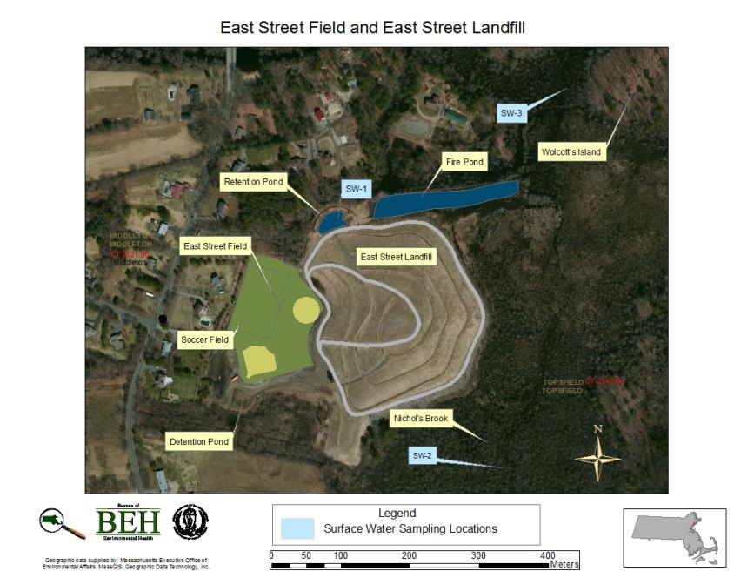
Figure 1:

TABLE 1

Table 1: East Street Field and Landfill, Middleton, MA
Detected Constituents in Surface Water (mg/L or ppm)
Compound | Maximum Detected Concentration | Comparison Value | MCL
Acetone | 0.0076 | Intermediate Child EMEG = 20 | MassDEP ORSG = 6.3
Arsenic | 0.006 | CREG = 2.30E-5 | MMCL = 0.01
 |  | Chronic Child EMEG = 0.003
Barium | 0.044 | Chronic Child EMEG = 2 | MMCL = 2
Cadmium | 0.0007 | Chronic Child EMEG = 0.001 | MMCL = 0.005
 |  | EPA HA = 0.005
Chloride | 230 | No Comparison Value | Massachusetts Secondary MCL = 250
Copper | 0.002 | Intermediate Child EMEG = 0.1 | MMCL = 1.3
Cyanide | 0.007 | Child RMEG = 0.006 | MMCL = 0.2
Iron | 6.5 | EPA RSL Ingestion Screening Level = 11 | Massachusetts Secondary MCL = 0.3
Manganese | 2.24 | Child RMEG = 0.5 | Massachusetts Secondary MCL = 0.05
 |  | EPA HA = 0.3
Nitrate-Nitrogen | 0.37 | Child RMEG = 16 | EPA MCL = 10
Sodium | 100 | No Comparison Value | MassDEP ORSG = 20
Sulfate | 27 | No Comparison Value | Massachusetts Secondary MCL = 250
ATSDR CREG = Cancer Risk Evaluation Guide | EPA MCL = Maximum Contaminant Level  EPA RSL = Regional Screening Level
ATSDR EMEG = Environmental Media Evaluation Guide
ATSDR RMEG = Reference Dose Media Evaluation Guide  EPA HA = Environmental Protection Agency Health Advisory Level | MassDEP ORSG = Massachusetts Department of Environmental Protection Office of Research and Standards Guidelines
 | MMCL = Massachusetts Maximum Contaminant Level
References for Table 1:
Agency for Toxic Substances and Disease Registry (ATSDR). 2013. Drinking Water Comparison Values from ATSDR’s Sequoia CV Database. March 2013.
CDM-Smith. 2010. Rubchinuk Landfill Monitoring Report. August.
CDM-Smith. 2011. Rubchinuk Landfill Monitoring Report. February.
CDM-Smith. 2011. Rubchinuk Landfill Monitoring Report. March.
CDM-Smith. 2011. Rubchinuk Landfill Monitoring Report. June.
CDM-Smith. 2012. Rubchinuk Landfill Monitoring Report. July.

References continued
CDM-Smith. 2013. Rubchinuk Landfill Monitoring Report. January.
Environmental Protection Agency (EPA). 2012. 2012 Edition of the Drinking Water Standards and Health Advisories. Accessed November 8, 2012. Available at http://water.epa.gov/action/advisories/drinking/upload/dwstandards2012.pdf. Last updated Spring 2012.
Environmental Protection Agency (EPA). 2013a. Drinking Water Contaminants. Accessed August 20, 2013. Available at http://water.epa.gov/drink/contaminants/index.cfm#List. Last updated June 03, 2013.
Environmental Protection Agency(EPA). 2013b. Regional Screening Level Summary Table. Available at http://www.epa.gov/region9/superfund/prg/. Last updated May 2013.
Massachusetts Department of Environmental Protection (MassDEP). 2012. Standards and Guidelines for Contaminants in Massachusetts Drinking Waters. Accessed May 2013. Available at: http://www.mass.gov/dep/water/dwstand.pdf. Last updated Spring 2012.

Appendix D: Letter and Consent Form Mailed to Physicians

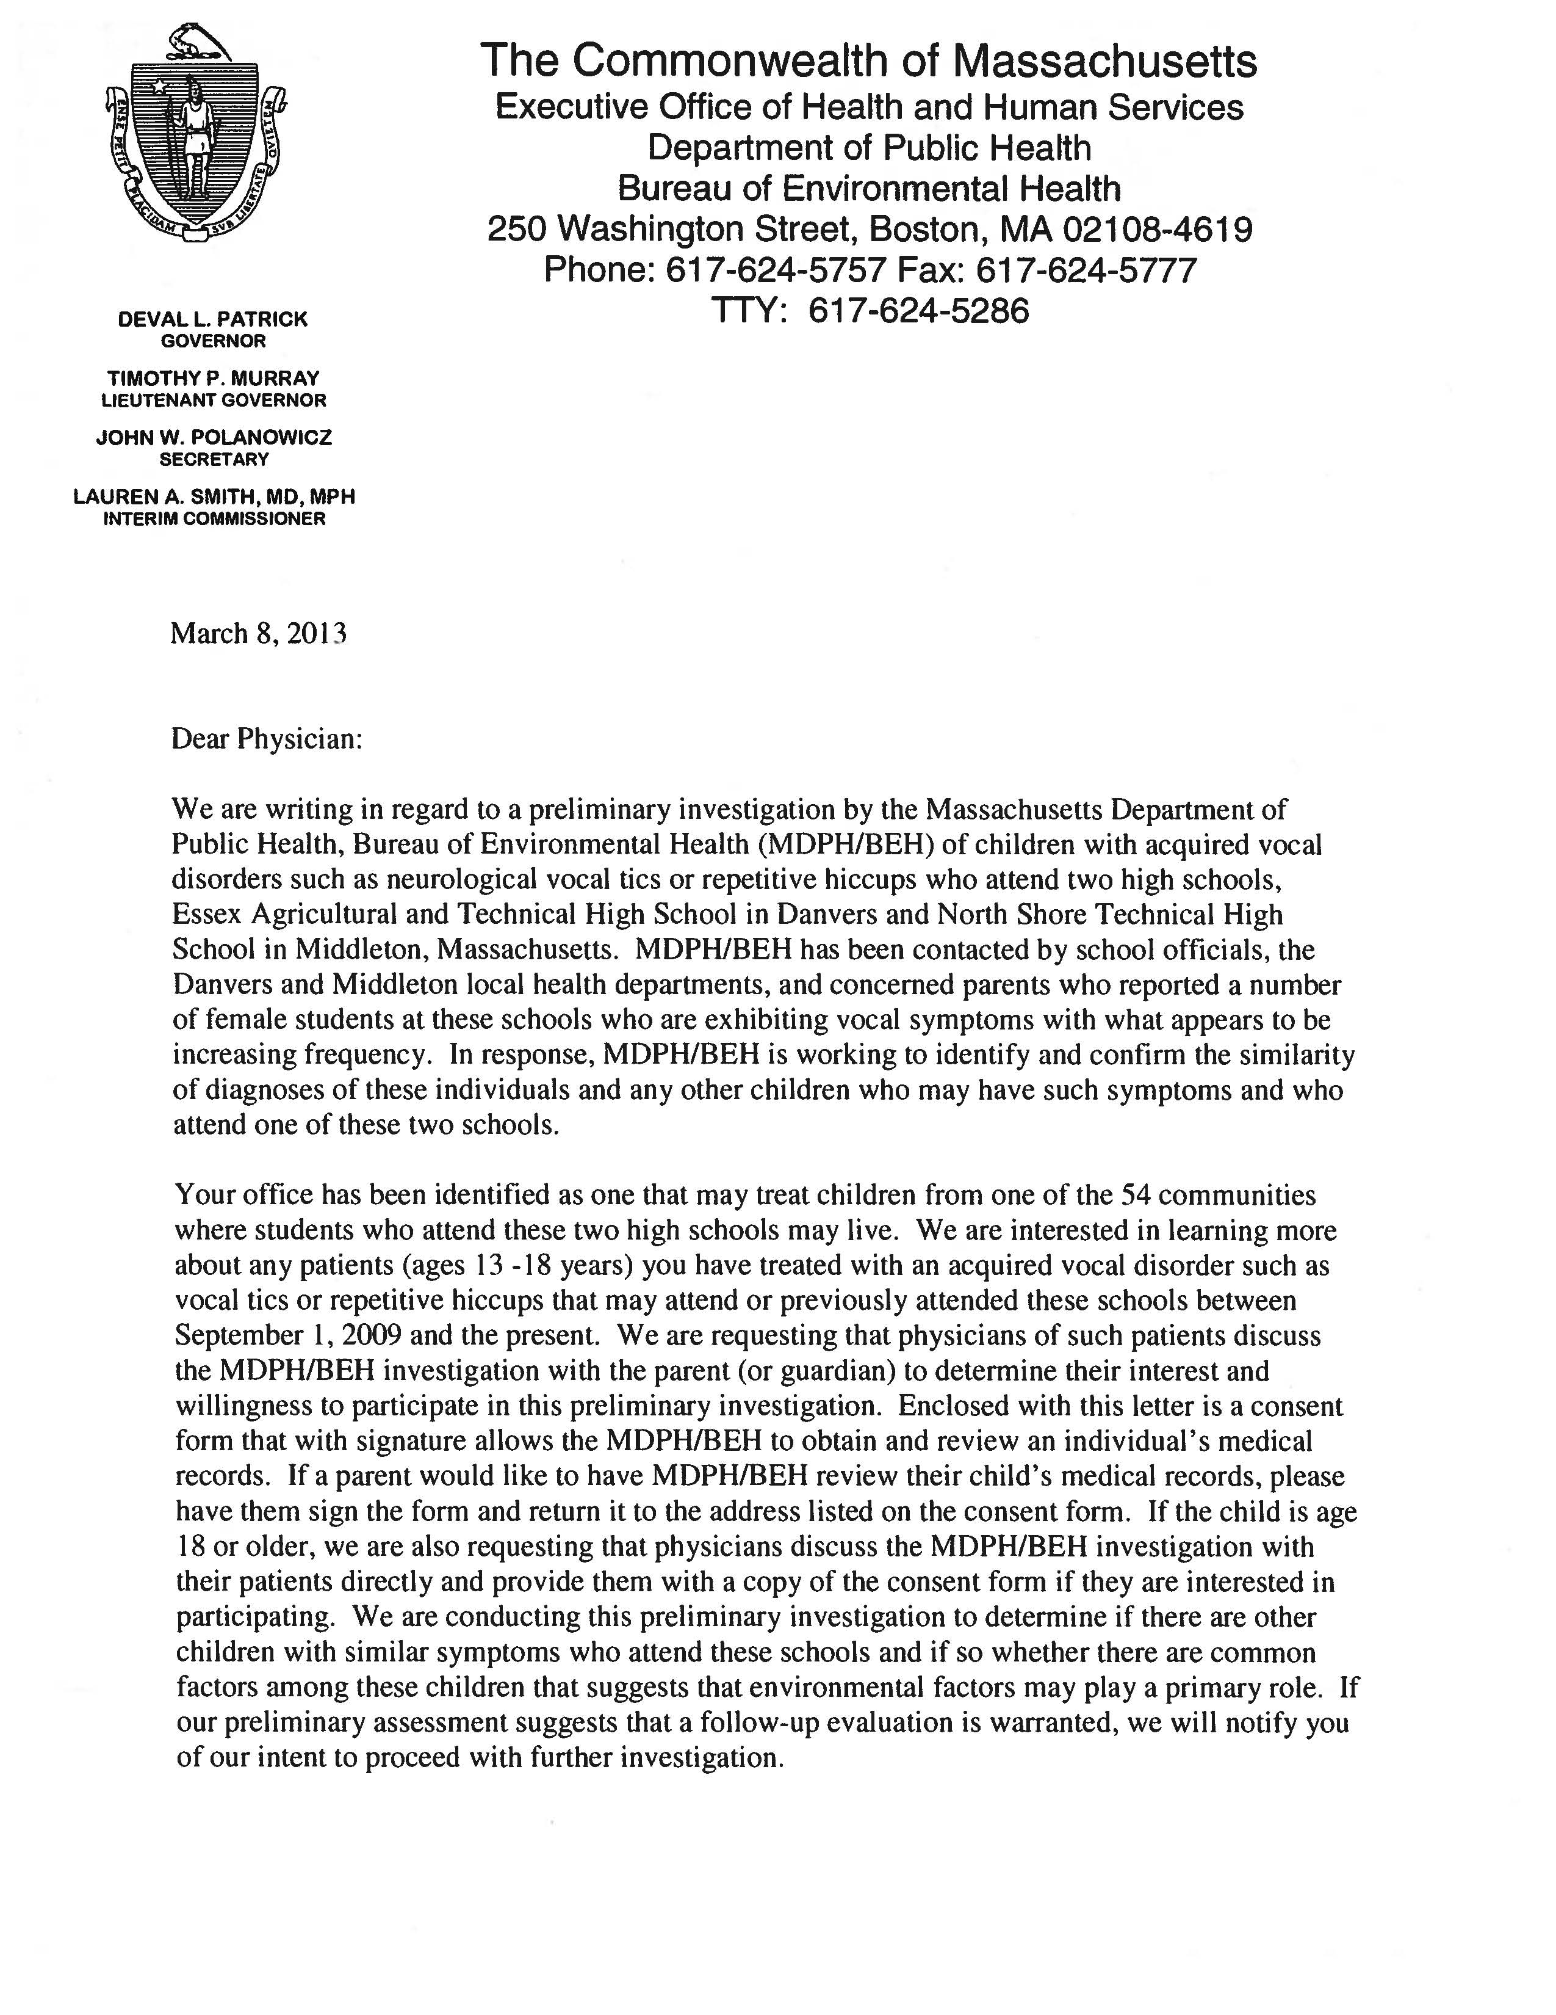
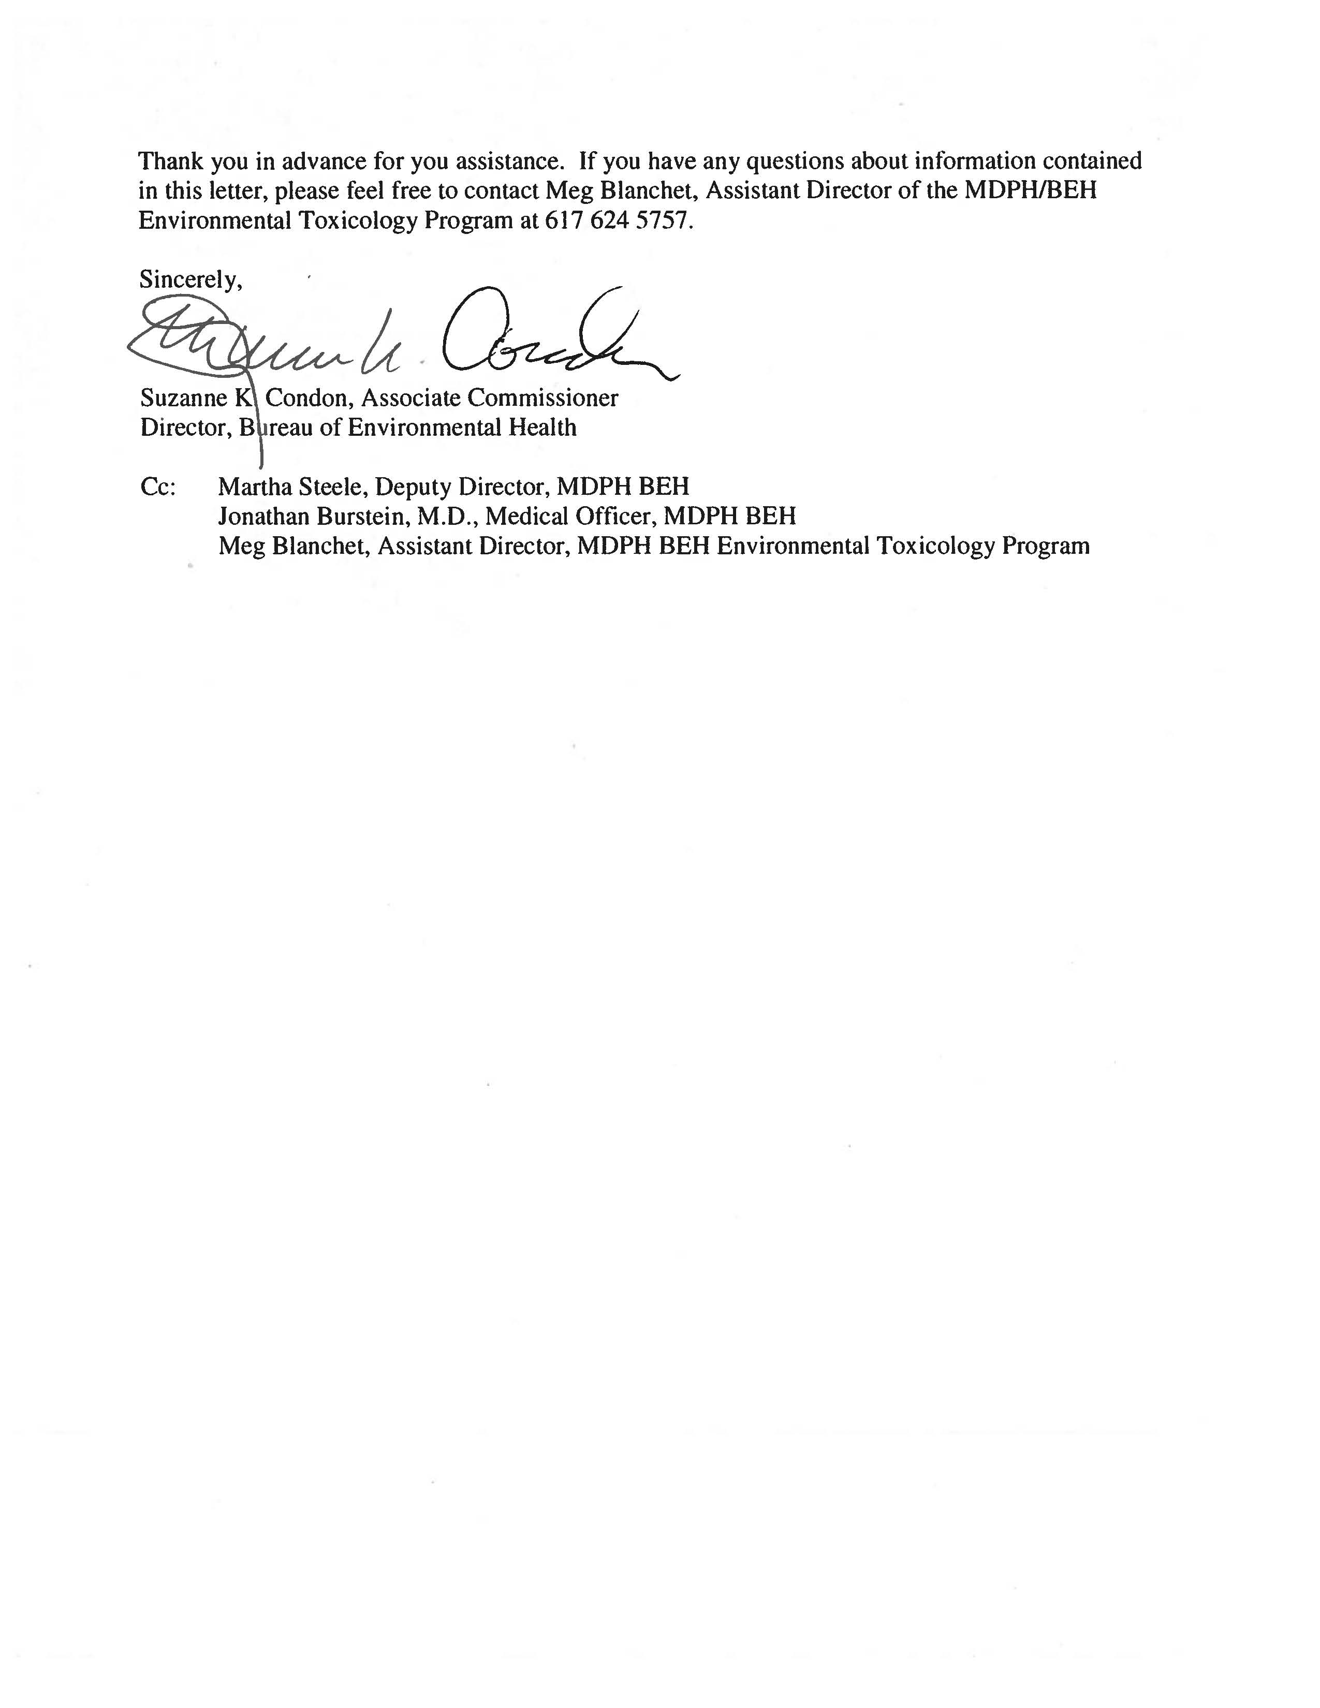
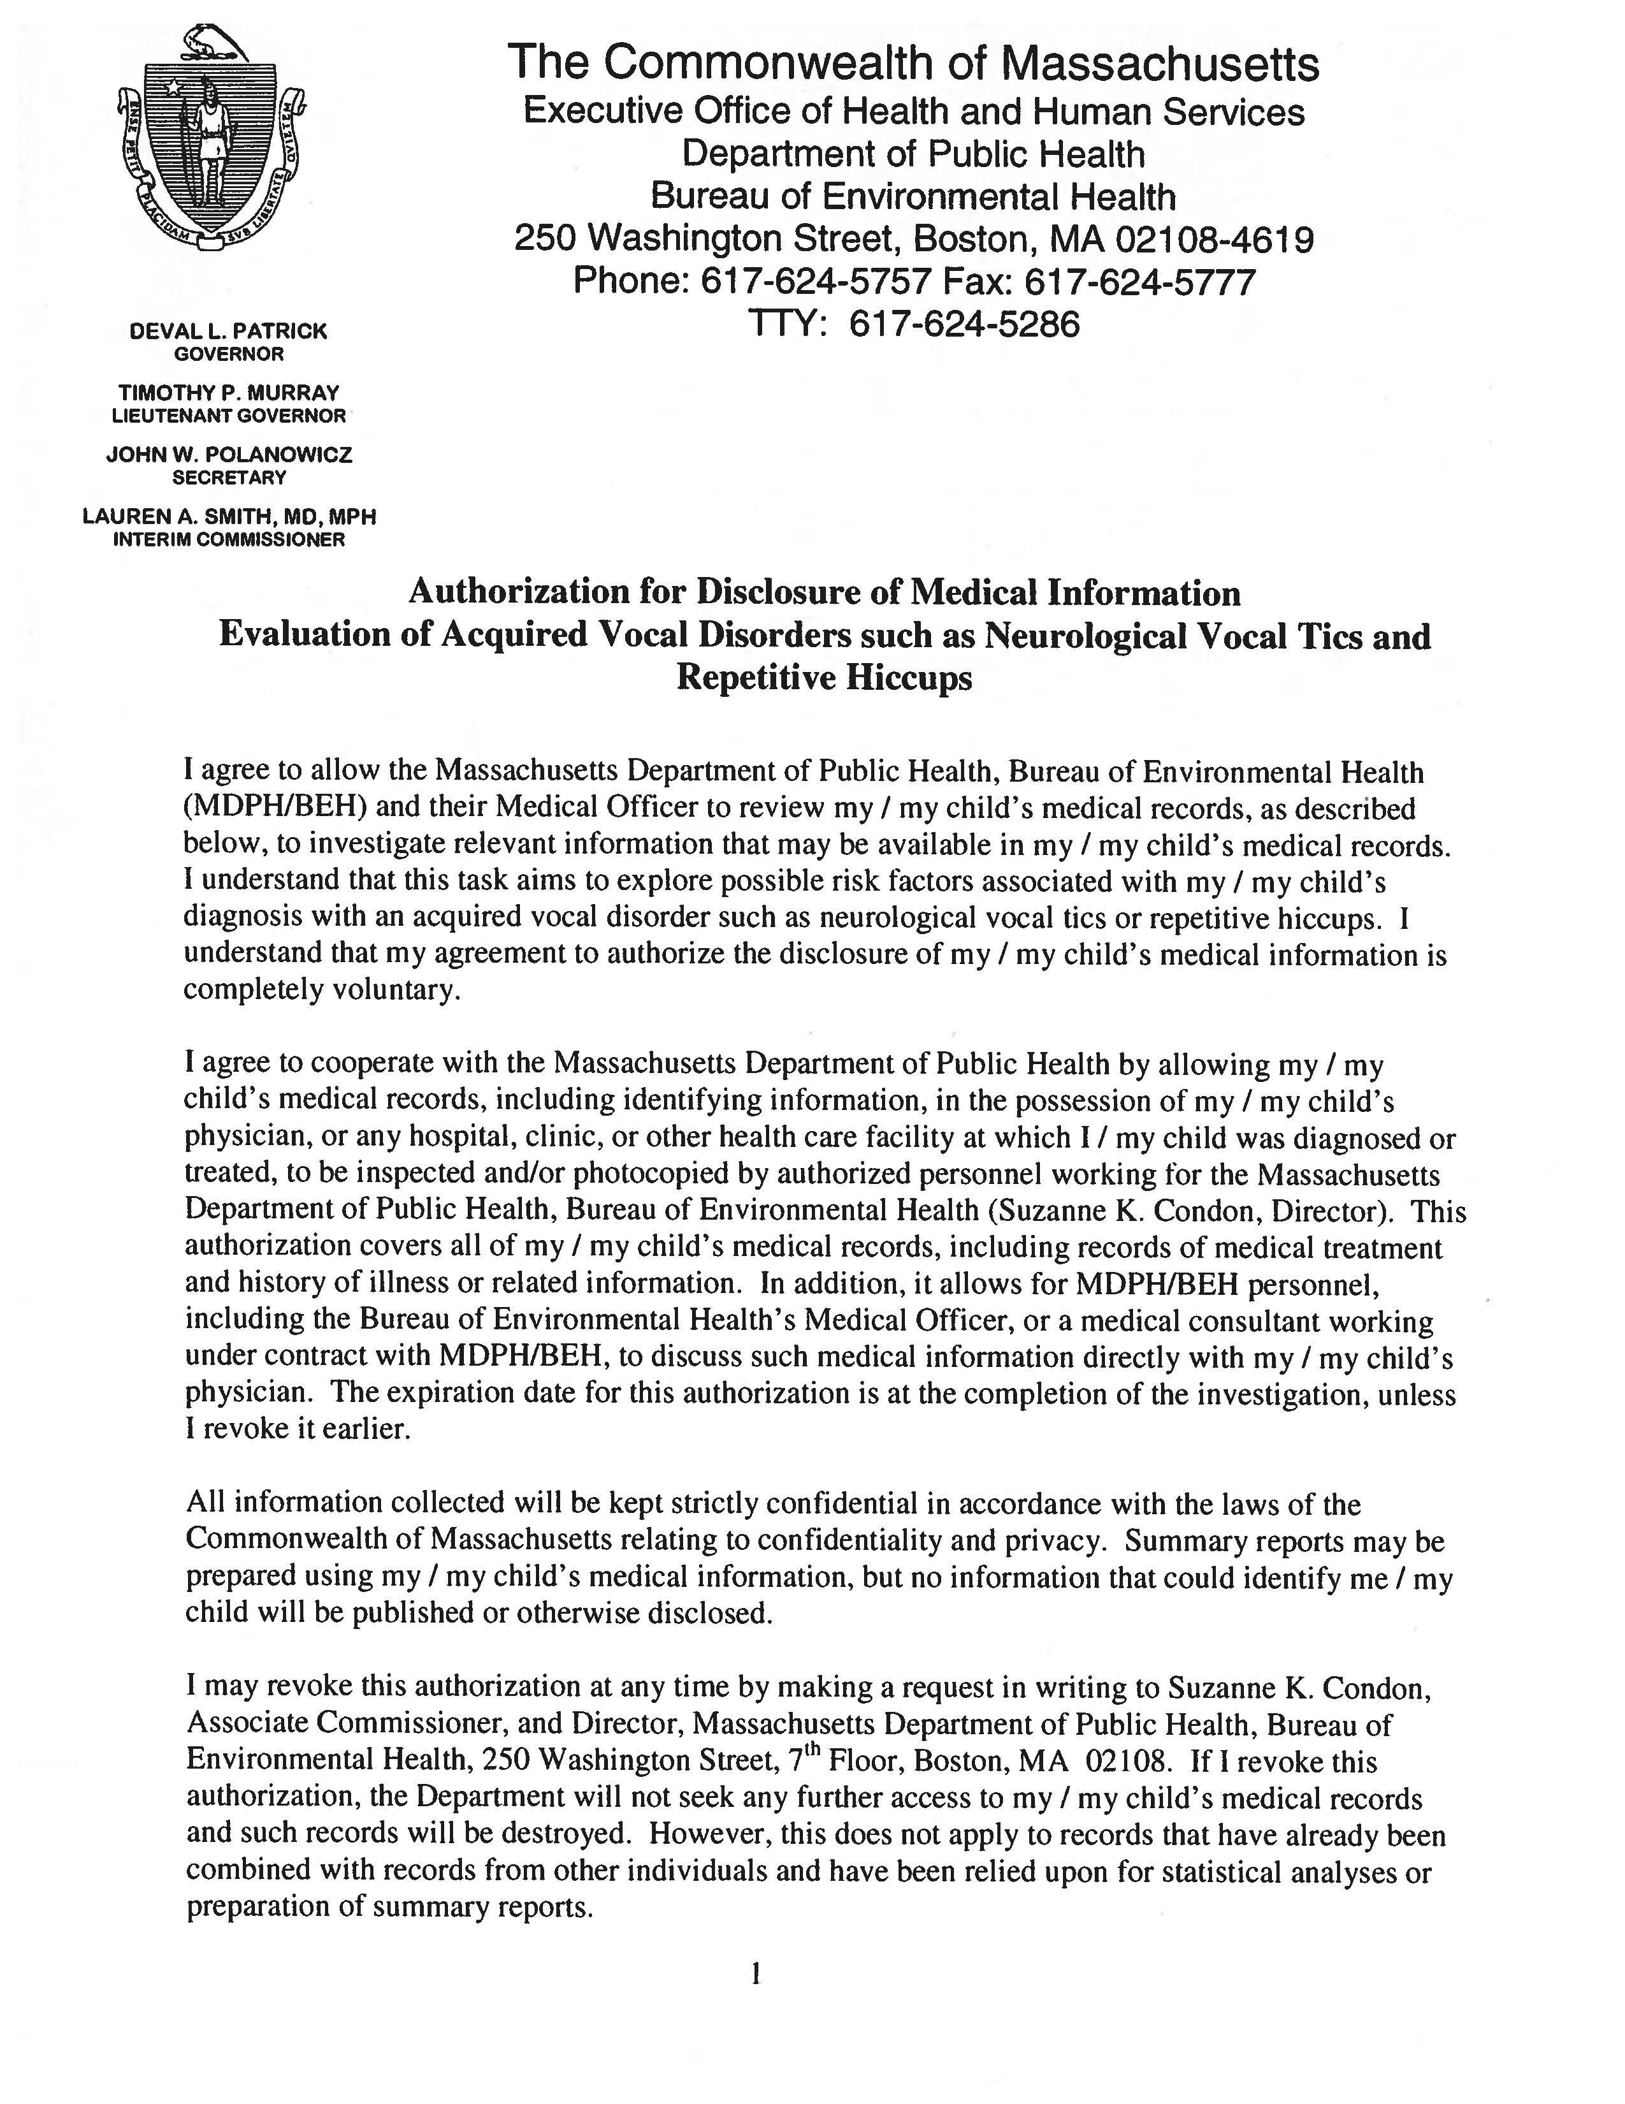
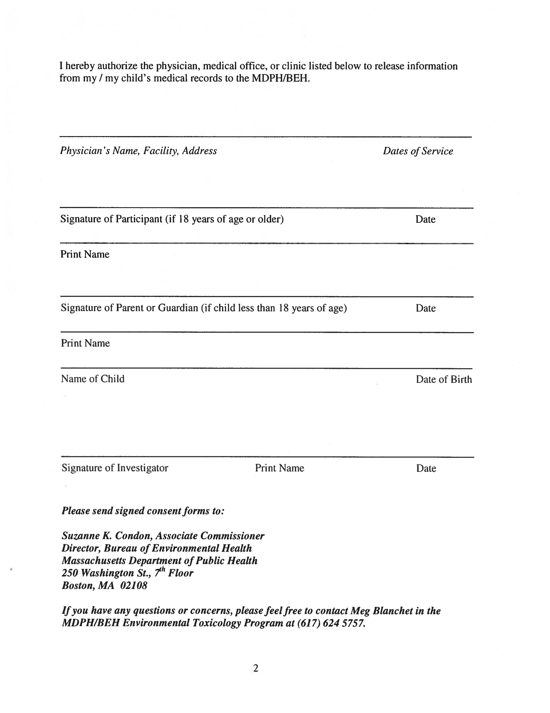

The service life is the median time during which a particular system or component of …[an HVAC]… system remains in its original service application and then is replaced. Replacement may occur for any reason, including, but not limited to, failure, general obsolescence, reduced reliability, excessive maintenance cost, and changed system requirements due to such influences as building characteristics or energy prices (ASHRAE, 1991).
This work was supported in part by funds from a cooperative agreement with the Agency for Toxic Substances and Disease Registry (ATSDR), U.S. Department of Health and Human Services. This document has not been reviewed and cleared by ATSDR.

