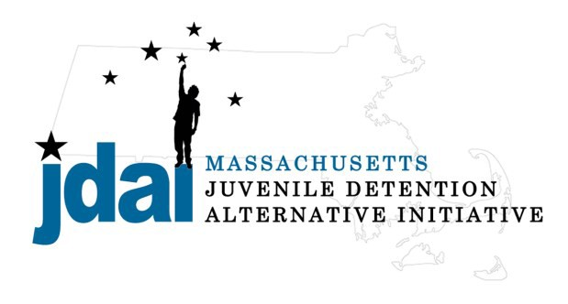Essex County Bench Card: Alternatives to Secure Detention
An Alternative to Detention is a location or supervision that allows a juvenile with an open delinquency matter, including violation of probation, to remain out of hardware secure detention pending further court action.

Family/ Communit y Supervision:

- Straight Release– Personal Recognizance
- Release to an Alternative/Extended Family Member

Low Sup ervision:
- Release with Section 87 Conditions
- Life Skills/ Afterschool: Bridging the Gap (Lawrence) 250 Haverhill Street, Lawrence, MA 01840, 978-360-8015, Robin DelNegro
Increasing Supervision
- Life Skills/ Afterschool: Bridging the Gap (Haverhill) 395 Main Street, Haverhill, MA 01830, 978-360-8015, Robin DelNegro
- Life Skills/ Afterschool: Bridging the Gap (Salem) 93 North Street, Salem, MA 01997, 978-744-5181, Katrina Polemenako
- Life Skills/ Mentoring: (Salem) The Plummer Home, On-Point Program 50 Leavitt Street, Salem, MA 01970, 978-774-1099 X123, Shane McMaster

Medium Supervision:
- Release with Pre-Trial Probation Conditions
- Release with Electronic Monitoring/ GPS

Medium – High Supervision:

- DYS: Shelter Care Options (Placement to Be Determined by DYS)
  - Lakeside, NFI, 629 Lowell Street, Peabody, MA 01960, 978-535-2366, Mike Chery (Males Only)
  - Carbone Hall, Eliot Human Services, 569 Salem End Road, Framingham, MA 01702, 508-532-7660, Marc Breau (Males Only)
  - Grafton Girls, Key, Inc., 30 Institute Road, North Grafton, MA 01536, 508-839- 4648, Meghan Rondeau (Females Only)
- Substance Abuse : Statewide Information and Referral 866-705-2807
  - Detox & Stabilization: MYR, Community Health link, 26 Queen Street, Worcester, MA 01610, 508-860-1244, Melonie Amir
  - Detox & Stabilization: CASTLE, High Point Treatment Center, 30 Meadowbrook Road, Brockton, MA 02301, 508-638-6009, Kim Fischer

Additional placement or services options may be available if the youth is involved with a state agency.

JDAI Massachusetts Alternative to Detention Committee has gathered these resources from the Essex JDAI Community. JDAI Massachusetts, and its affiliated partners, do not specifically endorse or recommend the services provided by the listed agencies and entities. Please send updates or corrections to jdai @stat e.ma.us . Updated: January 2016

