INDOOR AIR QUALITY ASSESSMENT

Essex County Superior Court
43 Appleton Way
Lawrence, MA

Prepared by:
Massachusetts Department of Public Health
Bureau of Environmental Health
Indoor Air Quality Program
August 2018

Background
Building: | Essex County Superior Court (ECSC)
Address: | 43 Appleton Way, Lawrence, MA
Assessment Requested by: | Mike Lane, Environmental Health & Safety Manager, Facilities Management & Capital Planning, Massachusetts Trial Courts
Reason for Request: | Water damage/infiltration and general indoor air quality (IAQ) concerns
Date of Assessment: | July 18, 2018
Massachusetts Department of Public Health/Bureau of Environmental Health (MDPH/BEH) Staff Conducting Assessment: | Ruth Alfasso, Environmental Engineer/Inspector, IAQ Program  Jason Dustin, Environmental Analyst/Inspector, IAQ Program
Building Description: | Stone and brick courthouse containing courtrooms, offices, waiting areas and a lockup. Building has three levels including lower level/basement area.
Building Population: | Approximately 50 employees and is visited by members of the public daily.
Year of Construction: | First built in 1858/1859, rebuilt in 1902, rededicated following renovations in 1992
Windows: | Openable in some areas

METHODS
Please refer to the IAQ Manual for methods, sampling procedures, and interpretation of results (MDPH, 2015).

IAQ Testing Results
The following is a summary of indoor air testing results (Table 1).
- Carbon dioxide levels were below the MDPH recommendation of 800 parts per million (ppm) in all areas tested, indicating adequate fresh air in the space. It should be noted that occupancy was minimal during this assessment which can reduce carbon dioxide levels.
- Temperature was within the recommended range of 70°F to 78°F in most areas tested.
- Relative humidity was above the MDPH recommended range of 40% to 60% in all areas tested.
- Carbon monoxide levels were non-detectable in all indoor areas tested.
- Fine particulate matter (PM2.5) concentrations measured were below the National Ambient Air Quality Standard (NAAQS) level of 35 μg/m³ in all areas tested.

Ventilation
A heating, ventilating and air conditioning (HVAC) system has several functions. First it provides heating and, if equipped, cooling. Second, it is a source of fresh air. Finally, an HVAC system will dilute and remove normally occurring indoor environmental pollutants by not only introducing fresh air, but by filtering the airstream and ejecting stale air to the outdoors via exhaust ventilation. Even if an HVAC system is operating as designed, point sources of respiratory irritation may exist and cause symptoms in sensitive individuals. The following analysis examines and identifies components of the HVAC system and likely sources of respiratory irritant/allergen exposure due to water damage, aerosolized dust and/or chemicals found in the indoor environment.
Fresh air is provided by air handling units (AHUs) located in mechanical rooms in the basement and attic. Fresh air is drawn into the AHUs via vents in the outside of the building (Pictures 1 and 2). Air from the AHUs is filtered, heated/cooled and delivered to rooms via ducted supply vents (Picture 3). Stale air is drawn into ceiling-mounted return vents (Picture 4) and is returned to the AHUs through the ceiling plenum.
Some restroom exhaust vents did not appear to be functioning at the time of the assessment. Functioning exhaust vents are necessary to prevent sources of water vapor and odors from migrating into occupied areas.
It is recommended that HVAC systems be re-balanced every five years to ensure adequate air systems function (SMACNA, 1994). It was unknown when the last time these systems had been balanced.

Microbial/Moisture Concerns
The lower level of the ECSC experiences chronic water infiltration through the stone foundation. A portion of this below-grade space is currently occupied by the Probation Office. The basement has a section that is currently unoccupied on the north side abutting Common Street. This area has had water infiltration in the past and had recently been remodeled including new gypsum wallboard (GW). GW abutting the north wall had measureable levels of moisture in most of this area (Picture 5; Table 1) and showed other signs of water damage, including damaged paint (Picture 6) and peeling coving. In addition, floor tiles were buckling (Picture 7) which may be the result of water infiltration or condensation on the concrete floor. The relative humidity measurements in the lower level were above outdoors (Table 1) which is an indicator that there is a source of moisture in this space. Gypsum wallboard and some coving have paper components that can become colonized with mold if moistened long enough, or repeatedly. Paint, debris on wall, and carpet may also become mold-colonized.
The US Environmental Protection Agency (US EPA) and the American Conference of Governmental Industrial Hygienists (ACGIH) recommends that porous materials (e.g., wallboard, carpeting) be dried with fans and heating within 24 to 48 hours of becoming wet (US EPA, 2008; ACGIH, 1989). If porous materials are not dried within this time frame, mold growth may occur. Since the porous building materials in the north side of the lower level have been chronically moistened without immediate drying as stated above, these materials should be removed and discarded.
Some work has reportedly been done to address drainage problems on this side of the building, including the installation of a sump pump and drain (Picture 8); paving over and sloping what had been a vegetated setback area along Common Street (Picture 9); and repairs to the foundation. While these efforts have reportedly reduced infiltration significantly, there is still water penetration below grade, particularly during heavy rains. Due to the age and construction of the building, it may be difficult to completely waterproof the foundation, but additional steps may be helpful. These may include: repairs to the sidewalk along the Common Street side to reduce infiltration and resetting the slope to drain away from the building (Picture 10), re-grading any other areas next to the foundation wall; extension of the sump pump drain line to remove water further away from the building; and additional repair/waterproofing of the exterior foundation wall, including ensuring any weep holes are operational to drain water from the wall drainage plenum.
Note that even given the best effort at drainage and waterproofing, this side of the building may still be subject to occasional water infiltration. In addition, a tile floor on slab below grade may collect condensation when the air is humid due to the floor temperature, which is likely below the dew point in hot humid weather. Therefore, it is highly recommended that any renovations to remove and replace water-damaged wallboard in this area should be performed with materials that are not readily colonized with mold, such as cement board without a paper backing. Any future occupants of this space should also be aware that other porous items (e.g., boxes, files, area rugs) brought into this space should not be placed directly on the floors or against the walls. Humidity and water infiltration may moisten these items and they could become mold-colonized. Dehumidifiers should also be used during wet or humid weather to reduce humidity.
Wall-to-wall carpeting was in use in the Probation Department floor on the lower level. Carpeting is not recommended in below grade spaces due to the likelihood of chronic moistening with possible microbial growth on the carpeting and/or debris within/beneath the carpet itself.
Water-damaged ceiling tiles were observed in several places (Pictures 4 and 11; Table 1), with some appearing to be colonized with mold. It was reported that the roof has active leaks on the third floor. Most other stained ceiling tiles were reported to be from leaking/corroded bleed valves from the HVAC system. Water-damaged ceiling tiles can provide a source of mold and should be replaced after a water leak is discovered and repaired. ECSC facilities staff stated that future capital improvement projects will address roof repairs and new chillers for the HVAC system.
Plants were observed in a few areas (Table 1) including on porous surfaces (e.g., carpet). Plants can be a source of pollen and mold, which can be respiratory irritants to some individuals. Plants should be properly maintained and equipped with drip pans to prevent water damage to porous materials. Plants should also be located away from air diffusers to prevent the aerosolization of dirt, pollen and mold. Water coolers (Picture 12) and bottles, fountains (Picture 13), and refrigerators (Picture 14) were found located on carpet (Table 1), where they can moisten the carpet and lead to microbial growth.
A water fountain on the lower level was out of order and covered in plastic (Picture 13). A sink and toilet in another office were also disconnected from the water supply. Unused or broken plumbing can be a source of leaks. In addition, unused/unusable fixtures can allow for dry drain traps, which can be a source of sewer gas, moisture and odors to occupied spaces. Plumbing fixtures should be repaired promptly or properly capped, and any unused drains should be periodically filled with water to maintain the trap seal.
There was a stack of boxes in the unused area on the lower level that were up on pallets, but had been water-damaged in the past (Picture 15). Water-damaged paper materials should be sorted and either professionally restored, copied to fresh paper or discarded as they may be colonized with mold or a source of odors.

Other IAQ Evaluations
Exposure to low levels of total volatile organic compounds (TVOCs) may produce eye, nose, throat, and/or respiratory irritation in some sensitive individuals. To determine if VOCs were present, BEH/IAQ staff examined rooms for products containing VOCs. BEH/IAQ staff observed air fresheners, hand sanitizers, cleaners, and dry erase materials in use within the building (Picture 16; Table 1). All of these products have the potential to be irritants to the eyes, nose, throat, and respiratory system of sensitive individuals. Note that scented products such as air fresheners do not remove odors; they only mask odors with another scent.
The fresh air intake in the alley to the rear of the building is susceptible to pollutants being drawn in from idling vehicles, stored garbage, smoking or other sources (Picture 2). Signs which say “no vehicle idling” and “no smoking within alley” with listed fines may be more effective to improve compliance. Note that M.G.L. c. 90:16A restricts idling of vehicles to no more than five minutes unless absolutely necessary (MGL, 1996). Also, since the alley way has enclosed walls and includes the fresh air intake, it may be considered an extension of the building itself where smoking is prohibited.
Some ECSC staff expressed concerns regarding allergy symptoms. Note that fresh air is filtered in the AHU before being distributed throughout the building. The BEH/IAQ program recommends that Minimum Efficiency Rating Value (MERV) 8 or higher filters be used, as these filters are effective in filtering out most common pollens and mold spores. Filters for the AHU in the basement were examined, and the filters are rated MERV 15 which should be highly effective in reducing most particulate matter. Filters should be changed on a regular schedule two to four times a year.
BEH/IAQ staff noted the presence of rodent traps in some areas (Picture 17). Rodents and rodent wastes are a common allergen. The principles of Integrated Pest Management (IPM) should be used to reduce incidence of rodents, including removing/containing food and food waste, removing access to water and harborage, and reducing pathways for rodents to travel into and through the building. Note that after rodents have been removed from the building, thorough cleaning is required to remove rodent-related allergens. ECSC staff reported that the building is under contract with a pest control company. The document “Integrated Pest Management Kit for Building Managers” provides additional strategies for IPM (MDFA, 1996).
Food and food crumbs were observed in some areas (Picture 18). Cooking /eating equipment and areas should be kept clean to prevent attracting pests and creating smoke and odors. Plaster dust and peeling plaster and paint were observed in many areas (Picture 19; Table 1). Dust can become airborne and be a source of irritation. Cleaning of plaster dust and repair of damaged plaster should be conducted regularly to prevent dust. Supply and return vents and adjacent ceiling tiles were also dusty in some areas (Picture 3) and should be cleaned periodically.
In some areas, items such as books, papers, and other items were on floors, tabletops and desks, which may make it more difficult to clean. Surfaces should be kept clear of items, or items should be moved periodically for thorough cleaning.
Carpets should be cleaned regularly in accordance with the Institute of Inspection, Cleaning and Restoration Certification (IICRC) recommendations (IICRC, 2012). Upholstered furniture should also be cleaned regularly. Wet wiping of surfaces and the use of a HEPA vacuum for daily vacuuming will help to keep aerosolized dust from acting as an irritant.

Conclusions/Recommendations
Based on observations at the time of assessment, a two-phase approach is required for remediation. The first consists of short-term measures to improve air quality and the second consists of long-term measures that will require planning and resources to adequately address overall concerns.

Short-term Recommendations
- Operate supply and exhaust ventilation continuously in all areas during occupied periods.
- Repair any non-functioning local exhaust vents (e.g., restrooms).
- Avoid idling of vehicles in the alley of the building near the air intakes in accordance with M.G.L. c. 90:16A which restricts idling of vehicles to no more than five minutes unless absolutely necessary (MGL, 1996).
- Install more explicit signs stating laws and fines in the area of the fresh air intake in the alley to minimize noncompliance and pollutant entrainment in this area. Monitor for compliance and enforce as necessary. This would also include no smoking enforcement.
- Continue to use MERV 8 or higher filters in the AHUs and change them on a regular schedule two to four times a year.
- Have the HVAC system balanced every five years to ensure proper functioning.
- Remove any porous building materials in the lower level that were water-damaged and not properly dried within 24-48 hours as recommended. This would include any gypsum wallboard, paper-backed insulation, and carpeting. Remediate any water-damaged materials in accordance with the US EPA guidance “Mold Remediation in Schools and Commercial Buildings” (US EPA, 2008).
- Discard any unneeded water-damaged stored materials. Any irreplaceable documents may require professional restoration.
- Continue with plans to make additional repairs to exterior drainage, sidewalk slope, and waterproof the exterior.
- Replace building materials and insulation with products that are not conducive to mold growth (e.g., cement board, rigid insulation).
- Ensure that future occupants in the currently-vacant area are regularly reminded not to store porous items such as boxes, rugs or posters on the floor or against walls and to keep air space between furniture and the outside walls.
- Use dehumidifiers in the below-grade spaces to reduce humidity during humid and wet seasonal weather. Ensure the units can drain properly or are emptied regularly to prevent stagnant water and that they are monitored and maintained on a regular schedule.
- Consider replacing existing carpeting in the lower level with non-porous tiles due to potential condensation issues.
- Keep windows closed while the air conditioning system is operating to prevent entry of hot, humid air which may cause condensation/mold colonization of porous surfaces.
- Repair roof/plumbing leaks (e.g., bleed valves) and replace water-damaged ceiling tiles.
- For more information on mold refer to the US EPA’s “Mold Remediation in Schools and Commercial Buildings”. Available at: http://www.epa.gov/mold/mold-remediation-schools-and-commercial-buildings-guide.
- Keep plants in good condition, avoid overwatering, and avoid placing them on porous items such as carpets or paper.
- Consider locating water coolers and refrigerators in areas without carpet, replacing the carpet in these areas with non-porous flooring, or using waterproof mats to protect carpeting.
- Repair broken plumbing fixtures or have them properly cut and capped to prevent leaks. Ensure unused or infrequently used drains are watered regularly to maintain the trap seal and prevent infiltration of sewer gases and odors into occupied space.
- Reduce the use of VOC-containing cleaners and sanitizers and avoid the use of air fresheners and scented candles.
- Use the principles of IPM to reduce pest issues in the building, including the sealing of pathways and reduction in sources of food and harborage. Consult “Integrated Pest Management Kit For Building Managers” (MDFA, 1996), http://www.mass.gov/eea/docs/agr/pesticides/publications/ipm-kit-for-bldg-mgrs.pdf.
- Clean food preparation areas and equipment regularly to remove debris that may be a source of odors and attractive to pests.
- Clean/repair damaged plaster and peeling paint periodically to remove loose material that can become airborne.
- Clean vents and personal fans periodically.
- Reduce accumulated materials and store in an organized manner to allow for thorough cleaning.
- Clean carpeting in accordance with IICRC recommendations (IICRC, 2012).
- Clean supply and exhaust vents and personal fans regularly to prevent aerosolization of debris.
- Refer to resource manual and other related IAQ documents located on the MDPH’s website for further building-wide evaluations and advice on maintaining public buildings. These documents are available at: http://mass.gov/dph/iaq.

Long-term recommendations:
- Continue with plans for capital improvement projects re: roof and HVAC chiller replacement.

References
ACGIH. 1989. Guidelines for the Assessment of Bioaerosols in the Indoor Environment. American Conference of Governmental Industrial Hygienists, Cincinnati, OH.
IICRC. 2012. Institute of Inspection, Cleaning and Restoration Certification. Carpet Cleaning: FAQ.
MDFA. 1996. Integrated Pest Management Kit for Building Managers. Massachusetts Department of Food and Agriculture, Pesticide Bureau, Boston, MA.
MDPH. 2015. Massachusetts Department of Public Health. Indoor Air Quality Manual: Chapters I-III. Available at: http://www.mass.gov/eohhs/gov/departments/dph/programs/environmental-health/exposure-topics/iaq/iaq-manual/.
MGL. 1996. Stopped motor vehicles; Operation of Engine; Time Limit; Penalty. Massachusetts General Laws. M.G.L. c. 90:16A.
SMACNA. 1994. HVAC Systems Commissioning Manual. 1st ed. Sheet Metal and Air Conditioning Contractors’ National Association, Inc., Chantilly, VA.
US EPA. 2008. Mold Remediation in Schools and Commercial Buildings. US Environmental Protection Agency, Office of Air and Radiation, Indoor Environments Division, Washington, D.C. EPA 402-K-01-001. http://www.epa.gov/mold/mold-remediation-schools-and-commercial-buildings-guide.
Picture 1
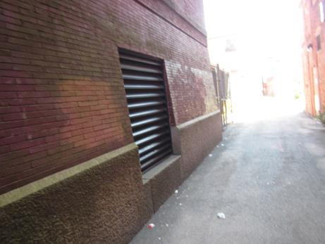
Air intake on side of the building in alleyway
Picture 2
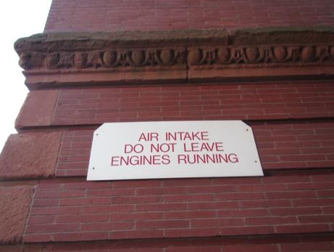
Sign in alleyway next to air intake
Picture 3
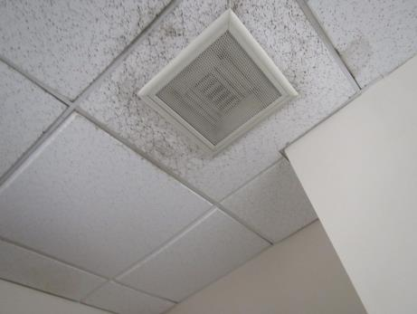
Typical supply vent, note dust/debris
Picture 4
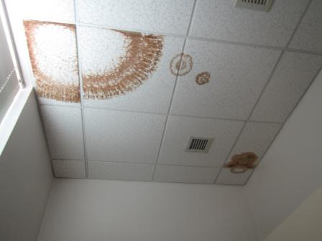
Return vent, note water-damaged ceiling tiles
Picture 5
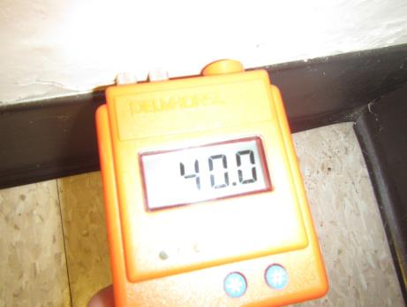
Measurement of moisture indicating wall is moist
Picture 6
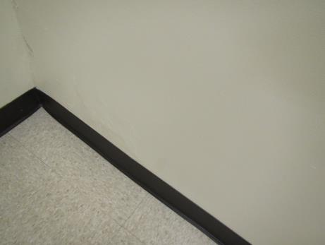
Bubbled/damaged paint
Picture 7
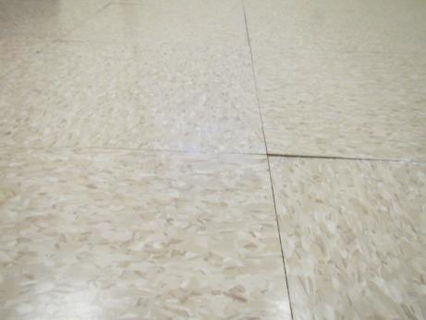
Buckled/delaminated floor tiles
Picture 8
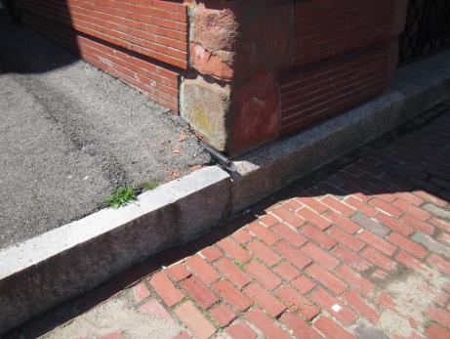
Sump pump drain pipe, note discharge directly against wall
Picture 9
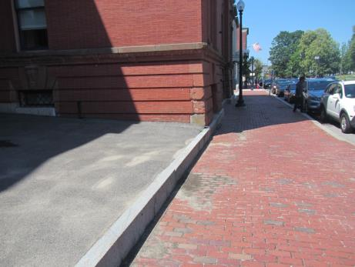
Paved area (left side of picture) which used to be vegetated, sloped away from the building
Picture 10
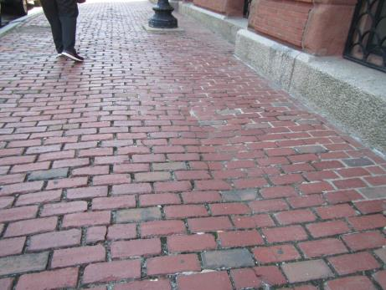
Sidewalk between building and Common Street, note lack of smooth slope away
Picture 11
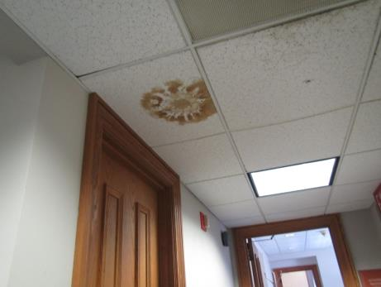
Water-damaged ceiling tile with possible mold colonization
Picture 12
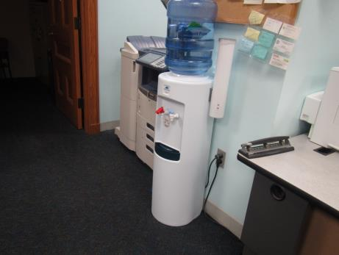
Water cooler on carpet
Picture 13
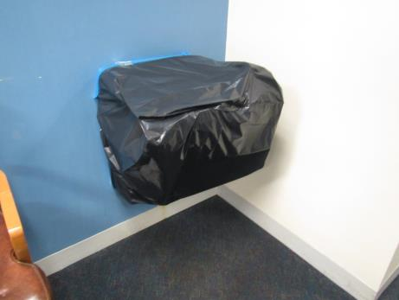
Broken water fountain in Probation Department area
Picture 14
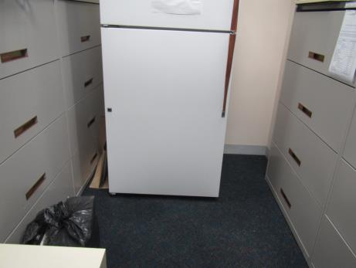
Refrigerator in carpeted area
Picture 15
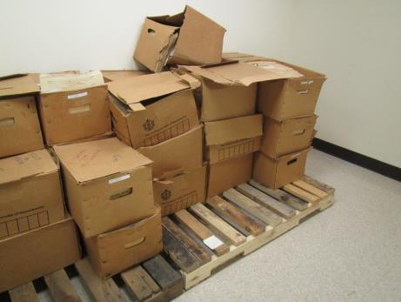
Water-damaged boxes in the lower level
Picture 16
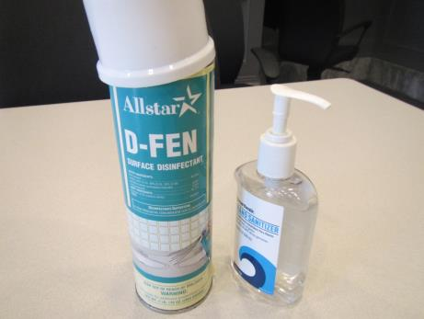
Disinfectant and hand sanitizer
Picture 17
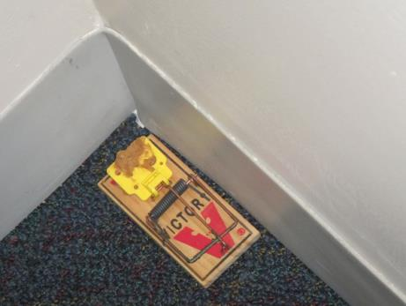
Rodent trap in occupied space
Picture 18
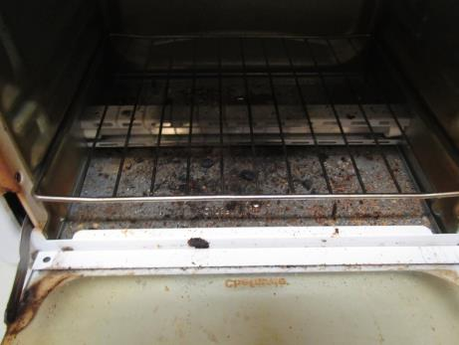
Toaster with crumbs
Picture 19
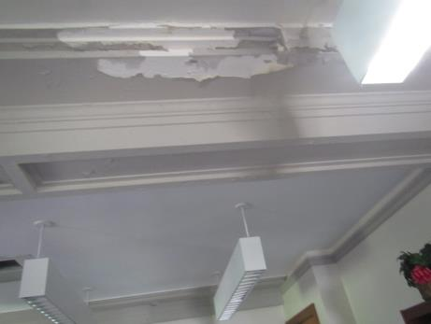
Peeling paint on ceiling

Location | Carbon  Dioxide  (ppm) | Carbon Monoxide  (ppm) | Temp  (°F) | Relative  Humidity  (%) | PM2.5  (µg/m³) | Occupants  in Room | Windows  Openable | Ventilation |  | Remarks
 |  |  |  |  |  |  |  | Supply | Exhaust
Background | 289 | ND | 72 | 63 | 21 | - | - | - | - | Sunny, traffic nearby
Ground floor
GO 7 | 514 | ND | 71 | 69 | 2 | 0 | Y | Y | Y | NC, WD GW, bubbling paint, moisture meter showed walls with current elevated moisture including interior partition wall
GO 6 | 362 | ND | 71 | 68 | 2 | 0 | Y | Y | Y | WD GW, all but interior wall showed elevated moisture with moisture meter
GO 5 | 366 | ND | 70 | 68 | 3 | 0 | Y | Y | Y | Elevated moisture in GW using moisture meter
GO 3 | 337 | ND | 70 | 68 | 2 | 0 | Y | Y | N | Elevated moisture on right side exterior GW
G-2 Storage | 478 | ND | 70 | 70 | 2 | 0 | N | Y | Y | Missing CT, boxes on pallets
Main basement room | 373 | ND | 70 | 69 | 2 | 0 | N | Y | Y
Maintenance office | 352 | ND | 70 | 69 | 2 | 4 | N | Y | Y | Missing CT, boxes on floor
Elevator lobby | 444 | ND | 70 | 70 | 3 | 0 | N | Y | N | NC, elevator
Basement Probation area entry | 378 | ND | 71 | 69 | 3 | 0 | N | Y vents dusty | Y | Waiting/seats, carpeted, old decommissioned water faucet over carpet, no (elevated) moisture detected in GW at this time
G-41 Probation waiting room | 421 | ND | 73 | 66 | 3 | 0 | N | Y | Y | Carpeted
Probation office | 482 | ND | 73 | 66 | 3 | 2 | N | Y | Y | Carpeted, WC on carpet, PC
G-35 | 492 | ND | 73 | 66 | 8 | 0 | N | Y | Y | Carpeted, HS, CP, AF, no moisture detected in GW at this time
G-36 | 390 | ND | 73 | 65 | 2 | 0 | N | Y | Y | PF on, items on floor, carpeted, coffee, no moisture detected in GW at this time
G-37 | 394 | ND | 73 | 64 | 2 | 0 | N | Y | Y | PF, carpeted, peeled coving (wall is dry), no moisture detected in GW at this time
G-38 | 480 | ND | 73 | 65 | 3 | 0 | N? | Y | Y | Carpeted, fridge, no moisture detected in GW at this time
G-39 | 431 | ND | 74 | 65 | 3 | 0 | Y | Y | Y | Fake plant, food, no moisture detected in GW at this time
G-40 | 444 | ND | 74 | 64 | 2 | 0 | N | Y | Y | Fridge, no moisture detected with moisture meter at this visit
First Floor
101 | 380 | ND | 73 | 62 | 3 | 0 | N | Y | Y | Plants, water bottles on carpet
Clerks office | 350 | ND | 73 | 63 | 3 | 2 | N | Y | Y | Plants, PC
Rear Office Right | 323 | ND | 73 | 63 | 3 | 0 | N | Y | Y | 2 couches, microwave
Rear Office Left | 433 | ND | 73 | 64 | 3 | 0 | Y | Y | Y | Books and papers
102 | 365 | ND | 73 | 63 | 3 | 0 | Y | Y | Y | Boxes on floor, paper on wall
Courtroom #1 | 372 | ND | 69 | 60 | 6 | 2 | N | Y | Y | carpet
File room | 301 | ND | 69 | 60 | 6 | 2 | N | Y | Y | WD CT, missing ceiling tile
Storage/food |  |  |  |  |  |  |  |  |  | Fridge on carpet, crumbs in toaster, 3 WD CT, attached bathroom has no water service
First floor women’s restroom | 370 | ND | 73 | 67 | 2 | 0 | Y | N | N | Bathroom odors, check fan
Clerk Office 1 | 314 | ND | 69 | 62 | 6 | 2 | N | Y | Y | WD CTs, HS, CPs, plants, window open w/AC on
Judge’s Office 1 | 389 | ND | 69 | 62 | 6 | 2 | N | Y | Y | Large area of active WD near window, carpet
Judge’s secretary file room 1 | 342 | ND | 71 | 65 | 5 | 3 | N | Y | Y | Capet
Second floor
Jury Pool | 346 | ND | 72 | 63 | 0 | 0 | Y | Y | Y | PC, fireplace (closed off)
Vending rear of Jury Pool | 311 | ND | 70 | 64 | 1 | 0 | N | Y | Y | Vending machines
Ladies restroom in Jury Pool | 339 | ND | 70 | 66 | 1 | 0 | N | N | Y | WD CT
Courtroom 3 | 379 | ND | 69 | 64 | 2 | 0 | Y | Y | Y | New carpet
Court 3 Judge’s lobby | 467 | ND | 67 | 64 | 3 | 2 | N | Y | Y
Judge office | 481 | ND | 64 | 65 | 17 | 3 | N | Y | Y | Scented humidifier
Records room | 454 | ND | 78 | 64 | 1 | 0 | Y | Y | Y | 1 WD CT
Restroom |  |  |  |  |  |  | N | Y | Y
Jury Pool | 464 | ND | 68 | 63 | 1 | 0 | N | Y | Y | DEM, restroom attached
221 | 475 | ND | 69 | 66 | 1 | 0 | Y | Y | Y | Portable AC, off
Judge’s room | 313 | ND | 69 | 63 | 3 | 0 | Y | Y | Y
Courtroom 2 | 379 | ND | 69 | 61 | 3 | 0 | Y | Y | Y | Falling ceiling plaster
Jury Deliberation 230 | 352 | ND | 68 | 70 | 3 | 0 | N | Y | Y | Carpet, HS
Third Floor
301 Law clerk | 351 | ND | 70 | 69 | 1 | 1 | N | Y | Y | Carpeted, peeling paint and plaster, allergy complaints
303 | 447 | ND | 71 | 69 | 1 | 0 | N | Y | Y | Vacant office
Courtroom 4 |  |  |  |  |  |  |  |  |  | In use, no access
District Atty | 354 | ND | 70 | 67 | 1 | 0 | N | Y | Y | Toys in DA waiting, birds nest visible outside windows
DA back office | 329 | ND | 70 | 67 | 4 | 0 | N | Y | Y | Carpet, HS
Victims and advocates room | 326 | ND | 71 | 65 | 3 | 0 | N | Y | Y | WD under sink, WD CTs x 4
Jury room 4 | 549 | ND | 68 | 58 | 1 | 0 | N | Y | Y | Slight musty smell, DEM, WD CTs
Jury anteroom | 482 | ND | 66 | 62 | 1 | 0 | N | Y | Y | WD CT
Judge’s clerk office | 538 | ND | 67 | 68 | 1 | 0 | N | Y | Y | WD CT, water cooler on carpet, fridge
Judge’s office | 505 | ND | 67 | 67 | 1 | 0 | N | Y | Y | DO, plaster damage

