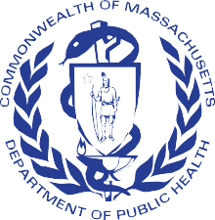
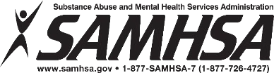
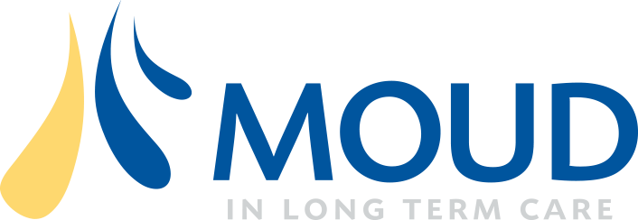
Massachusetts Department of Public Health

Peer-to-Peer Webinar:
Establishing Partnerships to Support Residents Affected by Opioid Use Disorder and/or Stimulant Use Disorder(s)

1

Welcome

Purpose of this webinar is to support facilities to:
- Effectively care for residents with opioid and/or stimulant use disorder(s)
- Develop partnerships with community Office- Based Opioid/Addiction Treatment (OBOT/OBAT) Programs, Opioid Treatment Program (OTP), and other community support resources
- Facilitate transition planning for safe discharge

Muting and Unmuting
- Mute microphone when not speaking
  - Left bottom corner of your screen
- Remember to unmute before speaking
- If on the phone, press *6 to unmute
To indicate your name and facility
- Click on the three dots on your small screen or click “Participants”
- Choose “rename”
- Type your name(s) and your facility’s name

Helpful tips

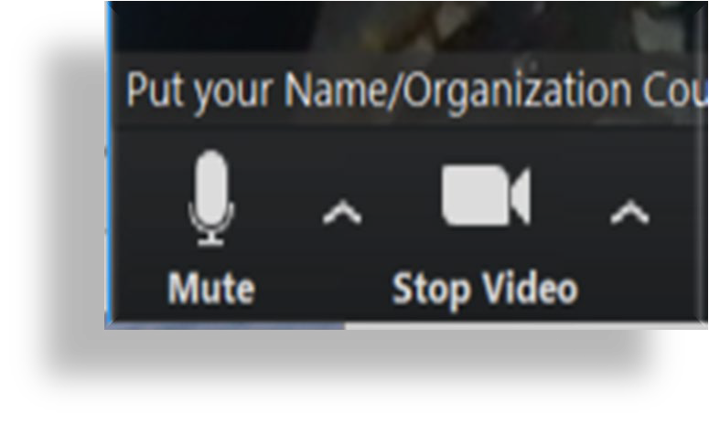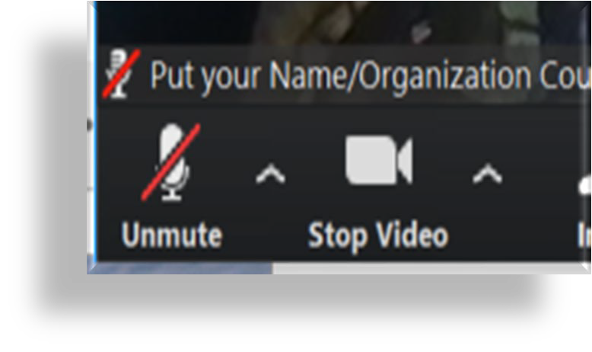

Helpful tips (cont.)

- Use chat function for comments and questions
  - Use chat function to submit names of all attendees from your site for attendance
  - You can chat to “everyone” or another participating group or individual

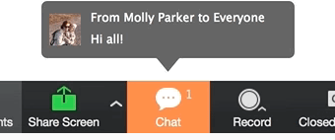

Rules of Engagement

Can we agree to support each other in following these guidelines?

Sharing. We are here to learn from one another. Take turns sharing and be concise to maximize our time together.
- Ask genuine questions and make comments that stay on topic. Enables focused conversation, fosters understanding of various viewpoints, and elicits curiosity about differing viewpoints.

Actively listen. Listen to whoever is speaking instead of mentally preparing a response.
- Honor all experience and expertise equally. They come in many forms.
- Confidentiality. If using a real-life example, don’t use any personal identifiers, like names.

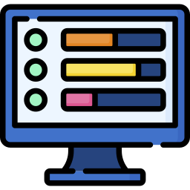

Polling Question

What of the following options best describes your organization?
- Nursing home or rest home
- Office-Based Opioid/Addiction Treatment (OBOT/OBAT) Program
- Opioid Treatment Program (OTP)
- Community resource
- Other

Laying the Framework
Important Facts for Providers

Opioid and Stimulant-Related Deaths in MA

1600

1400

1200

1000
Number of Deaths

800

600

400

200

0
2009 2010 2011 2012 2013 2014 2015 2016 2017 2018 2019
Opioids Stimulants Opioids with Stimulants

Source: Centers for Disease Control and Prevention, National Center for Health Statistics. Multiple Cause of Death 1999-2019 on CDC WONDER Online Database, released in 2020. Data are from the Multiple Cause of Death Files, 1999-2019, as compiled from data provided by the 57 vital statistics jurisdictions through the Vital Statistics Cooperative Program. Accessed at http://wonder.cdc.gov/mcd-icd10.html on Jul 9, 2021

Discussion

Based on your experience, how does the data relate to your work and experience? What surprises you?

A Walk Through the
Care Continuum
Navigating care for those affected by opioid and/or stimulant use disorder(s)

A Walk through the Care Continuum

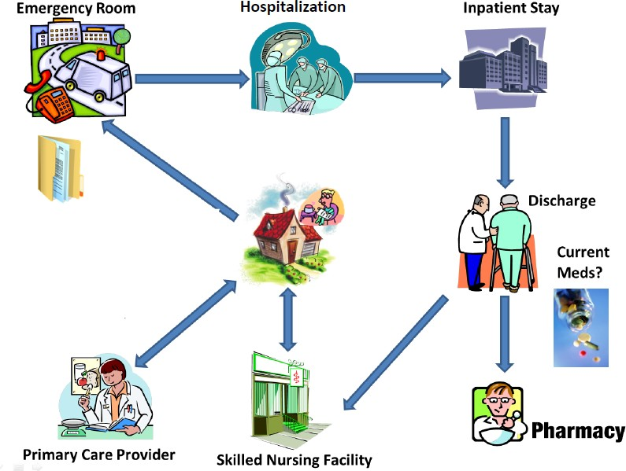
Long-Term Care Facilities
Pharmacy
OBOT/ OBAT OTP

Discussion

How have you worked with your acute care hospital to ensure continuity of care for residents with OUD and/or StUD between the hospital and the LTCF?

Community Partners
Supporting the continuity of care for residents with opioid and/or stimulant use disorder(s)

Treatment Providers: OTP, OBOT, and OBAT

 | OTP | OBOT | OBAT
How they operate …
Operate as outpatient facilities | ✓ | ✓ | ✓
Person-centered focus and minimizing duplication | ✓ | ✓ | ✓
Built on evidence-based models of care to treat SUD |  | ✓ | ✓
Care for OUD provided by primary care or general health care practitioners after obtaining a waiver to  prescribe buprenorphine |  | ✓ | ✓
Care for StUD provided by addiction trained and specially-licensed providers managed by a central  nurse care manager |  |  | ✓
What are they allowed to provide …
On-site treatment | ✓ | ✓ | ✓
Take-home treatment | ✓ | ✓ | ✓
Medications: buprenorphine, buprenorphine/naloxone, buprenorphine extended release, naltrexone,  naloxone | ✓ | ✓ | ✓
Methadone | ✓
Counseling | ✓ | ✓  Yes, if licensed by BSAS (referral encouraged)

Opioid Treatment Programs

- Opioid Treatment Programs (OTPs) are outpatient programs that provide services to treat and manage OUD in a clinical setting.
- View a directory of clinics by state
- Dispense or administer medications including:
  - Methadone (currently)
  - Buprenorphine, buprenorphine and naloxone combination, and/or naltrexone

Administration of medications occurs either:
  - On-site (majority of the time)
  - Take-home pre-poured doses

Admission criteria:
– One year history of documented opioid dependence

Opioid Treatment Program: Services

Admission process includes drug screens, in-depth clinical evaluation, medical screening, and physical examination.
- Person-centered and integrated emotional, social, and behavioral health services required by the Substance Abuse and Mental Health Services Administration (SAMHSA) include:
  - Counseling
  - Treatment
  - Care planning
  - Diversion control

Opioid Treatment Programs: Medications

- There are three FDA approved medications for opioid use disorder (MOUD):
  - methadone, buprenorphine, and naltrexone
- Methadone and buprenorphine are:
  - dispensed daily, unless an approved exception request
- MassHealth can reimburse for all FDA approved MOUD medications including methadone.

Opioid Treatment Programs: Regulatory Oversight

State
- Bureau of Substance Addiction Services (BSAS)
- Drug Control Program

Federal
- Drug Enforcement Agency (DEA)
- SAMHSA Center for Substance Abuse Treatment

OTP Regulatory Requirements: Take-Home Medication

- Follow federal and state regulatory requirements for take-home medications:
  - Absence of recent drug abuse
  - Attendance
  - General compliance with the policies of the OTP
  - Absence of known criminal activity
  - Stability of patient’s home environment and social relationships
  - Length of time in comprehensive maintenance treatment
  - Assurance that take-home medication can be safely stored within patient’s home
  - Whether the rehabilitative benefit the patient derived from decreasing the frequency of clinic attendance outweighs the potential risk of diversion

OTP Regulatory Requirements: Take-Home Medication (cont.)

- If patient meets the criteria, they may receive a certain number of take-home medications based on the federal and state schedules.

- Take-home medications belong to the patients and they can take them when traveling or to a residential facility as long as they are secured in a lockable container in compliance with the facility’s regulations.

Coronavirus Disease 2019 (COVID-19) Blanket Exception

  - In March of 2020 to help limit the spread of COVID-19, and consistent with SAMHSA guidance, BSAS received a blanket exception from SAMHSA on behalf of OTPs for take-home doses of MOUD.
  - The blanket COVID-19 exception enables medical directors to provide:
    - Up to 28 days of take-home medication for all stable patients
    - Up to 14 days of take-home medication for those who are less stable but who the OTP believes can safely handle this level of take-home medication
    - For COVID-19 take-home medication, the 8-point criteria is waived
    - All take-home medication decisions are made at the discretion of the OTP’s medical director in consultation with the clinical team
    - The LTCF should always consult with the OTP when a resident is being discharged and/or experiencing any medical/clinical emergencies, especially regarding take-home medications
Source: BSAS Practice Guidance: Integrating Opioid Overdose Prevention Strategies into Treatment

OBOTs/OBATs: Services

A typical visit may include:
  - Discuss recent substance use.
  - Assess medication dose, adherence, cravings, withdrawal.
  - Provide ongoing education: medication administration side effects, interactions, support.
  - Provide or connect a patient with counseling services.
  - Arrange for psychiatric evaluation with follow-up as needed.
  - Harm reduction services and strategies
  - Assess other medical needs
    - HIV, HCV, routine health maintenance, acute needs, family planning, etc .
  - Assess social needs
    - housing, employment, family, friends, recovery coach.
  - Order labs as clinically indicated.
  - Provide support for the recovery process and build trust at every step .

OBOTs/OBATs: Regulatory Oversight

State
- Bureau of Substance Addiction Services (BSAS)

Federal
- Drug Enforcement Agency (DEA)
- SAMHSA Center for Substance Abuse Treatment

Polling Question

Is there a practitioner with a DATA waiver at your facility?
- Yes
- No
- I do not know

OBOTs/OBATS: Become a Buprenorphine Waivered Practitioner

  - The Drug Addiction Treatment Act of 2000 (DATA) permits practitioners who meet certain qualifications to treat opioid addiction with Schedule III, IV, and V narcotic medications that have been specifically approved by the Food and Drug Administration for that indication.

  - Current practice guidelines permit qualified practitioners to treat up to 30 patients without DATA Waiver training:
    - must be a licensed provider with DEA registration
    - must register a letter of intent with SAMHSA and DEA
    - can prescribe buprenorphine

  - Massachusetts Department of Public Health (MDPH) encourages taking the DATA Waiver training.
    - Boston Medical Center: Office-Based Addiction Treatment Training and Technical Assistance + (OBAT TTA+) offers DATA Waiver Training.
      - Note: This website offers Data Waiver/X-Waiver Training

Stimulant Use Disorder
Treatment
Using behavioral and exercise therapy approaches to treat StUD is evidence-based and effective.

Stimulant Use Disorder Treatment Options

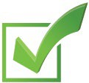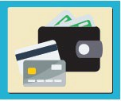
Community Reinforcement Approach
Treatment: Identifying
behaviors that reinforce stimulant use and making a substance-free lifestyle more rewarding.
Training
Available
Intensity and Duration of
Training: No prescribed intensity and duration; recommended for
24 weeks.
Contingency Management
Treatment: Tangible
reinforcers for behavior change such as a monetary incentive for a negative urine screen.
Training
Available
Intensity and Duration of
Training: No prescribed intensity and duration; typically 12 weeks.

Stimulant Use Disorder Treatment Options (cont.)

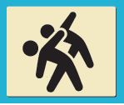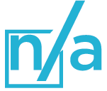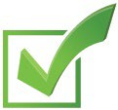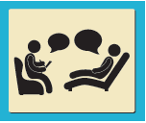
Exercise Supported Recovery
Treatment: Varying
exercise programs have been described, but those with a combination of daily aerobic and anaerobic exercise are associated with long-term recovery.
Training
Available
Intensity and Duration of
Training: Intensity and duration based on the physical limitations of the individual resident.
Cognitive Behavioral Therapy
Treatment: Helping clients
improve the quality of their lives not by changing their circumstances, but altering their perceptions of those circumstances.
Training
Available
Intensity and Duration of
Training: No prescribed intensity and duration; typically, 5 to 10 months.

Establishing Partnerships
with Your OBOT/OBAT, OTP, and Other Community Supports
It’s all about relationships!

How You Can Work with Your Local OTP or OBOT/OBAT

- Admission of resident on MOUD:
  - Develop a Qualified Services Organization Agreement (QSOA)
    - Best practice is to have a QSOA in place prior to admission, however it can also be initiated or in process.
    - QSOAs should include types of services provided (e.g., medical services, counseling services, on-site call coverage, treatment plan).
  - Discussions should occur between LTCF and OBOT/OBAT or OTP administrators prior to admission and throughout the stay.
  - Develop a Release of Information (ROI)
    - Designates what information can be shared.
  - Determine how the medication will be prescribed/dispensed to the resident.

How You Can Work with Your Local OTP

Determine how medication will be dispensed to the resident.
  - Take-home medications (with or without the waiver):
    - LTCF nurse picks up the take-home doses (daily or 1x weekly).
    - Varies for each client. One example is they could come in weekly to pick up one week’s worth of take-home doses.
  - Methadone and/or buprenorphine delivery:
    - OTP nurse delivers and administers the methadone daily.

Polling Question

Have you engaged or established a relationship with any of the following?
- Nursing home or rest home
- OBOT/OBAT
- OTP
- Community resources
- Other

Discussion

How have you engaged with your local
OTP, OBOT/OBAT, or other community addiction supports?
What are some of the considerations you are reviewing with your team?

Communication between OTPs, OBOTs/OBATs, and LTCFs

- The LTCF should immediately report to the OTP or OBOT/OBAT:
  - Signs of impairment
  - Sedation
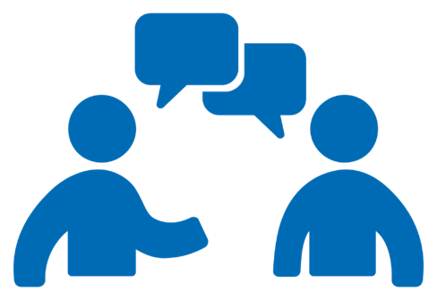
  - Illness
  - Hospitalizations
  - Instability

Communication between OTPs, OBOTs/OBATs, and LTCF (cont.)

- The LTCF reports the resident’s medications, including new prescriptions.
- OTP or OBOT/OBAT medical team conduct dose assessment and depends on many factors.
- The resident signs a consent to release of information, complying with 42 CFR Part 2 and HIPAA.

Opioid Overdose Prevention

Partner with your OTP and OBOT/OBAT to offer Opioid Overdose Prevention training.

- Integrate Opioid Overdose Prevention into your policies, including
– BSAS Practice Guidance – Integrating Opioid Overdose Prevention Strategies into Treatment

Partnership – Best Practices

Prior to admission:
  - Set up resident support systems.
  - Establish a team with whom you can communicate resident needs.
  - Partner with OTP or OBOT/OBAT prior to admission.

Know the expectations of the OTP, OBOT/OBAT at admission and overall:
  - Consider setting up OUD training for facility staff.

Community Resources
Community connections are essential to recovery and provide support for making healthy lifestyle changes.

Resources for Residents

Mutual Help Groups
- Narcotics Anonymous: 12-step recovery program
- Nar-Anon: 12-step recovery program for family and friends
- SMART Recovery®: For all addictive behaviors focusing on self-regulating thoughts, emotions, and actions
- Dual Recovery Anonymous: 12-step recovery program for people with SUDs with simultaneous emotional or psychiatric illness

“Going to meetings has kept me clean when nothing else could, talking to other addicts, service work and surrounding myself with this program has been invaluable." – Terry
Source: West Tennessee Area Narcotics Anonymous

Resources for Residents (cont.)

- Local services
  - Massachusetts Substance Use Helpline, 1-800-327-5050
    - English
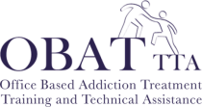
    - Spanish
  - BMC OBAT-TTA +
- National Helpline
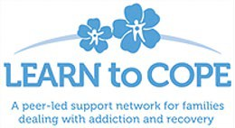
  - SAMHSA’s National Helpline, 1-800-662-HELP (4357)
- Learn to Cope
  - Is a non-profit support network for parents, family members, and friends coping with a loved one addicted to opioids or other drugs.
  - (508) 738-5148

Discussion

What are some of the best practices you have discovered in working with an OBOT/OBAT, OTP, or other community support resources?

Additional Resources

Access to Treatment for SUD:
  - SAMHSA National Hotline: 1-800-662-HELP (4357)
  - Massachusetts Treatment Resource linkage
  - PAATHs

Harm Reduction Education and Materials:
  - Harm Reduction Coalition
  - Needle Exchange Sites
  - BSAS Clearing House

Overdose Education and Naloxone:
  - Prescribe to Prevent
  - BMC OBAT TTA +
  - Where to Access Naloxone in Massachusetts

Massachusetts Department of Public Health

Thank you!

43

Connect with DPH
44

@MassDPH
Massachusetts Department of Public Health DPH blog
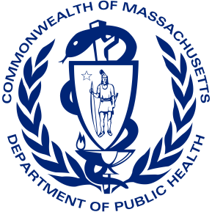
https://blog.mass.gov/publichealth

www.mass.gov/dph

