

Evaluation of Cancer Incidence in Salisbury, MA

July 2014

Bureau of
Environmental Health,
Community Assessment Program

Massachusetts
Department Of
Public Health
TABLE oF Contents

I. Introduction 1
II. Methods for Analyzing Cancer Incidence 1
A. Case Identification/Definition 1
B. Calculation of a Standardized Incidence Ratio 3
C. Interpretation of a Standardized Incidence Ratio 4
D. Calculation of the 95% Confidence Interval 5
E. Evaluation of Cancer Risk Factor Information 6
F. Determination of Geographic Distribution of Cancer Cases 7
III. Results 8
A. Bladder Cancer 9
B. Colorectal Cancer 11
C. Cancers of the Kidney and Renal Pelvis 13
D. Cancer of the Larynx (Laryngeal Cancer) 15
E. Lung and Bronchus Cancer 16
F. Cancer Incidence in the Areas of Concern 18
IV. Environmental Concerns 21
A. 12 Beach Road 22
B. 29 Elm Street 24
V. Discussion 25
VI. Conclusions 26
VII. Recommendations 28
VIII. References 29

LIST OF FIGURES

Figure 1: 2000 Population Density, Salisbury, Massachusetts

Figure 2: Areas of Concern, Salisbury, Massachusetts

LIST OF TABLES

Table 1: Cancer Incidence, Salisbury, Massachusetts, 1994-1998

Table 2: Cancer Incidence, Salisbury, Massachusetts, 1999-2003

Table 3: Cancer Incidence, Salisbury, Massachusetts, 2004-2008

Introduction
An evaluation of cancer incidence in Salisbury, MA was conducted at the request of a member of the Board of Health for the Town of Salisbury. The purpose of this evaluation was to address concerns raised by a resident regarding cancer diagnoses in the community of Salisbury. Staff in the Community Assessment Program (CAP) of the Massachusetts Department of Public Health (MDPH), Bureau of Environmental Health (BEH) reviewed and analyzed data available from the Massachusetts Cancer Registry (MCR) for diagnoses in the town of Salisbury during the period 1994 to 2008 (MCR 2011). For those cancer types with an elevation in incidence during this time period, MCR data were reviewed with respect to risk factors associated with each cancer type as well as the temporal and geographic distribution of the diagnoses. In addition, CAP conducted a qualitative review of cancer diagnoses that occurred within particular areas of community concern, which include Ferry Road, Mudnock Road, and Kendell Lane. CAP also conducted an evaluation of possible environmental exposures related to two properties of concern: a residential property at 12 Beach Road that was formerly used by a contracting company and a vacant property at 29 Elm Street that was historically used for a shoe factory, a vehicle repair facility, a furniture store and a lumberyard.

Methods for Analyzing Cancer Incidence

Case Identification/Definition
Cancer incidence data (i.e., reports of new cancer diagnoses) were obtained for the community of Salisbury from the MDPH MCR. Incidence rates for 23 cancer types are published by the MCR in its city and town supplement report. Individuals diagnosed with cancer are selected for inclusion based on the residential address provided to the hospital or reporting medical facility at the time of diagnosis. Cancer types were selected for evaluation in this investigation based on specific community concerns or statistically significant elevations reported by the MCR in the 2004-2008 city and town supplement: bladder cancer, brain and other nervous system (ONS) cancers, cervical cancer, colorectal cancer, kidney and renal pelvis cancer, laryngeal cancer, lung and bronchus cancers, and ovarian cancer (MCR 2011) .
The MCR is a population-based surveillance system that has been monitoring cancer incidence in the Commonwealth since 1982. All new diagnoses of invasive cancer, as well as certain in situ (localized) cancers, are required by law to be reported to the MCR within six months of the date of diagnosis (M.G.L. c.111. s 111b). This information is kept in a confidential database. Data are collected on a daily basis and reviewed for accuracy and completeness on an annual basis. Due to the high volume of data collected by the MCR and the 6-month period between diagnosis and required reporting, the most current registry data that are complete will be a minimum of 2.5 years prior to the current date. The five-year period 2004-2008 constitutes the period for which the most recent and complete cancer incidence data were available at the initiation of this analysis.
The term "cancer" is used to describe a variety of diseases associated with abnormal cell and tissue growth. Epidemiologic studies have revealed that different types of cancer are individual diseases with separate causes, risk factors, characteristics and patterns of survival (Berg 1996). Cancers are classified by the location in the body where the disease originated (the primary site) and the tissue or cell type of the cancer (histology). Therefore, each of the cancer types reviewed in this report was evaluated separately. Cancers that occur as the result of metastasis, or the spread of a primary site cancer to another location in the body, are not considered as separate cancers and, therefore, were not included in this analysis.
It should be noted that duplicate records have been eliminated from the MCR data used in this report. Duplicate cases are additional reports of the same primary site cancer diagnosed in an individual by another health-care provider. The decision that a diagnosis was a duplicate and should be excluded from the analyses was made by the MCR. However, reports of individuals with multiple primary site cancers were included as separate diagnoses in this report. A diagnosis of a multiple primary cancer is defined by the MCR as a new cancer in a different location in the body or a new cancer of the same histology as an earlier cancer, if diagnosed in the same primary site more than a specified period of time after the initial diagnosis depending upon the particular cancer type (NCI 2012).

Calculation of a Standardized Incidence Ratio
To assess the incidence of cancer in Salisbury, a statistic called the standardized incidence ratio (SIR) was calculated using data from the MCR. The SIR is a comparison of the number of diagnoses in the community to the number of expected diagnoses based on the statewide rate. Specifically, an SIR is the ratio of the observed number of cancer diagnoses in an area to the expected number of diagnoses multiplied by 100. Age-specific statewide incidence rates were applied to the population distribution of Salisbury to calculate the number of expected cancer diagnoses.
SIRs were not calculated for some cancer types due to the small number of observed cases (less than five). It is standard MCR policy not to calculate rates with fewer than five observed diagnoses due to the instability of the rate. However, the expected number of diagnoses was calculated and compared to the observed number of diagnoses to determine whether excess numbers of cancer diagnoses were occurring.

Interpretation of a Standardized Incidence Ratio
An SIR is an estimate of the occurrence of cancer in a population relative to what might be expected if the population had the same cancer experience as a larger comparison population designated as "normal" or average. Usually, the state as a whole is selected to be the comparison population, which provides a stable population base for the calculation of incidence rates. The statewide incidence rate is applied to the population structure of each community to calculate the number of expected cancer diagnoses. Comparison of SIRs between communities is not possible because each area has different population characteristics.
An SIR of 100 indicates that the number of cancer diagnoses observed in the population being evaluated is equal to the number of cancer diagnoses expected in the comparison or “normal” population. An SIR greater than 100 indicates that more cancer diagnoses occurred than expected, and an SIR less than 100 indicates that fewer cancer diagnoses occurred than expected. Accordingly, an SIR of 150 is interpreted as 50% more diagnoses than the expected number; an SIR of 90 indicates 10% fewer diagnoses than expected.
Caution should be exercised, however, when interpreting an SIR. The interpretation of an SIR depends on both its size and the stability. Two SIRs may have the same size but not the same stability. For example, an SIR of 150 based on four expected diagnoses and six observed diagnoses indicates a 50% excess in cancer, but the excess is actually only two diagnoses. Conversely, an SIR of 150 based on 400 expected diagnoses and 600 observed diagnoses represents the same 50% excess in cancer, but because the SIR is based upon a greater number of diagnoses, the estimate is more stable. It is very unlikely that 200 excess diagnoses of cancer would occur by chance alone. As a result of the instability of incidence rates based on small numbers of diagnoses, SIRs are not calculated when fewer than five diagnoses were observed for a particular cancer type.

Calculation of the 95% Confidence Interval
To help interpret or measure the stability of an SIR, the statistical significance of an SIR can be assessed by calculating a 95% confidence interval (CI) to determine if the observed number of diagnoses is “statistically significantly different” from the expected number or if the difference may be due solely to chance (Rothman and Boice 1982). Specifically, a 95% CI is the range of estimated SIR values that have a 95% probability of including the true SIR for the population. If the 95% CI range does not include the value 100, then the study population is significantly different from the comparison or “normal” population. “Statistically significantly different” means there is less than a 5% percent chance that the observed difference (either increase or decrease) in the rate is the result of random fluctuation in the number of observed cancer diagnoses.
For example, if a confidence interval does not include 100 and the interval is above 100 (e.g., 105-130), then there is a statistically significant excess in the number of cancer diagnoses. Similarly, if the confidence interval does not include 100 and the interval is below 100 (e.g., 45-96), then the number of cancer diagnoses is statistically significantly lower than expected. If the confidence interval range includes 100, then the true SIR may be 100. In this case, it cannot be determined with certainty whether the difference between the observed and expected number of diagnoses reflects a real cancer increase or decrease or is the result of chance. It is important to note that statistical significance alone does not necessarily imply public health significance. Determination of statistical significance is just one tool used to interpret cancer patterns.
In addition to the range of the estimates contained in the confidence interval, the width of the confidence interval also reflects the stability of the SIR estimate. For example, a narrow confidence interval (e.g., 103-115) allows a fair level of certainty that the calculated SIR is close to the true SIR for the population. A wide interval (e.g., 85-450) leaves considerable doubt about the true SIR, which could be much lower than or much higher than the calculated SIR. This would indicate an unstable statistic. Again, due to the instability of incidence rates based on a small numbers of diagnoses, statistical significance was not assessed when fewer than five diagnoses were observed.

Evaluation of Cancer Risk Factor Information
As previously mentioned, cancer is not just one disease but rather a general term used to describe a variety of different diseases. Studies have generally shown that different cancer types have different risk factors. One or even several factors acting over time can be related to the development of cancer. Available information reported to the MCR related to risk factors for cancer development was reviewed for residents of Salisbury who were diagnosed with a cancer type that was elevated in the community during 1994 to 2008. This information is collected for each individual at the time of diagnosis and may include the individual’s age at time of diagnosis, the stage of disease, and the individual’s history of tobacco use and occupation. The available risk factor information was compared to known or established incidence patterns for the specific type of cancer. To protect the privacy of those Salisbury residents diagnosed with cancer during this time period, the information is presented in this report as a summary without any specific identifying details. Unfortunately, information about personal risk factors such as family history, medical history, diet, and other factors that may also influence the development of cancer is not collected by the MCR. Therefore, it was not possible to consider their contributions to cancer development in this investigation.

Determination of Geographic Distribution of Cancer Cases
Using a computerized geographic information system (GIS), address at the time of diagnosis was mapped for each individual diagnosed with a type of cancer that was elevated in Salisbury during 1994 to 2008. This allowed for an evaluation of the spatial distribution of the individual diagnoses at a smaller geographic level within a community (i.e., neighborhoods). This evaluation of the point pattern of diagnoses included consideration of the variability in population density within the community (Figure 1).
The MDPH is bound by state and federal patient privacy and research laws not to make public the names or any other information (e.g., place of residence) that could personally identify individuals with cancer whose diagnoses have been reported to the MCR (M.G.L. c.111. s. 24A). Therefore, for confidentiality reasons, it is not possible to release maps showing the locations of individuals diagnosed with cancer in public reports. However, a summary of the evaluation of geographic distribution with any notable findings is presented in this report.

Results
Tables 1, 2 and 3 contain incidence data for eight types of cancer for the community of Salisbury for three five-year time periods of 1994-1998, 1999-2003, and 2004-2008, respectively. The incidence of brain and ONS cancers, cervical cancer, and ovarian cancer occurred about as expected or less frequently than expected during all three time periods evaluated. The incidence of the remaining five cancer types varied over time with elevations noted as follows:
- Statistically significant elevations occurred in bladder cancer among females during 1999-2003 and among males during 2004-2008, colorectal cancer among males during 1999-2003, kidney/renal pelvis cancer among males during 2004-2008, laryngeal cancer among males during 2004-2008, and lung and bronchus cancers among females during 1999-2003 and 2004-2008.
- Elevations that were not statistically significant were observed for colorectal cancer among both males and females during 1994-1998 and among females during 2004-2008; kidney/renal pelvis cancer among females during 1999-2003; and lung and bronchus cancers among both males and females during 1994-1998 and among males during 1999-2003.
The incidence of the five cancer types where elevations were observed during any of the three five-year periods evaluated is discussed further in the following sections.

Bladder Cancer
Bladder cancer can be either invasive or non-invasive depending on its extent in the wall of the bladder, which has several layers. If the cancer is confined to the inner layer of the bladder, it is called non-invasive cancer or carcinoma in situ. If the cancer extends into deeper layers of the bladder, it is considered invasive cancer. The data provided in this report include diagnoses of both invasive and non-invasive bladder cancers.
The incidence of bladder cancer among males in Salisbury was about as expected during 1994-1998 and 1999-2003 but was statistically significantly elevated during 2004-2008 (18 observed versus 9 expected, SIR = 202, 95% CI 120 – 320). Among females, the incidence of bladder cancer was about as expected during 1994-1998, statistically significantly elevated during 1999-2003 (8 observed versus 3 expected, SIR = 287, 95% CI 124 – 565), and about as expected again during 2004-2008.
The number of diagnoses of bladder cancer in any given year in Salisbury fluctuated over the 15-year time period from 1994 to 2008. A review of the geographic distribution of the reported residences of individuals diagnosed with bladder cancer in Salisbury during this time period did not reveal any unusual concentrations or spatio-temporal patterns.
Bladder cancer is much more common in men than women. According to the American Cancer Society (ACS), men are about 3 to 4 times more likely to get bladder cancer during their lifetime than women (ACS 2013a). In Salisbury, males comprised 75% of the individuals diagnosed with bladder cancer during 1994-2008.
The risk of bladder cancer increases with age. Nearly 90% of people with this cancer in the United States are over the age of 55 at the time of diagnosis, with an average age of 73 (ACS 2013a). Consistent with national trends, 85% of those diagnosed with bladder cancer in Salisbury during 1994 to 2008 were over the age of 55 at the time of diagnosis, with an average age of 65 (somewhat younger than the national average).
The ACS states that smoking is the most important risk factor for bladder cancer. Smokers are at least three times as likely to develop bladder cancer as nonsmokers (ACS 2013a). Of the 43 individuals diagnosed with bladder cancer in Salisbury for whom tobacco history was provided to the MCR, 35 (81%) reported being current or former smokers at the time of their diagnosis.
Workplace exposures to certain industrial chemicals, such as benzidine and beta-naphthylamine, may possibly increase the risk of bladder cancer. These chemicals are sometimes used in the dye industry. A higher risk of developing bladder cancer has also been observed among workers in the rubber, leather, textiles, printing, and paint products industries as well as among hairdressers, machinists and truck drivers. Further, the risk of bladder cancer from occupational exposures may be increased among smokers (ACS 2013a). Of the 32 individuals diagnosed with bladder cancer in Salisbury during 1994 to 2008 who reported an occupation to the MCR, two (6%) appeared to have worked in an occupation that may possibly be a risk factor for the development of bladder cancer. However, a complete occupational history or specific job information that could further define exposure potential for these individuals is not available through the MCR.
Other risk factors for bladder cancer include a family history of bladder cancer, certain rare birth defects involving the bladder, a previous cancer diagnosis in any part of the urinary tract, prior treatment with radiation to the pelvis, and medical conditions that cause chronic bladder irritation such as urinary infections or kidney and bladder stones. The MCR does not collect information related to these personal risk factors and, hence, they could not be evaluated.
Lastly, arsenic in drinking water has been associated with an increased risk of bladder cancer. The chance of being exposed to arsenic depends on where you live and the source of your drinking water (ACS 2013a). The CAP reviewed the Consumer Confidence Report (CCR) for 2013 for the municipal drinking water supply in Salisbury. The CCR is required by the U.S. Environmental Protection Agency to be provided annually to residents to inform them about the quality of their municipal drinking water. No violations of any applicable health standards regulated by the state and federal government were reported during this time (Pennichuck Water 2013). Testing of water from private wells is the responsibility of the homeowner. For more information on testing a private well, visit MassDEP’s website at http://www.mass.gov/eea/agencies/massdep/water/drinking/private-wells.html.

Colorectal Cancer
Among males, the incidence of colorectal cancer was elevated during 1994-1998 (14 observed versus 11 expected) but the elevation was not statistically significant. A statistically significant elevation was observed during 1999-2003 (22 observed versus 13 expected, SIR = 175, 95% CI 109 – 264) but the incidence was about as expected during 2004-2008. Among females, the incidence of colorectal cancer was elevated during 1994-1998 (13 observed versus 10 expected), less than expected during 1999-2003, and elevated during 2004-2008 (14 observed versus 10 expected). Neither the elevation during 1994-1998 nor 2004-2008 was statistically significant.
Diagnoses of colorectal cancer in Salisbury during 1994 to 2008 were reviewed to determine if any unusual temporal or spatial patterns existed. The number of diagnoses fluctuated from year to year. The geographic distribution of address at the time of diagnosis generally followed the pattern of population density within the community and no unusual concentrations of individuals were observed in any particular area.
The risk of developing colorectal cancer increases markedly after age 50. Approximately 90% of diagnoses occur in individuals 50 years of age or over, with an average age at diagnosis of 72 (ACS 2013b; ASCO 2012). In Salisbury, 94% of individuals diagnosed with colorectal cancer during 1994-2008 were age 50 or older, with an average age of 69 at the time of diagnosis.
Colorectal cancer is slightly more common among males than females (ACS 2013b). In Salisbury, more men were diagnosed with colorectal cancer than women during 1994-2008.
About 96% of colorectal cancers in the United States are of a histology (cell type) known as adenocarcinoma (ACS 2011a). The cell types of colorectal cancer diagnosed among residents of Salisbury during 1994 to 2008 generally followed this national statistic with about 94% diagnosed with adenocarcinomas.
A few factors that increase the risk of developing colorectal cancer have been identified. Smoking has been linked to colorectal cancer with long-term smokers being more likely than non-smokers to develop and die from colorectal cancer (ACS 2013b). Of the 67 individuals diagnosed with colorectal cancer in Salisbury for whom tobacco history was provided to the MCR, 43 (64%) reported being current or former smokers at the time of their diagnosis.
Additional risk factors for colorectal cancer include having a history of adenomatous polyps and certain medical conditions such as inflammatory bowel disease (IBD), which includes ulcerative colitis and Crohn’s disease. Although most colorectal cancers occur in individuals without a family history of this cancer type, it is estimated that up to 20% of individuals who develop colorectal cancer also have a family member who has been affected by the disease. Individuals who have a first-degree relative (i.e., parent, sibling, or child) with a history of colorectal cancer have nearly double the risk of developing colorectal cancer. Having family members who have had adenomatous polyps is also linked to a higher risk of colon cancer. Furthermore, individuals who have low levels of physical activity or suffer from obesity are at a higher risk for developing colorectal cancer (ACS 2013b). The MCR does not collect information related to these risk factors and, hence, they could not be evaluated.

Cancers of the Kidney and Renal Pelvis
Among males, the incidence of kidney and renal pelvis cancers was about as expected during 1994-1998 and 1999-2003 but was statistically significantly elevated during 2004-2008 (11 observed versus 5 expected, SIR = 226, 95% CI = 113 – 405). Among females, the incidence of kidney and renal pelvis cancers was about as expected during 1994-1998, elevated during 1999-2003 (5 observed versus 2 expected) and about as expected during 2004-2008. The elevation that occurred during 1999-2003 was not statistically significant.
Kidney and renal pelvis cancers occur most often in individuals age 55 and older and are uncommon in people younger than age 45. The average age at diagnosis is 64 (ACS 2013c). Among Salisbury residents diagnosed with kidney and renal pelvis cancers during 1994 to 2008, the average age at diagnosis was 63 years and 76% were age 55 or older at the time of their diagnosis.
The occurrence of kidney and renal pelvis cancers in Salisbury from 1994 to 2008 was reviewed to determine if any unusual temporal or spatial patterns existed. The number of diagnoses in any given year fluctuated. Place of residence at the time of diagnosis was mapped for each of the 29 individuals in Salisbury diagnosed with this cancer type during the 15-year time period. The geographic distribution of diagnoses generally followed the pattern of population density with no unusual concentrations.
According to the American Cancer Society (ACS), smoking is a major risk factor for kidney and renal pelvis cancers and the risk increases with quantity (ACS 2013c). Of the 26 individuals diagnosed with this cancer type in Salisbury during 1994 to 2008 and for whom tobacco history was reported to the MCR, 17 (65%) were current or former smokers at the time of their diagnosis.
Many studies suggest that workplace exposures to certain substances, such as asbestos, cadmium, and certain organic solvents and herbicides, are associated with an increased risk of developing kidney and renal pelvis cancers (ACS 2013c). Of the 20 individuals diagnosed with kidney and renal pelvis cancer during 1994 to 2008 who reported an occupation to the MCR, five (25%) appeared to have worked in an occupation that may possibly be a risk factor for the development of this cancer type. It should be noted, however, that such data are generally limited to job title and/or industry and often do not include specific job duty information that could further define exposure potential for individual diagnoses. Moreover, occupation was reported as unknown, at home, or retired for 31% of the individuals.
Other risk factors for kidney cancer include obesity, and genetic and hereditary risk factors, including certain inherited conditions and syndromes. Other possible risk factors include a family history of kidney cancer, high blood pressure, and certain medications, such as diuretics used to treat high blood pressure. As mentioned, the MCR does not collect information related to these personal risk factors and, hence, they could not be evaluated.

Cancer of the Larynx (Laryngeal Cancer)
The incidence of laryngeal cancer among males in Salisbury was about as expected during 1994-1998 and 1999-2003 but was statistically significantly elevated during 2004-2008 (6 observed versus 1 expected, SIR = 422, 95% CI 154-919). Among females, the incidence was about as expected during all three time periods that were evaluated.
Information for individuals diagnosed with laryngeal cancer in Salisbury from 1994 to 2008 was reviewed to determine if any unusual temporal or spatial patterns existed. The number of individuals diagnosed each year fluctuated. The geographic distribution of address at the time of diagnosis generally followed the pattern of population density within the community and no unusual concentrations were observed.
Cancers of the larynx are about four times more common in men than women. They are not common in young people, with more than half of patients older than 65 at the time of diagnosis (ACS 2013d). In Salisbury, about 86% of the individuals diagnosed during 1994-2008 were male and about 43% were over the age of 65, with an average age at diagnosis of 66 years.
Tobacco use is the most important risk factor for cancers of the larynx. Most people who develop this type of cancer have a history of smoking or other tobacco exposure (ACS 2013d). Of the 14 individuals diagnosed with laryngeal cancer in Salisbury during 1994-2008 and for whom tobacco use was reported to the MCR, 86% were current or former tobacco users at the time of their diagnosis.
According to the ACS, other risk factors for the development of laryngeal cancer include long and intense exposures to wood dust, paint fumes, and certain chemicals used in the metalworking, petroleum, plastics, and textile industries. Some studies have also shown that asbestos exposure may increase laryngeal cancer risk (ACS 2013d). Of the 13 individuals diagnosed with laryngeal cancer during 1994 to 2008 who reported an occupation to the MCR, 31% appeared to have worked in an occupation that may possibly be a risk factor for the development of this cancer type. As noted previously, such data are generally limited to job title and/or industry and often do not include specific job duty information that could further define exposure potential for individual diagnoses.
An additional risk factor for the development of this type of cancer is moderate or heavy alcohol use. Heavy drinkers have a risk of laryngeal cancer several times that of nondrinkers. The combination of smoking and drinking alcohol results in a risk of laryngeal cancer that is many times greater than that of individuals with neither habit (ACS 2013d). The MCR does not collect information related to this risk factor and, hence, it could not be evaluated.

Lung and Bronchus Cancer
Among males, the incidence of lung and bronchus cancer was elevated during 1994-1998 (19 observed versus 15 expected) and 1999-2003 (23 observed versus 16 expected). Neither of these elevations was statistically significant. During 2004-2008, the incidence among males was about as expected. Among females, the incidence of lung and bronchus cancer was elevated during 1994-1998 (15 observed versus 11 expected) and statistically significantly elevated during both 1999-2003 (23 observed versus 14 expected, SIR = 166, 95% CI 105-249) and 2004-2008 (29 observed versus 16 expected, SIR = 183, 95% CI 122-263).
Information for individuals diagnosed with lung and bronchus cancer in Salisbury from 1994 to 2008 was also reviewed to determine if any unusual temporal or spatial patterns existed. The number of individuals diagnosed each year was fairly evenly distributed over the time period. The geographic distribution of address at the time of diagnosis generally followed the pattern of population density within the community. No unusual spatial or temporal patterns were observed.
According to the ACS, about two-thirds of people diagnosed with lung and bronchus cancer in the U.S. are over 65 years of age at the time of diagnosis and fewer than 2% are under the age of 45. The average age at diagnosis is 70 (ACS 2013e, 2011b). In Salisbury, 56% of those diagnosed with this cancer type during 1994-2008 were over 65 years of age at diagnosis and 4% were under the age of 45. The average age at the time of diagnosis was 67.
Smoking is, by far, the most important risk factor for lung and bronchus cancer. It is estimated that at least 80% of deaths from lung and bronchus cancer are caused by smoking. The risk of developing this cancer type increases with the quantity and duration of cigarette consumption. In addition, there is no evidence that smoking low tar or “light” cigarettes reduces the risk of lung cancer and mentholated cigarettes are thought to increase the risk of lung cancer even more. If an individual stops smoking before a cancer develops, the damaged lung tissue gradually repairs itself. No matter the age of an individual or how long someone has used tobacco, quitting may help an individual to live longer (ACS 2013e, 2011b). Of the 105 individuals diagnosed with lung and bronchus cancer in Salisbury during 1994-2008 for whom tobacco use was reported to the MCR, 99% were current or former tobacco users at the time of their diagnosis.
According to the United States Environmental Protection Agency (USEPA), exposure to radon is the second leading cause of lung and bronchus cancer, and the leading cause among non-smokers. Radon is a naturally occurring radioactive gas produced by the breakdown of uranium in soil and rocks. High indoor levels of radon can occur in homes and buildings, especially in basements. Because radon levels in the soil vary across the country and can be high almost anywhere, testing is the only way to determine the radon level in a home (ACS 2013e, 2011b).
Workplace exposure to asbestos has also been identified as an important risk factor for lung and bronchus cancer. Exposure to asbestos may occur in mines, mills, textile plants, shipyards, and where insulation is used. Asbestos is not usually considered harmful as long as it is not released into the air by deterioration, demolition, or renovation. Additional chemical compounds that are occupational risk factors include arsenic, beryllium, cadmium, silica, vinyl chloride, nickel compounds, chromium compounds, coal products, mustard gas, chloromethyl ethers, diesel exhaust, and radioactive ores such as uranium (ACS 2013e, 2011b). Of the 88 individuals diagnosed with lung and bronchus cancer in Salisbury during 1994 to 2008 and for whom an occupation was reported to the MCR, approximately 43% appeared to have worked in an occupation possibly associated with an increased risk of developing this cancer type. As previously noted, such data are generally limited to job title and/or industry and often do not include specific job duty information that could further define exposure potential for individual diagnoses.

Cancer Incidence in the Areas of Concern
CAP staff conducted a qualitative review of cancer diagnoses that occurred during the 19-year time period of 1994-2012 in three particular areas of concern: Ferry Road, Mudnock Road, and Kendell Lane (Figure 2). Because accurate age-group and gender-specific population data are not available for these specific areas of concern, it is not possible to calculate actual cancer incidence rates for them; however, this type of review can provide information that is useful (e.g., are cancers of the same type concentrated in one particular area).
Ferry Road Area
A total of 41 individuals within this area of concern were diagnosed with 16 different cancer types during this 19-year time period. A separate evaluation by gender revealed that 21 females were diagnosed with 10 different cancer types, two of which are the most common cancer types diagnosed among Massachusetts females: breast cancer and lung and bronchus cancers. During 2005 to 2009, these two cancer types represented approximately 43% of all new cancer diagnoses among females in the Commonwealth. In the Ferry Road area, these two cancer types comprised nearly 48% of the diagnoses that occurred among females during 1994 to 2012. Similarly, twenty males were diagnosed with 9 different cancer types, three of which are among the most common cancer types diagnosed among Massachusetts males: prostate cancer, lung and bronchus cancers and colon/rectal cancers. These three cancer types represented 57% of all diagnoses among males in the area of concern during 1994 to 2012 compared to approximately 51% of all diagnoses among males in Massachusetts during 2005 to 2009 (MCR 2012).
For the majority of the individuals diagnosed with cancer in this area during 1994 to 2012, the age of the individual at the time of diagnosis as well as the histology of the cancer was consistent with what would be expected based on state and national trends for the specific cancer type.
Tobacco use history was reviewed for those individuals diagnosed with a cancer type for which smoking is an established risk factor. Of the 10 individuals diagnosed with one of five cancer types for which smoking is an established risk factor and for whom tobacco history was reported, 80% (n=8) were current or former smokers at the time of diagnosis.
Lastly, a review of the geographic distribution of address at the time of diagnosis did not reveal any unusual spatial patterns. The number of individuals diagnosed each year from 1994 to 2012 were fairly evenly distributed over the time period. No clustering in space or time was seen for any particular types of cancer. It should be noted that the northern half of Ferry Road is located in an area of higher population density within the community of Salisbury.
Kendell Lane Area
A total of 13 individuals within this area of concern were diagnosed with 5 different cancer types during 1994-2012. These cancer types are among the most common types diagnosed among Massachusetts residents: breast cancer, prostate cancer, lung and bronchus cancers, cancers of the colon/rectum, and cancers of the corpus uteri (uterus) (MCR 2012).
The age of the individuals at the time of diagnosis and the histology of the cancers were consistent with what would be expected based on state and national trends for the specific cancer type.
Smoking is an established risk factor for two of the five types of cancer. Of the 7 individuals diagnosed with these cancers and for whom tobacco history was reported, all were current or former smokers at the time of diagnosis.
A review of the geographic distribution of address at the time of diagnosis did not reveal any unusual spatial patterns. In addition, no unusual temporal patterns were observed.
Mudnock Road Area
A total of 30 individuals in this area of concern were diagnosed with 18 different types of cancer during the 19-year time period. A separate evaluation by gender revealed that 15 females were diagnosed with 8 different cancer types, with 67% of their diagnoses consisting of three of the most common types diagnosed among Massachusetts females (breast, lung and bronchus, and uterine). A total of 15 males were diagnosed with 12 different types of cancer, with 45% of their diagnoses consisting of three of the most common types diagnosed among Massachusetts males (prostate, lung and bronchus, and colon/rectum).
For the majority of the individuals in the Mudnock Road area, age at diagnosis and the histology were consistent with what would be expected based on state and national trends for the specific type of cancer.
Smoking is an established risk factor for seven of the cancer types diagnosed among residents in the Mudnock Road area during this 19-year time period. Of the 11 individuals diagnosed with these cancer types and for whom tobacco history was reported, 82% (n=9) were current or former smokers at the time of diagnosis.
Lastly, no unusual spatial or temporal patterns were observed in this area. It should be noted that the Mudnock Road area is located within an area of higher population density in the community of Salisbury. The number of individuals diagnosed each year also fluctuated.

Environmental Concerns
The Massachusetts Contingency Plan (MCP) is the statewide hazardous waste site cleanup program established in 1983 under Chapter 21E of Massachusetts General Laws (M.G.L. c21E, 310 CRM 40.0000). To address concerns about possible environmental exposures from historic releases at 12 Beach Road and 29 Elm Street, the CAP considered potential ways that people may come into contact with contaminants associated with these sites.
In general, five conditions must be present for exposure to occur. First, there must be a source of the chemical or contaminant. Second, an environmental medium must be contaminated by either the source or by chemicals transported away from the source. Third, there must be a location where a person can potentially contact the contaminated medium. Fourth, there must be a means by which the contaminated medium could enter a person’s body, such as ingestion, inhalation, or dermal absorption. Finally, a population of individuals that could potentially be exposed must be present (ATSDR 2005). A completed exposure pathway exists when all five elements are present and indicates that exposure to humans occurred in the past, is occurring in the present, or will occur in the future. A potential exposure pathway exists when one or more of the five elements is uncertain and indicates that exposure to a contaminant could have occurred in the past, could be occurring in the present, or could occur in the future. An exposure pathway can be eliminated if at least one of the five elements is missing and will not likely be present in the future.

12 Beach Road
The property at 12 Beach Road consists of two adjoining lots, totaling approximately 3.7 acres, and is located in a residential section of Salisbury, near the town center. The northern lot includes a former single-family residence, a 2-bay garage and a shed, while the southern lot is undeveloped. The property has been utilized solely for residential purposes since the late 1980s but, according to a town resident and the Salisbury Conservation Commission, was previously used by a contracting company (ENSTRAT 2013).
In 2012, the MassDEP was notified of petroleum detected in soil at concentrations reportable under the MCP and the property was assigned MCP Release Tracking Number (RTN) 3-31267. Subsequent assessment activities at the site included the collection of soil and groundwater samples. Results of these samples revealed petroleum in soil below the ground surface in an area located south/southeast of the shed as well as beneath one of two underground storage tanks (UST) discovered on-site. Both tanks were not documented at the Salisbury Fire Department; therefore, the time of their installation is unknown. Sampling results indicate that groundwater was not affected and that migration of vapors from soil is unlikely. Remediation activities included the removal of approximately 125 cubic yards of soil. In 2013, a Class A-2 RAO was issued for this release under the MCP, indicating that remedial work was completed, a permanent solution was achieved and, although contamination has not been reduced to background concentrations, a level of “no significant risk” of harm to health, safety, public welfare, and the environment exists currently and in the foreseeable future. In addition, no “activity and use limitations” on the property were required by MassDEP based upon current and foreseeable future conditions (ENSTRAT 2013).
Due to the depth below ground surface at which soil contamination was detected, no exposure pathways were complete in the past, present or future. Exposure to impacted soil remaining at the site is not expected to occur due to its presence at depths below ground surface and future use of the property is for the development of residential condominium buildings. The MassDEP considers the remediation of this release to be complete as indicated by the Class A-2 RAO that was issued (ENSTRAT 2012, 2013).

29 Elm Street
The property at 29 Elm Street encompasses approximately 0.8 acres and is a vacant, undeveloped parcel owned by the town of Salisbury in a mixed area of residential and commercial properties. Historically, the property has been used for shoe manufacturing (but not tanning), vehicle maintenance and repair, a furniture store, and a lumber yard and hardware business. The concrete slab foundation of a former building still exists in the western portion of the site with adjacent paved and unpaved areas.
During a Phase II environmental site assessment conducted on behalf of the town of Salisbury and the Merrimack Valley Planning Commission in 2008, soil contaminants (primarily metals and VOCs) were detected in the southern portion of the site at concentrations reportable under the MCP. As a result, the MassDEP was notified and RTN 3-28202 was assigned. Additional investigational activities conducted in 2010 revealed higher concentrations of previously reported compounds and additional compounds (petroleum hydrocarbons, phthalates, and PCBs) that had not been previously detected above reportable concentrations resulting in the additional assignment of RTN 3-30190 (TRC 2012).
Subsurface structures identified at the site include a concrete-lined pit associated with the elevator of the former building and two vaults believed to comprise an historical septic system used for the disposal of oil and hazardous material. The pit, which is located near the center of the foundation, was found to contain contaminated soil, debris and water. The vaults, located in the eastern portion of the site, were found to contain contaminated sludge and water. Testing confirmed that the contents of the pit and the vaults are contained and do not extend beyond these subsurface structures (TRC 2008, 2012). All have been backfilled with soil such that they are flush with the adjacent surface (V. Thompson, MassDEP, personal communication, 2014).
The southern portion of the site is wooded with an undulating surface indicative of historical dumping. Significant evidence indicates that waste materials (primarily scraps of leather) have historically been disposed of in this area with debris found to depths of 6 feet below ground surface. Some of the mounds were observed to extend to adjacent residential parcels to the south; however, testing confirmed that elevations in contaminants are generally limited to the property at 29 Elm Street (TRC 2008, 2012).
Although on-site remediation has not occurred, exposure of nearby residents or trespassers to contaminated subsurface soil would not be expected due to its depth below ground surface. In addition, it is important to note that the adjacent residential properties are heavily wooded and contain wetlands, with the nearest residence completely enclosed by a tall stockade fence. As such, nearby residents are unlikely to access the site under existing conditions and trespassing would be expected to be limited, if at all. No documented private drinking water wells are located on-site or in the immediate vicinity of the site. Based on these site conditions, it is unlikely that nearby residents would be exposed to site-related contaminants in the past, present or future (TRC 2007).

Discussion
According to ACS statistics, cancer is the second leading cause of death in Massachusetts and the United States. Not only will one out of three women and one out of two men develop cancer in their lifetime, but cancer will affect three out of every four families. For this reason, cancers often appear to occur in “clusters,” and it is understandable that someone may perceive that there are an unusually high number of cancer cases in their neighborhood or town. Upon close examination, many of these “clusters” are not unusual increases, as first thought, but are related to such factors as local population density, variations in reporting or chance fluctuations in occurrence. In other instances, the “cluster” in question includes a high concentration of individuals who possess related behaviors or risk factors for cancer. Some, however, are unusual; that is, they represent a true excess of cancer in a workplace, a community, or among a subgroup of people. A suspected cluster is more likely to be a true cancer cluster if it involves a large number of cases of one type of cancer diagnosed in a relatively short time period rather than several different types diagnosed over a long period of time (i.e., 20 years), a rare type of cancer rather than common types, and/or a large number of cases diagnosed among individuals in age groups not usually affected by that cancer. These types of clusters may warrant further public health investigation.
Descriptive epidemiological analyses such as this report can be useful in evaluating the pattern of cancer in a geographic context, assessing the possibility of a common cause or etiology, and determining whether further public health investigations or actions may be warranted. A descriptive analysis of cancer incidence data alone cannot be used to establish a causal link between a particular risk factor (either environmental or non-environmental) and the development of cancer. Similarly, this type of analysis cannot determine the cause of cancer in any one particular individual. The purpose of this report was to evaluate the incidence of cancer in the community of Salisbury to determine whether any unusual patterns were evident.

Conclusions
Overall, there does not appear to be an unusual pattern of cancer in the community of Salisbury or, more specifically, in the areas of concern near Ferry Road, Kendell Lane and Mudnock Road based on the information reviewed in this report.
Although elevations in the incidence of five cancer types did occur among Salisbury residents during 1994-2008, none constituted a consistent trend over the entire 15-year time period. Specifically, statistically significant elevations were noted for the following five cancer types at some point over the time period 1994-2008: bladder cancer among males and females, colorectal cancer among males, kidney and renal pelvis cancer among males, laryngeal cancer among males, and lung and bronchus cancer among females. The geographic distribution of the addresses at the time of diagnosis closely followed the pattern of population density within the community and no unusual spatial or temporal patterns were observed. Review of risk factors appropriate for each of these cancer types such as age at diagnosis, sex, and histology did not differ from what has been reported in the epidemiological literature. It is important to note that the major risk factor for each of these five types of cancer is smoking. Smoking appears to have contributed, significantly, to the increased incidences of these five cancer types. In some cases, occupational exposures may also have played a role.
A qualitative evaluation at the neighborhood level revealed that many different cancer types were diagnosed among residents of the three areas of concern during 1994 to 2012. Several of these cancer types were among the most common cancer types diagnosed among Massachusetts residents. No unusual spatial or temporal patterns were observed in each of the three areas. Age at diagnosis, sex and histology was consistent with what would be expected based on state and national trends for each specific type of cancer. For those cancer types for which tobacco use is an established risk factor, it appears that smoking may have contributed to their occurrence.
Based on site conditions and the depth below ground surface, it is unlikely that nearby residents would have been exposed to contaminants from historical releases at either 12 Beach Road or 29 Elm Street in the past, present or future. Because no exposure pathways are complete, adverse health effects would not be expected.

Recommendations
In response to the findings of this evaluation, the MDPH does not recommend further analysis of cancer data. The department does however recommend that residents who would like more information about quitting smoking contact the Massachusetts Smokers’ Helpline at 1-800-QuitNow or 1-800-784-8669. For Spanish call 1-800-8-Déjalo or 1-800-833-5256. Communities, employers and health and human service agencies may also contact their regional Tobacco-Free Community Partnership at the Greater Lawrence Family Health Center at 978-722-2864. A fact sheet on the use of tobacco in the community of Salisbury has been included as an attachment to this report.

References
American Cancer Society (ACS). 2011a. “Colorectal Cancer Facts & Figures 2011-2013.” http://www.cancer.org/acs/groups/content/@epidemiologysurveilance/documents/document/acspc-028323.pdf.
ACS. 2011b. “Detailed Guide: Lung Cancer - Small Cell.” http://www.cancer.org/Cancer/LungCancer-Non-SmallCell/DetailedGuide/index.
ACS. 2013a. “Detailed Guide: Bladder Cancer.” http://www.cancer.org/cancer/bladdercancer/detailedguide/index.
ACS. 2013b. “Detailed Guide: Colorectal Cancer.” http://www.cancer.org/cancer/colonandrectumcancer/detailedguide/.
ACS. 2013c. “Detailed Guide: Kidney Cancer (Adult) - Renal Cell Carcinoma.” http://www.cancer.org/cancer/kidneycancer/detailedguide/index.
ACS. 2013d. “Detailed Guide: Laryngeal and Hypopharyngeal Cancer.” http://www.cancer.org/cancer/laryngealandhypopharyngealcancer/detailedguide/.
ACS. 2013e. “Detailed Guide: Lung Cancer - Non-Small Cell.” http://www.cancer.org/Cancer/LungCancer-Non-SmallCell/index.
American Society of Clinical Oncologists (ASCO). 2012. “Colorectal Cancer | Cancer.Net.” http://www.cancer.net/cancer-types/colorectal-cancer.
Agency for Toxic Substances and Disease Registry (ATSDR). 2005. “Public Health Assessment Guidance Manual”. Atlanta: U.S. Department of Health and Human Services. http://www.atsdr.cdc.gov/hac/PHAManual/PDFs/PHAGM_final1-27-05.pdf.
Berg, JW. 1996. “Morphologic Classification of Human Cancer.” In Cancer Epidemiology and Prevention, edited by D Schottenfeld and JF Fraumeni, 2nd ed. New York: Oxford University Press.
ENSTRAT Strategic Environmental Services (ENSTRAT). 2012. “Release Abatement Measure Plan, 12 Beach Road, Salisbury, Massachusetts, RTN 3-31267.”
ENSTRAT. 2013. “Method 1 Risk Characterization, Release Abatement Measure Completion Statement, and Class A-2 Response Action Outcome Statement for 12 Beach Road, Salisbury, Massachusetts, RTN 3-31267.”
Massachusetts Cancery Registry (MCR). 2011. “Cancer Incidence in Massachusetts 2004-2008.” City and Town Supplement. Boston: Massachusetts Department of Public Health, Bureau of Health Statistics, Research, and Evaluation.
MCR. 2012. “Cancer Incidence and Mortality in Massachusetts 2005 - 2009: Statewide Report”. Boston: Massachusetts Department of Public Health, Bureau of Health Statistics, Research, and Evaluation. http://www.mass.gov/eohhs/docs/dph/cancer/registry-statewide-05-09-report.pdf.
MCR. 2013. “CDC/CER Innovative Uses of Cancer Registries for Public Health Applications: Primary Payer at Diagnosis Data Quality Evaluation for Invasive Colorectal and Breast Cancer Cases in the Massachusetts Cancer Registry (MCR) from 2005 to 2009” presented at the MCR Fall Educational Workshop, December 5, Boston, MA.
National Cancer Institute (NCI). 2012. “Multiple Primary and Histology Coding Rules - SEER.” http://seer.cancer.gov/tools/mphrules/.
Pennichuck Water Corporation. 2013. Water Quality Report for Salisbury Water Supply, Salisbury, Massachusetts, DEP PWSID # MA3259000. http://www.pennichuck.com/Town%20of%20Salisbury%20CCR.pdf.
Rothman, K, and J Boice. 1982. Epidemiological Analysis with a Programmable Calculator. Boston: Epidemiology Resources, Inc.
TRC Environmental Corporation (TRC). 2007. “Phase 1 Environmental Site Assessment for 29 Elm Street, Salisbury, Massachusetts”.
TRC. 2008. “Phase 2 Environmental Site Assessment for 29 Elm Street, Salisbury, Massachusetts, RTN 3-28202”.
TRC. 2012. “Phase I Initial Site Investigation Report and Tier Classification, 29 Elm Street, Salisbury, Massachusetts, MassDEP Release Tracking Number (RTNs) 3-28202 and 3-30190.”
Figure 1
Population Density
Salisbury, Massachusetts
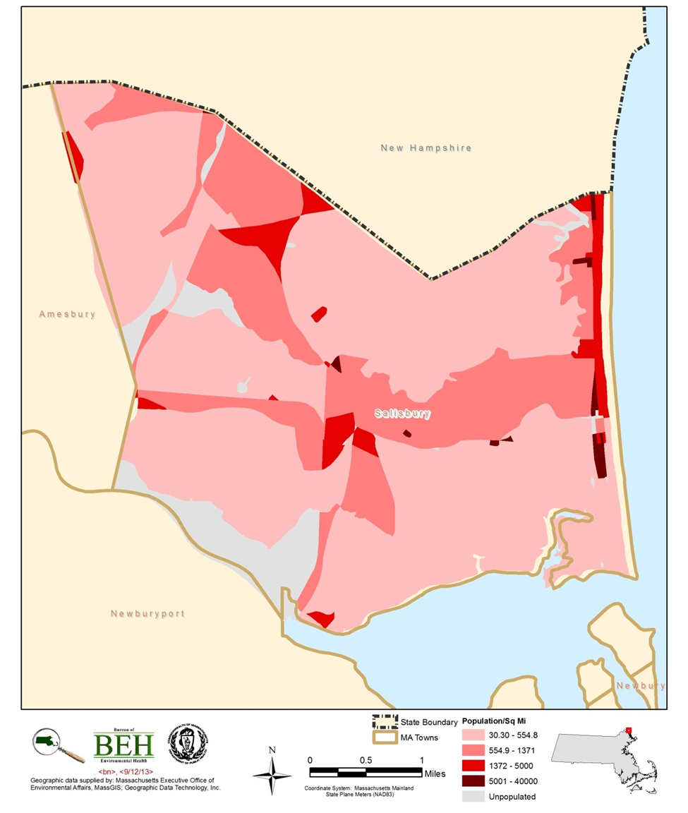

Figure 2
Areas of Concern
Salisbury, Massachusetts
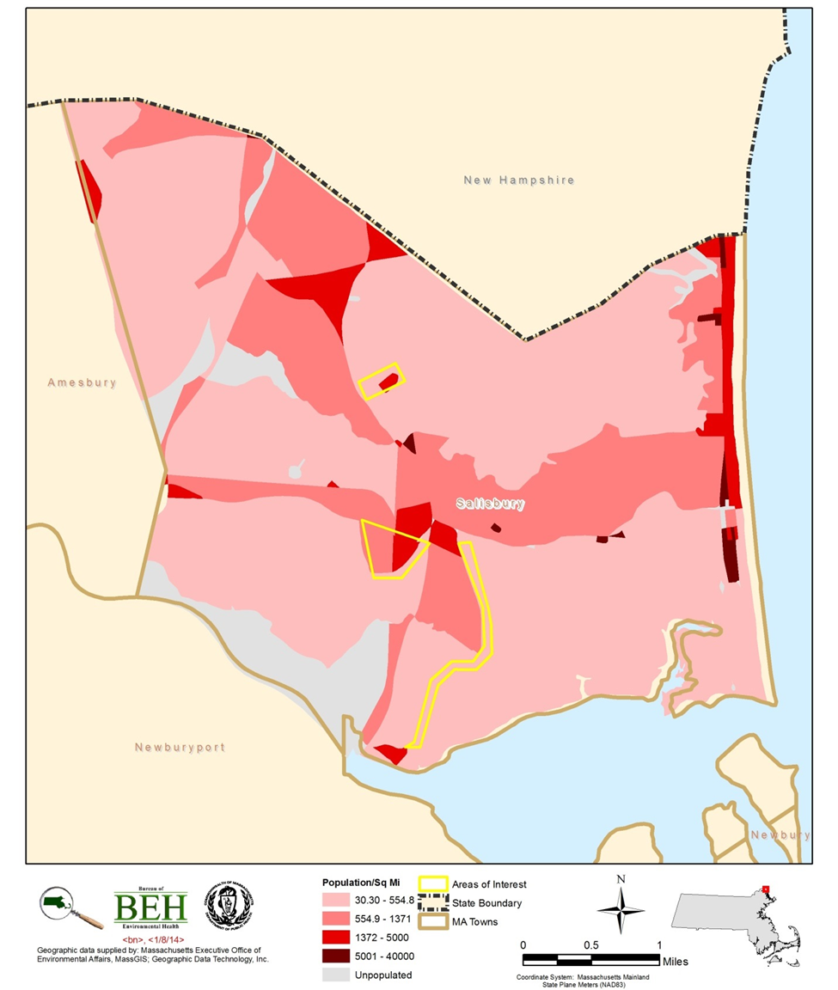

Community Fact Sheet

Salisbury, Massachusetts Updated 7/13/12

Cigarette Smoking
An estimated 2,105 smokers live in Salisbury (24.7% of adults, age 18+).
The adult smoking rate is 65% higher in Salisbury than statewide (24.7% in Salisbury compared to 15% statewide).
The rate of smoking during pregnancy in Salisbury is 178% higher than statewide (20.3% in Salisbury compared to 7.3% statewide).

MassHealth Tobacco Cessation Benefit
Since coverage of MassHealth tobacco cessation benefit began in July 2006, 177 smokers from Salisbury have used the benefit – an estimated 51.3% of MassHealth smokers living in Salisbury.
Statewide, 75,476 MassHealth smokers (40.8%) have used the tobacco cessation benefit since July 2006.

QuitWorks
Health care providers referred 20 smokers living in Salisbury to the QuitWorks program to help them quit smoking. In addition, 57 people from Salisbury called the Massachusetts Smokers’ Helpline to quit smoking (fiscal years 2004-2009).

Illegal Tobacco Sales to Minors
The rate of illegal sales to minors (those under age 18) is 135% higher is Salisbury (19%) compared to the state of Massachusetts (8.1%) based on data from fiscal years 2009 and 2010.

Health Effects of Smoking
Lung cancer incidence is 38% higher among males in Salisbury compare to the state of Massachusetts. The age-adjusted lung cancer incidence (per 100,000) for males is 114.92 in Salisbury compared to the 83.02 in Massachusetts.
Lung cancer incidence is 27% higher among females in Salisbury compared to the state of Massachusetts. The age-adjusted lung cancer incidence (per 100,000) for females is 82.66 in Salisbury compared to 65.15 in Massachusetts.
Mortality from lung cancer is 19% higher among males in Salisbury compared to Massachusetts.
Mortality from lung cancer is 107% higher among females in Salisbury compared to Massachusetts.
Community Fact Sheet

Salisbury, Massachusetts Updated 7/13/12

Data Sources
Smoking figures are small area estimates based on data from the 2009 Behavioral Risk Factor Surveillance System, Massachusetts Department of Public Health.
Figures on smoking during pregnancy are based on 2005 to 2009 Births (Vital Records), Massachusetts Department of Public Health.
MassHealth utilization of the tobacco cessation benefit was obtained from the Executive Office of Health and Human Services, MassHealth agency covering fiscal years 2007 to 2009 (through April 30, 2009).
The number of referrals to the QuitWorks program and calls to the Massachusetts Smokers’ Helpline is based on data collected by the Massachusetts Tobacco Cessation and Prevention Program from fiscal years 2004 to 2009.
The rate of illegal sales to minors is based on compliance checks performed during fiscal year 2009 and 2010.
Rates of lung cancer incidence are age-adjusted and based on data from 2004 to 2008 Cancer Registry maintained by the Massachusetts Department of Public Health.
Figures on lung cancer mortality are based on 2003 to 2007 Deaths (Vital Records), Massachusetts Department of Public Health.

The cancer statistics reported here may differ slightly from those in other publications. These differences may be due to file updates, differences in calculation methods (such as grouping ages differently or rounding off numbers at different points in calculations), and updates or differences in population estimates.
Based on recent research by the MCR (MCR 2013), which included an evaluation of the reliability of the tobacco use history information reported to the MCR, it appears that the category of “never smoker” is less reliable than other reporting categories (such as current or former smoker). Many individuals are reported as never having smoked when, based on medical record reviews, they are individuals who are not current smokers but whose past tobacco use is unknown. These individuals should more accurately be reported as having an unknown tobacco use history rather than being categorized as never having used tobacco products. This misclassification is expected to result in an overestimation of those categorized as “never smokers” and an underestimate of those categorized as “former smokers”.

